COMP 262: Natural Language Processing and Recommender Systems
Sentiment Analysis of Amazon All Beauty Reviews
Phase 1: Lexicon-based Models (VADER and TextBlob)
Team 2
Manav Chaudhary
Harsh Eary
Steven Hao Gong
Rishi Goyal
Parth Kishorbhai Kevadiya
Jasdish Singh

Table of Contents
1. Introduction 3
2. Data Exploration 3
3. Pre-processing 5
4. Models 5
5. Results 6
6. Conclusion 6
7. Assumptions 7
8. References 7
Appendix 1: Project Plan 8
Appendix 2: Meeting Register 8

1. Introduction
- Goal: label Amazon All Beauty reviews as Positive, Neutral or Negative using two lexicon models.
- Data: Amazon Review Data (2018), All Beauty 5-core, published by Ni, Li and McAuley (UCSD).
- Code: team2_phase1_lexicon_sentiment.py runs every step and saves all charts and tables (seed 42).

2. Data Exploration
Table 1. Dataset overview
Rows | Columns | Products | Reviewers | Avg rating | 5-star | Missing text
5,269 | 12 | 85 | 991 | 4.77 | 88.2% | 5 rows

- Duplicates: 3,890 rows (73.8%) are the same review copied under different product sizes/colours. Only 1,379 unique reviews remain.
- Imbalance: 91% of unique reviews are positive, so we use macro-F1, not accuracy.
- Products: median 4 reviews per product; 2 products hold 62.5% of all reviews.
- Users: 86% of reviewers wrote only one unique review.
- Length: median 29 words; 106 long outliers (> 161 words). 2-3 star reviews are the longest.
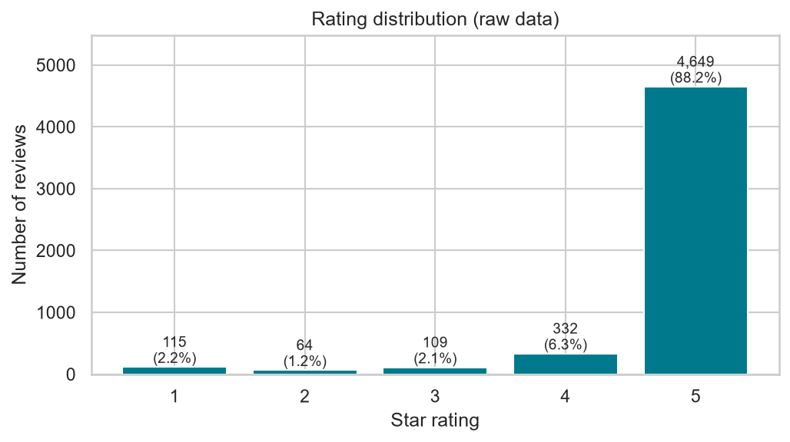
Figure 1. Rating distribution
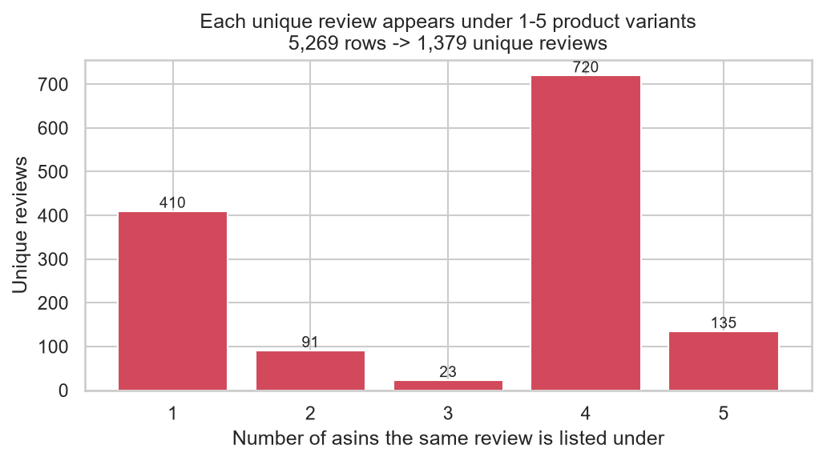
Figure 2. Product variants each review is copied to
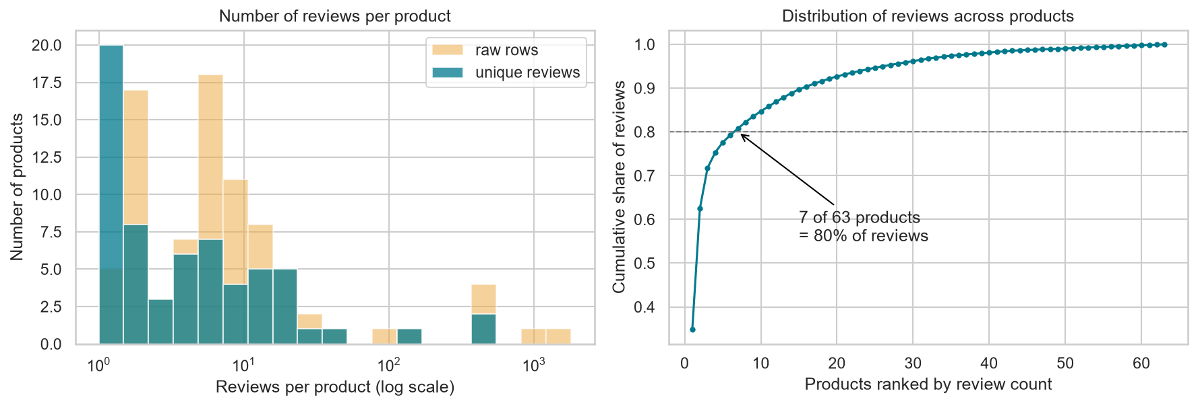
Figure 3. Reviews per product and their cumulative share
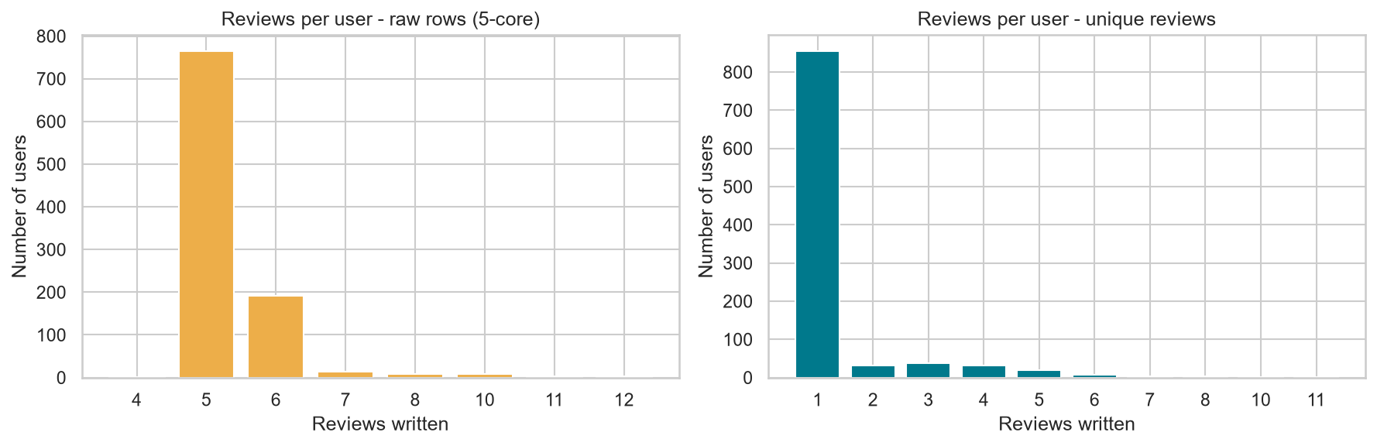
Figure 4. Reviews per user: raw vs unique
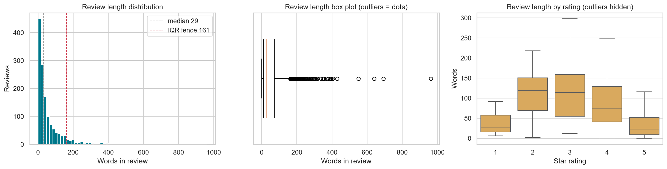
Figure 5. Review length, outliers and length by rating

3. Pre-processing
Table 2. Labels from star ratings
Label | Ratings | Reviews | Share
Positive | 4, 5 | 1,259 | 91.3%
Neutral | 3 | 64 | 4.6%
Negative | 1, 2 | 56 | 4.1%

- Columns used: reviewText + summary as input; overall as the label only. Other columns were used only for exploration.
- Removed: duplicate copies, 1 empty review, and auto-generated "Five Stars" titles (they repeat the rating, so they leak the label).
- Kept: short and long reviews. They are real opinions, and long ones are mostly the minority classes.
Table 3. Pre-processing per model
Step | VADER | TextBlob | Reason
Clean HTML, URLs, "sooooo" | Yes | Yes | Noise
Lower-case, remove punctuation | No | Yes | VADER uses CAPS and "!"
Remove stop words | No | Yes, keep "not" | Negations carry sentiment
Lemmatise | No | Yes | Match TextBlob's base words

- Tested on 378 held-out reviews: this setup gave TextBlob macro-F1 0.506 vs 0.460 with light cleaning. Removing "not" hurt both models.

4. Models
- Lexicons studied: VADER, TextBlob, SentiWordNet. We chose VADER (handles negation, CAPS, "!!!", emoticons, "but") and TextBlob (adjective lexicon with subjectivity). SentiWordNet was rejected: it scores "not good" as positive.
Table 4. The two models
 | VADER | TextBlob
How it works | Rated word list + grammar rules; compound score -1 to +1 | Averages adjective scores; flips on negation; polarity -1 to +1
Rule | Pos >= 0.05, Neg <= -0.05 | Pos > 0, Neg < 0
Tuned threshold | +/- 0.40 | Pos >= 0.075, Neg <= 0.05

- Test data: 1,000 random unique reviews (911 Positive, 51 Neutral, 38 Negative). Thresholds were tuned only on the other 378 reviews.

5. Results
Table 5. Results on the 1,000-review test sample
Model | Accuracy | Macro-F1 | F1 Neg | F1 Neu | F1 Pos
Majority baseline (always Positive) | 0.911 | 0.318 | 0.000 | 0.000 | 0.953
VADER (default thresholds) | 0.891 | 0.469 | 0.432 | 0.023 | 0.951
TextBlob (default thresholds) | 0.866 | 0.404 | 0.234 | 0.044 | 0.933
VADER (tuned (0.4, -0.4)) | 0.859 | 0.490 | 0.361 | 0.177 | 0.932
TextBlob (tuned (0.075, 0.05)) | 0.834 | 0.391 | 0.225 | 0.030 | 0.919

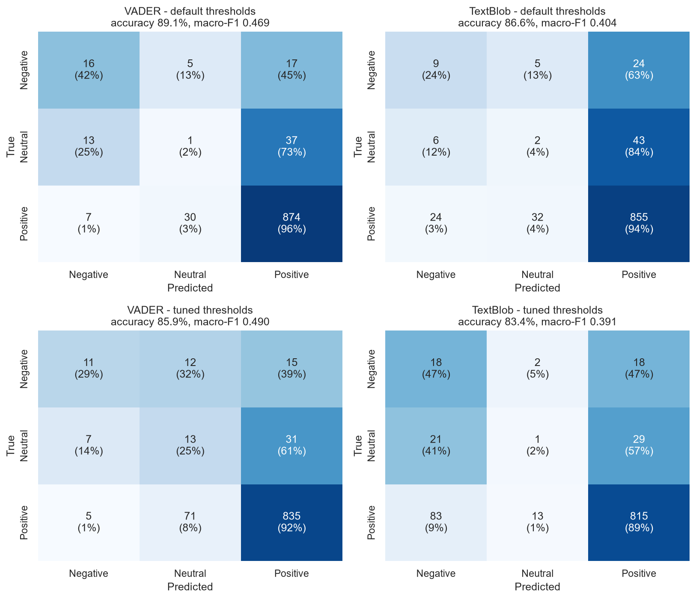
Figure 6. Confusion matrices (default and tuned thresholds)
- VADER wins: macro-F1 0.469 vs 0.404, and it finds far more negative reviews.
- Neutral is the weak spot: 73-84% of neutral reviews are predicted Positive.
- Long reviews are harder: accuracy falls from 95% (11-30 words) to 74% (150+ words).
- Tuning raised VADER to 0.490 but did not help TextBlob.

6. Conclusion
- De-duplication was essential: 74% of rows were copies.
- VADER is the better lexicon for these reviews.
- Both lexicons miss neutral and mixed reviews, which Phase 2's machine-learning models will target on the same 1,000 reviews.

7. Assumptions
- The star rating is the true sentiment.
- Same reviewer + text + timestamp = the same review.

8. References
- Ni, J., Li, J., & McAuley, J. (2019). Justifying recommendations using distantly-labeled reviews and fine-grained aspects. EMNLP-IJCNLP 2019. https://nijianmo.github.io/amazon/index.html
- Hutto, C. J., & Gilbert, E. (2014). VADER: A parsimonious rule-based model for sentiment analysis of social media text. ICWSM-14.
- Loria, S. TextBlob documentation. https://textblob.readthedocs.io
- Baccianella, S., Esuli, A., & Sebastiani, F. (2010). SentiWordNet 3.0. LREC 2010.
- Bird, S., Klein, E., & Loper, E. (2009). Natural Language Processing with Python. O'Reilly.

Appendix 1: Project Plan
Table 6. Project plan
Week | Task | Owner | Status
3 | Teams formed, dataset assigned | All | Done
4-5 | Exploration and pre-processing | Manav Chaudhary, Rishi Goyal | Done
6 | Lexicon study and per-model cleaning | Steven Hao Gong, Harsh Eary | Done
7 | Models and validation | Parth Kishorbhai Kevadiya, Jasdish Singh | Done
8 | Report and Phase 1 demo | All | In progress
9-14 | Phase 2 | All | Planned

Appendix 2: Meeting Register
Table 7. Meeting register
Date | Attendees | Subjects | Assignments
21-10-2026 | All | Kick-off, dataset | Manav, Rishi: exploration and pre-processing
29-10-2026 | All | Exploration findings | Steven, Harsh: lexicons and cleaning
02-11-2026 | All | Lexicons and results | Parth, Jasdish: models and results

