Week 1

Question
1. Write a program in C to find the second smallest element in an array.
Program
#include <stdio.h>

int main()
{
int n, i, j, temp;

printf("Enter number of elements: ");
scanf("%d", &n);
int arr[n];
printf("Enter elements:\n");
for(i = 0; i < n; i++) {
scanf("%d", &arr[i]);
}
for(i = 0; i < n - 1; i++) {
for(j = i + 1; j < n; j++) {
if(arr[i] > arr[j]) {
temp = arr[i];
arr[i] = arr[j];
arr[j] = temp;
}
}
}

printf("Second smallest element: %d\n", arr[1]);

return 0;
}

Output
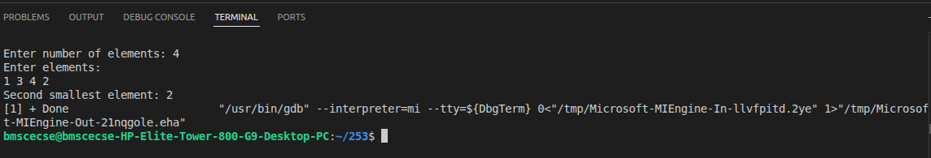

Question
Write a program in C to find the sum of the left diagonals of a matrix.
Program
#include <stdio.h>

int main() {
int n, i, j, sum = 0;
printf("Enter order of matrix: ");
scanf("%d", &n);
int matrix[n][n];
printf("Enter matrix elements:\n");
for(i = 0; i < n; i++) {
for(j = 0; j < n; j++) {
scanf("%d", &matrix[i][j]);
}
}
for(i = 0; i < n; i++) {
sum += matrix[i][i];
}
printf("Sum of left diagonal: %d\n", sum);
return 0;
}

Output
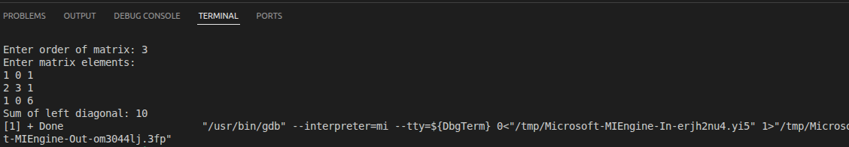

Question
Write a program in C to find the sum of rows and columns of a matrix.
Program
#include <stdio.h>

int main() {
int r, c, i, j;

printf("Enter number of rows and columns: ");
scanf("%d %d", &r, &c);

int matrix[r][c];

printf("Enter matrix elements:\n");
for(i = 0; i < r; i++) {
for(j = 0; j < c; j++) {
scanf("%d", &matrix[i][j]);
}
}

for(i = 0; i < r; i++) {
int rowSum = 0;
for(j = 0; j < c; j++) {
rowSum += matrix[i][j];
}
printf("Sum of row %d: %d\n", i + 1, rowSum);
}

for(j = 0; j < c; j++) {
int colSum = 0;
for(i = 0; i < r; i++) {
colSum += matrix[i][j];
}
printf("Sum of column %d: %d\n", j + 1, colSum);
}

return 0;
}

Output
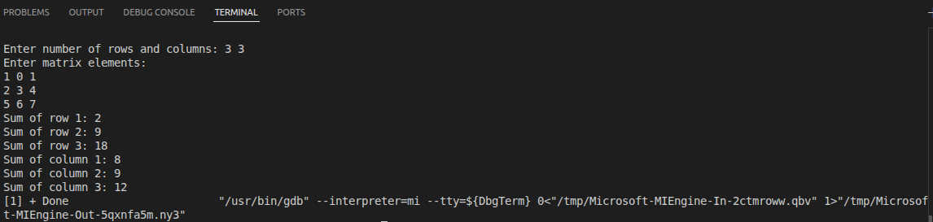

Question
Write a program in C to count the total number of duplicate elements in an array.
Program
#include <stdio.h>

int main() {
int n, i, j, count = 0;

printf("Enter number of elements: ");
scanf("%d", &n);
int arr[n];

printf("Enter elements:\n");
for(i = 0; i < n; i++)
{
scanf("%d", &arr[i]);
}
for(i = 0; i < n; i++)
{
if(arr[i] == -1)
{
continue;
}
for(j = i + 1; j < n; j++)
{
if(arr[i] == arr[j])
{
count++;
arr[j] = -1;
break;
}
}
}

printf("Total number of duplicate elements: %d\n", count);
return 0;
}

Output
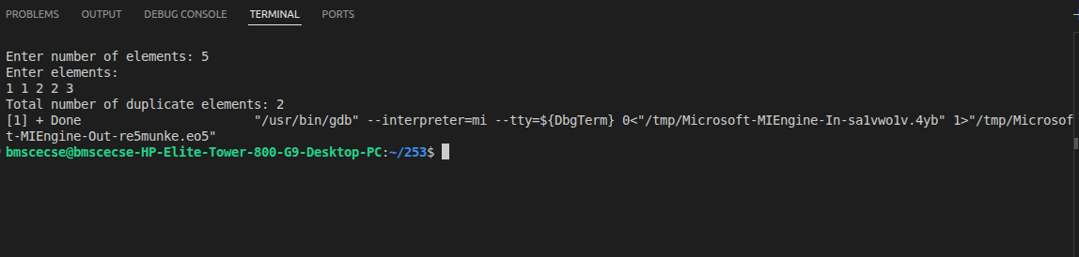

Question
Write a program in C to find the second largest element in an array.

Program
#include <stdio.h>

int main() {
int n, i, j, temp;

printf("Enter number of elements: ");
scanf("%d", &n);
int arr[n];
printf("Enter elements:\n");
for(i = 0; i < n; i++) {
scanf("%d", &arr[i]);
}
for(i = 0; i < n - 1; i++) {
for(j = i + 1; j < n; j++) {
if(arr[i] < arr[j]) {
temp = arr[i];
arr[i] = arr[j];
arr[j] = temp;
}
}
}
int secondLargest = -1;
for(i = 1; i < n; i++) {
if(arr[i] != arr[0]) {
secondLargest = arr[i];
break;
}
}
printf("Second largest element: %d\n", secondLargest);

return 0;
}

Output
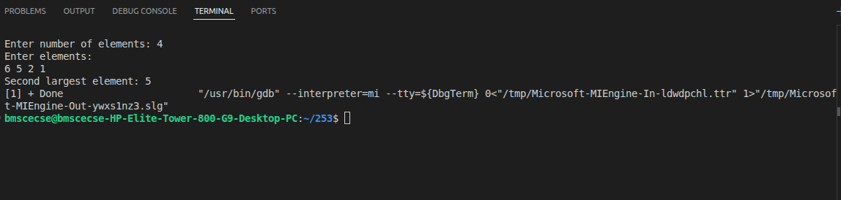

Question
Write a program in C to delete an element at a desired position from an array.

Program
#include <stdio.h>

int main() {
int n, i, pos;

printf("Enter number of elements: ");
scanf("%d", &n);

int arr[n];

printf("Enter elements:\n");
for(i = 0; i < n; i++) {
scanf("%d", &arr[i]);
}

printf("Enter position to delete (1 to %d): ", n);
scanf("%d", &pos);

if(pos < 1 || pos > n)
{
printf("Invalid position!\n");
}
else
{
for(i = pos - 1; i < n - 1; i++)
{
arr[i] = arr[i + 1];
}
n--;

printf("Array after deletion:\n");
for(i = 0; i < n; i++)
{
printf("%d ", arr[i]);
}
}
printf("\n");
return 0;
}

Output
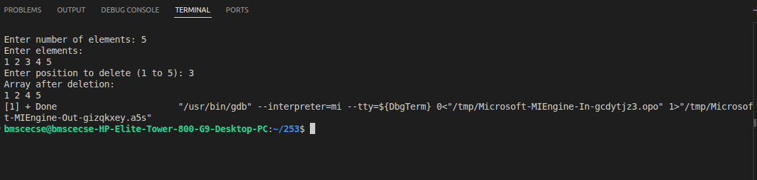

Week 2

Question
Write a C program to simulate the following CPU scheduling algorithm to find turnaround time and waiting time.
a) FCFS
b) SJF(Preemptive and non preemptive )

Program
a)FCFS
#include <stdio.h>

int main() {
int n, bt[20], wt[20], tat[20], at[20], ct[20], pid[20];
int i, j;
float twt = 0.0, ttat = 0.0, awt, att;

printf("Enter the number of processes: ");
scanf("%d", &n);

// Input Arrival Time and Burst Time
for (i = 0; i < n; i++) {
pid[i] = i + 1; // Store process ID

printf("Enter Arrival Time for Process %d: ", i + 1);
scanf("%d", &at[i]);

printf("Enter Burst Time for Process %d: ", i + 1);
scanf("%d", &bt[i]);
}

// Bubble Sort based on Arrival Time
for (i = 0; i < n - 1; i++) {
for (j = 0; j < n - i - 1; j++) {
if (at[j] > at[j + 1]) {
// Swap Arrival Time
int temp = at[j];
at[j] = at[j + 1];
at[j + 1] = temp;

// Swap Burst Time
temp = bt[j];
bt[j] = bt[j + 1];
bt[j + 1] = temp;

// Swap Process ID
temp = pid[j];
pid[j] = pid[j + 1];
pid[j + 1] = temp;
}
}
}

// FCFS Scheduling
ct[0] = at[0] + bt[0];
wt[0] = 0;
tat[0] = bt[0];

for (i = 1; i < n; i++) {
if (ct[i - 1] < at[i]) {
ct[i] = at[i] + bt[i]; // CPU idle case
wt[i] = 0;
} else {
wt[i] = ct[i - 1] - at[i];
ct[i] = ct[i - 1] + bt[i];
}

tat[i] = wt[i] + bt[i];
}

// Calculate averages
for (i = 0; i < n; i++) {
twt += wt[i];
ttat += tat[i];
}

awt = twt / n;
att = ttat / n;

// Output Table
printf("\nPROCESS\tAT\tBT\tCT\tWT\tTAT");

for (i = 0; i < n; i++) {
printf("\nP%d\t%d\t%d\t%d\t%d\t%d",
pid[i], at[i], bt[i], ct[i], wt[i], tat[i]);
}

printf("\n\nAverage Waiting Time = %.2f", awt);
printf("\nAverage Turnaround Time = %.2f\n", att);

return 0;
}

Output
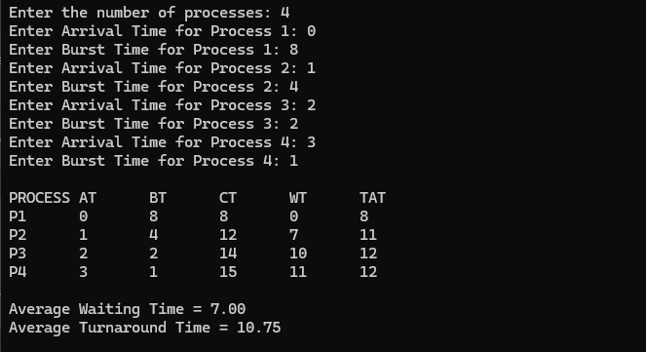

B i) SJF Non - Preemptive
#include <stdio.h>
#include <limits.h>

int main() {
int n, bt[20], at[20], wt[20], tat[20], ct[20];
int pid[20], completed[20] = {0};
int i, time = 0, count = 0, pos;
float twt = 0.0, ttat = 0.0, awt, att;

printf("Enter number of processes: ");
scanf("%d", &n);

// Input
for (i = 0; i < n; i++) {
pid[i] = i + 1;

printf("Enter Arrival Time for Process %d: ", i + 1);
scanf("%d", &at[i]);

printf("Enter Burst Time for Process %d: ", i + 1);
scanf("%d", &bt[i]);
}

// Non-Preemptive SJF Scheduling
while (count < n) {
int min = INT_MAX;
pos = -1;

// Find shortest job among arrived processes
for (i = 0; i < n; i++) {
if (at[i] <= time && completed[i] == 0) {
if (bt[i] < min) {
min = bt[i];
pos = i;
}
// Tie breaker: earlier arrival time
else if (bt[i] == min) {
if (at[i] < at[pos]) {
pos = i;
}
}
}
}

if (pos == -1) {
time++; // CPU idle
}
else {
time += bt[pos]; // Run full burst time
ct[pos] = time;
tat[pos] = ct[pos] - at[pos];
wt[pos] = tat[pos] - bt[pos];

completed[pos] = 1;
count++;
}
}

// Calculate averages
for (i = 0; i < n; i++) {
twt += wt[i];
ttat += tat[i];
}

awt = twt / n;
att = ttat / n;

// Output
printf("\nPROCESS\tAT\tBT\tCT\tWT\tTAT");
for (i = 0; i < n; i++) {
printf("\nP%d\t%d\t%d\t%d\t%d\t%d",
pid[i], at[i], bt[i], ct[i], wt[i], tat[i]);
}

printf("\n\nAverage Waiting Time = %.2f", awt);
printf("\nAverage Turnaround Time = %.2f\n", att);

return 0;
}

Output
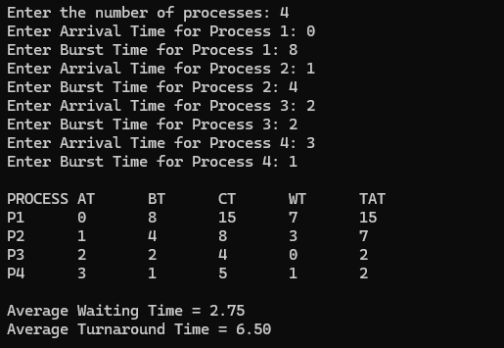
B ii) SJF Preemptive
#include <stdio.h>
#include <limits.h>

int main() {
int n, bt[20], rt[20], wt[20], tat[20], at[20], ct[20], pid[20];
int i, time = 0, count = 0, min, pos;
float twt = 0.0, ttat = 0.0, awt, att;

printf("Enter the number of processes: ");
scanf("%d", &n);

// Input Arrival Time and Burst Time
for (i = 0; i < n; i++) {
pid[i] = i + 1;

printf("Enter Arrival Time for Process %d: ", i + 1);
scanf("%d", &at[i]);

printf("Enter Burst Time for Process %d: ", i + 1);
scanf("%d", &bt[i]);

rt[i] = bt[i]; // Remaining Time
}

// SRTF Scheduling
while (count < n) {
min = INT_MAX;
pos = -1;

// Find process with shortest remaining time at current time
for (i = 0; i < n; i++) {
if (at[i] <= time && rt[i] > 0) {
if (rt[i] < min) {
min = rt[i];
pos = i;
}
// Tie-breaking: earlier arrival time
else if (rt[i] == min) {
if (at[i] < at[pos]) {
pos = i;
}
}
}
}

if (pos == -1) {
time++; // CPU Idle
}
else {
rt[pos]--; // Execute 1 unit
time++;

if (rt[pos] == 0) {
count++;
ct[pos] = time;
tat[pos] = ct[pos] - at[pos];
wt[pos] = tat[pos] - bt[pos];
}
}
}

// Calculate averages
for (i = 0; i < n; i++) {
twt += wt[i];
ttat += tat[i];
}

awt = twt / n;
att = ttat / n;

// Output
printf("\nPROCESS\tAT\tBT\tCT\tWT\tTAT");
for (i = 0; i < n; i++) {
printf("\nP%d\t%d\t%d\t%d\t%d\t%d",
pid[i], at[i], bt[i], ct[i], wt[i], tat[i]);
}

printf("\n\nAverage Waiting Time = %.2f", awt);
printf("\nAverage Turnaround Time = %.2f\n", att);

return 0;
}

Output
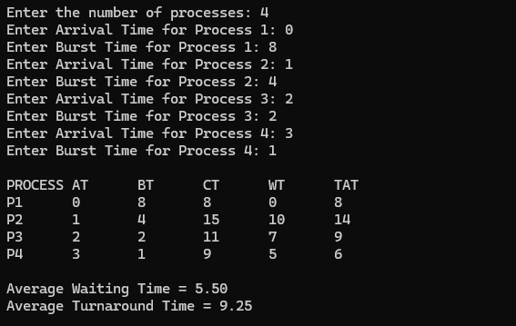

Week 3

Question
3. Write a C program to simulate the following CPU scheduling
algorithm to find turnaround time and waiting time.
Priority Scheduling(Preemptive and non Preemptive)
Program
a)Priority Scheduling(Preemptive)
#include <stdio.h>

struct Process {
int pid, at, bt, pr, rt, ct, tat, wt;
};

int main() {
int n, time = 0, completed = 0;
struct Process p[20];

printf("Enter number of processes: ");
scanf("%d", &n);

for(int i = 0; i < n; i++) {
printf("Enter AT BT Priority for P%d: ", i+1);
scanf("%d %d %d", &p[i].at, &p[i].bt, &p[i].pr);
p[i].pid = i+1;
p[i].rt = p[i].bt;
}

while(completed < n) {
int idx = -1;
int highest = 9999;

for(int i = 0; i < n; i++) {
if(p[i].at <= time && p[i].rt > 0) {
if(p[i].pr < highest) {
highest = p[i].pr;
idx = i;
}
}
}

if(idx != -1) {
p[idx].rt--;
time++;

if(p[idx].rt == 0) {
p[idx].ct = time;
p[idx].tat = p[idx].ct - p[idx].at;
p[idx].wt = p[idx].tat - p[idx].bt;
completed++;
}
}
else {
time++;
}
}

float avgwt = 0, avgtat = 0;

printf("\nPID\tAT\tBT\tPR\tCT\tTAT\tWT\n");
for(int i = 0; i < n; i++) {
printf("P%d\t%d\t%d\t%d\t%d\t%d\t%d\n",
p[i].pid, p[i].at, p[i].bt, p[i].pr,
p[i].ct, p[i].tat, p[i].wt);

avgwt += p[i].wt;
avgtat += p[i].tat;
}

printf("\nAverage Waiting Time = %.2f", avgwt/n);
printf("\nAverage Turnaround Time = %.2f\n", avgtat/n);

return 0;
}

Output
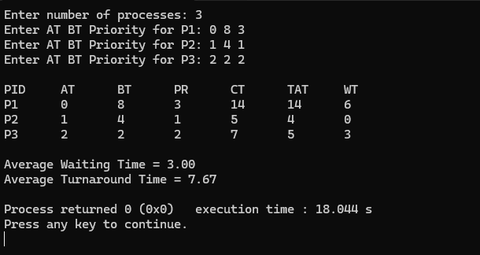

b)Priority Scheduling (non Preemptive)
#include <stdio.h>

struct Process {
int pid, at, bt, pr, ct, tat, wt, completed;
};

int main() {
int n, time = 0, completed = 0;
struct Process p[20];

printf("Enter number of processes: ");
scanf("%d", &n);

for(int i = 0; i < n; i++) {
printf("Enter AT BT Priority for P%d: ", i+1);
scanf("%d %d %d", &p[i].at, &p[i].bt, &p[i].pr);
p[i].pid = i+1;
p[i].completed = 0;
}

while(completed < n) {
int idx = -1;
int highest = 9999;

for(int i = 0; i < n; i++) {
if(p[i].at <= time && p[i].completed == 0) {
if(p[i].pr < highest) {
highest = p[i].pr;
idx = i;
}
}
}

if(idx != -1) {
time += p[idx].bt;
p[idx].ct = time;
p[idx].tat = p[idx].ct - p[idx].at;
p[idx].wt = p[idx].tat - p[idx].bt;
p[idx].completed = 1;
completed++;
}
else {
time++;
}
}

float avgwt = 0, avgtat = 0;

printf("\nPID\tAT\tBT\tPR\tCT\tTAT\tWT\n");
for(int i = 0; i < n; i++) {
printf("P%d\t%d\t%d\t%d\t%d\t%d\t%d\n",
p[i].pid, p[i].at, p[i].bt, p[i].pr,
p[i].ct, p[i].tat, p[i].wt);

avgwt += p[i].wt;
avgtat += p[i].tat;
}

printf("\nAverage Waiting Time = %.2f", avgwt/n);
printf("\nAverage Turnaround Time = %.2f\n", avgtat/n);

return 0;
}

Output
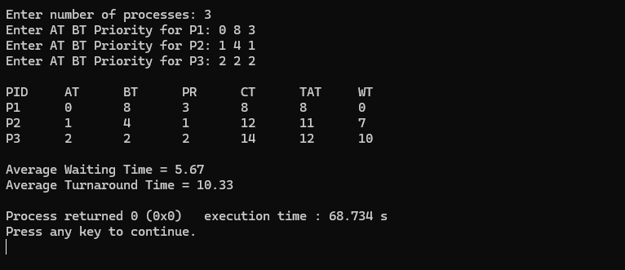

Week 4

Question
Write a C program to simulate the following CPU scheduling
algorithm to find turnaround time and waiting time.
a) Round Robin (Experiment with different quantum sizes
for RR algorithm)
Write the complete program with 2 outputs having different time quantum.

Program
#include <stdio.h>

int main() {
int n, tq;

printf("Enter number of processes: ");
scanf("%d", &n);

int bt[n], rt[n], wt[n], tat[n];

printf("Enter burst times:\n");
for (int i = 0; i < n; i++) {
printf("P%d: ", i + 1);
scanf("%d", &bt[i]);
rt[i] = bt[i]; // remaining time
}

printf("Enter time quantum: ");
scanf("%d", &tq);

int time = 0, done;

do {
done = 1;

for (int i = 0; i < n; i++) {
if (rt[i] > 0) {
done = 0;

if (rt[i] > tq) {
time += tq;
rt[i] -= tq;
} else {
time += rt[i];
wt[i] = time - bt[i];
rt[i] = 0;
}
}
}

} while (!done);

// Calculate Turnaround Time
for (int i = 0; i < n; i++) {
tat[i] = bt[i] + wt[i];
}

// Output
float total_wt = 0, total_tat = 0;

printf("\nProcess\tBT\tWT\tTAT\n");
for (int i = 0; i < n; i++) {
printf("P%d\t%d\t%d\t%d\n", i + 1, bt[i], wt[i], tat[i]);
total_wt += wt[i];
total_tat += tat[i];
}

printf("\nAverage Waiting Time = %.2f", total_wt / n);
printf("\nAverage Turnaround Time = %.2f\n", total_tat / n);

return 0;
}

Output
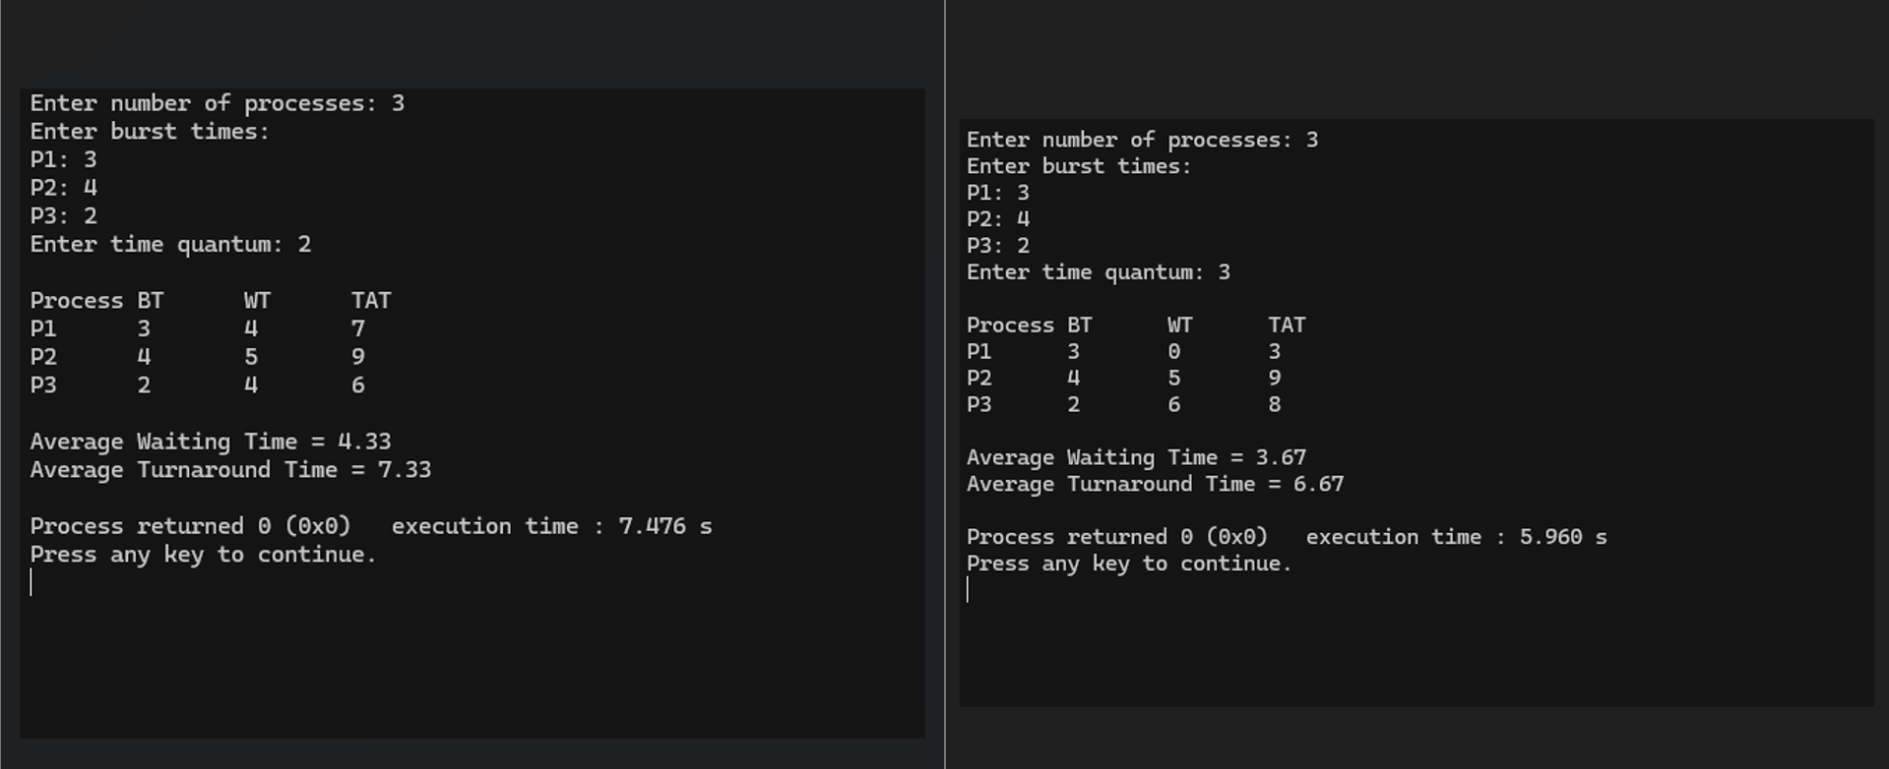

Question
Program
Output

Question
Program
Output

Question
Program
Output

Question
Program
Output

Question
Program
Output

Question
Program
Output

