RECYCLEV1SION AI
Vision-Based Recycling Intelligence
Technical Interview Submission
Model: Llama 4 Scout 17B via Groq API
Stack: Python | Streamlit | OpenCV | Plotly
Date: May 2026

Deliverables Included

1 | Working Prototype (runnable Streamlit app + backend)
2 | Architecture Diagram & Design Decisions
3 | AI/ML Approach — Chosen, Rejected, and Why
4 | Data Strategy — Collection, Labelling, Improvement
5 | Evaluation Plan — Business-Relevant Metrics
6 | MLOps Note — Prototype to Production
7 | README with Setup, Assumptions & Sample Output

1. Working Prototype
A fully runnable Streamlit dashboard backed by a Python analysis engine. Upload any image or short video of plastic bottles and receive a live AI analysis report.

What the Prototype Does
- Accepts JPG, PNG, WEBP images or MP4/MOV/AVI video files
- Produces all 6 required outputs: bottle count, PET vs non-PET composition, colour distribution, quality distribution, confidence score, human-review flag, and batch grade/value
- Displays results in a dark-themed Streamlit dashboard with Plotly charts
- Exports results as a plain-text report, JSON file, and CSV summary

File Structure
File | Purpose
app.py | Streamlit frontend — dashboard UI, charts, export buttons
backend.py | Analysis engine — Groq API calls, image/video processing, report generation
architecture.py | Generates the architecture diagram (matplotlib)
requirements.txt | Python dependencies (groq, streamlit, opencv, plotly, pandas)
README.md | Setup instructions, assumptions, sample output

How to Run
- Install Python 3.10+ and run: pip install -r requirements.txt
- Obtain a free Groq API key from console.groq.com
- Set the environment variable: export GROQ_API_KEY="gsk_..."
- Launch the dashboard: streamlit run app.py
- Open http://localhost:8501, upload a batch image or video, click Analyse Batch

Cost estimate: Groq's free tier supports ~14,400 requests/day. At ~1 analysis per batch, this covers high-volume facility throughput at zero cost during prototyping.

2. Architecture Diagram & Design Decisions
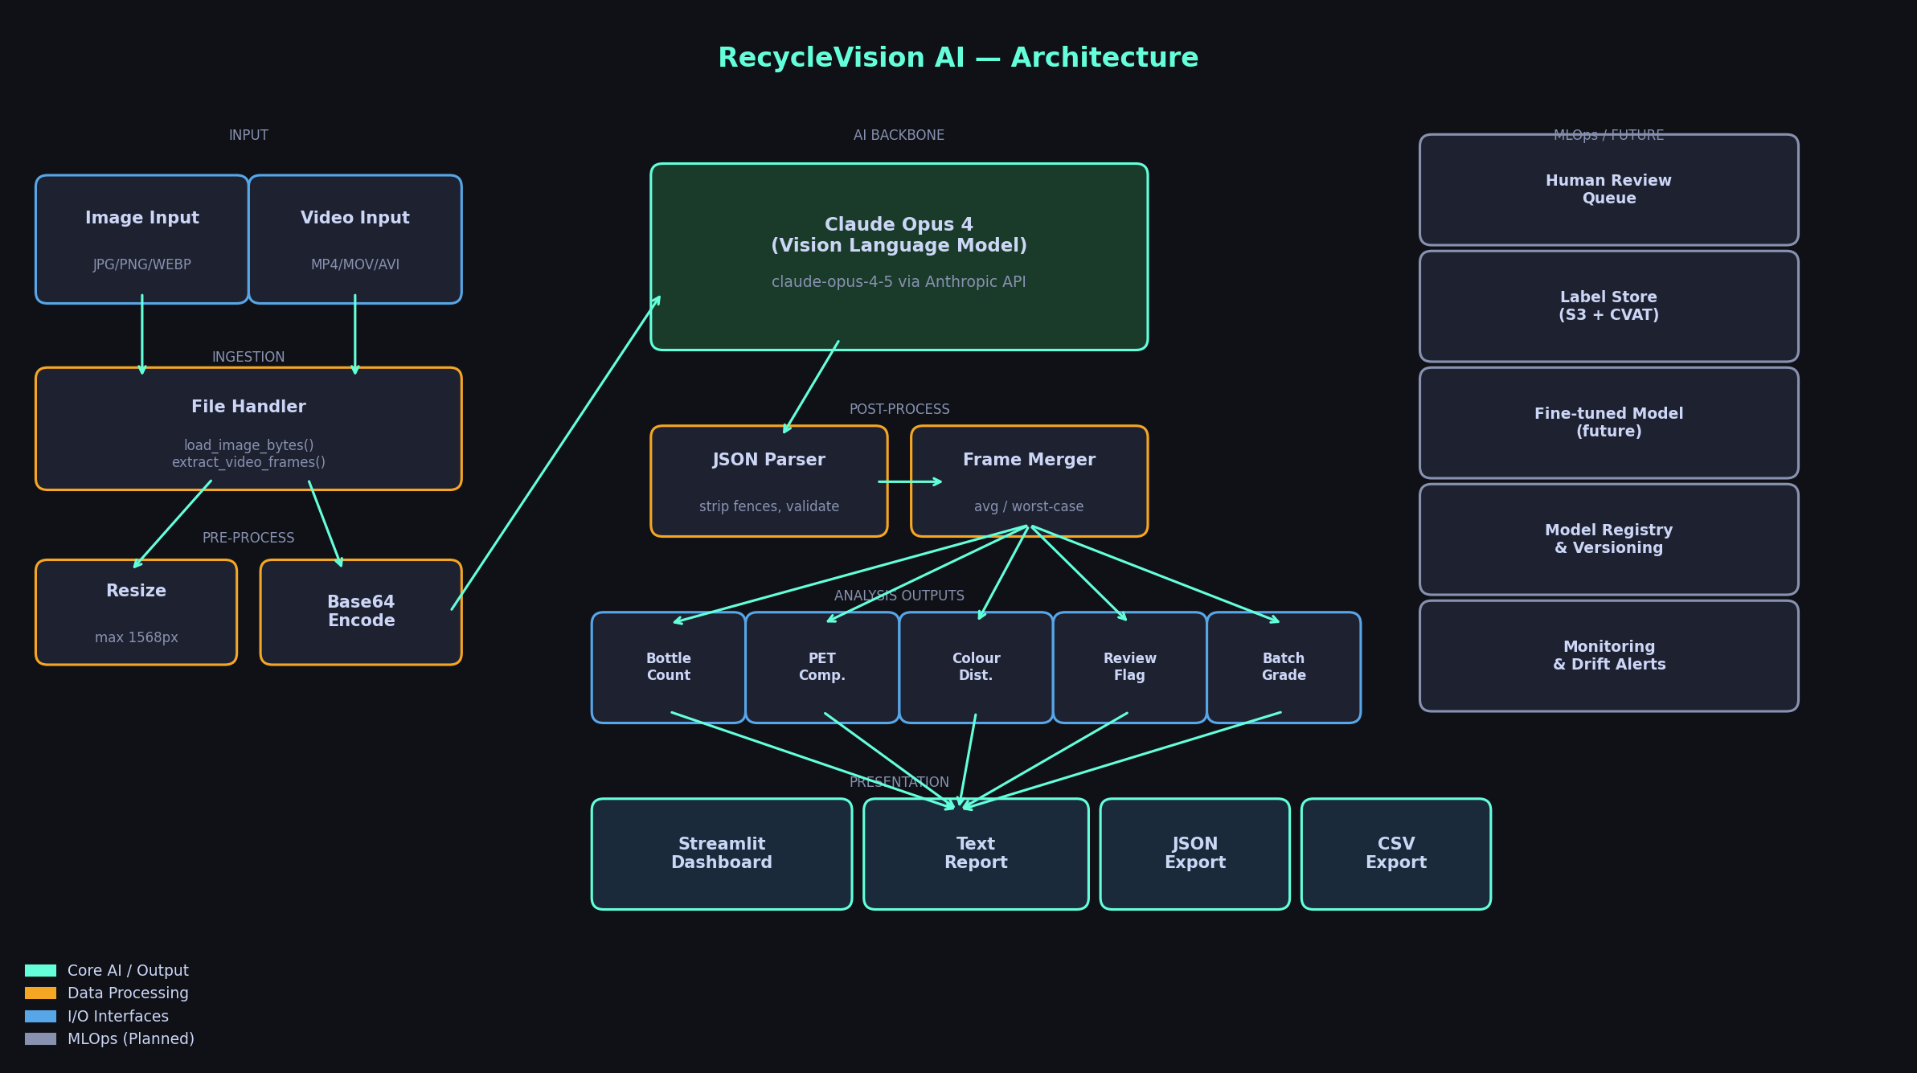

Layer-by-Layer Explanation
Input Layer
Two input types are supported. Images (JPG/PNG/WEBP) are loaded directly. Videos (MP4/MOV/AVI) are sampled using OpenCV, extracting up to 6 evenly-spaced frames.
Pre-processing
All images are resized to a maximum of 1024px on the longest edge and converted to JPEG before being sent to the API. This reduces token usage and keeps latency low without meaningful loss in classification accuracy for batch-level tasks.
Vision Language Model (Groq)
The core inference engine is Llama 4 Scout 17B running on Groq's LPU hardware. It receives images as base64-encoded data URLs in an OpenAI-compatible chat.completions request. A detailed system prompt encodes the full grading rubric, JSON output schema, and review-flag logic.
Post-processing
The raw model response is stripped of any accidental markdown fences and parsed as JSON. For video inputs, multiple frame results are merged: numeric fields are averaged, contamination risk and grade take the worst case (conservative for facility safety).
Presentation Layer
Streamlit renders the dashboard. Plotly handles the donut, bar, and distribution charts. Three export formats are generated: a plain-text operational report, raw JSON, and a CSV summary row.
MLOps Side Rail (Planned)
Low-confidence predictions are flagged for human review. Corrected labels feed back into a label store (S3 + CVAT). Over time this data trains a fine-tuned YOLO or RT-DETR model that replaces the VLM for high-throughput scenarios.

3. AI/ML Approach

What Was Chosen
Primary model: meta-llama/llama-4-scout-17b-16e-instruct via Groq API Rationale: Zero training data requirement, sub-second inference on Groq LPUs, strong visual reasoning, and structured JSON output via prompt engineering.

The VLM approach was chosen because it solves the cold-start problem. A recycling facility has no labelled dataset on day one. A fine-tuned object detector would need thousands of annotated images per material class before it could be deployed. The VLM requires none: it generalises from pretraining across diverse visual and semantic knowledge.

Groq was chosen over other API providers for three reasons: (1) LPU inference is 10-20x faster than GPU-based APIs at comparable quality, (2) the free tier is generous enough for a prototype, (3) the OpenAI-compatible SDK makes future provider swaps trivial.

What Was Rejected

Approach | Rejected Because | Future Role
YOLOv8 / Detectron2 | Requires 5,000+ labelled images per class. Cold-start problem is fatal for day 1. | Primary model once 10k+ labelled images exist
Classic CV (HSV thresholding) | Brittle under varying lighting, label colours, and camera angles. No material reasoning. | Colour pre-filter only as lightweight heuristic
OCR on resin codes | Resin triangles are often occluded, dirty, or absent in batch photography. | Supplement when labels are clean and visible
SAM / Mask R-CNN segmentation | High compute cost, needs per-pixel labels. Overkill for batch-level analysis. | Per-bottle mask + colour sampling in v2
Claude Vision / GPT-4V | Higher latency and cost vs. Groq. Easy swap via one env variable change. | Fallback if Groq availability drops

Key Trade-offs Acknowledged
- Speed vs. accuracy: VLMs at ~500ms per image are fast enough for intake scanning but not real-time conveyor belts (need <50ms). YOLO would be needed for that.
- Count accuracy: VLMs estimate count from visual cues. Heavily occluded piles, >300 bottles, or poor lighting reduce accuracy. We surface this via the confidence score and human-review flag.
- Material ambiguity: HDPE and PET can look similar (especially in opaque colours). The model is instructed to be conservative and flag uncertain cases.
- Weight estimation: No scale integration exists. Weight = count x 0.03 kg (average empty bottle). Real integration with a load cell would eliminate this assumption.

4. Data Strategy
No labelled dataset exists on day one. The strategy progresses through three phases, each building on the last.

Phase 1 — Bootstrap with Weak Labels (Months 1-3)
- Every batch image analysed by the VLM is stored in S3 alongside its JSON prediction
- High-confidence predictions (confidence > 0.80) are auto-accepted as weak labels
- All images are stored regardless — unlabelled data is still valuable for later
- Target: 2,000+ images with weak labels in the first quarter

Phase 2 — Active Learning Loop (Months 3-9)
- Low-confidence predictions (< 0.60) are routed to a human review queue (Label Studio or CVAT)
- Reviewers correct: bottle count, material class per bottle, colour, condition
- Corrected labels are stored in a structured label registry (DynamoDB or Postgres)
- The model is retrained (fine-tune or full train) when the corrected set passes 2,000 samples

Phase 3 — Fine-tuned Specialist Model (Month 9+)
- YOLOv8n or RT-DETR is trained on facility-specific data — actual bottle types, lighting, angles
- The specialist model replaces the VLM for standard cases; VLM is kept as fallback for edge cases
- Continuous retraining triggers when model drift is detected (e.g., a new bottle type appears)

Labelling Schema
Field | Values
material_class | PET / HDPE / PVC / PP / other
colour | clear / green / blue / brown / other
condition | clean / lightly_soiled / heavily_soiled / crushed_deformed
bounding_box | [x1, y1, x2, y2] per bottle
batch_id | UUID linking to batch record and scale weight
review_source | auto / human / dispute

5. Evaluation Plan
Accuracy alone is insufficient for a business deployment. The metrics below are tied directly to operational and financial outcomes.

Primary Business Metrics
Metric | Why It Matters | Target
Value MAE ($/batch) | Directly measures revenue estimation error. A $0.50 error on 1,000 batches/day = $500/day mismatch. | < $0.10 per batch
Contamination False Negative Rate | Missing a high-risk batch causes equipment damage and downstream rejection fines. | < 2%
PET Recall | Missing PET = lost revenue. Low recall means undervaluing batches. | > 92%
Human Review Rate | If > 20% of batches need review, the system adds overhead rather than saves it. | < 15%
Count MAE (bottles) | Count drives weight and value estimates. Systematic over/under-counting compounds. | < 10% relative error
Confidence Calibration | Confidence score must correlate with actual accuracy; otherwise the review flag is unreliable. | ECE < 0.08
Time-to-Result (seconds) | Facility throughput constraint. Each truck waits for the scan result. | < 5 s per batch

Evaluation Protocol
- Hold-out test set: 10% of labelled images, never used in training. Stratified by material mix, season, camera angle.
- Monthly evaluation run: re-run test set after each model update and compare all metrics to baseline.
- A/B testing: when deploying a new model version, route 10% of live traffic to the new model and compare value MAE and review rate against the incumbent.
- Ground-truth anchoring: weekly, select 50 batches where scale weight and manual sort records exist. Compare predicted vs. actual value as the gold-standard revenue metric.

Key insight: A model with 85% PET classification accuracy but good contamination recall is more valuable than 95% accuracy with poor contamination recall. The evaluation plan prioritises business risk over raw accuracy.

6. MLOps: Prototype to Production

Deployment Stages
Stage | Timeline | Actions
Prototype | Now | Streamlit app, Groq API, local or single-server deployment, manual file upload
Pilot | Month 1-2 | Deploy on facility server; integrate fixed camera feed -> auto-upload; add basic auth; alert ops team on human-review flags
Production | Month 3-6 | Containerise with Docker; expose REST API (FastAPI); queue via Celery + Redis; horizontal scaling behind load balancer
Continuous ML | Month 6+ | MLflow experiment tracking; model registry in S3; automated retraining trigger; canary deployments; drift monitoring

Production Architecture Additions
- REST API: POST /analyse endpoint (FastAPI) accepting multipart image/video; returns JSON within 5s SLA
- Queue: Celery + Redis for async processing; webhook callback for high-volume batches
- Storage: S3 for images + predictions; Postgres for batch records and label registry
- Monitoring: Prometheus + Grafana for latency, error rate, confidence distribution; PagerDuty alert if contamination FNR spikes
- Model registry: MLflow tracks every experiment; production model is pinned by SHA; rollback is one env-var change
- Retraining: triggered automatically when corrected label set grows by 2,000+ samples; CI/CD runs eval suite before promotion

Security & Compliance
- API keys stored in AWS Secrets Manager / environment variables only — never in code
- Images containing facility layout are treated as internal-only; no external logging of raw images to third-party APIs beyond Groq
- Audit log: every prediction stored with timestamp, model version, and operator ID

7. README

Prerequisites
- Python 3.10 or higher
- Node.js 18+ (only needed to regenerate this document via architecture.py)
- A Groq API key — free tier available at console.groq.com
- A camera or sample batch images for testing

Installation
# 1. Install Python dependencies pip install -r requirements.txt # 2. Set Groq API key export GROQ_API_KEY="gsk_..." # 3. Launch dashboard streamlit run app.py

Assumptions
- Images are taken from above or at an angle showing the top of the batch — not individual bottle close-ups
- Lighting is sufficient (not pitch-dark or heavily overexposed)
- Batch size is under 500 bottles per image (beyond this, count accuracy degrades due to occlusion)
- The facility has reliable internet connectivity for Groq API calls
- Weight estimate uses a fixed 0.03 kg per bottle average — production should integrate with a physical scale
- Market pricing ($/kg per grade) is hardcoded — production should pull from a live commodity API

Sample JSON Output
{ "bottle_count": 47, "pet_percentage": 82.0, "non_pet_percentage": 18.0, "color_distribution": { "clear": 55.0, "green": 15.0, "blue": 20.0, "brown": 5.0, "other": 5.0 }, "quality_distribution": { "clean": 60.0, "lightly_soiled": 25.0, "heavily_soiled": 10.0, "crushed_deformed": 5.0 }, "contamination_risk": "low", "confidence": 0.81, "human_review_flag": false, "batch_grade": "B", "estimated_value_per_kg": 0.22, "estimated_weight_kg": 1.41, "estimated_total_value": 0.31, "model_used": "meta-llama/llama-4-scout-17b-16e-instruct", "analysis_timestamp": "2026-05-16T08:22:11Z" }

Known Limitations
- Bottle count is estimated visually — heavily occluded piles will under-count
- Material classification relies on visual cues (shape, transparency, label text) — black HDPE can be misclassified as PET
- No real-time video support — frames are sampled, not streamed
- Value estimates are approximate until scale integration and live commodity pricing are added
For questions or integration support, raise a GitHub issue or contact the project author. The codebase is structured for easy extension — swap the model, add a REST API layer, or plug in a database with minimal changes.

