

EEE.620.M001.SPRING23.FOUNDATIONS OF ENTREPRENEURSHIP

BUSINESS MODEL

REAL FERTILIZER

TEAM – 3

*Prepared for*

Teaching Professor: Eric Alderman

By

SHIVA DHANUSH MALLELA ([smallela@syr.edu](mailto:smallela@syr.edu))

SRAVAN KUMAR MANDHADAPU ([smandhad@syr.edu](mailto:smandhad@syr.edu))

RISHI SIDDANTH YAGA ([riyaga@syr.edu](mailto:riyaga@syr.edu))

MANJUSHA BADDIPUDI ([mbaddipu@syr.edu](mailto:mbaddipu@syr.edu))

**TABLE OF CONTENTS**

Table of Contents

**THE OPPORTUNITY2-3**

**THE BUSINESS CONCEPT4**

Idea4

Unique Value Proposition4

Business Model Canvas4

**THE BUSINESS MODEL5-8**

How we create value5

For whom we create value5-6

Means of Market Differentiation6

Source of Internal Advantage6

How We Make Money6-8

Investment Model8

Characterizing Business Model8

**INTERNAL** **CONSISTENCY8-9**

**REFERENCES9**

**THE OPPORTUNITY**

The way we farm and eat makes a lot of difference. Farmers add fertilizers to their soils to provide crops with nutrients they need to grow. This has led to a significant amount of environmental pollution and greenhouse gas emissions from the chemical fertilizers and pesticides used in farming. This in turn affecting the soil, environment and finally our health.

Fertilizers have been a potential threat to wildlife. 41% of Britain’s Wild Life have declined since 1970 and more than 1 in 10 are facing extinction. We are losing insects 8 times faster than mammals, birds, and reptiles. Bees have lost over 97% of wildflower meadows, hedgerows, and woodland.

This below statistics explains that the loss of insects in the coming years will be massive and it would lead to massive reduction in food production and wild life across the globe.

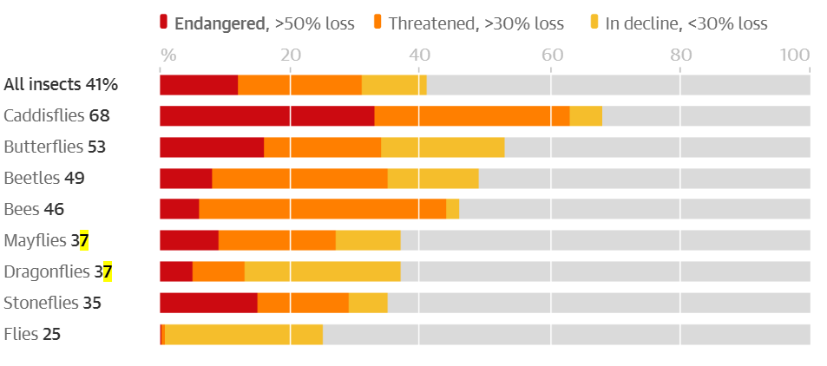

Organic food contains little or no pesticides, no GM(Genetically Modified) ingredients, nutritionally enriched components. Eating organic food means supporting a way of farming that works for people long into the future – from farmers to people sitting at home.

Thus, by joining the dots between our own health, health of the wildlife and planet, it all leads to organic farming. On an average there will be a 50% growth in the life of plants , insects, and bird life if they are surrounded by organic farms.

Consumer demand for organically produced goods has shown strong growth since the 1990s, providing market incentives for U.S. farmers across a broad range of products. A typical organic food consumer is difficult to pinpoint, with organic consumers coming from all types of consumer demographics. Organic price premiums remain high in many markets as the demand for organic products increases.

USDA does not have official statistics on U.S. organic retail sales, but information is available from industry sources. U.S. sales of organic food products were an estimated $26.9 billion in 2010 (inflation adjusted to 2021 dollars) and reached $52.0 billion in 2021, according to the Nutrition Business Journal (NBJ, 2022).

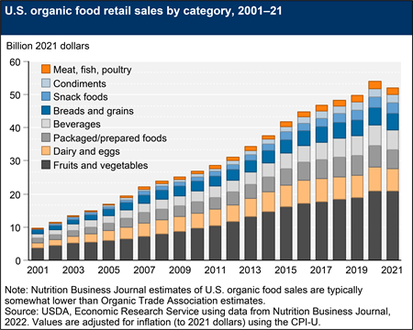

So, to support a healthy lifestyle by making the organic products available to everyone at an economical rate is what led us to the idea of Real Fertilizer.

[The Catastrophic Decline of Insects & Animals: The Facts, and What You Can Do About It – Fire & Future (fireandfuture.com)](https://fireandfuture.com/2019/02/11/catastrophic-decline-of-insects-animals-the-facts-and-what-you-can-do-about-it/)

**THE BUSINESS CONCEPT**

*IDEA*

To create a website which can facilitate the customers to order the organic products from their mobile phones while sitting at home for an economical rate. We are also planning to supply the natural/less chemical concentrated fertilizers to farmers and encourage them to produce organic products.

*UNIQUE VALUE PROPOSITION*

Organic, one of the most important parts of a healthy diet. There are many reasons one should be consuming organic products. Not only does our organic food contain limited or no fertilizers or pesticides but also it is fresh and more flavoursome.

Our Real Fertilizer focuses on providing chemical free and naturally produced organic food at an economical rate. We focus on online delivering of fresh and high-quality products to households which helps us gain our own audience.

*BUSINESS MODEL CANVAS*

Designed For: REAL FERTILIZER

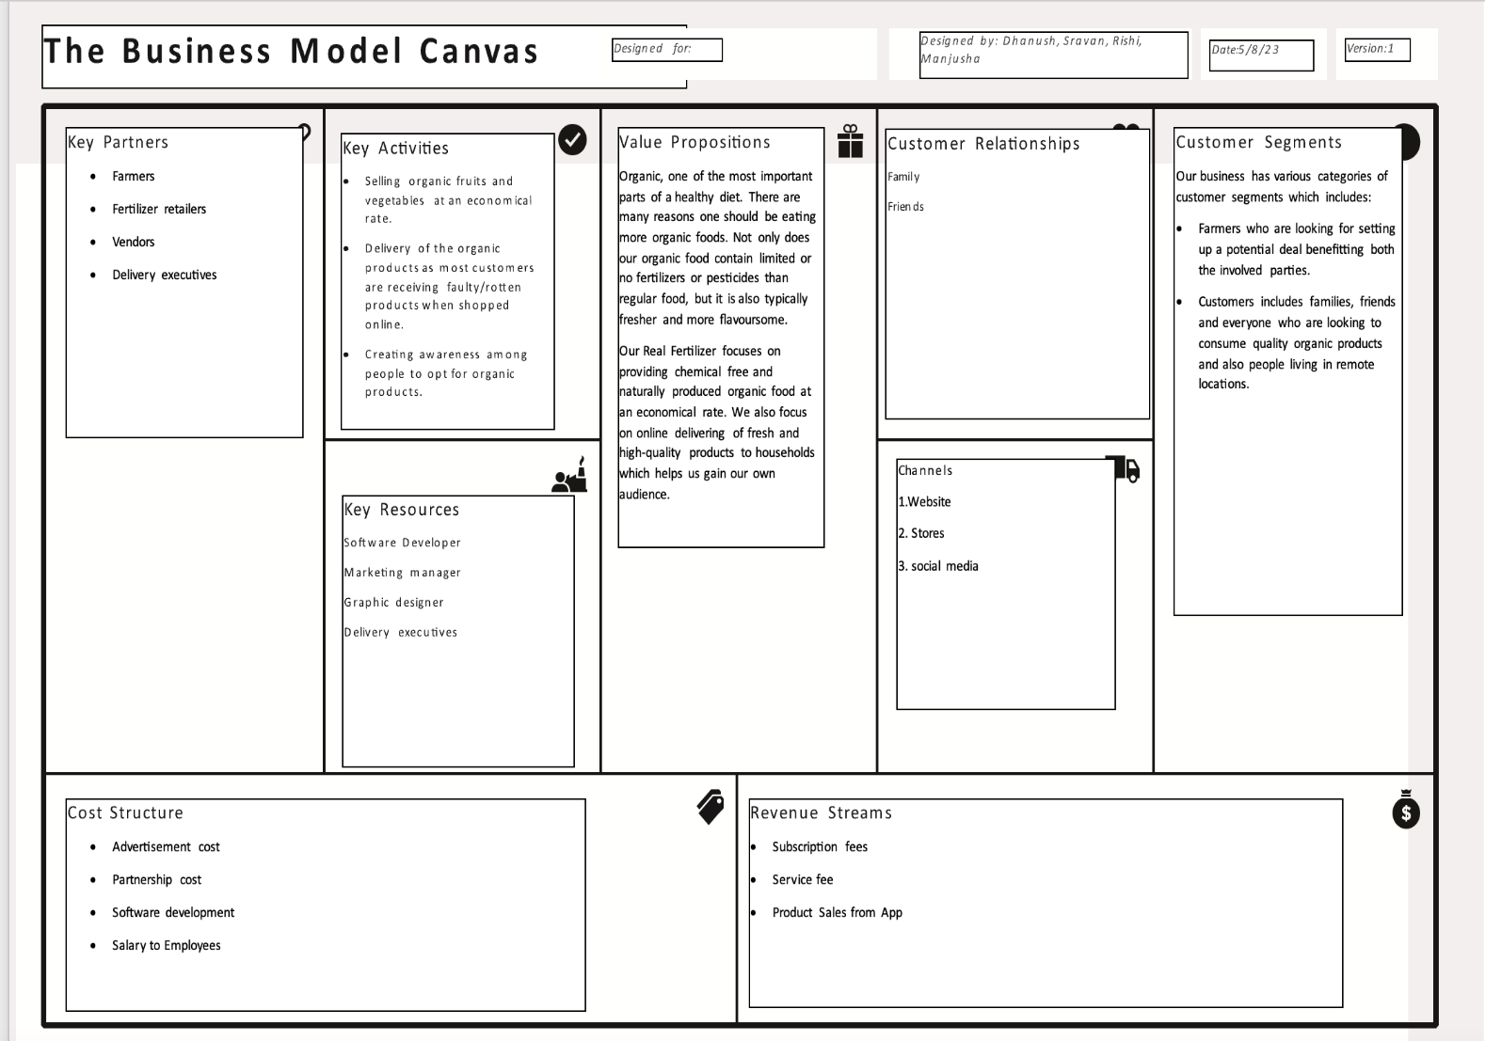

**THE BUSINESS MODEL**

***Subscription Business Model***

Our business model comes under subscription business model because our main source of revenue comes from the subscriptions of our organic products and this helps us in retaining customers rather than re-engaging with them again.

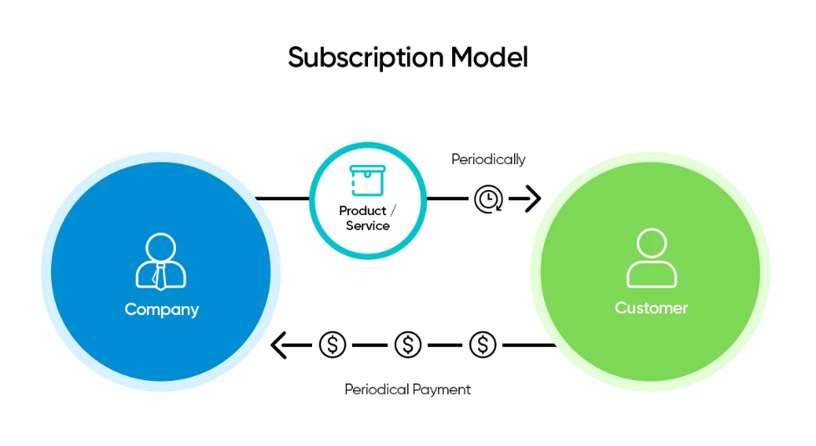

Website

Real fertilizer

*How we create value*

We primarily offer fresh and high-quality organic products at an economical rate compared to other retailers. For that we partner with the local farmers who produce organic products and we sell their organic products through our online website. Delivery executives’ delivery the fresh products at a free delivery charge.

*For whom we create value*

Our business targets the local middle-class and lower middle-class customers who are unable to afford buying organic products but want to consume products to live a healthy lifestyle.

*Statistics shows that*: A little less than half of Americans, 45%, actively try to include organic foods in their diets, while 15% actively avoid them. More than a third, 38%, say they "don't think either way" about organic foods.

Household income is a factor in food choices, with almost half of upper-income Americans actively including organic foods, compared with 42% of lower-income Americans. Almost a quarter of lower-income Americans, however, actively avoid organic foods, while among upper-income Americans it is closer to one in 10. This could be a reaction to cost, as organic foods typically cost 20% to 100% more than non-organic foods.

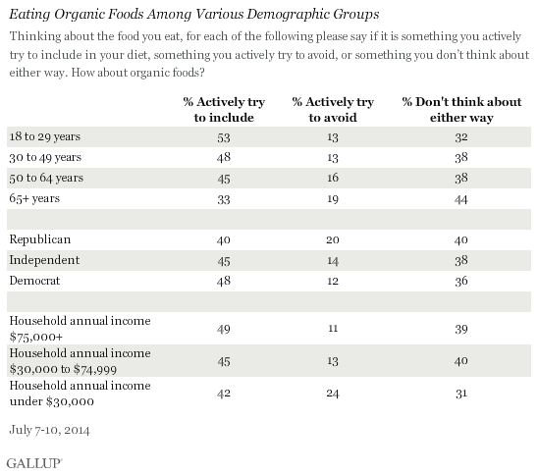

*Means of market differentiation*

Our website provides a free trail of 5 days for customers to try our various products which is unique and provides a competitive advantage in the market, then they can opt for a monthly one subscription to all our various kinds of products.

*Source of internal advantage*

Our business is better in terms of delivering fresh and quality products on-time consistently every time to each household making it easier for people and saving their time in retail stores. We believe in our professional delivery executives and we even offer a partial refund if the delivery is not in between the estimated time interval.

*How we make money*

* Our pricing includes a subscription fee which is a fixed 25$ per month and we are estimating that an average customer will make 6 purchases per year. (Total $150/person)
* Our Total Annual Early Adopters are 6419 (3 categories including website visits, Instagram visits, Retail store visits)
* Our salaries are costing 3,62,000 per year for 7 employees (4 founders and 3 employees including software developer, marketing manager and graphic designer)
* Total Real Estate cost is $870 which has 30 sq. Ft with $27/sq. Ft.
* Our CAC is through google display network which costs $63.59 per person through website, $26.77 per person through Instagram visits totalling $3,27,475 for 5960 Adopters.
* Our LTV is $1800 per person calculated as shown below.

* Our hardware and other miscellaneous expenses costs around $27,700. Operating Leverage is high for subscription costs and low for other revenue streams.

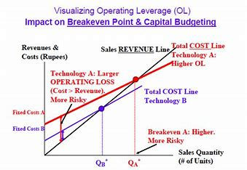

|  |  |  |  |  |  |  |  |
| --- | --- | --- | --- | --- | --- | --- | --- |
| **BUSINESS ECONOMIC MODEL VALUES** | | | | | | | |
| **Revenue Streams** | **Operating Leverage (Low-High)** | **Product or Service Unit Cost** | **CAC (Customer Acquisition)** | **LTV (Customer Lifetime Value)** | **Contribution Margin** | **TOTAL** |  |
| **Subscription Costs** | High | $ 25.00 | $ 63.59 | $ 1,800.00 | $ 8,94,000.00 | $ 10,54,920.00 |  |
| **Service Fee** | low | $ 2.00 | $ 63.59 | $ 1,800.00 | $ 71,520.00 |  |  |
| **Individual product sales from website** | low | $ 15.00 | $ 63.59 | $ 1,800.00 | $ 89,400.00 |  |  |

* Our Breakeven point would be an annual revenue of $948,000 and below is the chart describing annual revenue vs annual expenses for optimistic, pessimistic, and average diffusion of innovation ratios.

[PPT - Cost-Volume-Profit Relationships PowerPoint Presentation, free download - ID:216663 (slideserve.com)](https://www.slideserve.com/Patman/cost-volume-profit-relationships)

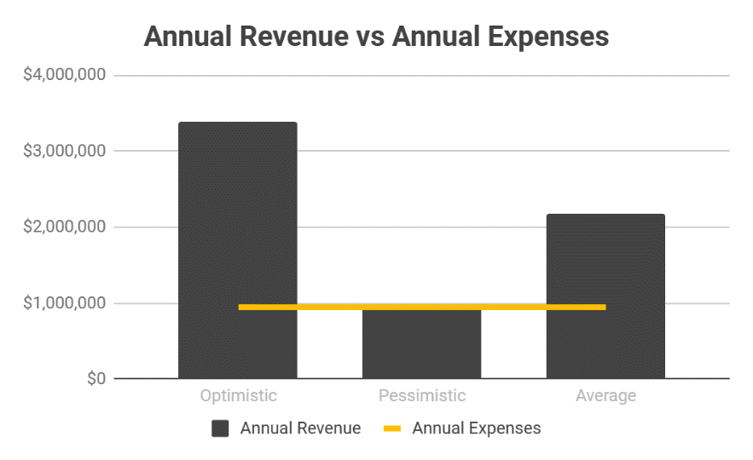

*Investment model*

Our business model used is the income model where we have invested till the business became stable and we have our estimated no of early adopters for our real fertilizer. Our business runs on customer loyalty and keeping our subscriptions active. Apart from these we also try to provide an excellent delivery service to the customers.

We estimate that our necessary funding comes from IT companies where employees doesn’t spend much time in consuming high quality and a healthy food. We might also get necessary funding from the retailers asking us to sell the products at their stores.

*Characterizing Business Model of Real Fertilizer*

|  |  |
| --- | --- |
| COMPONENTS | FOUNDATION LEVEL |
| 1. Factors related to Offering | * Sell services of organic products * Online service delivery |
| 1. Market Factors | * Local Market * Retailers |
| 1. Internal Capability Factors | * Selling/marketing our products |
| 1. Competitive Strategy Factors | * Consistency * Product Quality |
| 1. Economic Factors | * High operating leverage * High volumes |
| 1. Growth Factors | * Income model |

**INTERNAL CONSISTENCY**

Mass customization is being used in our online website where each individual product will be unique to each customer. For example, if a customer has been a consistent subscriber of our products, then we offer special customized products and they can become the first to try out our newly introduced organic products. We also offer special discounts to existing customers who have been using our subscription for at least 6 months.

[Financial Projection Simulator for smallela@syr.edu - Google Sheets](https://docs.google.com/spreadsheets/d/1I4_D2DVq9ZZQ9oBSJWV8esSW7-MITSPVpsARifBEcsg/edit#gid=1190616131)

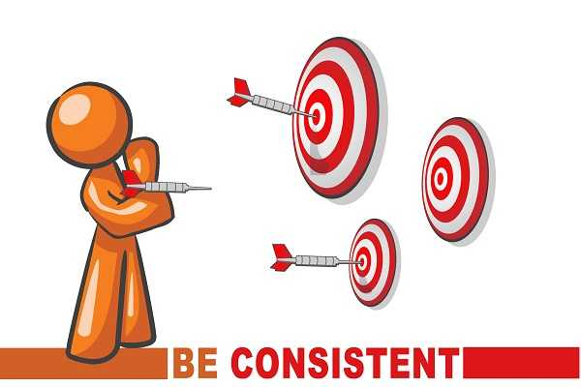

Achieving customization in our website includes following set of choices:

* **Online ordering of products** where they can customize as per their requirements and it also has latest pictures of the products to ensure customers are happy with their customizations.
* Using the latest **Technology** in making our website as advanced as possible with all the options in an ordering system.
* **Logistics,** where delivery executives succeed in shipping right product to the right customer.

***Benefits***

* Internal Consistency allows us to completely offer something new and fresh organic products which is different from other firms providing unique benefit to customers.
* Our model is difficult to imitate by others as this is tailor-made for our business and others cannot integrate our model in their business.

***Growth***

* We are estimating our contribution margin is more than 60% of our sales revenue after deducting expenses.
* We are aspiring a growth rate of 10% per year for the first 5 years and then a 15% for the next 10 years.

**REFERENCES**

* Markides C. A dynamic view of strategy. Sloan Manage Rev 1999.
* Linder JC, Cantrell S. Changing business models. Chicago: Institute for Strategic Change, Accenture, 2000.
* [What’s a Subscription Business Model & How Does It Work? (hubspot.com)](https://blog.hubspot.com/service/subscription-business-model) .
* The_Entrepreneurs_Business_Model_Toward_a_Unified.pdf .
* A_dynamic_view_of_strategy.pdf .

[USDA ERS - Organic Agriculture](https://www.ers.usda.gov/topics/natural-resources-environment/organic-agriculture/)