ParkEase Project - Personal Contribution Report

Name:
Priyanka Manjarekar

Role:
Frontend Developer

Project Overview:
ParkEase is an AI-based smart parking management system developed to solve real-world urban parking challenges. The system allows users to find, view, and reserve parking slots in real-time through a digital interface. It reduces traffic congestion, minimizes fuel wastage, and enhances user convenience by providing a seamless parking experience. The platform also includes an admin dashboard for efficient parking management and monitoring.

Project Objectives:
- Provide real-time parking slot availability
- Enable advance booking of parking spaces
- Reduce traffic congestion and time wastage
- Improve user experience through a simple and interactive interface
- Optimize parking space utilization
- Support smart city initiatives using AI-based solutions

My Contributions as Frontend Developer:
I played a major role in designing and developing the user interface of the ParkEase application. My focus was on creating a visually appealing, user-friendly, and responsive frontend.
Key Contributions:
- Designed and developed the Landing Page with modern UI layout
- Built the Settings Page interface for user customization
- Worked on UI enhancements across the application
- Improved overall user experience with better layout structuring
- Added styling elements such as colors, spacing, and alignment
- Ensured responsive design for better usability
- Collaborated with backend developers for smooth integration

Work Screenshots:
- Landing Page UI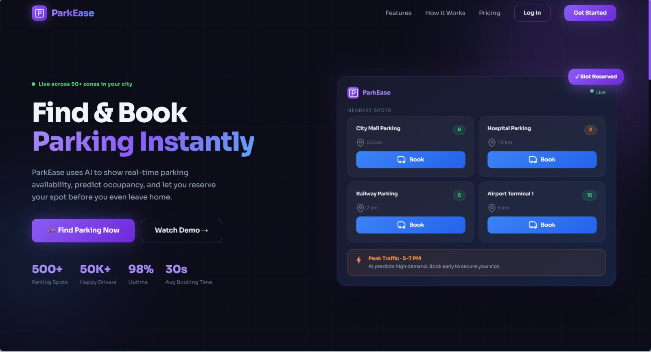
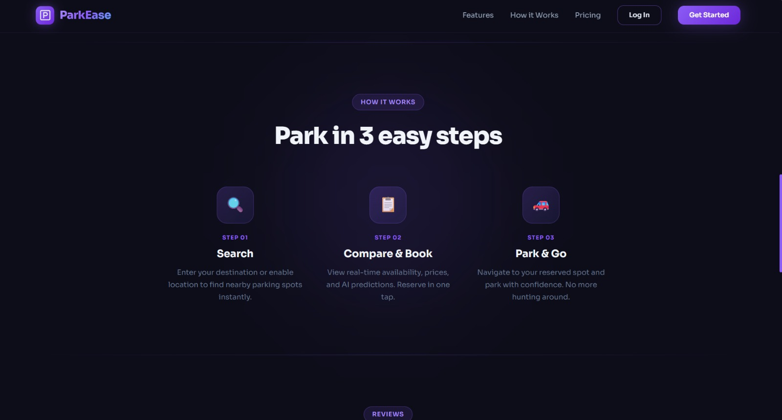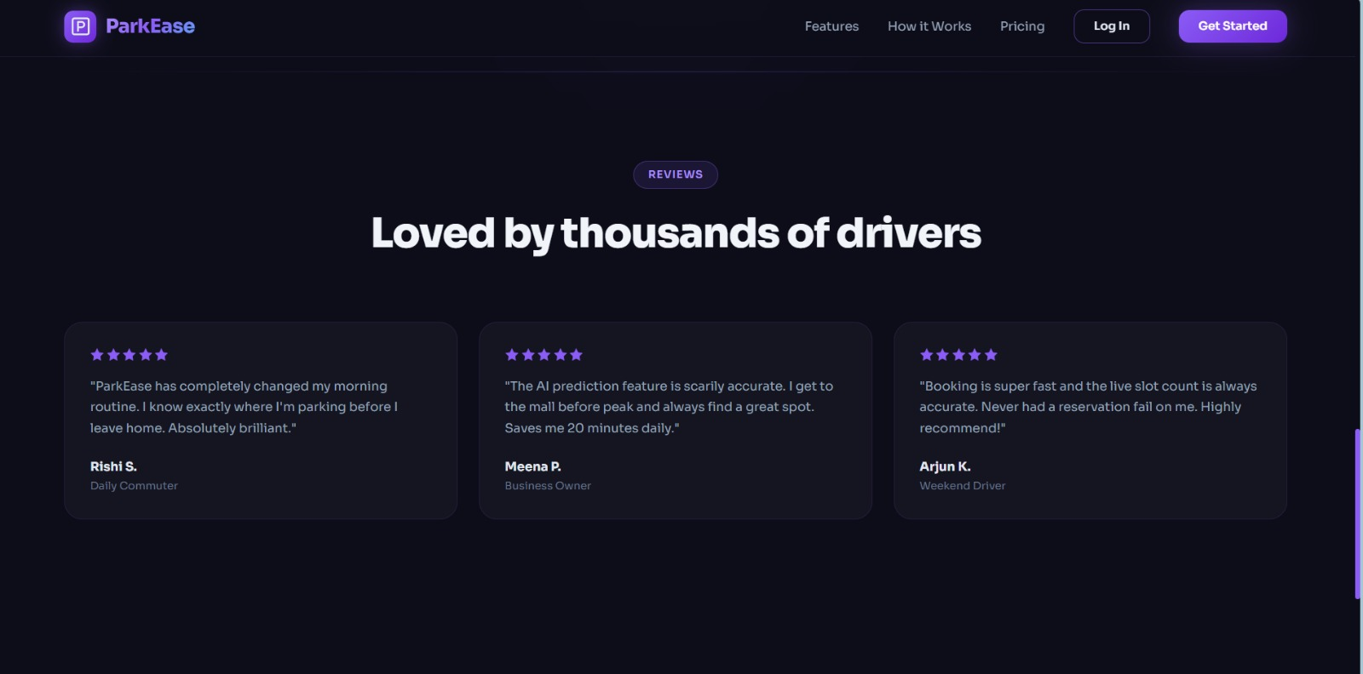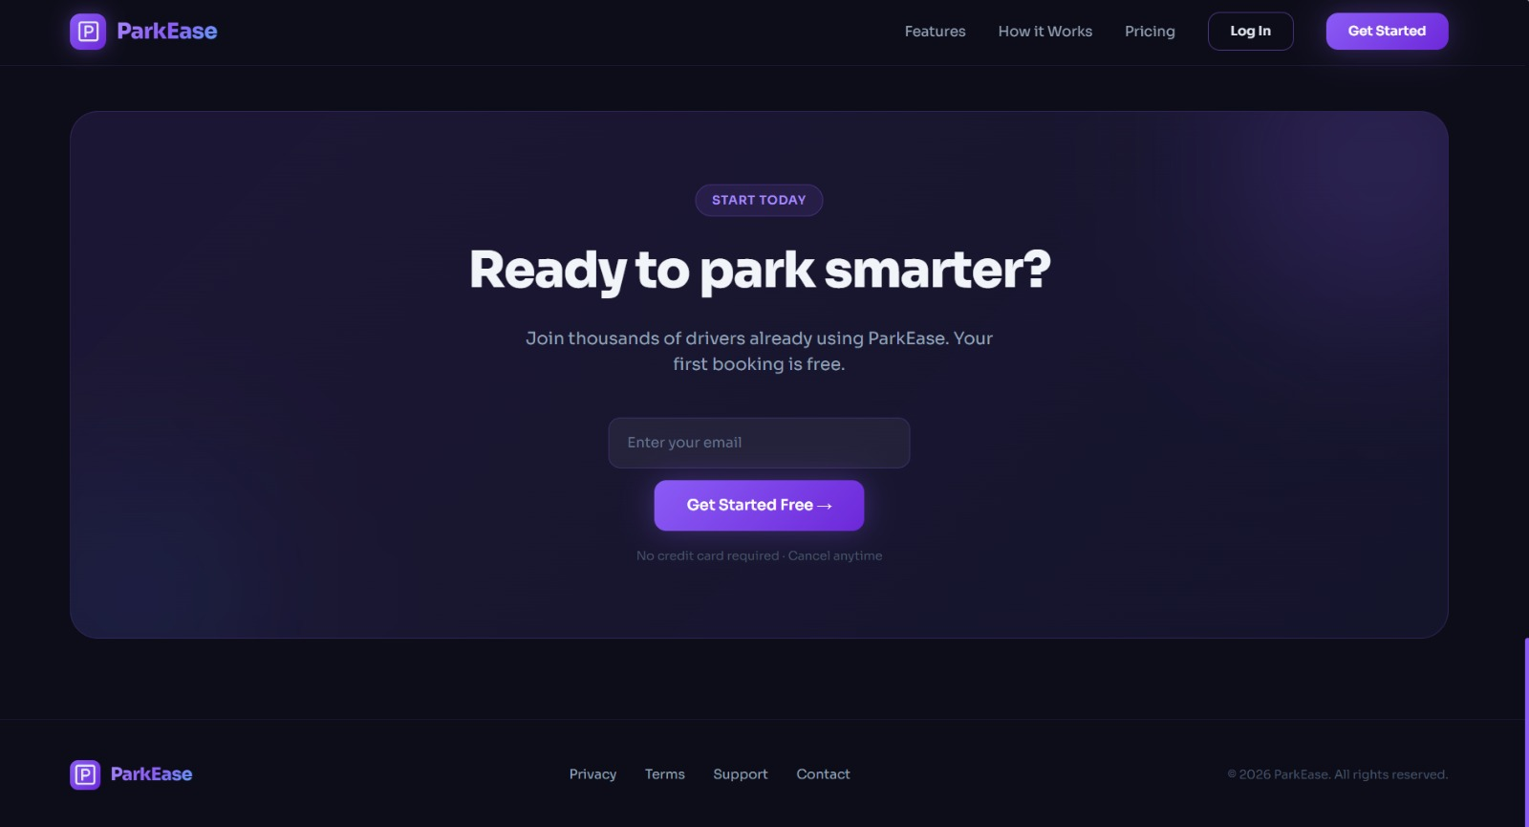

Description:
Designed a modern and attractive landing page with proper layout, colors, and user-friendly interface to give the first impression of the application.

- Settings Page UI of User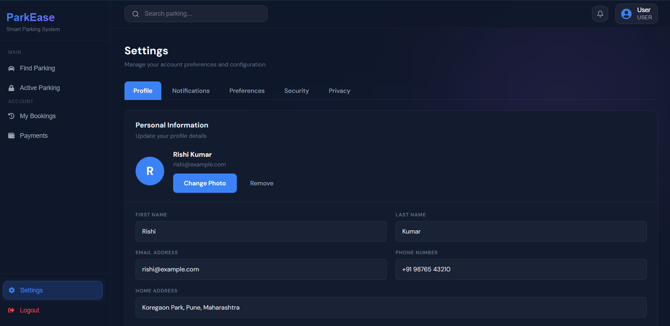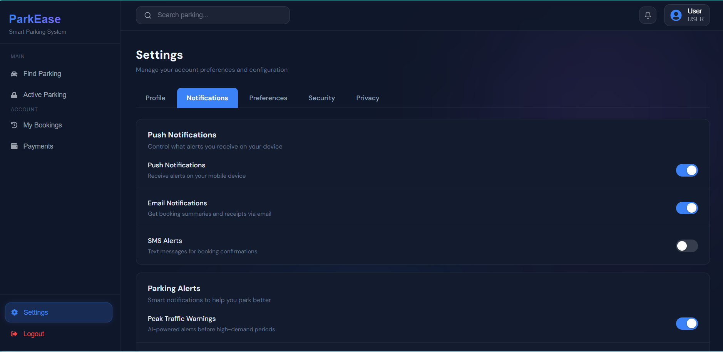

- Setting Page UI of Owner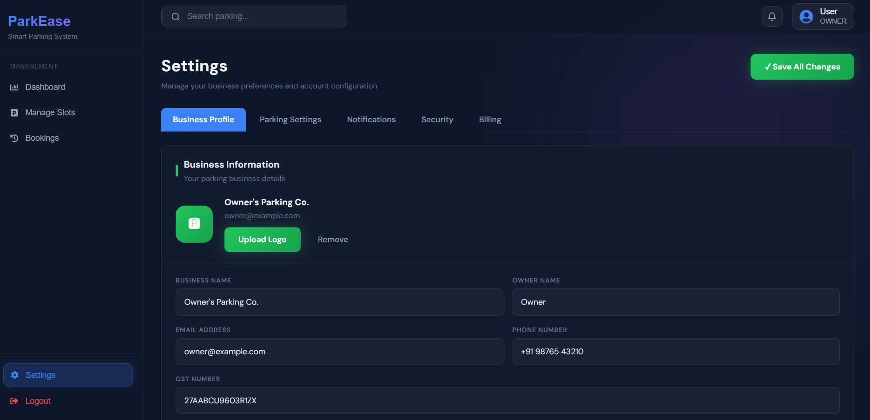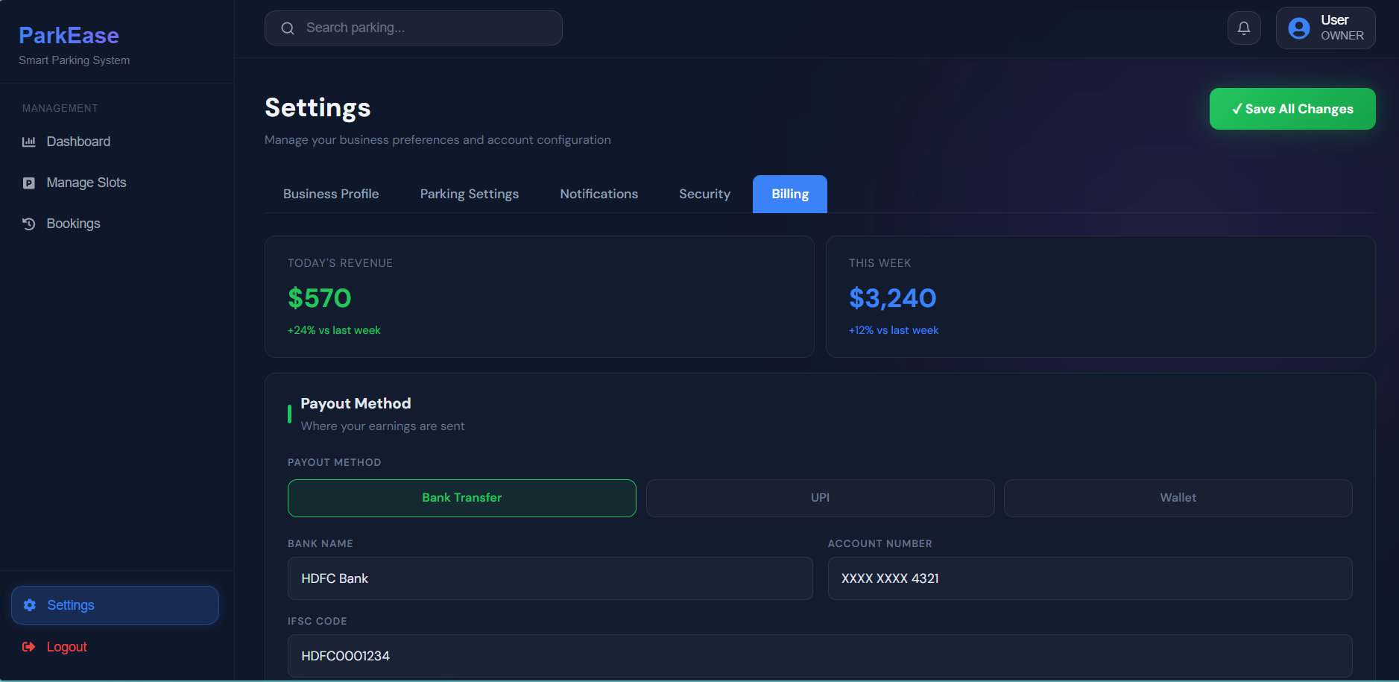
- Setting Page UI of Admin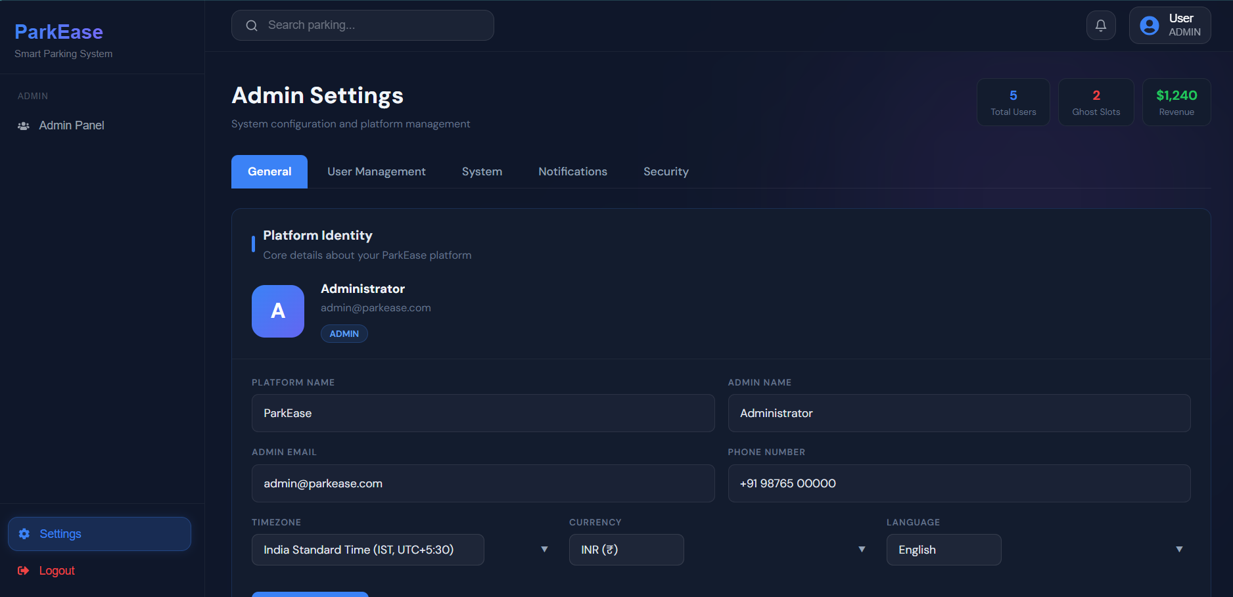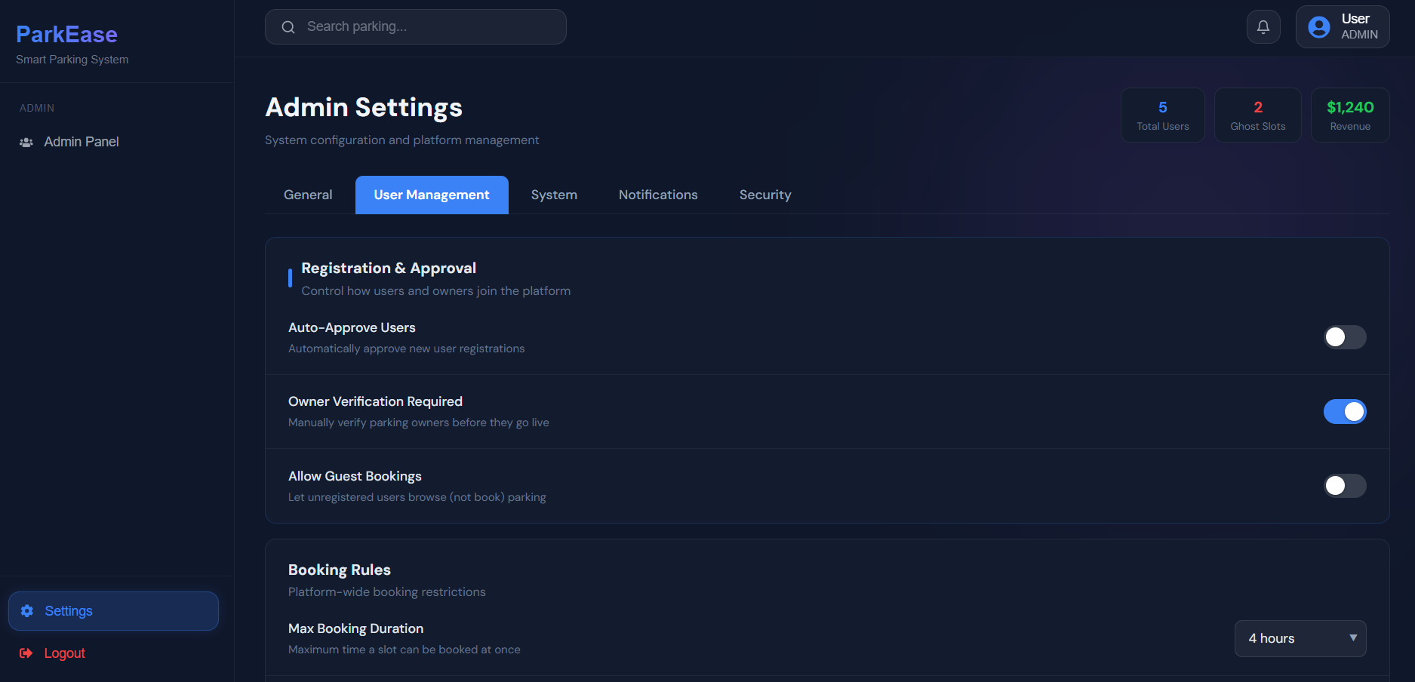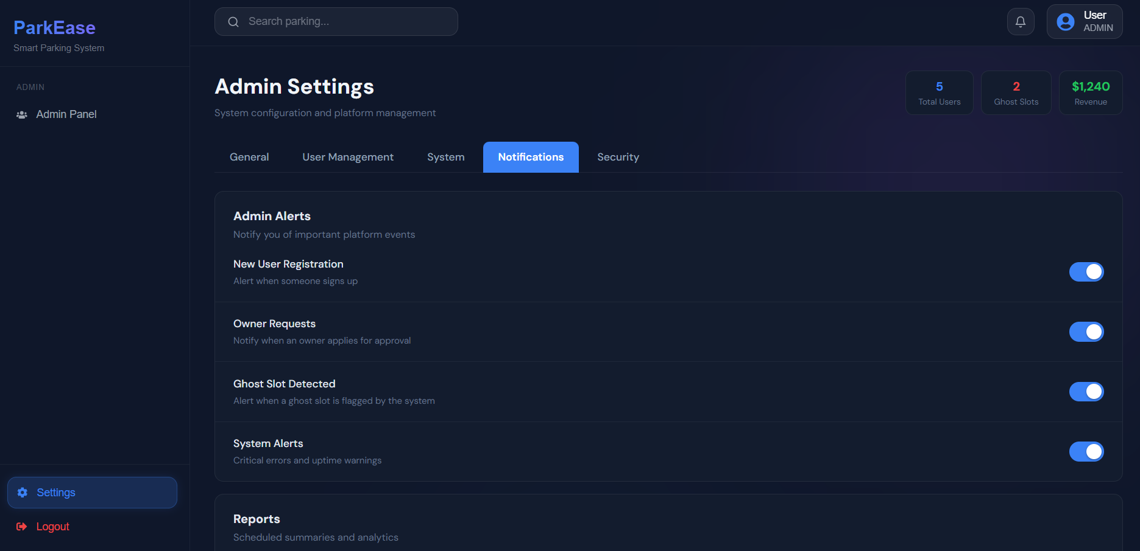

UI/UX Enhancements:
- Designed clean and modern user interface
- Improved navigation flow between pages
- Applied consistent design patterns
- Enhanced visual hierarchy using fonts and spacing
- Focused on simplicity and ease of use
- Made interface intuitive for first-time users

Technologies Used:
Frontend Technologies:
- React.js
- HTML
- CSS
- JavaScript
Backend Technologies (Team Use):
- Java
- Spring Boot
Database:
- MySQL
Tools & Platforms:
- VS Code (Development)
- Git & GitHub (Version Control)
- Postman (API Testing)

Challenges Faced:
- Designing a user-friendly interface for complex functionality
- Maintaining consistency across multiple UI screens
- Integrating frontend with backend APIs
- Ensuring responsiveness and proper layout alignment

Key Learnings:
- Improved skills in React.js and frontend development
- Gained experience in UI/UX design principles
- Learned how to work in a team-based project
- Understood real-world problem solving using technology
- Learned integration of frontend with backend systems

Conclusion:
My contribution to the ParkEase project focused on building a clean, interactive, and user-friendly frontend. I ensured that users can easily navigate and interact with the system. This project helped me enhance my technical skills and gain practical experience in real-world application development.

