

Introduction
I am Rishi Gupta, a frontend-focused developer with a strong interest in building practical, user-centric web applications. I have experience working with modern web technologies and collaborating on team-based projects using GitHub.
In the ParkEase – Smart Parking Spot Finder project, I contributed primarily as a Frontend Developer and actively managed version control and collaboration through GitHub. My work involved developing key dashboard interfaces, implementing core user features, and continuously improving the application through iterative commits.

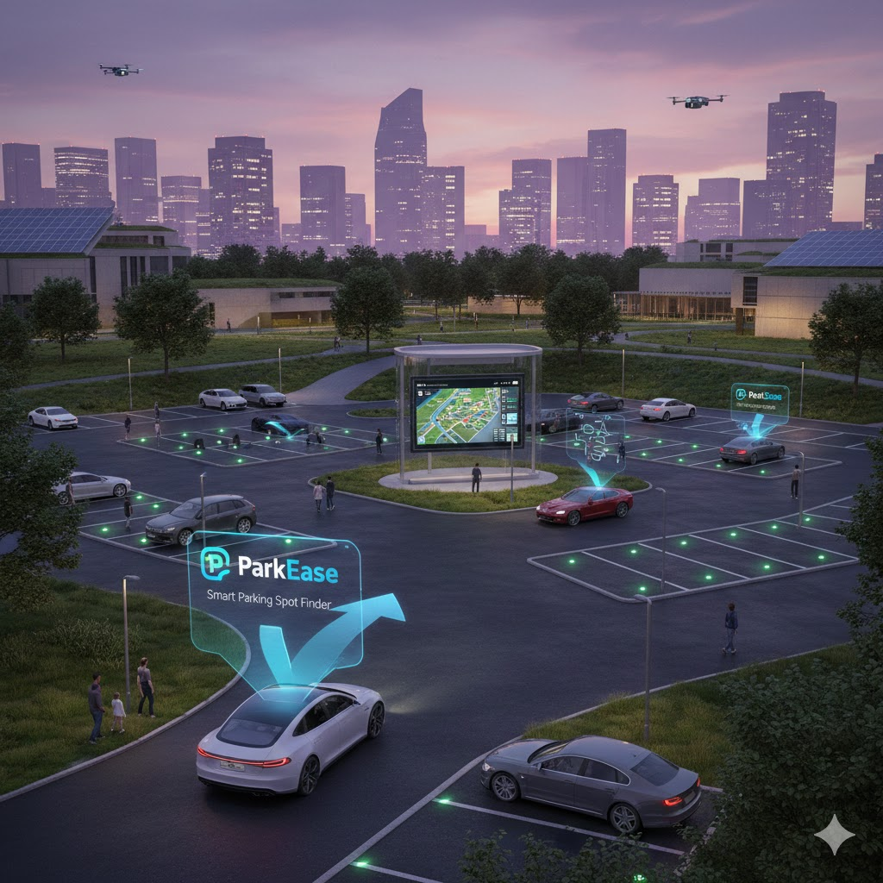
Tech Stack Used
Frontend:
- HTML5
- CSS3
- JavaScript
- React.js
Tools and Technologies:
- Git and GitHub (version control and repository management)
- REST API integration
- VS Code

Project Overview
ParkEase is a smart parking system designed to help users find, book, and manage parking slots efficiently. It also provides a dedicated dashboard for parking owners to manage their parking spaces, slots, and bookings.
The system includes:
- User Dashboard for booking parking slots
- Owner Dashboard for managing parking spaces
- Admin Dashboard for system-level control
- Authentication system (login and registration)
- Payment and billing functionality

My Contributions

1. Authentication and Initial Dashboard Setup
- Implemented login and registration functionality
- Developed initial dashboards for user, owner, and admin
- Contributed to the overall structure of the frontend application
This phase laid the foundation for role-based access and dashboard navigation.

2. Payment System and Booking Flow
- Implemented payment system after slot booking
- Added features such as:
  - Payment history
  - Account status
  - Extended parking functionality
- Improved the booking-to-payment workflow
This ensured a complete user journey from booking to payment tracking.

3. Parking and Slot Management Features
- Developed “Add Parking” feature in Owner Dashboard
- Implemented slot management functionality:
  - Adding slots for each parking space
  - Managing slot availability
- Modified dashboard structure by removing unnecessary options (e.g., manage slot from sidebar)
These changes improved usability for parking owners and made management more structured.

4. Billing and Penalty Logic
- Fixed issues related to multiple payments
- Implemented and updated penalty logic
- Developed final bill calculation after applying penalties
This enhanced the accuracy and reliability of the payment system.

5. Dashboard Enhancements and UI Improvements
- Redesigned Admin Dashboard with improved UI and additional features
- Created separate settings pages for each dashboard (user, owner, admin)
- Improved routing and navigation across payment-related pages
- Worked on landing page improvements and navigation (e.g., back button to login)
These updates focused on improving user experience and interface clarity.

6. GitHub Repository Management and Collaboration
- Regularly committed code with structured updates under the username “rishicodess”
- Managed multiple pull requests and branch merges
- Integrated changes from different contributors
- Maintained proper commit history for tracking development progress
- Handled merge operations and synchronization with the main branch
This ensured smooth collaboration and consistent project development.

Challenges Faced

• Managing Multiple Dashboards
Handling different dashboards (user, owner, admin) with separate functionalities required proper structuring and state management.

• Payment and Billing Logic
Implementing payment flow with penalty and final bill calculation was complex and required debugging to fix issues like multiple payments.

• Routing and Navigation Issues
Ensuring smooth navigation between pages and dashboards involved fixing routing configuration and page flow errors.

• GitHub Merge Conflicts
Working in a team led to merge conflicts, which required careful handling of branches and proper synchronization.

Key Skills Demonstrated
- Frontend development using React.js
- Building dashboard-based applications
- Implementing real-world features such as payments and booking systems
- Debugging and fixing functional issues
- GitHub collaboration, pull requests, and version control
- Understanding of full application flow (frontend to backend interaction)

Conclusion
Through this project, I gained hands-on experience in developing a real-world application with multiple user roles and complex features. I improved my skills in frontend development, problem-solving, and collaborative coding.
My contributions focused on building functional dashboards, implementing core features like payment and slot management, and maintaining the project repository effectively.

