ParkEase
Smart Parking Management System
Frontend Contribution Report

Prepared by:
Krithigayogasri SSG
Frontend Developer
Infosys Internship Project
March 2026

1. Project Overview
ParkEase is a full-stack Smart Parking Management System designed to streamline the process of finding, booking, and managing parking slots in real time. The platform serves three distinct user roles: regular Users who book parking, Owners who list and manage their parking lots, and Admins who oversee the entire platform.

Project Name: ParkEase - Smart Parking Management System
Type: Full-Stack Web Application (Internship Project)
Organisation: Infosys
Duration: January 2026 - March 2026
My Role: Frontend Developer

2. Technology Stack

Category | Technologies Used
Core Framework | React.js 18 (Create React App)
Routing | React Router DOM v6 - role-based routing, nested routes, navigation guards
Styling | Tailwind CSS v3 with custom theme (neon colour palette, dark mode)
Animations | Framer Motion - page transitions, card animations, live slot grid
Charts & Graphs | Recharts - BarChart, LineChart, PieChart, ResponsiveContainer
Icons | React Icons (Font Awesome 6 set)
State Management | React Hooks: useState, useEffect, useMemo, useRef
HTTP / API | Spring Boot REST API (backend)
Auth | JWT-based role authentication (USER / OWNER / ADMIN)
Build Tool | npm + react-scripts
Version Control | Git

3. Frontend Architecture

3.1 Folder Structure
src/
components/
layout/ DashboardLayout.jsx, Sidebar.jsx, Topbar.jsx
dashboard/ StatCard.jsx, RevenueChart.jsx, OccupancyChart.jsx
common/ TopBar.jsx, AuthBackground.jsx, ProfileModal.jsx
pages/
admin/ AdminDashboard, AdminUsers, AdminParkings,
AdminBookings, AdminPayments, AdminGhostSlots
owner/ OwnerDashboard, OwnerSlots, OwnerBookings
user/ UserDashboard, ParkingSlots, BookingHistory,
ActiveParking, PaymentPage, PaymentsDashboard,
FinalBillPage, Settingspage
Landing_page.jsx, Login.jsx, Register.jsx
App.js Root router with all role-based routes
index.css Tailwind directives + custom utilities
tailwind.config Custom dark theme, neon colour tokens

4. My Contributions

Admin Pages

Admin Page | Key Features Built
Admin Dashboard | Live 60-slot parking grid (updates every 3s), occupancy pie chart, revenue/usage bar and line charts, quick-link cards to all admin sections
Admin Users | Searchable user table, role filter, block/unblock toggle, delete with confirmation modal, side drawer with full user details and role change
Admin Parkings | Parking lot approval workflow (Pending / Approved / Rejected / Suspended), detail modal, filter tabs with count badges
Admin Bookings | Platform-wide booking table with search, status filter tabs, force-cancel with confirmation dialog, mini stat pills
Admin Payments | Revenue stats cards, revenue trend chart (RevenueChart), owner payout breakdown table, transaction table with status filter, CSV export
Ghost Slot Monitor | Detects bookings with no check-in past 30-minute threshold, elapsed time progress bar, force-release action, released history table

Key Features & Logic Implemented

Overtime Penalty System
Built in ActiveParking.jsx using useRef and setInterval to track overtime start time and calculate Rs.10 penalty per 15 minutes, displayed in real time.

Live Parking Grid
60-slot grid in AdminDashboard animates slot status (occupied/available) every 3 seconds using setInterval with functional state updaters to avoid stale closure bugs.

Ghost Slot Monitor
Tracks time elapsed since booking using a per-minute interval. Slots past the 30-minute threshold are flagged. Force-release removes from active list and logs to a released history table.

Role-Aware Sidebar
Single Sidebar component renders entirely different navigation menus based on the role prop (USER / OWNER / ADMIN). Uses React Router NavLink for active state highlighting without any manual state management.

Payment Flow
PaymentPage accepts booking state via React Router location.state, validates UPI or Card input, simulates processing with a 2.5s delay, then navigates to the appropriate next page (active-parking, final-bill, or payments dashboard) based on intent (book / extend / final).

5. Unique & Innovative Features
- Ghost Slot Detection - automatically identifies abandoned bookings and allows admins to forcefully free the slot
- Live Real-Time Slot Grid - 60-slot parking grid updates every 3 seconds simulating a live IoT-connected system
- Overtime Penalty Engine - auto-calculates penalty charges when session exceeds booked duration, shown to user in real time
- Role-Based Dynamic Sidebar - single component adapts its entire menu based on user role with zero code duplication
- CSV Export - admin can download full transaction history as a .csv file directly from the browser
- Extend Parking Mid-Session - users can add more hours while parked without losing their booking
- Dark Theme with Neon Accent System - custom Tailwind theme with neon-blue, neon-purple, neon-green, neon-red tokens for consistent styling

6. Challenges & How I Solved Them
- Role-based Sidebar Bug - admin was showing generic user menu. Root cause was two conflicting Sidebar.jsx files (one in components/, one in layout/). Fixed by making both files identical and self-contained.
- Tailwind CSS Not Applying - styles not rendering due to missing @tailwind directives in index.css and missing import in index.js. Fixed by adding directives and the CSS import.
- File Encoding Issues - parsing errors on Windows due to BOM characters in .jsx files copied via clipboard. Fixed by regenerating all files using bash heredoc (clean ASCII output).

7. Implementation screenshots

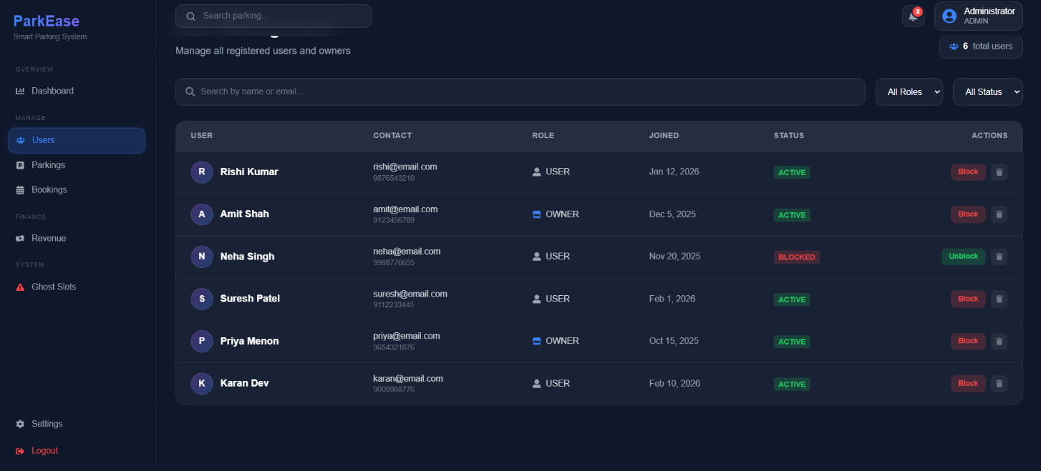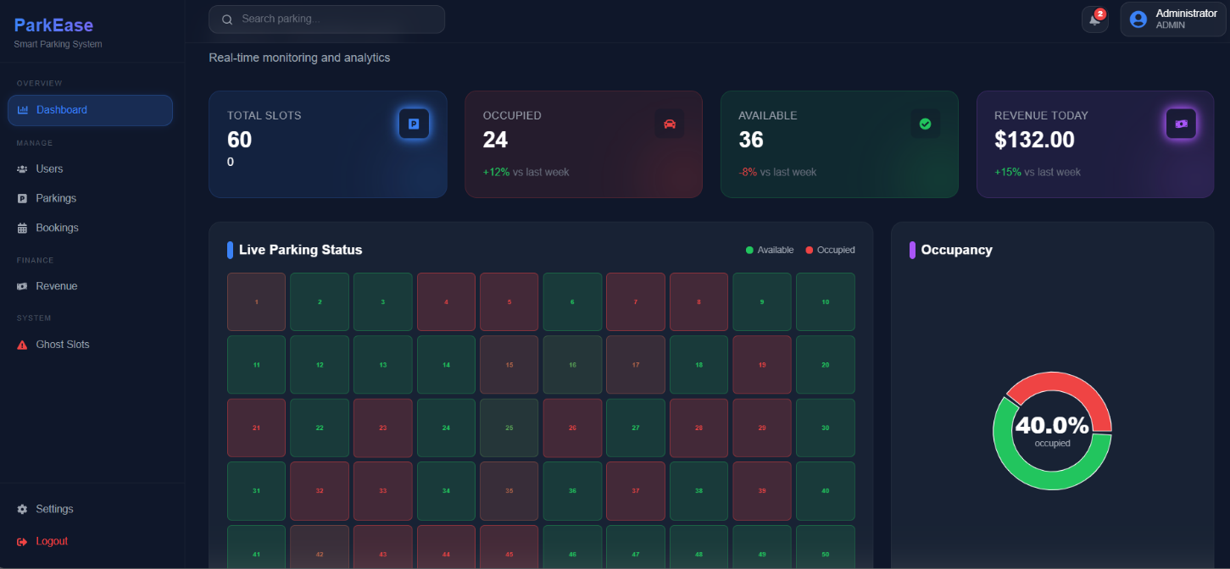
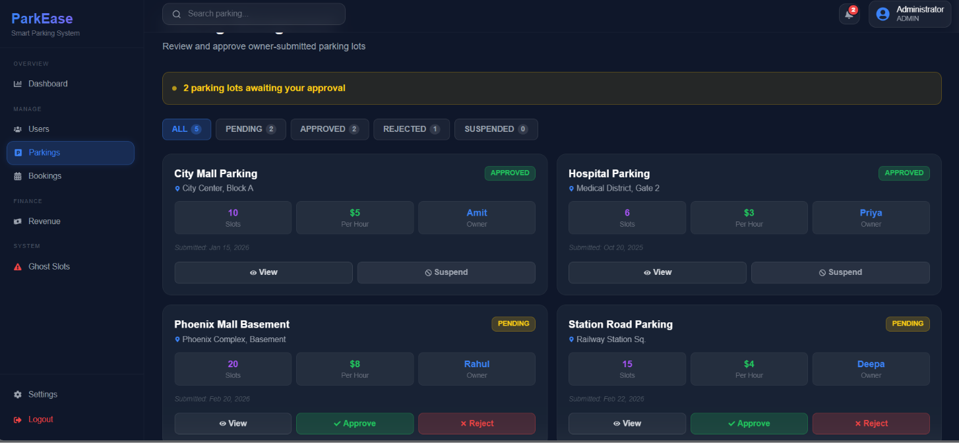

8. Summary Statement
I independently designed and developed the entire frontend of ParkEase from scratch. This included architecting the component system, implementing role-based routing for three user types, building all 17 pages across the user, owner, and admin dashboards, and engineering unique real-time features such as the live parking grid, ghost slot detection engine, and overtime penalty calculator. The project demonstrates practical skills in React.js, Tailwind CSS, Recharts, Framer Motion, and full frontend-to-API integration patterns.

