Home/Office Network Mapping & Analysis
Cisco Packet Tracer Lab Report — Project 1 & Project 2

Project 1 — Home/Office Network Mapping

1. Devices Identified on the Network
The following devices were identified in the simulated home/office network built in Cisco Packet Tracer:
- Router0 — Cisco 1941 router (connects the LAN to the outside network / internet)
- Switch0 — Cisco 2960-24TT switch (connects wired devices within the LAN)
- Access Point0 — wireless access point (provides Wi-Fi connectivity to wireless devices)
- PC0 — wired desktop PC
- Laptop0 — wireless laptop connected via Access Point0

2. Network Diagram
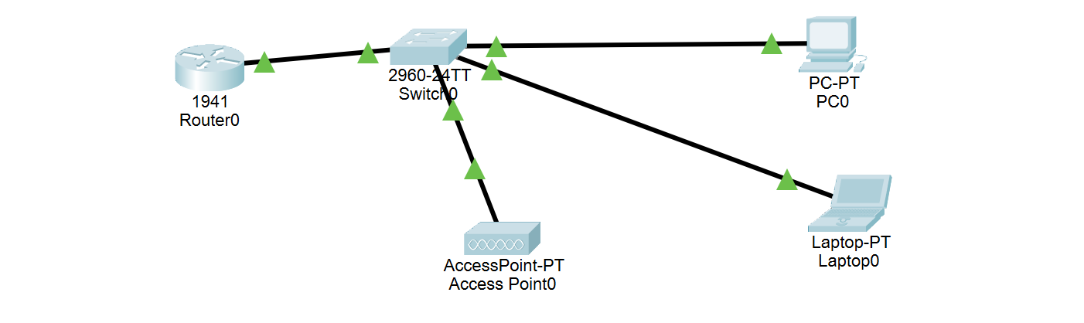
Figure 1. Packet Tracer topology — Router0 connects to Switch0, which connects to Access Point0, PC0, and Laptop0.

3. Devices Mapped to OSI Layers
Device | Model / Type | Primary OSI Layer(s) | Reason
Router0 | Cisco 1941 | Layer 3 — Network | Routes packets between networks using IP addressing
Switch0 | 2960-24TT | Layer 2 — Data Link | Forwards frames within the LAN using MAC addresses
Access Point0 | AccessPoint-PT | Layer 1–2 — Physical/Data Link | Transmits radio signals (L1) and frames Wi-Fi traffic (L2)
PC0 | PC-PT | Layers 3–7 | Full host: IP addressing, transport sessions, and applications
Laptop0 | Laptop-PT | Layers 3–7 | Full host, connected wirelessly through Access Point0

4. Short Explanation
This network follows a simple hierarchical design: Router0 sits at the top as the Layer 3 device responsible for routing between the local network and any external network. Switch0 operates at Layer 2, forwarding traffic between wired devices (PC0) based on MAC address without needing to inspect IP information. Access Point0 bridges the wired LAN to wireless clients (Laptop0), operating at the physical layer for radio transmission and the data link layer for 802.11 framing. The end devices, PC0 and Laptop0, are full network hosts that participate in every layer of the OSI model — they hold IP addresses (Layer 3), manage sessions over TCP/UDP (Layer 4), and run user-facing applications (Layers 5–7). Infrastructure devices, by contrast, are specialized to operate efficiently at just one or two lower layers.

Project 2 — Network Analysis

1. ipconfig Output
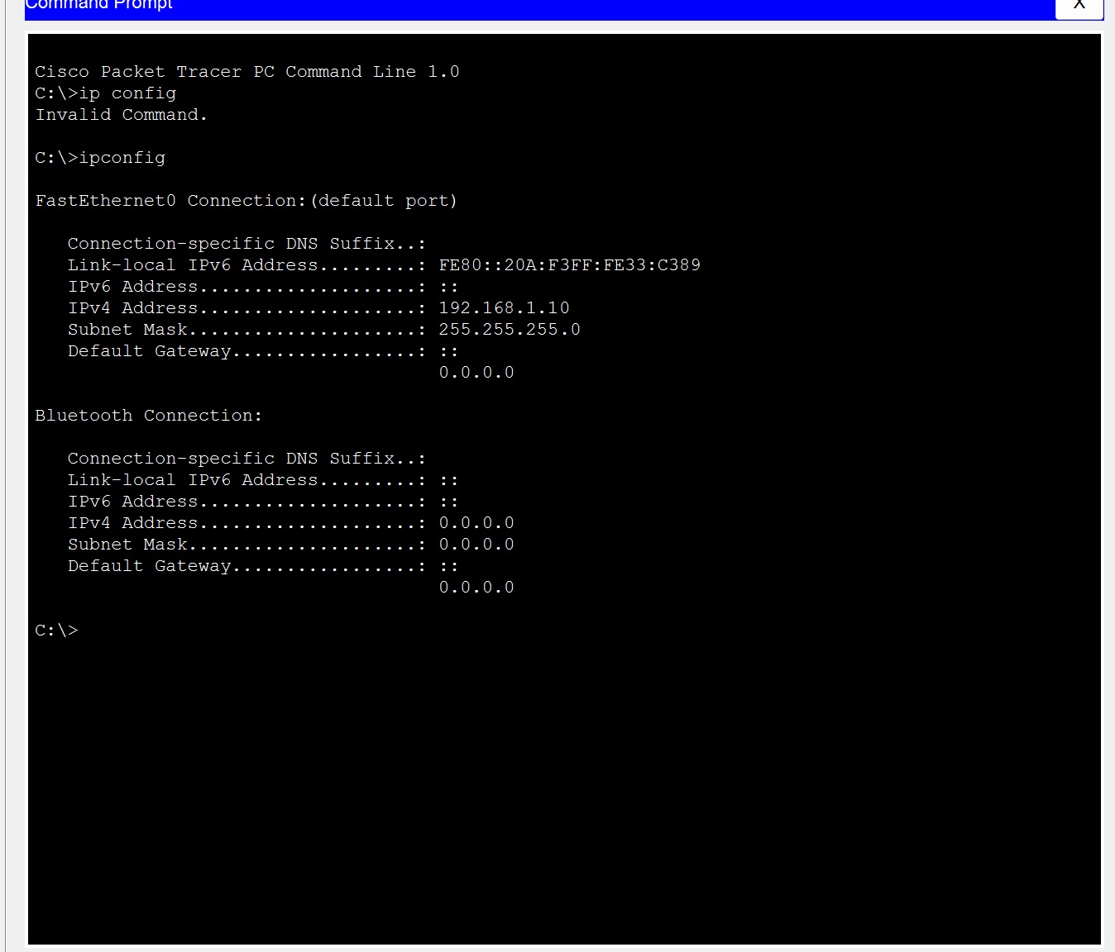
Figure 2. ipconfig output from PC0's command prompt.
Parameter | Value
Interface | FastEthernet0
IPv4 Address | 192.168.1.10
Subnet Mask | 255.255.255.0
Default Gateway | 0.0.0.0 (not configured)
Link-local IPv6 Address | FE80::20A:F3FF:FE33:C389

Note: PC0's default gateway shows as 0.0.0.0, meaning no gateway was set on this interface at the time of capture. Without a gateway, this device could reach others on its own subnet (192.168.1.0/24) but could not route traffic out to other networks.

2. ping and tracert Output (Laptop0)
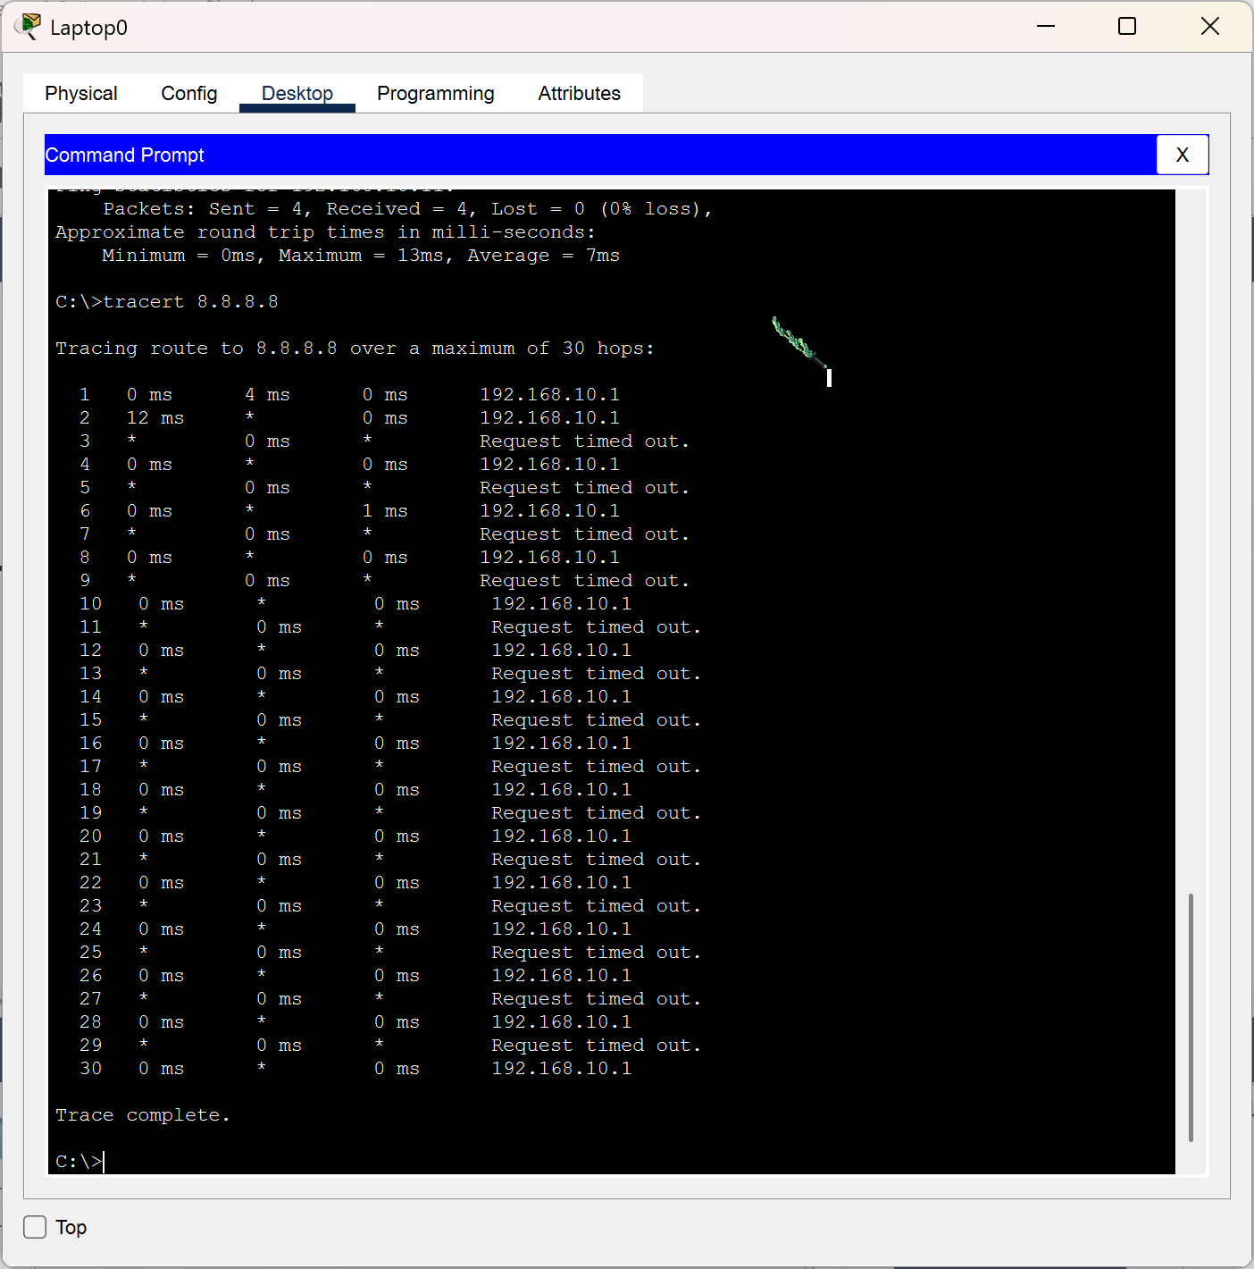
Figure 3. ping and tracert results from Laptop0's command prompt.
Test | Result
ping (previous command, partial view) | 4 sent, 4 received, 0% loss — min 0ms / avg 7ms / max 13ms
tracert 8.8.8.8 | Reached only hop 1 (192.168.10.1); all further hops timed out through hop 30

3. Hop Path Explanation
The tracert command sends packets toward 8.8.8.8 with an increasing Time-To-Live (TTL) value, one higher per attempt, so that each router along the path replies once its TTL expires — this is how each hop is discovered.
In this trace, hop 1 consistently returned a reply from 192.168.10.1, which is Laptop0's default gateway (the router/access point interface on its subnet). From hop 2 onward, replies alternate between the same gateway address and "Request timed out," and the trace runs all the way to the maximum of 30 hops without ever reaching 8.8.8.8.
This happens because Cisco Packet Tracer has no real connection to the internet: 8.8.8.8 does not correspond to an actual reachable device anywhere in this topology. Router0 has no route to that address, so packets are never forwarded past the local gateway, and the trace simply keeps retrying until it hits the 30-hop limit and reports "Trace complete" without success. This is expected behavior for a simulated lab network and demonstrates the same underlying mechanism (TTL expiry revealing each hop) that a real traceroute to an internet host would show, just without a real multi-hop ISP path beyond the local router.
In a real home/office network with an actual internet connection, this same command would typically show: hop 1 as the local router/gateway, hop 2 as the ISP's local access point, several more hops across the ISP's and internet backbone routers, and a final hop at the destination server itself — usually completing in well under 15–20 hops.

