Project 3 — Multi-Switch Network Build & Verification
Cisco Packet Tracer Lab Report

1. Network Topology
The network was built with two switches, one router, and four end devices, as required:
- Router1 — Cisco 2911 (routes between the two LAN segments)
- Switch1 — Cisco 2960-24TT (connects PC2 and PC3)
- Switch0 — Cisco 2960-24TT (connects PC0 and PC1)
- PC0, PC1 — end devices on Switch0's segment
- PC2, PC3 — end devices on Switch1's segment
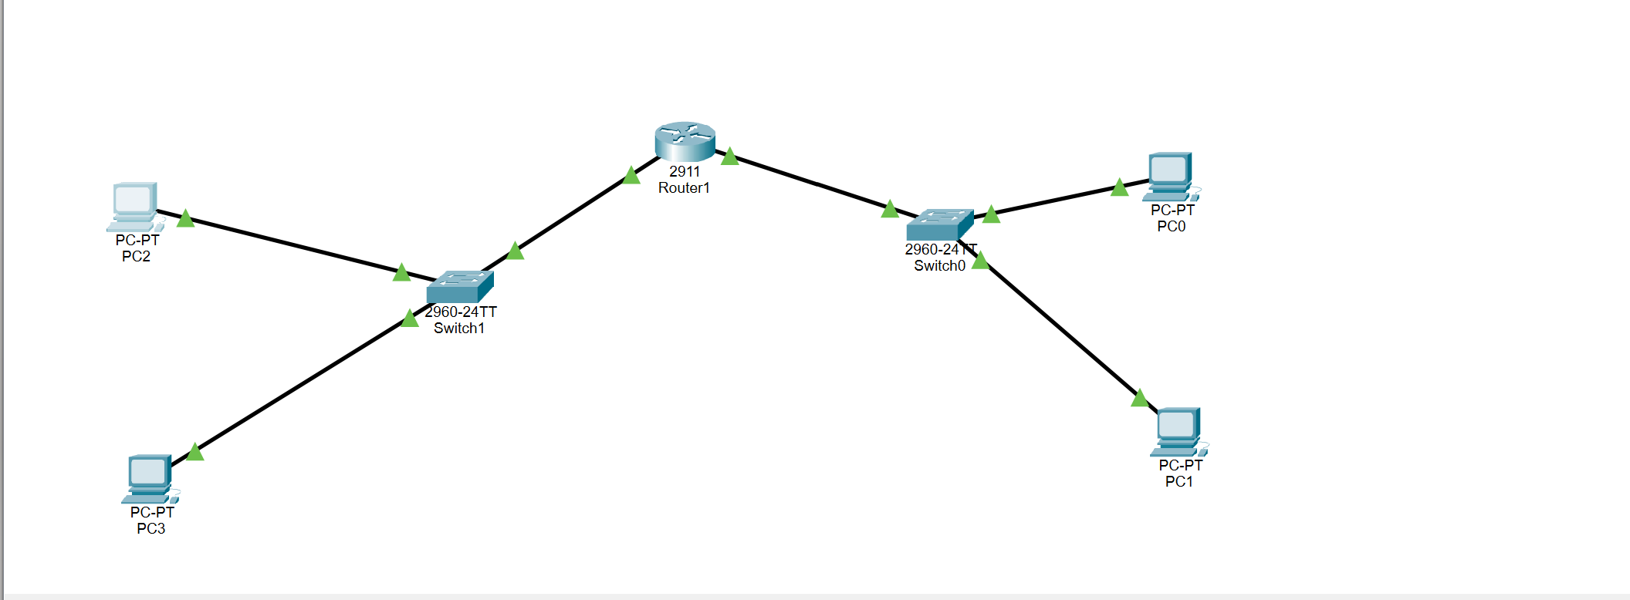
Figure 1. Packet Tracer topology: Router1 connects Switch1 (PC2, PC3) and Switch0 (PC0, PC1).

2. Devices Mapped to OSI Layers
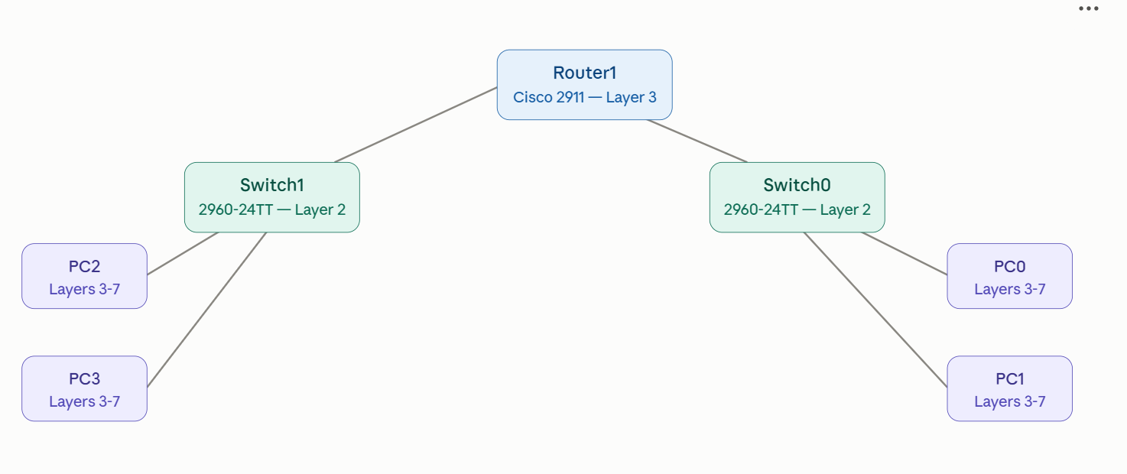
Figure 2. OSI layer mapping — Router1 (Layer 3), both switches (Layer 2), and all PCs (Layers 3-7).

3. IP Addressing Configuration
Router1 was configured with two separate LAN interfaces, one per switch segment, so that each segment forms its own subnet and Router1 handles routing between them:
Segment | Router1 Interface | Subnet | Gateway IP | Devices
Switch1 side | GigabitEthernet0/0 | 192.168.10.0/24 | 192.168.10.1 | PC2, PC3
Switch0 side | GigabitEthernet0/1 | 192.168.20.0/24 | 192.168.20.1 | PC0, PC1

Each PC was assigned a static IPv4 address within its segment's subnet, with the corresponding Router1 interface address set as its default gateway. This allows devices on the same segment to communicate directly through their switch (Layer 2), while traffic destined for the other segment is forwarded through Router1 (Layer 3).

4. Connectivity Verification

4.1 Cross-Segment and Local Ping Tests
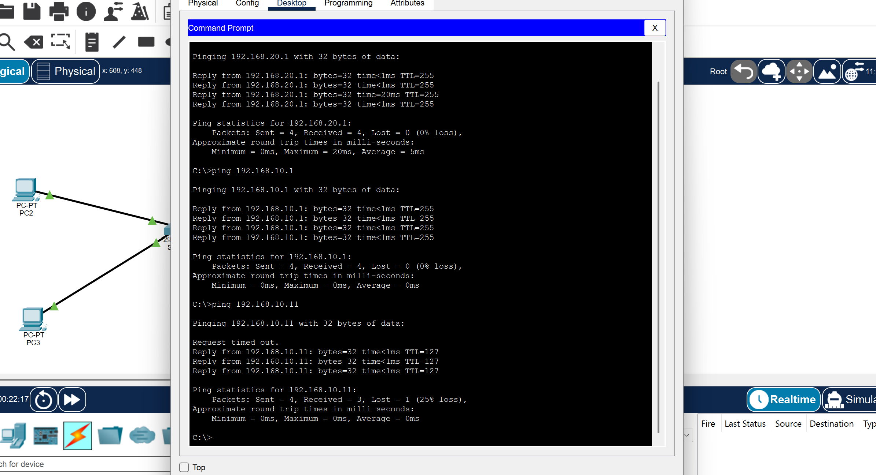
Figure 3. Ping tests from a PC on the Switch1 segment.
From a PC on the Switch1 segment, three pings were run:
- ping 192.168.20.1 — succeeded (4/4, avg 5ms, TTL=255): confirms the router successfully routes to the opposite segment's gateway interface, proving inter-segment routing is working.
- ping 192.168.10.1 — succeeded (4/4, avg 0ms, TTL=255): confirms the local gateway (Router1's interface on this segment) is reachable.
- ping 192.168.10.11 — mostly succeeded (3/4, 25% loss): the first packet timed out because the device had to perform ARP resolution to learn the destination's MAC address before the reply could be delivered; subsequent packets succeeded normally. This is expected, normal behavior for the first ping to a new destination.

4.2 Additional Local Connectivity Test
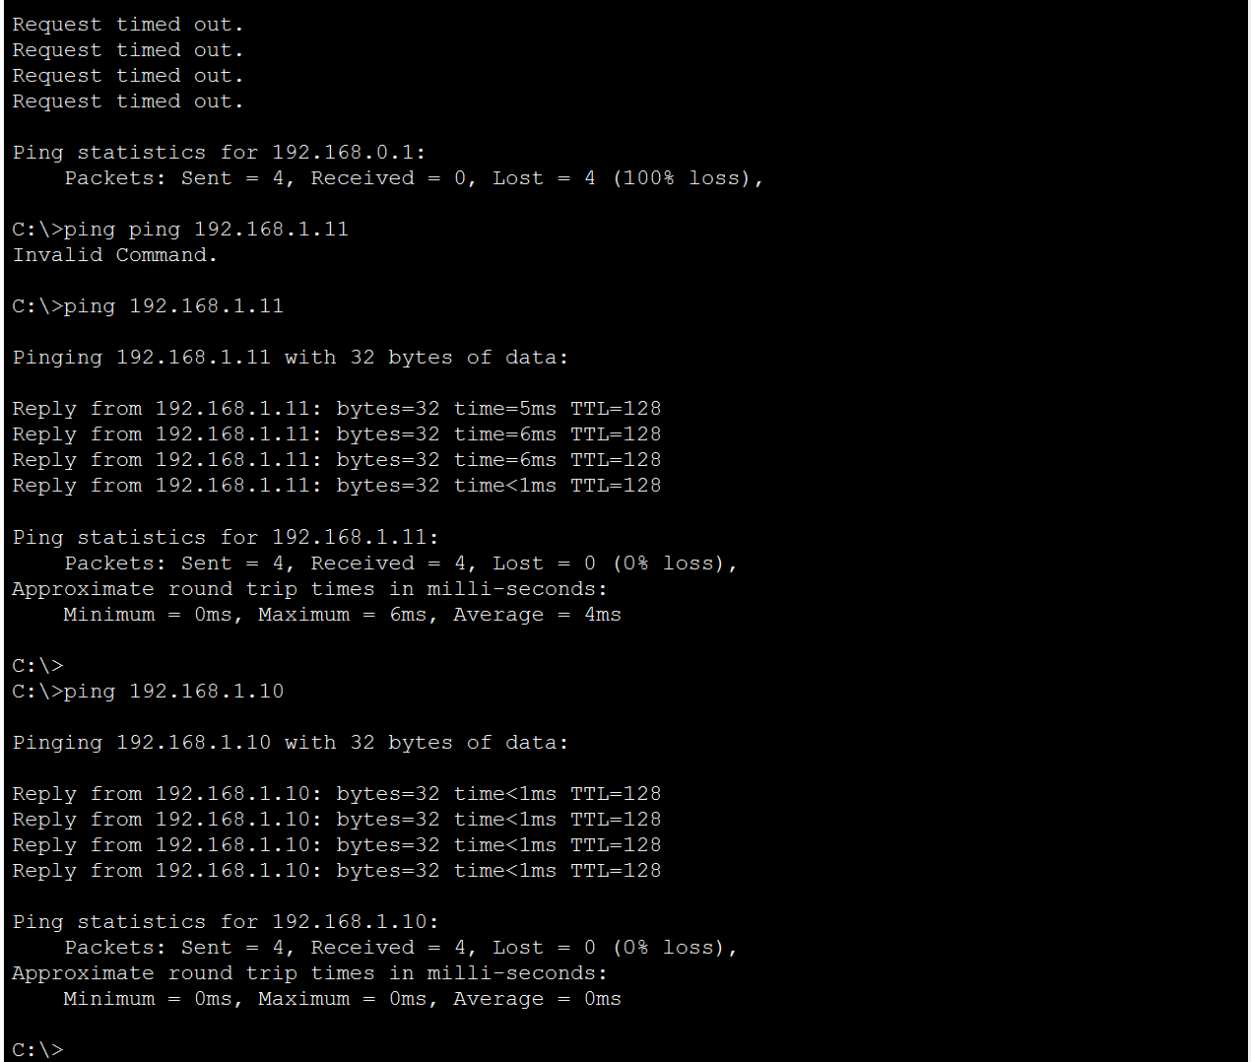
Figure 4. Additional ping tests, including a failed attempt to an unreachable/incorrect address.
- ping 192.168.0.1 — failed (100% loss / "Request timed out"): this address is not part of either configured subnet, so no device could respond — demonstrating what happens when a gateway or destination IP is mistyped or outside the configured addressing scheme.
- ping 192.168.1.11 and ping 192.168.1.10 — both succeeded with 0% loss (TTL=128), confirming successful host-to-host reachability once a correct, in-subnet address was used.

5. Configuration Explanation
Router1 was configured with two LAN-facing interfaces, each placed in its own IP subnet, turning it into the routing boundary between the two switch segments. Each switch operates purely at Layer 2, using MAC address tables to forward frames between the router and its connected PCs without needing to inspect IP information. Each PC was given a static IP address within its segment's subnet and pointed to the correct Router1 interface as its default gateway, so it knows to hand off any traffic destined outside its own subnet to the router.
The verification tests confirm three things end-to-end: (1) devices within the same segment can reach each other directly through their switch, (2) devices can reach their own segment's gateway, and (3) traffic can successfully cross from one segment to the other through Router1 — meeting the assignment's requirement to demonstrate end-to-end connectivity across the full topology. The one failed ping (to an out-of-range address) was included to show a negative test case, illustrating what an addressing mismatch looks like versus a correctly reachable host.
Note: the .pkt file itself should be submitted alongside this report and its screenshots, since it is the working Packet Tracer file used to build and test this topology.

