This API contains below methods

AddItems(tblShopBridge tblShopBridge) – you need to pass object data while posting a http request, this method add item in the data base.

Using postman you can test this api method please find below snap for the same

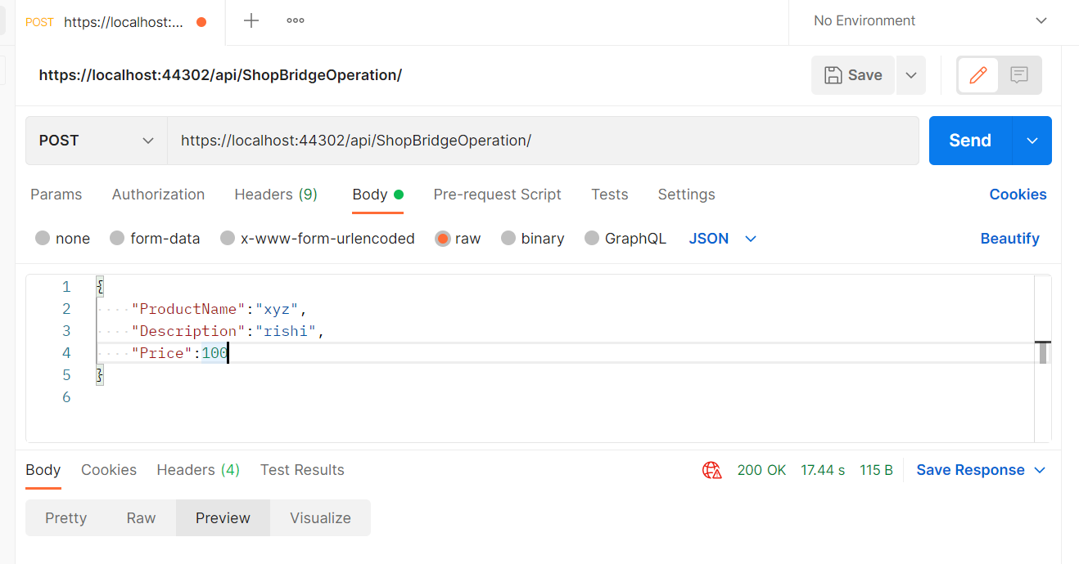

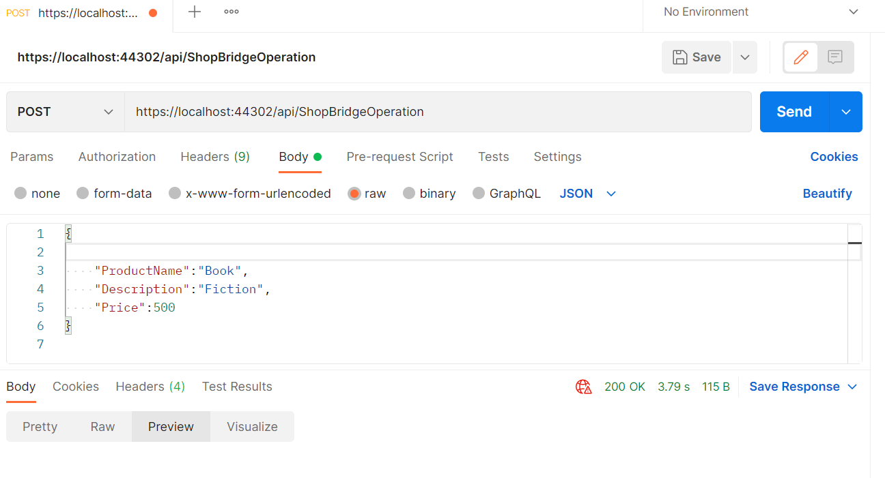

Please find DB entry for above two post request

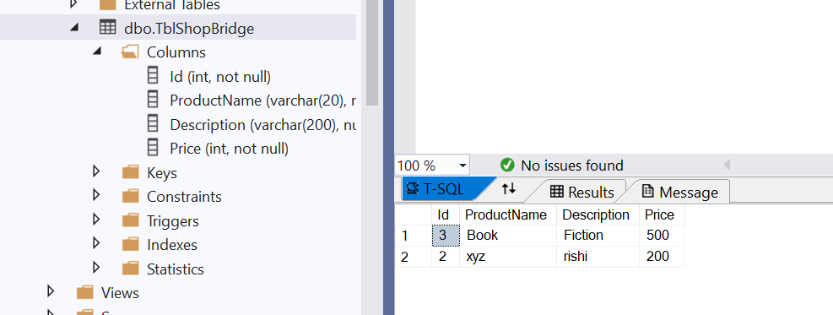

EditItems(tblShopBridge tblShopBridge) – you can use this method to edit the item just you need to paas updated object data.

Using postman you can test this api method please find below snap for the same

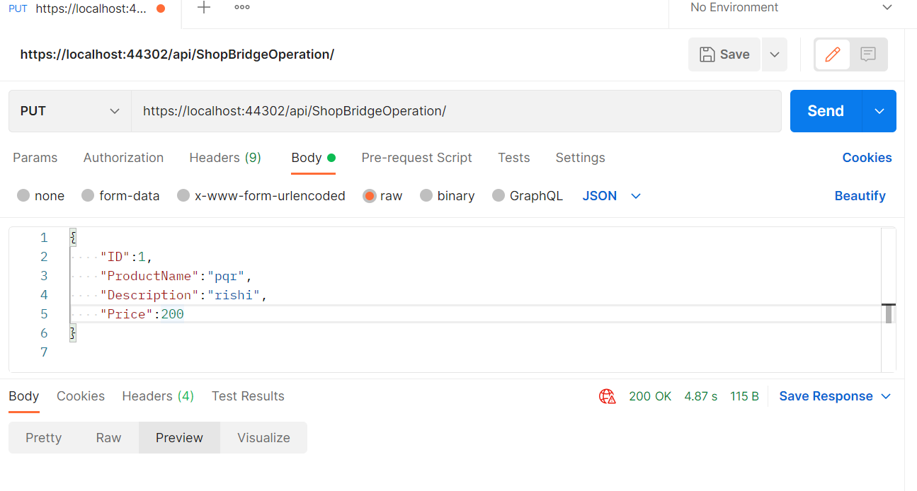

DeleteItems(int id) :- you can use this method to delete the item you need to pass id of the item which you want to delete.

Using postman you can test this api method please find below snap for the same

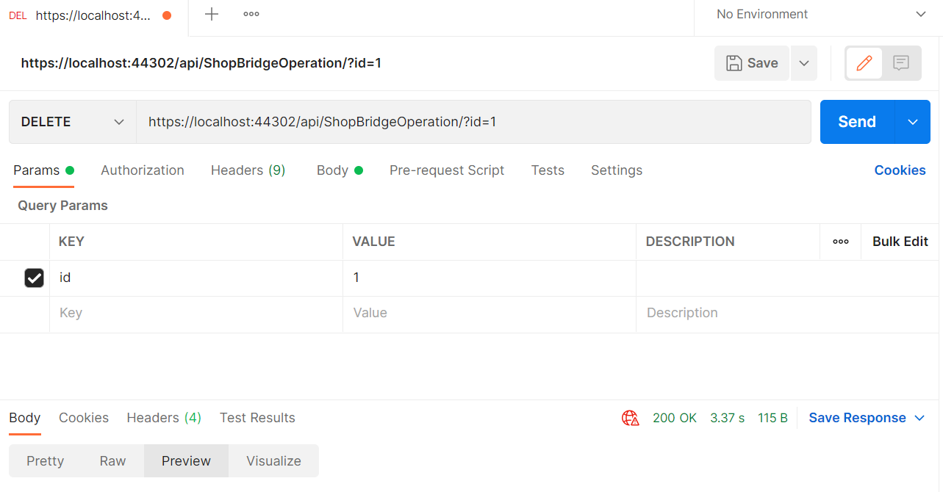

ListItemsbyid(int id) – if you want to see item by passing id as parameter use this method.

Using postman you can test this api method please find below snap for the same

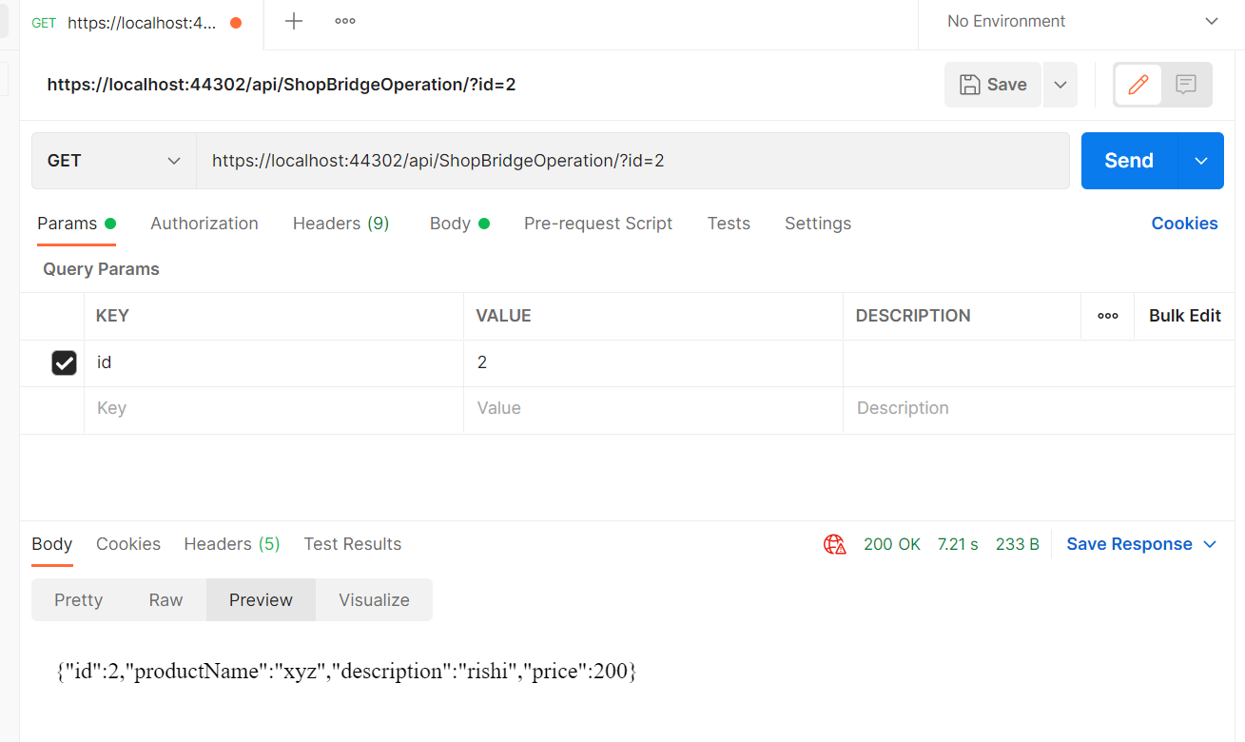

GetAllItemDetail() :- use this method when you want to get all the item details

Using postman you can test this api method please find below snap for the same

