Atria Institute of Technology


“Mini Project Title”
Machine Learning (BCS602) Mini Project Report

Submitted by:
Rajapu Chitesh – 1AT23IS128
Rishikesh – 1AT23IS135
S J Yeshwanth – 1AT23IS138

Guided by:
Dr. K S Ananda Kumar
Associate Professor
Department of ISE

Department of Information Science & Engineering
Atria Institute of Technology, Bengaluru
Academic Year: 2025-2026

Atria Institute of Technology

Department of Information Science & Engineering

CERTIFICATE

This is to certify that the mini project titled “BookFlix – Book Recommendation System” has been successfully carried out by Rajapu Chitesh (1AT23IS128), Rishikesh (1AT23IS135), and S J Yeshwanth (1AT23IS138) of 6th Semester, as a part of the subject Machine Learning (BCS602), during the academic year 2025-2026. The project work is a bonafide record of the work completed by the above-named students.

Signature of Guide Signature of HOD

Dr. K S Ananda Kumar HOD, Dept. of ISE
Associate Professor, Dept. of ISE
Atria Institute of Technology

TABLE OF CONTENTS

Sl. No. | Title | Page No.
— | Acknowledgement | iii
— | Abstract | iv
1 | Introduction | 1
2 | Problem Statement | 2
3 | Objectives | 3
4 | Dataset Used | 5
5 | Methodology | 7
6 | Results and Discussion | 10
7 | Applications | 15
8 | Conclusion | 16
— | References | 17

ACKNOWLEDGEMENT
We express our sincere gratitude to the Management and Principal of Atria Institute of Technology for providing the facilities and academic environment required for the successful completion of this mini project.
We would like to convey our heartfelt thanks to the Head of the Department, Department of Information Science & Engineering, for the constant encouragement, support, and guidance throughout the project work.
We extend our special thanks to our project guide, Dr. K S Ananda Kumar, Associate Professor, for his invaluable suggestions, continuous motivation, and technical guidance provided at every stage of the project.
We also thank all the teaching and non-teaching staff members of the department for their cooperation and assistance. Finally, we express our gratitude to our friends and classmates for their support and encouragement in completing this project successfully.

ABSTRACT
BookFlix is an intelligent, web-based book recommendation system that leverages Machine Learning to deliver personalized reading suggestions. Inspired by modern streaming platforms, the system combines Item-Based Collaborative Filtering (CF) using the K-Nearest Neighbors (KNN) algorithm with Content-Based Filtering (CBF) via TF-IDF vectorization and Cosine Similarity. The resulting Hybrid Recommendation Engine balances collaborative signals (user rating patterns) with content signals (author and genre metadata) to produce highly relevant suggestions.
The backend is developed in Python using FastAPI and Scikit-learn, serving a dataset of over 5,400 books and 257,000 user ratings. The frontend is built with Next.js and React, presenting a Netflix-style UI with personalized carousels, a hero banner, real-time book search, a wishlist, and an admin analytics dashboard. The system also handles cold-start scenarios by recommending highly-rated books from a user’s preferred genres. Evaluation metrics including Click-Through Rate (CTR) and Recommendation Precision are tracked in real time through the admin panel.
This project demonstrates the practical application of collaborative and content-based ML techniques within a full-stack software environment, bridging the gap between academic algorithms and real-world user experience.

1. INTRODUCTION
The rapid growth of digital content has resulted in an overwhelming number of choices for readers. Traditional methods of book discovery – such as recommendations from friends, bookstore staff, or bestseller lists – are unable to scale to the volume of available titles. This has created a demand for intelligent, automated systems capable of filtering content and presenting users with options most relevant to their interests.
Recommendation systems are a well-established sub-field of Machine Learning and Information Retrieval. They power many of today’s most-used applications: Netflix recommends movies, Spotify recommends songs, and Amazon recommends products. These systems learn patterns from historical user interactions to predict future preferences. The two dominant approaches are Collaborative Filtering (CF), which identifies users with similar taste profiles, and Content-Based Filtering (CBF), which identifies items with similar metadata attributes.
BookFlix applies both these approaches in a Hybrid Recommendation architecture. The project is designed to emulate the user experience of a modern streaming platform, making book discovery engaging and intuitive. The application has two main components:
- Backend: A RESTful API server built with Python FastAPI, hosting the ML models and data processing pipelines.
- Frontend: A Next.js/React web application offering a rich, interactive UI styled after streaming services.

The combination of a scientifically grounded recommendation engine with a polished user interface makes BookFlix both an academic ML project and a demonstration of real-world software engineering.

2. PROBLEM STATEMENT

BookFlix addresses the difficulty readers face in finding books that match their individual interests from a large digital catalogue. Common discovery methods such as bestseller lists, genre browsing, and general recommendations are mostly static and do not adapt to each user’s reading history.

The core problem is to build an intelligent system that learns from user-book ratings and book metadata to provide accurate, real-time, and personalized recommendations. The solution must also handle sparse rating data, new-user cold start cases, scalability, recommendation quality, and a smooth user experience through a hybrid ML engine and web interface.
3. OBJECTIVES
- To implement an Item-Based Collaborative Filtering model using the KNN algorithm on a real-world user–book ratings dataset.
- To implement a Content-Based Filtering model using TF-IDF vectorization and Cosine Similarity on book metadata (author, genre).
- To combine both models into a tunable Hybrid Recommendation Engine with a configurable alpha weighting parameter.
- To develop a User-Based Collaborative Filtering mechanism that recommends books based on similar user profiles.
- To address the cold-start problem by recommending popular books in a new user’s preferred genres.
- To expose all ML functionalities through a RESTful API built with FastAPI.
- To build an engaging, Netflix-style frontend interface using Next.js and React with personalized carousels and real-time search.
- To implement a real-time admin analytics dashboard tracking Click-Through Rate (CTR) and Recommendation Precision.

4. DATASET USED
The project uses a curated version of the Book-Crossing dataset, pre-processed and stored as two CSV files in the backend/data/ directory.

4.1 books.csv
Contains metadata for 5,410 books. Each record includes the following fields:

Column | Description | Example Value
book_id | Unique integer identifier | 1
ISBN | International Standard Book Number | 0440234743
title | Book title | The Testament
author | Author name | John Grisham
year | Year of publication | 1999
publisher | Publisher name | Dell
genre | Genre / publisher used as proxy | Dell
image_url | URL to book cover image | http://images.amazon.com/...

4.2 ratings.csv
Contains 257,325 user-book rating entries. Each record has the following fields:

Column | Description | Range
user_id | Unique user identifier (integer) | 1 – N
book_id | Book identifier (references books.csv) | 0 – 5409
rating | User’s rating for the book | 1 – 10

The ratings matrix is highly sparse – most users rate only a small fraction of all books – which is the typical characteristic of real-world Collaborative Filtering datasets. Sparsity is efficiently managed using SciPy Compressed Sparse Row (CSR) matrices, significantly reducing memory consumption.

5. METHODOLOGY
The system follows a client-server architecture. The Next.js frontend communicates with the Python FastAPI backend via HTTP REST API calls. On startup, the backend loads the dataset into memory, builds the sparse rating matrix, and trains all ML models. Figure 1 illustrates the overall system flow.

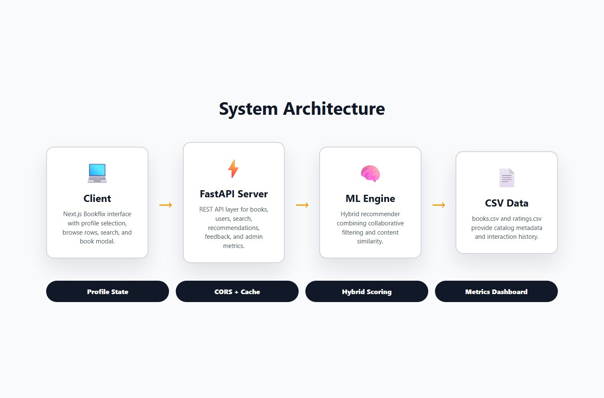
Figure 1: System Architecture – Client → FastAPI Server → ML Engine → CSV Data

5.1 Data Preprocessing
On server startup, the recommender module executes the following steps in order:

- Load books.csv and ratings.csv into Pandas DataFrames.
- Pivot the ratings DataFrame into a book–user matrix (rows = books, columns = users). Missing values are filled with 0.
- Convert the pivot matrix to a SciPy CSR sparse matrix to reduce memory usage.
- Concatenate the author and genre fields of each book to form a combined ‘content’ text field.
- Apply TF-IDF Vectorization on the content field to produce a numerical book-content feature matrix.

5.2 Item-Based Collaborative Filtering (KNN)
A KNN model (sklearn.neighbors.NearestNeighbors) is trained on the sparse book–user matrix using Cosine Similarity as the distance metric. Cosine similarity is preferred over Euclidean distance because it is invariant to the absolute magnitude of ratings, focusing instead on the direction of the rating pattern vector.
When a user requests recommendations for a specific book, the system performs the following steps:
- Looks up the target book’s row vector in the sparse matrix.
- Queries the KNN model for k = 10 nearest neighbours.
- Returns the similar books ranked by cosine similarity score (Confidence Score = 1 – Distance).

5.3 Content-Based Filtering (TF-IDF + Cosine Similarity)
A TF-IDF matrix is computed across all book content fields (author + genre). For any query book, the pre-computed pairwise Cosine Similarity matrix is indexed to retrieve the most similar books by author and genre profile. This approach ensures that books sharing the same author or genre are recommended even when there is limited user-rating overlap.

5.4 Hybrid Recommendation
Both approaches are combined using a configurable weighted average controlled by an alpha parameter (α):

Final Score = α × CF Score + (1 – α) × Content Score

The default value of α = 0.5 gives equal weight to both signals. A higher α prioritises collaborative signals (what similar users have read), while a lower α prioritises content signals (similar genres and authors). The API exposes α as a tunable parameter in the recommendation request body.

5.5 User-Based Recommendation
A separate KNN model is trained on the transposed user–book matrix (rows = users, columns = books). When a logged-in user requests personalised recommendations, the system identifies the 5 most similar users by cosine similarity and aggregates their highest-rated books (rating ≥ 8) that the current user has not yet interacted with.

5.6 Cold-Start Handling
For new users without any rating history, the system falls back to recommending the most-rated books within the user’s stated preferred genres. This ensures a meaningful and relevant starting experience even for first-time users.

5.7 Response Caching
An in-memory LRU-style cache with a 6-hour TTL stores API responses, keyed by a combination of book_id, user_id, and α. Cache hits are logged as a metric, allowing the admin panel to measure system efficiency over time.

6. RESULTS AND DISCUSSION
The complete system was tested end-to-end with the full dataset (5,410 books, 257,325 ratings). The following subsections describe each major functional screen and its corresponding output.

6.1 Profile Selection Screen
Upon launching the application, users are presented with a Netflix-style profile selection screen. Up to four user profiles are loaded dynamically from the backend API (/api/users). Each profile displays a colour-coded avatar with the user’s name. Selecting a profile authenticates the session and redirects to the personalised browse page.

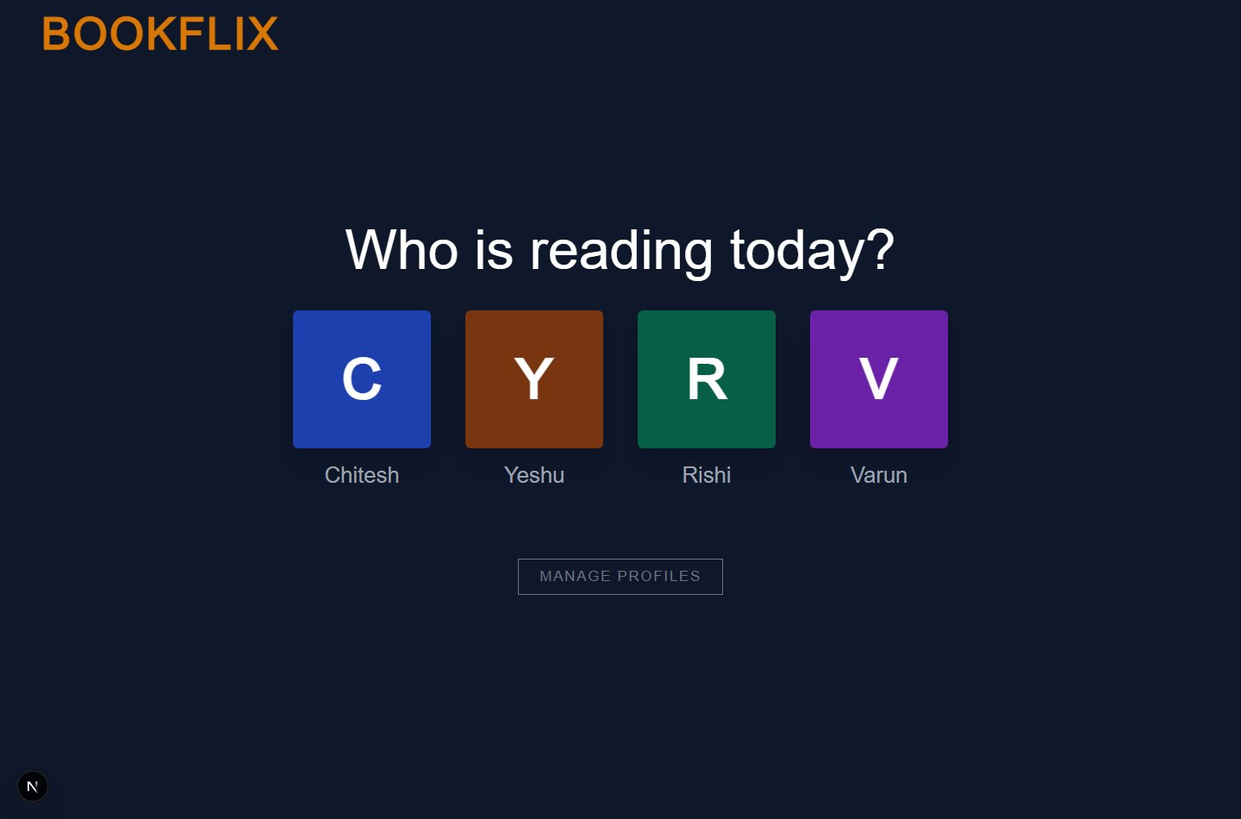
Figure 2: Profile Selection Screen – “Who is reading today?”

6.2 Browse Page – Personalised Carousels
The main browse page features a full-width Hero Banner displaying a featured book, followed by multiple horizontally scrollable carousels:
- Recommended for You – Powered by User-Based Collaborative Filtering for the logged-in user.
- My List – Books saved to the user’s personal wishlist.
- Trending Now – Top books from the overall catalogue.
- Popular Series, Author Spotlight, Award Winners – Curated slices of the catalogue.

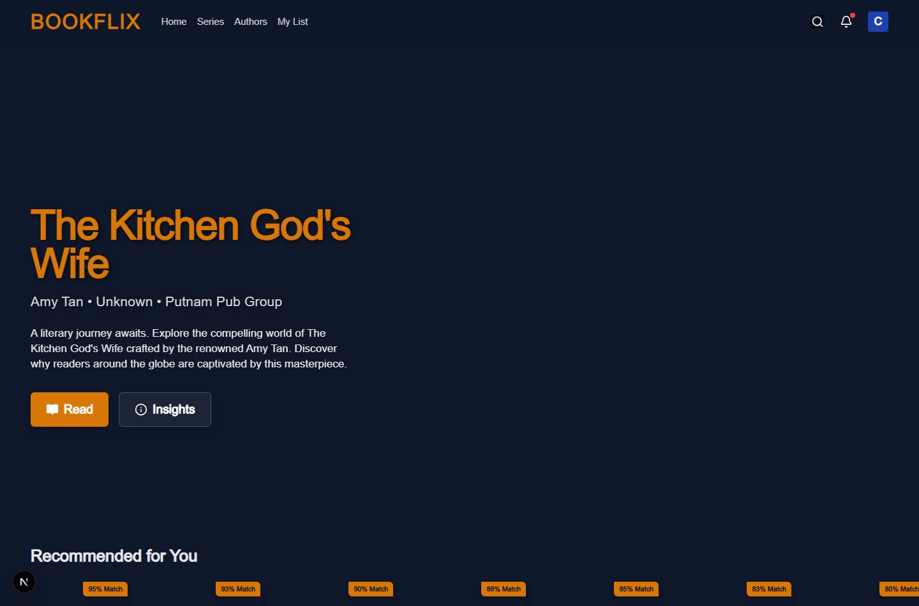
Figure 3: Browse Page with Hero Banner and Recommendation Carousels

6.3 Book Detail Modal – Hybrid Recommendations
Clicking any book card opens a detail modal displaying the book cover, title, author, year, genre, and simulated AI Insights (match percentage, estimated reading time, and vibe tags). Below the book details, a “More Like This” carousel renders hybrid recommendations computed in real time using α = 0.5.
The modal also provides Thumbs Up / Thumbs Down feedback buttons. Feedback is logged on the server and triggers a refresh of the personalised recommendation carousels on the browse page, demonstrating a live feedback loop.


Figure 4: Book Detail Modal with Hybrid Recommendations and AI Insights

6.4 Real-Time Search
The navigation bar includes a debounced search bar (300 ms delay) that queries the /api/search endpoint. Results are filtered across title, author, and genre fields and displayed in a live dropdown. Selecting a search result opens its detail modal directly without navigating away from the current page.

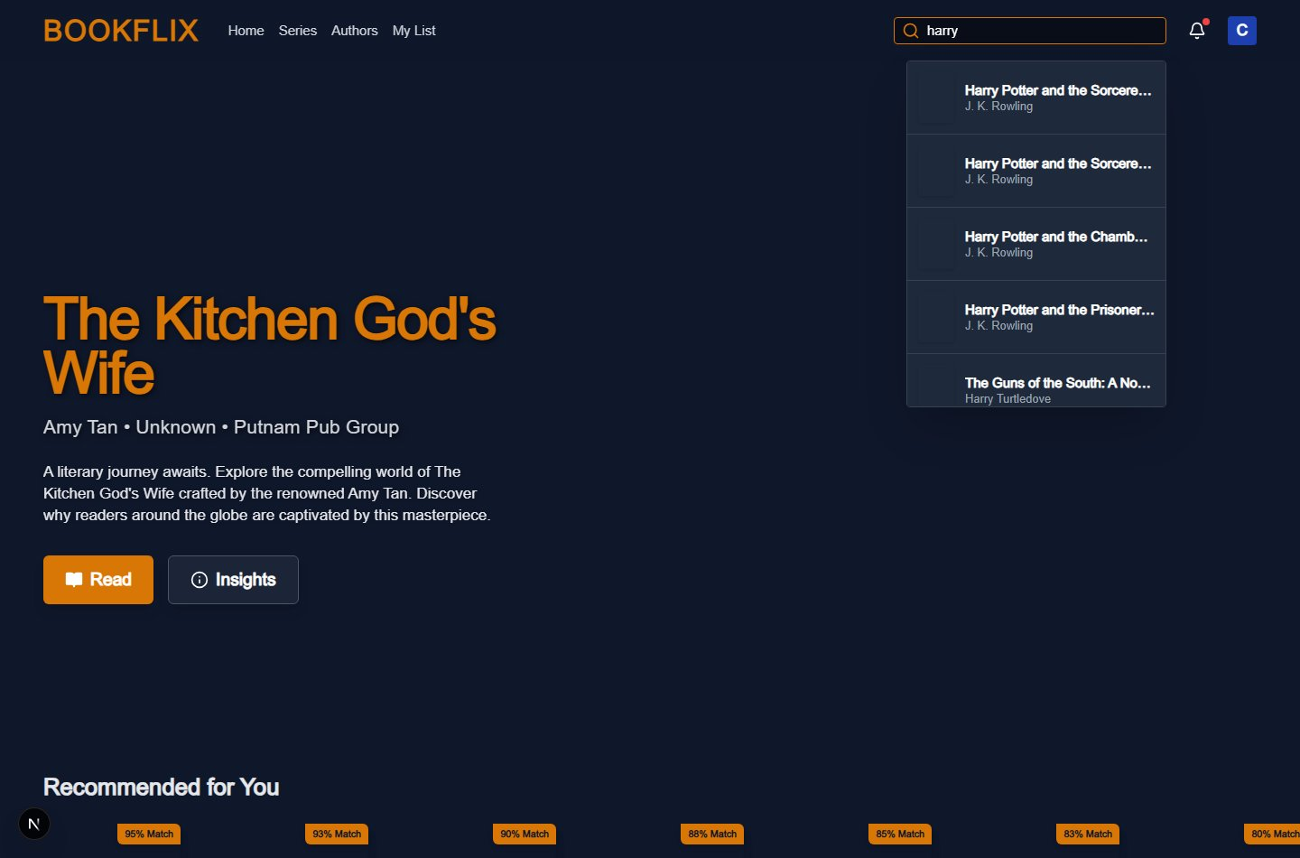
Figure 5: Navbar Search with Live Dropdown Results

6.5 Admin Analytics Dashboard
The admin page (/admin) fetches real-time metrics from /api/admin/metrics and presents the following key performance indicators:

Metric | Description
Click-Through Rate (CTR %) | Percentage of recommended items that were subsequently clicked
Recommendation Precision (%) | Percentage of user feedback interactions that were positive
Total Recommendations Served | Cumulative count of /api/recommend endpoint calls
Total Clicks | Cumulative count of book-card click interactions
Cache Hit Count | Number of recommendation responses served directly from cache
Positive / Negative Feedback | Individual counts of thumbs-up and thumbs-down responses

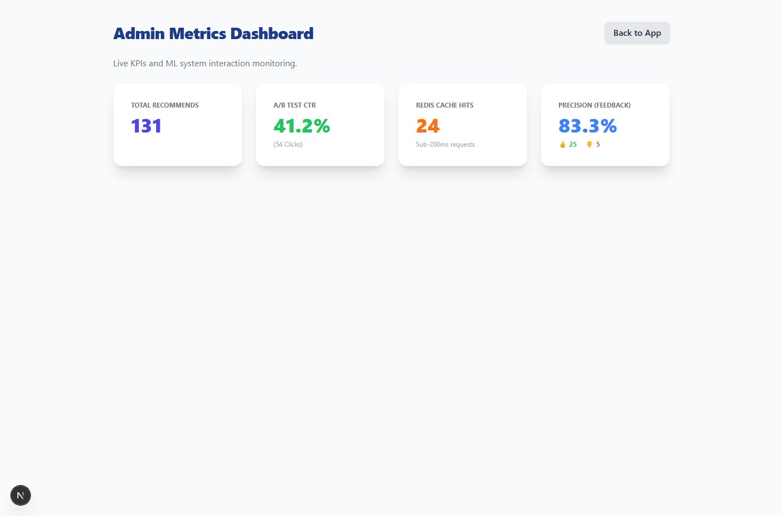
Figure 6: Admin Dashboard showing CTR, Precision, and Raw Interaction Counts

6.6 API Endpoints Summary

Method | Endpoint | Description
GET | /api/users | Fetch top 20 most active user IDs
GET | /api/users/{id}/history | Fetch a user’s highly-rated books
GET | /api/books | Fetch book catalogue (paginated, default 50)
GET | /api/books/{id} | Fetch details for a single book
GET | /api/search?q= | Search books by title, author, or genre
POST | /api/recommend | Get hybrid / user-based / cold-start recommendations
POST | /api/feedback | Log positive or negative user feedback
POST | /api/interactions/click | Log a book-card click interaction
GET | /api/admin/metrics | Retrieve real-time admin analytics metrics

7. APPLICATIONS
- Online bookstores and e-commerce platforms (e.g., Amazon, Flipkart) can use this system to personalise book listings for each individual shopper.
- Public library management systems can deploy this to suggest relevant titles to registered members based on their borrowing history.
- Educational institutions can recommend supplementary reading material to students based on their course subjects and prior reading behaviour.
- Digital reading applications (e.g., Kindle, Kobo) can provide continuously adapting reading suggestions that evolve with a reader’s preferences.
- Publishing houses can use the content-based variant to identify books similar to a newly published title for targeted marketing campaigns.
- Personalised news and article recommendation engines can be built on the same hybrid architecture by replacing books with articles and ratings with dwell-time signals.

8. CONCLUSION
BookFlix successfully demonstrates the design and deployment of a full-stack, ML-powered book recommendation system. By combining Item-Based Collaborative Filtering (KNN with Cosine Similarity) and Content-Based Filtering (TF-IDF Cosine Similarity) in a Hybrid architecture, the system achieves personalised and contextually relevant recommendations. User-Based Collaborative Filtering and Cold-Start genre recommendations further extend coverage to diverse user scenarios.
The FastAPI backend efficiently handles a dataset of over 257,000 ratings and 5,400 books, with SciPy sparse matrix storage and an in-memory cache ensuring low-latency responses. The Next.js frontend delivers an engaging, production-quality interface that makes the underlying ML functionality accessible and intuitive.
This project reinforces the practical applicability of core ML concepts – KNN, TF-IDF, Cosine Similarity, Collaborative and Content-Based Filtering – in solving a real-world information overload problem. Future enhancements could include deep learning-based embeddings (e.g., Neural Collaborative Filtering), persistent user authentication, and a dedicated model evaluation pipeline using Precision@K and NDCG metrics.

REFERENCES

- Sarwar, B., Karypis, G., Konstan, J., & Riedl, J. (2001). Item-based collaborative filtering recommendation algorithms. Proceedings of the 10th International Conference on World Wide Web (WWW), pp. 285–295.
- Pedregosa, F., et al. (2011). Scikit-learn: Machine Learning in Python. Journal of Machine Learning Research, 12, pp. 2825–2830.
- Ziegler, C.-N., McNee, S. M., Konstan, J. A., & Lausen, G. (2005). Improving recommendation lists through topic diversification. Proceedings of WWW 2005, pp. 22–32.
- Ricci, F., Rokach, L., & Shapira, B. (Eds.). (2011). Introduction to Recommender Systems Handbook. Springer, New York.
- FastAPI Documentation. (2024). FastAPI – Modern, fast web framework for building APIs with Python 3.8+. Available at: https://fastapi.tiangolo.com
- Next.js Documentation. (2024). The React Framework for the Web. Available at: https://nextjs.org/docs
- Ziegler, C.-N. (2004). Book-Crossing Dataset. Semantic Web and Web Mining Project, University of Freiburg. Available at: http://www2.informatik.uni-freiburg.de/~cziegler/BX/

