AI CAPSTONE
PROJECT PROPOSAL

Team Members

Rishi Joseph Johny - 301433650 - Soft eng technology& Ai-002
Jerin Gogi - 301378927 - Soft eng technology& Ai-002
Arjun Mungath - 301355232 - Soft eng technology& Ai-002
Sreenandhu Byju- 301394220 - Soft eng technology& Ai-002
Rui Sun - 301480676 - Soft eng technology& Ai-002

Date: 2026-01-29

Table of Contents

Introduction 3
Problem Statement 4
Methodology 4
Hypothesis 5
Literature Review 6
Scope 6
AI Capability 7
1.AI Capability Design 7
2. Data Sources and Model Training 8
3. AI Limitations 9
4. Compliance and Safety 9
Stakeholder Register 11
Functional Requirements 12
Non-Functional Requirements 15
End User Use Cases 18
Research References 20

Introduction
The Health Care web applications is a modern, AI-enabled online platform which is made to make the health care more accessible.The web application would improve the access to medical assistance, book appointments and so on. The web application integrates with AI and connects with the tradition healthcare routines to provide health assessment and assist in medical decision making.
The topic was selected because the healthcare is not being that much accessible for the common people due to long waiting periods. Many people are losing their lives due to this terrible scenario, we believe that our web application would be able to give a hand to this scenario

Problem Statement
An intelligent pre-consultation layer that processes patient-reported symptoms using machine learning and natural language processing techniques as it is absent from current healthcare applications. As a result, doctors spend too much time gathering basic information, appointment prioritizing is ineffective, and symptom data is still unstructured, all of which lower the effectiveness of consultations and the healthcare system.

Methodology
This project will use the Agile methodology while following design principals that’s centred around the user i.e.; patient and user. It will be built iteratively while testing and improving the AI Virtual Clinic platform.
The development process will be as follows:
- Requirement Analysis and System Design
Using stakeholder register, functional requirement, non functional requirements, and end-user use cases, we will create architecture diagrams of the system. We will use free tools such as draw.io to create diagrams and modelling, Figma will be used for creating the initial prototypes. This phase ensures that technical design will guide the development process.
- AI Capability Development
The AI diagnosis will be developed using machine learning models trained and fine tuned on open source medical datasets that our team finds online. We will use Natural Language to get user inputs from the user. The inputs can be in the form of text or audio. The AI services will be exposed using REST endpoints for integrating it with our main application.
- App Development
We will be using React for the user facing side of our application. For backend and will be using Flask, JWT for authentication, vector database for implementing Retrieval Augmented Generation (RAG). The app will be implemented using MVC architecture.
- Testing
We will conduct unit testing, user testing, integration testing using mock doctor and patient.
Throughout the project we will maintain a backlog in Jira to incorporate reviews and ensure that the final product is functional and user friendly.

Hypothesis
Implementing an AI powered Clinic with integrated preliminary diagnosis, that makes the healthcare more accessible ,reduces patient wait time, gets early diagnosis, improves doctor patient matching, thereby enhancing accessibility and user satisfaction in digital healthcare delivery.

Literature Review
The latest development of Artificial Intelligence in healthcare has led to the development of AI powered symptom checkers that aim in improving early stage medical assessment. There are a number of platforms that demonstrate how AI is able to provide preliminary diagnosis. This section focuses on four main platforms: Ada Health, Buoy Health, Isabel Healthcare, and WebMD Symptom Checker.
Ada Health is a symptom assessment platform that uses AI to analyze user symptoms using natural language processing and machine learning. It guides users through a set of questions and generates a possible condition with recommendation. However the platform does not support doctor dashboard, symptom diagnostics for clinical review, and an appointment management system.
Buoy Health is a platform that puts an emphasis on accessibility. Similar to Ada, this platform mainly functions as a symptom checker rather than a clinical support tool. It lacks features such as AI assistance for doctors and appointment scheduling.
Isabel Healthcare is an AI based clinical support system that's designed for healthcare professionals. It analyses symptom patterns and clinical inputs to give possible diagnoses based on medical knowledge base. It lacks layman-friendly explanations and patient facing features.
WebMD is a Symptom Checker that is widely used by the public that provides symptom based condition suggestions through rule based logic. It offers condition explanation and care information. However it relies on predefined symptom input rather than natural language.
To address these limitations, the AI Virtual Clinic will introduce and intelligent preliminary diagnosis layer that uses AI and natural language processing, symptom processing, data transformation, independent facing interfaces for patients and doctors.

Scope
The web application covers the implementation of a digital platform which integrates with artificial intelligence to make healthcare more accessible to the people. According to the WHO, digital technologies are now an integral part of life and the interconnection between the people are at the most compared to the older times. Our health care web application is intended to make use of this connection of the people with the digital life and make it more accessible. Even though we are able to connect the patients with the doctors the online sessions could be the very end of their medication as the diagnosis could not be 100% accurate as there is no physical contact.

AI Capability
The core of this project is an Intelligent Pre-consultation Layer, designed to analyse patient-entered symptom information using machine learning and natural language processing techniques. The purpose of this AI component is to support preliminary medical decision-making and improve the medical consultation and appointment workflow.

1.AI Capability Design
The AI system focuses on analysing symptoms submitted by patients in text form. First, natural language processing (NLP) techniques are used to convert user-entered symptom descriptions into structured feature representations. Then, trained machine learning models identify symptom patterns and generate possible condition categories or risk levels to support early-stage medical decisions.
The AI functionality is implemented as a backend service and is exposed through RESTful APIs, allowing integration with a React-based frontend and a Flask-based backend application.
The AI component supports the following use cases:
- Preliminary Symptom Analysis (Use Case A1):
The AI analyses patient symptoms and generates possible condition categories and risk indicators to help users decide whether further medical consultation is needed.
- Doctor Support Information (Use Case A2):
When doctors review patient information, the AI provides symptom-based reference information to support clinical decision-making. The AI does not provide diagnoses or medication recommendations.
- Layman-Friendly Explanation (Use Case A3):
The AI converts medical analysis results into simple and easy-to-understand language for users without a medical background.
- Symptom Data Standardization (Use Case A4):
The AI maps natural language symptom descriptions into standardized feature formats that can be processed by medical datasets and machine learning models.

2. Data Sources and Model Training
The AI models are trained and evaluated using publicly available medical datasets that can be accessed through Kaggle and Hugging Face.
Dataset Name | Purpose in This Project | Source
Disease-Symptoms-Dataset | Main dataset for training symptom-disease classification models using structured symptom data | Kaggle
Symptom-Based Disease Prediction Dataset | Used to build preliminary disease analysis and risk prediction models based on patient-reported symptoms | Kaggle
dux-tecbic/symptom-disease-dataset | Supports NLP processing and symptom standardization from natural language input | Hugging Face
Heart Disease Dataset (UCI) | Used for extended validation and simple symptom correlation experiments | Kaggle / UCI
Mental Health Survey Data | Used for limited validation and model generalization testing | Kaggle
Note : Only the first three datasets are used as core training data. The remaining datasets are used for experimental validation and are not part of the core system functionality.

3. AI Limitations
As this project is a capstone project, the AI capability is limited by dataset size, data quality and problem scope. The model may not perform accurately for rare diseases or incomplete symptom descriptions.

4. Compliance and Safety
All AI-generated outputs are provided for preliminary reference only. Clear disclaimers are included in the system to indicate that the results do not represent final medical diagnoses or treatment advice. Final medical decisions must be made by qualified healthcare professionals. User data is handled securely and protected during processing and transmission.

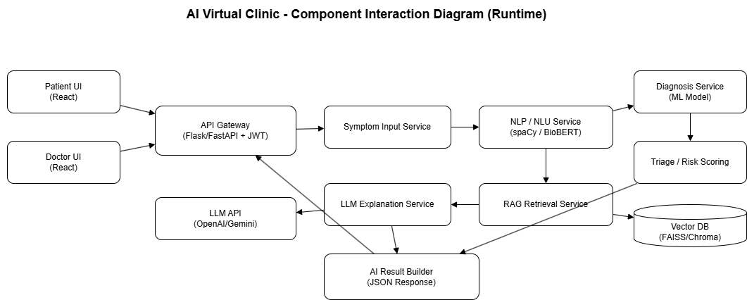

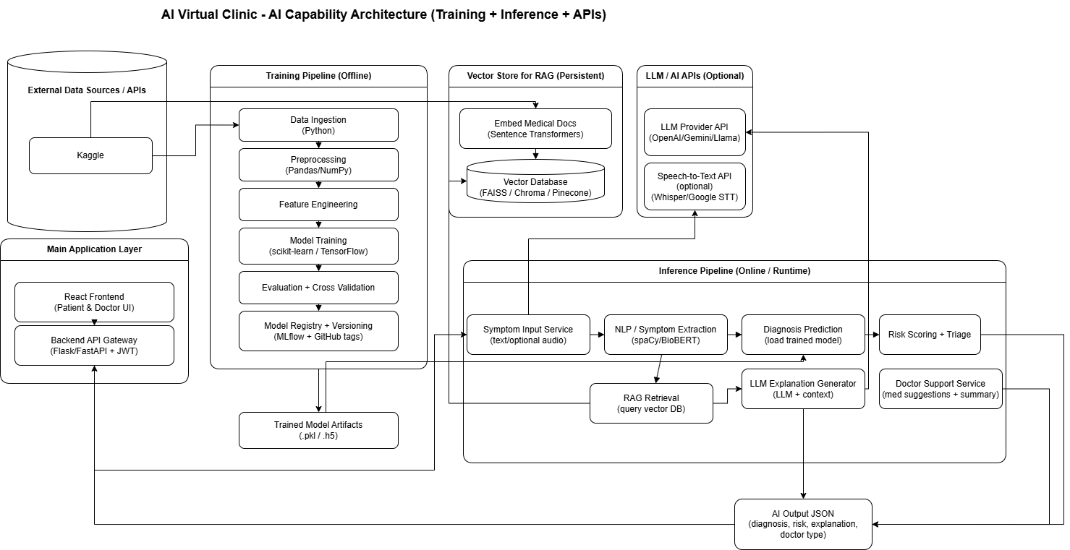

Stakeholder Register

Stakeholder Name | Role | External/ Internal | Stakeholder Contact Details | Operational/ Executive | Interest  (high, medium, low)
Rishi Joseph Johny | Team Lead | Internal | rjohny1@my.centennialcollege.ca | Operational | high
Arjun Mungath | Investor | External | amungath@my.centennialcollege.ca | Executive | Medium
Jerin Gogi | IT Security Officer | Internal | jkuria13@my.centennialcollege.ca | Operational | high
Rui Sun | Programmer | Internal | rsun29@my.centennialcollege.ca | Operational | medium
Sreenandhu Byju | Tester | External | Sbyju@my.centennialcollege.ca | Operational | Medium

Functional Requirements

Requirement ID | Functionality | Short Description | Priority | Requester
FR01 | Notifications | Should alert users to give them reminders about the appointment. | Medium | Patient,Doctor
FR02 | User Login | Allows users to securely login to the application. | High | Patient
FR03 | User Dashboard | Displays personalized information about the user after login. | High | Patient
FR04 | Book Appointments | Allows users to book appointments with a doctor. | High | Patient
FR05 | View Appointments | Shows upcoming appointments. | Medium | Patient,Doctor
FR06 | Doctors List | Shows a list of available doctors. | High | Patient
FR07 | Symptom Input | Users can input their symptoms before booking. | Medium | Patient
FR08 | AI Diagnosis | AI provides initial diagnosis based on user input | High | AI System
FR09 | Diagnosis Report | Display AI diagnosis in an analysis format. | Medium | Patient,Doctor
FR10 | Seek Assistance | Doctors can seek assistance from AI | High | Doctor
FR11 | Doctors Dashboard | Displays personalized patient information to the doctor. | High | Doctor
FR12 | Doctor Login | Allows users to securely login to the application. | High | Doctor
FR13 | Session Management | Manages Login state for both user and doctor | Medium | Patient,Doctor
FR14 | Appointment Management | Allows doctors to reschedule, and cancel appointments. | Medium | Doctor
FR15 | Upload Prescription | Allows doctors to upload prescriptions. | High | Doctor

Non-Functional Requirements

Requirement ID | Functionality | Short Description | Priority | Requester
NFR01 | Security | All user data must be encrypted | High | Patient,Doctor
NFR02 | Security | The system must have RBAC for doctors and users. | High | Patient,Doctor
NFR03 | Security | Authentication using secure methods such as JWT. | HIgh | System, Developer
NFR04 | Security | Systems must use data that follow healthcare regulations. | High | Doctor, System
NFR05 | Performance | Applications must load a page under 3 seconds for most users. | Medium | System, Developer
NFR06 | Performance | AI diagnosis should be loaded under 10 seconds | Medium | AI System, Developer
NFR07 | Availability | The system must be up 99% of the time, excluding maintenance. | High | System, Developer
NFR08 | Usability | The application must be responsive and supported on mobile phones. | High | System, UI/UX Designer
NFR09 | Interoperability | The application must be integrated into a third party medical database. | High | Developer
NFR10 | Maintainability | Codebase must follow modular design with documentation for updates and bug fixes. | Medium | Developer
NFR11 | Portability | The application must be deployable on cloud services | Low | DevOps
NFR12 | Legal/ Compliance | All AI generated diagnosis should include a disclaimer that its not the final but preliminary diagnosis. | Medium | Developer

End User Use Cases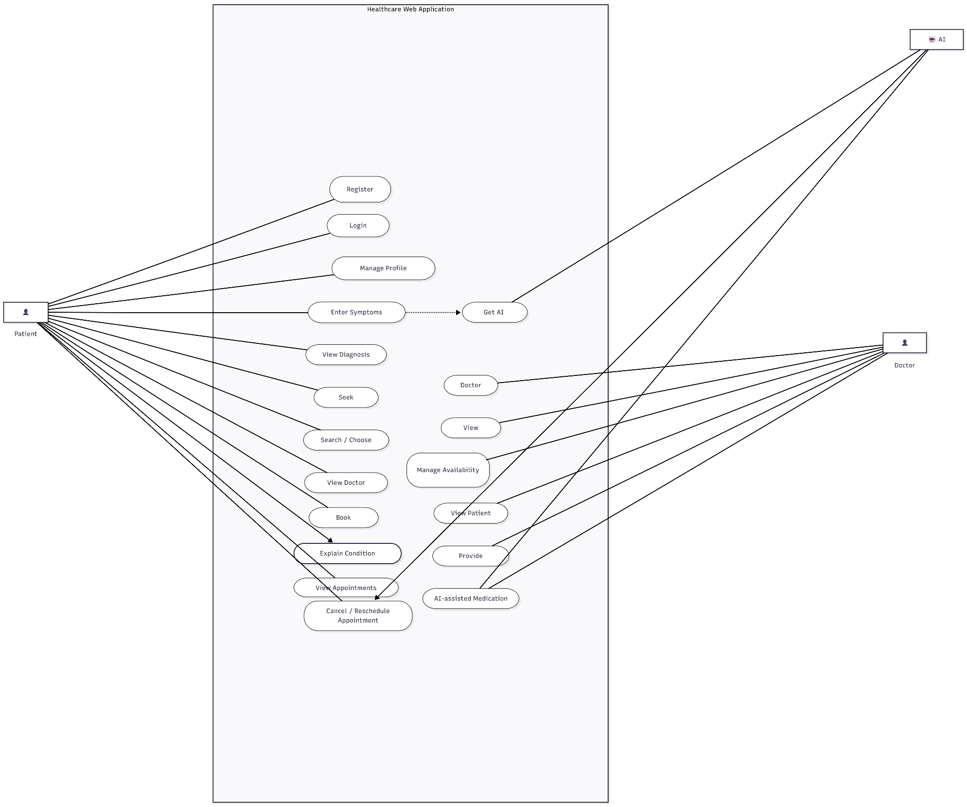

Use Case ID | Use Case Name | Primary Actor | Description | Inputs | Output
A1 | Get Diagnosis | AI | Analysis  Patient symptoms and gives  Results accordingly | symptoms,duration | List of all possible diseases according to the symptoms
A2 | Seek assistance | Ai | Ai suggests the best medications with the help of doctors' findings.. | Symptoms, Doctors findings regarding the matter | Suggests medications
A3 | Condition explanation | AI | Ai would explain the disease or the condition in a way a  non-healthcare would be able t o understand. | Ai diagnosed data | Explanation of the data
A4 | Data transformations | AI | Ai would transform the data from human language to the data which is available in the dataset | Human symptoms | Data from the dataset

Research References
- Kaggle. (2020). Symptom-based disease prediction dataset https://www.kaggle.com/datasets/miltonmacgyver/symptom-based-disease-prediction-dataset

- Detrano, R., Janosi, A., Steinbrunn, W., Pfisterer, M., Schmid, J. J., Sandhu, S., Guppy, K. H., Lee, S., & Froelicher, V. (1989). Heart disease dataset. UCI Machine Learning Repository.
https://archive.ics.uci.edu/ml/datasets/heart+disease

- Little, M. A., McSharry, P. E., Hunter, E. J., Spielman, J., & Ramig, L. O. (2009). Parkinsons dataset. UCI Machine Learning Repository.
https://archive.ics.uci.edu/ml/datasets/parkinsons

- Wang, X., Peng, Y., Lu, L., Lu, Z., Bagheri, M., & Summers, R. M. (2017).
ChestX-ray8: Hospital-scale chest X-ray database.
National Institutes of Health.
https://www.kaggle.com/datasets/nih-chest-xrays/data

- Tschandl, P., Rosendahl, C., & Kittler, H. (2018).
HAM10000: A large collection of multi-source dermatoscopic images of common pigmented skin lesions.
https://www.kaggle.com/datasets/kmader/skin-cancer-mnist-ham10000

- OSMI. (2016). Mental health in tech survey dataset.
https://www.kaggle.com/datasets/osmi/mental-health-in-tech-survey
7.World Health Organization. (n.d.). Digital health. https://www.who.int/health-topics/digital-health

8.Take care of yourself with Ada. more than a symptom checker. Ada. (n.d.). https://ada.com/app

9. Symptom checker: Isabel - the symptom checker doctors use. Isabel. (n.d.). https://symptomchecker.isabelhealthcare.com/isabel-tool-page

10. Check your symptoms and find the right care: Buoy. Buoy Health: Check Symptoms & Find the Right Care. (n.d.). https://www.buoyhealth.com/symptom-checker/
11.WebMD. (n.d.). Symptom checker with body from webmd - check your medical symptoms. WebMD. https://symptoms.webmd.com/

