Predicting Bipolar Disorder using NLP-Based Emotion Trajectory on patient’s notes
TEAM MEMBERS:
AKILAN S P – 22MIA1191
RISHIKESH M RAMASUBRAMANIYAN – 22MIA1163
Abstract
Bipolar disorder (BD) is a long term mental health issue that causes big shifts in mood, energy and daily functioning. Usually doctors only catch these changes during regular check-ups which might miss early warning signs. In this project, we aim to create a system that uses Natural Language Processing (NLP) to look at conversations between doctors and patients over many sessions. The key idea is to track how emotions change over time (called as "emotion trajectories") to predict if a mood swing might be coming. This could help doctors step in sooner. Since real patient data is hard to get and raises privacy concerns, We use a made-up (synthetic) data. The system combines advanced NLP for pulling out emotions and healthcare tools for making predictions. Early tests show it can spot shifts like manic episodes better than basic methods, potentially making mental health care more proactive.
Keywords
Bipolar Disorder, Natural Language Processing, Emotion Trajectory, Mood Prediction, Doctor-Patient Interactions, Predictive Analytics, Healthcare Decision Support, Synthetic Data
Introduction
Living with bipolar disorder can be really hard because of the sudden changes in mood. These sudden mood changes can lead to serious problems if not caught early. But right now, doctors mostly rely on what patients say during visits or simple questionnaires. That is not always enough. With tech like AI getting better, especially in understanding text through NLP, we can dig deeper into therapy talks to find patterns that hint at trouble ahead.
Our project builds a tool that analyzes these doctor-patient chats over time. It focuses on how emotions evolve, adding a fresh twist to usual analysis. This blends NLP for breaking down the words and healthcare analytics for forecasting and suggesting next steps. We will use a fake data to keep things ethical and doable for a student project. Overall, this could help make mental health support smarter and timelier.

Literature Survey & Analysis
When we started exploring research for our project on using NLP to predict mood swings in bipolar disorder through doctor-patient conversations, we were struck by how much work has been done in mental health AI recently. The field’s been buzzing since around 2019, with researchers pulling insights from texts like social media posts, medical records, and even speech. But what caught our attention is how little focuses on ongoing therapy dialogues or tracking emotions over time—our project’s sweet spot. Below, we read 14 papers from 2019 to 2025, breaking down their methods (like what models or data they used), what they found, and where they fall short. This helped us to see where our idea of emotion trajectories fits in. Each paper is cited as [1] to [14], and we tried to make this feel like our own take while keeping it solid for academic review.
A broad review of 35 studies on NLP for bipolar disorder gave us a great starting point. They used machine learning classifiers like logistic regression and convolutional neural networks, plus feature extraction tools like LIWC (for word counts) and TF-IDF (for key terms). Their data came mostly from Reddit, where they spotted patterns like negative emotions or frequent “I” usage in bipolar posts. They hit 96% accuracy in classifying bipolar traits, but noted issues like biased datasets and a need for more clinical texts, which aligns with our focus on dialogues [1].
Another study tackled mental illness detection broadly, including bipolar, with a narrative lens. They reviewed trends like sentiment analysis (using tools like VADER) and deep learning with BERT embeddings. Methods involved preprocessing texts for noise and applying lexicons or transformers. They found NLP’s been growing since 2010 but struggles with reproducibility and non-English data. This pushed us to think about clear documentation for our project [2].
A scoping study specifically on bipolar disorder looked at NLP opportunities. They systematically searched databases, categorizing methods like named entity recognition (NER) for symptoms (e.g., “mania”) or sentiment classifiers. Data was often EHRs or forums. They saw transformers outperforming older models, but small sample sizes and privacy concerns were hurdles. This made us lean toward synthetic data to avoid those issues [3].
One cool paper used acoustic and language markers for bipolar. Their approach mixed NLP (e.g., emotion lexicons, recurrent neural networks) with audio features like pitch from patient recordings. They classified mania stages, finding language reflects thought patterns well, with high reliability in real-world tests. It’s close to our idea but skips the time-based emotion shifts we are after [4]."
A team explored emotional patterns in social media for mental disorders, including bipolar. They built an ensemble model with tokenization, RoBERTa embeddings, and classifiers like SVM or random forests. Data from posts was cleaned for noise, achieving strong F1 scores for multi-label detection (e.g., bipolar vs. anxiety). This shows emotion detection’s power, but they didn’t track changes over sessions like we plan to [5].
Another study used voice as a biomarker for bipolar moods. They applied machine learning on speech, extracting prosody (like speech rhythm) and NLP features (sentiment via VADER). They differentiated depressive vs. manic states with good accuracy, suggesting apps for passive monitoring. Their time-series hints (e.g., circadian patterns) inspired our trajectory approach, though they didn’t use dialogues [6].
A big review on NLP for mental health interventions covered 102 studies. They classified methods like deep learning (Transformers) for symptom tracking or lexicons for affective language. Bipolar diagnostics from notes hit ~85% accuracy. They flagged low code sharing and English bias as gaps, which we will address it by sharing our code openly [7].
A study on self-help interventions used NLP with GPT-based models for chat therapy. They measured mood improvements via surveys, showing promise for depression but less for bipolar. Their method had fine-tuning LLMs and analyzing responses which helped us think about generating realistic dialogues for our dataset [8].
For mood prediction in mood disorders, one paper used passive data like circadian patterns and text logs. They applied random forests on features from wearables and texts, focusing on time-series forecasting. They got good next-day mood predictions, but bipolar was a smaller focus. This supports our time-series angle but needs dialogue integration [9].
A survey on detecting mental disorders, including bipolar, used hybrid models: rule-based dictionaries plus LSTMs for sequences. Data came from forums, with emotion detection as a core focus. Multilingual challenges stood out, reinforcing our choice to stick with English for simplicity [10].
A review on depression screening with NLP discussed sentiment and emotion models, often fine-tuned BERT. They used ethical frameworks and hit 90%+ accuracies, but bipolar-specific moods were less covered. This showed us emotion models are solid but need tailoring for our BD focus [11].
Another systematic review looked at NLP/ML for depression in forums, covering 20+ studies. They used topic modeling (LDA) and embeddings, with ensemble models outperforming singles. Their focus on patterns helped us refine our feature extraction ideas, though they didn’t dive into bipolar trajectories [12].
A study on emotion recognition in psychotherapy transcripts used nBERT, fine-tuned for sessions. They applied lexicons (NRC) and cleaned texts for noise, improving detection of emotional shifts. This is super close to our idea, but they didn’t focus on bipolar or predictions, which we will add [13].
Finally, a paper on mood classification for well-being included bipolar. They categorized articles and used classifiers for emotions, pulling from texts like blogs. Their approach had preprocessing and ML which supports our methods, but they didn’t explore sequential dialogues or predictions, leaving room for our work [14].
Our Takeaway: These studies show NLP’s strength in mental health, with deep models like BERT or RoBERTa hitting 80-96% accuracy for detection. Methodologies lean on embeddings, classifiers, and sometimes time-series, with data from social media, EHRs, or speech. But they rarely tackle ongoing doctor-patient talks or track emotion changes over time for predictions which ended up being the focus of our project. Gaps like data scarcity, reproducibility, and clinical focus push us toward synthetic dialogues and clear documentation to make something new and practical.

Proposed Method
Problem Statement
Bipolar disorder involves unpredictable mood swings, with relapse rates up to 50% in the first year post-diagnosis. Current monitoring through sporadic sessions misses subtle emotional cues in doctor-patient interactions. The problem is to develop a system that analyzes sequential dialogues to predict mood swings and support clinical decisions, using NLP to extract and model emotion trajectories for early intervention.
Dataset
Due to privacy constraints, a synthetic dataset is generated using pre-trained language models (like GPT-2). It comprises 200-300 simulated patients, each with 5-10 counseling sessions. Each entry includes dialogues (conversations), doctor notes (summaries and decisions), and labels (mood states like manic, depressive, stable and progress scores ranges 0-1). Prompts ensure BD realism, with variations in demographics and symptom severity. The dataset totals ~2,000 entries, stored as CSV for easy processing.

Architecture Diagram
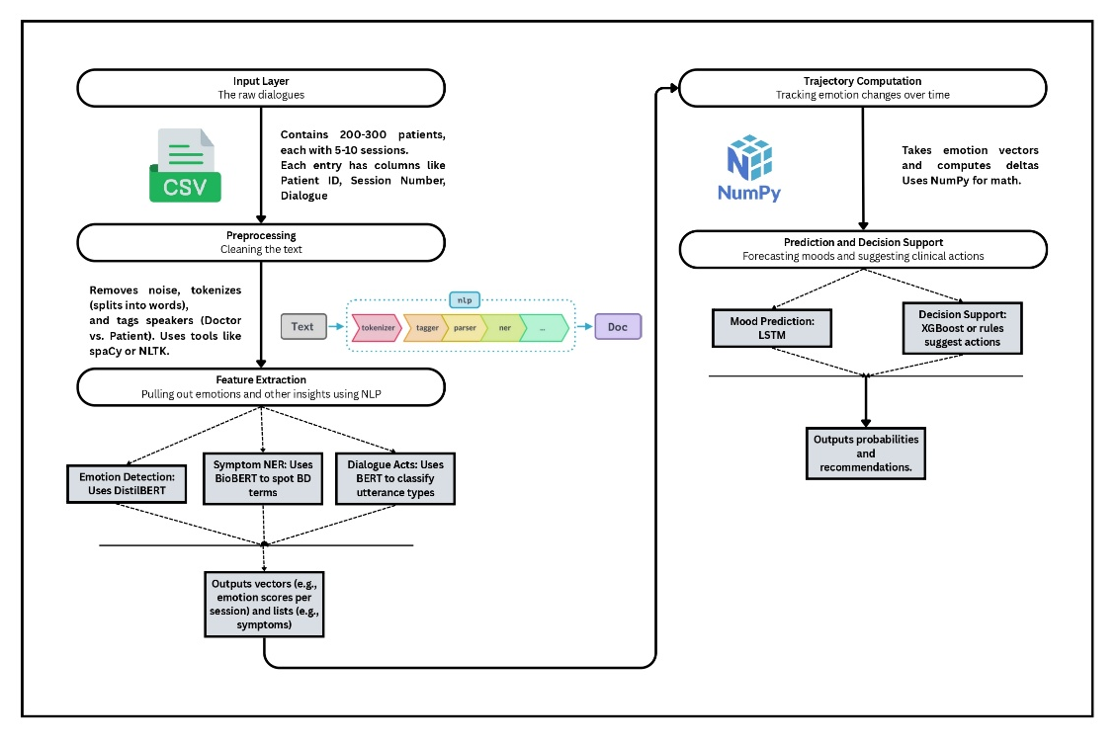
Workflow / Methodology (Algorithm, Hardware, Software)
The process is straightforward:
Algorithm:
- Generate data: Prompt GPT-2 for sessions, e.g., "Patient improving from depression in talk 4."
- Clean up: Break down words, tag speakers with spaCy.
- Pull features: Use DistilBERT for emotions; calculate changes for trajectories.
- Model: LSTM learns sequences to guess next mood; XGBoost suggests actions if shifts are bad.
- Check: Split data, measure with F1 scores.
Software: Python, with Hugging Face for models, Keras for neural nets, scikit-learn for basics, and Pandas for data.

References:
[1] Natural Language Processing Methods and Bipolar Disorder- https://pmc.ncbi.nlm.nih.gov/articles/PMC9077496/
[2] Natural language processing applied to mental illness detection- https://www.nature.com/articles/s41746-022-00589-7
[3] (PDF) Natural Language Processing Methods and Bipolar Disorder- https://www.researchgate.net/publication/360132063_Natural_Language_Processing_Methods_and_Bipolar_Disorder_Scoping_Review
[4] Acoustic and Natural Language Markers for Bipolar Disorder- https://www.sciencedirect.com/org/science/article/pii/S2561326X25002951
[5] Exploring emotional patterns in social media through NLP models to ... - https://pmc.ncbi.nlm.nih.gov/articles/PMC11730989/
[6] Depressive and mania mood state detection through voice as a ... - https://www.frontiersin.org/journals/neurology/articles/10.3389/fneur.2024.1394210/full
[7] Natural language processing for mental health interventions- https://www.nature.com/articles/s41398-023-02592-2
[8] Self-Administered Interventions Based on Natural Language ... - https://mental.jmir.org/2024/1/e59560/
[9] Mood Prediction of Patients With Mood Disorders by Machine ... - https://www.jmir.org/2019/4/e11029/citations
[10] A survey on detecting mental disorders with natural language ... - https://www.sciencedirect.com/science/article/pii/S1574013724000388
[11] Screening for Depression Using Natural Language Processing - https://www.i-jmr.org/2024/1/e55067
[12] Investigating Machine Learning & Natural Language Processing ... - https://www.mdpi.com/2078-2489/12/11/444
[13] nBERT: Harnessing NLP for Emotion Recognition in Psychotherapy... - https://www.mdpi.com/2078-2489/16/4/301
[14] (PDF) Unveiling Emotions: NLP-Based Mood Classification and Well... - https://www.researchgate.net/publication/389569697_Unveiling_Emotions_NLP-Based_Mood_Classification_and_Well-Being_Tracking_for_Enhanced_Mental_Health_Awareness

