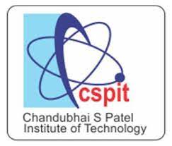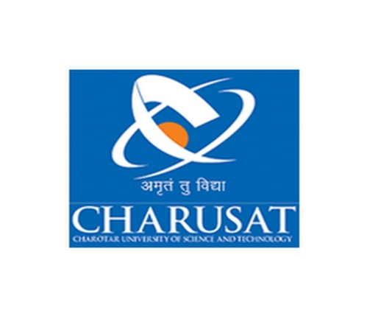

**CHAROTAR UNIVERSITY OF SCIENCE AND TECHNOLOGY**

* As the name suggests, Object-Oriented Programming or OOPs refers to languages that use objects in programming. Object-oriented programming aims to implement real-world entities like inheritance, hiding, polymorphism, etc. in programming. The main aim of OOP is to bind together the data and the functions that operate on them so that no other part of the code can access this data except that function.
* **Concepts in OOPs**

1. Class
2. Object
3. Inheritance
4. Polymorphism
5. Data Abstraction
6. Encapsulation
7. Data Binding
8. Message Passing

* **Comparison of java with other Object-Oriented Programming Languages:**

Java is one of the most popular and widely used programming language and platform. A platform is an environment that helps to develop and run programs written in any programming language.

1. **Comparison with C++:**

* Java was basically derived from C++.
* C++ is both procedural and object-oriented programming language whereas Java is a pure object-oriented language.
* Both the languages have different objectives which means it has many differences too.
* The main objective of C++ is to design a system of programming.

1. **Comparison with Java:**

* Python is a high-level language. It fully supports object-oriented programming. Python is not a pure object-oriented language.
* Python is an interpreted language whereas Java is not an interpreted language, it is a compiled language.
* Python is a scripting language whereas JAVA is a low-level implementation language.

1. **Comparison with Ruby:**

* Ruby and Java are object-oriented languages and also they are strongly typed.
* Java is statically typed whereas Ruby is dynamically typed.
* Both languages have a different method for executing the code. Java first converts the code into machine language so that it can be understood by it and because of this Java code runs faster than Ruby’s code.
* **INTRODUCTION TO JDK, JRE, JVM, JAVADOC AND COMMAND LINE ARGUMENT:**

1. **JDK**

* The Java Development Kit (JDK) is one of three core technology packages used in Java programming, along with the JVM (Java Virtual Machine) and the JRE (Java Runtime Environment).
* Developers new to Java often confuse the Java Development Kit and the Java Runtime Environment. The distinction is that the JDK is a package of tools for developing Java-based software, whereas the JRE is a package of tools for running Java code.

1. **JRE**

* The Java Runtime Environment (JRE) is software that Java programs require to run correctly. Java is a computer language that powers many current web and mobile applications. The JRE is the underlying technology that communicates between the Java program and the operating system.
* A software program needs a runtime environment that provides access to memory and other system resources such as program files and dependencies. In the past, most software used the operating system directly as its runtime environment. However, this meant that developers had to write different code for each operating system that they wanted their applications to run on. The Java Runtime Environment (JRE) technology was created as a solution to this problem.
* The JRE is actually one of three Java platform components that are required for any Java program to run successfully. The Java Development Kit (JDK) and Java Virtual Machine (JVM) are the other two components.

1. **JVM**

* Java Virtual Machine (JVM) is a engine that provides runtime environment to drive the Java Code or applications.
* It converts Java bytecode into machines language. JVM is a part of Java Runtime Environment (JRE).
* In other programming languages, the compiler produces machine code for a particular system. However, Java compiler produces code for a Virtual Machine known as Java Virtual Machine.

1. **JAVADOCK**

* JavaDoc tool is a document generator tool in Java programming language for generating standard documentation in HTML format. It generates API documentation. It parses the declarations ad documentation in a set of source file describing classes, methods, constructors, and fields.
* Before using JavaDoc tool, you must include JavaDoc comments /**………………. */ providing information about classes, methods, and constructors, etc. For creating a good and understandable document API for any java file you must write better comments for every class, method, constructor.

1. **COMMAND LINE ARGUMENT**

* Java command-line argument is an argument i.e. passed at the time of running the Java program. In the command line, the arguments passed from the console can be received in the java program and they can be used as input. The users can pass the arguments during the execution bypassing the command-line arguments inside the main() method.
* We need to pass the arguments as space-separated values. We can pass both strings and primitive data types(int, double, float, char, etc) as command-line arguments. These arguments convert into a string array and are provided to the main() function as a string array argument.
* When command-line arguments are supplied to JVM, JVM wraps these and supplies them to args[]. It can be confirmed that they are wrapped up in an args array by checking the length of args using args.length.
* Internally, JVM wraps up these command-line arguments into the args[ ] array that we pass into the main() function. We can check these arguments using args.length method. JVM stores the first command-line argument at args[0], the second at args[1], the third at args[2], and so on.