Protocol Document for Double side
Platform Display.

Document Title | Protocol Details
Document Number | V7.1
Purpose | Protocol details for main controller.
From | Chemito InfoTech Pvt. Ltd.
To
Date | 07 MARCH 2022

Prepared By | Reviewed By | Approved By
Name: Ms.Shivanjali Mutadak.  Signature: | Name: Mr. Dinesh More.  Signature: | Name: Mr. Naresh Panchal  Signature:

Revision History

Revision No | Date | Title / Brief Description of Changes | Prepared By | Reviewed By | Approved By
1.1 | 07/03/2022 | Original Document | Miss.Shivanjali  Mutadak | Mr. Dinesh more | Mr. Naresh Panchal
1.2 | 08/03/2022 | Added below commands  - Erase Memory  - STORE BITMAP DATA  - Get Stored Bitmap ID  - Diagnosis Command  - Led Test Pattern  - SET SENSOR Parameters  - GET SENSOR Parameters  - GET SENSOR Values  - GET SENSOR Events  - SEND SENSOR Events | Miss.Shivanjali  Mutadak | Mr. Dinesh more | Mr. Naresh Panchal
1.3 | 09/03/2022 | - Link check Response Function. | Miss.Shivanjali  Mutadak | Mr. Dinesh more | Mr. Naresh Panchal
1.4 | 10/03/2022 | - Response function for Display Data | Miss.Shivanjali  Mutadak | Mr. Dinesh more | Mr. Naresh Panchal

Table of Contents

SRN | CHAPTER NAME AND DETAILS | PAGE NO
1 | - Purpose  - Introduction | 5
2 | Statuses  - Function code  - Response Function code  - Packet status  - System significance (configuration status)  - A. system status B. System status  - Sensor status  - Line controller status  - Font table. | 6-11
3 | 3 Protocol Format for Display Data  3.1 Details of Individual Bytes of V7.1 Protocols  3.2 Data Byte (N byte)  3.3 Screen Data  3.4 Response Code for Display Data. | 12-17
4 | Steps for sending the packet with Hercules Tool. | 18
5 | 5. Protocol Format for Link Check.  5.1 Response for link check. | 19-20
6 | Protocol Format for start command. | 21
7 | Protocol Format for stop command. | 22
8 | - Protocol Format for Set Configuration command.  8.1Response Function | 23-25
9 | - Protocol Format for Get Configuration command.  9.1 Response Function. | 26-28
10 | 10. Protocol Format for Soft Reset command.  10.1 Response function | 29-30
11 | - Protocol Format for Erase  11.1 Response function for Erase | 31-32
12 | 12. Protocol Format for store bitmap  12.1 Response function store bitmap | 33-35
13 | 13. Protocol Format for sync message bit map  13.1 Response function for sync message bit map | 36-38
14 | 14. Protocol Format for LED Test Pattern  14.1 Response function for LED Test Pattern | 39-41
15 | 15. Protocol Format for Set Sensor Parameter  15.1 Response function for Set Sensor Parameter | 42-44
16 | 16.Protocol Format for Get Sensor Parameter  16.1 Response function for Get Sensor Parameter | 45-47
17 | 17. Protocol Format for Get Sensor Value  17.1 Response function for Get Sensor Value | 48-50
18 | 18. Protocol Format for Get Sensor Event  18.1 Response function for Get Sensor Event | 51-53
19 | - Protocol Format for Send Sensor Event  19.1 Response function for Send Sensor Event | 54-56
20 | 20. Protocol Format for Get Sensor Event  20.1 Response function for Get Sensor Event | 57-58

Purpose:
This Document contains Detail description for any Double Sided Platform Display. The document provides communication details of displays and required protocols.

1.2 Introduction:

The main function of Platform Display Board is to display Expected Time of Arrival in Minutes, Arrival Time and Destination. In case there is no train during a certain span of day it will display information related to special events, public information items. It will show messages in emergency situations.

DSPF will display information for approaching train as well as emergency messages and advertisements. It will be useful and entertaining for passengers waiting at station. The types of information will mainly consist of route number, destination, and expected time of arrival. Destination will be displayed in English & Regional languages.
Service provider will design the layout of display area by selecting the types of information and their sequence.

- Function Code:

Function code will represent different type of packets and functions. The range of function code is
limited to $80 - $ 95. The range $C0 - $D5 shall be only used for giving response to any of the packet.
This is dried by adding $40 to any of the function code received. From this it can be identified that
the packet is response packet or not.

Function Code | Command | Description
80 | Link Check | Link Check status for display connectivity
81 | Display Data | To display Route/Emergency/Adhoc data on display
82 | STOP | Blank display
83 | START | Start displaying last display data frame
84 | SET CONFIG | Sending Configuration data of Display
85 | GET CONFIG | Getting configuration data from Display
86 | Soft Reset | Software reset for display
87 | Erase Memory
88 | STORE BITMAP DATA | Store bitmap with bitmap id in NAND Flash
89 | Get Stored Bitmap ID
8A | Diagnosis Command | Different type of diagnostic status
8C | Led Test Pattern | To test the LED patterns on Display board
91 | SET SENSOR Parameters | Set sensor set points high and low for event check
92 | GET SENSOR Parameters | Get sensor parameters present in DSPF
93 | GET SENSOR Values | Get sensor run time values form DSPF
94 | GET SENSOR Events | Get last updated sensor events from DSPF
95 | SEND SENSOR Events | This command will get received only Server ,DSPF will send this command when specific sensor event gets triggered,Software will respond to it with response function code

2.1 Response Function Code:

Response Function Code | Command | Description
C0 | Link Check | Link Check status for display connectivity
C1 | Display Data | To display Route/Emergency/Adhoc data on display
C2 | STOP | Blank display
C3 | START | Start displaying last display data frame
C4 | SET CONFIG | Sending Configuration data of Display
C5 | GET CONFIG | Getting configuration data from Display
C8 | STORE BITMAP DATA | Store bitmap with bitmap id in NAND Flash
CA | Diagnosis Command | Different type of diagnostic status
CC | Led Test Pattern | To test the LED patterns on Display board
D1 | SET SENSOR Parameters | Set sensor set points high and low for event check
D2 | GET SENSOR Parameters | Get sensor parameters present in DSPF
D3 | GET SENSOR Values | Get sensor run time values form DSPF
D4 | GET SENSOR Events | Get last updated sensor events from DSPF
D5 | SEND SENSOR Events | This command will get received only Server ,DSPF will send this command when specific sensor event gets triggered,Software will respond to it with response function code

2.2 Packet Status:

Sr.No. | Value | Description (Packet status)
1 | 01 | Packet received and processed successfully
3 | 02 | CRC fail
4 | 03 | Invalid Destination Address
5 | 04 | Invalid from address
6 | 05 | IP Conflict
7 | 06 | Invalid function code
11 | 0A | No configuration
 | 0B | Invalid configuration
17 | 23 | Invalid data length
18 | 24 | Invalid data
19 | 25 | Internal write error
20 | 26 | Due to other conditions
22 | 31 | No Sensor parameters yet set
23 | 35 | mem full flag

2.3 System significance (configuration status) :

Bit | System significance(Configuration status)
B7 |  | NOT USED
B6 |  | NOT USED
B5-B4 | 00 | Configuration not Available
B5-B4 | 01 | Configuration Available
B5-B4 | 10 | Configuration with default values
B5-B4 | 11 | not used
B3 |  | NOT USED
B2 |  | NOT USED
B1 |  | NOT USED
B0 |  | NOT USED

2.4 A.System Status:

B7 | 1 | Side 1 Link (Main Board 1 ) OK
B7 | 0 | Side 1Link not OK
B6 | 1 | Side 2 Link (Main Board 2 ) OK
B6 | 0 | Side 2Link not OK
B5 | 1 | Sensor Board Link OK
B5 | 0 | Sensor Board Link NOT OK
B4-B3 | `00 | Configuration not Available
B4-B3 | `01 | Configuration Available
B4-B3 | 10 | Configuration with default values
B4-B3 | 11 | not used
B2 |  | NOT USED
B1 |  | NOT USED
B0 |  | NOT USED

2.4 B. System Status:

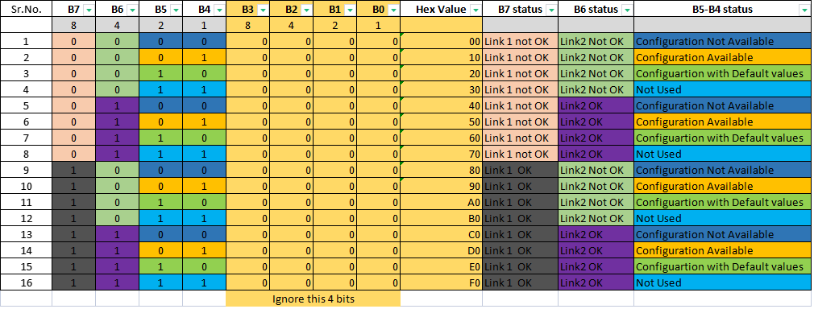

2.5 Sensor status:
B7 | 1/0 | Temp Low/TEMP OK (within range)
B6 | 1/0 | TEMP High/TEMP OK (within range)
B5 | 1/0 | HUMIDIDTY Low / HUMIDITY OK (within range)
B4 | 1/0 | HUMIDITY High / HUMIDITY OK (within range)
B3 | 1/0 | Door open Low (vibration) / Door open OK (within range)
B2 | 1/0 | Door open High (vibration) / Door open OK (within range)
B1 | 1/0 | RESERVED
B0 | 1/0 | RESERVED

2.6 Line controller Status:

B7 | 1/0 | Line Controller 1 OK / Line Controller 1 Fail
B6 | 1/0 | Line Controller 2 OK / Line Controller 1 Fail
B5 | 1/0 | Line Controller 3 OK / Line Controller 1 Fail
B4 | 1/0 | Line Controller 4 OK / Line Controller 1 Fail
B3 | 1/0 | Line Controller 5 OK / Line Controller 1 Fail
B2 | 1/0 | Line Controller 6 OK / Line Controller 1 Fail
B1 | 1/0 | RESERVED
B0 | 1/0 | RESERVED

2.7 Font Table
1 | Bold | 00 | 16 | 10
34 | Condense | 33 | 16 | 6
35 | Normal | 34 | 16 | 9
36 | Bold | 35 | 16 | 10
32 | Normal | 31 | 15 | 9
33 | Normal | 32 | 15 | 10
27 | Condense | 26 | 14 | 6
28 | Condense | 27 | 14 | 6
29 | Normal | 28 | 14 | 10
30 | Normal | 29 | 14 | 10
25 | Condense | 24 | 13 | 6
26 | Normal | 25 | 13 | 10
31 | Condense | 30 | 13 | 6
20 | Condense | 19 | 11 | 4
21 | Normal | 20 | 11 | 7
22 | Normal | 21 | 11 | 7
23 | Normal | 22 | 11 | 7
17 | Condense | 16 | 10 | 4
18 | Condense | 17 | 10 | 5
19 | Normal | 18 | 10 | 7
13 | Bold Center | 12 | 9 | 6
14 | Normal | 13 | 9 | 6
16 | Normal | 15 | 9 | 5
24 | Bold | 23 | 9 | 8
10 | Condense | 09 | 8 | 3
11 | Bold | 10 | 8 | 6
12 | Bold | 11 | 8 | 6
15 | Bold | 14 | 8 | 7
6 | Condense | 05 | 7 | 4
7 | Normal | 06 | 7 | 5
8 | Normal | 07 | 7 | 5
9 | Bold | 08 | 7 | 6
4 | Normal | 03 | 6 | 4
5 | Normal | 04 | 6 | 5
2 | Normal | 01 | 5 | 4
3 | Normal | 02 | 5 | 4

3. Protocol Format of Display Data

Figure 1.

3.1 Details of Individual Bytes of V7.1 Protocols:

Byte Name | Size | Detail
Header MSB | 1 Byte | Most significant Bit of Header (Hex Value - 0xAA)
Header LSB | 1 Byte | Least significant bit of Header. (Hex value -0x99)
Packet length | 2 Byte | It is a length of Packet and it is calculated as select line of packet it contain 2 bytes LSB and MSB, MSB is a bit of the highest digit, and the LSB is a bit of the lowest digit
Serial Number | 1 Byte | 2 digit ASCII value indicate current packet number. In case of multiple packet telegram, It starts with ASCII “ 01” and increments by one count up to “99”
Packet Status | 1 Byte | It Shows packet status it can be 0x00/0xFF.  0x00 Packet in continuation  0xFF Last Packet
Function Code | 1 Byte | Bit indicates a function code of packet i.e. Display Data.  Function code 0x81.
Data  Data Bytes | N Byte | This is a Data byte (Note: consider 2.2)
Footer MSB | 1 Byte | Most significant Bit of Header (Hex Value - 0xFF)
Footer LSB | 1 Byte | Least significant bit of Header. (Hex value -0xFF)
Checksum  - Checksum MSB  - Checksum LSB | 2 Byte | - MSB is a bit of the highest digit in checksum.  - LSB is a bit of the lowest digit in Checksum.  CRC is 16-bit value. This is calculated as CRC of all the  bytes starting from Length MSB to last byte stored in  BLOCK 2. CRC-16-CCITT (also known as CRC-CCITT)  is used for data integrity. The polynomial of CRC-16  is “x16+x12+x5+1” and its hex value is 1021

3.2 Data Byte (N byte)

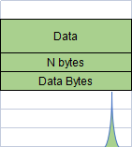

Figure 2.

- Data Field

Byte Name | Size | Detail
Video Speed | 1 Byte | Default Value 0x00
Delay | 1 Byte | 0x00 (it is delay time to refresh a displayed data )
Message Type | 1 Byte | 0x00 : normal data Train data and Message data  0x01 : default data
STX | 1 Byte | 0x02 (Start of transmission)
Line Number | 1 Byte | Line number should be 1 byte. It Shows Screen Data.
ETX | 1 Byte | 0x03 (End of transmission)

Note: Table consist of Data field which shown on screen, so as shown in figure B we can multiple screen in same packet.

3.3 Screen Data

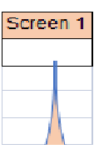

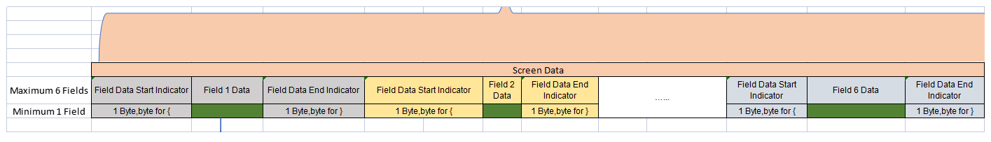
Figure 3.

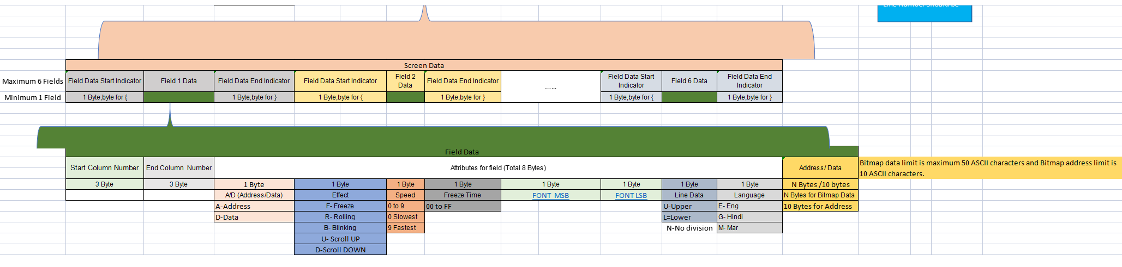
Figure 4.

- Screen Data field

Byte Name | Size | Detail
1st Field Data Start Indicator | 1 Byte | 1 digit ASCII char ‘{’ (Hex Value – 0x7B) indicates starting of line field for display.
Field 1 Data |  | In Field data you can add maximum 6 field.
- Start of column number. | 3 Byte | 3 digit ASCII value indicate starting column no. of field for display. It’s range is “000” to “999” and should be in 3-digit form.
- End Column Number | 3 Byte | 3 digit ASCII value indicate ending column number of field for display. It’s range is “000” to “999” and should be in 3-digit form.
Attributes for field | 8 Byte | 1st Byte – A for address, D for Data.*Note 1  2nd Byte – Effect: F-Freeze, R – Rolling, B – Blinking / Flashing, U-Scroll UP D- Scroll Down  3rd Byte – Speed of rolling or flashing combination in steps of 0 for slowest to 9 for fastest  4th Byte - freeze time for language (0x00 to 0xFF)  5th Byte-Font size MSB Font size applicable to English only.  6th Byte-Font size LSB Font size applicable to English only.  7th Byte-Upper or lower line data (“U” for upper, “L” for lower line and “N” for complete 16 row (no Division) )  8th byte –Language (“E” for English, “H” for Hindi, “M” for Marathi)
Address /Data | Variable Bytes | Bitmap data in maximum 50 ASCII characters.  Bitmap address in 10 ASCII characters.  e.g.  ETA – Expected Time of Arrival in minutes in 2 ASCII digits  ROUTE – Root Number in ASCII digits  DESTINATION – Status of arrival in ASCII letters  Sequence of the fields on the display will be as per the sequence in telegram. 1st byte in the attribute will decide that the data in telegram which is following is to be treated as file name or ASCII data. * see note
1st Field Data End | 1 Byte | 1 digit ASCII char ‘}’ (Hex Value – 0x7D) indicates ending of line field data for display.
2nd Field Data Start | 1 Byte | 1 digit ASCII char ‘{’ (Hex Value – 0x7B) indicates starting of line field for display.
Column number for Field_2 Start | 3 Byte | 3 digit ASCII value indicate starting column no. of field for display. It’s range is “000” to “999”
Column number for Field_2 End | 3 Byte | 3 digit ASCII value indicate end column no. of field for display. It’s range is “000” to “999”
Attributes | 8 Bytes | Attributes are applicable for the data before next ‘ETX'
Address /Data | Variable Bytes | Bitmap data in maximum 50 ASCII characters.  Bitmap address in 10 ASCII characters.

*Note1 : The data in the protocol will be either ASCII which need ASCII to font conversion or address of the BMP file. This basic nature is to be declared in the attributes for the field.
This decides which way the data is to be processed.
A suitable frame or screen is then prepared for overall line area. If it fits into matrix of the display then acknowledge is given. No of columns are thus automatically adjusted.

3.4 Sample Packets :

- Packet

<0xAA><0x99><0x00><0x68><0x75><0xFF><0x81><0x00><0x00><0x00><0x02><0x31><{000100DF6.00NEANJANPURA}><{128160DF6.00NE03 }.><.2{001100DF6.00NHAMjaanapura}><{128160DF6.00NH03 }.><<0xFF><0xFF><E0><13>

- Packet

0xAA><0x99><0x00><0x63><0x75><0xFF><0x81><0x00><0x00><0x00><0x02><0x31><{000100DF6.00NEANJANPURA}><{128160DB6.00NE03}.><.2{001160DR9.00NEWelcome To Bangalore Metro}.>

3.4 Response function :

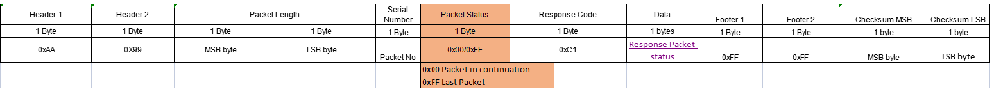
Figure 5.

- Details of Individual Bytes of V7.1 Protocols:

Byte Name | Size | Detail
Header 1 | 1 Byte | Most significant Bit of Header (Hex Value - 0xAA)
Header 2 | 1 Byte | Least significant bit of Header. (Hex value -0x99)
Packet Length (LOP MSB to Data Last byte) | 1 Byte (MSB)  1 Byte (LSB) | It is a length of Packet and it is calculated as select line of packet it contain 2 bytes LSB and MSB, MSB is a bit of the highest digit, and the LSB is a bit of the lowest digit
Serial number | 1 Byte | 2 digit ASCII value indicate current packet number. In case of multiple packet telegram, It starts with ASCII “ 01” and increments by one count up to “99”
Packet Status | 1 Byte | It Shows packet status it can be 0x00/0xFF.  0x00 Packet in continuation  0xFF Last Packet
Response Code | 1 Byte | Bit indicates a function code of packet i.e. Display Data response code 0x0C
Data | 1 Bytes | 1 Byte: (Note: consider Table 2.2 Packet Status)
Footer 1 | 1 Byte | Most significant Bit of Header (Hex Value - 0xFF)
Footer 2 | 1 Byte | Least significant bit of Header. (Hex value -0xFF)
Checksum  - Checksum MSB  - Checksum LSB | 2 Byte | - MSB is a bit of the highest digit in checksum.  - LSB is a bit of the lowest digit in Checksum.  CRC is 16-bit value. This is calculated as CRC of all the  bytes starting from Length MSB to last byte stored in CRC-16-CCITT (also known as CRC-CCITT)  is used for data integrity. The polynomial of CRC-16  is “x16+x12+x5+1” and its hex value is 1021

4. Steps for sending the packet with Hercules Tool is mentioned below:

1. First connect to the client or server.
2. Paste the copied hex code in the hex option of the Hercules Tool.
3. Then send the packet by clicking on the send option next to Hex.

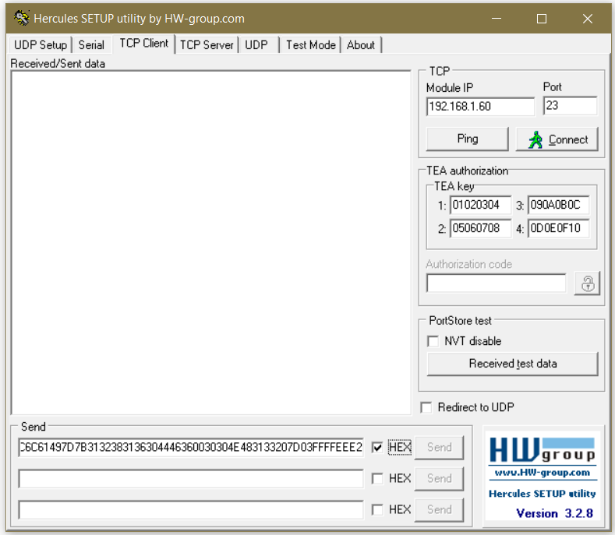

Figure 6.

5. Protocol Format of Link Check.

Figure 7.

5.1 Details of Individual Bytes:

Byte Name | Size | Detail
Header 1 | 1 Byte | Most significant Bit of Header (Hex Value - 0xAA)
Header 2 | 1 Byte | Least significant bit of Header. (Hex value -0x99)
Packet Length (LOP MSB to Data Last byte) | 1 Byte (MSB)  1 Byte (LSB) | It is a length of Packet and it is calculated as select line of packet it contain 2 bytes LSB and MSB, MSB is a bit of the highest digit, and the LSB is a bit of the lowest digit
Serial number | 1 Byte | 2 digit ASCII value indicate current packet number. In case of multiple packet telegram, It starts with ASCII “ 01” and increments by one count up to “99”
Packet Status | 1 Byte | It Shows packet status it can be 0x00/0xFF.  0x00 Packet in continuation  0xFF Last Packet
Response Code | 1 Byte | Bit indicates a function code of packet i.e. link check  Response code 0x82.
Footer 1 | 1 Byte | Most significant Bit of Header (Hex Value - 0xFF)
Footer 2 | 1 Byte | Least significant bit of Header. (Hex value -0xFF)
Checksum  - Checksum MSB  - Checksum LSB | 2 Byte | - MSB is a bit of the highest digit in checksum.  - LSB is a bit of the lowest digit in Checksum.  CRC is 16-bit value. This is calculated as CRC of all the  bytes starting from Length MSB to last byte stored in CRC-16-CCITT (also known as CRC-CCITT)  is used for data integrity. The polynomial of CRC-16  is “x16+x12+x5+1” and its hex value is 1021

Sample Packet :

<0xAA><0x99><0x00><0x0A><0x01><0x00><0xFF><0x80><0xFF><0xFF><AC7D>

5.1 Response function :

Figure 8.
Details of Individual Bytes:

Byte Name | Size | Detail
Header 1 | 1 Byte | Most significant Bit of Header (Hex Value - 0xAA)
Header 2 | 1 Byte | Least significant bit of Header. (Hex value -0x99)
Packet Length (LOP MSB to Data Last byte) | 1 Byte (MSB)  1 Byte (LSB) | It is a length of Packet and it is calculated as select line of packet it contain 2 bytes LSB and MSB, MSB is a bit of the highest digit, and the LSB is a bit of the lowest digit
Serial number | 1 Byte | 2 digit ASCII value indicate current packet number. In case of multiple packet telegram, It starts with ASCII “ 01” and increments by one count up to “99”
Packet Status | 1 Byte | It Shows packet status it can be 0x00/0xFF.  0x00 Packet in continuation  0xFF Last Packet
Response Code | 1 Byte | Bit indicates a function code of packet i.e. link check Function code 0xC0.
Data | 5 Bytes | 1st Byte: (Note: consider Table 2.2 Packet Status)  2nd Byte: (Note: consider Table 2.3 Packet Status)  3rd Byte: (Note: consider Table 2.5 Packet Status)  4th Byte: This Byte is reserved for future Use.  5th Byte: (Note: consider Table 2.6 Packet Status)
Footer 1 | 1 Byte | Most significant Bit of Header (Hex Value - 0xFF)
Footer 2 | 1 Byte | Least significant bit of Header. (Hex value -0xFF)
Checksum  - Checksum MSB  - Checksum LSB | 2 Byte | - MSB is a bit of the highest digit in checksum.  - LSB is a bit of the lowest digit in Checksum.  CRC is 16-bit value. This is calculated as CRC of all the  bytes starting from Length MSB to last byte stored in CRC-16-CCITT (also known as CRC-CCITT)  is used for data integrity. The polynomial of CRC-16  is “x16+x12+x5+1” and its hex value is 1021

- Protocol Format for start command.

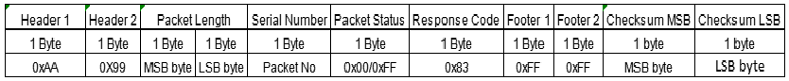
Figure 9.

Details of Individual Bytes:

Byte Name | Size | Detail
Header 1 | 1 Byte | Most significant Bit of Header (Hex Value - 0xAA)
Header 2 | 1 Byte | Least significant bit of Header. (Hex value -0x99)
Packet Length (LOP MSB to Data Last byte) | 1 Byte (MSB)  1 Byte (LSB) | It is a length of Packet and it is calculated as select line of packet it contain 2 bytes LSB and MSB, MSB is a bit of the highest digit, and the LSB is a bit of the lowest digit
Serial number | 1 Byte | 2 digit ASCII value indicate current packet number. In case of multiple packet telegram, It starts with ASCII “ 01” and increments by one count up to “99”
Packet Status | 1 Byte | It Shows packet status it can be 0x00/0xFF.  0x00 Packet in continuation  0xFF Last Packet
Response Code | 1 Byte | Bit indicates a function code of packet i.e. start command  Function code 0x83.
Footer 1 | 1 Byte | Most significant Bit of Header (Hex Value - 0xFF)
Footer 2 | 1 Byte | Least significant bit of Header. (Hex value -0xFF)
Checksum  - Checksum MSB  - Checksum LSB | 2 Byte | - MSB is a bit of the highest digit in checksum.  - LSB is a bit of the lowest digit in Checksum.  CRC is 16-bit value. This is calculated as CRC of all the  bytes starting from Length MSB to last byte stored in CRC-16-CCITT (also known as CRC-CCITT)  is used for data integrity. The polynomial of CRC-16  is “x16+x12+x5+1” and its hex value is 1021

Sample Packet :

<0xAA><0x99><0x00><0x05><0x47><0xFF><0x83><0xFF><0xFF><0x97><0x60>

- Protocol Format for stop command.

Figure 10.

Details of Individual Bytes:

Byte Name | Size | Detail
Header 1 | 1 Byte | Most significant Bit of Header (Hex Value - 0xAA)
Header 2 | 1 Byte | Least significant bit of Header. (Hex value -0x99)
Packet Length (LOP MSB to Data Last byte) | 1 Byte (MSB)  1 Byte (LSB) | It is a length of Packet and it is calculated as select line of packet it contain 2 bytes LSB and MSB, MSB is a bit of the highest digit, and the LSB is a bit of the lowest digit
Serial number | 1 Byte | 2 digit ASCII value indicate current packet number. In case of multiple packet telegram, It starts with ASCII “ 01” and increments by one count up to “99”
Packet Status | 1 Byte | It Shows packet status it can be 0x00/0xFF.  0x00 Packet in continuation  0xFF Last Packet
Response Code | 1 Byte | Bit indicates a function code of packet i.e. start command  Response code 0x82.
Footer 1 | 1 Byte | Most significant Bit of Header (Hex Value - 0xFF)
Footer 2 | 1 Byte | Least significant bit of Header. (Hex value -0xFF)
Checksum  - Checksum MSB  - Checksum LSB | 2 Byte | - MSB is a bit of the highest digit in checksum.  - LSB is a bit of the lowest digit in Checksum.  CRC is 16-bit value. This is calculated as CRC of all the  bytes starting from Length MSB to last byte stored in. CRC-16-CCITT (also known as CRC-CCITT)  is used for data integrity. The polynomial of CRC-16  is “x16+x12+x5+1” and its hex value is 1021

Sample Packet :

<0xAA><0x99><0x00><0x05><0x45><0xFF><0x82><0xFF><0xFF><0xE9><0x21>

- Protocol Format for set configuration command.

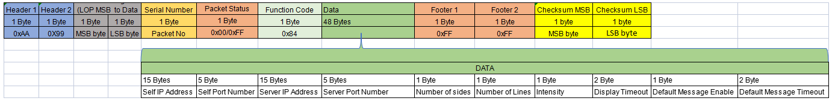
Figure 11.

Details of Individual Bytes:

Byte Name | Size | Detail
Header 1 | 1 Byte | Most significant Bit of Header (Hex Value - 0xAA)
Header 2 | 1 Byte | Least significant bit of Header. (Hex value -0x99)
Packet Length (LOP MSB to Data Last byte) | 1 Byte (MSB)  1 Byte (LSB) | It is a length of Packet and it is calculated as select line of packet it contain 2 bytes LSB and MSB, MSB is a bit of the highest digit, and the LSB is a bit of the lowest digit
Serial number | 1 Byte | 2 digit ASCII value indicate current packet number. In case of multiple packet telegram, It starts with ASCII “ 01” and increments by one count up to “99”
Packet Status | 1 Byte | It Shows packet status it can be 0x00/0xFF.  0x00 Packet in continuation  0xFF Last Packet
Function Code | 1 Byte | Bit indicates a function code of packet i.e. set configuration  Function code 0x84.
Data | 48 Bytes | 15 bytes : Self IP address.  5 bytes : Self Port Number  15 bytes :Server IP Address  5 bytes : Server Port Number  1 bytes : Number of sides ( hex value 0x32)  1 bytes : Number of Lines  1 bytes : Intensity  2 bytes : Display Timeout  1 bytes :Default Message Enable  2 bytes : Default Message Timeout
Footer 1 | 1 Byte | Most significant Bit of Header (Hex Value - 0xFF)
Footer 2 | 1 Byte | Least significant bit of Header. (Hex value -0xFF)
Checksum  - Checksum MSB  - Checksum LSB | 2 Byte | - MSB is a bit of the highest digit in checksum.  - LSB is a bit of the lowest digit in Checksum.  CRC is 16-bit value. This is calculated as CRC of all the  bytes starting from Length MSB to last byte stored in CRC-16-CCITT (also known as CRC-CCITT)  is used for data integrity. The polynomial of CRC-16  is “x16+x12+x5+1” and its hex value is 1021

8.1 Response function :

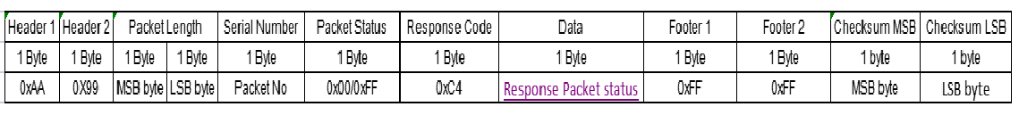
Figure 12.

- Details of Individual Bytes:

Byte Name | Size | Detail
Header 1 | 1 Byte | Most significant Bit of Header (Hex Value - 0xAA)
Header 2 | 1 Byte | Least significant bit of Header. (Hex value -0x99)
Packet Length (LOP MSB to Data Last byte) | 1 Byte (MSB)  1 Byte (LSB) | It is a length of Packet and it is calculated as select line of packet it contain 2 bytes LSB and MSB, MSB is a bit of the highest digit, and the LSB is a bit of the lowest digit
Serial number | 1 Byte | 2 digit ASCII value indicate current packet number. In case of multiple packet telegram, It starts with ASCII “ 01” and increments by one count up to “99”
Packet Status | 1 Byte | It Shows packet status it can be 0x00/0xFF.  0x00 Packet in continuation  0xFF Last Packet
Response Code | 1 Byte | Bit indicates a Response code of packet i.e. set configuration  Response code 0xC4.
Data | 1 Bytes | Packet received and processed successfully (hex value- 0x01) (Note: consider 1.5 Packet Status )
Footer 1 | 1 Byte | Most significant Bit of Header (Hex Value - 0xFF)
Footer 2 | 1 Byte | Least significant bit of Header. (Hex value -0xFF)
Checksum  - Checksum MSB  - Checksum LSB | 2 Byte | - MSB is a bit of the highest digit in checksum.  - LSB is a bit of the lowest digit in Checksum.  CRC is 16-bit value. This is calculated as CRC of all the  bytes starting from Length MSB to last byte stored in CRC-16-CCITT (also known as CRC-CCITT)  is used for data integrity. The polynomial of CRC-16  is “x16+x12+x5+1” and its hex value is 1021

- Protocol Format for Get configuration command.

Figure 13.

- Details of Individual Bytes:

Byte Name | Size | Detail
Header 1 | 1 Byte | Most significant Bit of Header (Hex Value - 0xAA)
Header 2 | 1 Byte | Least significant bit of Header. (Hex value -0x99)
Packet Length (LOP MSB to Data Last byte) | 1 Byte (MSB)  1 Byte (LSB) | It is a length of Packet and it is calculated as select line of packet it contain 2 bytes LSB and MSB, MSB is a bit of the highest digit, and the LSB is a bit of the lowest digit
Serial number | 1 Byte | 2 digit ASCII value indicate current packet number. In case of multiple packet telegram, It starts with ASCII “ 01” and increments by one count up to “99”
Packet Status | 1 Byte | It Shows packet status it can be 0x00/0xFF.  0x00 Packet in continuation  0xFF Last Packet
Function Code | 1 Byte | Bit indicates a function code of packet i.e. Get configuration  Function code 0x85.
Footer 1 | 1 Byte | Most significant Bit of Header (Hex Value - 0xFF)
Footer 2 | 1 Byte | Least significant bit of Header. (Hex value -0xFF)
Checksum  - Checksum MSB  - Checksum LSB | 2 Byte | - MSB is a bit of the highest digit in checksum.  - LSB is a bit of the lowest digit in Checksum.  CRC is 16-bit value. This is calculated as CRC of all the  bytes starting from Length MSB to last byte stored in CRC-16-CCITT (also known as CRC-CCITT)  is used for data integrity. The polynomial of CRC-16  is “x16+x12+x5+1” and its hex value is 1021

9.1 Response function :

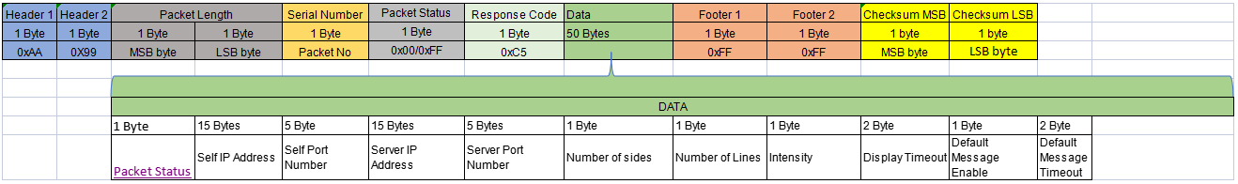

Figure 14.

- Details of Individual Bytes:

Byte Name | Size | Detail
Header 1 | 1 Byte | Most significant Bit of Header (Hex Value - 0xAA)
Header 2 | 1 Byte | Least significant bit of Header. (Hex value -0x99)
Packet Length (LOP MSB to Data Last byte) | 1 Byte (MSB)  1 Byte (LSB) | It is a length of Packet and it is calculated as select line of packet it contain 2 bytes LSB and MSB, MSB is a bit of the highest digit, and the LSB is a bit of the lowest digit
Serial number | 1 Byte | 2 digit ASCII value indicate current packet number. In case of multiple packet telegram, It starts with ASCII “ 01” and increments by one count up to “99”
Packet Status | 1 Byte | It Shows packet status it can be 0x00/0xFF.  0x00 Packet in continuation  0xFF Last Packet
Response Code | 1 Byte | Bit indicates a Response code of packet i.e. Get configuration  Response code 0xC5.
Data | 50 Bytes | 1 byte : Packet status (Note: consider 8.2 )  15 bytes : self IP address.  5 bytes : Self Port Number  15 bytes :Server IP Address  5 bytes : Server Port Number  1 bytes : Number of sides ( hex value 0x32)  1 bytes : Number of Lines  1 bytes : Intensity  2 bytes : Display Timeout  1 bytes :Default Message Enable  2 bytes : Default Message Timeout
Footer 1 | 1 Byte | Most significant Bit of Header (Hex Value - 0xFF)
Footer 2 | 1 Byte | Least significant bit of Header. (Hex value -0xFF)
Checksum  - Checksum MSB  - Checksum LSB | 2 Byte | - MSB is a bit of the highest digit in checksum.  - LSB is a bit of the lowest digit in Checksum.  CRC is 16-bit value. This is calculated as CRC of all the  bytes starting from Length MSB to last byte stored in CRC-16-CCITT (also known as CRC-CCITT)  is used for data integrity. The polynomial of CRC-16  is “x16+x12+x5+1” and its hex value is 1021

- Protocol Format for Soft Reset command.

Figure 15.

- Details of Individual Bytes:

Byte Name | Size | Detail
Header 1 | 1 Byte | Most significant Bit of Header (Hex Value - 0xAA)
Header 2 | 1 Byte | Least significant bit of Header. (Hex value -0x99)
Packet Length (LOP MSB to Data Last byte) | 1 Byte (MSB)  1 Byte (LSB) | It is a length of Packet and it is calculated as select line of packet it contain 2 bytes LSB and MSB, MSB is a bit of the highest digit, and the LSB is a bit of the lowest digit
Serial number | 1 Byte | 2 digit ASCII value indicate current packet number. In case of multiple packet telegram, It starts with ASCII “ 01” and increments by one count up to “99”
Packet Status | 1 Byte | It Shows packet status it can be 0x00/0xFF.  0x00 Packet in continuation  0xFF Last Packet
Response Code | 1 Byte | Bit indicates a function code of packet i.e. Soft Reset  Function code 0x86.
Footer 1 | 1 Byte | Most significant Bit of Header (Hex Value - 0xFF)
Footer 2 | 1 Byte | Least significant bit of Header. (Hex value -0xFF)
Checksum  - Checksum MSB  - Checksum LSB | 2 Byte | - MSB is a bit of the highest digit in checksum.  - LSB is a bit of the lowest digit in Checksum.  CRC is 16-bit value. This is calculated as CRC of all the  bytes starting from Length MSB to last byte stored in CRC-16-CCITT (also known as CRC-CCITT)  is used for data integrity. The polynomial of CRC-16  is “x16+x12+x5+1” and its hex value is 1021

10.1 Response function :

Figure 16.

- Details of Individual Bytes:

Byte Name | Size | Detail
Header 1 | 1 Byte | Most significant Bit of Header (Hex Value - 0xAA)
Header 2 | 1 Byte | Least significant bit of Header. (Hex value -0x99)
Packet Length (LOP MSB to Data Last byte) | 1 Byte (MSB)  1 Byte (LSB) | It is a length of Packet and it is calculated as select line of packet it contain 2 bytes LSB and MSB, MSB is a bit of the highest digit, and the LSB is a bit of the lowest digit
Serial number | 1 Byte | 2 digit ASCII value indicate current packet number. In case of multiple packet telegram, It starts with ASCII “ 01” and increments by one count up to “99”
Packet Status | 1 Byte | It Shows packet status it can be 0x00/0xFF.  0x00 Packet in continuation  0xFF Last Packet
Response Code | 1 Byte | Bit indicates a Response code of packet i.e. Soft Reset Response code 0xC6.
Data | 1 Bytes | 1 byte : Consider Response Packet status 2.2
Footer 1 | 1 Byte | Most significant Bit of Header (Hex Value - 0xFF)
Footer 2 | 1 Byte | Least significant bit of Header. (Hex value -0xFF)
Checksum  - Checksum MSB  - Checksum LSB | 2 Byte | - MSB is a bit of the highest digit in checksum.  - LSB is a bit of the lowest digit in Checksum.  CRC is 16-bit value. This is calculated as CRC of all the  bytes starting from Length MSB to last byte stored in CRC-16-CCITT (also known as CRC-CCITT)  is used for data integrity. The polynomial of CRC-16  is “x16+x12+x5+1” and its hex value is 1021

- Protocol Format for Erase.

Figure 17.

- Details of Individual Bytes:

Byte Name | Size | Detail
Header 1 | 1 Byte | Most significant Bit of Header (Hex Value - 0xAA)
Header 2 | 1 Byte | Least significant bit of Header. (Hex value -0x99)
Packet Length (LOP MSB to Data Last byte) | 1 Byte (MSB)  1 Byte (LSB) | It is a length of Packet and it is calculated as select line of packet it contain 2 bytes LSB and MSB, MSB is a bit of the highest digit, and the LSB is a bit of the lowest digit
Serial number | 1 Byte | 2 digit ASCII value indicate current packet number. In case of multiple packet telegram, It starts with ASCII “ 01” and increments by one count up to “99”
Packet Status | 1 Byte | It Shows packet status it can be 0x00/0xFF.  0x00 Packet in continuation  0xFF Last Packet
Response Code | 1 Byte | - Bit indicates a Response code of packet i.e. Erase command  Response code 0x87.
Footer 1 | 1 Byte | Most significant Bit of Header (Hex Value - 0xFF)
Footer 2 | 1 Byte | Least significant bit of Header. (Hex value -0xFF)
Checksum  - Checksum MSB  - Checksum LSB | 2 Byte | - MSB is a bit of the highest digit in checksum.  - LSB is a bit of the lowest digit in Checksum.  CRC is 16-bit value. This is calculated as CRC of all the  bytes starting from Length MSB to last byte stored in CRC-16-CCITT (also known as CRC-CCITT)  is used for data integrity. The polynomial of CRC-16  is “x16+x12+x5+1” and its hex value is 1021

Sample Packet :

<0xAA><0x99><0x00><0x05><0x01><0xFF><0x87><0xFF><0xFF><0x78><0xE9>

11.1 Response function :
Figure 18.

- Details of Individual Bytes:

Byte Name | Size | Detail
Header 1 | 1 Byte | Most significant Bit of Header (Hex Value - 0xAA)
Header 2 | 1 Byte | Least significant bit of Header. (Hex value -0x99)
Packet Length (LOP MSB to Data Last byte) | 1 Byte (MSB)  1 Byte (LSB) | It is a length of Packet and it is calculated as select line of packet it contain 2 bytes LSB and MSB, MSB is a bit of the highest digit, and the LSB is a bit of the lowest digit
Serial number | 1 Byte | 2 digit ASCII value indicate current packet number. In case of multiple packet telegram, It starts with ASCII “ 01” and increments by one count up to “99”
Packet Status | 1 Byte | It Shows packet status it can be 0x00/0xFF.  0x00 Packet in continuation  0xFF Last Packet
Response Code | 1 Byte | Bit indicates a Response code of packet i.e. start command  Response code 0xC7.
Data | 1 Bytes | 1 byte : Packet status (Note: consider 2.2)
Footer 1 | 1 Byte | Most significant Bit of Header (Hex Value - 0xFF)
Footer 2 | 1 Byte | Least significant bit of Header. (Hex value -0xFF)
Checksum  - Checksum MSB  - Checksum LSB | 2 Byte | - MSB is a bit of the highest digit in checksum.  - LSB is a bit of the lowest digit in Checksum.  CRC is 16-bit value. This is calculated as CRC of all the  bytes starting from Length MSB to last byte stored in CRC-16-CCITT (also known as CRC-CCITT)  is used for data integrity. The polynomial of CRC-16  is “x16+x12+x5+1” and its hex value is 1021

- Protocol Format for store Bitmap.

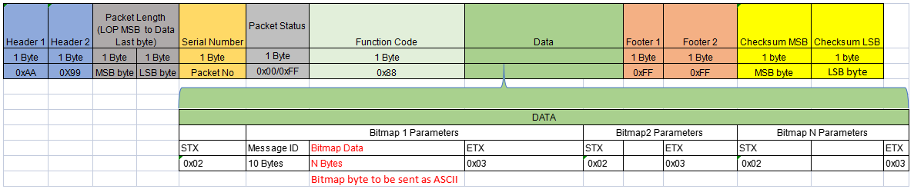
Figure 19.

- Details of Individual Bytes:

Byte Name | Size | Detail
Header 1 | 1 Byte | Most significant Bit of Header (Hex Value - 0xAA)
Header 2 | 1 Byte | Least significant bit of Header. (Hex value -0x99)
Packet Length (LOP MSB to Data Last byte) | 1 Byte (MSB)  1 Byte (LSB) | It is a length of Packet and it is calculated as select line of packet it contain 2 bytes LSB and MSB, MSB is a bit of the highest digit, and the LSB is a bit of the lowest digit
Serial number | 1 Byte | 2 digit ASCII value indicate current packet number. In case of multiple packet telegram, It starts with ASCII “ 01” and increments by one count up to “99”
Packet Status | 1 Byte | It Shows packet status it can be 0x00/0xFF.  0x00 Packet in continuation  0xFF Last Packet
Function Code | 1 Byte | Bit indicates a function code of packet i.e. store Bitmap Function code 0x88.
Data | N Bytes | - Bitmap Parameter 1:  - STX - Start of transmission (Hex Value- 0x02)  - Message ID should be 10 Bytes.  - Bitmap Data is N Bytes  - ETX - End of transmission (Hex value -0x03)  - Bitmap Parameter 2:  - STX - Start of transmission (Hex Value- 0x02)  - Bitmap Data is N Bytes  - ETX - End of transmission (Hex value -0x03)  - Bitmap Parameter 3:  - STX - Start of transmission (Hex Value- 0x02)  - Bitmap Data is N Bytes  - ETX - End of transmission (Hex value -0x03)  - Add N number of bitmap parameters.
Footer 1 | 1 Byte | Most significant Bit of Header (Hex Value - 0xFF)
Footer 2 | 1 Byte | Least significant bit of Header. (Hex value -0xFF)
Checksum  - Checksum MSB  - Checksum LSB | 2 Byte | - MSB is a bit of the highest digit in checksum.  - LSB is a bit of the lowest digit in Checksum.  CRC is 16-bit value. This is calculated as CRC of all the  bytes starting from Length MSB to last byte stored in CRC-16-CCITT (also known as CRC-CCITT)  is used for data integrity. The polynomial of CRC-16  is “x16+x12+x5+1” and its hex value is 1021

12.1 Response function :

Figure 20.

- Details of Individual Bytes:

Byte Name | Size | Detail
Header 1 | 1 Byte | Most significant Bit of Header (Hex Value - 0xAA)
Header 2 | 1 Byte | Least significant bit of Header. (Hex value -0x99)
Packet Length (LOP MSB to Data Last byte) | 1 Byte (MSB)  1 Byte (LSB) | It is a length of Packet and it is calculated as select line of packet it contain 2 bytes LSB and MSB, MSB is a bit of the highest digit, and the LSB is a bit of the lowest digit
Serial number | 1 Byte | 2 digit ASCII value indicate current packet number. In case of multiple packet telegram, It starts with ASCII “ 01” and increments by one count up to “99”
Packet Status | 1 Byte | It Shows packet status it can be 0x00/0xFF.  0x00 Packet in continuation  0xFF Last Packet
Response Code | 1 Byte | Bit indicates a Response code of packet i.e. store Bitmap  Response code 0xC8.
Data | 1 Bytes | 1 byte : Response Packet status (Note: consider 2.2 )
Footer 1 | 1 Byte | Most significant Bit of Header (Hex Value - 0xFF)
Footer 2 | 1 Byte | Least significant bit of Header. (Hex value -0xFF)
Checksum  - Checksum MSB  - Checksum LSB | 2 Byte | - MSB is a bit of the highest digit in checksum.  - LSB is a bit of the lowest digit in Checksum.  CRC is 16-bit value. This is calculated as CRC of all the  bytes starting from Length MSB to last byte stored in CRC-16-CCITT (also known as CRC-CCITT)  is used for data integrity. The polynomial of CRC-16  is “x16+x12+x5+1” and its hex value is 1021

13. Protocol Format for Sync Message Bitmaps

Header 1 | Header 2 | Packet Length (LOP MSB to Data Last byte) |  | Serial Number | Packet Status | Function Code | Footer 1 | Footer 2 | Checksum MSB | Checksum LSB
1 Byte | 1 Byte | 1 Byte | 1 Byte | 1 Byte | 1 Byte | 1 Byte | 1 Byte | 1 Byte | 1 byte | 1 byte
0xAA | 0X99 | MSB byte | LSB byte | Packet No | 0x00/0xFF | 0x89 | 0xFF | 0xFF | MSB byte | LSB byte

Figure 21.

- Details of Individual Bytes:

Byte Name | Size | Detail
Header 1 | 1 Byte | Most significant Bit of Header (Hex Value - 0xAA)
Header 2 | 1 Byte | Least significant bit of Header. (Hex value -0x99)
Packet Length (LOP MSB to Data Last byte) | 1 Byte (MSB)  1 Byte (LSB) | It is a length of Packet and it is calculated as select line of packet it contain 2 bytes LSB and MSB, MSB is a bit of the highest digit, and the LSB is a bit of the lowest digit
Serial number | 1 Byte | 2 digit ASCII value indicate current packet number. In case of multiple packet telegram, It starts with ASCII “ 01” and increments by one count up to “99”
Packet Status | 1 Byte | It Shows packet status it can be 0x00/0xFF.  0x00 Packet in continuation  0xFF Last Packet
Function Code | 1 Byte | Bit indicates a function code of packet i.e.  Function code 0x89.
Footer 1 | 1 Byte | Most significant Bit of Header (Hex Value - 0xFF)
Footer 2 | 1 Byte | Least significant bit of Header. (Hex value -0xFF)
Checksum  - Checksum MSB  - Checksum LSB | 2 Byte | - MSB is a bit of the highest digit in checksum.  - LSB is a bit of the lowest digit in Checksum.  CRC is 16-bit value. This is calculated as CRC of all the  bytes starting from Length MSB to last byte stored in CRC-16-CCITT (also known as CRC-CCITT)  is used for data integrity. The polynomial of CRC-16  is “x16+x12+x5+1” and its hex value is 1021

13.1 Response Sync Message Bitmaps

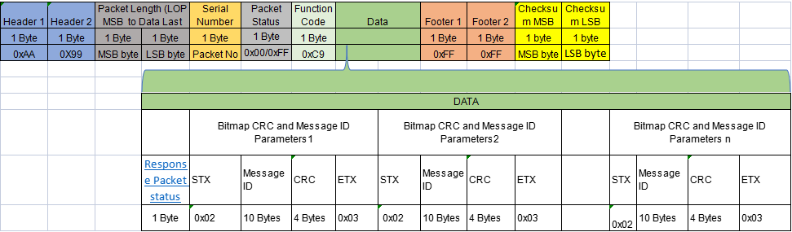

Figure 22.

- Details of Individual Bytes:

Byte Name | Size | Detail
Header 1 | 1 Byte | Most significant Bit of Header (Hex Value - 0xAA)
Header 2 | 1 Byte | Least significant bit of Header. (Hex value -0x99)
Packet Length (LOP MSB to Data Last byte) | 1 Byte (MSB)  1 Byte (LSB) | It is a length of Packet and it is calculated as select line of packet it contain 2 bytes LSB and MSB, MSB is a bit of the highest digit, and the LSB is a bit of the lowest digit
Serial number | 1 Byte | 2 digit ASCII value indicate current packet number. In case of multiple packet telegram, It starts with ASCII “ 01” and increments by one count up to “99”
Packet Status | 1 Byte | It Shows packet status it can be 0x00/0xFF.  0x00 Packet in continuation  0xFF Last Packet
Function Code | 1 Byte | Bit indicates a function code of packet i.e. Sync Message Bitmaps Function code 0xC9.
Data | N Bytes | 1 . Bitmap CRC and Message ID Parameters 1.  - 1 Byte Response status (Note: consider 1.6 table)  - 1 Byte STX Start of transmission (Hex Value 0x02).  - Message ID should be 10 Bytes.  - 4 bytes CRC This CRC is 16-bit value, and it is placed in the.This is calculated as CRC of all the bytes starting from Length MSB to last byte stored CRC-16-CCITT (also known as CRC CCITT) is used for data integrity. The polynomial of CRC-16 is “x16+x12+x5+1” and its hex value is 1021.  - 1 Bytes ETX End of transmission (Hex Value- 0x03)  2. Bitmap CRC and Message ID Parameters 2.  - 1 Byte Response status (Note: consider 1.6 table)  - 1 Byte STX Start of transmission (Hex Value 0x02).  - Message ID should be 10 Bytes.  - 4 bytes for CRC This CRC is 16-bit value, and it is placed in the.This is calculated as CRC of all the bytes starting from Length MSB to last byte stored CRC-16-CCITT (also known as CRC CCITT) is used for data integrity. The polynomial of CRC-16 is “x16+x12+x5+1” and its hex value is 1021.  - 1 Bytes ETX End of transmission (Hex Value- 0x03).  - Add N Number of Bitmap CRC and Message ID Parameters.
Footer 1 | 1 Byte | Most significant Bit of Header (Hex Value - 0xFF)
Footer 2 | 1 Byte | Least significant bit of Header. (Hex value -0xFF)
Checksum  - Checksum MSB  - Checksum LSB | 2 Byte | - MSB is a bit of the highest digit in checksum.  - LSB is a bit of the lowest digit in Checksum.  CRC is 16-bit value. This is calculated as CRC of all the  bytes starting from Length MSB to last byte stored in CRC-16-CCITT (also known as CRC-CCITT)  is used for data integrity. The polynomial of CRC-16  is “x16+x12+x5+1” and its hex value is 1021

14 . Protocol Format for LED Test Pattern

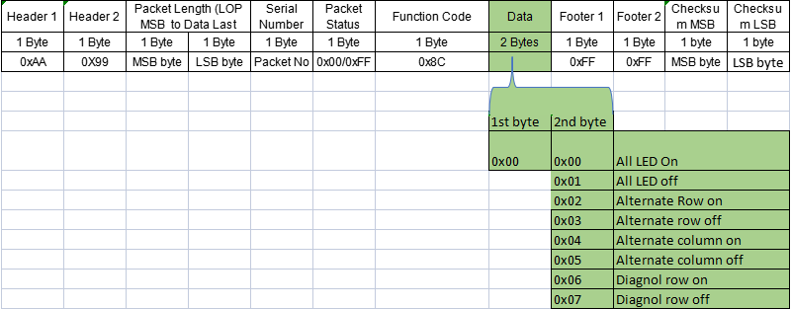

Figure 23.

- Details of Individual Bytes:

Byte Name | Size | Detail
Header 1 | 1 Byte | Most significant Bit of Header (Hex Value - 0xAA)
Header 2 | 1 Byte | Least significant bit of Header. (Hex value -0x99)
Packet Length (LOP MSB to Data Last byte) | 1 Byte (MSB)  1 Byte (LSB) | It is a length of Packet and it is calculated as select line of packet it contain 2 bytes LSB and MSB, MSB is a bit of the highest digit, and the LSB is a bit of the lowest digit
Serial number | 1 Byte | 2 digit ASCII value indicate current packet number. In case of multiple packet telegram, It starts with ASCII “ 01” and increments by one count up to “99”
Packet Status | 1 Byte | It Shows packet status it can be 0x00/0xFF.  0x00 Packet in continuation  0xFF Last Packet
Function Code | 1 Byte | Bit indicates a function code of packet i.e. LED Test Pattern  Function code 0x8C.
Data | 2 Bytes | 1st byte : Hex Value 0x00  2nd byte : All LED On (Hex Value: 0x00 )  All LED off (Hex Value: 0x01 )  Alternate Row on (Hex Value: 0x02 )  Alternate row off (Hex Value: 0x03 )  Alternate column on (Hex Value: 0x04 )  Alternate column off (Hex Value: 0x05 )  Diagnol row on (Hex Value: 0x06 )  Diagnol row on (Hex Value: 0x07 )
Footer 1 | 1 Byte | Most significant Bit of Header (Hex Value - 0xFF)
Footer 2 | 1 Byte | Least significant bit of Header. (Hex value -0xFF)
Checksum  - Checksum MSB  - Checksum LSB | 2 Byte | - MSB is a bit of the highest digit in checksum.  - LSB is a bit of the lowest digit in Checksum.  CRC is 16-bit value. This is calculated as CRC of all the  bytes starting from Length MSB to last byte stored in CRC-16-CCITT (also known as CRC-CCITT)  is used for data integrity. The polynomial of CRC-16  is “x16+x12+x5+1” and its hex value is 1021

14.1 Response Code For LED Test Pattern.

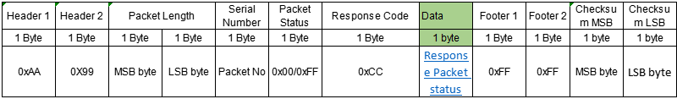

Figure 24.
- Details of Individual Bytes:

Byte Name | Size | Detail
Header 1 | 1 Byte | Most significant Bit of Header (Hex Value - 0xAA)
Header 2 | 1 Byte | Least significant bit of Header. (Hex value -0x99)
Packet Length (LOP MSB to Data Last byte) | 1 Byte (MSB)  1 Byte (LSB) | It is a length of Packet and it is calculated as select line of packet it contain 2 bytes LSB and MSB, MSB is a bit of the highest digit, and the LSB is a bit of the lowest digit
Serial number | 1 Byte | 2 digit ASCII value indicate current packet number. In case of multiple packet telegram, It starts with ASCII “ 01” and increments by one count up to “99”
Packet Status | 1 Byte | It Shows packet status it can be 0x00/0xFF.  0x00 Packet in continuation  0xFF Last Packet
Response Code | 1 Byte | Bit indicates a Response code of packet i.e. LED Test Pattern  Response code 0xCC.
Data | 1 Bytes | 1 byte : Packet status (Note: consider 2.2 )
Footer 1 | 1 Byte | Most significant Bit of Header (Hex Value - 0xFF)
Footer 2 | 1 Byte | Least significant bit of Header. (Hex value -0xFF)
Checksum  - Checksum MSB  - Checksum LSB | 2 Byte | 1.MSB is a bit of the highest digit in checksum.  2. LSB is a bit of the lowest digit in Checksum.  CRC is 16-bit value. This is calculated as CRC of all the  bytes starting from Length MSB to last byte stored in CRC-16-CCITT (also known as CRC-CCITT)  is used for data integrity. The polynomial of CRC-16  is “x16+x12+x5+1” and its hex value is 1021

15 . Protocol Format for Set Sensor Parameter

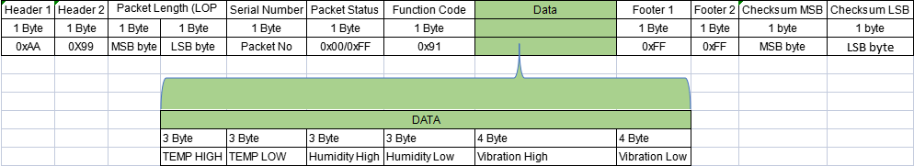

Figure 25.

- Details of Individual Bytes:

Byte Name | Size | Detail
Header 1 | 1 Byte | Most significant Bit of Header (Hex Value - 0xAA)
Header 2 | 1 Byte | Least significant bit of Header. (Hex value -0x99)
Packet Length (LOP MSB to Data Last byte) | 1 Byte (MSB)  1 Byte (LSB) | It is a length of Packet and it is calculated as select line of packet it contain 2 bytes LSB and MSB, MSB is a bit of the highest digit, and the LSB is a bit of the lowest digit
Serial number | 1 Byte | 2 digit ASCII value indicate current packet number. In case of multiple packet telegram, It starts with ASCII “ 01” and increments by one count up to “99”
Packet Status | 1 Byte | It Shows packet status it can be 0x00/0xFF.  0x00 Packet in continuation  0xFF Last Packet
Function Code | 1 Byte | Bit indicates a function code of packet i.e. Set Sensor Parameter  Function code 0x91.
Data | 20 Bytes | - Temperature HIGH 3 byte  - Temperature LOW 3 bytes  - Humidity HIGH 3 bytes  - Humidity LOW 3 bytes  - Vibration HIGH 4 bytes  - Vibration LOW 4 bytes
Footer 1 | 1 Byte | Most significant Bit of Header (Hex Value - 0xFF)
Footer 2 | 1 Byte | Least significant bit of Header. (Hex value -0xFF)
Checksum  - Checksum MSB  - Checksum LSB | 2 Byte | - MSB is a bit of the highest digit in checksum.  - LSB is a bit of the lowest digit in Checksum.  CRC is 16-bit value. This is calculated as CRC of all the  bytes starting from Length MSB to last byte stored in CRC-16-CCITT (also known as CRC-CCITT)  is used for data integrity. The polynomial of CRC-16  is “x16+x12+x5+1” and its hex value is 1021

15.1 Response Code For Set Sensor Parameter.

Figure 26.

- Details of Individual Bytes:

Byte Name | Size | Detail
Header 1 | 1 Byte | Most significant Bit of Header (Hex Value - 0xAA)
Header 2 | 1 Byte | Least significant bit of Header. (Hex value -0x99)
Packet Length (LOP MSB to Data Last byte) | 1 Byte (MSB)  1 Byte (LSB) | It is a length of Packet and it is calculated as select line of packet it contain 2 bytes LSB and MSB, MSB is a bit of the highest digit, and the LSB is a bit of the lowest digit
Serial number | 1 Byte | 2 digit ASCII value indicate current packet number. In case of multiple packet telegram, It starts with ASCII “ 01” and increments by one count up to “99”
Packet Status | 1 Byte | It Shows packet status it can be 0x00/0xFF.  0x00 Packet in continuation  0xFF Last Packet
Response Code | 1 Byte | Bit indicates a Response code of packet i.e. Set Sensor Parameter  Response code 0xD1.
Data | 1 Bytes | 1 byte : Packet status (Note: consider 2.2 )
Footer 1 | 1 Byte | Most significant Bit of Header (Hex Value - 0xFF)
Footer 2 | 1 Byte | Least significant bit of Header. (Hex value -0xFF)
Checksum  - Checksum MSB  - Checksum LSB | 2 Byte | 1.MSB is a bit of the highest digit in checksum.  2. LSB is a bit of the lowest digit in Checksum.  CRC is 16-bit value. This is calculated as CRC of all the  bytes starting from Length MSB to last byte stored in CRC-16-CCITT (also known as CRC-CCITT)  is used for data integrity. The polynomial of CRC-16  is “x16+x12+x5+1” and its hex value is 1021

- Protocol Format for Get Sensor Parameter

Figure 27.

- Details of Individual Bytes:

Byte Name | Size | Detail
Header 1 | 1 Byte | Most significant Bit of Header (Hex Value - 0xAA)
Header 2 | 1 Byte | Least significant bit of Header. (Hex value -0x99)
Packet Length (LOP MSB to Data Last byte) | 1 Byte (MSB)  1 Byte (LSB) | It is a length of Packet and it is calculated as select line of packet it contain 2 bytes LSB and MSB, MSB is a bit of the highest digit, and the LSB is a bit of the lowest digit
Serial number | 1 Byte | 2 digit ASCII value indicate current packet number. In case of multiple packet telegram, It starts with ASCII “ 01” and increments by one count up to “99”
Packet Status | 1 Byte | It Shows packet status it can be 0x00/0xFF.  0x00 Packet in continuation  0xFF Last Packet
Function Code | 1 Byte | Bit indicates a function code of packet i.e. Get Sensor Parameter  Function code 0x92.
Footer 1 | 1 Byte | Most significant Bit of Header (Hex Value - 0xFF)
Footer 2 | 1 Byte | Least significant bit of Header. (Hex value -0xFF)
Checksum  - Checksum MSB  - Checksum LSB | 2 Byte | 1.MSB is a bit of the highest digit in checksum.  2. LSB is a bit of the lowest digit in Checksum.  CRC is 16-bit value. This is calculated as CRC of all the  bytes starting from Length MSB to last byte stored in CRC-16-CCITT (also known as CRC-CCITT)  is used for data integrity. The polynomial of CRC-16  is “x16+x12+x5+1” and its hex value is 1021

16.1 Response Code For Get Sensor Parameter.

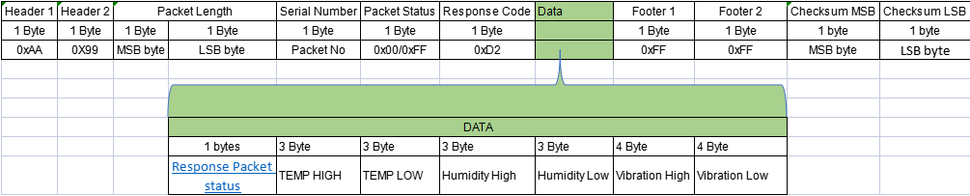

Figure 28.

- Details of Individual Bytes:

Byte Name | Size | Detail
Header 1 | 1 Byte | Most significant Bit of Header (Hex Value - 0xAA)
Header 2 | 1 Byte | Least significant bit of Header. (Hex value -0x99)
Packet Length (LOP MSB to Data Last byte) | 1 Byte (MSB)  1 Byte (LSB) | It is a length of Packet and it is calculated as select line of packet it contain 2 bytes LSB and MSB, MSB is a bit of the highest digit, and the LSB is a bit of the lowest digit
Serial number | 1 Byte | 2 digit ASCII value indicate current packet number. In case of multiple packet telegram, It starts with ASCII “ 01” and increments by one count up to “99”
Packet Status | 1 Byte | It Shows packet status it can be 0x00/0xFF.  0x00 Packet in continuation  0xFF Last Packet
Response Code | 1 Byte | Bit indicates a function code of packet i.e. Get Sensor Parameter  Function code 0xD2.
Data | 21 Bytes | - Consider 2.2 packet status 1 byte  - Temperature HIGH 3 byte  - Temperature LOW 3 bytes  - Humidity HIGH 3 bytes  - Humidity LOW 3 bytes  - Vibration HIGH 4 bytes  - Vibration LOW 4 bytes
Footer 1 | 1 Byte | Most significant Bit of Header (Hex Value - 0xFF)
Footer 2 | 1 Byte | Least significant bit of Header. (Hex value -0xFF)
Checksum  - Checksum MSB  - Checksum LSB | 2 Byte | - MSB is a bit of the highest digit in checksum.  - LSB is a bit of the lowest digit in Checksum.  CRC is 16-bit value. This is calculated as CRC of all the  bytes starting from Length MSB to last byte stored in CRC-16-CCITT (also known as CRC-CCITT)  is used for data integrity. The polynomial of CRC-16  is “x16+x12+x5+1” and its hex value is 1021

- Protocol Format for Get Sensor Value

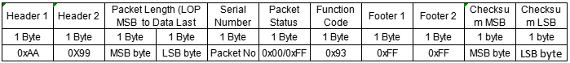

Figure 29.

- Details of Individual Bytes:

Byte Name | Size | Detail
Header 1 | 1 Byte | Most significant Bit of Header (Hex Value - 0xAA)
Header 2 | 1 Byte | Least significant bit of Header. (Hex value -0x99)
Packet Length (LOP MSB to Data Last byte) | 1 Byte (MSB)  1 Byte (LSB) | It is a length of Packet and it is calculated as select line of packet it contain 2 bytes LSB and MSB, MSB is a bit of the highest digit, and the LSB is a bit of the lowest digit
Serial number | 1 Byte | 2 digit ASCII value indicate current packet number. In case of multiple packet telegram, It starts with ASCII “ 01” and increments by one count up to “99”
Packet Status | 1 Byte | It Shows packet status it can be 0x00/0xFF.  0x00 Packet in continuation  0xFF Last Packet
Function Code | 1 Byte | Bit indicates a function code of packet i.e. Get Sensor Value  Function code 0x93.
Footer 1 | 1 Byte | Most significant Bit of Header (Hex Value - 0xFF)
Footer 2 | 1 Byte | Least significant bit of Header. (Hex value -0xFF)
Checksum  - Checksum MSB  - Checksum LSB | 2 Byte | 1.MSB is a bit of the highest digit in checksum.  2. LSB is a bit of the lowest digit in Checksum.  CRC is 16-bit value. This is calculated as CRC of all the  bytes starting from Length MSB to last byte stored in CRC-16-CCITT (also known as CRC-CCITT)  is used for data integrity. The polynomial of CRC-16  is “x16+x12+x5+1” and its hex value is 1021

17.1 Response Code For Get Sensor Value.

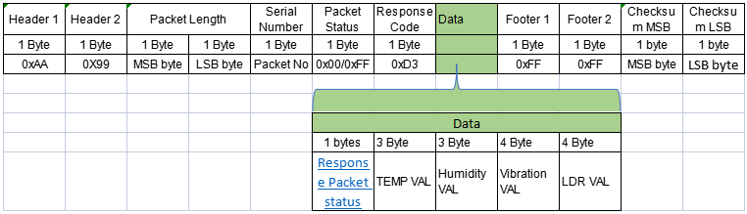
Figure 30.

- Details of Individual Bytes:

Byte Name | Size | Detail
Header 1 | 1 Byte | Most significant Bit of Header (Hex Value - 0xAA)
Header 2 | 1 Byte | Least significant bit of Header. (Hex value -0x99)
Packet Length (LOP MSB to Data Last byte) | 1 Byte (MSB)  1 Byte (LSB) | It is a length of Packet and it is calculated as select line of packet it contain 2 bytes LSB and MSB, MSB is a bit of the highest digit, and the LSB is a bit of the lowest digit
Serial number | 1 Byte | 2 digit ASCII value indicate current packet number. In case of multiple packet telegram, It starts with ASCII “ 01” and increments by one count up to “99”
Packet Status | 1 Byte | It Shows packet status it can be 0x00/0xFF.  0x00 Packet in continuation  0xFF Last Packet
Response Code | 1 Byte | Bit indicates a Response code of packet i.e. Get Sensor Value  Response code 0xD3.
Data | 15 Bytes | - Consider 2.2 packet status 1 byte  - Temperature valve 3 bytes  - Humidity valve 3 bytes  - Vibration valve 4 bytes  - LDR valve 4 bytes
Footer 1 | 1 Byte | Most significant Bit of Header (Hex Value - 0xFF)
Footer 2 | 1 Byte | Least significant bit of Header. (Hex value -0xFF)
Checksum  - Checksum MSB  - Checksum LSB | 2 Byte | - MSB is a bit of the highest digit in checksum.  - LSB is a bit of the lowest digit in Checksum.  CRC is 16-bit value. This is calculated as CRC of all the  bytes starting from Length MSB to last byte stored in CRC-16-CCITT (also known as CRC-CCITT)  is used for data integrity. The polynomial of CRC-16  is “x16+x12+x5+1” and its hex value is 1021

- Protocol Format for Get Sensor Event.

Figure 31.

- Details of Individual Bytes:

Byte Name | Size | Detail
Header 1 | 1 Byte | Most significant Bit of Header (Hex Value - 0xAA)
Header 2 | 1 Byte | Least significant bit of Header. (Hex value -0x99)
Packet Length (LOP MSB to Data Last byte) | 1 Byte (MSB)  1 Byte (LSB) | It is a length of Packet and it is calculated as select line of packet it contain 2 bytes LSB and MSB, MSB is a bit of the highest digit, and the LSB is a bit of the lowest digit
Serial number | 1 Byte | 2 digit ASCII value indicate current packet number. In case of multiple packet telegram, It starts with ASCII “ 01” and increments by one count up to “99”
Packet Status | 1 Byte | It Shows packet status it can be 0x00/0xFF.  0x00 Packet in continuation  0xFF Last Packet
Function Code | 1 Byte | Bit indicates a function code of packet i.e. Get Sensor Event  Function code 0x94.
Footer 1 | 1 Byte | Most significant Bit of Header (Hex Value - 0xFF)
Footer 2 | 1 Byte | Least significant bit of Header. (Hex value -0xFF)
Checksum  - Checksum MSB  - Checksum LSB | 2 Byte | 1.MSB is a bit of the highest digit in checksum.  2. LSB is a bit of the lowest digit in Checksum.  CRC is 16-bit value. This is calculated as CRC of all the  bytes starting from Length MSB to last byte stored in CRC-16-CCITT (also known as CRC-CCITT)  is used for data integrity. The polynomial of CRC-16  is “x16+x12+x5+1” and its hex value is 1021

18.1 Response Code For Get Sensor Event.

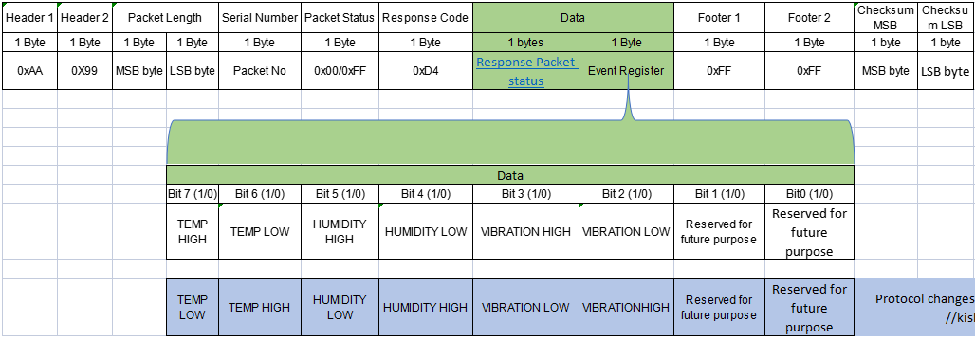

Figure 32.

- Details of Individual Bytes:

Byte Name | Size | Detail
Header 1 | 1 Byte | Most significant Bit of Header (Hex Value - 0xAA)
Header 2 | 1 Byte | Least significant bit of Header. (Hex value -0x99)
Packet Length (LOP MSB to Data Last byte) | 1 Byte (MSB)  1 Byte (LSB) | It is a length of Packet and it is calculated as select line of packet it contain 2 bytes LSB and MSB, MSB is a bit of the highest digit, and the LSB is a bit of the lowest digit
Serial number | 1 Byte | 2 digit ASCII value indicate current packet number. In case of multiple packet telegram, It starts with ASCII “ 01” and increments by one count up to “99”
Packet Status | 1 Byte | It Shows packet status it can be 0x00/0xFF.  0x00 Packet in continuation  0xFF Last Packet
Response Code | 1 Byte | Bit indicates a Response code of packet i.e.Get Sensor Event  Response code 0xD4.
Data | 1 Byte | Consider 2.2 packet status 1 byte
Event Register | 1 Byte | Bit 7 (1/0) temperature high /low  Bit 6 (1/0) temperature Low / high  Bit 5 (1/0) humidity High /low  Bit 4 (1/0) humidity Low / high  Bit 3 (1/0) vibration High / low  Bit 2 (1/0) vibration Low / high  Bit 1 (1/0) reserve for future use.  Bit 0 (1/0) reserve for future use
Footer 1 | 1 Byte | Most significant Bit of Header (Hex Value - 0xFF)
Footer 2 | 1 Byte | Least significant bit of Header. (Hex value -0xFF)
Checksum  - Checksum MSB  - Checksum LSB | 2 Byte | - MSB is a bit of the highest digit in checksum.  - LSB is a bit of the lowest digit in Checksum.  CRC is 16-bit value. This is calculated as CRC of all the  bytes starting from Length MSB to last byte stored in CRC-16-CCITT (also known as CRC-CCITT)  is used for data integrity. The polynomial of CRC-16  is “x16+x12+x5+1” and its hex value is 1021

- Protocol Format for Send Sensor Events .

Display will send this Command

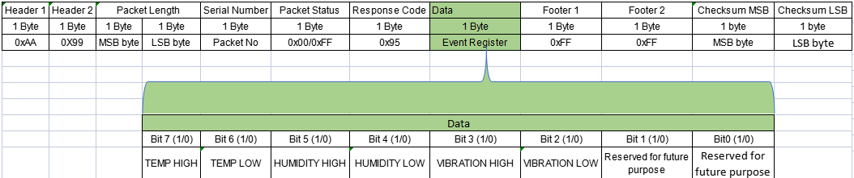

Figure 33.

- Details of Individual Bytes:

Byte Name | Size | Detail
Header 1 | 1 Byte | Most significant Bit of Header (Hex Value - 0xAA)
Header 2 | 1 Byte | Least significant bit of Header. (Hex value -0x99)
Packet Length (LOP MSB to Data Last byte) | 1 Byte (MSB)  1 Byte (LSB) | It is a length of Packet and it is calculated as select line of packet it contain 2 bytes LSB and MSB, MSB is a bit of the highest digit, and the LSB is a bit of the lowest digit
Serial number | 1 Byte | 2 digit ASCII value indicate current packet number. In case of multiple packet telegram, It starts with ASCII “ 01” and increments by one count up to “99”
Packet Status | 1 Byte | It Shows packet status it can be 0x00/0xFF.  0x00 Packet in continuation  0xFF Last Packet
Response Code | 1 Byte | Bit indicates a function code of packet i.e. Send Sensor Events  Function code 0x95.
Data  Event Register | 1 Byte | Bit 7 (1/0) temperature high  Bit 6 (1/0) temperature Low  Bit 5 (1/0) humidity High  Bit 4 (1/0) humidity Low  Bit 3 (1/0) vibration High  Bit 2 (1/0) vibration Low  Bit 1 (1/0) reserve for future use.  Bit 0 (1/0) reserve for future use
Footer 1 | 1 Byte | Most significant Bit of Header (Hex Value - 0xFF)
Footer 2 | 1 Byte | Least significant bit of Header. (Hex value -0xFF)
Checksum  - Checksum MSB  - Checksum LSB | 2 Byte | - MSB is a bit of the highest digit in checksum.  - LSB is a bit of the lowest digit in Checksum.  CRC is 16-bit value. This is calculated as CRC of all the  bytes starting from Length MSB to last byte stored in CRC-16-CCITT (also known as CRC-CCITT)  is used for data integrity. The polynomial of CRC-16  is “x16+x12+x5+1” and its hex value is 1021

19.1 Response Code For Send Sensor Event.

Software will send response

Figure 34.

- Details of Individual Bytes:

Byte Name | Size | Detail
Header 1 | 1 Byte | Most significant Bit of Header (Hex Value - 0xAA)
Header 2 | 1 Byte | Least significant bit of Header. (Hex value -0x99)
Packet Length (LOP MSB to Data Last byte) | 1 Byte (MSB)  1 Byte (LSB) | It is a length of Packet and it is calculated as select line of packet it contain 2 bytes LSB and MSB, MSB is a bit of the highest digit, and the LSB is a bit of the lowest digit
Serial number | 1 Byte | 2 digit ASCII value indicate current packet number. In case of multiple packet telegram, It starts with ASCII “ 01” and increments by one count up to “99”
Packet Status | 1 Byte | It Shows packet status it can be 0x00/0xFF.  0x00 Packet in continuation  0xFF Last Packet
Function Code | 1 Byte | Bit indicates a Response code of packet i.e. Send Sensor Events  Response code 0xD5.
Data | 1 Byte | Consider Response packet status 2.2
Footer 1 | 1 Byte | Most significant Bit of Header (Hex Value - 0xFF)
Footer 2 | 1 Byte | Least significant bit of Header. (Hex value -0xFF)
Checksum  - Checksum MSB  - Checksum LSB | 2 Byte | 1.MSB is a bit of the highest digit in checksum.  2. LSB is a bit of the lowest digit in Checksum.  CRC is 16-bit value. This is calculated as CRC of all the  bytes starting from Length MSB to last byte stored in CRC-16-CCITT (also known as CRC-CCITT)  is used for data integrity. The polynomial of CRC-16  is “x16+x12+x5+1” and its hex value is 1021

- Protocol Format for Get Sensor Events .

Figure 35.

- Details of Individual Bytes:

Byte Name | Size | Detail
Header 1 | 1 Byte | Most significant Bit of Header (Hex Value - 0xAA)
Header 2 | 1 Byte | Least significant bit of Header. (Hex value -0x99)
Packet Length (LOP MSB to Data Last byte) | 1 Byte (MSB)  1 Byte (LSB) | It is a length of Packet and it is calculated as select line of packet it contain 2 bytes LSB and MSB, MSB is a bit of the highest digit, and the LSB is a bit of the lowest digit
Serial number | 1 Byte | 2 digit ASCII value indicate current packet number. In case of multiple packet telegram, It starts with ASCII “ 01” and increments by one count up to “99”
Packet Status | 1 Byte | It Shows packet status it can be 0x00/0xFF.  0x00 Packet in continuation  0xFF Last Packet
Function Code | 1 Byte | Bit indicates a function code of packet i.e. Get Sensor Events  Function code 0x96.
System time in ASCII | 8 Bytes | It is System time Which is in ASCII form  Eg. 23:59:59
Footer 1 | 1 Byte | Most significant Bit of Header (Hex Value - 0xFF)
Footer 2 | 1 Byte | Least significant bit of Header. (Hex value -0xFF)
Checksum  - Checksum MSB  - Checksum LSB | 2 Byte | 1.MSB is a bit of the highest digit in checksum.  2. LSB is a bit of the lowest digit in Checksum.  CRC is 16-bit value. This is calculated as CRC of all the  bytes starting from Length MSB to last byte stored in CRC-16-CCITT (also known as CRC-CCITT)  is used for data integrity. The polynomial of CRC-16  is “x16+x12+x5+1” and its hex value is 1021

  - Response Code For Get Sensor Events.

Figure 36.

- Details of Individual Bytes:

Byte Name | Size | Detail
Header 1 | 1 Byte | Most significant Bit of Header (Hex Value - 0xAA)
Header 2 | 1 Byte | Least significant bit of Header. (Hex value -0x99)
Packet Length (LOP MSB to Data Last byte) | 1 Byte (MSB)  1 Byte (LSB) | It is a length of Packet and it is calculated as select line of packet it contain 2 bytes LSB and MSB, MSB is a bit of the highest digit, and the LSB is a bit of the lowest digit.
Serial number | 1 Byte | 2 digit ASCII value indicate current packet number. In case of multiple packet telegram, It starts with ASCII “ 01” and increments by one count up to “99”
Packet Status | 1 Byte | It Shows packet status it can be 0x00/0xFF.  0x00 Packet in continuation  0xFF Last Packet
Response Code | 1 Byte | Bit indicates a function code of packet i.e. Get Sensor Events  Response code 0xD6.
Data | 1 Byte | Consider Response packet status 2.2
Footer 1 | 1 Byte | Most significant Bit of Header (Hex Value - 0xFF)
Footer 2 | 1 Byte | Least significant bit of Header. (Hex value -0xFF)
Checksum  - Checksum MSB  - Checksum LSB | 2 Byte | 1.MSB is a bit of the highest digit in checksum.  2. LSB is a bit of the lowest digit in Checksum.  CRC is 16-bit value. This is calculated as CRC of all the  bytes starting from Length MSB to last byte stored in CRC-16-CCITT (also known as CRC-CCITT)  is used for data integrity. The polynomial of CRC-16  is “x16+x12+x5+1” and its hex value is 1021

