Game Design Document

Fill up the Following document

1. Write the title of your project.

The Barbarous Neighborhood

1. What is the goal of the game?

To stop animal Abuse

1. Write a brief story of your game?

One night there was a dog trying to protect the neighborhood from a gang of robbers.

The dog tried barking and shouting loudly but the whole neighborhood was asleep when one resident woke up and started pelting the dog with stones and the dog ran away. He did not notice the robbers and slept

Then the next morning he realized that his house was robbed and he felt sorry for the dog and he felt ashamed and promised he wouldn’t hurt any animal in the near future.

1. Which are the playing characters of this game?

* Playing characters are the ones which respond to the user based on the input from the user
* Cars, monkeys, dinos, wizards etc, are the playing characters in the game.

|  |  |  |
| --- | --- | --- |
| Number | Character Name | What can this character do? |
| 1 | Dog | Can move, bark |
| 2 |  |  |
| 3 |  |  |
| 4 |  |  |
| 5 |  |  |
| 6 |  |  |
| 7 |  |  |
| 8 |  |  |

1. Which are the Non Playing Characters of this game?

* Non Playing characters are the ones which don't have an action or a behaviour when the user interacts with the game.
* Hurdles, stones, bananas, coins, etc are non playing characters in the game.

|  |  |  |
| --- | --- | --- |
| Number | Character Name | What can this character do? |
| 1 | The resident | Pelts the dog with stones |
| 2 | The robbers | Can move |
| 3 |  |  |
| 4 |  |  |
| 5 |  |  |
| 6 |  |  |
| 7 |  |  |
| 8 |  |  |

Draw your imagination of this game. What does this game look like?

* Draw the game either on your computer or on paper,
* Add images of scenes of the game to show each of the playing and non-playing characters at least once.

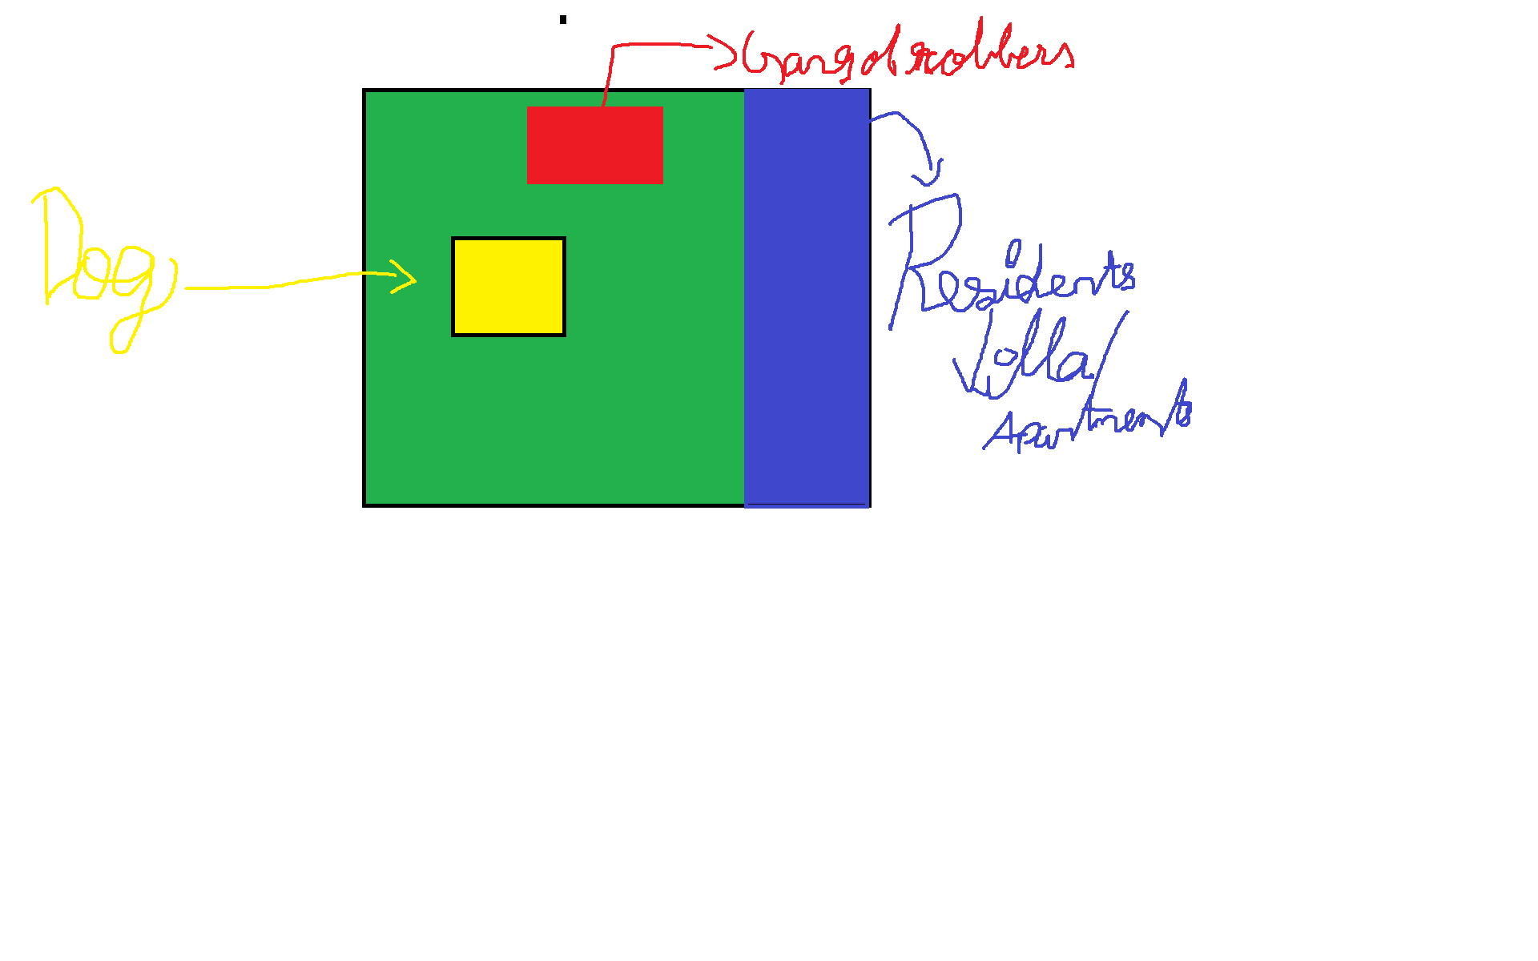

How do you plan to make your game engaging?