Name : Rishi Bharadwaj R
SRN : PES1UG24AM223
Scenario – 62
SE LAB - 01

Requirements Table
ID | Type | Description | Priority | Acceptance Criteria | Rationale
FR-001 | Functional | The system shall allow Donor Partners to list surplus food batches with dietary tags, total quantity, and a perishable expiry countdown timer. | High | Pass: A new food batch is visible on the platform with accurate tags and an active countdown timer.  Fail: A batch is published without a mandatory expiry time. | Establishes the core inventory of the platform and prevents the distribution of unsafe food.
FR-002 | Functional | The system shall automatically unlist and flag food batches as unavailable once their perishable expiry countdown timer reaches zero. | High | Pass: Expired batch immediately disappears from the active claim board and cannot be reserved.  Fail: Expired food batch remains active and claimable by shelters. | Ensures strict compliance with food safety and health regulations.
FR-003 | Functional | The system shall enable Shelter Coordinators to reserve available food batches and select a designated pickup time window. | High | Pass: Inventory quantity decreases or is marked "Reserved" upon successful selection of a pickup window.  Fail: Multiple shelters can reserve the exact same batch simultaneously. | Facilitates organized redistribution and prevents double-booking of resources.
FR-004 | Functional | The system shall generate a secure, unique alphanumeric pickup verification code for the Shelter Coordinator upon reservation, which the Donor Partner must validate at handover. | Medium | Pass: Status updates to "Picked Up" only after the Donor Partner enters the matching code.  Fail: Handover completes without code validation. | Ensures food is securely handed over to the verified and intended recipient.
FR-005 | Functional | The system shall provide a dashboard for Donor Partners to track the lifecycle status of their posted batches (Listed, Reserved, Picked Up, Expired). | Low | Pass: Dashboard reflects real-time status transitions corresponding to platform activity.  Fail: Status on the dashboard lags or contradicts the active system state. | Provides necessary operational visibility and reporting metrics for the donor's CSR initiatives.
NFR-001 | Performance | The platform shall dispatch push notifications to verified shelters within a 5 km radius within 2.0 seconds of a high-quantity perishable food listing being posted. | High | Pass: Benchmarking confirms 95th percentile notification latency is $≤2.0\text{ s}$ under simulated peak load.  Fail: Notification delivery exceeds the latency threshold. | Guarantees rapid mobilization of resources for highly perishable, large-volume donations.
NFR-002 | Security & Compliance | The system must enforce mandatory OAuth 2.0 authentication and strictly verify non-profit organizational credentials before granting account activation to Shelter Coordinators. | High | Pass: Unverified accounts are blocked from accessing the active claim board.  Fail: Public or unauthenticated users can reserve food batches. | Prevents fraud and ensures surplus food is strictly distributed to authorized charitable entities.

UML Diagram

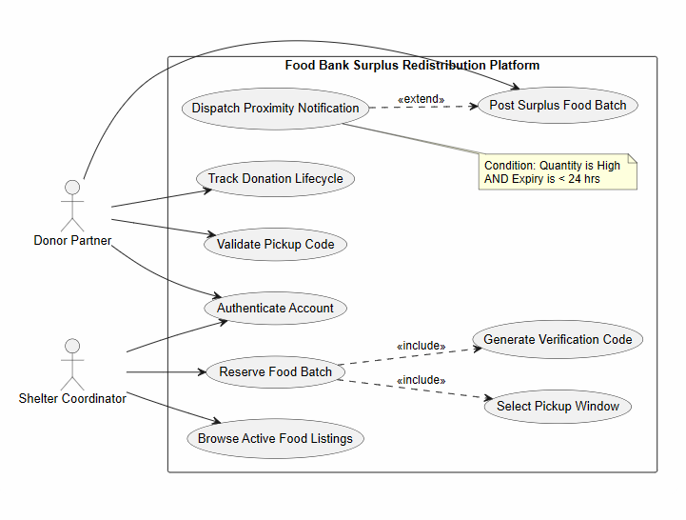

Use-Case Flow Specification
Use Case ID: UC-05
Use Case Name: Reserve Food Batch
Primary Actor: Shelter Coordinator
Secondary Actor: Donor Partner (System Notified)
- Preconditions:
  - The Shelter Coordinator is authenticated and has a verified non-profit status.
  - The Donor Partner has an active, unexpired food batch listed on the platform.
  - The Shelter Coordinator is within the permissible geographic radius to view the batch.
- Postconditions:
  - The selected food batch is removed from the public active claim board and marked as "Reserved".
  - A unique pickup verification code is generated and tied to the transaction.
  - The Donor Partner is notified of the reservation and the selected pickup window.
- Main Success Scenario (MSS):
  - Shelter Coordinator browses the active claim board and selects a specific surplus food batch.
  - System displays batch details, including dietary tags, quantity, location, and the expiry countdown timer.
  - Shelter Coordinator selects Reserve Batch.
  - System prompts the Shelter Coordinator to select an available pickup window (<<include>> UC6).
  - Shelter Coordinator chooses a time slot and confirms the reservation.
  - System verifies the batch has not expired and is still available in the inventory.
  - System locks the batch, changes its status to "Reserved", and generates a secure verification code (<<include>> UC7).
  - System displays the verification code and pickup instructions to the Shelter Coordinator.
  - System automatically notifies the Donor Partner of the reservation and upcoming pickup schedule.
- Alternate Flow (A1 - Batch Expires or Claimed During Selection):
  - 6a. System detects that the expiry countdown timer has reached zero OR another shelter has concurrently reserved the final quantity of the batch during step 4/5.
  - 6b. System aborts the reservation lock.
  - 6c. System displays an error message: "This food batch is no longer available or has expired."
  - 6d. System automatically redirects the Shelter Coordinator back to the refreshed active claim board.

