INTRODUCTION TO DATA MANAGEMENT
PROJECT REPORT
(Project Semester January-April 2025)

(Student Depression Dashboard)

Submitted by:

(Rishi Balodi)

Registration No:12319907

Programme and Section B. TECH CSE(K23EG)
Course Code INT217

Under the Guidance of

Jaffar Amin Chacket (30453)

Discipline of CSE/IT

Lovely School of Computer Science

Lovely Professional University, Phagwara

CERTIFICATE

This is to certify that Rishi Balodi bearing Registration no. 12319907 has completed INT217 project titled, “Student Depression Dashboard” under my guidance and supervision. To the best of my knowledge, the present work is the result of his/her original development, effort and study.

Signature and Name of the Supervisor
Designation of the Supervisor
School of Computer Science
Lovely Professional University
Phagwara, Punjab.

Date:

DECLARATION

I, Rishi Balodi student of B. Tech CSE under CSE/IT Discipline at, Lovely Professional University, Punjab, hereby declare that all the information furnished in this project report is based on my own intensive work and is genuine.

Date:

Registration No. 12319907 Rishi Balodi

1. Introduction
With rising awareness of mental health, understanding the factors influencing student depression has become increasingly important. This project explores student mental health data through comprehensive analysis and an interactive dashboard. The objective is to uncover meaningful insights into how various academic, social, and personal factors relate to depression among students.
2. Source of Dataset
The dataset used in this project was obtained from Kaggle. It contains detailed information collected through surveys on various factors that might influence depression in students, including demographic information, academic and work pressures, lifestyle habits, and mental health indicators.
3. Dataset Preprocessing
The raw dataset included inconsistencies, missing values, and formatting issues. To prepare the data for analysis, the following preprocessing steps were taken:
- Removing duplicates to ensure data integrity.
- Handling missing values through appropriate imputation methods (e.g., mean/mode substitution or removal).
- Standardizing text columns (title case, trimming whitespaces).
- Encoding categorical using label encoding or one-hot encoding where applicable.
- Converting (like age or sleep duration) to numeric formats for quantitative analysis to numeric formats for quantitative analysis.
4. Analysis on Dataset
Objective 1: Analyze the Impact of Academic and Work Pressure on Mental Health
- General Description: This analysis evaluates how academic and work pressures correlate with depression.
- Specific Requirements: Assess depression levels across different levels of academic and work pressure.
- Analysis Results: A positive correlation was observed between high academic/work pressure and increased signs of depression.
- Visualization: bar chart showing depression levels segmented by academic and work pressure categories.
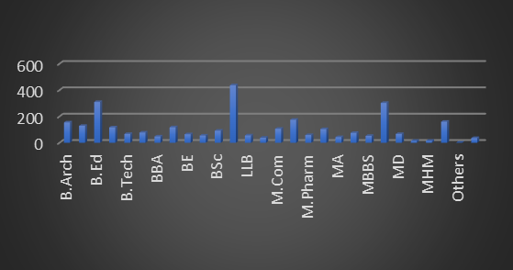

Objective 2: Study the Relationship Between CGPA and Sleep Duration
- General Description: This objective explores the connection between CGPA and sleep duration..
- Specific Requirements: Perform analysis and calculate correlation between CGPA and sleep hours.
- Analysis Results: A mild positive correlation was found, indicating that students with better CGPA tend to have more regulated sleep patterns.
- Visualization: Bar Plot of CGPA vs. Sleep Duration with trendline.

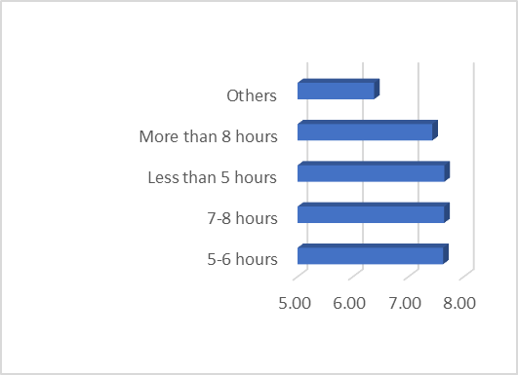
Objective 3: Evaluate the Effect of Study and Job Satisfaction on Depression
General Description: Satisfaction with study or work can affect mental well-being. Specific Requirements: Group data by satisfaction levels and compare average depression indicators.
- Analysis Results: Students reporting low study or job satisfaction showed higher depression symptoms.
- Visualization: bar chart comparing depression rates across satisfaction levels.
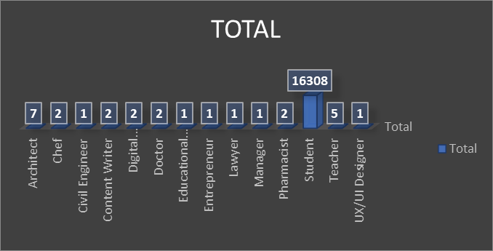

Objective 4: Compare Work/Study Hours with Mental Health Outcomes.
- General Description: Overworking or underworking can both impact mental health.
- Specific Requirements: Analyze depression scores across binned work/study hour ranges.
- Analysis Results: Students working/studying over 8 hours a day showed higher rates of depression.
- Visualization: Pie chart showing depression trends across work/study hour intervals.

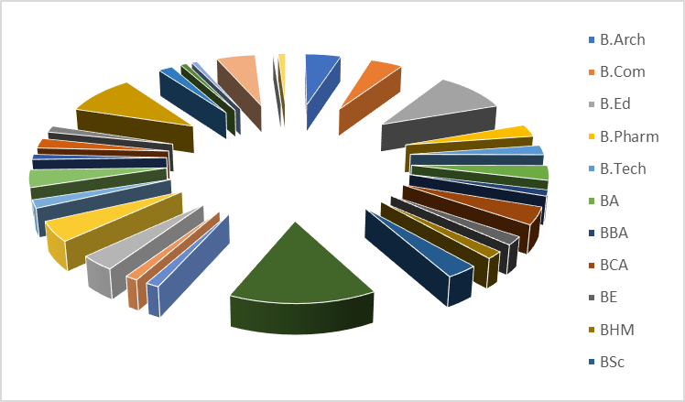
Objective 5: Analyze the Influence of Educational Degree on Mental Well-being.
- General Description: Educational level may play a role in how students experience and cope with depression.
- Specific Requirements: Group data by degree level (e.g., Bachelor's, Master's, PhD) and assess average depression levels.
- Analysis Results: Variation in depression levels was observed across different degrees, with undergraduates showing the highest susceptibility.
- Visualization: Bar chart comparing average depression scores across degree categories.
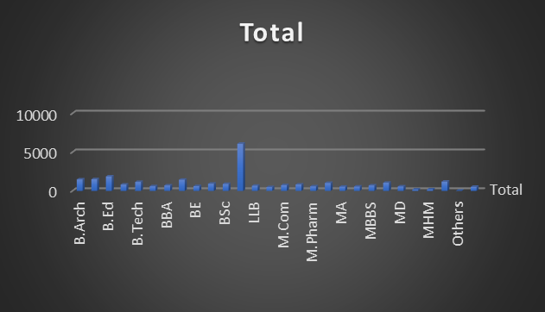

5. Conclusion
The analysis revealed key factors influencing student depression, including academic pressure, work hours, and satisfaction levels. Understanding these relationships can help institutions support student well-being through informed decisions and targeted interventions.
6. Future Scope
Future work can include:
- Apply predictive models to identify students at risk of depression.
- Perform sentiment analysis on student responses.
- Segment students based on mental health patterns.
- Analyse trends over time with longitudinal data.

7. References
- Student Depression (Kaggle/Public Repository)- https://www.kaggle.com/datasets/hopesb/student-depression-dataset
- Python Libraries: pandas, matplotlib, seaborn, NumPy.
- Online articles and documentation for visualization best practices
- LinkedIn: https://www.linkedin.com/in/rishibalodi/

