3. Find the highest-priced product
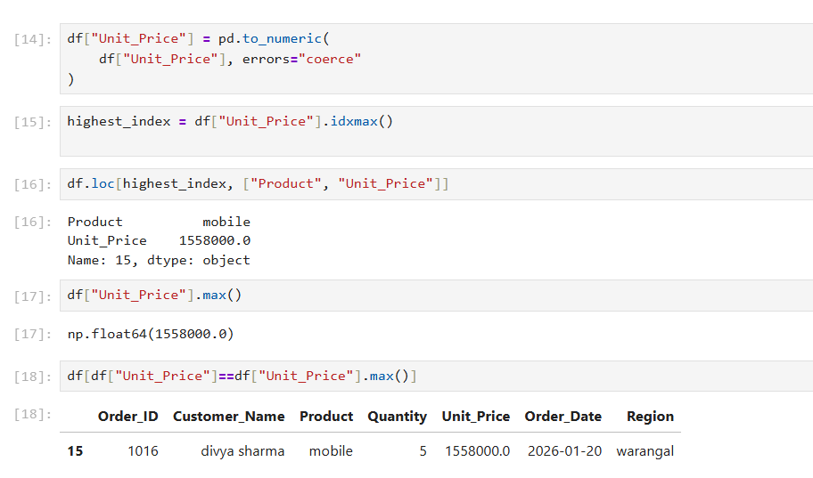
Possible Errors and Solutions
- Problem: Invalid values in the unit price column can cause errors during numerical analysis. Unusually high prices can also produce misleading results and affect revenue calculations.
- Possible causes:
- Employees may accidentally enter incorrect prices while recording orders.
- Text values such as "unknown" may be stored in a numerical column.
- Extra digits or misplaced decimal points may result in unrealistic prices.
- Incorrect product pricing or outdated price records may remain in the dataset.
- Solution: Use pd.to_numeric(errors="coerce") to convert invalid text values into missing values. Then use idxmax() to identify the row containing the highest unit price and max() to retrieve the highest price itself. Verify unusually high prices against the original records before correcting them.
-idxmax() returns the index of the row with the highest value, whereas max() returns the highest value itself.

