Task 3: Linux Permissions
Practical exercise using Linux chmod and ls -l
This document records the terminal steps for creating a practice file and changing its permissions with chmod. The final screenshot shows a typo in the command (chmodr instead of chmod), so it records an unsuccessful attempt rather than a successful 777 permission change.

1. Creating the practice file and checking initial permissions
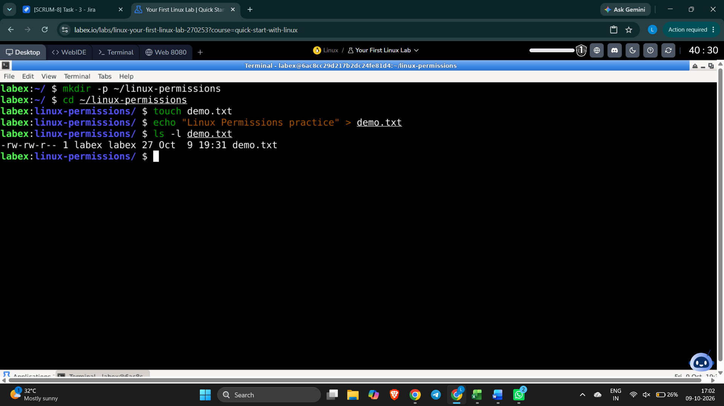

2. Applying chmod 755
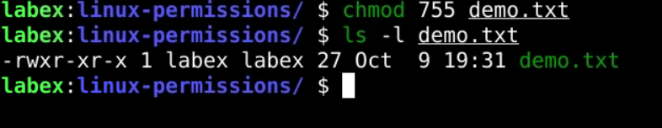

3. Applying chmod 644
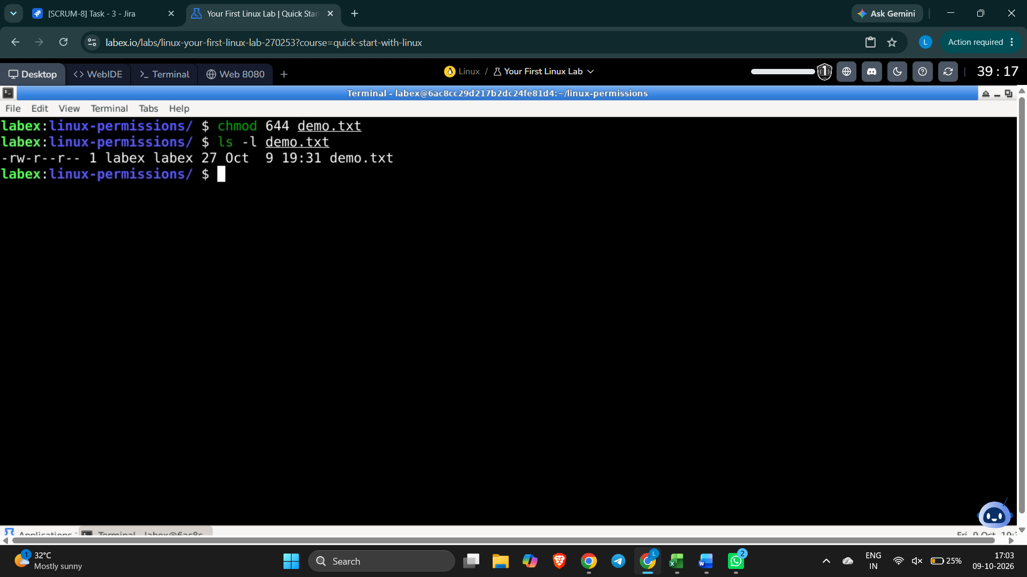

4. Attempted chmod 777 — command typo and terminal error
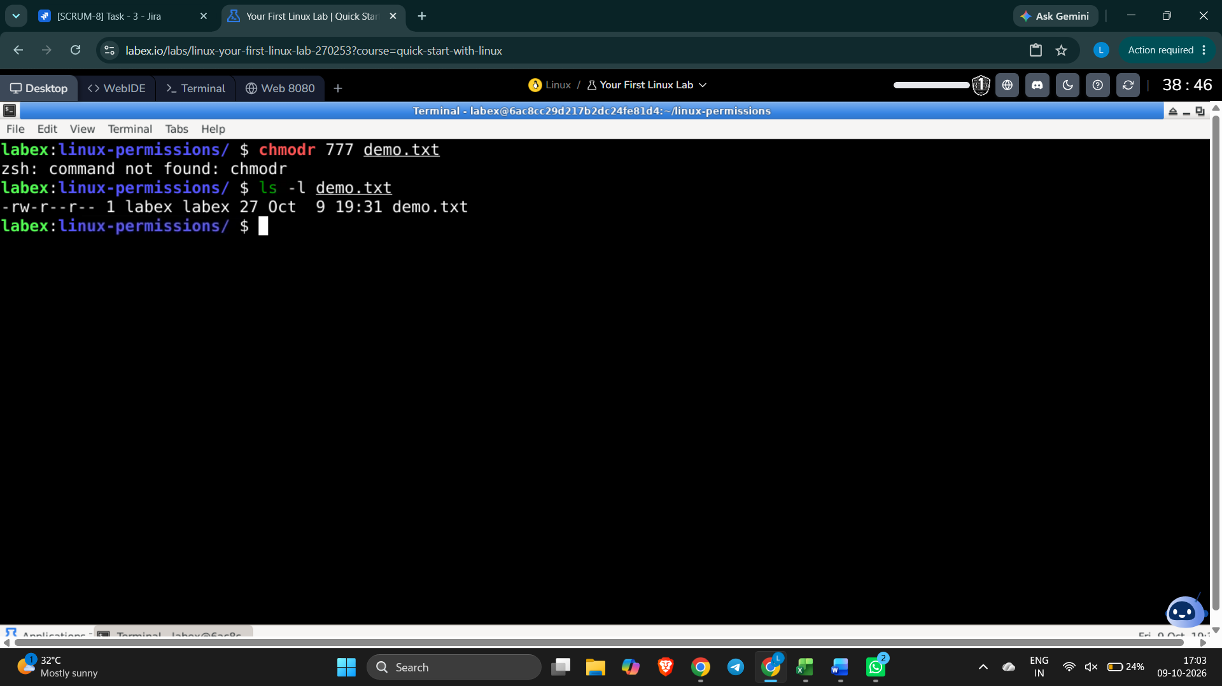

Correct command to complete the 777 test
chmod 777 demo.txt
ls -l demo.txt
Expected permissions: -rwxrwxrwx

