Task 1: Linux File System Explorer
Linux directory exploration using the ls command
This document records the terminal output for the Linux filesystem directories /etc, /var, /home, /tmp, and /usr.

1. /etc — configuration files and system settings
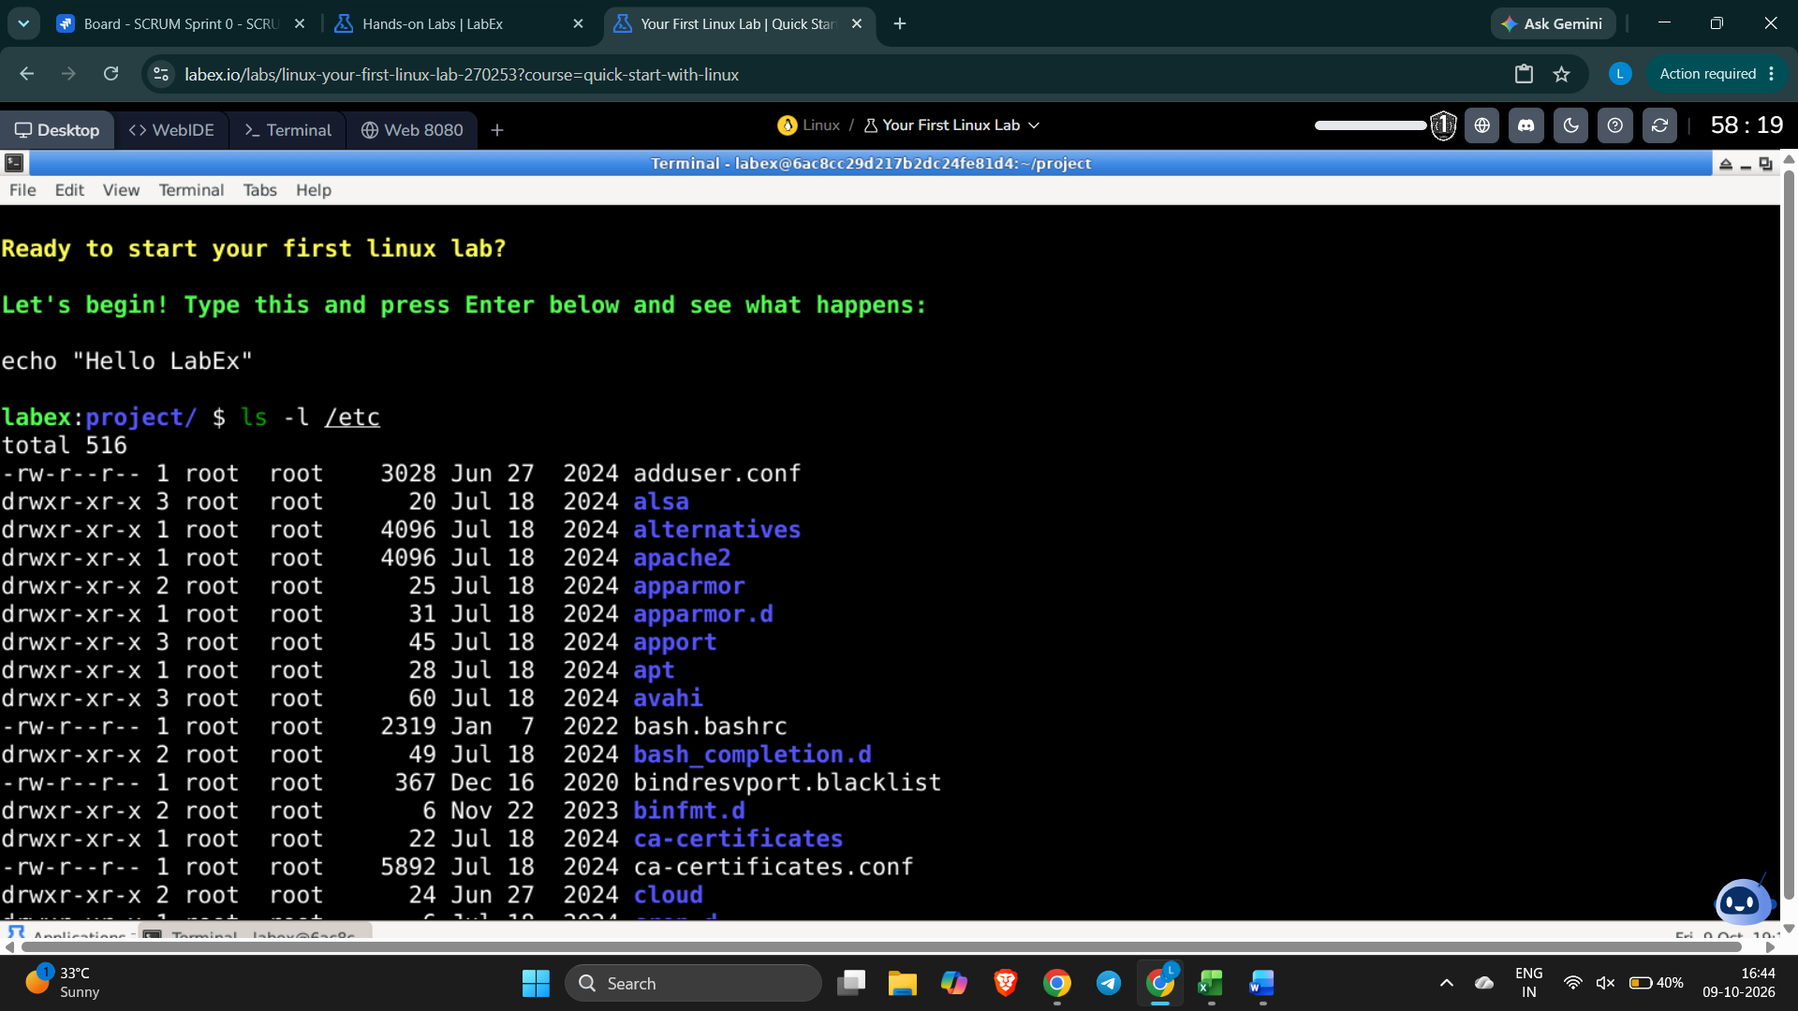

2. /var — variable data such as logs, cache, and temporary runtime files
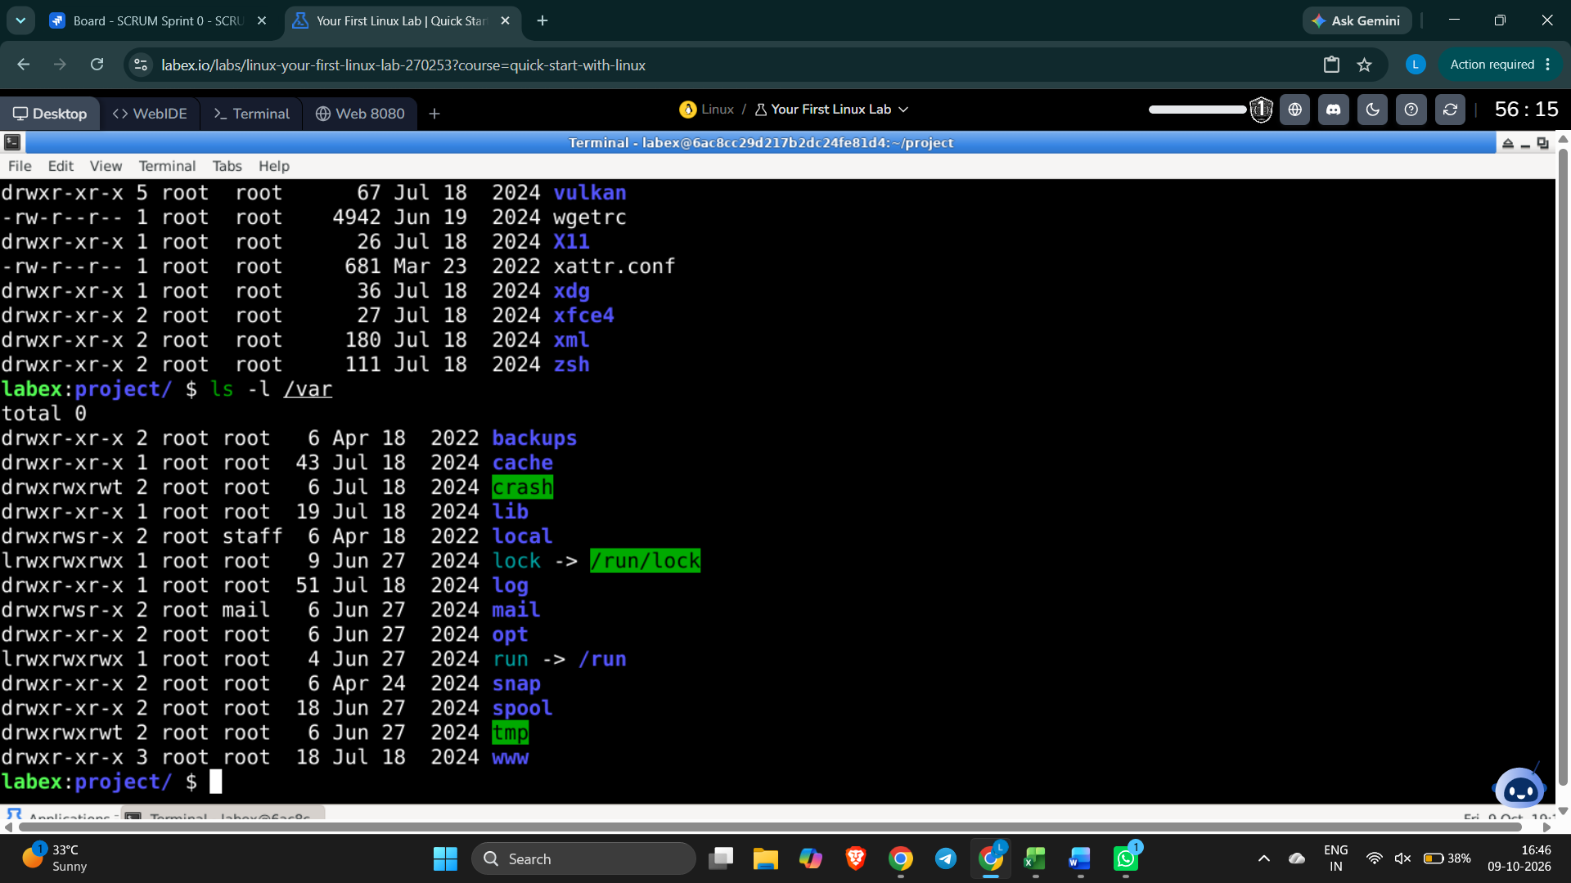

3. /home — users’ home directories
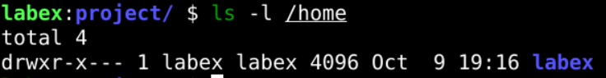

4. /tmp — temporary files and session-related files
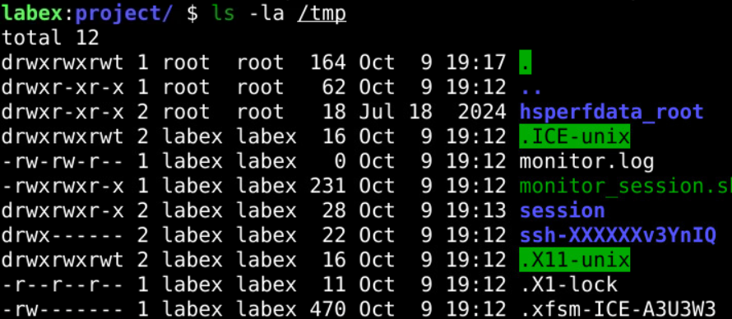

5. /usr — installed programs, libraries, and shared resources
