Task 2: Linux Commands Investigation
Practical Linux terminal command exploration
This document contains screenshots demonstrating the use of pwd, ls, ls -la, cd, mkdir, rm, and rmdir in an online Linux terminal.

1. Checking pwd, ls, and ls -la
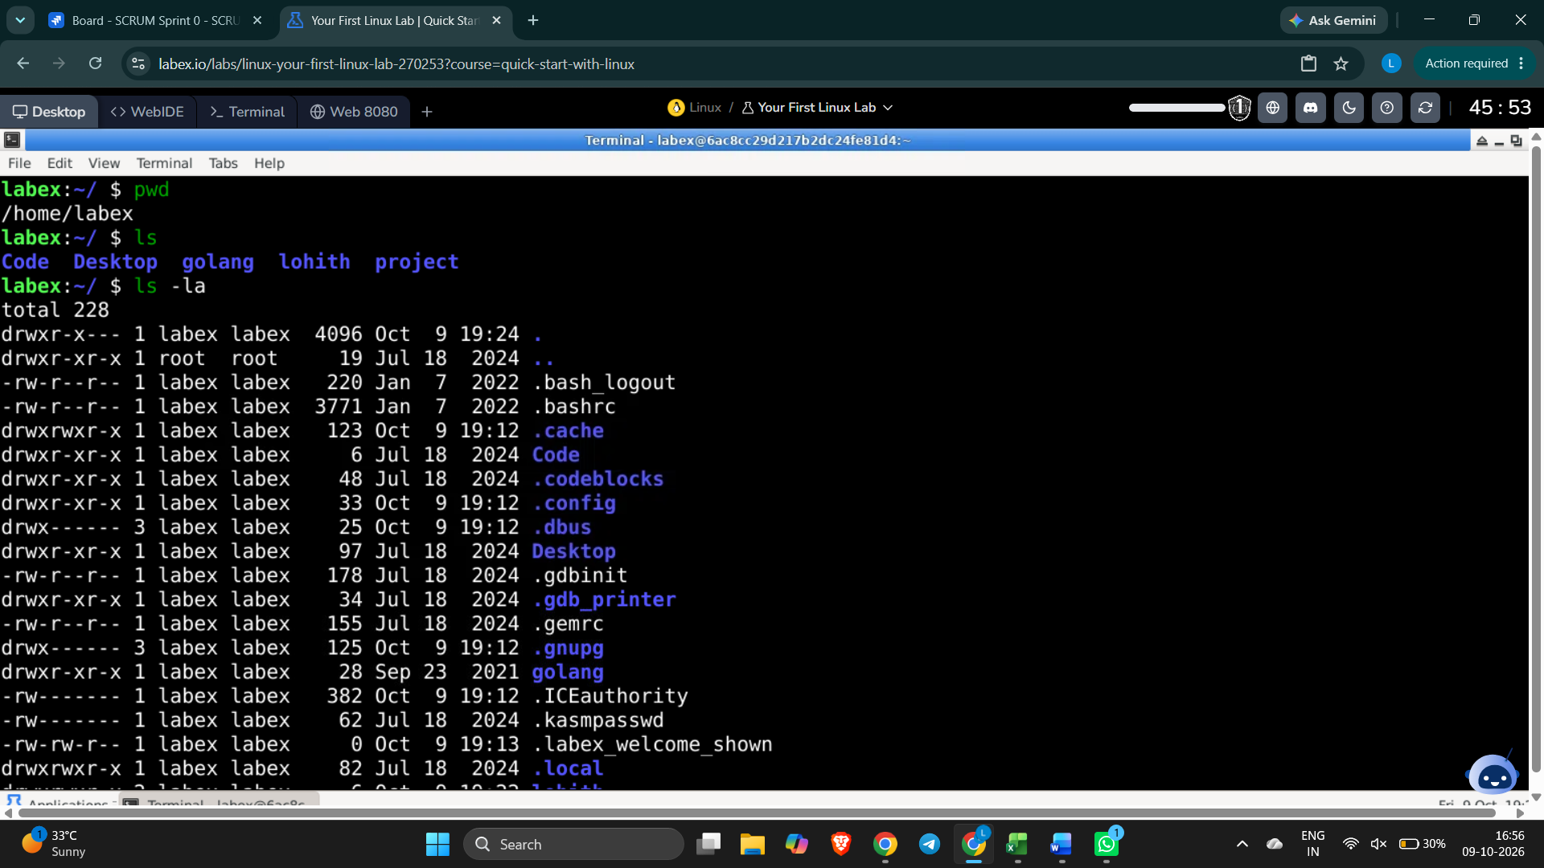

2. Creating and entering linuxpractice with mkdir and cd
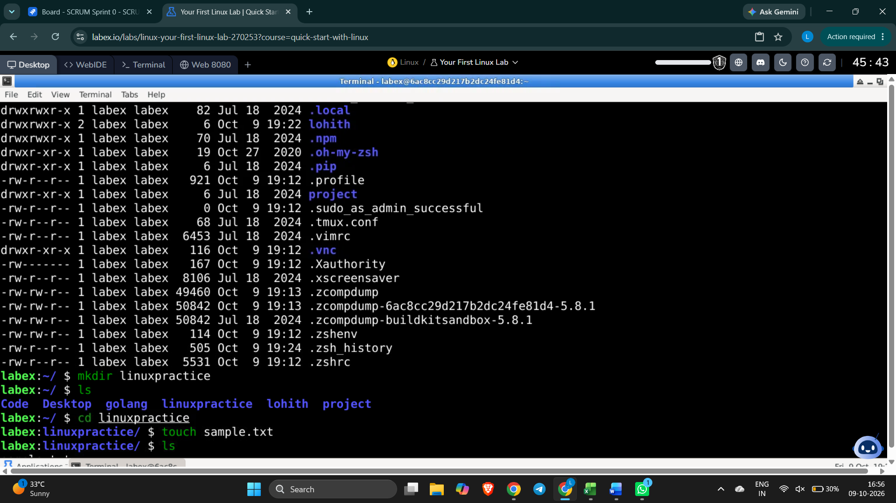

3. Testing rm, rmdir, and directory navigation
