2. Identify duplicate orders and repeated Order IDs
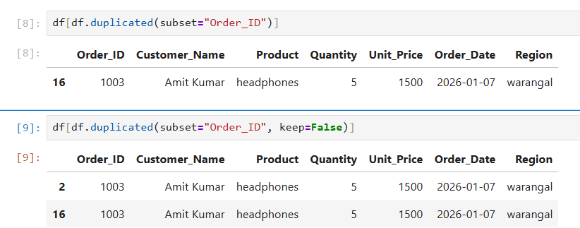

Removing The Duplicate Records :
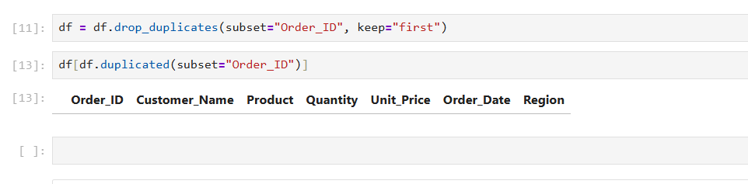
Possible Errors and Solutions
- Problem: Duplicate orders can inflate total sales, revenue, and order counts, leading to incorrect business reports and decisions.
- Possible causes:
- The same sales file may have been imported into the system more than once.
- Employees may accidentally enter the same order details multiple times.
- Data from different sources may contain overlapping order records.
- System or synchronization issues may create duplicate entries during data transfers.
- Solution: Use df.duplicated(subset="Order_ID", keep=False) to identify all rows with repeated order IDs. Verify the records to determine whether they are genuine duplicates before removing them with drop_duplicates(). If repeated IDs contain different order details, investigate further instead of deleting them blindly.

