4. Group revenue by city
First, clean the city names and calculate revenue.

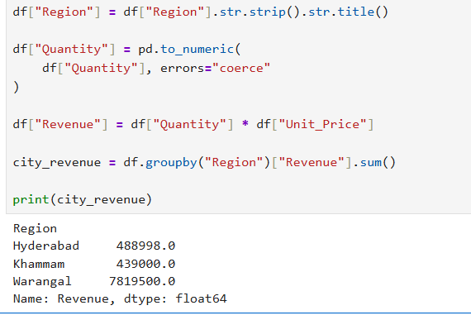
Possible Errors and Solutions
- Problem: Revenue may be calculated incorrectly, and sales from the same city may appear under separate names. This can lead to inaccurate city-wise comparisons and business decisions.
- Possible causes:
- City names may have inconsistent capitalization, such as "HYDERABAD" and "hyderabad".
- Extra spaces in city names may cause the same city to be treated as multiple groups.
- Missing or invalid quantity and unit price values may result in incomplete revenue calculations.
- Incorrect quantities or prices may produce unrealistic revenue totals.
- Solution: Use str.strip().str.title() to standardize city names and pd.to_numeric(errors="coerce") to convert invalid numerical values into missing values. Calculate revenue by multiplying quantity by unit price, then use groupby() and sum() to calculate city-wise revenue. Check records with missing revenue before interpreting the results, because Pandas sum() skips missing values by default.
Example: " hyderabad ", "HYDERABAD" and "hyderabad" will all become "Hyderabad", ensuring that their revenue is grouped together.

