Dataset used :
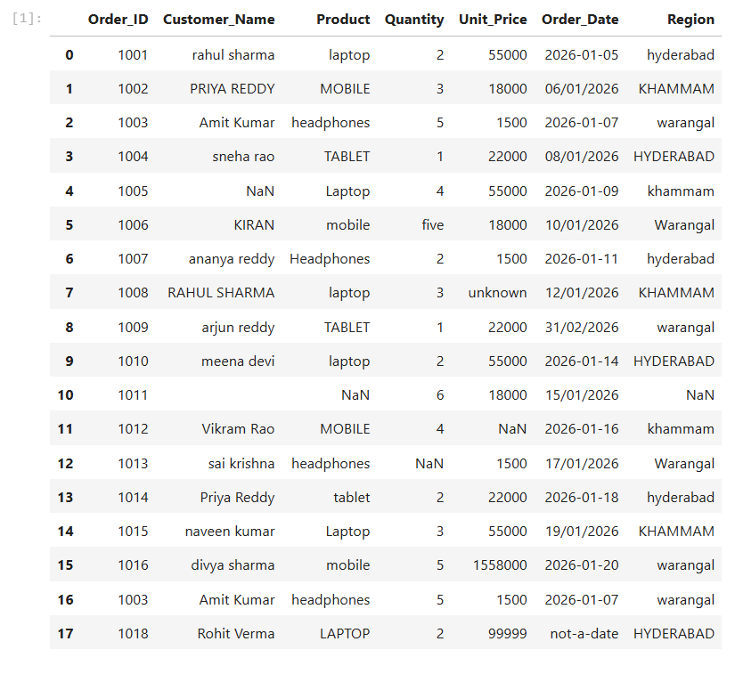
1. Identify missing values in every column
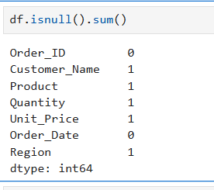
only columns containing missing values:
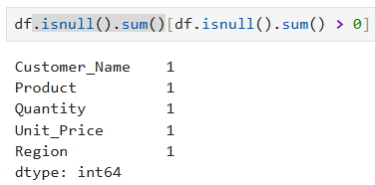
Total Count :
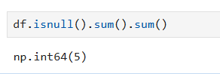
Possible Errors and Solutions
- Problem: Missing values can lead to incorrect revenue calculations, incomplete reports, and unreliable business decisions.
- Possible causes:
- Customers may leave fields such as customer name, quantity, or region blank while placing an order.
- Data may be lost during file imports, database transfers, or system failures.
- Employees may accidentally skip fields while entering order details.
- Some values may be unavailable because the information was not collected at the time of the transaction.
- Solution: Use df.isnull().sum() to identify missing values in each column. Fill missing values with appropriate values where possible, or remove incomplete records when justified. For important fields such as quantity and unit price, investigate the original records before making corrections to avoid inaccurate revenue calculations.

