Connect 4 Game Project

Tech Stack:-

1)Djnago

2)Python

3)Mysql

4)Redis

**Objectives Achieved:-**

1. Unique id returned for parallel games
2. Api get request returning all moves or a game
3. Win determined and game win state save and returned
4. Caching system added to reduce db load

API:-

1. **Start a new game api :-**

Url :-

http://127.0.0.1:8000/api/1/game/start

Sample Curl:-

curl --location --request GET 'http://127.0.0.1:8000/api/1/game/start'

Sample Response:- Unique id returned to play the game

{

"status": "success",

"detail": {

"id": "d8271b18-0060-484e-b38b-05b498e7556c"

},

"code": 200

}

**2) Game Move Api :-**

Url :-

http://127.0.0.1:8000/api/1/game/start

Put Request:-

Sample Curl:- Send the id and move dictionary in body

curl --location --request PUT 'http://127.0.0.1:8000/api/1/game' \

--header 'Content-Type: application/json' \

--data-raw '{

"id": "d8271b18-0060-484e-b38b-05c498e7556c",

"move":{

"player_colour":"Red",

"column":1

}

}'

Sample Responses:-

1)If a valid move played :-

{

"status": "success",

"detail": {

"id": "82d23f96-4983-4dcf-990b-d0cfad9fe09c",

"board": "[[0, 1, 0, 0, 0, 0, 0], [0, 2, 0, 0, 0, 0, 0], [0, 0, 0, 0, 0, 0, 0], [0, 0, 0, 0, 0, 0, 0], [0, 0, 0, 0, 0, 0, 0], [0, 0, 0, 0, 0, 0, 0]]",

"move_count": 2,

"updated_on": "2020-09-27T15:09:09.100009-05:00"

},

"code": 200

}

2)Wrong Turn

{

"status": "error",

"detail": {

"player_colour": [

"Invalid player_colour.Right Now its Yellow Turn "

]

},

"code": 400

}

3)If game ended and yellow wins

{

"status": "success",

"detail": {

"Game ended": "Yellow Wins the Game"

},

"code": 200

}

Get Request:- To get the moves of a game

Sample Curl:- Send the id in request params

curl --location --request GET 'http://127.0.0.1:8000/api/1/game?id=d8271b18-0060-484e-b38b-05b498e7556c'

Sample Response:-

{

"detail": {

"id": "82d23f96-4983-4dcf-990b-d0cfad9fe09c",

"moves": [

{

"id": "905006db-463b-4575-b79e-88d979e69748",

"player_colour": "Red",

"column": 1,

"move_number": 2,

"added_on": "2020-09-27T15:10:05.409894-05:00"

},

{

"id": "9b9f0571-7623-4934-90e8-588e92282ddb",

"player_colour": "Yellow",

"column": 1,

"move_number": 1,

"added_on": "2020-09-27T15:09:30.056352-05:00"

}

]

}

}

**Screenshots**

**Redis Caching**

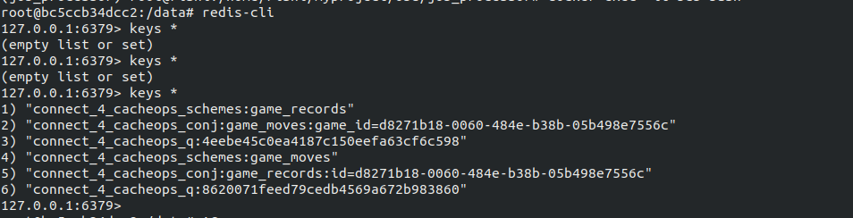

Starting a Game

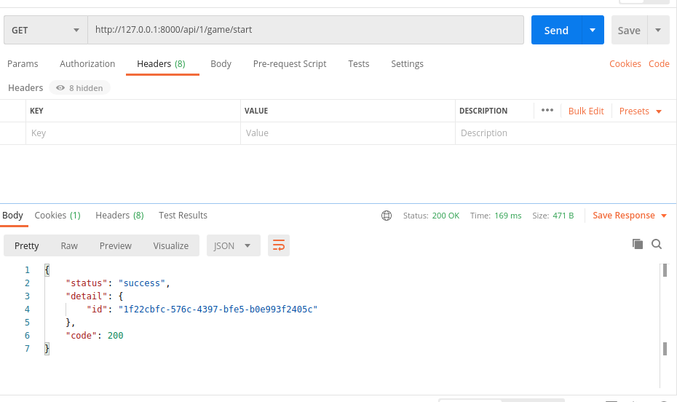

**Invalid Turn**

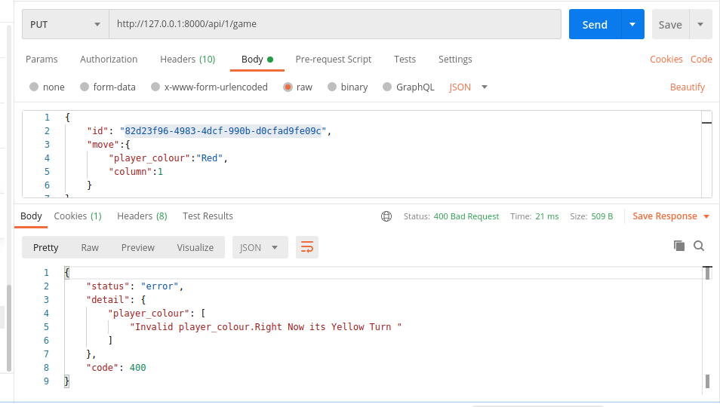

Get all Moves of a game

