COLLEGE MANAGEMENT SYSTEM
Project Report
Built with Django, HTML, CSS, Tailwind CSS and SQLite

Particular | Details
Submitted By | RISHI KUMAR
Enrollment No. | 2350636647
Programme | Master of Computer Applications (MCA)
Course | MCSP-232
Submitted To | School of Computer and Information Sciences, IGNOU
Project Guide | Mr. Karmveer, Sr. Software Engineer, NIC, Delhi
Session | 2024-2026

Certificate
This is to certify that the project report entitled 'College Management System' has been prepared as part of the academic submission requirement for the Master of Computer Applications programme. The work represents a software system designed and implemented to automate institutional operations including student records, faculty records, courses, attendance, examinations, library, hostel, fee processing, reporting, authentication, and system activity auditing.
The application has been developed using the Django web framework with SQLite as the database engine and responsive presentation layers built through HTML, CSS, Tailwind CSS, JavaScript, and Django templates. The project was examined against the synopsis objectives and the implemented codebase to prepare this comprehensive technical documentation.

Declaration
I hereby declare that the project work presented in this report is based on the College Management System synopsis and the implemented Django project files. The documentation has been prepared for academic submission and explains the problem domain, design decisions, implementation details, testing approach, database structure, screenshots, and future scope of the system.
The project aims to demonstrate the practical application of web development, database management, software engineering methodology, and secure role-based access control in the context of institutional administration.

Acknowledgement
I express my sincere gratitude to Almighty God, my parents, family members, teachers, friends, and well-wishers whose continuous support made this project possible. I also place on record my deep sense of gratitude to my project guide, Mr. Karmveer, Sr. Software Engineer, NIC, Delhi, for valuable guidance, motivation, and technical direction throughout the project work.
I extend my thanks to the faculty members and academic staff for their cooperation during the course. Their encouragement helped in understanding the institutional requirements and converting them into a practical software solution.

Abstract
The College Management System is a centralized web application developed to simplify academic and administrative operations in a college environment. The synopsis identifies the core problem as the inefficiency of manual record keeping, delayed access to information, repetitive administrative tasks, and the risk of inconsistent records across departments. The implemented application addresses these problems through a Django-based modular system.
The system provides role-based access for administrators, faculty, students, and staff-like administrative users. It maintains linked records for students, faculty, courses, attendance, examinations, library transactions, hostel allocations, fee structures, payments, reports, notifications, password reset requests, and audit trails. The use of Django ORM with SQLite gives the project a structured relational foundation while remaining lightweight enough for academic deployment and testing.
The report expands the synopsis into a complete academic document covering system analysis, objectives, methodology, feasibility, planning, design diagrams, database schema, code explanations, implementation, testing, screenshots, and future recommendations.

Table of Contents
The following academic sections are included in this detailed project report.
- Overview
- Profile of Problem Assigned
- Introduction to Project
- Existing System
- Proposed System
- Objective
- Methodology
- Modules
- Technology Used
- Requirement Analysis
- Hardware Specification
- Software Specification
- Requirement Specification
- Functional Requirements
- Non-Functional Requirements
- Feasibility Analysis
- Project Planning
- Schedule Table
- Design and Diagrams
- Database Schema
- Coding
- Testing
- Implementation
- Screenshots of Project
- Future Recommendation
- Bibliography

Overview
The College Management System is intended to become a single operational platform for an educational institution. Instead of storing student records in isolated registers or spreadsheets, it places all important entities inside a relational database and exposes them through a secure web interface. The application follows a modular structure where each major institutional function is implemented as a separate Django app.
The implemented project contains apps for user authentication, student management, faculty management, course management, attendance management, examination management, library management, hostel management, fee management, and reporting. A common base template integrates a responsive Tailwind CSS shell so the system can be used on desktop and mobile devices.
The current seeded database contains 24 students, 6 faculty members, 8 courses, 240 attendance records, 24 examinations, and 32 payments. These records demonstrate that the project is not merely a set of static pages but a database-driven application.

Synopsis Interpretation
The synopsis emphasizes automation, centralized data storage, role-specific interfaces, attendance tracking, grade management, fee management, and administrative efficiency. The implemented project directly reflects these goals. It uses Django views and templates to expose CRUD-style operations for the principal entities and uses Django models to enforce relational links among students, courses, faculty, attendance, examinations, payments, and hostels.
The synopsis originally describes a compact schema with Student, Faculty, Course, Attendance, Examination, Library, and Hostel tables. The codebase expands this into a more complete structure by adding UserProfile, AuditTrail, PasswordResetRequest, BookIssue, HostelAllocation, FeeCategory, FeeStructure, Payment, Notification, Report, and DatabaseBackup models.
This report therefore combines the synopsis expectations with the actual implemented architecture. Where the implementation is more detailed than the synopsis, the report documents the real codebase so that the submission matches the running project.

Profile of Problem Assigned
Colleges handle large volumes of information related to student admissions, course assignments, faculty workloads, attendance sheets, examination results, hostel occupancy, library circulation, and fee payments. In a manual environment each department may maintain its own files, leading to duplication, inconsistent updates, delayed verification, and difficulty in generating reports.
The assigned problem is to design and implement a system that automates these activities, preserves referential accuracy, and provides role-based access. The system must reduce clerical effort, improve transparency, and make institutional records available in real time to authorized users.
The problem also includes security and accountability. Since academic records are sensitive, the software must restrict access based on roles and keep a record of important system activities such as login, logout, profile updates, user creation, and administrative actions.

Introduction to Project
The College Management System is a web-based information system built using Python and Django. It uses Django's MTV architecture: models define the database structure, templates define the presentation layer, and views coordinate request processing, validation, and response rendering. The system is accessed through a browser and persists data in SQLite.
The front end uses HTML templates, Tailwind CSS through CDN, compatibility CSS for existing Bootstrap-style classes, Font Awesome icons, and JavaScript for small interactive behaviors such as sidebar toggling and password visibility. The project is suitable for academic demonstration because it combines full-stack development concepts with a realistic institutional use case.
The application includes separate modules that work together. A student profile is linked to a user account and a course. A course is linked to faculty. Attendance links student and course. Results link student and examination. Payments link student and fee structure. These relationships demonstrate practical database normalization.

Existing System
In many institutions the existing system is manual or semi-digital. Student information may be kept in paper files, attendance may be recorded in registers, fee records may be maintained in spreadsheets, and library or hostel data may be handled by separate staff members. The absence of a single source of truth creates delays and errors.
Manual systems are difficult to search, vulnerable to physical damage, and inefficient for producing reports. If a student changes course information, the same change must be repeated in multiple places. If a fee payment is posted late, departments may not have updated information. If examination results are entered manually, calculation errors can occur.
The existing system also lacks real-time visibility. Administrators cannot easily view overall statistics, faculty cannot instantly track attendance summaries, and students cannot access their academic status without contacting the office.

Limitations of Existing System
The major limitations of the existing manual system include data redundancy, slow retrieval, missing audit accountability, difficulty in correcting errors, lack of centralized reporting, and limited support for remote access. Paper-based operations also depend heavily on staff availability and physical storage.
Manual attendance and fee systems create repetitive clerical work. They also make it difficult to generate accurate summaries for management decisions. In an academic environment where semester timelines are fixed, delays in record processing directly affect students, faculty, and administration.
Security is also weak in manual systems because access control is not enforced consistently. A digital system can apply authentication, permissions, validation, and audit logs in a more systematic way.

Proposed System
The proposed system is a Django-based College Management System with centralized data storage and module-wise workflows. It provides login-based access, role-aware navigation, CRUD operations, dashboards, reports, notifications, and activity logs. SQLite is used as the database engine for a lightweight and portable deployment.
The system improves the existing process by storing every major entity in related tables. For example, a student is connected to a course, a course is assigned to faculty, attendance belongs to both student and course, and payment belongs to a student and fee structure. This helps prevent orphan records and improves data integrity.
The Tailwind-styled interface makes the system usable across screen sizes. Administrators can manage institutional data; faculty can view academic workflows; students can access relevant records; staff users can assist with operational processes.

Benefits of Proposed System
The proposed system offers faster access to records, reduction of manual errors, improved data consistency, secure role-based access, better reporting, and a more professional user experience. Because the system is web-based, it can be accessed through standard browsers without installing separate client applications.
Django's ORM reduces the risk of SQL injection by generating parameterized queries and object-oriented access patterns. Django templates separate presentation from business logic, and model relationships enforce the structure required by the institution.
The use of audit logs improves accountability by recording authentication and selected user actions. This supports administrative monitoring and helps identify important changes in the system.

Objective
The primary objective of the College Management System is to automate academic and administrative operations so that institutional data is accurate, accessible, and secure. The system replaces isolated manual records with a centralized database and role-based web interface.
The project also aims to demonstrate practical knowledge of software engineering, database design, web application development, user authentication, frontend responsiveness, testing, and deployment.
- Develop a centralized platform for managing college operations.
- Provide role-based access for administrator, faculty, student, and staff-like users.
- Maintain student, faculty, course, attendance, examination, fee, library, hostel, report, and audit records.
- Improve data retrieval and reduce manual record duplication.
- Provide dashboards, reports, and responsive screens for operational visibility.

Specific Academic Objectives
From an academic perspective, the project demonstrates how theoretical concepts such as SDLC, ER modeling, DFD modeling, normalization, authentication, and testing can be converted into a working web application.
The project validates the ability to analyze a real-world administrative problem, identify entities and relationships, build a modular architecture, and verify the system through end-to-end workflows.
- Apply Django's MTV architecture in a real project.
- Use SQLite relational storage with meaningful constraints and relationships.
- Implement form validation and role-aware workflows.
- Generate a maintainable project structure with separate Django apps.
- Produce documentation suitable for academic submission.

Methodology: SDLC Overview
The project follows the Software Development Life Cycle. The SDLC approach gives the project a disciplined structure by separating planning, analysis, design, implementation, testing, deployment, and maintenance activities.
For this College Management System, the methodology is best understood as an iterative SDLC model. Initial requirements came from the synopsis, while additional improvements were made after reviewing the running codebase and testing workflows.

Methodology: Planning Phase
In the planning phase the scope was defined as a college administration platform covering student, faculty, course, attendance, examination, library, hostel, fee, report, and authentication modules. Technical resources were selected: Python, Django, SQLite, HTML, CSS, Tailwind CSS, and JavaScript.
The planning phase also identified expected users: administrators, faculty members, students, and staff users. These users require different levels of access and different navigation flows.

Methodology: Analysis Phase
The analysis phase studied the limitations of manual systems and the objectives listed in the synopsis. Major entities such as Student, Faculty, Course, Attendance, Examination, Library Book, Hostel Room, Fee Structure, Payment, Report, and AuditTrail were identified.
The analysis also recognized security requirements such as authentication, password validation, user profile roles, and audit logging.

Methodology: Design Phase
The design phase produced the logical database schema, module boundaries, URL patterns, view responsibilities, forms, templates, and navigation structure. ER diagrams and DFDs represent how data flows through the system.
A responsive layout was designed through a common base template. Tailwind CSS provides utility-based styling while compatibility CSS supports legacy Bootstrap-style class names already present in templates.

Methodology: Implementation Phase
Implementation was carried out using Django apps. Each module contains models, views, forms, URLs, and templates as required. SQLite stores the data and Django migrations define schema changes.
The codebase implements key workflows including login, student listing, faculty listing, course management, attendance display, examination result handling, library circulation, hostel allocation, fee payment listing, report generation forms, and system activity logs.

Methodology: Testing and Maintenance Phase
Testing includes Django system checks, migration checks, route sweeps, login verification, role-specific workflow testing, CSV export validation, and visual checks through Chrome DevTools screenshots. Maintenance considerations include future migration to a production database, stronger permission checks, API hardening, and automated test expansion.
The maintenance phase also includes database backup planning, audit log review, and regular refinement of UI responsiveness.

Authentication and Role Management Module
This module manages email-based login, password validation, user profiles, password reset requests, and role-based redirection. It uses Django's User model with a UserProfile extension. The module now records login and logout events through Django authentication signals.
The module is integrated with the rest of the application through Django URLs, views, templates, model relationships, and common layout inheritance. This modular approach improves maintainability because changes in one domain remain mostly localized.
From a user perspective the module contributes to an end-to-end academic management workflow rather than functioning as a standalone screen. The relationships among modules are what make the system valuable for institutional administration.

Administrator Dashboard Module
The dashboard summarizes students, faculty, courses, reports, attendance statistics, examination performance, library activity, hostel occupancy, fee collection, system information, and recent audit events.
The module is integrated with the rest of the application through Django URLs, views, templates, model relationships, and common layout inheritance. This modular approach improves maintainability because changes in one domain remain mostly localized.
From a user perspective the module contributes to an end-to-end academic management workflow rather than functioning as a standalone screen. The relationships among modules are what make the system valuable for institutional administration.

Student Management Module
This module stores student identity, email, course assignment, academic year, and profile linkage. It supports list, create, update, detail, and delete confirmation workflows.
The module is integrated with the rest of the application through Django URLs, views, templates, model relationships, and common layout inheritance. This modular approach improves maintainability because changes in one domain remain mostly localized.
From a user perspective the module contributes to an end-to-end academic management workflow rather than functioning as a standalone screen. The relationships among modules are what make the system valuable for institutional administration.

Faculty Management Module
Faculty records include linked user account, name, email, and department. Faculty are assigned to courses and participate in attendance and examination workflows.
The module is integrated with the rest of the application through Django URLs, views, templates, model relationships, and common layout inheritance. This modular approach improves maintainability because changes in one domain remain mostly localized.
From a user perspective the module contributes to an end-to-end academic management workflow rather than functioning as a standalone screen. The relationships among modules are what make the system valuable for institutional administration.

Course Management Module
Courses are identified by unique course codes and names. Each course may be linked to faculty, has credits, description, active status, and appears in dashboards and student records.
The module is integrated with the rest of the application through Django URLs, views, templates, model relationships, and common layout inheritance. This modular approach improves maintainability because changes in one domain remain mostly localized.
From a user perspective the module contributes to an end-to-end academic management workflow rather than functioning as a standalone screen. The relationships among modules are what make the system valuable for institutional administration.

Attendance Management Module
Attendance links students and courses for a specific date and status. A unique constraint prevents duplicate attendance for the same student, course, and date.
The module is integrated with the rest of the application through Django URLs, views, templates, model relationships, and common layout inheritance. This modular approach improves maintainability because changes in one domain remain mostly localized.
From a user perspective the module contributes to an end-to-end academic management workflow rather than functioning as a standalone screen. The relationships among modules are what make the system valuable for institutional administration.

Examination and Result Module
Examinations are scheduled per course with date, type, duration, total marks, and passing marks. Results link a student to an examination and automatically calculate percentage, grade, and pass/fail status.
The module is integrated with the rest of the application through Django URLs, views, templates, model relationships, and common layout inheritance. This modular approach improves maintainability because changes in one domain remain mostly localized.
From a user perspective the module contributes to an end-to-end academic management workflow rather than functioning as a standalone screen. The relationships among modules are what make the system valuable for institutional administration.

Library Management Module
Books are stored with title, author, ISBN, publication, and availability. BookIssue records connect students with books and track issue dates, return dates, actual return dates, fine amounts, and return status.
The module is integrated with the rest of the application through Django URLs, views, templates, model relationships, and common layout inheritance. This modular approach improves maintainability because changes in one domain remain mostly localized.
From a user perspective the module contributes to an end-to-end academic management workflow rather than functioning as a standalone screen. The relationships among modules are what make the system valuable for institutional administration.

Hostel Management Module
Hostels contain rooms, rooms have capacity and occupancy status, and hostel allocations link active students to rooms. The one-to-one student allocation prevents multiple active hostel records for the same student.
The module is integrated with the rest of the application through Django URLs, views, templates, model relationships, and common layout inheritance. This modular approach improves maintainability because changes in one domain remain mostly localized.
From a user perspective the module contributes to an end-to-end academic management workflow rather than functioning as a standalone screen. The relationships among modules are what make the system valuable for institutional administration.

Fee Management Module
Fee categories, fee structures, and payments form the financial workflow. FeeStructure relates a category and course for an academic year, while Payment records student payment details, status, receipt number, method, and transaction ID.
The module is integrated with the rest of the application through Django URLs, views, templates, model relationships, and common layout inheritance. This modular approach improves maintainability because changes in one domain remain mostly localized.
From a user perspective the module contributes to an end-to-end academic management workflow rather than functioning as a standalone screen. The relationships among modules are what make the system valuable for institutional administration.

Reporting Module
The reporting module maintains generated report metadata, notification records, and database backup records. It supports dashboard summaries, report forms, notifications, and export workflows.
The module is integrated with the rest of the application through Django URLs, views, templates, model relationships, and common layout inheritance. This modular approach improves maintainability because changes in one domain remain mostly localized.
From a user perspective the module contributes to an end-to-end academic management workflow rather than functioning as a standalone screen. The relationships among modules are what make the system valuable for institutional administration.

System Activity Logs Module
AuditTrail records login, logout, create, update, delete, and view events. The activity log page supports dynamic filtering by module, action, user, date range, and search terms with pagination and CSV export.
The module is integrated with the rest of the application through Django URLs, views, templates, model relationships, and common layout inheritance. This modular approach improves maintainability because changes in one domain remain mostly localized.
From a user perspective the module contributes to an end-to-end academic management workflow rather than functioning as a standalone screen. The relationships among modules are what make the system valuable for institutional administration.

Database Backup Utility
The backup utility supports SQLite database backup workflows. It is relevant for operational safety and supports future maintenance procedures in production-like environments.
The module is integrated with the rest of the application through Django URLs, views, templates, model relationships, and common layout inheritance. This modular approach improves maintainability because changes in one domain remain mostly localized.
From a user perspective the module contributes to an end-to-end academic management workflow rather than functioning as a standalone screen. The relationships among modules are what make the system valuable for institutional administration.

Detailed Workflow Analysis: Authentication and Role Management
The Authentication and Role Management module belongs primarily to the user_authentication area of the project. Its workflow is designed around email login, password checks, session creation, logout, password reset and profile routing. In a college environment this workflow is important because it connects day-to-day administrative actions with persistent records and role-aware access. The module does not operate in isolation; it exchanges data with related modules so that the institution can view a complete academic and administrative picture.
The major data entities involved are User, UserProfile, PasswordResetRequest and AuditTrail. These entities are represented as Django models or operational records and are accessed through Django views. The system uses the ORM to convert user actions into database queries, which reduces direct SQL handling and improves maintainability. This approach also makes validation and future migration easier because model definitions become the single source of truth for the database structure.
In practical use, a user begins from the navigation shell or dashboard and reaches the relevant screens for this module. The view retrieves database records, applies filters or permission checks where needed, passes context data to templates, and renders a responsive page. This flow follows Django's MTV architecture and supports the academic objective of demonstrating structured full-stack development.

Data Flow and Validation: Authentication and Role Management
The data flow for Authentication and Role Management starts with a browser request and continues through URL routing, view processing, model querying, template rendering, and response delivery. Input values entered through forms are validated before they are saved. Where model relationships exist, foreign keys ensure that child records reference valid parent records. This is particularly important in a college system because invalid references can affect attendance, payments, results, and reports.
Validation is handled at multiple levels. HTML controls provide basic client-side structure, Django forms validate submitted fields, and model constraints protect database consistency. For example, unique fields and unique-together constraints prevent duplicate records where duplication would create institutional confusion. Authentication and decorators restrict sensitive workflows to logged-in users.
The module also contributes to reporting and auditability. Records created in this module may be displayed in dashboards, counted in reports, or referenced in audit descriptions. This integrated data flow is one of the key improvements over manual systems, where departments often maintain isolated registers that cannot easily communicate with each other.

User Interface and Responsiveness: Authentication and Role Management
The user interface for Authentication and Role Management is rendered through Django templates and the common Tailwind-enabled base layout. Important screens include login page, profile page, password reset pages and activity log pages. These screens use headings, tables, cards, forms, buttons, icons, and alerts to make information easier to scan. The layout is intentionally consistent across modules so users do not need to learn a new interface for every administrative task.
Responsive behavior is essential because administrators, faculty, and students may access the system from different devices. The common base template includes viewport configuration, Tailwind CDN loading, a responsive sidebar/header layout, and compatibility CSS for legacy Bootstrap-like classes. Tables use responsive containers where horizontal space is limited, which prevents broken layouts on mobile screens.
The interface design also supports user confidence. Important actions are presented as clear buttons, destructive actions use confirmation pages, and badges distinguish statuses such as payment state, result status, or activity action. These visual cues reduce mistakes and make the system more suitable for regular institutional use.

Testing and Maintenance Considerations: Authentication and Role Management
Testing for Authentication and Role Management should include page loading, form validation, permission behavior, database persistence, related-object display, and error handling. For example, list pages should render real database rows, detail pages should show the correct linked records, and invalid identifiers should return safe errors rather than application crashes.
Maintenance considerations include adding automated unit tests, keeping template variable names aligned with model field names, checking migrations after model changes, and using seeded data for repeatable verification. Since the project already contains multiple modules, regression testing is important whenever a shared template, base layout, authentication form, or model relationship changes.
Future maintenance of Authentication and Role Management may include AJAX-based filtering, API endpoints, richer permissions, better audit coverage, and dashboard visualizations. These enhancements can be added gradually because the existing module boundaries already separate responsibilities and provide a clear location for future code.

Detailed Workflow Analysis: Administrator Dashboard
The Administrator Dashboard module belongs primarily to the college_management_system area of the project. Its workflow is designed around summary calculation, recent activity retrieval, role-based dashboard rendering and institutional monitoring. In a college environment this workflow is important because it connects day-to-day administrative actions with persistent records and role-aware access. The module does not operate in isolation; it exchanges data with related modules so that the institution can view a complete academic and administrative picture.
The major data entities involved are students, faculty, courses, reports, attendance, results, payments and backups. These entities are represented as Django models or operational records and are accessed through Django views. The system uses the ORM to convert user actions into database queries, which reduces direct SQL handling and improves maintainability. This approach also makes validation and future migration easier because model definitions become the single source of truth for the database structure.
In practical use, a user begins from the navigation shell or dashboard and reaches the relevant screens for this module. The view retrieves database records, applies filters or permission checks where needed, passes context data to templates, and renders a responsive page. This flow follows Django's MTV architecture and supports the academic objective of demonstrating structured full-stack development.

Data Flow and Validation: Administrator Dashboard
The data flow for Administrator Dashboard starts with a browser request and continues through URL routing, view processing, model querying, template rendering, and response delivery. Input values entered through forms are validated before they are saved. Where model relationships exist, foreign keys ensure that child records reference valid parent records. This is particularly important in a college system because invalid references can affect attendance, payments, results, and reports.
Validation is handled at multiple levels. HTML controls provide basic client-side structure, Django forms validate submitted fields, and model constraints protect database consistency. For example, unique fields and unique-together constraints prevent duplicate records where duplication would create institutional confusion. Authentication and decorators restrict sensitive workflows to logged-in users.
The module also contributes to reporting and auditability. Records created in this module may be displayed in dashboards, counted in reports, or referenced in audit descriptions. This integrated data flow is one of the key improvements over manual systems, where departments often maintain isolated registers that cannot easily communicate with each other.

User Interface and Responsiveness: Administrator Dashboard
The user interface for Administrator Dashboard is rendered through Django templates and the common Tailwind-enabled base layout. Important screens include dashboard cards, system information panels, recent activities and module shortcuts. These screens use headings, tables, cards, forms, buttons, icons, and alerts to make information easier to scan. The layout is intentionally consistent across modules so users do not need to learn a new interface for every administrative task.
Responsive behavior is essential because administrators, faculty, and students may access the system from different devices. The common base template includes viewport configuration, Tailwind CDN loading, a responsive sidebar/header layout, and compatibility CSS for legacy Bootstrap-like classes. Tables use responsive containers where horizontal space is limited, which prevents broken layouts on mobile screens.
The interface design also supports user confidence. Important actions are presented as clear buttons, destructive actions use confirmation pages, and badges distinguish statuses such as payment state, result status, or activity action. These visual cues reduce mistakes and make the system more suitable for regular institutional use.

Testing and Maintenance Considerations: Administrator Dashboard
Testing for Administrator Dashboard should include page loading, form validation, permission behavior, database persistence, related-object display, and error handling. For example, list pages should render real database rows, detail pages should show the correct linked records, and invalid identifiers should return safe errors rather than application crashes.
Maintenance considerations include adding automated unit tests, keeping template variable names aligned with model field names, checking migrations after model changes, and using seeded data for repeatable verification. Since the project already contains multiple modules, regression testing is important whenever a shared template, base layout, authentication form, or model relationship changes.
Future maintenance of Administrator Dashboard may include AJAX-based filtering, API endpoints, richer permissions, better audit coverage, and dashboard visualizations. These enhancements can be added gradually because the existing module boundaries already separate responsibilities and provide a clear location for future code.

Detailed Workflow Analysis: Student Management
The Student Management module belongs primarily to the student_management area of the project. Its workflow is designed around student registration, profile lookup, course assignment, update, detail view and deletion confirmation. In a college environment this workflow is important because it connects day-to-day administrative actions with persistent records and role-aware access. The module does not operate in isolation; it exchanges data with related modules so that the institution can view a complete academic and administrative picture.
The major data entities involved are Student linked to Django User and Course. These entities are represented as Django models or operational records and are accessed through Django views. The system uses the ORM to convert user actions into database queries, which reduces direct SQL handling and improves maintainability. This approach also makes validation and future migration easier because model definitions become the single source of truth for the database structure.
In practical use, a user begins from the navigation shell or dashboard and reaches the relevant screens for this module. The view retrieves database records, applies filters or permission checks where needed, passes context data to templates, and renders a responsive page. This flow follows Django's MTV architecture and supports the academic objective of demonstrating structured full-stack development.

Data Flow and Validation: Student Management
The data flow for Student Management starts with a browser request and continues through URL routing, view processing, model querying, template rendering, and response delivery. Input values entered through forms are validated before they are saved. Where model relationships exist, foreign keys ensure that child records reference valid parent records. This is particularly important in a college system because invalid references can affect attendance, payments, results, and reports.
Validation is handled at multiple levels. HTML controls provide basic client-side structure, Django forms validate submitted fields, and model constraints protect database consistency. For example, unique fields and unique-together constraints prevent duplicate records where duplication would create institutional confusion. Authentication and decorators restrict sensitive workflows to logged-in users.
The module also contributes to reporting and auditability. Records created in this module may be displayed in dashboards, counted in reports, or referenced in audit descriptions. This integrated data flow is one of the key improvements over manual systems, where departments often maintain isolated registers that cannot easily communicate with each other.

User Interface and Responsiveness: Student Management
The user interface for Student Management is rendered through Django templates and the common Tailwind-enabled base layout. Important screens include student list, student form, student detail and student profile workflows. These screens use headings, tables, cards, forms, buttons, icons, and alerts to make information easier to scan. The layout is intentionally consistent across modules so users do not need to learn a new interface for every administrative task.
Responsive behavior is essential because administrators, faculty, and students may access the system from different devices. The common base template includes viewport configuration, Tailwind CDN loading, a responsive sidebar/header layout, and compatibility CSS for legacy Bootstrap-like classes. Tables use responsive containers where horizontal space is limited, which prevents broken layouts on mobile screens.
The interface design also supports user confidence. Important actions are presented as clear buttons, destructive actions use confirmation pages, and badges distinguish statuses such as payment state, result status, or activity action. These visual cues reduce mistakes and make the system more suitable for regular institutional use.

Testing and Maintenance Considerations: Student Management
Testing for Student Management should include page loading, form validation, permission behavior, database persistence, related-object display, and error handling. For example, list pages should render real database rows, detail pages should show the correct linked records, and invalid identifiers should return safe errors rather than application crashes.
Maintenance considerations include adding automated unit tests, keeping template variable names aligned with model field names, checking migrations after model changes, and using seeded data for repeatable verification. Since the project already contains multiple modules, regression testing is important whenever a shared template, base layout, authentication form, or model relationship changes.
Future maintenance of Student Management may include AJAX-based filtering, API endpoints, richer permissions, better audit coverage, and dashboard visualizations. These enhancements can be added gradually because the existing module boundaries already separate responsibilities and provide a clear location for future code.

Detailed Workflow Analysis: Faculty Management
The Faculty Management module belongs primarily to the faculty_management area of the project. Its workflow is designed around faculty creation, department assignment, course ownership and faculty-specific access. In a college environment this workflow is important because it connects day-to-day administrative actions with persistent records and role-aware access. The module does not operate in isolation; it exchanges data with related modules so that the institution can view a complete academic and administrative picture.
The major data entities involved are Faculty linked to Django User and Course. These entities are represented as Django models or operational records and are accessed through Django views. The system uses the ORM to convert user actions into database queries, which reduces direct SQL handling and improves maintainability. This approach also makes validation and future migration easier because model definitions become the single source of truth for the database structure.
In practical use, a user begins from the navigation shell or dashboard and reaches the relevant screens for this module. The view retrieves database records, applies filters or permission checks where needed, passes context data to templates, and renders a responsive page. This flow follows Django's MTV architecture and supports the academic objective of demonstrating structured full-stack development.

Data Flow and Validation: Faculty Management
The data flow for Faculty Management starts with a browser request and continues through URL routing, view processing, model querying, template rendering, and response delivery. Input values entered through forms are validated before they are saved. Where model relationships exist, foreign keys ensure that child records reference valid parent records. This is particularly important in a college system because invalid references can affect attendance, payments, results, and reports.
Validation is handled at multiple levels. HTML controls provide basic client-side structure, Django forms validate submitted fields, and model constraints protect database consistency. For example, unique fields and unique-together constraints prevent duplicate records where duplication would create institutional confusion. Authentication and decorators restrict sensitive workflows to logged-in users.
The module also contributes to reporting and auditability. Records created in this module may be displayed in dashboards, counted in reports, or referenced in audit descriptions. This integrated data flow is one of the key improvements over manual systems, where departments often maintain isolated registers that cannot easily communicate with each other.

User Interface and Responsiveness: Faculty Management
The user interface for Faculty Management is rendered through Django templates and the common Tailwind-enabled base layout. Important screens include faculty list, faculty form, faculty detail and role-aware profile links. These screens use headings, tables, cards, forms, buttons, icons, and alerts to make information easier to scan. The layout is intentionally consistent across modules so users do not need to learn a new interface for every administrative task.
Responsive behavior is essential because administrators, faculty, and students may access the system from different devices. The common base template includes viewport configuration, Tailwind CDN loading, a responsive sidebar/header layout, and compatibility CSS for legacy Bootstrap-like classes. Tables use responsive containers where horizontal space is limited, which prevents broken layouts on mobile screens.
The interface design also supports user confidence. Important actions are presented as clear buttons, destructive actions use confirmation pages, and badges distinguish statuses such as payment state, result status, or activity action. These visual cues reduce mistakes and make the system more suitable for regular institutional use.

Testing and Maintenance Considerations: Faculty Management
Testing for Faculty Management should include page loading, form validation, permission behavior, database persistence, related-object display, and error handling. For example, list pages should render real database rows, detail pages should show the correct linked records, and invalid identifiers should return safe errors rather than application crashes.
Maintenance considerations include adding automated unit tests, keeping template variable names aligned with model field names, checking migrations after model changes, and using seeded data for repeatable verification. Since the project already contains multiple modules, regression testing is important whenever a shared template, base layout, authentication form, or model relationship changes.
Future maintenance of Faculty Management may include AJAX-based filtering, API endpoints, richer permissions, better audit coverage, and dashboard visualizations. These enhancements can be added gradually because the existing module boundaries already separate responsibilities and provide a clear location for future code.

Detailed Workflow Analysis: Course Management
The Course Management module belongs primarily to the course_management area of the project. Its workflow is designed around course code maintenance, credit assignment, active status handling, enrollment display and dashboard analytics. In a college environment this workflow is important because it connects day-to-day administrative actions with persistent records and role-aware access. The module does not operate in isolation; it exchanges data with related modules so that the institution can view a complete academic and administrative picture.
The major data entities involved are Course connected to Faculty, Student, Attendance, Examination and FeeStructure. These entities are represented as Django models or operational records and are accessed through Django views. The system uses the ORM to convert user actions into database queries, which reduces direct SQL handling and improves maintainability. This approach also makes validation and future migration easier because model definitions become the single source of truth for the database structure.
In practical use, a user begins from the navigation shell or dashboard and reaches the relevant screens for this module. The view retrieves database records, applies filters or permission checks where needed, passes context data to templates, and renders a responsive page. This flow follows Django's MTV architecture and supports the academic objective of demonstrating structured full-stack development.

Data Flow and Validation: Course Management
The data flow for Course Management starts with a browser request and continues through URL routing, view processing, model querying, template rendering, and response delivery. Input values entered through forms are validated before they are saved. Where model relationships exist, foreign keys ensure that child records reference valid parent records. This is particularly important in a college system because invalid references can affect attendance, payments, results, and reports.
Validation is handled at multiple levels. HTML controls provide basic client-side structure, Django forms validate submitted fields, and model constraints protect database consistency. For example, unique fields and unique-together constraints prevent duplicate records where duplication would create institutional confusion. Authentication and decorators restrict sensitive workflows to logged-in users.
The module also contributes to reporting and auditability. Records created in this module may be displayed in dashboards, counted in reports, or referenced in audit descriptions. This integrated data flow is one of the key improvements over manual systems, where departments often maintain isolated registers that cannot easily communicate with each other.

User Interface and Responsiveness: Course Management
The user interface for Course Management is rendered through Django templates and the common Tailwind-enabled base layout. Important screens include course dashboard, course list, course detail and course forms. These screens use headings, tables, cards, forms, buttons, icons, and alerts to make information easier to scan. The layout is intentionally consistent across modules so users do not need to learn a new interface for every administrative task.
Responsive behavior is essential because administrators, faculty, and students may access the system from different devices. The common base template includes viewport configuration, Tailwind CDN loading, a responsive sidebar/header layout, and compatibility CSS for legacy Bootstrap-like classes. Tables use responsive containers where horizontal space is limited, which prevents broken layouts on mobile screens.
The interface design also supports user confidence. Important actions are presented as clear buttons, destructive actions use confirmation pages, and badges distinguish statuses such as payment state, result status, or activity action. These visual cues reduce mistakes and make the system more suitable for regular institutional use.

Testing and Maintenance Considerations: Course Management
Testing for Course Management should include page loading, form validation, permission behavior, database persistence, related-object display, and error handling. For example, list pages should render real database rows, detail pages should show the correct linked records, and invalid identifiers should return safe errors rather than application crashes.
Maintenance considerations include adding automated unit tests, keeping template variable names aligned with model field names, checking migrations after model changes, and using seeded data for repeatable verification. Since the project already contains multiple modules, regression testing is important whenever a shared template, base layout, authentication form, or model relationship changes.
Future maintenance of Course Management may include AJAX-based filtering, API endpoints, richer permissions, better audit coverage, and dashboard visualizations. These enhancements can be added gradually because the existing module boundaries already separate responsibilities and provide a clear location for future code.

Detailed Workflow Analysis: Attendance Management
The Attendance Management module belongs primarily to the attendance_management area of the project. Its workflow is designed around daily attendance recording, status filtering, student attendance summaries and duplicate prevention. In a college environment this workflow is important because it connects day-to-day administrative actions with persistent records and role-aware access. The module does not operate in isolation; it exchanges data with related modules so that the institution can view a complete academic and administrative picture.
The major data entities involved are Attendance connected to Student and Course. These entities are represented as Django models or operational records and are accessed through Django views. The system uses the ORM to convert user actions into database queries, which reduces direct SQL handling and improves maintainability. This approach also makes validation and future migration easier because model definitions become the single source of truth for the database structure.
In practical use, a user begins from the navigation shell or dashboard and reaches the relevant screens for this module. The view retrieves database records, applies filters or permission checks where needed, passes context data to templates, and renders a responsive page. This flow follows Django's MTV architecture and supports the academic objective of demonstrating structured full-stack development.

Data Flow and Validation: Attendance Management
The data flow for Attendance Management starts with a browser request and continues through URL routing, view processing, model querying, template rendering, and response delivery. Input values entered through forms are validated before they are saved. Where model relationships exist, foreign keys ensure that child records reference valid parent records. This is particularly important in a college system because invalid references can affect attendance, payments, results, and reports.
Validation is handled at multiple levels. HTML controls provide basic client-side structure, Django forms validate submitted fields, and model constraints protect database consistency. For example, unique fields and unique-together constraints prevent duplicate records where duplication would create institutional confusion. Authentication and decorators restrict sensitive workflows to logged-in users.
The module also contributes to reporting and auditability. Records created in this module may be displayed in dashboards, counted in reports, or referenced in audit descriptions. This integrated data flow is one of the key improvements over manual systems, where departments often maintain isolated registers that cannot easily communicate with each other.

User Interface and Responsiveness: Attendance Management
The user interface for Attendance Management is rendered through Django templates and the common Tailwind-enabled base layout. Important screens include attendance list, bulk attendance, attendance detail and student attendance report. These screens use headings, tables, cards, forms, buttons, icons, and alerts to make information easier to scan. The layout is intentionally consistent across modules so users do not need to learn a new interface for every administrative task.
Responsive behavior is essential because administrators, faculty, and students may access the system from different devices. The common base template includes viewport configuration, Tailwind CDN loading, a responsive sidebar/header layout, and compatibility CSS for legacy Bootstrap-like classes. Tables use responsive containers where horizontal space is limited, which prevents broken layouts on mobile screens.
The interface design also supports user confidence. Important actions are presented as clear buttons, destructive actions use confirmation pages, and badges distinguish statuses such as payment state, result status, or activity action. These visual cues reduce mistakes and make the system more suitable for regular institutional use.

Testing and Maintenance Considerations: Attendance Management
Testing for Attendance Management should include page loading, form validation, permission behavior, database persistence, related-object display, and error handling. For example, list pages should render real database rows, detail pages should show the correct linked records, and invalid identifiers should return safe errors rather than application crashes.
Maintenance considerations include adding automated unit tests, keeping template variable names aligned with model field names, checking migrations after model changes, and using seeded data for repeatable verification. Since the project already contains multiple modules, regression testing is important whenever a shared template, base layout, authentication form, or model relationship changes.
Future maintenance of Attendance Management may include AJAX-based filtering, API endpoints, richer permissions, better audit coverage, and dashboard visualizations. These enhancements can be added gradually because the existing module boundaries already separate responsibilities and provide a clear location for future code.

Detailed Workflow Analysis: Examination and Result Management
The Examination and Result Management module belongs primarily to the examination area of the project. Its workflow is designed around exam scheduling, result entry, automatic grade calculation, pass/fail determination and student result views. In a college environment this workflow is important because it connects day-to-day administrative actions with persistent records and role-aware access. The module does not operate in isolation; it exchanges data with related modules so that the institution can view a complete academic and administrative picture.
The major data entities involved are Examination and Result connected to Course and Student. These entities are represented as Django models or operational records and are accessed through Django views. The system uses the ORM to convert user actions into database queries, which reduces direct SQL handling and improves maintainability. This approach also makes validation and future migration easier because model definitions become the single source of truth for the database structure.
In practical use, a user begins from the navigation shell or dashboard and reaches the relevant screens for this module. The view retrieves database records, applies filters or permission checks where needed, passes context data to templates, and renders a responsive page. This flow follows Django's MTV architecture and supports the academic objective of demonstrating structured full-stack development.

Data Flow and Validation: Examination and Result Management
The data flow for Examination and Result Management starts with a browser request and continues through URL routing, view processing, model querying, template rendering, and response delivery. Input values entered through forms are validated before they are saved. Where model relationships exist, foreign keys ensure that child records reference valid parent records. This is particularly important in a college system because invalid references can affect attendance, payments, results, and reports.
Validation is handled at multiple levels. HTML controls provide basic client-side structure, Django forms validate submitted fields, and model constraints protect database consistency. For example, unique fields and unique-together constraints prevent duplicate records where duplication would create institutional confusion. Authentication and decorators restrict sensitive workflows to logged-in users.
The module also contributes to reporting and auditability. Records created in this module may be displayed in dashboards, counted in reports, or referenced in audit descriptions. This integrated data flow is one of the key improvements over manual systems, where departments often maintain isolated registers that cannot easily communicate with each other.

User Interface and Responsiveness: Examination and Result Management
The user interface for Examination and Result Management is rendered through Django templates and the common Tailwind-enabled base layout. Important screens include exam list, result list, result detail, bulk result form and student result pages. These screens use headings, tables, cards, forms, buttons, icons, and alerts to make information easier to scan. The layout is intentionally consistent across modules so users do not need to learn a new interface for every administrative task.
Responsive behavior is essential because administrators, faculty, and students may access the system from different devices. The common base template includes viewport configuration, Tailwind CDN loading, a responsive sidebar/header layout, and compatibility CSS for legacy Bootstrap-like classes. Tables use responsive containers where horizontal space is limited, which prevents broken layouts on mobile screens.
The interface design also supports user confidence. Important actions are presented as clear buttons, destructive actions use confirmation pages, and badges distinguish statuses such as payment state, result status, or activity action. These visual cues reduce mistakes and make the system more suitable for regular institutional use.

Testing and Maintenance Considerations: Examination and Result Management
Testing for Examination and Result Management should include page loading, form validation, permission behavior, database persistence, related-object display, and error handling. For example, list pages should render real database rows, detail pages should show the correct linked records, and invalid identifiers should return safe errors rather than application crashes.
Maintenance considerations include adding automated unit tests, keeping template variable names aligned with model field names, checking migrations after model changes, and using seeded data for repeatable verification. Since the project already contains multiple modules, regression testing is important whenever a shared template, base layout, authentication form, or model relationship changes.
Future maintenance of Examination and Result Management may include AJAX-based filtering, API endpoints, richer permissions, better audit coverage, and dashboard visualizations. These enhancements can be added gradually because the existing module boundaries already separate responsibilities and provide a clear location for future code.

Detailed Workflow Analysis: Library Management
The Library Management module belongs primarily to the library_management area of the project. Its workflow is designed around book catalog maintenance, issue workflow, return workflow, fine calculation and availability updates. In a college environment this workflow is important because it connects day-to-day administrative actions with persistent records and role-aware access. The module does not operate in isolation; it exchanges data with related modules so that the institution can view a complete academic and administrative picture.
The major data entities involved are Book and BookIssue connected to Student. These entities are represented as Django models or operational records and are accessed through Django views. The system uses the ORM to convert user actions into database queries, which reduces direct SQL handling and improves maintainability. This approach also makes validation and future migration easier because model definitions become the single source of truth for the database structure.
In practical use, a user begins from the navigation shell or dashboard and reaches the relevant screens for this module. The view retrieves database records, applies filters or permission checks where needed, passes context data to templates, and renders a responsive page. This flow follows Django's MTV architecture and supports the academic objective of demonstrating structured full-stack development.

Data Flow and Validation: Library Management
The data flow for Library Management starts with a browser request and continues through URL routing, view processing, model querying, template rendering, and response delivery. Input values entered through forms are validated before they are saved. Where model relationships exist, foreign keys ensure that child records reference valid parent records. This is particularly important in a college system because invalid references can affect attendance, payments, results, and reports.
Validation is handled at multiple levels. HTML controls provide basic client-side structure, Django forms validate submitted fields, and model constraints protect database consistency. For example, unique fields and unique-together constraints prevent duplicate records where duplication would create institutional confusion. Authentication and decorators restrict sensitive workflows to logged-in users.
The module also contributes to reporting and auditability. Records created in this module may be displayed in dashboards, counted in reports, or referenced in audit descriptions. This integrated data flow is one of the key improvements over manual systems, where departments often maintain isolated registers that cannot easily communicate with each other.

User Interface and Responsiveness: Library Management
The user interface for Library Management is rendered through Django templates and the common Tailwind-enabled base layout. Important screens include library dashboard, book list, book detail, issue list, issue form and return form. These screens use headings, tables, cards, forms, buttons, icons, and alerts to make information easier to scan. The layout is intentionally consistent across modules so users do not need to learn a new interface for every administrative task.
Responsive behavior is essential because administrators, faculty, and students may access the system from different devices. The common base template includes viewport configuration, Tailwind CDN loading, a responsive sidebar/header layout, and compatibility CSS for legacy Bootstrap-like classes. Tables use responsive containers where horizontal space is limited, which prevents broken layouts on mobile screens.
The interface design also supports user confidence. Important actions are presented as clear buttons, destructive actions use confirmation pages, and badges distinguish statuses such as payment state, result status, or activity action. These visual cues reduce mistakes and make the system more suitable for regular institutional use.

Testing and Maintenance Considerations: Library Management
Testing for Library Management should include page loading, form validation, permission behavior, database persistence, related-object display, and error handling. For example, list pages should render real database rows, detail pages should show the correct linked records, and invalid identifiers should return safe errors rather than application crashes.
Maintenance considerations include adding automated unit tests, keeping template variable names aligned with model field names, checking migrations after model changes, and using seeded data for repeatable verification. Since the project already contains multiple modules, regression testing is important whenever a shared template, base layout, authentication form, or model relationship changes.
Future maintenance of Library Management may include AJAX-based filtering, API endpoints, richer permissions, better audit coverage, and dashboard visualizations. These enhancements can be added gradually because the existing module boundaries already separate responsibilities and provide a clear location for future code.

Detailed Workflow Analysis: Hostel Management
The Hostel Management module belongs primarily to the hostel_management area of the project. Its workflow is designed around hostel creation, room capacity tracking, allocation, vacating and student hostel history. In a college environment this workflow is important because it connects day-to-day administrative actions with persistent records and role-aware access. The module does not operate in isolation; it exchanges data with related modules so that the institution can view a complete academic and administrative picture.
The major data entities involved are Hostel, Room and HostelAllocation connected to Student. These entities are represented as Django models or operational records and are accessed through Django views. The system uses the ORM to convert user actions into database queries, which reduces direct SQL handling and improves maintainability. This approach also makes validation and future migration easier because model definitions become the single source of truth for the database structure.
In practical use, a user begins from the navigation shell or dashboard and reaches the relevant screens for this module. The view retrieves database records, applies filters or permission checks where needed, passes context data to templates, and renders a responsive page. This flow follows Django's MTV architecture and supports the academic objective of demonstrating structured full-stack development.

Data Flow and Validation: Hostel Management
The data flow for Hostel Management starts with a browser request and continues through URL routing, view processing, model querying, template rendering, and response delivery. Input values entered through forms are validated before they are saved. Where model relationships exist, foreign keys ensure that child records reference valid parent records. This is particularly important in a college system because invalid references can affect attendance, payments, results, and reports.
Validation is handled at multiple levels. HTML controls provide basic client-side structure, Django forms validate submitted fields, and model constraints protect database consistency. For example, unique fields and unique-together constraints prevent duplicate records where duplication would create institutional confusion. Authentication and decorators restrict sensitive workflows to logged-in users.
The module also contributes to reporting and auditability. Records created in this module may be displayed in dashboards, counted in reports, or referenced in audit descriptions. This integrated data flow is one of the key improvements over manual systems, where departments often maintain isolated registers that cannot easily communicate with each other.

User Interface and Responsiveness: Hostel Management
The user interface for Hostel Management is rendered through Django templates and the common Tailwind-enabled base layout. Important screens include hostel dashboard, room list, allocation list, allocation detail and vacate confirmation. These screens use headings, tables, cards, forms, buttons, icons, and alerts to make information easier to scan. The layout is intentionally consistent across modules so users do not need to learn a new interface for every administrative task.
Responsive behavior is essential because administrators, faculty, and students may access the system from different devices. The common base template includes viewport configuration, Tailwind CDN loading, a responsive sidebar/header layout, and compatibility CSS for legacy Bootstrap-like classes. Tables use responsive containers where horizontal space is limited, which prevents broken layouts on mobile screens.
The interface design also supports user confidence. Important actions are presented as clear buttons, destructive actions use confirmation pages, and badges distinguish statuses such as payment state, result status, or activity action. These visual cues reduce mistakes and make the system more suitable for regular institutional use.

Testing and Maintenance Considerations: Hostel Management
Testing for Hostel Management should include page loading, form validation, permission behavior, database persistence, related-object display, and error handling. For example, list pages should render real database rows, detail pages should show the correct linked records, and invalid identifiers should return safe errors rather than application crashes.
Maintenance considerations include adding automated unit tests, keeping template variable names aligned with model field names, checking migrations after model changes, and using seeded data for repeatable verification. Since the project already contains multiple modules, regression testing is important whenever a shared template, base layout, authentication form, or model relationship changes.
Future maintenance of Hostel Management may include AJAX-based filtering, API endpoints, richer permissions, better audit coverage, and dashboard visualizations. These enhancements can be added gradually because the existing module boundaries already separate responsibilities and provide a clear location for future code.

Detailed Workflow Analysis: Fee Management
The Fee Management module belongs primarily to the fee_management area of the project. Its workflow is designed around fee structure definition, student payment recording, receipt maintenance, status filtering and fee dashboards. In a college environment this workflow is important because it connects day-to-day administrative actions with persistent records and role-aware access. The module does not operate in isolation; it exchanges data with related modules so that the institution can view a complete academic and administrative picture.
The major data entities involved are FeeCategory, FeeStructure and Payment connected to Course and Student. These entities are represented as Django models or operational records and are accessed through Django views. The system uses the ORM to convert user actions into database queries, which reduces direct SQL handling and improves maintainability. This approach also makes validation and future migration easier because model definitions become the single source of truth for the database structure.
In practical use, a user begins from the navigation shell or dashboard and reaches the relevant screens for this module. The view retrieves database records, applies filters or permission checks where needed, passes context data to templates, and renders a responsive page. This flow follows Django's MTV architecture and supports the academic objective of demonstrating structured full-stack development.

Data Flow and Validation: Fee Management
The data flow for Fee Management starts with a browser request and continues through URL routing, view processing, model querying, template rendering, and response delivery. Input values entered through forms are validated before they are saved. Where model relationships exist, foreign keys ensure that child records reference valid parent records. This is particularly important in a college system because invalid references can affect attendance, payments, results, and reports.
Validation is handled at multiple levels. HTML controls provide basic client-side structure, Django forms validate submitted fields, and model constraints protect database consistency. For example, unique fields and unique-together constraints prevent duplicate records where duplication would create institutional confusion. Authentication and decorators restrict sensitive workflows to logged-in users.
The module also contributes to reporting and auditability. Records created in this module may be displayed in dashboards, counted in reports, or referenced in audit descriptions. This integrated data flow is one of the key improvements over manual systems, where departments often maintain isolated registers that cannot easily communicate with each other.

User Interface and Responsiveness: Fee Management
The user interface for Fee Management is rendered through Django templates and the common Tailwind-enabled base layout. Important screens include fee dashboard, category pages, structure pages, payment pages and student fee pages. These screens use headings, tables, cards, forms, buttons, icons, and alerts to make information easier to scan. The layout is intentionally consistent across modules so users do not need to learn a new interface for every administrative task.
Responsive behavior is essential because administrators, faculty, and students may access the system from different devices. The common base template includes viewport configuration, Tailwind CDN loading, a responsive sidebar/header layout, and compatibility CSS for legacy Bootstrap-like classes. Tables use responsive containers where horizontal space is limited, which prevents broken layouts on mobile screens.
The interface design also supports user confidence. Important actions are presented as clear buttons, destructive actions use confirmation pages, and badges distinguish statuses such as payment state, result status, or activity action. These visual cues reduce mistakes and make the system more suitable for regular institutional use.

Testing and Maintenance Considerations: Fee Management
Testing for Fee Management should include page loading, form validation, permission behavior, database persistence, related-object display, and error handling. For example, list pages should render real database rows, detail pages should show the correct linked records, and invalid identifiers should return safe errors rather than application crashes.
Maintenance considerations include adding automated unit tests, keeping template variable names aligned with model field names, checking migrations after model changes, and using seeded data for repeatable verification. Since the project already contains multiple modules, regression testing is important whenever a shared template, base layout, authentication form, or model relationship changes.
Future maintenance of Fee Management may include AJAX-based filtering, API endpoints, richer permissions, better audit coverage, and dashboard visualizations. These enhancements can be added gradually because the existing module boundaries already separate responsibilities and provide a clear location for future code.

Detailed Workflow Analysis: Reporting and Notifications
The Reporting and Notifications module belongs primarily to the reporting area of the project. Its workflow is designed around report metadata generation, notification listing, dashboard statistics, export preparation and backup records. In a college environment this workflow is important because it connects day-to-day administrative actions with persistent records and role-aware access. The module does not operate in isolation; it exchanges data with related modules so that the institution can view a complete academic and administrative picture.
The major data entities involved are Report, Notification and DatabaseBackup connected to User. These entities are represented as Django models or operational records and are accessed through Django views. The system uses the ORM to convert user actions into database queries, which reduces direct SQL handling and improves maintainability. This approach also makes validation and future migration easier because model definitions become the single source of truth for the database structure.
In practical use, a user begins from the navigation shell or dashboard and reaches the relevant screens for this module. The view retrieves database records, applies filters or permission checks where needed, passes context data to templates, and renders a responsive page. This flow follows Django's MTV architecture and supports the academic objective of demonstrating structured full-stack development.

Data Flow and Validation: Reporting and Notifications
The data flow for Reporting and Notifications starts with a browser request and continues through URL routing, view processing, model querying, template rendering, and response delivery. Input values entered through forms are validated before they are saved. Where model relationships exist, foreign keys ensure that child records reference valid parent records. This is particularly important in a college system because invalid references can affect attendance, payments, results, and reports.
Validation is handled at multiple levels. HTML controls provide basic client-side structure, Django forms validate submitted fields, and model constraints protect database consistency. For example, unique fields and unique-together constraints prevent duplicate records where duplication would create institutional confusion. Authentication and decorators restrict sensitive workflows to logged-in users.
The module also contributes to reporting and auditability. Records created in this module may be displayed in dashboards, counted in reports, or referenced in audit descriptions. This integrated data flow is one of the key improvements over manual systems, where departments often maintain isolated registers that cannot easily communicate with each other.

User Interface and Responsiveness: Reporting and Notifications
The user interface for Reporting and Notifications is rendered through Django templates and the common Tailwind-enabled base layout. Important screens include report dashboard, report list, report forms, report detail and notification APIs. These screens use headings, tables, cards, forms, buttons, icons, and alerts to make information easier to scan. The layout is intentionally consistent across modules so users do not need to learn a new interface for every administrative task.
Responsive behavior is essential because administrators, faculty, and students may access the system from different devices. The common base template includes viewport configuration, Tailwind CDN loading, a responsive sidebar/header layout, and compatibility CSS for legacy Bootstrap-like classes. Tables use responsive containers where horizontal space is limited, which prevents broken layouts on mobile screens.
The interface design also supports user confidence. Important actions are presented as clear buttons, destructive actions use confirmation pages, and badges distinguish statuses such as payment state, result status, or activity action. These visual cues reduce mistakes and make the system more suitable for regular institutional use.

Testing and Maintenance Considerations: Reporting and Notifications
Testing for Reporting and Notifications should include page loading, form validation, permission behavior, database persistence, related-object display, and error handling. For example, list pages should render real database rows, detail pages should show the correct linked records, and invalid identifiers should return safe errors rather than application crashes.
Maintenance considerations include adding automated unit tests, keeping template variable names aligned with model field names, checking migrations after model changes, and using seeded data for repeatable verification. Since the project already contains multiple modules, regression testing is important whenever a shared template, base layout, authentication form, or model relationship changes.
Future maintenance of Reporting and Notifications may include AJAX-based filtering, API endpoints, richer permissions, better audit coverage, and dashboard visualizations. These enhancements can be added gradually because the existing module boundaries already separate responsibilities and provide a clear location for future code.

Detailed Workflow Analysis: System Activity Logs
The System Activity Logs module belongs primarily to the user_authentication area of the project. Its workflow is designed around authentication event logging, profile audit entries, filtering, pagination, CSV export and staff/admin review. In a college environment this workflow is important because it connects day-to-day administrative actions with persistent records and role-aware access. The module does not operate in isolation; it exchanges data with related modules so that the institution can view a complete academic and administrative picture.
The major data entities involved are AuditTrail connected to User. These entities are represented as Django models or operational records and are accessed through Django views. The system uses the ORM to convert user actions into database queries, which reduces direct SQL handling and improves maintainability. This approach also makes validation and future migration easier because model definitions become the single source of truth for the database structure.
In practical use, a user begins from the navigation shell or dashboard and reaches the relevant screens for this module. The view retrieves database records, applies filters or permission checks where needed, passes context data to templates, and renders a responsive page. This flow follows Django's MTV architecture and supports the academic objective of demonstrating structured full-stack development.

Data Flow and Validation: System Activity Logs
The data flow for System Activity Logs starts with a browser request and continues through URL routing, view processing, model querying, template rendering, and response delivery. Input values entered through forms are validated before they are saved. Where model relationships exist, foreign keys ensure that child records reference valid parent records. This is particularly important in a college system because invalid references can affect attendance, payments, results, and reports.
Validation is handled at multiple levels. HTML controls provide basic client-side structure, Django forms validate submitted fields, and model constraints protect database consistency. For example, unique fields and unique-together constraints prevent duplicate records where duplication would create institutional confusion. Authentication and decorators restrict sensitive workflows to logged-in users.
The module also contributes to reporting and auditability. Records created in this module may be displayed in dashboards, counted in reports, or referenced in audit descriptions. This integrated data flow is one of the key improvements over manual systems, where departments often maintain isolated registers that cannot easily communicate with each other.

User Interface and Responsiveness: System Activity Logs
The user interface for System Activity Logs is rendered through Django templates and the common Tailwind-enabled base layout. Important screens include system activity log table, filter form, summary counters and CSV export link. These screens use headings, tables, cards, forms, buttons, icons, and alerts to make information easier to scan. The layout is intentionally consistent across modules so users do not need to learn a new interface for every administrative task.
Responsive behavior is essential because administrators, faculty, and students may access the system from different devices. The common base template includes viewport configuration, Tailwind CDN loading, a responsive sidebar/header layout, and compatibility CSS for legacy Bootstrap-like classes. Tables use responsive containers where horizontal space is limited, which prevents broken layouts on mobile screens.
The interface design also supports user confidence. Important actions are presented as clear buttons, destructive actions use confirmation pages, and badges distinguish statuses such as payment state, result status, or activity action. These visual cues reduce mistakes and make the system more suitable for regular institutional use.

Testing and Maintenance Considerations: System Activity Logs
Testing for System Activity Logs should include page loading, form validation, permission behavior, database persistence, related-object display, and error handling. For example, list pages should render real database rows, detail pages should show the correct linked records, and invalid identifiers should return safe errors rather than application crashes.
Maintenance considerations include adding automated unit tests, keeping template variable names aligned with model field names, checking migrations after model changes, and using seeded data for repeatable verification. Since the project already contains multiple modules, regression testing is important whenever a shared template, base layout, authentication form, or model relationship changes.
Future maintenance of System Activity Logs may include AJAX-based filtering, API endpoints, richer permissions, better audit coverage, and dashboard visualizations. These enhancements can be added gradually because the existing module boundaries already separate responsibilities and provide a clear location for future code.

Detailed Workflow Analysis: Database Backup Utility
The Database Backup Utility module belongs primarily to the tools area of the project. Its workflow is designed around backup file naming, backup history, operator attribution and maintenance support. In a college environment this workflow is important because it connects day-to-day administrative actions with persistent records and role-aware access. The module does not operate in isolation; it exchanges data with related modules so that the institution can view a complete academic and administrative picture.
The major data entities involved are SQLite database file and DatabaseBackup metadata. These entities are represented as Django models or operational records and are accessed through Django views. The system uses the ORM to convert user actions into database queries, which reduces direct SQL handling and improves maintainability. This approach also makes validation and future migration easier because model definitions become the single source of truth for the database structure.
In practical use, a user begins from the navigation shell or dashboard and reaches the relevant screens for this module. The view retrieves database records, applies filters or permission checks where needed, passes context data to templates, and renders a responsive page. This flow follows Django's MTV architecture and supports the academic objective of demonstrating structured full-stack development.

Data Flow and Validation: Database Backup Utility
The data flow for Database Backup Utility starts with a browser request and continues through URL routing, view processing, model querying, template rendering, and response delivery. Input values entered through forms are validated before they are saved. Where model relationships exist, foreign keys ensure that child records reference valid parent records. This is particularly important in a college system because invalid references can affect attendance, payments, results, and reports.
Validation is handled at multiple levels. HTML controls provide basic client-side structure, Django forms validate submitted fields, and model constraints protect database consistency. For example, unique fields and unique-together constraints prevent duplicate records where duplication would create institutional confusion. Authentication and decorators restrict sensitive workflows to logged-in users.
The module also contributes to reporting and auditability. Records created in this module may be displayed in dashboards, counted in reports, or referenced in audit descriptions. This integrated data flow is one of the key improvements over manual systems, where departments often maintain isolated registers that cannot easily communicate with each other.

User Interface and Responsiveness: Database Backup Utility
The user interface for Database Backup Utility is rendered through Django templates and the common Tailwind-enabled base layout. Important screens include command-line utility and backup tracking records. These screens use headings, tables, cards, forms, buttons, icons, and alerts to make information easier to scan. The layout is intentionally consistent across modules so users do not need to learn a new interface for every administrative task.
Responsive behavior is essential because administrators, faculty, and students may access the system from different devices. The common base template includes viewport configuration, Tailwind CDN loading, a responsive sidebar/header layout, and compatibility CSS for legacy Bootstrap-like classes. Tables use responsive containers where horizontal space is limited, which prevents broken layouts on mobile screens.
The interface design also supports user confidence. Important actions are presented as clear buttons, destructive actions use confirmation pages, and badges distinguish statuses such as payment state, result status, or activity action. These visual cues reduce mistakes and make the system more suitable for regular institutional use.

Testing and Maintenance Considerations: Database Backup Utility
Testing for Database Backup Utility should include page loading, form validation, permission behavior, database persistence, related-object display, and error handling. For example, list pages should render real database rows, detail pages should show the correct linked records, and invalid identifiers should return safe errors rather than application crashes.
Maintenance considerations include adding automated unit tests, keeping template variable names aligned with model field names, checking migrations after model changes, and using seeded data for repeatable verification. Since the project already contains multiple modules, regression testing is important whenever a shared template, base layout, authentication form, or model relationship changes.
Future maintenance of Database Backup Utility may include AJAX-based filtering, API endpoints, richer permissions, better audit coverage, and dashboard visualizations. These enhancements can be added gradually because the existing module boundaries already separate responsibilities and provide a clear location for future code.

Technology Used: Python
Python is used as the primary programming language. Its readability, large ecosystem, and strong Django support make it suitable for academic web application development.
This technology choice balances academic simplicity with real-world relevance. The stack is widely used, documented, and suitable for MVC/MTV style web development.

Technology Used: Django
Django provides the framework for URL routing, views, models, forms, templates, authentication integration, sessions, CSRF protection, migrations, and ORM-based database operations.
This technology choice balances academic simplicity with real-world relevance. The stack is widely used, documented, and suitable for MVC/MTV style web development.

Technology Used: SQLite
SQLite is used as the relational database engine. It is lightweight, file-based, simple to configure, and appropriate for academic projects and development environments.
This technology choice balances academic simplicity with real-world relevance. The stack is widely used, documented, and suitable for MVC/MTV style web development.

Technology Used: HTML and Django Templates
HTML templates define the structure of web pages. Django template tags render dynamic values from the database and allow conditionals, loops, inheritance, and URL reversing.
This technology choice balances academic simplicity with real-world relevance. The stack is widely used, documented, and suitable for MVC/MTV style web development.

Technology Used: CSS and Tailwind CSS
Tailwind CSS provides utility classes for responsive design. The system loads Tailwind through CDN and includes compatibility CSS for legacy form, table, card, button, and grid classes.
This technology choice balances academic simplicity with real-world relevance. The stack is widely used, documented, and suitable for MVC/MTV style web development.

Technology Used: JavaScript
JavaScript is used for interactive elements such as sidebar toggles, password visibility, dashboard behavior, tooltips, and notification refresh behavior.
This technology choice balances academic simplicity with real-world relevance. The stack is widely used, documented, and suitable for MVC/MTV style web development.

Technology Used: Font Awesome
Font Awesome provides icons used in navigation, buttons, dashboard cards, filters, and module screens, improving visual recognition and usability.
This technology choice balances academic simplicity with real-world relevance. The stack is widely used, documented, and suitable for MVC/MTV style web development.

Technology Used: Chrome DevTools Testing
Chrome DevTools Protocol was used during verification to capture responsive screenshots and measure viewport overflow behavior at desktop and mobile widths.
This technology choice balances academic simplicity with real-world relevance. The stack is widely used, documented, and suitable for MVC/MTV style web development.

Requirement Analysis
Requirement analysis identifies what the system must do and under what constraints it must operate. The CMS must support secure login, role-based workflows, management of institutional entities, report viewing, audit logging, responsive layout, database storage, and reliable form validation.
The requirements were derived from the synopsis, project codebase, seeded workflows, and real interactions among modules.

Hardware Specification
The application can run on modest hardware in a development or small institutional environment. A minimum Intel i3 or equivalent processor, 4 GB RAM, and 20 GB available disk space are sufficient for academic demonstration. For larger institutional deployment, higher RAM, SSD storage, and server-grade backup arrangements are recommended.
Client machines require only a modern web browser and network access to the Django server.

Software Specification
The system requires Python 3.x, Django, SQLite, a modern browser, and optional packages for exports and report generation such as openpyxl and reportlab. The development environment is Windows with PowerShell, but the Django application itself is portable to Linux-based deployment environments.
Static assets include CSS, JavaScript, Font Awesome, Tailwind CDN, and project images.

Requirement Specification
The system must store normalized records, provide email-based login, enforce password checks, render responsive pages, prevent duplicate attendance rows, calculate examination result percentage and grades, maintain payment records with unique receipts, and allow administrators to view system logs.
It should also allow future migration to a larger database engine and addition of REST APIs or mobile access.

Functional Requirements Part 1
Functional requirements define services that the system must provide to users. The following requirements are implemented or represented in the project modules.
- The system shall allow users to authenticate using registered email and password.
- The system shall maintain student profiles linked to user accounts and course records.
- The system shall maintain faculty profiles linked to user accounts and departments.
- The system shall allow course records to be created, viewed, updated, and deleted by authorized users.

Functional Requirements Part 2
Functional requirements define services that the system must provide to users. The following requirements are implemented or represented in the project modules.
- The system shall record attendance by student, course, date, and status.
- The system shall schedule examinations by course and maintain result records.
- The system shall calculate result percentage, grade, and pass/fail status.
- The system shall maintain library books and book issue/return information.

Functional Requirements Part 3
Functional requirements define services that the system must provide to users. The following requirements are implemented or represented in the project modules.
- The system shall maintain hostels, rooms, and active student hostel allocation.
- The system shall maintain fee categories, fee structures, payments, and receipt numbers.
- The system shall generate and list report metadata for institutional modules.
- The system shall record login, logout, profile, user, password reset, and other audit events.

Functional Requirements Part 4
Functional requirements define services that the system must provide to users. The following requirements are implemented or represented in the project modules.
- The system shall provide filterable and paginated system activity logs.
- The system shall render pages with responsive layout across desktop and mobile devices.

Non-Functional Requirements: Security
The system must authenticate users before granting access to protected pages. Django sessions and CSRF protection are used. Audit logging improves traceability of authentication and selected user actions.
Role-based navigation restricts visible workflows according to user type. Future production deployment should add more granular object-level permissions where required.

Non-Functional Requirements: Usability
The interface must be understandable for administrators, faculty, students, and staff. The Tailwind layout provides clean navigation, responsive filters, readable tables, and card-based summaries.
Forms should provide meaningful labels and input controls. Tables should remain usable on smaller screens through horizontal scrolling where necessary.

Non-Functional Requirements: Performance
The system must load common pages within acceptable time in a development environment. Querysets use pagination for logs and lists so large result sets do not overload the browser.
SQLite is suitable for academic and small-scale use. For high concurrency, PostgreSQL or MySQL is recommended.

Non-Functional Requirements: Reliability
The system should preserve data integrity through model constraints and foreign keys. Attendance and result uniqueness constraints reduce duplicate academic records.
Backup procedures and database backup metadata support operational recovery planning.

Non-Functional Requirements: Maintainability
The project is divided into Django apps by domain. This makes it easier to maintain module-specific models, views, templates, and URLs.
Shared templates and compatibility CSS reduce duplication in layout and styling.

Non-Functional Requirements: Scalability
The system is modular and can be expanded with additional modules such as timetable management, online admission, mobile apps, APIs, and analytics.
Migration to a production database and deployment behind a web server would support more users and larger datasets.

Technical Feasibility
The project is technically feasible because Django, SQLite, HTML, CSS, Tailwind, and JavaScript are mature technologies. The codebase demonstrates working modules and verified end-to-end routes.
The feasibility analysis indicates that the project is suitable for academic submission and can be refined for real institutional use with additional production hardening.

Operational Feasibility
The application is operationally feasible because it matches common college workflows. Users can interact through a browser, and the system reduces manual record handling.
The feasibility analysis indicates that the project is suitable for academic submission and can be refined for real institutional use with additional production hardening.

Economic Feasibility
The stack is open-source and does not require licensing cost for academic use. Hosting can begin on inexpensive infrastructure and scale when needed.
The feasibility analysis indicates that the project is suitable for academic submission and can be refined for real institutional use with additional production hardening.

Schedule Feasibility
The modular structure supports phased delivery. Core authentication, student, faculty, and course modules can be completed first, followed by attendance, examination, library, hostel, fee, and reporting modules.
The feasibility analysis indicates that the project is suitable for academic submission and can be refined for real institutional use with additional production hardening.

Legal and Security Feasibility
The system can support institutional privacy requirements by limiting access to authenticated users, protecting forms with CSRF, using password hashing, and maintaining audit logs.
The feasibility analysis indicates that the project is suitable for academic submission and can be refined for real institutional use with additional production hardening.

Project Planning
Project planning divides the work into stages so that analysis, design, implementation, testing, documentation, and deployment are completed systematically. The College Management System was planned around modular delivery and iterative verification.
A practical plan starts with requirement study, then database design, core authentication, module implementation, UI integration, test data creation, testing, documentation, and final review.

Schedule Table
Phase | Activity | Duration | Deliverable
1 | Requirement Study and Synopsis Analysis | 1 week | Problem scope and project objectives finalized
2 | Database and ER Design | 1 week | Entities, relationships, constraints, and migrations planned
3 | Authentication and Base Layout | 1 week | Login, profiles, role access, Tailwind shell
4 | Core Academic Modules | 3 weeks | Student, faculty, course, attendance, examination modules
5 | Administrative Modules | 2 weeks | Library, hostel, fee, reporting, activity logs
6 | Testing and Dummy Data | 1 week | Seeded data, login checks, route sweeps
7 | Screenshots and Documentation | 1 week | Report, diagrams, code explanation, screenshots
8 | Final Review and Submission | 1 week | Corrections, packaging, final DOCX generation

Design and Diagrams
Design artifacts convert requirements into a visual and technical blueprint. The project uses data flow diagrams to describe movement of information, an ER diagram to describe data structure, a use case diagram to describe user interactions, and an architecture diagram to describe implementation layers.
The diagrams included in the following pages are generated from the actual project understanding and current database model relationships.

Data Flow Diagram Level 0
The context diagram shows major actors interacting with the College Management System.
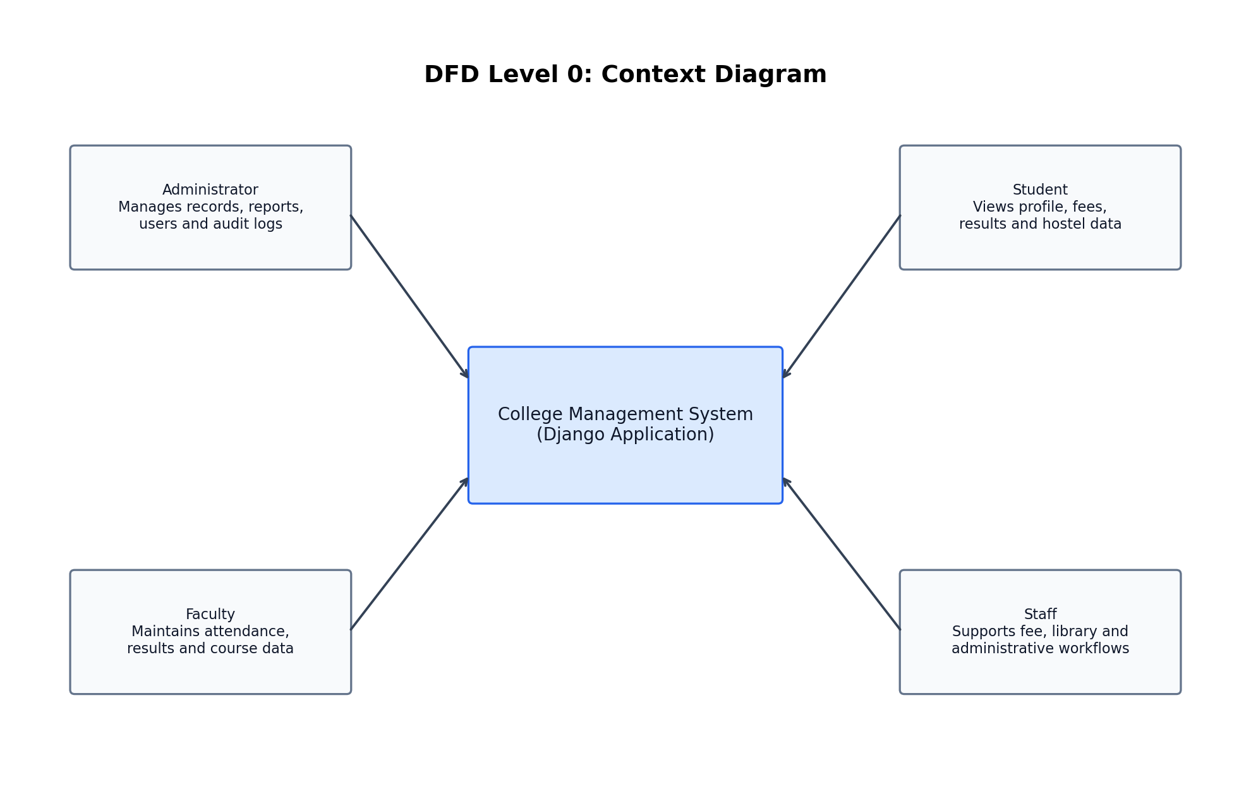
Figure: DFD Level 0 Context Diagram

Data Flow Diagram Level 1
The Level 1 diagram decomposes the system into major modules and shows how they interact with the central SQLite database.
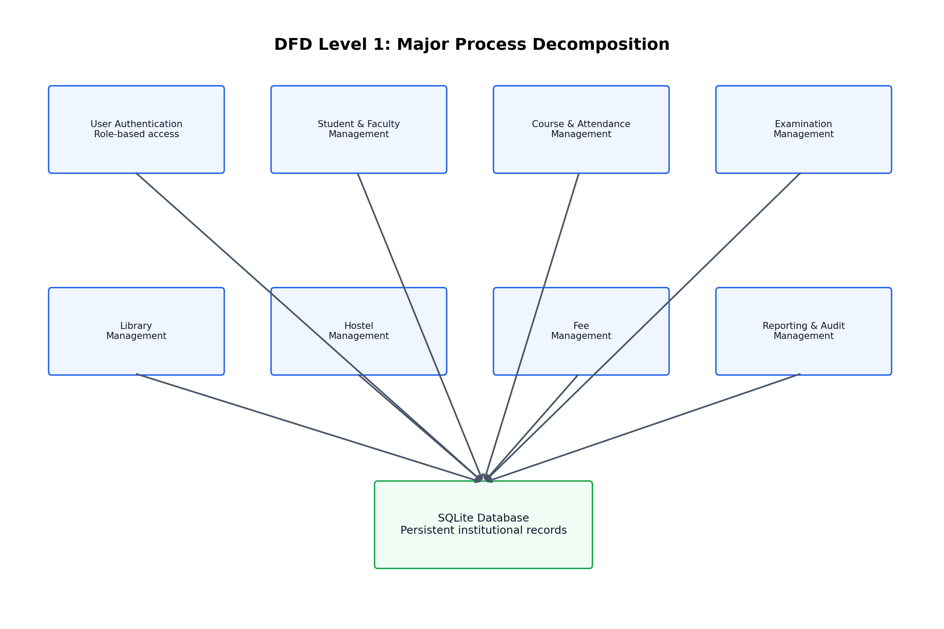
Figure: DFD Level 1 Process Diagram

Entity Relationship Diagram
The ER diagram shows important tables and relationships in the implemented database schema.
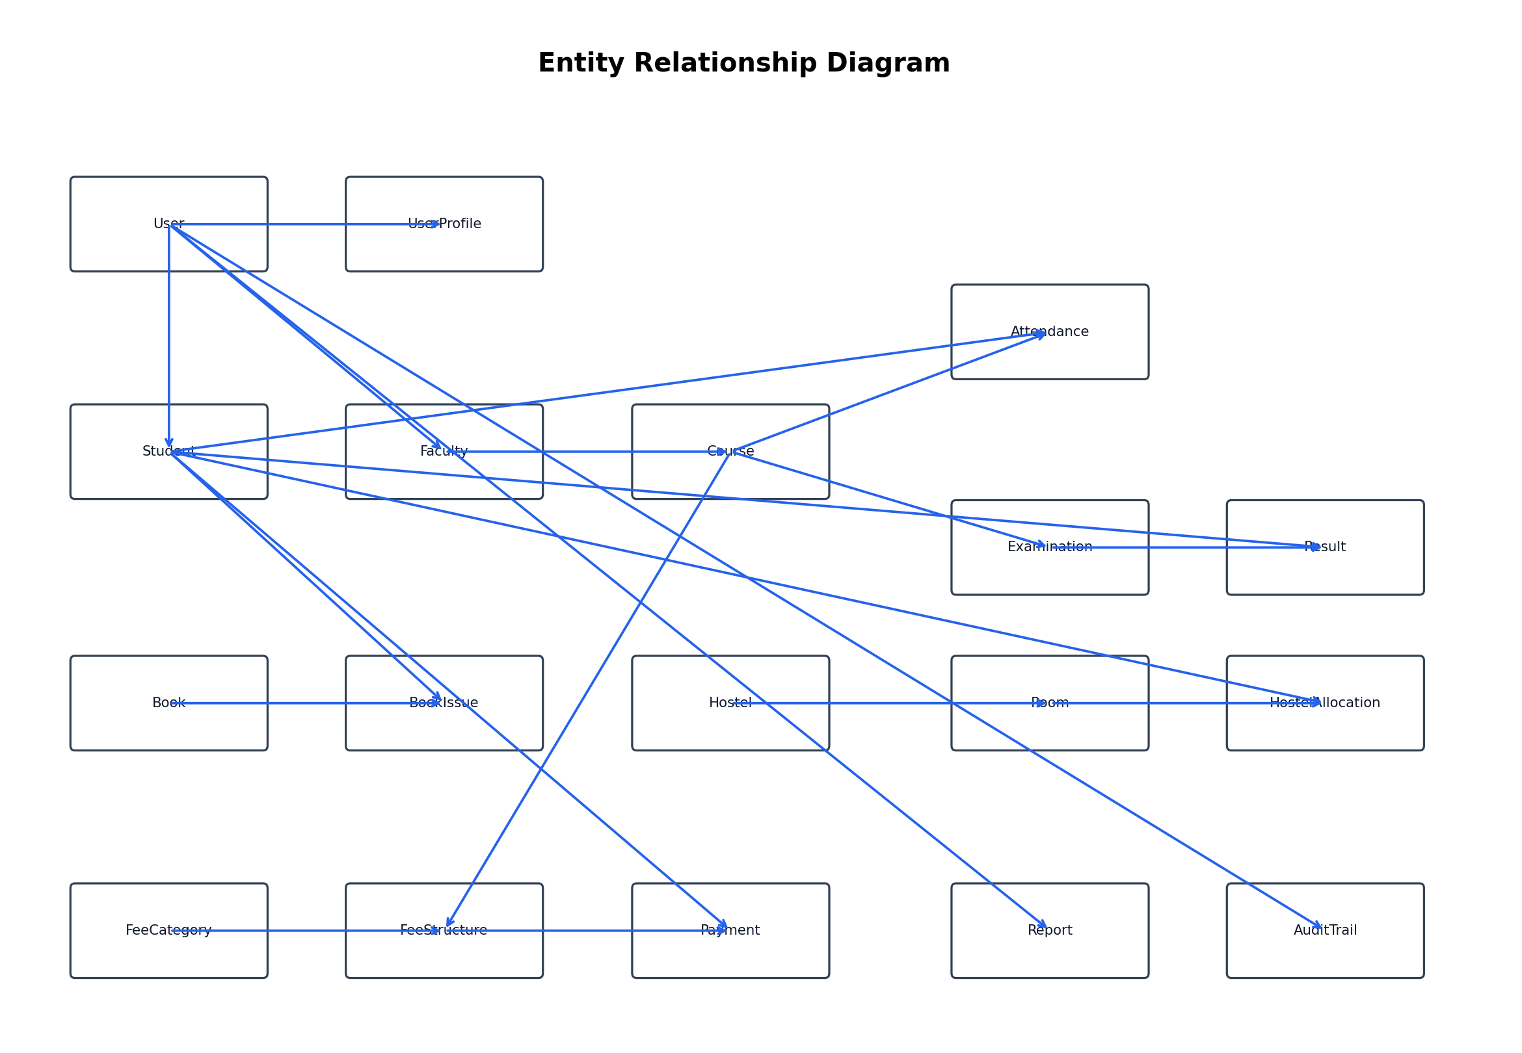
Figure: ER Diagram for CMS

Use Case Diagram
The use case diagram shows the interaction of administrators, faculty, students, and staff users with system functions.
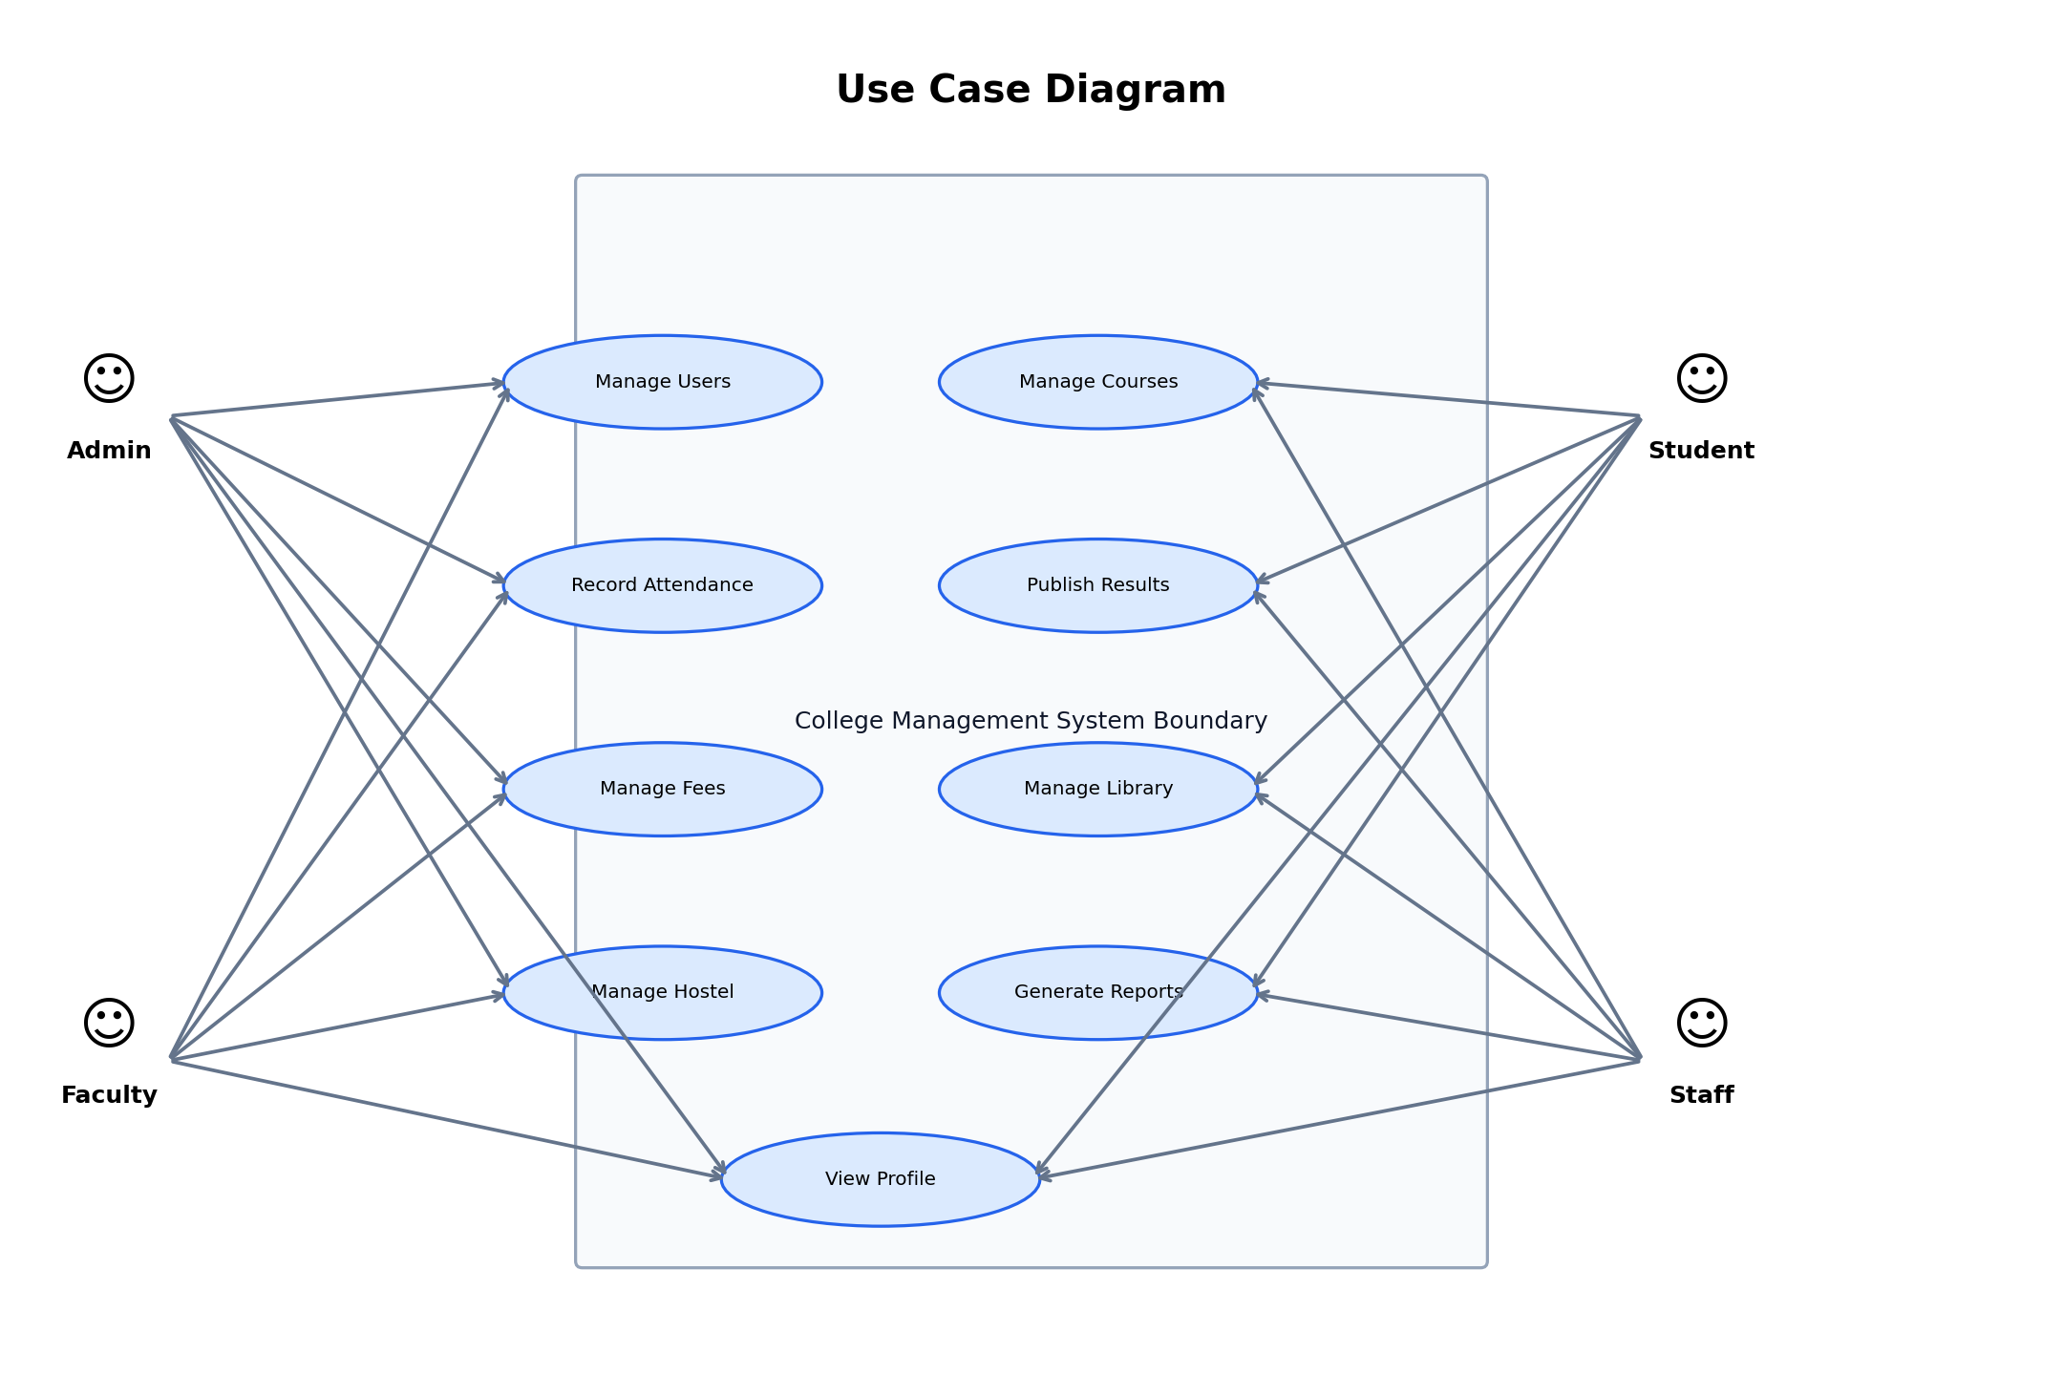
Figure: Use Case Diagram

Application Architecture Diagram
The architecture diagram explains the high-level request flow from browser to Django routing, templates, ORM, and SQLite storage.
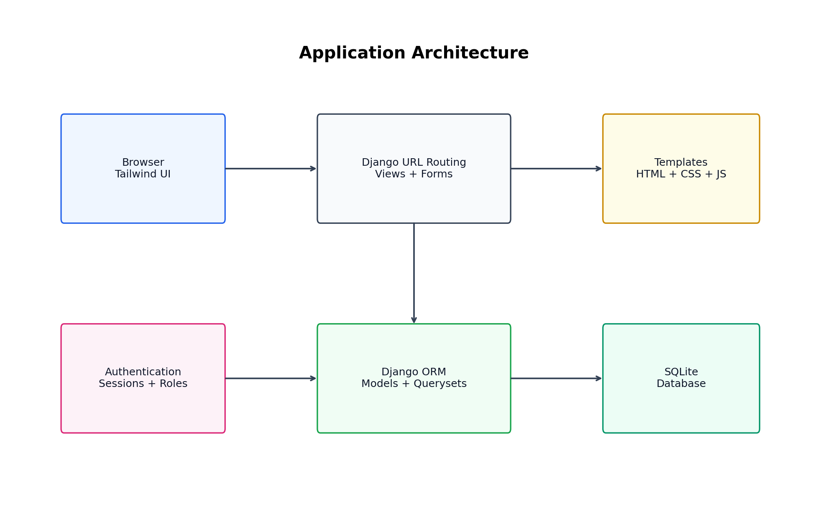
Figure: Application Architecture

Database Schema Overview
The database schema is implemented through Django models and migrations. The following table summarizes model counts currently available in the seeded SQLite database.
Model | Current Record Count
Attendance | 240
AuditTrail | 26
Book | 12
BookIssue | 10
Course | 8
DatabaseBackup | 1
Examination | 24
Faculty | 6
FeeCategory | 5
FeeStructure | 37
Hostel | 2
HostelAllocation | 10
Notification | 4
PasswordResetRequest | 0
Payment | 32
Report | 7
Result | 24
Room | 8
Student | 24
UserProfile | 32

Database Schema: UserProfile
Application: user_authentication. Database table: user_authentication_userprofile. This model participates in the College Management System persistence layer.
Field | Type | Constraint/Relationship
id | BigAutoField | Primary Key, Unique, Blank Allowed
user | OneToOneField | Unique, FK to User (CASCADE)
user_type | CharField | Standard field
profile_picture | ImageField | Nullable, Blank Allowed
phone_number | CharField | Nullable, Blank Allowed
address | TextField | Nullable, Blank Allowed
date_of_birth | DateField | Nullable, Blank Allowed
is_email_verified | BooleanField | Standard field
is_first_login | BooleanField | Standard field
created_at | DateTimeField | Blank Allowed
updated_at | DateTimeField | Blank Allowed

Database Schema: AuditTrail
Application: user_authentication. Database table: user_authentication_audittrail. This model participates in the College Management System persistence layer.
Field | Type | Constraint/Relationship
audit_id | AutoField | Primary Key, Unique, Blank Allowed
user | ForeignKey | Nullable, FK to User (SET_NULL)
action | CharField | Standard field
action_time | DateTimeField | Blank Allowed
ip_address | GenericIPAddressField | Nullable, Blank Allowed
user_agent | CharField | Nullable, Blank Allowed
module | CharField | Standard field
record_id | IntegerField | Nullable, Blank Allowed
description | TextField | Standard field

Database Schema: PasswordResetRequest
Application: user_authentication. Database table: user_authentication_passwordresetrequest. This model participates in the College Management System persistence layer.
Field | Type | Constraint/Relationship
request_id | UUIDField | Primary Key, Unique
user | ForeignKey | FK to User (CASCADE)
requested_at | DateTimeField | Blank Allowed
processed_at | DateTimeField | Nullable, Blank Allowed
processed_by | ForeignKey | Nullable, Blank Allowed, FK to User (SET_NULL)
status | CharField | Standard field
notes | TextField | Nullable, Blank Allowed

Database Schema: Student
Application: student_management. Database table: student_management_student. This model participates in the College Management System persistence layer.
Field | Type | Constraint/Relationship
student_id | AutoField | Primary Key, Unique, Blank Allowed
user | OneToOneField | Unique, FK to User (CASCADE)
name | CharField | Standard field
email | EmailField | Unique
course | ForeignKey | FK to Course (CASCADE)
year | IntegerField | Standard field
created_at | DateTimeField | Blank Allowed
updated_at | DateTimeField | Blank Allowed

Database Schema: Faculty
Application: faculty_management. Database table: faculty_management_faculty. This model participates in the College Management System persistence layer.
Field | Type | Constraint/Relationship
faculty_id | AutoField | Primary Key, Unique, Blank Allowed
user | OneToOneField | Unique, FK to User (CASCADE)
name | CharField | Standard field
email | EmailField | Unique
department | CharField | Standard field
created_at | DateTimeField | Blank Allowed
updated_at | DateTimeField | Blank Allowed

Database Schema: Course
Application: course_management. Database table: course_management_course. This model participates in the College Management System persistence layer.
Field | Type | Constraint/Relationship
course_id | AutoField | Primary Key, Unique, Blank Allowed
code | CharField | Unique
name | CharField | Standard field
faculty | ForeignKey | Nullable, Blank Allowed, FK to Faculty (CASCADE)
description | TextField | Nullable, Blank Allowed
credits | IntegerField | Standard field
is_active | BooleanField | Standard field
created_at | DateTimeField | Blank Allowed
updated_at | DateTimeField | Blank Allowed

Default Ordering: ['code', 'name']

Database Schema: Attendance
Application: attendance_management. Database table: attendance_management_attendance. This model participates in the College Management System persistence layer.
Field | Type | Constraint/Relationship
attendance_id | AutoField | Primary Key, Unique, Blank Allowed
student | ForeignKey | FK to Student (CASCADE)
course | ForeignKey | FK to Course (CASCADE)
date | DateField | Standard field
status | CharField | Standard field
created_at | DateTimeField | Blank Allowed
updated_at | DateTimeField | Blank Allowed

Unique Together Constraints: [('student', 'course', 'date')]

Database Schema: Examination
Application: examination. Database table: examination_examination. This model participates in the College Management System persistence layer.
Field | Type | Constraint/Relationship
exam_id | AutoField | Primary Key, Unique, Blank Allowed
course | ForeignKey | FK to Course (CASCADE)
exam_name | CharField | Standard field
exam_type | CharField | Standard field
date | DateTimeField | Standard field
duration | IntegerField | Standard field
total_marks | DecimalField | Standard field
passing_marks | DecimalField | Standard field
created_at | DateTimeField | Blank Allowed
updated_at | DateTimeField | Blank Allowed

Default Ordering: ['-date']

Database Schema: Result
Application: examination. Database table: examination_result. This model participates in the College Management System persistence layer.
Field | Type | Constraint/Relationship
result_id | AutoField | Primary Key, Unique, Blank Allowed
student | ForeignKey | FK to Student (CASCADE)
examination | ForeignKey | FK to Examination (CASCADE)
marks_obtained | DecimalField | Standard field
percentage | DecimalField | Nullable, Blank Allowed
grade | CharField | Nullable, Blank Allowed
status | CharField | Standard field
remarks | TextField | Nullable, Blank Allowed
created_at | DateTimeField | Blank Allowed
updated_at | DateTimeField | Blank Allowed

Unique Together Constraints: [('student', 'examination')]

Database Schema: Book
Application: library_management. Database table: library_management_book. This model participates in the College Management System persistence layer.
Field | Type | Constraint/Relationship
book_id | AutoField | Primary Key, Unique, Blank Allowed
title | CharField | Standard field
author | CharField | Standard field
isbn | CharField | Unique
publication | CharField | Standard field
availability | BooleanField | Standard field
created_at | DateTimeField | Blank Allowed
updated_at | DateTimeField | Blank Allowed

Database Schema: BookIssue
Application: library_management. Database table: library_management_bookissue. This model participates in the College Management System persistence layer.
Field | Type | Constraint/Relationship
issue_id | AutoField | Primary Key, Unique, Blank Allowed
student | ForeignKey | FK to Student (CASCADE)
book | ForeignKey | FK to Book (CASCADE)
issue_date | DateField | Blank Allowed
return_date | DateField | Standard field
actual_return_date | DateField | Nullable, Blank Allowed
fine_amount | DecimalField | Standard field
is_returned | BooleanField | Standard field
created_at | DateTimeField | Blank Allowed
updated_at | DateTimeField | Blank Allowed

Database Schema: Hostel
Application: hostel_management. Database table: hostel_management_hostel. This model participates in the College Management System persistence layer.
Field | Type | Constraint/Relationship
hostel_id | AutoField | Primary Key, Unique, Blank Allowed
hostel_name | CharField | Standard field
warden_name | CharField | Standard field
contact_number | CharField | Standard field
total_rooms | IntegerField | Standard field
created_at | DateTimeField | Blank Allowed
updated_at | DateTimeField | Blank Allowed

Database Schema: Room
Application: hostel_management. Database table: hostel_management_room. This model participates in the College Management System persistence layer.
Field | Type | Constraint/Relationship
room_id | AutoField | Primary Key, Unique, Blank Allowed
hostel | ForeignKey | FK to Hostel (CASCADE)
room_number | CharField | Standard field
capacity | IntegerField | Standard field
status | CharField | Standard field
created_at | DateTimeField | Blank Allowed
updated_at | DateTimeField | Blank Allowed

Unique Together Constraints: [('hostel', 'room_number')]

Database Schema: HostelAllocation
Application: hostel_management. Database table: hostel_management_hostelallocation. This model participates in the College Management System persistence layer.
Field | Type | Constraint/Relationship
allocation_id | AutoField | Primary Key, Unique, Blank Allowed
student | OneToOneField | Unique, FK to Student (CASCADE)
room | ForeignKey | FK to Room (CASCADE)
allocation_date | DateField | Blank Allowed
end_date | DateField | Nullable, Blank Allowed
is_active | BooleanField | Standard field
created_at | DateTimeField | Blank Allowed
updated_at | DateTimeField | Blank Allowed

Database Schema: FeeCategory
Application: fee_management. Database table: fee_management_feecategory. This model participates in the College Management System persistence layer.
Field | Type | Constraint/Relationship
fee_category_id | AutoField | Primary Key, Unique, Blank Allowed
name | CharField | Standard field
description | TextField | Nullable, Blank Allowed
created_at | DateTimeField | Blank Allowed
updated_at | DateTimeField | Blank Allowed

Database Schema: FeeStructure
Application: fee_management. Database table: fee_management_feestructure. This model participates in the College Management System persistence layer.
Field | Type | Constraint/Relationship
fee_structure_id | AutoField | Primary Key, Unique, Blank Allowed
category | ForeignKey | FK to FeeCategory (CASCADE)
course | ForeignKey | FK to Course (CASCADE)
amount | DecimalField | Standard field
academic_year | CharField | Standard field
due_date | DateField | Standard field
created_at | DateTimeField | Blank Allowed
updated_at | DateTimeField | Blank Allowed

Unique Together Constraints: [('category', 'course', 'academic_year')]

Database Schema: Payment
Application: fee_management. Database table: fee_management_payment. This model participates in the College Management System persistence layer.
Field | Type | Constraint/Relationship
payment_id | AutoField | Primary Key, Unique, Blank Allowed
student | ForeignKey | FK to Student (CASCADE)
fee_structure | ForeignKey | FK to FeeStructure (CASCADE)
amount | DecimalField | Standard field
payment_date | DateField | Blank Allowed
payment_method | CharField | Standard field
transaction_id | CharField | Nullable, Blank Allowed
status | CharField | Standard field
receipt_number | CharField | Unique
remarks | TextField | Nullable, Blank Allowed
created_at | DateTimeField | Blank Allowed
updated_at | DateTimeField | Blank Allowed

Database Schema: Notification
Application: reporting. Database table: reporting_notification. This model participates in the College Management System persistence layer.
Field | Type | Constraint/Relationship
id | BigAutoField | Primary Key, Unique, Blank Allowed
user | ForeignKey | FK to User (CASCADE)
message | CharField | Standard field
notification_type | CharField | Standard field
link | CharField | Nullable, Blank Allowed
created_at | DateTimeField | Blank Allowed
read | BooleanField | Standard field
read_at | DateTimeField | Nullable, Blank Allowed

Default Ordering: ['-created_at']

Database Schema: Report
Application: reporting. Database table: reporting_report. This model participates in the College Management System persistence layer.
Field | Type | Constraint/Relationship
report_id | AutoField | Primary Key, Unique, Blank Allowed
title | CharField | Standard field
description | TextField | Nullable, Blank Allowed
report_type | CharField | Standard field
generated_by | ForeignKey | FK to User (CASCADE)
generation_date | DateTimeField | Blank Allowed
is_scheduled | BooleanField | Standard field
schedule_frequency | CharField | Nullable, Blank Allowed
last_run | DateTimeField | Nullable, Blank Allowed
parameters | JSONField | Blank Allowed
file_path | CharField | Nullable, Blank Allowed
created_at | DateTimeField | Blank Allowed
updated_at | DateTimeField | Blank Allowed
report_data | TextField | Nullable, Blank Allowed
report_file | FileField | Nullable, Blank Allowed

Database Schema: DatabaseBackup
Application: reporting. Database table: reporting_databasebackup. This model participates in the College Management System persistence layer.
Field | Type | Constraint/Relationship
backup_id | AutoField | Primary Key, Unique, Blank Allowed
backup_file | CharField | Standard field
backup_date | DateTimeField | Standard field
backup_size | IntegerField | Standard field
created_by | ForeignKey | Nullable, Blank Allowed, FK to User (SET_NULL)
is_automatic | BooleanField | Standard field
status | CharField | Standard field
notes | TextField | Nullable, Blank Allowed

Default Ordering: ['-backup_date']

Coding: Email Based Login Form
This snippet shows email-based authentication. The form locates active users by email and delegates password checking to Django's authentication backend so password validation remains case-sensitive.
class LoginForm(AuthenticationForm):
error_messages = {
'invalid_login': "Please enter a correct email and password. Passwords are case-sensitive.",
'inactive': "This account is inactive.",
}
username = forms.EmailField(label='Email', widget=forms.EmailInput(attrs={
'class': 'form-control',
'placeholder': 'Email address',
'autocomplete': 'email',
}))
password = forms.CharField(widget=forms.PasswordInput(attrs={
'class': 'form-control',
'placeholder': 'Password',
'autocomplete': 'current-password',
}))
def clean(self):
email = self.cleaned_data.get('username')
password = self.cleaned_data.get('password')
if email is not None and password:
users = User.objects.filter(email__iexact=email, is_active=True)
# Django's password hash check is case-sensitive; pass the exact
# password string through without normalization.
matching_users = []
for user in users:
authenticated_user = authenticate(
self.request,
username=user.get_username(),
password=password,
)
if authenticated_user is not None:
matching_users.append(authenticated_user)
if not matching_users:
raise self.get_invalid_login_error()
if len(matching_users) > 1:
raise forms.ValidationError(
"Multiple active accounts match this email and password. Please contact an administrator.",
code='duplicate_email_password',
)

Coding: Login and Logout Audit Signals
This snippet shows centralized audit logging for authentication events. It records user, action, module, record id, IP address, user agent, and description.
def log_user_login(sender, request, user, **kwargs):
AuditTrail.objects.create(
user=user,
action='login',
module='authentication',
record_id=user.id,
description=f'{user.get_username()} signed in',
ip_address=_request_ip(request),
user_agent=_request_user_agent(request),
)
@receiver(user_logged_out)
def log_user_logout(sender, request, user, **kwargs):
if user is None:
return
AuditTrail.objects.create(
user=user,
action='logout',
module='authentication',
record_id=user.id,
description=f'{user.get_username()} signed out',
ip_address=_request_ip(request),
user_agent=_request_user_agent(request),
)

Coding: Activity Log Filtering View
This snippet shows dynamic filtering by module, action, user, search text, and date range. It also prepares pagination and CSV export context.
def system_activity_logs(request):
"""View for detailed system activity logs with filtering"""
module_filter = request.GET.get('module', '')
action_filter = request.GET.get('action', '')
date_from_str = request.GET.get('date_from', '')
date_to_str = request.GET.get('date_to', '')
user_filter = request.GET.get('user_filter', '')
search_query = request.GET.get('search', '')
export_format = request.GET.get('export', '')
profile = getattr(request.user, 'profile', None)
user_type = getattr(profile, 'user_type', None)
is_admin_user = request.user.is_superuser or user_type == 'admin'
if is_admin_user:
visible_activities = AuditTrail.objects.select_related('user', 'user__profile').all()
else:
visible_activities = get_relevant_activities(request.user, limit=None).select_related('user', 'user__profile')
total_activity_count = visible_activities.count()
activities = visible_activities
date_error = ''
date_from = None
date_to = None
if date_from_str:
try:
parsed_from = datetime.datetime.strptime(date_from_str, '%Y-%m-%d').date()
date_from = timezone.make_aware(
datetime.datetime.combine(parsed_from, datetime.time.min),
timezone.get_current_timezone()
)
except ValueError:
date_error = 'Invalid start date ignored.'
if date_to_str:
try:
parsed_to = datetime.datetime.strptime(date_to_str, '%Y-%m-%d').date()
date_to = timezone.make_aware(
datetime.datetime.combine(parsed_to, datetime.time.max),
timezone.get_current_timezone()
)

Coding: Student Model
The student model links a student to a Django User and a Course, preserving a normalized academic record.
class Student(models.Model):
student_id = models.AutoField(primary_key=True)
user = models.OneToOneField(User, on_delete=models.CASCADE, related_name='student_profile')
name = models.CharField(max_length=100)
email = models.EmailField(unique=True)
course = models.ForeignKey('course_management.Course', on_delete=models.CASCADE)
year = models.IntegerField()
created_at = models.DateTimeField(auto_now_add=True)
updated_at = models.DateTimeField(auto_now=True)
def __str__(self):
return f"{self.name} ({self.formatted_id})"
@property
def formatted_id(self):
"""Return the student ID formatted as ST000001, ST000002, etc.
Note: This is for display purposes only. The actual student_id field
remains an integer (AutoField) in the database. This property allows us
to show student IDs in a consistent format throughout the application
while maintaining database integrity with proper data types.
"""
return f"ST{self.student_id:06d}"

Coding: Attendance Model
The attendance model stores student, course, date, and status. The unique constraint prevents duplicate attendance rows for the same date and course.
class Attendance(models.Model):
ATTENDANCE_STATUS = (
('present', 'Present'),
('absent', 'Absent'),
('late', 'Late'),
('excused', 'Excused'),
)
attendance_id = models.AutoField(primary_key=True)
student = models.ForeignKey('student_management.Student', on_delete=models.CASCADE, related_name='attendances')
course = models.ForeignKey('course_management.Course', on_delete=models.CASCADE, related_name='attendances')
date = models.DateField()
status = models.CharField(max_length=10, choices=ATTENDANCE_STATUS)
created_at = models.DateTimeField(auto_now_add=True)
updated_at = models.DateTimeField(auto_now=True)
class Meta:
unique_together = ('student', 'course', 'date')
def __str__(self):
return f"{self.student.name} - {self.course.name} - {self.date} - {self.status}"

Coding: Result Calculation
The Result model calculates percentage, pass/fail status, and grade before saving the row.
def save(self, *args, **kwargs):
# Calculate percentage
if self.marks_obtained and self.examination.total_marks:
self.percentage = (self.marks_obtained / self.examination.total_marks) * 100
# Determine status
if self.marks_obtained >= self.examination.passing_marks:
self.status = 'pass'
else:
self.status = 'fail'
# Assign grade based on percentage
if self.percentage >= 90:
self.grade = 'A+'
elif self.percentage >= 80:
self.grade = 'A'
elif self.percentage >= 70:
self.grade = 'B+'
elif self.percentage >= 60:
self.grade = 'B'
elif self.percentage >= 50:
self.grade = 'C+'
elif self.percentage >= 40:
self.grade = 'C'
elif self.percentage >= 33:
self.grade = 'D'
else:
self.grade = 'F'
super().save(*args, **kwargs)

Coding: Fee Payment Model
The Payment model stores fee payment details, payment method, transaction id, status, and unique receipt number.
class Payment(models.Model):
PAYMENT_STATUS = (
('pending', 'Pending'),
('completed', 'Completed'),
('failed', 'Failed'),
('refunded', 'Refunded'),
)
PAYMENT_METHODS = (
('cash', 'Cash'),
('credit_card', 'Credit Card'),
('debit_card', 'Debit Card'),
('bank_transfer', 'Bank Transfer'),
('online_payment', 'Online Payment'),
)
payment_id = models.AutoField(primary_key=True)
student = models.ForeignKey('student_management.Student', on_delete=models.CASCADE, related_name='payments')
fee_structure = models.ForeignKey(FeeStructure, on_delete=models.CASCADE, related_name='payments')
amount = models.DecimalField(max_digits=10, decimal_places=2)
payment_date = models.DateField(auto_now_add=True)
payment_method = models.CharField(max_length=20, choices=PAYMENT_METHODS)
transaction_id = models.CharField(max_length=100, null=True, blank=True)
status = models.CharField(max_length=20, choices=PAYMENT_STATUS, default='pending')
receipt_number = models.CharField(max_length=50, unique=True)
remarks = models.TextField(null=True, blank=True)
created_at = models.DateTimeField(auto_now_add=True)
updated_at = models.DateTimeField(auto_now=True)
def __str__(self):
return f"{self.student.name} - {self.fee_structure.category.name} - {self.payment_date} - ${self.amount}"

Coding: Base Tailwind Layout
The base template loads Tailwind CDN, defines responsive navigation, renders messages, and provides shared layout blocks.
<!DOCTYPE html>
{% load static %}
<html lang="en">
<head>
<meta charset="UTF-8">
<meta name="viewport" content="width=device-width, initial-scale=1.0">
<title>{% block title %}College Management System{% endblock %}</title>
<script src="https://cdn.tailwindcss.com"></script>
<link rel="stylesheet" href="https://cdnjs.cloudflare.com/ajax/libs/font-awesome/6.0.0/css/all.min.css">
<link rel="stylesheet" href="{% static 'css/tailwind-compat.css' %}">
{% block extra_css %}{% endblock %}
</head>
<body class="min-h-screen bg-slate-100 text-slate-900 antialiased">
{% with user_type=user.profile.user_type|default:'' %}
{% if user.is_authenticated %}
<div class="min-h-screen lg:flex">
<div id="sidebarBackdrop" class="fixed inset-0 z-30 hidden bg-slate-950/50 lg:hidden"></div>
<aside id="appSidebar" class="fixed inset-y-0 left-0 z-40 flex w-72 -translate-x-full flex-col border-r border-slate-800 bg-slate-950 text-slate-100 shadow-2xl transition-transform duration-200 lg:translate-x-0">
<div class="flex h-16 items-center gap-3 border-b border-slate-800 px-5">
<div class="grid h-10 w-10 place-items-center rounded-xl bg-blue-600 text-white">
<i class="fas fa-university"></i>
</div>
<div>
<a href="{% url 'home' %}" class="block text-base font-bold tracking-wide text-white">College MS</a>
<span class="text-xs text-slate-400">Management Portal</span>
</div>
</div>
<nav class="flex-1 space-y-5 overflow-y-auto px-4 py-5 text-sm">
<a href="{% url 'home' %}" class="flex items-center gap-3 rounded-xl px-3 py-2.5 font-semibold text-slate-200 hover:bg-slate-800 hover:text-white">
<i class="fas fa-home w-5 text-blue-300"></i> Dashboard
</a>
{% if user_type == 'admin' or user.is_staff %}
<section>
<p class="px-3 pb-2 text-xs font-bold uppercase tracking-wider text-slate-500">Administration</p>
<details class="group">
<summary class="flex cursor-pointer list-none items-center justify-between rounded-xl px-3 py-2.5 font-semibold hover:bg-slate-800">
<span><i class="fas fa-user-graduate mr-3 w-5 text-blue-300"></i>Students</span>
<i class="fas fa-chevron-down text-xs text-slate-500 group-open:rotate-180"></i>
</summary>
<div class="mt-1 space-y-1 pl-10">

Coding: Activity Logs Template
The template provides one filter form, responsive summary cards, a horizontally scrollable table, pagination, and CSV export link.
{% block title %}System Activity Logs | College Management System{% endblock %}
{% block content %}
<div class="space-y-6">
<div class="flex flex-col gap-4 sm:flex-row sm:items-center sm:justify-between">
<div>
<p class="text-sm font-medium text-slate-500">Security and operations</p>
<h1 class="text-2xl font-bold tracking-tight text-slate-950 sm:text-3xl">System Activity Logs</h1>
</div>
<div class="flex flex-wrap gap-2">
<a href="{% url 'admin_dashboard' %}" class="inline-flex items-center gap-2 rounded-lg border border-slate-300 bg-white px-4 py-2 text-sm font-semibold text-slate-700 shadow-sm hover:bg-slate-50">
<i class="fas fa-arrow-left"></i>
Dashboard
</a>
<a href="?{% if filter_querystring %}{{ filter_querystring }}&{% endif %}export=csv" class="inline-flex items-center gap-2 rounded-lg bg-emerald-600 px-4 py-2 text-sm font-semibold text-white shadow-sm hover:bg-emerald-700">
<i class="fas fa-file-csv"></i>
Export CSV
</a>
</div>
</div>
<div class="grid gap-4 md:grid-cols-3">
<div class="rounded-xl border border-slate-200 bg-white p-5 shadow-sm">
<p class="text-sm font-medium text-slate-500">Visible Logs</p>
<p class="mt-2 text-3xl font-bold text-slate-950">{{ total_activity_count }}</p>
</div>
<div class="rounded-xl border border-slate-200 bg-white p-5 shadow-sm">
<p class="text-sm font-medium text-slate-500">Filtered Results</p>
<p class="mt-2 text-3xl font-bold text-blue-700">{{ filtered_activity_count }}</p>
</div>
<div class="rounded-xl border border-slate-200 bg-white p-5 shadow-sm">
<p class="text-sm font-medium text-slate-500">Active Filters</p>
<p class="mt-2 text-3xl font-bold text-slate-950">{{ active_filter_count }}</p>
</div>
</div>
{% if date_error %}
<div class="rounded-lg border border-amber-200 bg-amber-50 px-4 py-3 text-sm text-amber-800">
{{ date_error }}
</div>
{% endif %}

Coding: Database Backup Utility
The backup utility supports operational maintenance by creating copies of the SQLite database and recording backup metadata.
--manual Marks the backup as manually triggered (default is automatic)
--notes Additional notes about the backup
"""
import os
import sys
import datetime
import argparse
import shutil
import django
# Add the project root directory to the Python path
script_dir = os.path.dirname(os.path.abspath(__file__))
project_dir = os.path.dirname(script_dir)
sys.path.append(project_dir)
# Set up Django environment
os.environ.setdefault('DJANGO_SETTINGS_MODULE', 'college_management_system.settings')
django.setup()
from django.conf import settings
from django.utils import timezone
from django.contrib.auth.models import User
from reporting.models import DatabaseBackup
def create_backup(is_automatic=True, notes=None, user=None):
"""
Create a database backup and record it in the DatabaseBackup model.
Args:
is_automatic (bool): Whether the backup was triggered automatically
notes (str): Additional notes about the backup
user (User): The user who initiated the backup (for manual backups)
Returns:
DatabaseBackup: The created backup record
"""
try:
# Create backup directory if it doesn't exist
backup_dir = os.path.join(project_dir, 'backups')
os.makedirs(backup_dir, exist_ok=True)

Testing
Testing was performed using Django system checks, migration checks, test-client route verification, authentication checks, CSV export checks, and Chrome DevTools responsive inspection. The table below summarizes major test cases.
Test ID | Test Scenario | Expected Result | Result
TC-01 | Login with admin email and valid password | User is redirected to admin dashboard | Pass
TC-02 | Login with wrong password case | Login is rejected because password is case-sensitive | Pass
TC-03 | Open student list as admin | Student records from database are displayed | Pass
TC-04 | Open faculty list as admin | Faculty records and departments are displayed | Pass
TC-05 | Open course dashboard | Course statistics and recent courses are displayed | Pass
TC-06 | Filter activity logs by action=login | Only login-related audit events appear | Pass
TC-07 | Export activity logs as CSV | CSV response contains log columns and rows | Pass
TC-08 | Open attendance detail | Attendance row renders with linked student and course | Pass
TC-09 | Open examination result detail | Result renders with marks, grade, percentage, and status | Pass
TC-10 | Open payment detail | Payment receipt and status information render correctly | Pass
TC-11 | Open library book detail | Book and issue history appear | Pass
TC-12 | Open hostel allocation detail | Student-room allocation appears | Pass
TC-13 | Open report dashboard | Report summaries and notifications render | Pass
TC-14 | Mobile login page visual check | No horizontal overflow and form fits viewport | Pass
TC-15 | Mobile activity log page visual check | No document-level horizontal overflow | Pass

Testing Detail: TC-01
Scenario: Login with admin email and valid password.
Expected Result: User is redirected to admin dashboard.
Actual Result: Pass. The validation confirms that the implemented module is connected to dynamic database records and behaves according to the project objectives.

Testing Detail: TC-02
Scenario: Login with wrong password case.
Expected Result: Login is rejected because password is case-sensitive.
Actual Result: Pass. The validation confirms that the implemented module is connected to dynamic database records and behaves according to the project objectives.

Testing Detail: TC-03
Scenario: Open student list as admin.
Expected Result: Student records from database are displayed.
Actual Result: Pass. The validation confirms that the implemented module is connected to dynamic database records and behaves according to the project objectives.

Testing Detail: TC-04
Scenario: Open faculty list as admin.
Expected Result: Faculty records and departments are displayed.
Actual Result: Pass. The validation confirms that the implemented module is connected to dynamic database records and behaves according to the project objectives.

Testing Detail: TC-05
Scenario: Open course dashboard.
Expected Result: Course statistics and recent courses are displayed.
Actual Result: Pass. The validation confirms that the implemented module is connected to dynamic database records and behaves according to the project objectives.

Testing Detail: TC-06
Scenario: Filter activity logs by action=login.
Expected Result: Only login-related audit events appear.
Actual Result: Pass. The validation confirms that the implemented module is connected to dynamic database records and behaves according to the project objectives.

Testing Detail: TC-07
Scenario: Export activity logs as CSV.
Expected Result: CSV response contains log columns and rows.
Actual Result: Pass. The validation confirms that the implemented module is connected to dynamic database records and behaves according to the project objectives.

Testing Detail: TC-08
Scenario: Open attendance detail.
Expected Result: Attendance row renders with linked student and course.
Actual Result: Pass. The validation confirms that the implemented module is connected to dynamic database records and behaves according to the project objectives.

Testing Detail: TC-09
Scenario: Open examination result detail.
Expected Result: Result renders with marks, grade, percentage, and status.
Actual Result: Pass. The validation confirms that the implemented module is connected to dynamic database records and behaves according to the project objectives.

Testing Detail: TC-10
Scenario: Open payment detail.
Expected Result: Payment receipt and status information render correctly.
Actual Result: Pass. The validation confirms that the implemented module is connected to dynamic database records and behaves according to the project objectives.

Testing Detail: TC-11
Scenario: Open library book detail.
Expected Result: Book and issue history appear.
Actual Result: Pass. The validation confirms that the implemented module is connected to dynamic database records and behaves according to the project objectives.

Testing Detail: TC-12
Scenario: Open hostel allocation detail.
Expected Result: Student-room allocation appears.
Actual Result: Pass. The validation confirms that the implemented module is connected to dynamic database records and behaves according to the project objectives.

Testing Detail: TC-13
Scenario: Open report dashboard.
Expected Result: Report summaries and notifications render.
Actual Result: Pass. The validation confirms that the implemented module is connected to dynamic database records and behaves according to the project objectives.

Testing Detail: TC-14
Scenario: Mobile login page visual check.
Expected Result: No horizontal overflow and form fits viewport.
Actual Result: Pass. The validation confirms that the implemented module is connected to dynamic database records and behaves according to the project objectives.

Testing Detail: TC-15
Scenario: Mobile activity log page visual check.
Expected Result: No document-level horizontal overflow.
Actual Result: Pass. The validation confirms that the implemented module is connected to dynamic database records and behaves according to the project objectives.

Implementation Overview
Implementation begins by setting up Python, installing Django and project dependencies, applying migrations, and running the development server. The application is then accessed through a browser at the configured host and port.
The current development server uses Django runserver with local static serving for testing. In production, static files should be collected and served through a web server or CDN.

Deployment Process
Deployment involves preparing environment variables, setting DEBUG to False, configuring ALLOWED_HOSTS, applying migrations, collecting static files, and running the Django application behind a WSGI or ASGI server.
For production-scale use, SQLite should be replaced with PostgreSQL or MySQL. Database backups should be scheduled and stored securely.

Environment Setup
The development environment uses Python 3.10, Django, SQLite, PowerShell, Chrome for responsive verification, and project assets under static and templates directories.
The project can be started with: python manage.py runserver 127.0.0.1:8000 --insecure in the current local setup because DEBUG is false and local static CSS is needed during verification.

Data Seeding
The database was reset and seeded with realistic dummy data including role accounts, students, faculty, courses, attendance, examinations, results, books, book issues, hostels, rooms, allocations, fees, payments, reports, notifications, and audit rows.
Seeded data supports end-to-end testing and makes screenshots meaningful for submission.

Security Implementation
Security is implemented through Django's password hashing, session authentication, CSRF protection, login-required decorators, user profile roles, and audit logging. The login form uses email but authenticates through Django's secure backend.
Future hardening should add object-level permission checks, HTTPS-only cookies, password complexity policies, rate limiting, and detailed audit coverage for all CRUD events.

Screenshots of Project
The following screenshots were captured from the live Django application. They demonstrate the working user interface, dynamic database records, role-aware screens, and responsive Tailwind layout.

Screenshot: Login Page
The login page uses email-based authentication and a responsive Tailwind card layout.
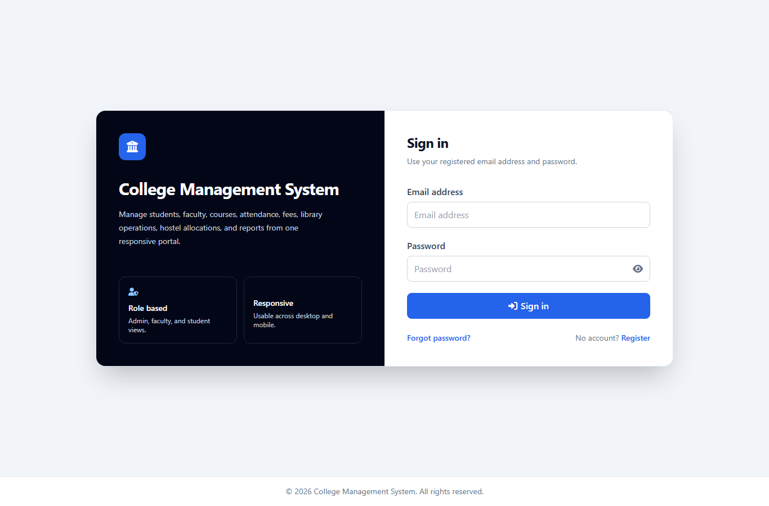
Screenshot: Login Page

Screenshot: Admin Dashboard
The dashboard shows institutional metrics and module summaries for administrative users.
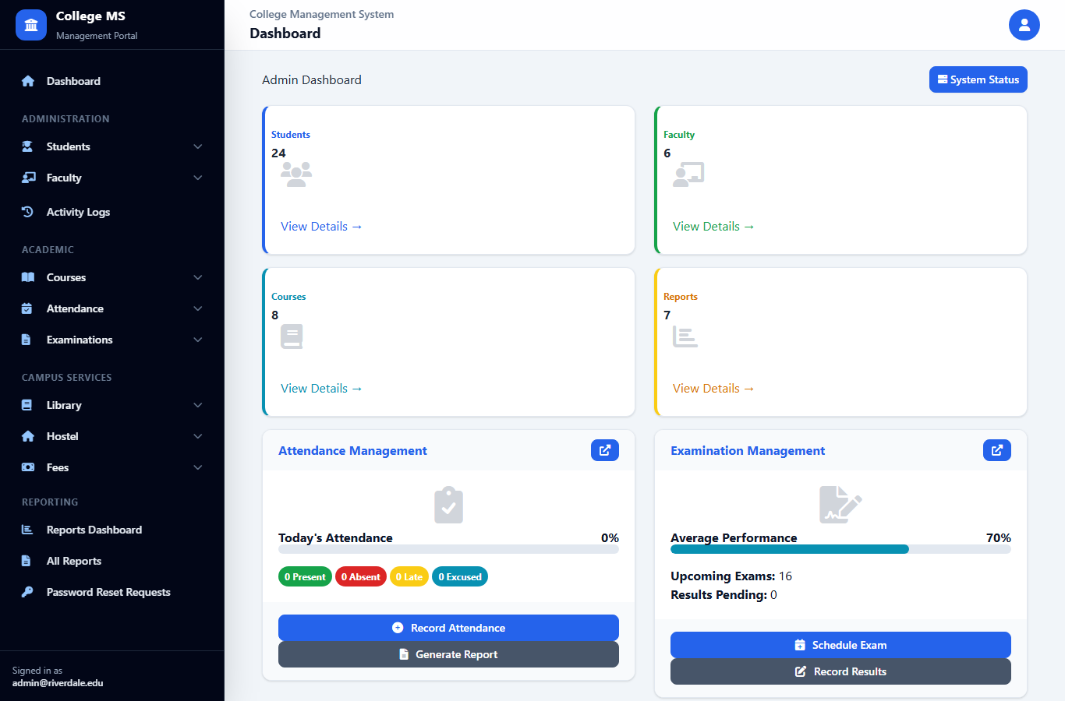
Screenshot: Admin Dashboard

Screenshot: Student Profile / Detail
The student detail screen displays academic identity, linked course, and related workflows.
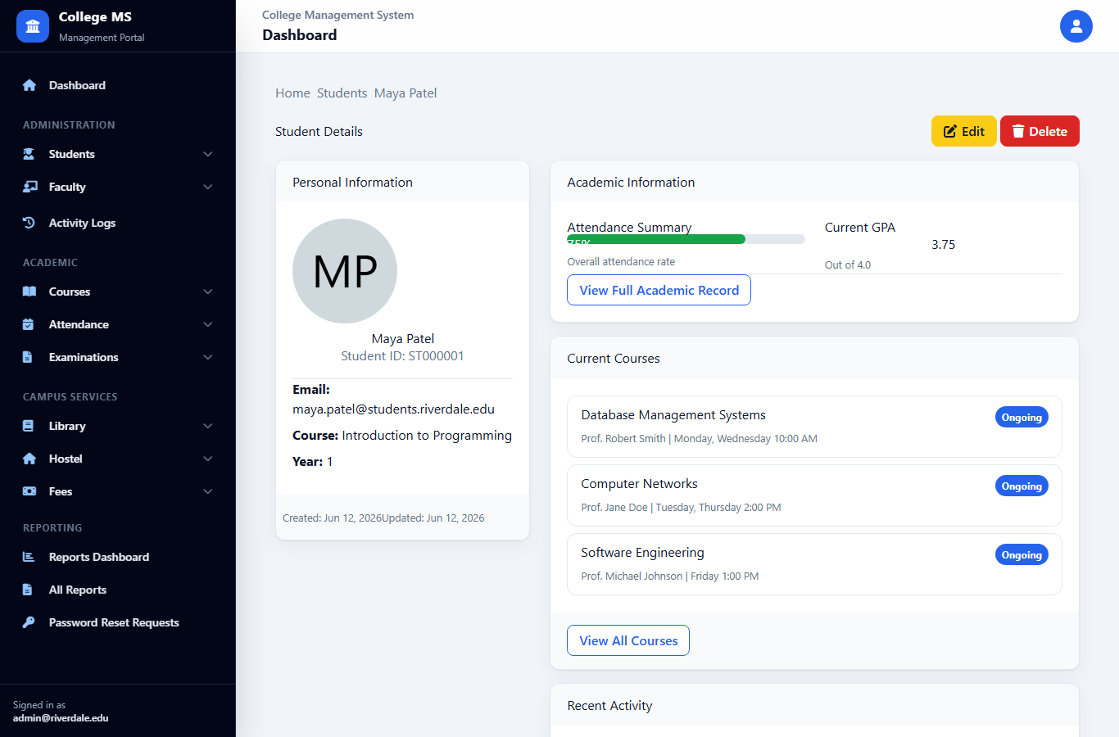
Screenshot: Student Profile / Detail

Screenshot: Faculty Module
The faculty module lists faculty members, departments, and available actions.
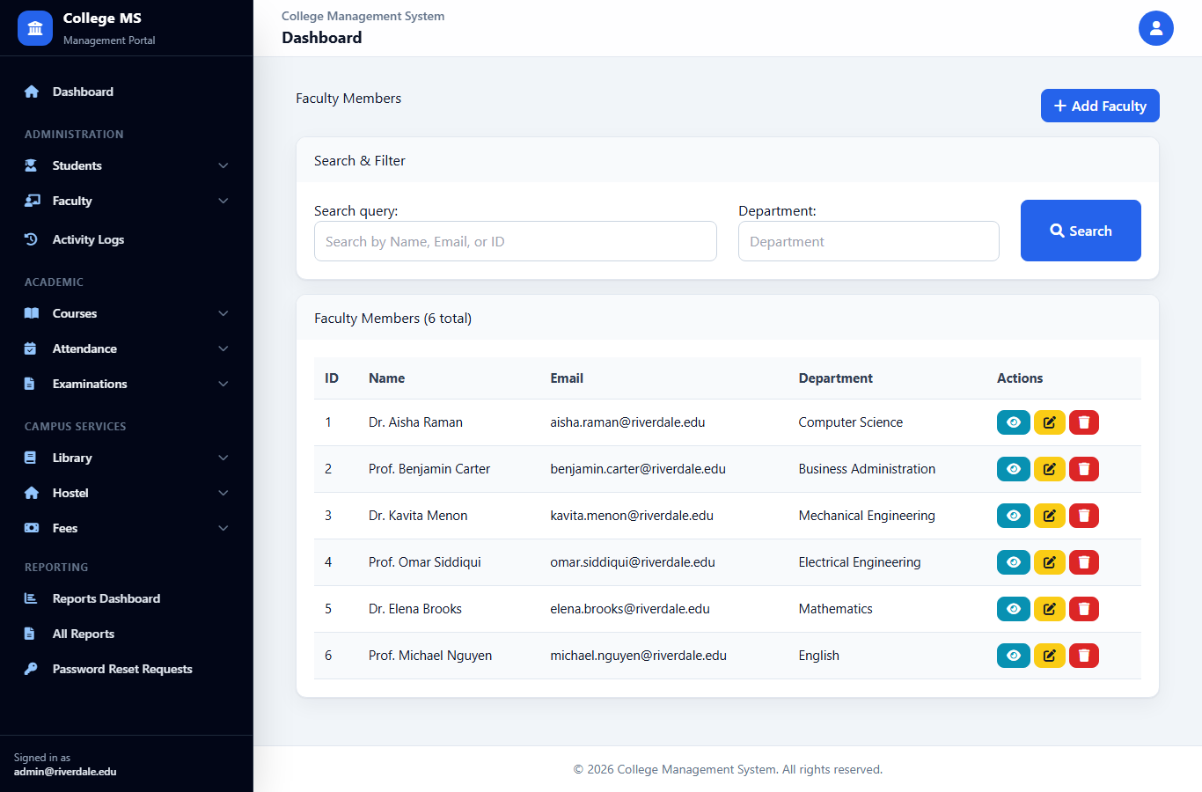
Screenshot: Faculty Module

Screenshot: Course Dashboard
The course dashboard summarizes active courses, credits, and recent course data.
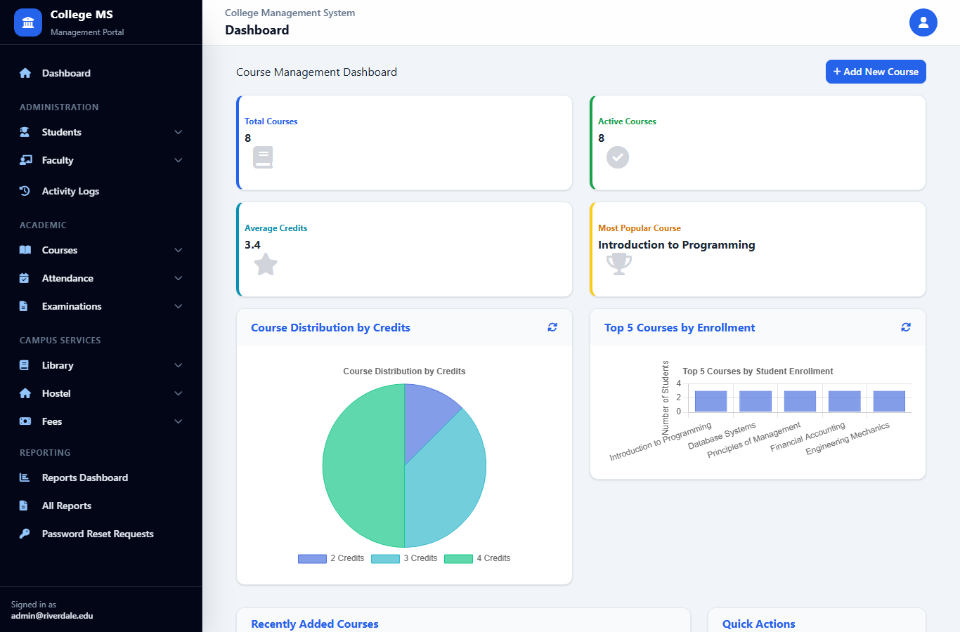
Screenshot: Course Dashboard

Screenshot: Attendance Module
The attendance module displays real attendance rows connected to students and courses.
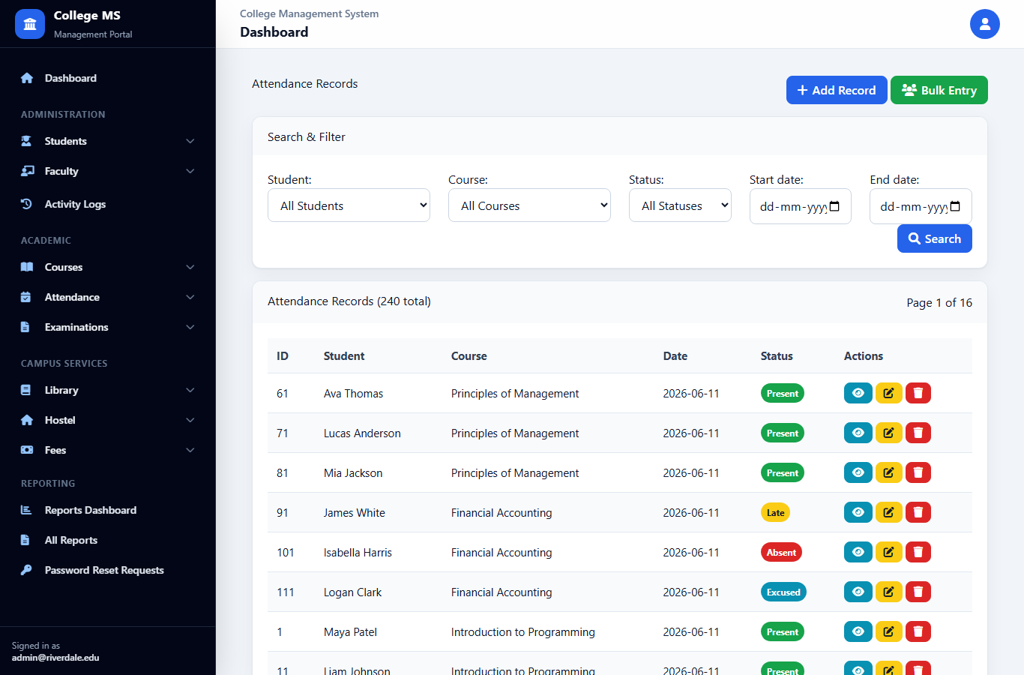
Screenshot: Attendance Module

Screenshot: Reports Dashboard
The reporting dashboard provides generated report metadata and operational summaries.
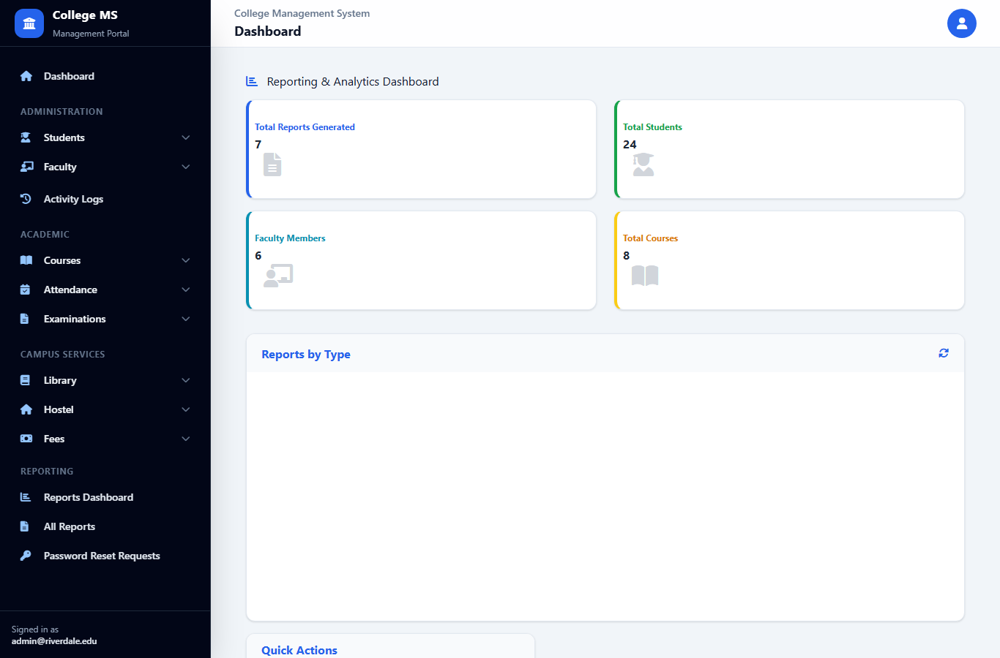
Screenshot: Reports Dashboard

Screenshot: System Activity Logs
The activity log page shows dynamic database-backed audit events with filters and pagination.
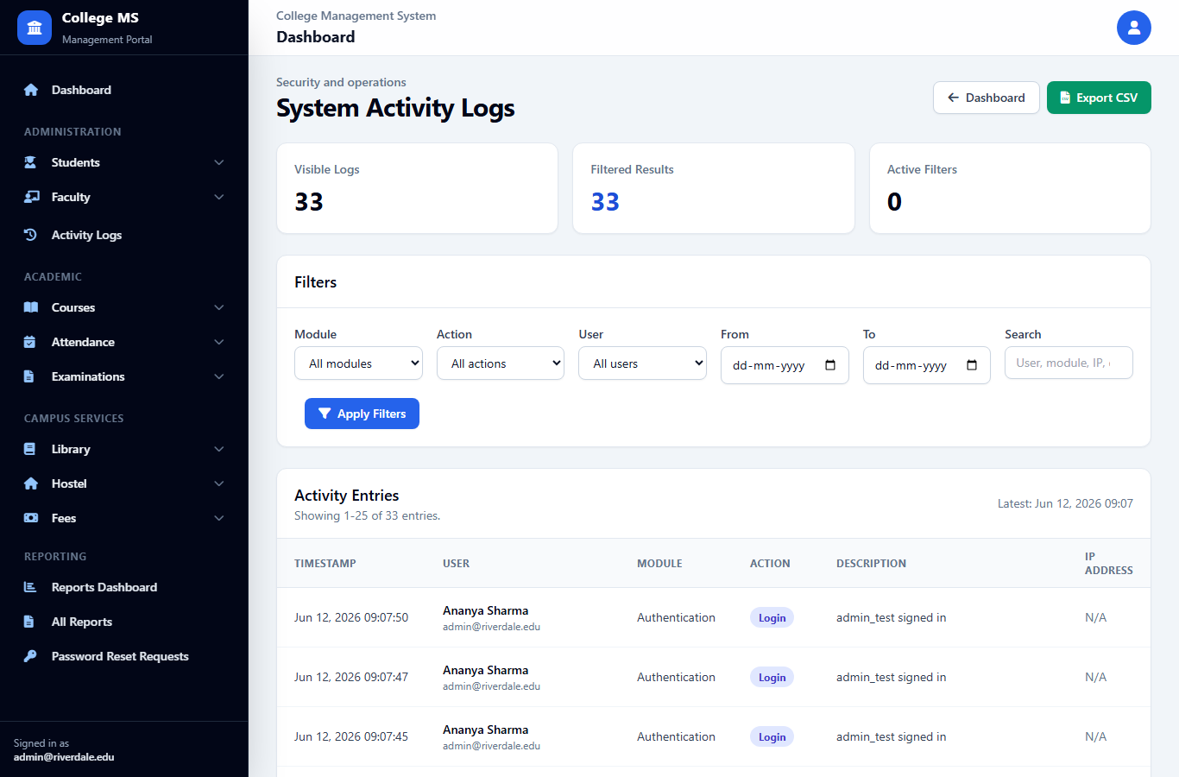
Screenshot: System Activity Logs

Screenshot: Student Portal
The student portal shows role-specific student information and self-service links.
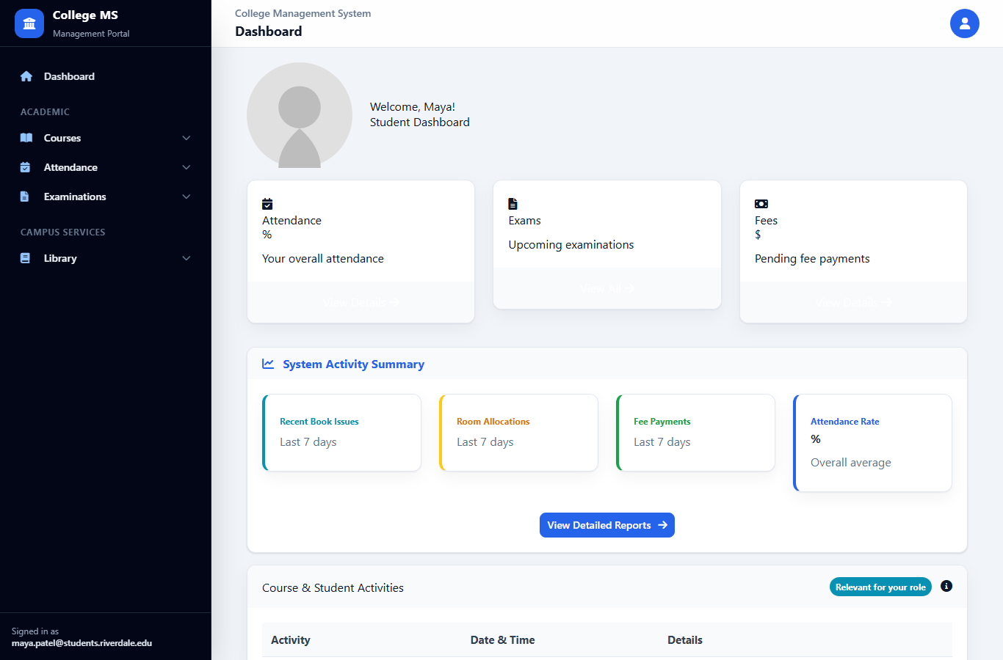
Screenshot: Student Portal

Screenshot: Faculty Portal
The faculty portal shows role-specific course and examination information.
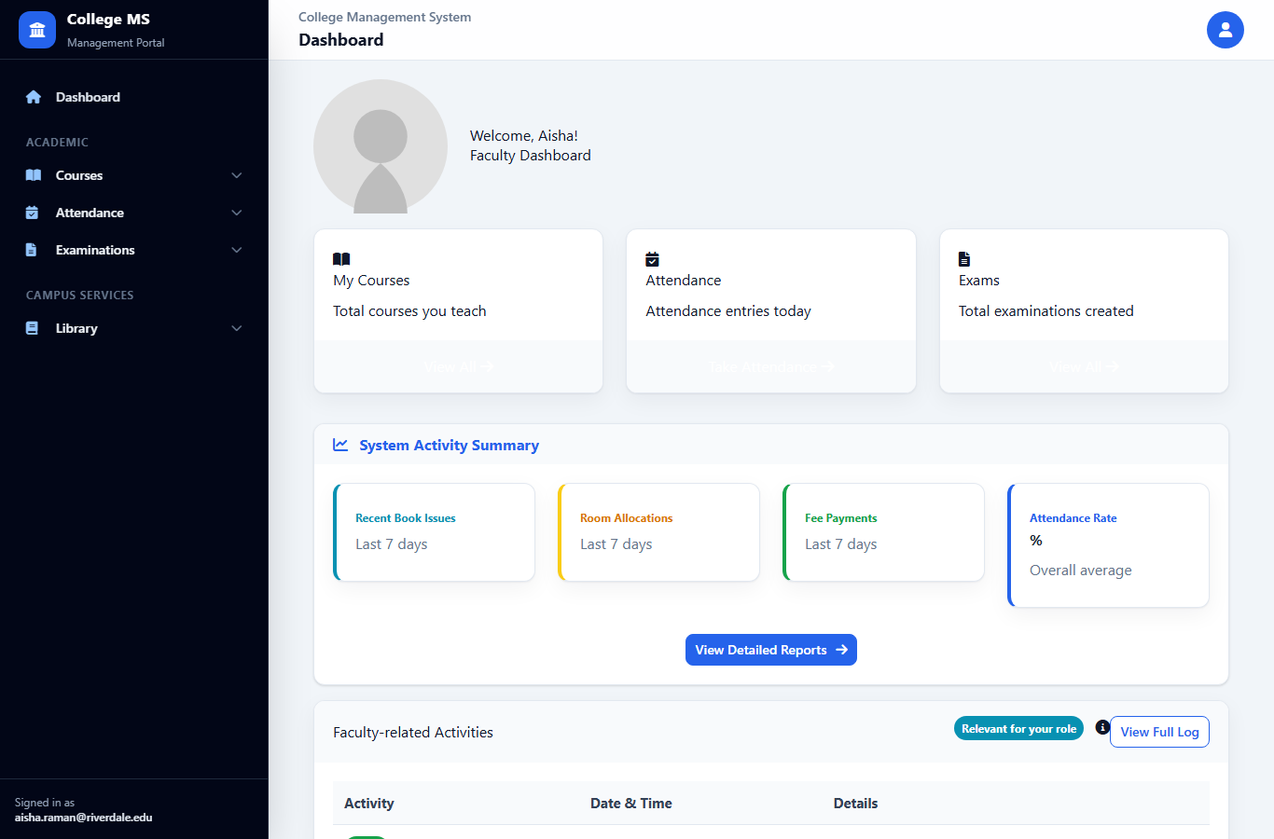
Screenshot: Faculty Portal

Screenshot: Mobile Activity Logs
The mobile activity log screen demonstrates responsive layout on a narrow viewport.
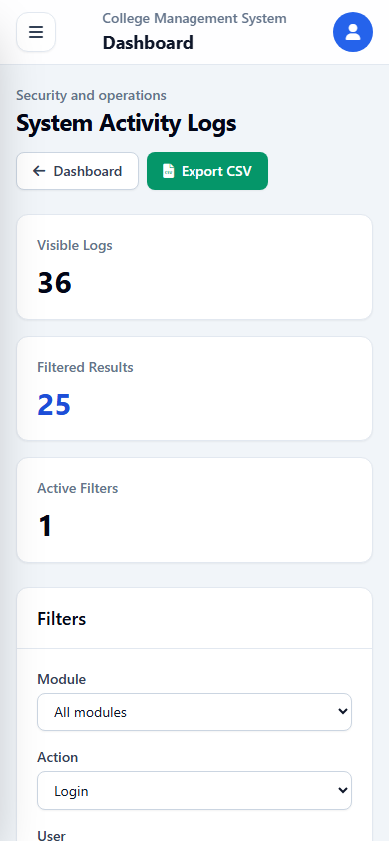
Screenshot: Mobile Activity Logs

Future Recommendation
The system can be enhanced by adding REST APIs, mobile applications for students and faculty, timetable management, online admission, automated email/SMS notifications, biometric attendance integration, advanced analytics, and role-specific dashboards.
A production deployment should migrate from SQLite to PostgreSQL or MySQL, add background tasks for notifications and backups, improve object-level permissions, and introduce automated unit and integration tests.

Future Enhancement: Analytics
Analytics can help administrators understand attendance trends, payment delays, examination performance, library circulation, and hostel occupancy. Graphical dashboards can support data-driven decision-making.
Machine learning could later be explored for attendance risk prediction or fee default alerts, but this should be added only after the transactional system is stable.

Future Enhancement: Cloud Deployment
Cloud deployment would make the system accessible to distributed users and support secure backups, monitoring, scaling, and managed databases. It should include HTTPS, domain configuration, environment variables, and production static file serving.
Containerization with Docker can make deployment repeatable across development, testing, and production environments.

Conclusion
The College Management System successfully demonstrates how academic and administrative workflows can be centralized in a Django-based web application. It addresses the core problems identified in the synopsis: manual workload, delayed record retrieval, duplicated data, limited visibility, and weak accountability.
The project implements practical modules for authentication, students, faculty, courses, attendance, examinations, library, hostel, fees, reporting, and audit logs. The relational database schema shows normalized relationships, while the Tailwind interface makes the application usable across devices.
The project is suitable for college submission because it combines software engineering methodology, database design, implementation, testing, deployment explanation, screenshots, and future scope into a complete academic report.

Bibliography
Django Software Foundation. Django Documentation.
Python Software Foundation. Python 3 Documentation.
SQLite Consortium. SQLite Documentation.
Tailwind Labs. Tailwind CSS Documentation.
Mozilla Developer Network. HTML, CSS, and JavaScript Web Documentation.
IGNOU MCSP-232 project synopsis guidelines and academic report conventions.
Project source code and local SQLite database of the College Management System.

Appendix A: Synopsis Source Summary
This appendix records supporting project-specific information used while preparing the report.
- INDIRA GANDHI NATIONAL OPEN UNIVERSITY
- MCSP-232
- College Management System (CMS)
- BY
- RISHI KUMAR
- 2350636647
- Under Guidance of
- Karmveer
- Submitted to the School of Computer and Information Sciences, IGNOU in partial fulfilment of the requirements for the award of the degree Master of Computer Applications (MCA)
- 2024
- Indira Gandhi National Open University
- Maidan Garhi

Appendix B: Authentication Credentials Used for Testing
This appendix records supporting project-specific information used while preparing the report.
- Admin: admin@riverdale.edu / Admin@12345
- Faculty: aisha.raman@riverdale.edu / Faculty@12345
- Student: maya.patel@students.riverdale.edu / Student@12345
- Staff: nora.wilson@riverdale.edu / Staff@12345

Appendix C: Important Local URLs
This appendix records supporting project-specific information used while preparing the report.
- /login/
- /dashboard/
- /students/
- /faculty/
- /courses/
- /attendance/
- /examinations/
- /library/
- /hostel/
- /fees/
- /reports/
- /auth/system-activity-logs/

