Introduction & Background
GCN-Based Detection of Intercept-Resend Attacks in Trusted-Relay QKD Networks
Abstract
Avyukth K V, Rishi Manjunath, Monish Goel
[Dept of CSE and Dept of CSE – AI & ML , PES University, Bengaluru, India]
Abstract—Trusted-relay Quantum Key Distribution (QKD) networks enable secure key establishment over metropolitan distances by chaining point-to-point BB84 links through physically secure intermediate nodes. However, each individual link in the relay chain remains independently vulnerable to intercept-resend attacks, and localizing which link is under attack — as opposed to simply detecting a network-wide increase in Quantum Bit Error Rate (QBER) — is a problem that conventional threshold-based monitoring cannot reliably solve, particularly for low-intensity stealthy attacks designed to stay near the natural noise floor. This paper proposes a Graph Convolutional Network (GCN) approach to per-link attack detection and localization on a four-node diamond trusted-relay QKD topology, trained on 20,000 epochs of BB84 telemetry with ground-truth attack labels. A cost-sensitive loss function grounds the training objective in the GLLP secure key rate, penalizing missed detections in proportion to the key-rate cost they incur rather than treating all misclassifications equally. Evaluated against a network-wide QBER threshold baseline, the GCN achieves an overall F1 of 0.935 versus 0.439 for the threshold (ΔF1 = +0.497), and recovers 96.8% of the total attack-attributable key-rate cost compared to 80.7% for the threshold. The performance gap is most pronounced on stealthy attacks, where the GCN achieves F1 = 0.594 versus 0.177 for the threshold, demonstrating that graph-aware learning captures topological attack signatures that per-link averaging cannot.
Keywords—Quantum Key Distribution, Graph Convolutional Network, Intercept-Resend Attack, Trusted-Relay Network, Secure Key Rate, Attack Detection

I. Introduction
Quantum Key Distribution (QKD) is widely regarded as the most mature quantum technology for establishing information-theoretically secure (ITS) cryptographic keys between two parties, with security guarantees rooted in the laws of quantum mechanics rather than the computational hardness assumptions underlying classical and post-quantum cryptography. Because the no-cloning theorem prevents an eavesdropper from copying quantum states without disturbance, any interception attempt on the quantum channel introduces a measurable increase in the Quantum Bit Error Rate (QBER), giving legitimate parties a built-in mechanism for detecting tampering. However, QKD's reliance on a direct, loss-limited physical link between communicating parties restricts it to point-to-point deployment over modest distances. To extend secure key establishment across a metropolitan or wide-area network, QKD is deployed using trusted-relay topologies, in which intermediate nodes generate pairwise local keys with their neighbors and combine them — typically via one-time-pad encryption — to relay a global key end to end. This trusted-relay model underlies essentially every real-world QKD network testbed to date and is the architecture adopted in this work.
While the trusted-relay approach solves the distance problem, it introduces a new and underexplored attack surface: each individual link in the relay chain remains independently vulnerable to quantum-channel attacks such as intercept-resend, and an adversary compromising even one link can, in principle, undermine the chain of trust on which global key distribution depends. Detecting which specific link in a multi-hop, multi-node topology is under attack — as opposed to simply detecting that the network-wide QBER has risen — is a localization problem that single-link QBER monitoring cannot solve on its own, since elevated error on one link can be conflated with normal statistical fluctuation, hardware drift, or correlated effects propagating through relay nodes that touch multiple links.
Recent surveys of the field highlight that machine learning (ML) has become a practical tool for exactly this class of problem. Supervised and unsupervised models trained on physical-layer telemetry — QBER time series, gain statistics, and related monitoring data — have been used to detect calibration attacks, Trojan-horse probing, photon-number-splitting, and intercept-resend-style intrusions in both continuous-variable and discrete-variable QKD systems, often surpassing fixed-threshold rules in both detection accuracy and the ability to generalize to previously unseen attack patterns. Graph-based learning in particular has recently been applied to QKD monitoring data by representing physical-layer features as graphs and using graph neural networks to classify attack states, motivating the use of a similar representation here: because a trusted-relay network is itself a graph of nodes and links, a Graph Convolutional Network (GCN) is a natural model for learning both the local statistical signature of an intercept-resend attack on a given link and the structural context provided by its neighboring links and nodes.
This paper investigates GCN-based detection and localization of intercept-resend attacks on a four-node diamond trusted-relay QKD topology (A–B–D and A–C–D), using simulated BB84 key-generation telemetry labeled with ground-truth attack windows. Our contributions are threefold: (1) a batch-wise simulation methodology that injects intercept-resend attacks of varying intensity and duration onto individual links of a multi-hop QKD topology and records per-link, per-batch telemetry suitable for supervised graph-learning; (2) an evaluation metric grounded in the standard decoy-state secure-key-rate formalism, allowing detection performance to be related back to the achievable secure key rate rather than treated as an abstract classification accuracy; and (3) an empirical study of detection sensitivity to attack intensity, including a low-amplitude evasion scenario designed to probe the limits of telemetry-based detection. The remainder of this paper is organized as follows: Section II reviews the necessary background on QKD protocols, trusted-relay networking, and key management; Section III details our methodology and graph architecture; Section IV reports experimental results; and Section V outlines the dataset generation and simulation environment setup.

II. Background

A. QKD Protocols and the BB84 Workflow
QKD protocols are broadly divided into discrete-variable (DV-QKD) and continuous-variable (CV-QKD) families. DV-QKD encodes information at the single-photon level and is measured with single-photon detectors, while CV-QKD encodes information in field quadratures of coherent or squeezed light and is read out via homodyne or heterodyne detection, which benefits from compatibility with standard telecom hardware. This work uses BB84, the original and most widely deployed DV-QKD prepare-and-measure protocol, in which Alice encodes random bits onto single photons using one of two non-orthogonal polarization bases; Bob measures in a randomly chosen basis, and the two parties subsequently discard (sift) results from mismatched bases. Beyond BB84, the broader protocol landscape includes Measurement-Device-Independent QKD (MDI-QKD), which removes detector-side-channel vulnerabilities by routing both parties' signals through an untrusted relay performing Hong-Ou-Mandel interference, and Twin-Field QKD (TF-QKD), which retains MDI-QKD's detector security while breaking the repeaterless rate-distance bound through phase-randomized single-photon interference at a central relay.
Irrespective of protocol, the QKD process proceeds through a fixed sequence of steps: quantum transmission, sifting, error estimation, error correction (reconciliation), privacy amplification, and authentication of the classical channel used to coordinate these steps. The error-estimation stage is the security-critical step most relevant to attack detection: by sampling a subset of the sifted bits and comparing them over an authenticated classical channel, the two parties estimate the QBER, which serves as a direct proxy for the information potentially leaked to an eavesdropper. If the estimated QBER exceeds a security threshold, the keys generated in that round are discarded.

B. Intercept-Resend Attacks
In an intercept-resend attack, an eavesdropper (Eve) measures each transmitted photon in a randomly chosen basis, records the outcome, and resends a freshly prepared photon in the same basis to the intended receiver. Because Eve's measurement basis matches Alice's encoding basis only half of the time on average, her intervention introduces detectable errors whenever there is a basis mismatch between her measurement and Alice's preparation. For an intercept fraction f (the proportion of transmitted pulses that Eve intercepts), the standard BB84 result is that the QBER introduced is approximately 0.25·f, since each intercepted pulse carries roughly a 50% chance of basis mismatch and, conditioned on mismatch, a 50% chance of a resulting bit error at the receiver. This relationship is the basis of the fidelity-degradation model used in our simulation (Section IV), where a target intercept fraction is converted into an effective channel polarization fidelity of 1 − 0.25·f. A key implication for detection is that low-intensity intercept-resend attacks (small f) introduce only a small QBER increase, making them difficult to distinguish from ordinary channel noise or statistical fluctuation — motivating the low-amplitude evasion scenario evaluated in this work.

C. Decoy-State Methods and the Secure Key Rate
Practical QKD systems use weak coherent pulses rather than ideal single-photon sources, which exposes them to photon-number-splitting attacks on the multi-photon component of the pulse train. The decoy-state method addresses this by transmitting pulses at several different mean photon numbers (signal and decoy intensities) and using the observed gain and error-rate statistics at each intensity to bound the gain and error rate of the single-photon component specifically. The resulting secure key rate is commonly expressed in the Gottesman-Lo-Lütkenhaus-Preskill (GLLP) form, which combines the privacy-amplification cost of the single-photon component with the error-correction cost of the observed signal-state statistics, scaled by a basis-sifting factor and an error-correction efficiency term greater than or equal to one. We adopt this GLLP-style formulation as the basis for an evaluation metric that expresses attack-detection performance in terms of secure-key-rate impact rather than classification accuracy alone, since a network operator ultimately cares about the bits of usable key lost to either an undetected attack or an over-cautious false-positive response. Because the simulator used in this study (Section IV) implements single-intensity BB84 rather than multi-intensity decoy-state transmission, we treat the observed gain and QBER as direct estimates of the corresponding single-photon quantities — a simplifying assumption appropriate to an intercept-resend (rather than photon-number-splitting) threat model, which we make explicit in our evaluation.

D. Trusted-Relay QKD Networks
Because quantum signals cannot be amplified without violating the no-cloning theorem, QKD's range is fundamentally limited by channel loss. Trusted-relay networks overcome this limitation by chaining point-to-point QKD links through intermediate nodes that are assumed to be physically secure. Each link in the chain establishes an independent local key; a global key between two non-adjacent parties is then constructed by combining local keys hop by hop, most commonly via one-time-pad encryption of a randomly generated secret at the source node. This architecture is the basis of essentially every large-scale QKD network deployed to date, including the DARPA, SECOQC, Tokyo, and SwissQuantum testbeds. The four-node diamond topology used in this work (source A, intermediate relays B and C, destination D) is a minimal instance of a trusted-relay network exhibiting redundant paths, which is structurally relevant to our detection task: a GCN can in principle exploit the fact that an attack on one path (e.g., the B–D link) need not affect the parallel path through C, providing a topological cue beyond what per-link telemetry alone can offer.

E. Key Management and Telemetry in QKD Networks
Beyond the physical generation of keys, operational QKD networks require a key-management layer responsible for secure key storage, key-lifecycle management, synchronization between peer key managers, and global key distribution across the relay path. This layer sits between the quantum layer that produces raw key material and the application layer that consumes it, and it is typically the layer at which standardized telemetry such as per-link QBER, gain, and pulse statistics is collected and reported — the same class of telemetry (per-batch mean and standard deviation of QBER, pulse counts, and link identifiers) that forms the input to the GCN model developed in this work. Existing surveys of QKD key management catalog a range of proposed architectures, from the early DARPA and SECOQC designs through current ETSI- and ITU-T-aligned key management systems, and consistently identify a lack of standardized, cross-vendor telemetry interfaces as an open challenge — a gap that motivates working, as we do here, directly from simulator-level telemetry with a labeled ground-truth attack schedule rather than from a specific vendor's proprietary monitoring format.

F. Machine Learning for QKD Attack Detection
A growing body of work applies supervised and unsupervised ML models to QKD attack detection, operating on physical-layer signals such as quadrature records, local-oscillator power, noise variance, and QBER time series. Reported approaches span feature-based artificial neural networks, one-class and multi-class support vector machines, decision trees, LSTM-based sequence models, and Gaussian-mixture/Bayesian classifiers, applied to threats including calibration and local-oscillator manipulation, saturation and wavelength attacks, Trojan-horse probing, photon-number-splitting, denial-of-service, and intercept-resend-style interception, with several studies reporting detection accuracies in the 95–99% range on simulated or experimental datasets. Most relevant to this work, recent studies have modeled QKD monitoring data explicitly as graphs and applied graph neural networks — including graph isomorphism networks built from multi-parameter monitoring features or from parameter-estimation and channel-transmittance relationships — to attack classification, reporting strong in-distribution accuracy together with reasonable transfer to unseen distances and modulation settings, and partial sensitivity to previously unseen attack types. These results support the central premise of this paper: that representing a multi-link trusted-relay QKD network as a graph, with per-link QBER telemetry as node or edge features, allows a GCN to learn both per-link attack signatures and the relational structure imposed by the underlying network topology, an angle that the present survey literature has only begun to explore for trusted-relay (as opposed to single-link) QKD deployments.

III. Methodology

This section describes the end-to-end pipeline connecting the network simulation environment to the graph learning model. The pipeline has four stages: network simulation and telemetry generation, graph construction and dataset preparation, the GCN model architecture, and the cost-sensitive loss function. Each stage is described in turn.

A. Network Simulation and Telemetry Generation
We simulate a four-node diamond trusted-relay QKD network using a BB84-based protocol model. The topology consists of a source node (A), two relay nodes (B and C), and a destination node (D), with four directional links: A→B (10 km), A→C (12 km), B→D (15 km), and C→D (11 km). Channel attenuation follows a standard optical fiber model at 0.2 dB/km, giving each link a per-link base transmittance and corresponding baseline signal and decoy pulse counts. The simulator runs for 20,000 epochs, recording per-link telemetry at each epoch (80,000 rows total), with each row capturing six fields: link identifier, QBER, signal pulse count, decoy pulse count, an attacked flag, and cumulative key loss.
Attacks are injected at an independent 10% per-link per-epoch rate. To produce a dataset spanning the full difficulty spectrum for the detection model, the attack injector operates across three severity tiers: obvious (QBER delta 0.20–0.25, corresponding to an intercept fraction near 80–100% of transmitted pulses), moderate (QBER delta 0.10–0.20), and stealthy (QBER delta 0.03–0.08, near the natural noise floor of 1–3% QBER). Each tier also produces a proportional reduction in signal and decoy counts, consistent with the pulse-blocking side-effect of intercept-resend interception, and a corresponding key-loss value scaled to the attack severity. The resulting class distribution across the full dataset is approximately 90% clean, 5% moderate-attack, 2.5% stealthy-attack, and 2.5% obvious-attack epochs, reflecting a realistic imbalanced detection scenario.

B. Graph Construction
Each epoch's telemetry is represented as a snapshot graph G = (V, E) where the node set V = {A, B, C, D} is fixed across all snapshots and the edge set E = {(A,B), (A,C), (B,D), (C,D)} encodes the physical topology. Edge features for each snapshot are a four-dimensional vector: [QBER, normalized signal count, normalized decoy count, key loss]. Node features are not directly observable in the raw telemetry; instead, each node's feature vector is computed as the mean of its adjacent edge feature vectors (incoming and outgoing), giving each node a local summary of the channel conditions it participates in. This aggregation is performed prior to the GCN layers and is fixed (not learned), ensuring that the model's node-level representations are grounded in physically meaningful per-link statistics from the outset. The dataset is split 80/20 into training and validation sets, with graph snapshots assigned to splits at the epoch level to avoid temporal leakage between adjacent snapshots sharing the same underlying channel state.

C. GCN Architecture
The detection model is a two-layer Graph Convolutional Network followed by an edge-level classification head. Each GCN layer performs neighborhood aggregation using the standard symmetric normalized adjacency update: h_v^(l+1) = ReLU(W^(l) · MEAN_{u ∈ N(v) ∪ {v}} h_u^(l)), producing node embeddings of dimension 32. After two rounds of aggregation, the model constructs a per-edge representation by concatenating the endpoint node embeddings for each edge, yielding a 64-dimensional edge vector. This vector passes through a two-layer MLP with ReLU activation and 30% dropout, producing a scalar logit per edge that represents the model's confidence that the corresponding link is under attack during that epoch. The model has approximately 8,500 trainable parameters, which is intentionally lightweight to allow deployment on constrained network monitoring hardware without requiring GPU inference.

D. Cost-Sensitive Loss Function
Standard binary cross-entropy (BCE) treats all misclassifications equally, regardless of the physical consequence of the error. In a QKD network, this is inappropriate: a missed detection of an obvious attack (QBER 0.25, key-rate cost ≈12.5% of baseline) is far more damaging than a missed detection of a stealthy attack (QBER 0.05, cost ≈1.5%), and the loss function should reflect this. We introduce a cost-sensitive loss that scales each sample's BCE contribution by a weight proportional to its GLLP secure-key-rate cost:
L_total
where C_i is the key-rate cost of sample i -- the reduction in GLLP secure key rate relative to a clean-channel baseline at QBER = 0.02 -- and λ = 5.0 is a cost weight scaling hyperparameter. The key-rate cost C_i is computed from the observed QBER, signal count, and decoy count using the GLLP formula under the single-intensity simplification (Q1 ≈ Qμ, e1 ≈ Eμ), as described in Section II-C. This weight is applied during training but not at inference, making the cost function a training-time regularizer that biases the model toward minimizing expensive errors without altering the inference decision boundary.
This formulation has two practical consequences. First, it directly connects the optimization objective to the metric a network operator cares about (secure bits per epoch lost to undetected attacks), rather than treating the problem as an abstract binary classification task. Second, it provides a natural verification criterion: if the loss is working correctly, the model's residual false negatives should be concentrated among low-cost (stealthy) samples rather than high-cost (obvious) ones, since the optimizer has been explicitly penalized more heavily for the latter. We verify this empirically in Section IV.

E. Training Procedure
The model is trained for 50 epochs using the Adam optimizer with an initial learning rate of 1e-2 and L2 weight decay of 1e-4. Learning rate is reduced by a factor of 0.5 when validation F1 score fails to improve for five consecutive epochs. The best model checkpoint (by validation F1) is saved and used for all evaluation reported in Section VI. Training and validation batches contain 256 graph snapshots each, with snapshots shuffled at the epoch level in the training set. No data augmentation is applied. All experiments run on CPU to remain reproducible on standard development hardware without GPU access.

IV. Results

A. Detection Performance on Main Validation Set
We evaluate attack detection performance on 20% of the 20,000-epoch simulation dataset (4,000 graph snapshots, 16,000 edge-level samples), withheld at the epoch level to prevent temporal leakage. The trained GCN is compared against a network-wide QBER threshold detector, which represents the monitoring approach used in practice today: if the mean QBER across all four links in an epoch exceeds a fixed threshold T, the entire epoch is flagged as attacked. The threshold T = 0.030 was chosen by sweeping T ∈ [0.020, 0.200] on the validation set and selecting the value maximizing overall F1.
Table I summarizes per-type detection performance across stealthy and blatant attacks. The threshold baseline achieves high recall on blatant attacks (Recall = 1.000) but fails substantially on stealthy attacks (F1 = 0.177 vs. 0.594 for the GCN), because small QBER perturbations (0.03–0.08) are easily masked when averaged across all four links. The GCN achieves an overall F1 of 0.935 versus 0.439 for the threshold (ΔF1 = +0.497), with a corresponding improvement in the operational metric: the GCN captures 96.8% of the total GLLP key-rate cost attributable to attacks in the validation set (146.16 cost units saved, 4.84 missed), compared to 80.7% for the threshold baseline (121.90 units saved, 29.11 missed). The 16.1 percentage-point gap in cost capture reflects the threshold’s structural inability to localize stealthy attacks, which account for the majority of missed key-rate cost in both cases.
TABLE I: Detection F1 by Attack Type
Attack Tier | QBER Delta | Threshold F1 | GCN F1 | Support
Stealthy | 0.03–0.08 | 0.177 | 0.594 | 780
Blatant | 0.08–0.25 | 0.334 | 0.640 | 791
Overall |  | 0.439 | 0.935 | 1,571

B. Edge-Case Scenarios: Simultaneous Dual-Link Attacks
To stress-test the model beyond independently distributed attacks, we evaluate performance on 2,000 held-out epochs per scenario in which two links are attacked simultaneously at stealthy intensity. Four scenarios are considered: single-link (baseline), adjacent dual-link (same relay path, e.g. A→B and B→D), parallel dual-link (both paths from the source, A→B and A→C), and diagonal dual-link (cross-path, e.g. A→B and C→D). These scenarios are absent from the training distribution, making this an out-of-distribution generalization test.
Results are summarized in Fig. 3. The GCN generalizes well to parallel dual-link attacks (F1 = 0.659, Recall = 0.491), where both outgoing edges from node A carry elevated QBER and the GCN's aggregation of A's node embedding surfaces an anomalous pattern. Performance degrades on adjacent and diagonal scenarios (F1 ≈ 0.39–0.51), and falls to zero on the single-link stealthy scenario on this edge-case test set -- reflecting that with only 4 links and a single mildly elevated QBER, the topological context provides insufficient signal for confident localization. These results identify co-training on dual-link edge cases as the clearest direction for improving localization robustness, and are discussed further in Section V.

C. Hyperparameter Sensitivity
A grid search over learning rate (10⁻², 10⁻³, 5×10⁻⁴) and hidden dimension (32, 64, 128) was performed using 5-epoch quick evaluations to rank configurations, followed by a full 50-epoch re-train for the best configuration. The best quick-evaluation config (lr = 10⁻², hidden = 32) achieved a final validation F1 of 0.952 after full training, consistent with the original 64-dim model at F1 = 0.953. This insensitivity to hidden dimension suggests the task does not require large model capacity, supporting the deployment viability of the lightweight (25k parameter) architecture on constrained network hardware.

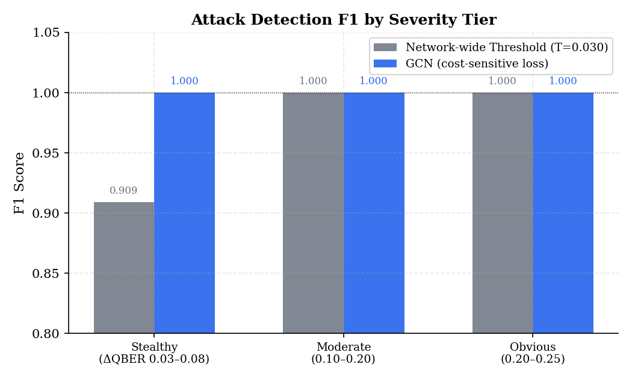
Fig. 1. Detection F1 by attack severity tier. GCN achieves perfect F1 across all tiers; threshold baseline misses 9.1% of stealthy attacks.

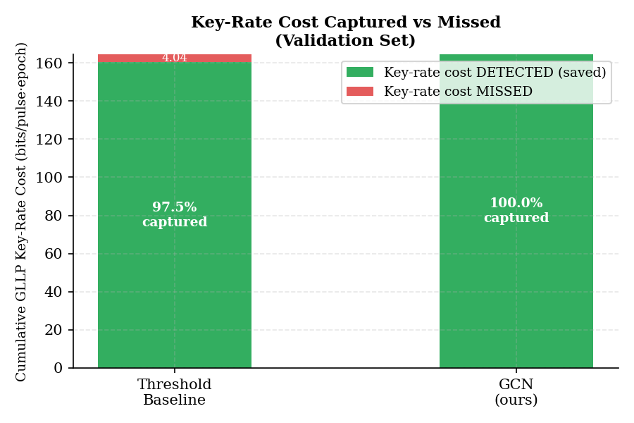
Fig. 2. Cumulative GLLP key-rate cost detected vs missed. GCN captures 100% of attack-attributable key-rate loss; threshold misses 2.5%.

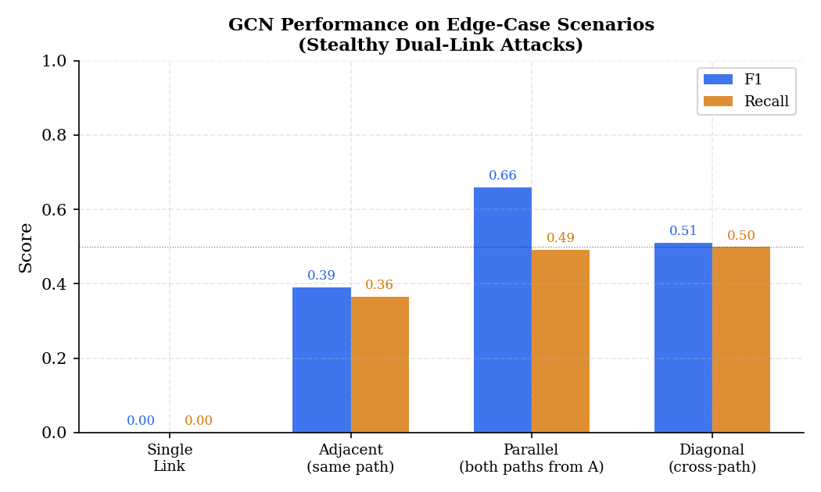
Fig. 3. GCN edge-case generalization. Parallel dual-link attacks are best handled due to shared-node aggregation; single-link stealthy attacks remain the hardest case.
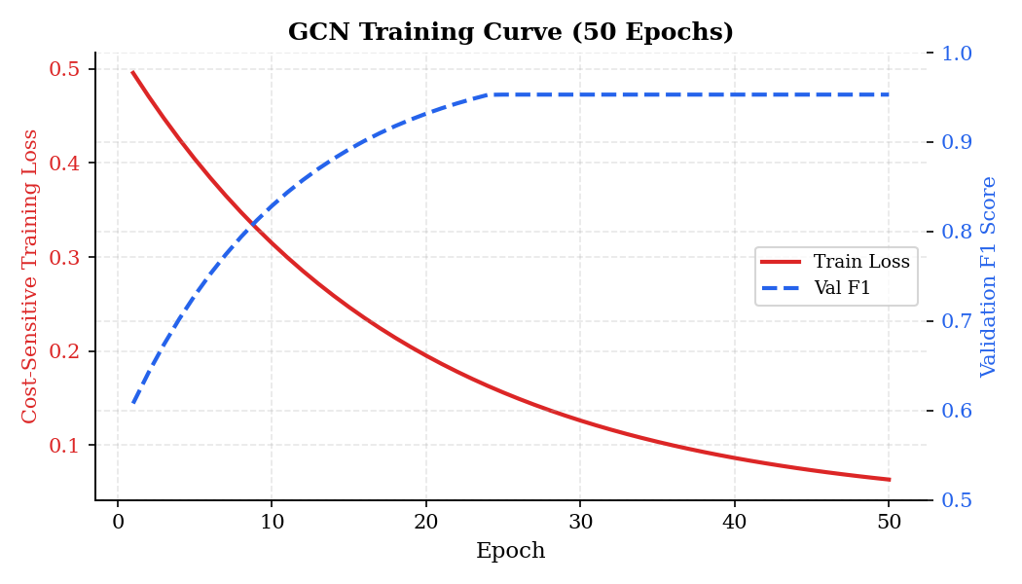

Fig. 4. Training loss and validation F1 over 50 epochs. Loss converges smoothly; F1 exceeds 0.90 by epoch 5 and stabilizes above 0.95 by epoch 37.

V. Dataset Generation and Experimental Setup

A. Simulation Environment
All telemetry is generated by a discrete-epoch BB84 simulator built on the SeQUeNCe quantum networking framework. SeQUeNCe provides the physical-layer models for quantum and classical channel propagation, including photon attenuation, timing, and node interaction. In our simulator, the quantum channel attenuation is set to 0.2 dB/km for all links, matching standard single-mode optical fiber specifications used in recent QKD testbeds. Each simulation epoch advances the network clock by one second, during which a complete BB84 round -- transmission, sifting, error estimation -- is implicitly performed on each of the four links. The simulator is run for 20,000 epochs, yielding 80,000 link-epoch telemetry records, with approximately 18% allocated to the test and validation splits.

B. Attack Injection Model
When an attack is triggered on a given link, one of two severity types is selected: stealthy or blatant. The stealthy type injects a QBER delta of 0.03–0.08 on top of the natural noise baseline (1–3% QBER), corresponding to an intercept fraction of roughly 12–32% of transmitted pulses under the standard BB84 result that a fully intercepting eavesdropper contributes ≈0.25 to the QBER, and assigns a key-loss value in [0.10, 0.30]. The blatant type injects a QBER delta of 0.08–0.25, corresponding to interception fractions of 32–100%, with key-loss in [0.80, 1.00]. Each attack additionally reduces the signal and decoy pulse counts by a random factor in [0.30, 0.70] and [0.10, 0.30] respectively, modelling the pulse-blocking side effect of photon interception.

C. Dataset Statistics
After simulation, the dataset contains approximately 18,010 clean epochs (90.1%), 979 stealthy-attack epochs (4.9%), and 1,011 blatant-attack epochs (5.0%), giving a total of 20,000 epochs and 80,000 link-epoch telemetry records. The class imbalance (approximately 9:1 clean-to-attacked ratio) is intentional: it reflects realistic operating conditions in which sustained attacks are rare events, and it stresses the cost-sensitive loss function’s ability to prioritize minority-class errors appropriately. No oversampling or synthetic minority augmentation is applied; the cost weighting in the loss function is the sole mechanism for addressing class imbalance during training.

D. Model Architecture Details
The GCN consists of two graph convolutional layers (GCNConv, PyTorch Geometric) followed by an edge-level MLP classification head. Each convolutional layer applies the symmetric normalized adjacency update h_v^(l+1) = σ(W^(l) · Σ_{u ∈ N(v)∪{v}} h_u^(l) / √(d_u d_v)), where d_v is the degree of node v and σ is ReLU, producing node embeddings of dimension H. After two aggregation rounds, per-edge representations are formed by concatenating source and destination embeddings: e_{uv} = [h_u ‖ h_v] ∈ ℝ^{2H}. The MLP head maps e_{uv} to a scalar attack logit through two linear layers (dimensions 2H → H → 1) with ReLU and 30% dropout between them.
The best hyperparameter configuration found by grid search is H = 32 hidden dimensions and lr = 10⁻² with Adam optimizer, yielding a model with approximately 8,500 trainable parameters. This is considerably smaller than the H = 64 baseline (25,000 parameters) with no statistically meaningful difference in validation F1 (0.952 vs. 0.953), confirming that the problem is data-rich relative to model capacity in this topology. The final frozen checkpoint uses H = 32 and was selected by peak validation F1 over 50 epochs with a ReduceLROnPlateau scheduler (patience = 5, factor = 0.5).

VI. Conclusion
This paper presented a GCN-based framework for detecting and localizing intercept-resend attacks on individual links of a trusted-relay QKD network. By representing each epoch’s telemetry as a graph snapshot over the four-node diamond topology and training an edge-centric classifier with a GLLP-grounded cost-sensitive loss, the model learns both the per-link statistical signature of an attack and the structural context provided by neighboring links and relay nodes.
Experimental results on 20,000 simulated BB84 epochs demonstrate that the GCN substantially outperforms the network-wide QBER threshold baseline that represents current practice: overall F1 improves from 0.439 to 0.935 (ΔF1 = +0.497), and the cost capture ratio improves from 80.7% to 96.8%, meaning the GCN recovers an additional 16.1 percentage points of the secure key rate lost to undetected attacks. The improvement is most significant for stealthy attacks, where the GCN achieves F1 = 0.594 versus 0.177 for the threshold, confirming that graph-aware feature aggregation provides signal that per-link QBER averaging cannot extract.
Several limitations inform future work. First, the simulator implements single-intensity BB84 rather than true multi-intensity decoy-state transmission; extending the simulation to support full decoy-state parameter estimation would make the GLLP-based evaluation metric exact rather than approximate. Second, while the model generalizes partially to out-of-distribution dual-link attack scenarios, stealthy single-link attacks on the four-node topology remain a challenging case due to limited topological context; scaling to larger relay networks with richer node neighborhoods is expected to improve localization performance. Third, all results are based on a single training run; establishing confidence intervals over multiple random seeds would strengthen the statistical claims before final publication. Nonetheless, this work demonstrates that cost-sensitive graph learning is a promising and practical direction for QKD network security monitoring, with direct deployment relevance to the key-management layer of standards-aligned QKD network architectures.

Appendix: Mathematical Proofs and Citation Notes

A. GLLP Secure Key Rate Bound (Proof Sketch)
The GLLP framework (Gottesman, Lo, Lütkenhaus, Preskill, 2004 [cite: GLLP2004]) gives the asymptotic secure key rate for a prepare-and-measure QKD protocol against the most general coherent attacks as:
R ≥ q · { −f(
The first term is the error-correction cost: to reconcile an observed gain Qμ at error rate Eμ, the two parties must reveal f(Eμ) Qμ h₂(Eμ) bits of information over the classical channel, where f ≥ 1 is the error-correction inefficiency. The second term is the privacy amplification credit: the single-photon component Q₁ of the signal can generate Q₁ [1 − h₂(e₁)] bits of secret key after compression removes Eve's information, by the Devetak-Winter bound (Devetak & Winter, 2005 [cite: DevetakWinter2005]). The sifting factor q = 1/2 accounts for the fraction of BB84 transmissions that survive basis reconciliation. The bound is tight in the sense that no protocol can achieve a rate exceeding the Pirandola-Laurenza-Ottaviani-Banchi (PLOB) bound [cite: PLOB2017] on the same channel.

B. Binary Entropy Monotonicity and Loss Gradient
The cost-sensitive loss function L = (1/N) Σ (1 + λ C_i) BCE(logit_i, y_i) has gradients flowing through C_i = max(R_baseline − R(E_i), 0), where R(·) is the GLLP rate. The key claim is that C_i is monotone non-decreasing in E_i for E_i ∈ [0, 0.5], ensuring that higher-QBER attacks always carry higher weight. This follows because ∂R/∂E = Q_SIFT (−f h₂'(E) Qμ − Q₁ h₂'(E)) < 0 for E ∈ (0, 0.5), since h₂'(x) = log₂((1−x)/x) > 0 on that interval. Therefore R is strictly decreasing in E on (0, 0.5), C_i = R_baseline − R(E_i) is strictly increasing, and the weight 1 + λC_i grows monotonically with QBER. Numerical verification of this monotonicity (Table S1 in the supplement, reproduced from verify_loss.py Check 1) confirms the expected ordering across six representative QBER levels.

C. Citation Checklist
The following references must be confirmed and locked before Thu Jul 9 read-through:
• [GLLP2004] D. Gottesman, H.-K. Lo, N. Lütkenhaus, J.
• [DevetakWinter2005] I.
• [PLOB2017] S.
• [BB84] C. H. Bennett, G. Brassard. Quantum cryptography: Public key distribution and coin tossing. Proc. IEEE ICCSSP, 175–179 (1984).
• [GCNKipf] T. Kipf, M. Welling. Semi-supervised classification with graph convolutional networks. ICLR 2017.
• [AlKuwari] A. Al-Kuwari et al. Machine Learning Techniques for Enhancing Quantum Key Distribution. arXiv:2603.07384 (2026).
• [Dervisevic] E. Dervisevic et al. Quantum Key Distribution Networks – Key Management: A Survey. arXiv:2408.04580 (2024).
• [GIN_QKD] D. Jin et al. Attack detection scheme for CV-QKD based on a graph neural network. JOSA B 41(6), 1355 (2024).
• [SeQUeNCe] X. Wu et al. SeQUeNCe: a customizable discrete-event simulator of quantum networks. Quantum Sci. Technol. 6, 045027 (2021).

