D:\Downloads\MSF_International_logo_colour_RGB.tif 

|  |  |  |
| --- | --- | --- |
| **Dossiers App.** | v0.8 | |
| Manual: Setup, Usage, Maintenance | |  |

|  |  |  |
| --- | --- | --- |
| **Author** | **Contact** | **Date** |
| B. Raimbault – HMIS Team | [hmis@barcelona.msf.org](mailto:hmis@barcelona.msf.org) | 29/08/2016 |
| R. Sukul – HMIS Team | / | 31/05/2016 |

Table of Contents

[Introduction 2](#_Toc460248651)

[Server configuration. Structural elements 2](#_Toc460248652)

[DataSets and IndicatorGroups: Attribute “serviceCode” 4](#_Toc460248653)

[Dossiers App Install 4](#_Toc460248654)

[Export of dossier app into a new server 4](#_Toc460248655)

[User manual 5](#_Toc460248656)

[Potential Troubles 6](#_Toc460248657)

[Dhis2 Menu 6](#_Toc460248658)

[Session ends 6](#_Toc460248659)

[Bad connection 6](#_Toc460248660)

[Adding a language 6](#_Toc460248661)

[First javacript file controller.js 6](#_Toc460248662)

[Add language file to languages folder 6](#_Toc460248663)

[See Dataelements for the dossiers 6](#_Toc460248664)

[Add OU for new language 6](#_Toc460248665)

# Introduction

Dossiers are an essential part of the HMIS. They are the main reference in terms of health information for both dataelements and indicators. And they help users to know the exact definition of what has to be collected and how the predefined indicators were calculated. An App was developped (thank you Rishi!) to facilitate the task of dossier maintenance and delivery to HMIS users, both in online and offline servers. This document describes :

1. Elements required to configure an HMIS server to be used with the Dossiers App.
2. Exporting Dossier App structure to another server.
3. How to create a new dossier or update an existing one.
4. User manual.

# Server configuration. Structural elements

The following sections describe the elements that need to be incorporated in an HMIS server to be able to use the Dossiers App.

***Services: List***

The list of services is assumed to be the list of element in the OrganisationUnitGroups in the OrganisationUnitGroupSet: “1. Health Service” with uid: BtFXTpKRl6n.

**List via API:** api/organisationUnitGroupSets/BtFXTpKRl6n?fields=organisationUnitGroups[id,code,displayName]&paging=false

**List of existing Health Services (organisationUnitGroups in organisationUnitGroupSet):**

|  |
| --- |
| Outbreak Meningitis |
| Sexual and Rep. Health OPD |
| Intensive Care Unit |
| Observation Room |
| NUT ITFC |
| Surveillance Nut |
| Operating Theatre |
| NUT ATFC |
| Outbreak Dengue |
| Surgical Ward |
| Outbreak Malaria OPD |
| Emergency Room |
| Outbreak Cholera |
| HIV |
| Sexual and Rep. Health IPD |

|  |
| --- |
| External Consultations |
| Hospitalization Ward |
| Outbreak Malaria IPD |
| Gender Based Violence |
| External Consultations (children) |
| Neonatology |
| Mental Health |
| Outbreak Measles |
| Hospitalization Ward (children) |
| Vaccination |
| NUT TSFC |
| Early Warning System |
| Diagnostic test |
| TB |
| Surveillance Mortality |

***Services: Descriptions***

The descriptions of services are stored in the organisationUnitGroup descriptions.

*NB: Currently the “Description” does not appear as a field for an organisationUnitGroup. It only appears as a translation.*

The field Description has to be translated into the different languages considered, since it is included in the dossiers displayed to the final user.

Edition of the description can be done directly in the Dossiers App for users who are member of the Administrators group.

***Services: Association to DataSets and IndicatorGroups via “Code”***

|  |  |
| --- | --- |
| OUG\_HSV\_DT | Diagnostic test |
| OUG\_HSV\_EWS | Early Warning System |
| OUG\_HSV\_ER | Emergency Room |
| OUG\_HSV\_EC | External Consultations |
| OUG\_HSV\_ECp | External Consultations (children) |
| OUG\_HSV\_GBV | Gender Based Violence |
| OUG\_HSV\_HIV | HIV |
| OUG\_HSV\_HW | Hospitalization Ward |
| OUG\_HSV\_HWp | Hospitalization Ward (children) |
| OUG\_HSV\_ICU | Intensive Care Unit |
| OUG\_HSV\_MH | Mental Health |
| OUG\_HSV\_NEO | Neonatology |
| OUG\_HSV\_ATFC | NUT ATFC |
| OUG\_HSV\_ITFC | NUT ITFC |
| OUG\_HSV\_TSFC | NUT TSFC |
| OUG\_HSV\_OR | Observation Room |
| OUG\_HSV\_OT | Operating Theatre |
| OUG\_HSV\_CH | Outbreak Cholera |
| OUG\_HSV\_DEN | Outbreak Dengue |
| OUG\_HSV\_MOHW | Outbreak Malaria IPD |
| OUG\_HSV\_MOEC | Outbreak Malaria OPD |
| OUG\_HSV\_MSL | Outbreak Measles |
| OUG\_HSV\_MNG | Outbreak Meningitis |
| OUG\_HSV\_SRHHW | Sexual and Rep. Health IPD |
| OUG\_HSV\_SRHEC | Sexual and Rep. Health OPD |
| OUG\_HSV\_SW | Surgical Ward |
| OUG\_HSV\_MOR | Surveillance Mortality |
| OUG\_HSV\_NS | Surveillance Nut |
| OUG\_HSV\_TB | TB |
| OUG\_HSV\_VAC | Vaccination |

All the organisationUnitGroups are assigned a “Code” with the following pattern:

OUG\_HSV\_*\*\*TYPE OF SERVICE\*\**

The \*\*type of service\*\* (part of the “Code”) is used to match DataSets and IndicatorGroups that are related to a Service.

A specific “serviceCode” attribute is associated to these two objects (which definition is described in the following part) so they can be matched.

For DataSets the “serviceCode” pattern is:

DS\_*\*\*TYPE OF SERVICE\*\**

For IndicatorGroups the “serviceCode” pattern is:

ING\_*\*\*TYPE OF SERVICE\*\**

The “serviceCode” can be used to match both the objects to various Services using the following syntax:

\_*\*\*TYPE OF SERVICE1\*\**\_*\*\*TYPE OF SERVICE2\*\**

## DataSets and IndicatorGroups: Attribute “serviceCode”

Required for the use of the App. Created in Apps -> Data administration -> Attribute as shown at left.

It defines a new text field to be configured in the datasets and indicator groups. Introducing the code of one of the *dossier dataelements*, all the dataelements within the dataset or the indicators within the indicator group will be included in the dossier.

## Dossiers App Install

Finally, the Dossiers App has to be installed in the system, in instance through Apps -> App Management. The code is contained in the package available in GitHub: <https://github.com/MSFOCBA/dhis2Reports/releases>

# 

# Export of dossier app into a new server

Export the following items:

1. organisationUnitGroups and the organisationUnitGroupSet
2. Translations (not available in the detailed Meta-Data Export, but quick to import):

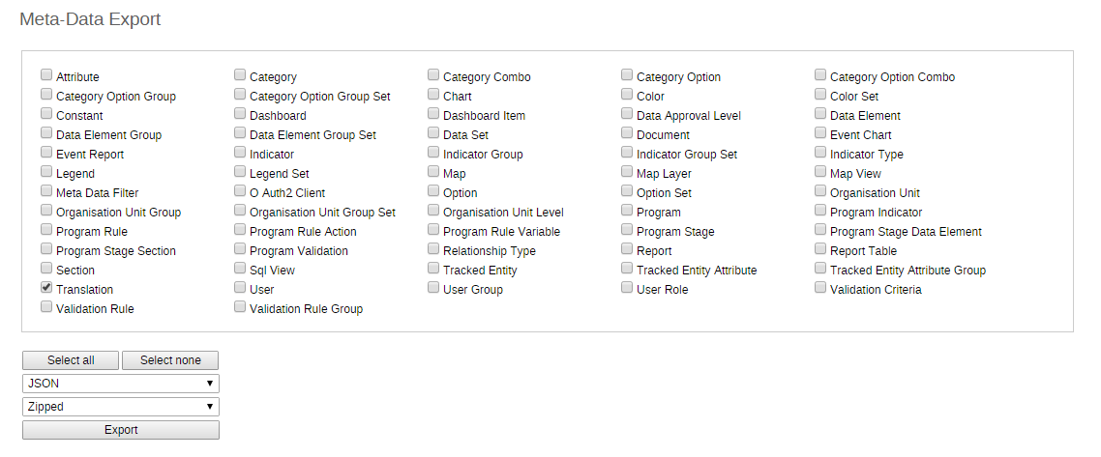

1. Attribute: serviceCode
2. DataSets and IndicatorGroups

# User manual

Press Apps->Dossiers, as shown below.

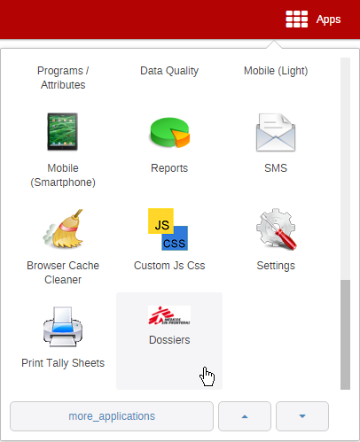

Two tabs will be displayed:

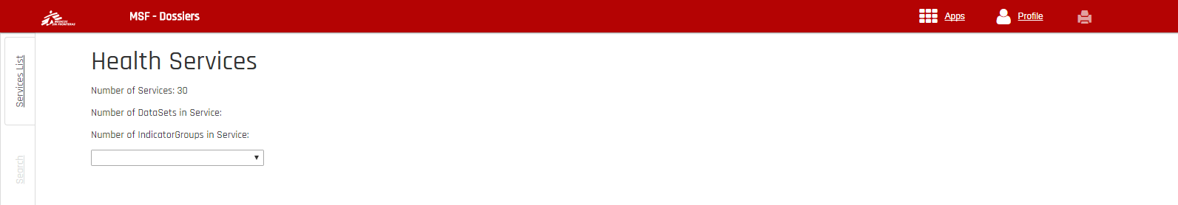

1. **Services**: where the dossiers will be compiled. Select the service you are interested in by means of the drop-down list. The dossier will be displayed, including:
   1. Introduction of the dossier.
   2. Table of content.
   3. Description of dataelements assigned to the service.
   4. Description of indicators assigned to the service.

***Note****:* the dossier is shown in the same language as it is configured in the HMIS account (Profile->Settings).

1. **Search**: displays all dataelements (health information) all indicators in the system and give the possibility to search them.

# Potential Troubles

## Dhis2 Menu

In the developer manual of dhis2 it is described how to implement the OOB menu of dhis2. It requires a bit of javascript to be added to index.html file. The code I copied from the manual. It has one important drawback, the tomcat app name is hard coded. So I assume that when the app name is not dhis, you have to change the following line as well.

dhis2.settings.baseUrl = 'dhis';

## Session ends

There is a build in feature in the app the will direct you to the login page when your session is ended because of a timeout. This however doesn’t always works, especially when there is a server reset this feature doesn’t work, the user will then get a “weird” result (json result or then ”ping” message).

## Bad connection

The dossier are dynamic assembled using multiple AJAX calls when there is in the middle a bad interruption the app will still come back with a result but some AJAX call might have failed to return a result this can result in some tables with 0 elements. It only happened once to me, so it could have been freak incident.

# Adding a language

## First javacript file app.config.js

Check if your language is in the following in app.config.js:

$translateProvider.registerAvailableLanguageKeys(

['es', 'fr', 'en', 'pt'],

{

'en\*': 'en',

'es\*': 'es',

'fr\*': 'fr',

'pt\*': 'pt',

'\*': 'en' // must be last!

}

);

## Add language file to languages folder

Go to the app subfolder languages and add the language file, check out fr.json as example.

If you see something like “{{'Health Services' | translate}}” in one of the html files you have to look for “Health Services” in fr.json to find the translation at the right side.

For a new language you better copy fr.json rename the copy to something like nl.json (Dutch ☺ ) and replace the right side translation with translations for the new language.