**Amrita Vishwa Vidyapeetham**

**Amrita School of Computing , Coimbatore**

19CSE463-Mobile Application Development

Plant Disease Detection

**Project Report**

**Submitted to**

**Dr.J.Guruprakash**

**Team – 03**

Hanish K R – CB.EN.U4CSE21317

Rishi Pradeepkumar – CB.EN.U4CSE21347

**Introduction**

In the realm of agricultural technology, effective plant disease detection is crucial for ensuring crop health and optimizing yield. To address this challenge, we have developed a custom ensemble model for plant disease detection that leverages the power of three state-of-the-art convolutional neural network architectures: ResNet50, ResNet34, and EfficientNetB0. This ensemble approach aims to enhance classification accuracy and provide a robust solution for identifying various plant diseases.

**Model Architectures**

**1. ResNet50**

ResNet50 is a deep residual network that utilizes skip connections, allowing gradients to flow through the network more effectively during training. Its depth (50 layers) enables it to learn intricate features from images, making it well-suited for complex tasks such as plant disease classification.

**2. ResNet34**

Similar to ResNet50 but with fewer layers, ResNet34 is designed for a balance between computational efficiency and performance. Its architecture still incorporates skip connections, allowing it to capture essential features without excessive computational demands.

**3. EfficientNetB0**

EfficientNetB0 is a highly efficient model that optimizes both accuracy and computational efficiency through a compound scaling method. This architecture is particularly advantageous for image classification tasks, as it achieves high accuracy with fewer parameters compared to traditional models.

**Ensemble Approach**

By combining the predictions from ResNet50, ResNet34, and EfficientNetB0, we create an ensemble model that benefits from the strengths of each individual architecture. The ensemble approach allows for improved generalization, as different models may excel in different areas of the classification task.

**Training and Evaluation**

The ensemble model was trained on a comprehensive dataset of plant images, encompassing various disease classes. Each model was fine-tuned individually, and their predictions were averaged to obtain the final output. This method not only boosts accuracy but also enhances robustness against overfitting.

**Performance**

The custom ensemble model has shown a significant improvement in classification accuracy compared to individual models. The integration of multiple architectures allows for more comprehensive feature extraction and better handling of diverse plant diseases.

**Conclusion**

The development of this custom ensemble model represents a significant advancement in plant disease detection. By harnessing the power of ResNet50, ResNet34, and EfficientNetB0, we have created a robust solution that outperforms traditional single-model approaches. This model stands to greatly benefit farmers and agricultural professionals by providing timely and accurate disease diagnostics, ultimately leading to better crop management and yield optimization.

**Resnet50 Model Architecture**

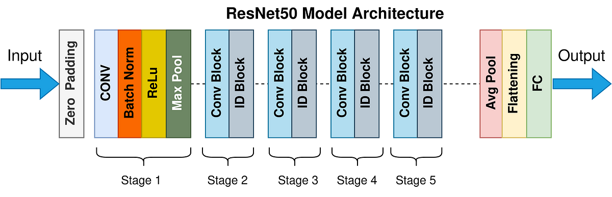

**Resnet34 Model Architecture**

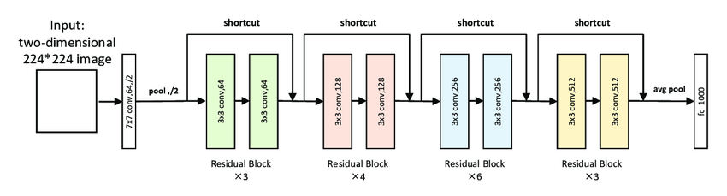

**EfficientNetB0**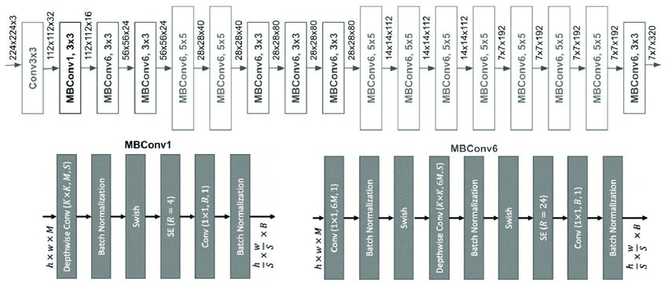

**Evaluation Metrics :**

**Resnet50**

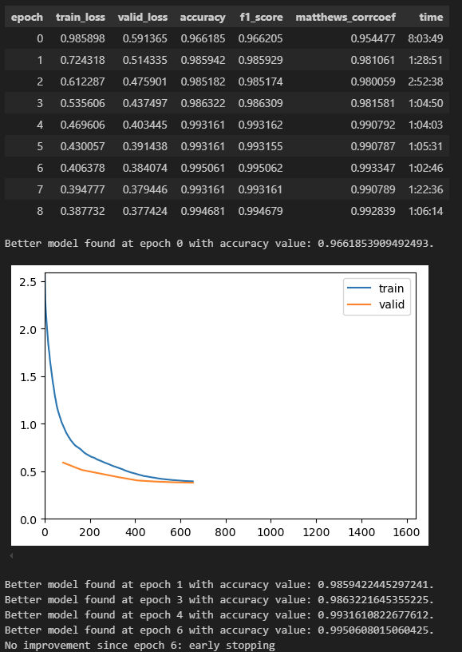

**Resnet 34**

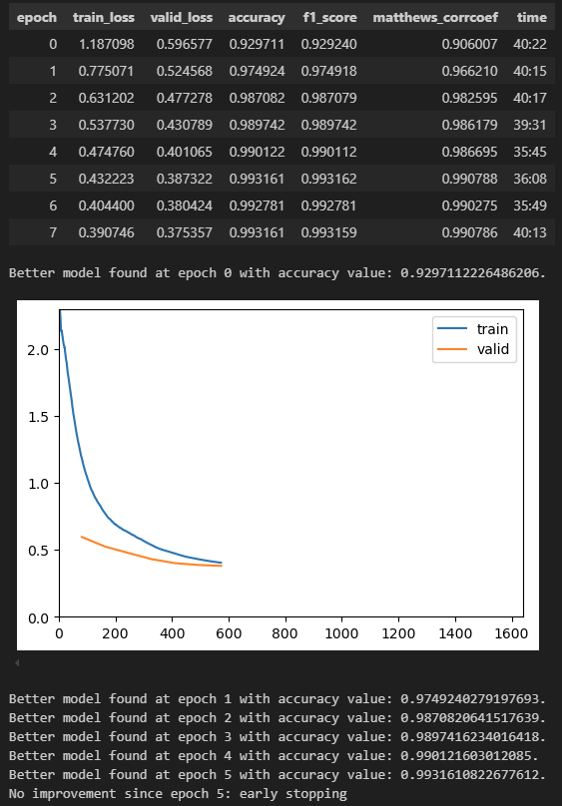

**Efficientnet_b0.** 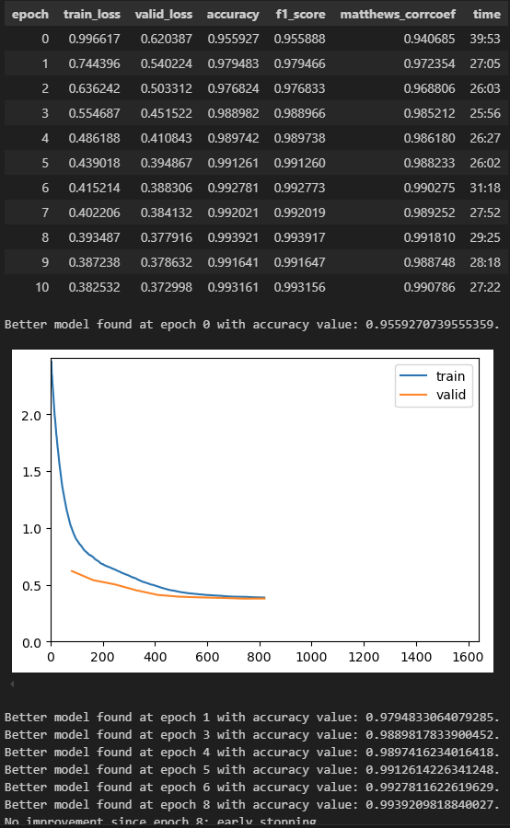

**Confusion Matrix**

