**Amrita Vishwa Vidyapeetham**

**Amrita School of Computing , Coimbatore**

19CSE463-Mobile Application Development

Plant Disease Detection

Review – 02

Submitted To :

**Dr.J.Guruprakash**

**Team No – 03**

Hanish K R – CB.EN.U4CSE21317

Rishi Pradeepkumar – CB.EN.U4CSE21347

**Model Name :** Resnet50

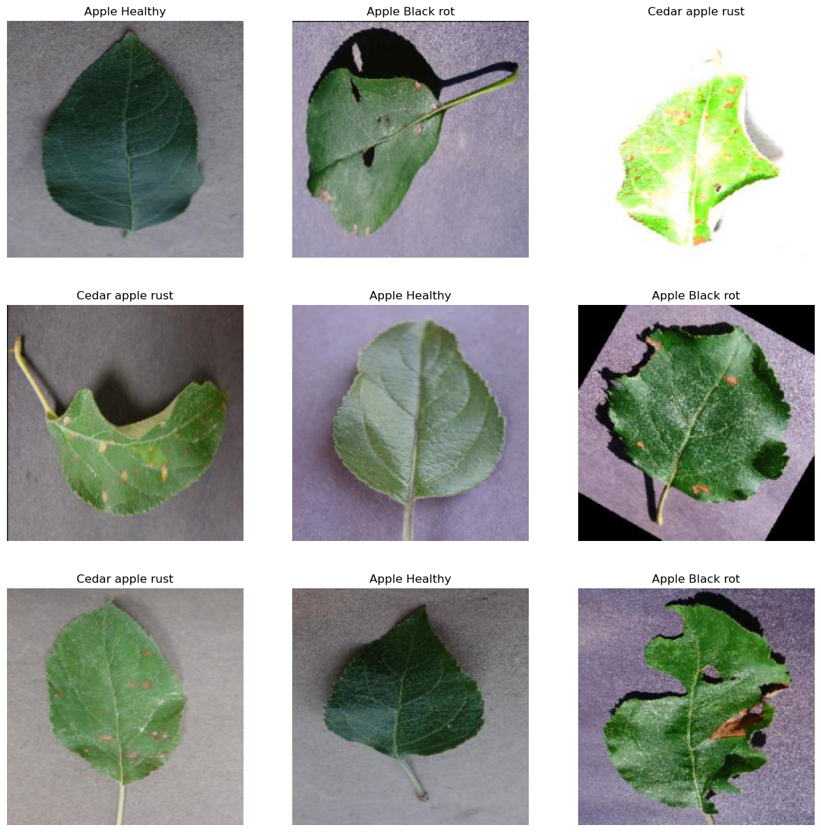

**Accuracy :**

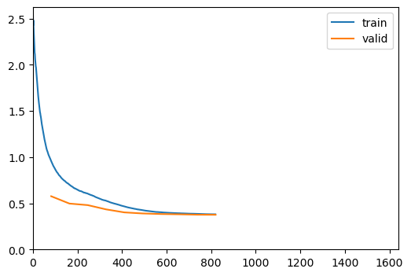

Better model found at epoch 0 with accuracy value: 0.9623860120773315.

Better model found at epoch 1 with accuracy value: 0.9848024249076843.

Better model found at epoch 2 with accuracy value: 0.990121603012085.

Better model found at epoch 3 with accuracy value: 0.9920212626457214.

Better model found at epoch 5 with accuracy value: 0.9924012422561646.

Better model found at epoch 6 with accuracy value: 0.9931610822677612.

Better model found at epoch 7 with accuracy value: 0.9946808218955994.

Better model found at epoch 8 with accuracy value: 0.9950608015060425.

No improvement since epoch 8: early stopping

**Summary :**

Sequential (Input shape: 128 x 3 x 224 x 224)

============================================================================

Layer (type) Output Shape Param # Trainable

============================================================================

128 x 64 x 112 x 11

Conv2d 9408 False

BatchNorm2d 128 True

ReLU

____________________________________________________________________________

128 x 64 x 56 x 56

MaxPool2d

Conv2d 4096 False

BatchNorm2d 128 True

Conv2d 36864 False

BatchNorm2d 128 True

____________________________________________________________________________

128 x 256 x 56 x 56

Conv2d 16384 False

BatchNorm2d 512 True

ReLU

Conv2d 16384 False

BatchNorm2d 512 True

____________________________________________________________________________

128 x 64 x 56 x 56

Conv2d 16384 False

...

Callbacks:

- TrainEvalCallback

- CastToTensor

- Recorder

- ProgressCallback

*Output is truncated. View as a* [*scrollable element*](command:cellOutput.enableScrolling?405f22cd-842a-4914-9ef1-5ad8036f0407) *or open in a* [*text editor*](command:workbench.action.openLargeOutput?405f22cd-842a-4914-9ef1-5ad8036f0407)*. Adjust cell output* [*settings*](command:workbench.action.openSettings?%5B%22%40tag%3AnotebookOutputLayout%22%5D)*...*

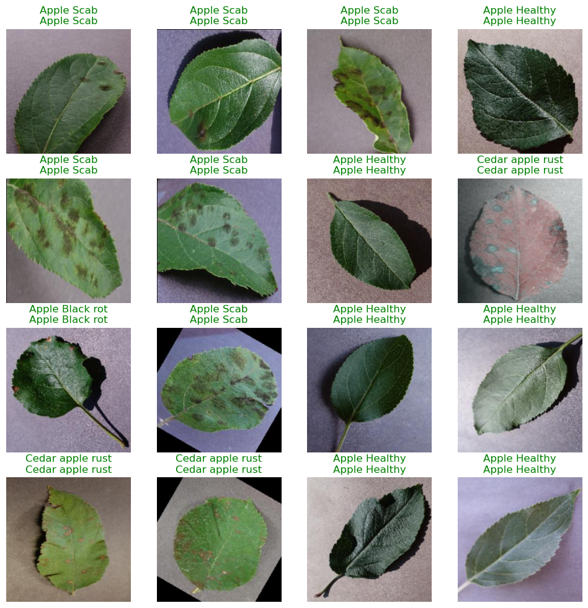

**Confusion Matrix :**

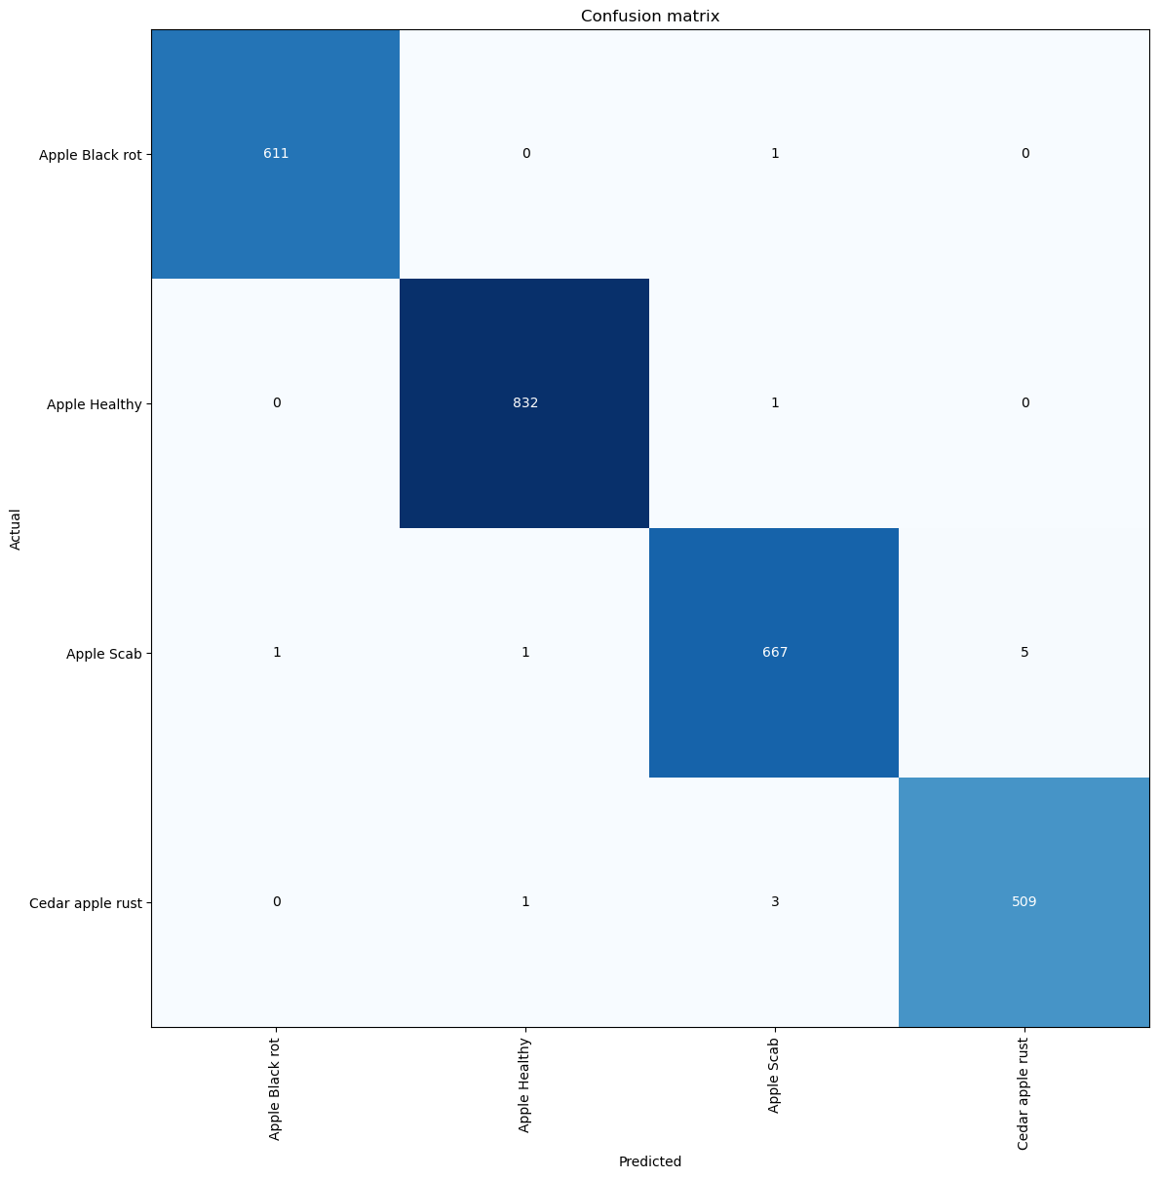

**UI :**

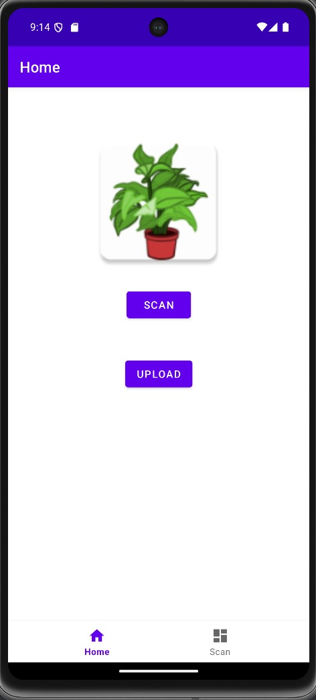

Click Upload Button to upload Image from Local Storage

