Game Design Document

Fill up the following document

1. Write the title of your project.

Shooter Robo

1. What is the goal of the game?

Goal of the game is to shoot the zombies and don’t let them go out into the city

1. Write a brief story of your game.

The story of the game is in a distopian world where a zombie apoclypce

is happening.The main character is a Robot whose task is to kill the

Zombies and keep them out of the city.

1. Which are the playing characters of this game?

* Playing characters are the ones who respond to the user based on the input from the user.
* Cars, monkeys, dinos, wizards, etc., are the playing characters in the game.

|  |  |  |
| --- | --- | --- |
| Number | Character Name | What can this character do? |
| 1 | Robo | Shoot,run,fly |
| 2 |  |  |
| 3 |  |  |
| 4 |  |  |
| 5 |  |  |
| 6 |  |  |
| 7 |  |  |
| 8 |  |  |

1. Which are the Non-Playing Characters of this game?

* Non-Playing characters are the ones that don't have an action or behavior when the user interacts with the game.
* Hurdles, stones, bananas, coins, etc., are non-playing characters in the game.

|  |  |  |
| --- | --- | --- |
| Number | Character Name | What can this character do? |
| 1 | zombies | Walk,attack |
| 2 |  |  |
| 3 |  |  |
| 4 |  |  |
| 5 |  |  |
| 6 |  |  |
| 7 |  |  |
| 8 |  |  |

Draw your imagination of this game. What does this game look like?

* Draw the game either on your computer or on paper.
* Add images of the game scenes to show each of the playing and non-playing characters at least once.

The background of the game is given below.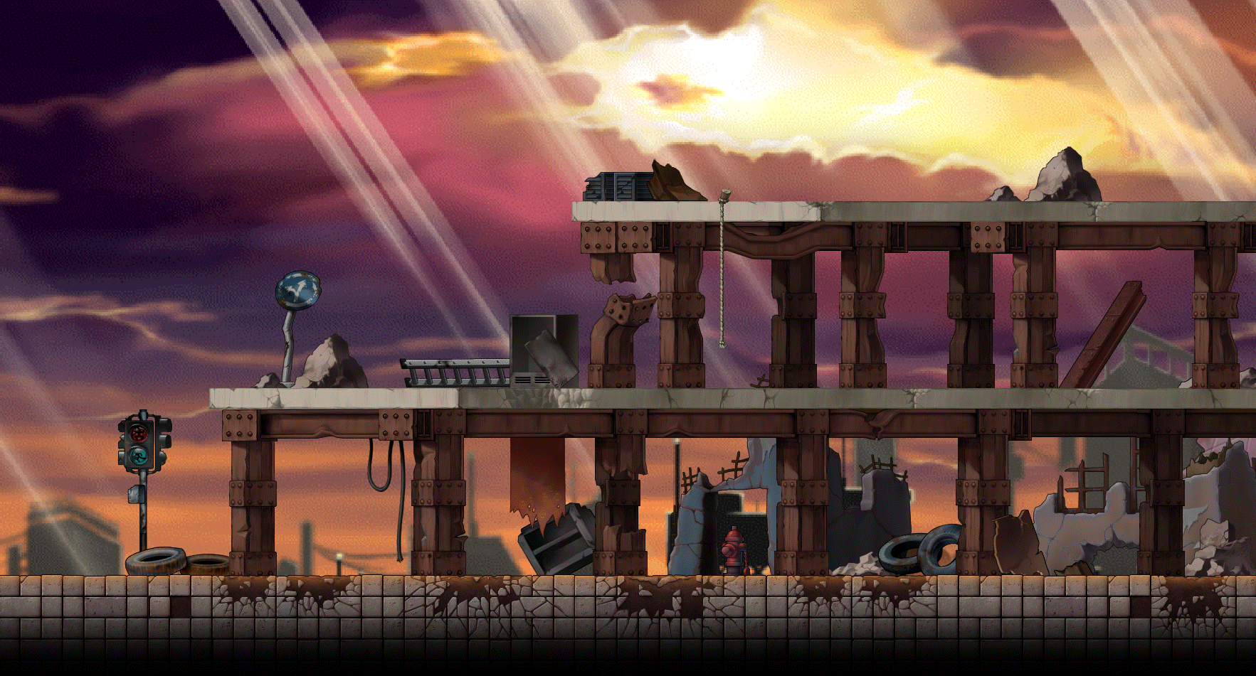

The robot will look like this

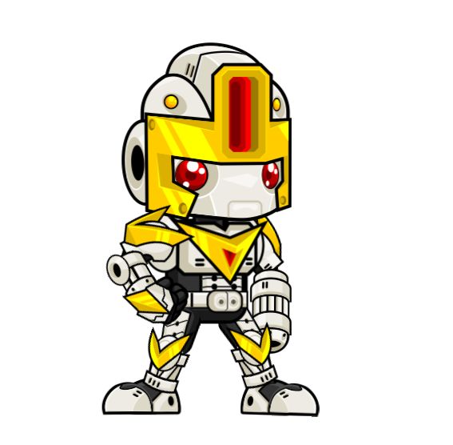

The zombies i mage are given below

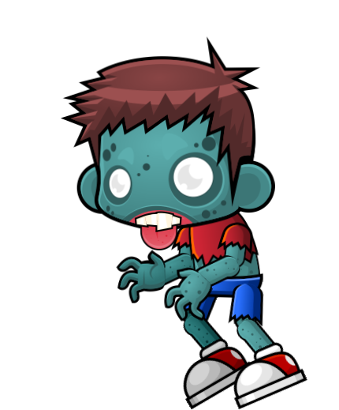

How do you plan to make your game engaging?

To make the game more engaging we have added Life and Score to the game.We have added Animation for the Robot and Zombies.