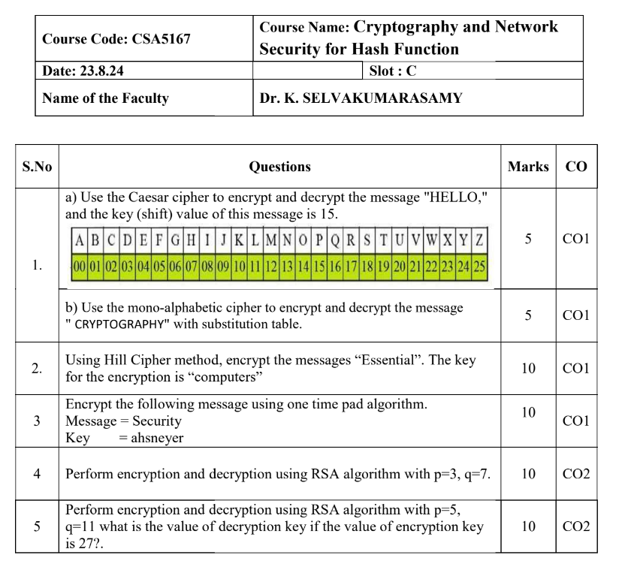

JAI SHRI RAM  
- No matter what, will complete

The assignments for Crypto

by 23/09/2 fully.

Day- 1

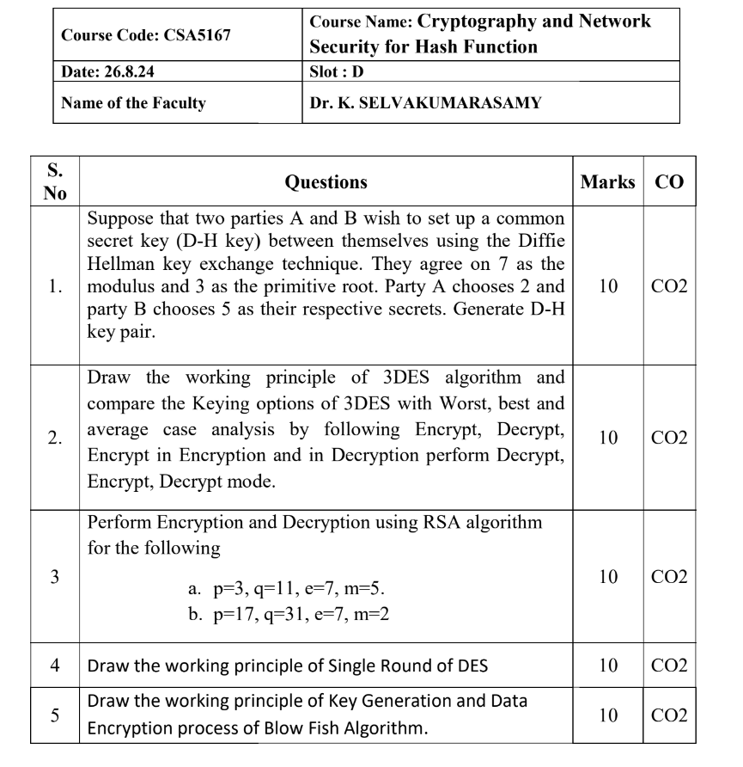

Day- 2

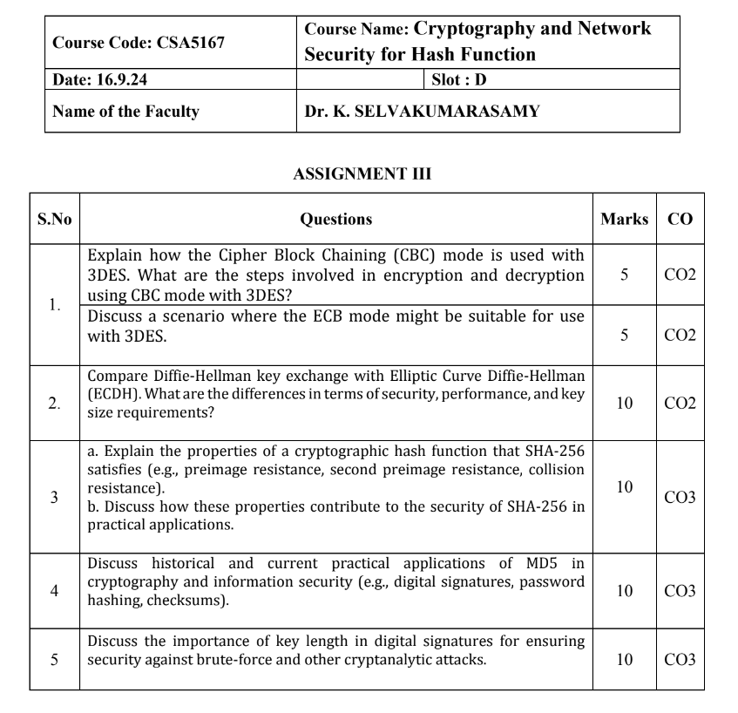

Day- 3

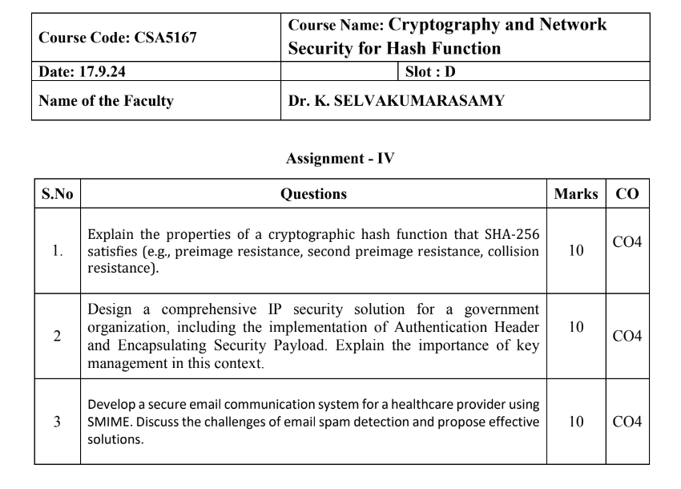

Day- 5

Day- 4

