**Practical-2**

**Aim: Create a web page that collects user information using a form and displays it when the user clicks the submit button**.

**Code:**

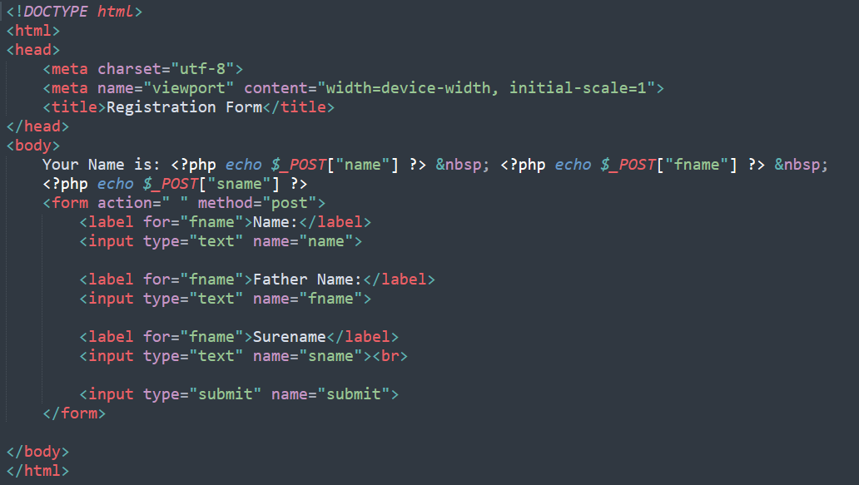

**Output:**

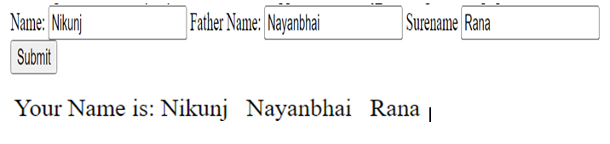

**Practical-3(i)**

**Aim:** **Write a script to implement a simple calculator for mathematical operations**.

**Code:**

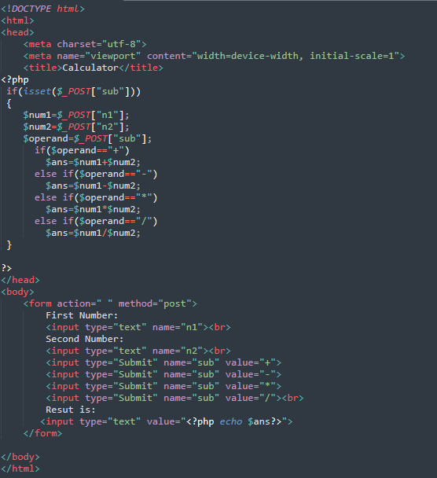

**Outputs:**

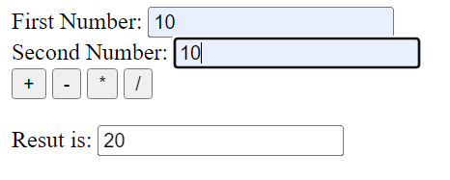

**Practical-3(ii)**

**Aim:** **A company has following payment scheme for their staff: a. Net Salary = Gross Salary – Deduction b. Gross Salary = Basic pay + DA + HRA + Medical c. Deduction = Insurance + PF Where, DA (Dearness Allowance) = 50% of Basic pay HRA (House Rent Allowance) = 10% of Basic pay Medical = 4% of Basic pay Insurance = 7% of Gross salary PF (Provident Fund) = 5% of Gross salary Write a script to take the basic salary of an employee as input and calculate the net payment to any** **employee.**

**Code:**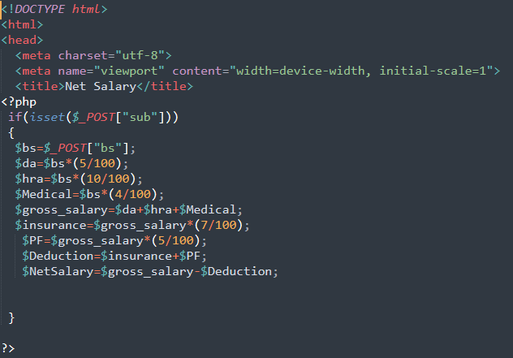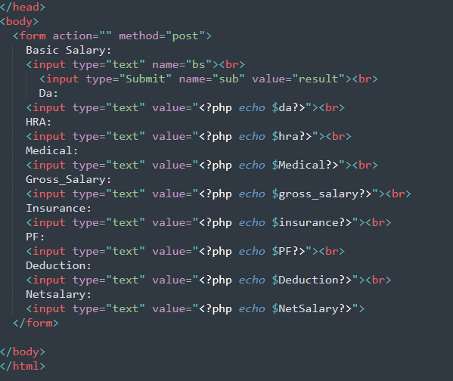

**Output:**

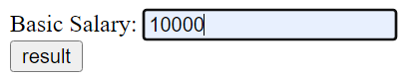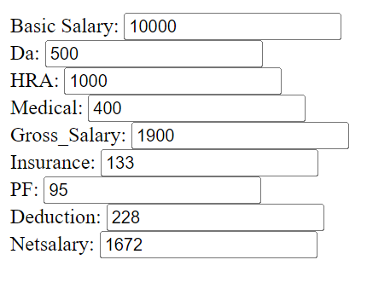

**Practical-4(i)**

**Aim:** **Write a script that reads the name of the car and displays the name of the company the car belongs to as per the below table:**

**Code:**

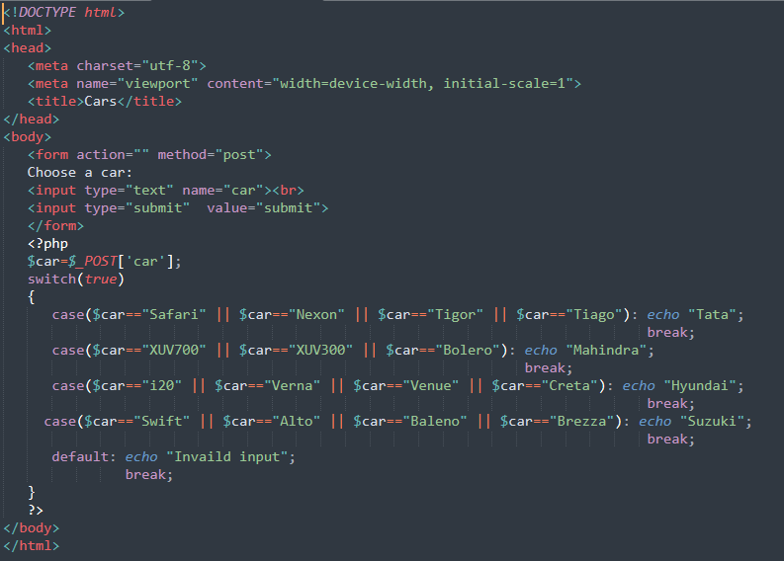

**Output:**

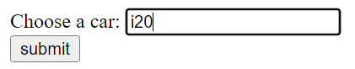



**Practical-4(ii)**

**Aim:** **Write a script to read the marks of 4 subjects and display the result as per the below instructions:**

**A)Each of the four subjects is worth 100 marks.**

**B) If a student gets less than 35 marks in any subject, then he/she will be marked as FAIL, otherwise he/she will be marked as PASS. The result contains the grade of each individual subject in tabular format as per the above table.**

**Code:**

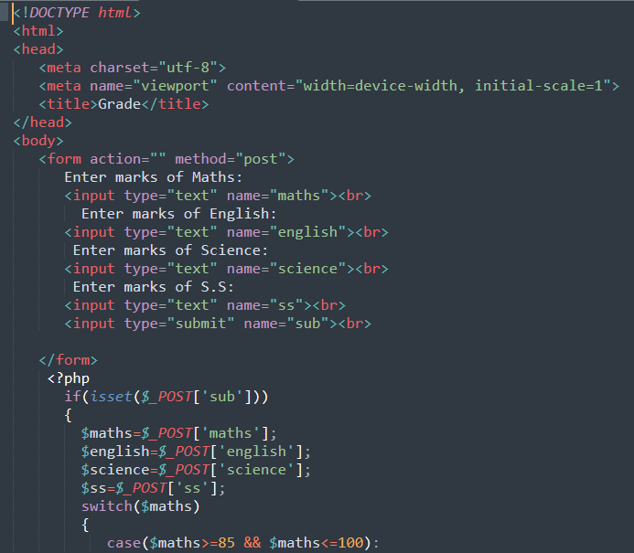 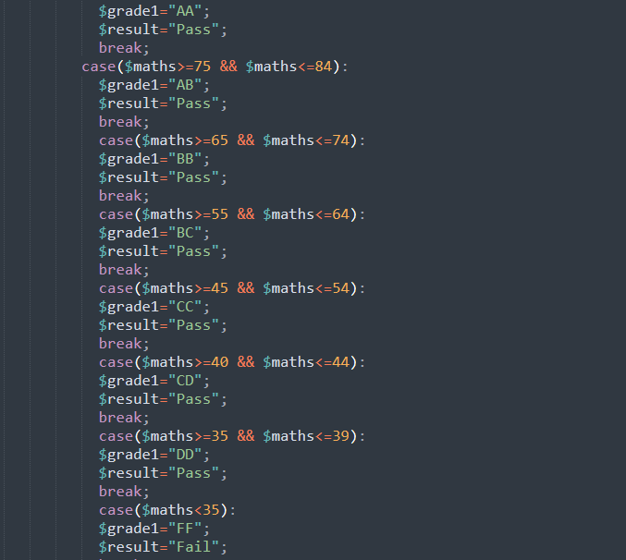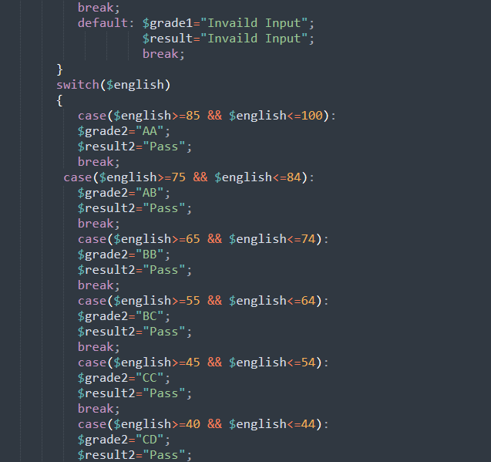 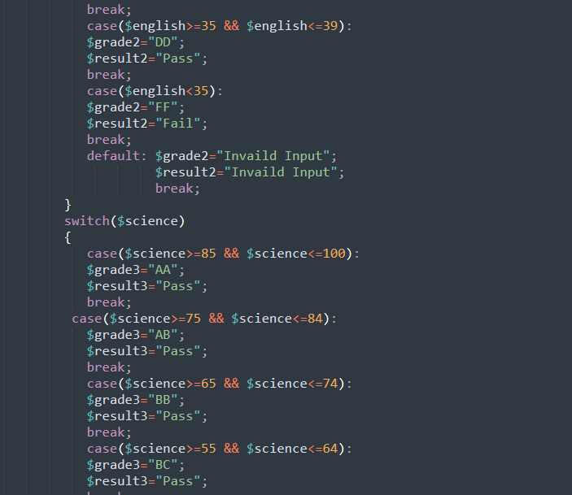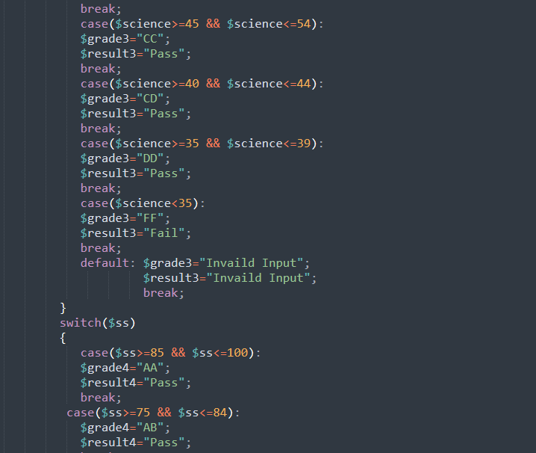 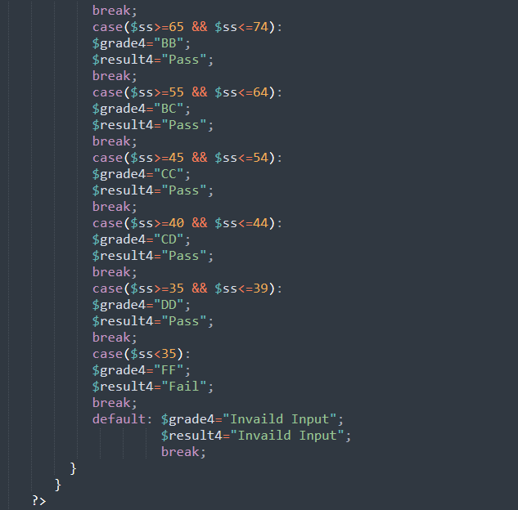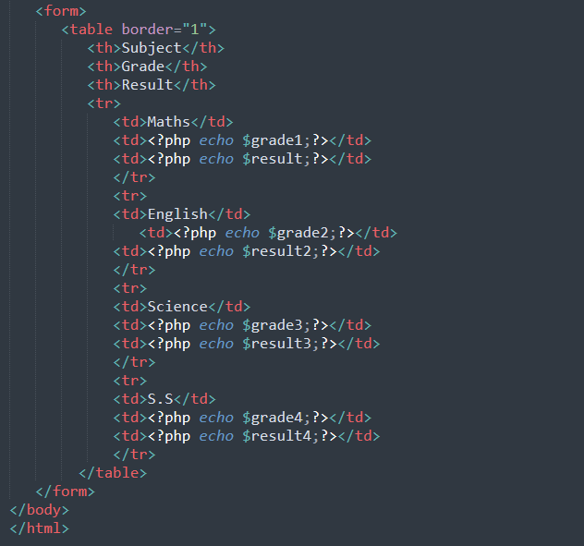

**Output:**

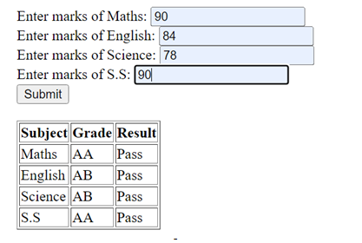**-**

**Practical-4(iii)**

**Aim:** **Write a script to display Fibonacci numbers up to a given term.**

**Code:**

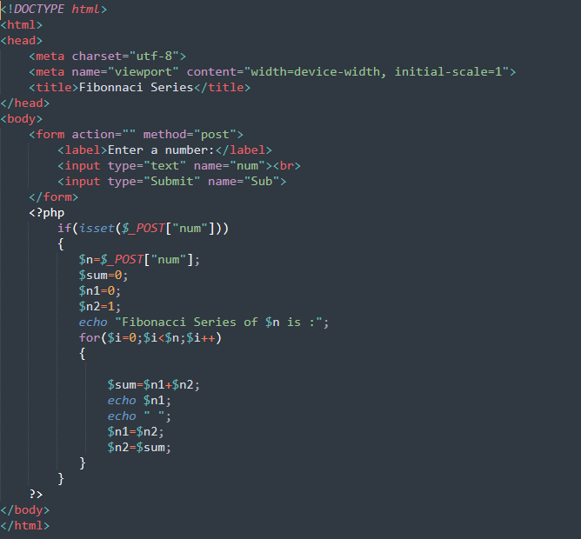

**Output:**

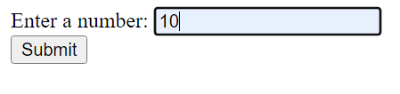 

**Practical-4(iv)**

**Aim:** **Write a script to display a multiplication table for the given number.**

**Code:**

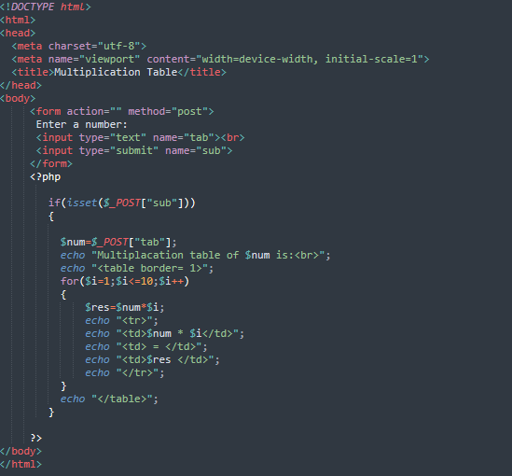

**Output:**

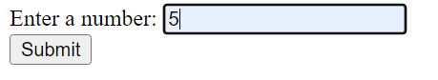 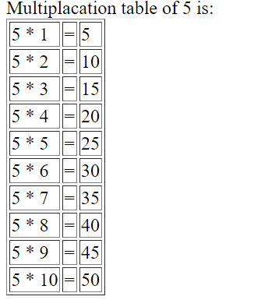

**Practical-5(i)**

**Aim:** **Write a script to calculate the length of a string and count the number of words in the given string without using string functions.**

**Code:**

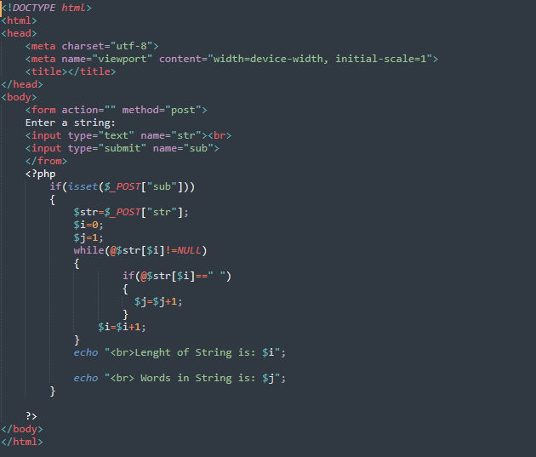

**Output:**

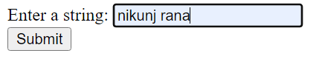 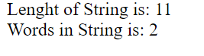

**Practical-5(ii)**

**Aim:** **Write a script to sort a given indexed array.**

**Code:**

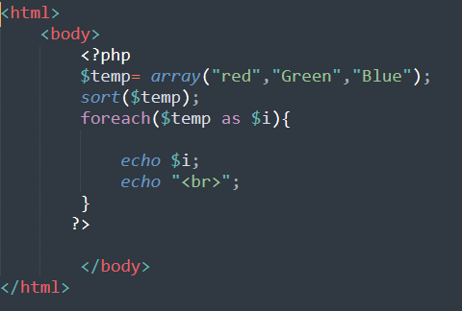

**Output:**

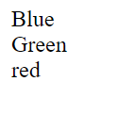

**Practical-5(iii)**

**Aim:** **Write a script to perform 3 x 3 matrix Multiplication.**

**Code:**

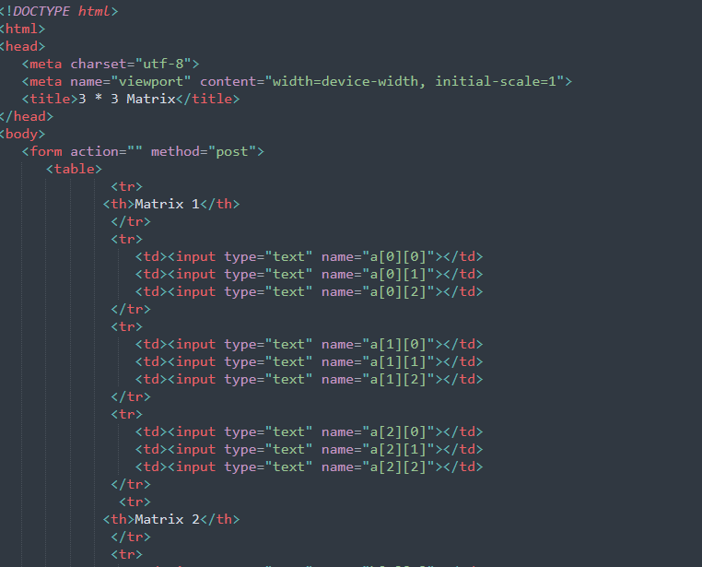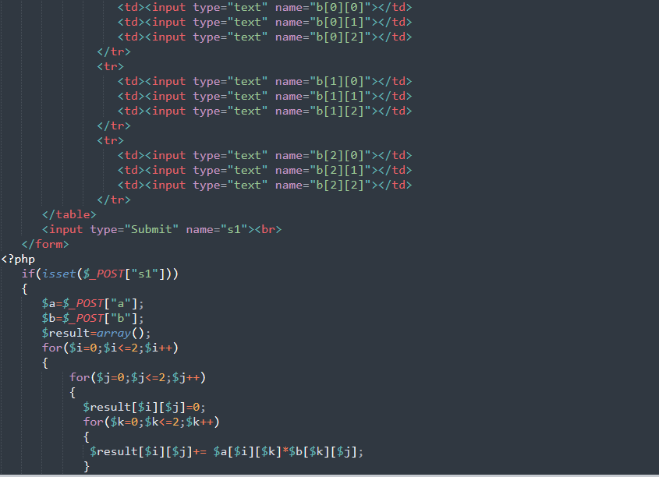

**Practical-6(i)**

**Aim: Consider a currency system in which there are notes of 7 denominations, namely Rs. 1, Rs. 2, Rs. 5, Rs. 10, Rs. 20, Rs. 50and Rs. 100. Write a function that computes the smallest number of notes that will combine for a given amount of money.**

**Code:**

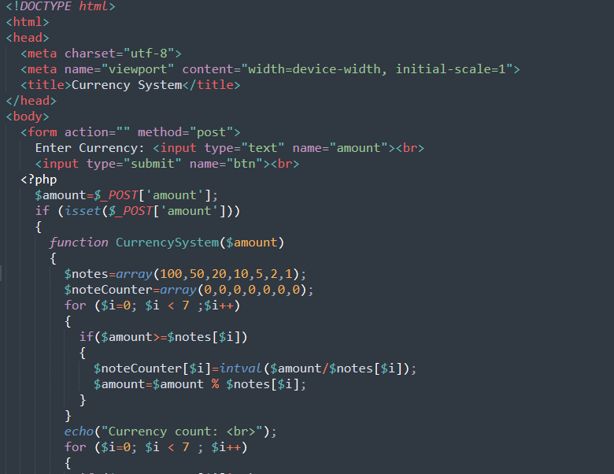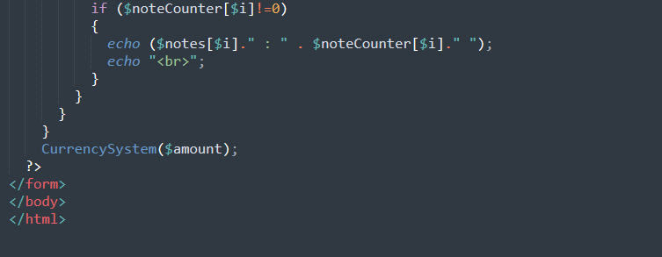

**Output:**



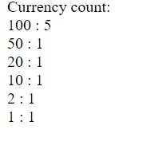

**Practical-6(ii)**

**Aim: Write scripts using string functions: a. to check if the given string is lowercase or not. b. to reverse the given string. c. to remove white spaces from the given string. d. to replace the given word from the given string.**

**Code:**

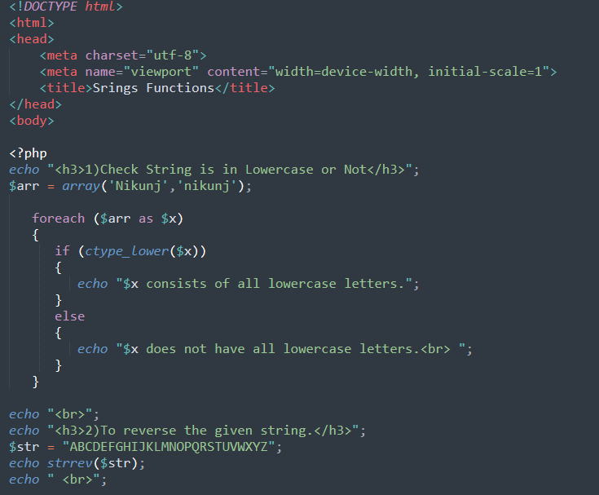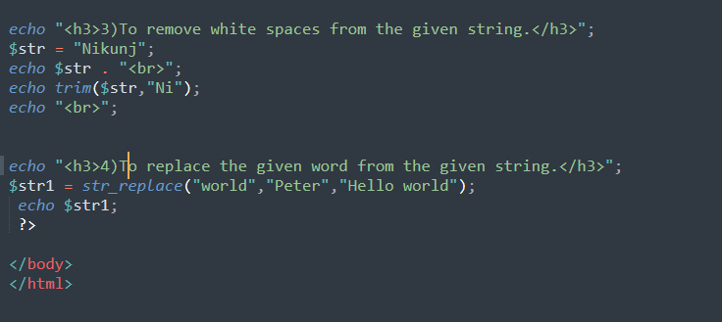

**Output:**

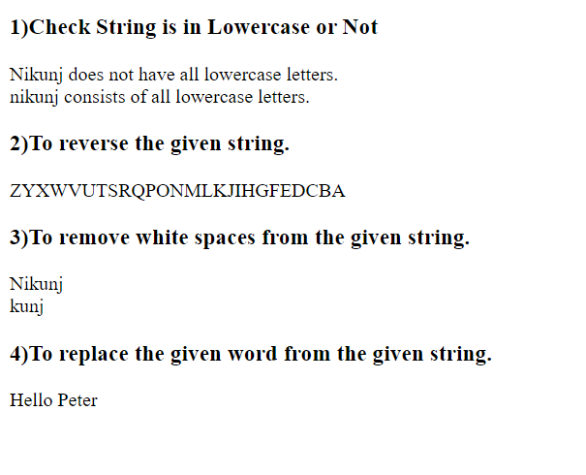

**Practical-6(iii)**

**Aim: Write scripts using math functions:**

**A)to generate a random number between the given range.**

**Code:**

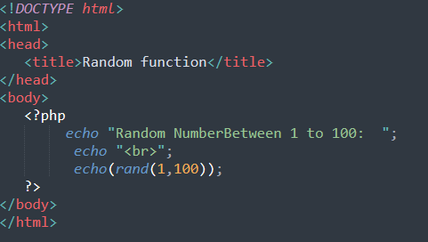

**Output:**

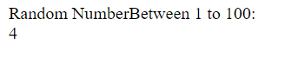 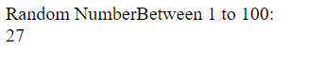 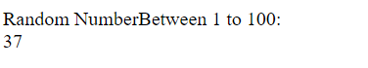

**Practical-6(iii)**

**Aim: Write scripts using math functions:**

**B. to display the binary, octal and hexadecimal of a given decimal number.**

**Code:**

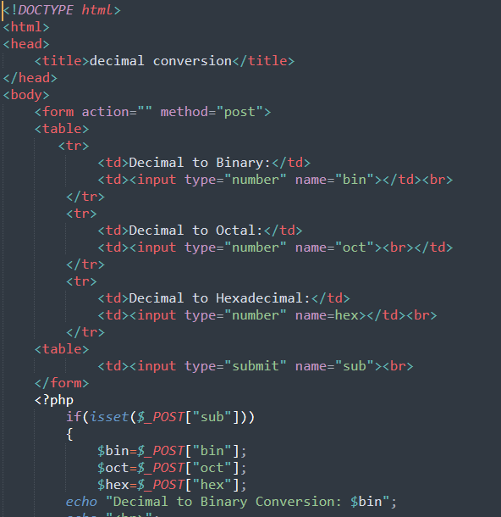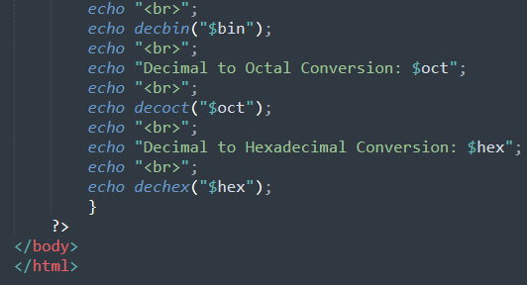

**Output:**

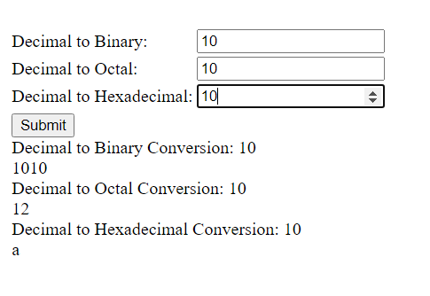

**Practical-6(iii)**

**Aim: Write scripts using math functions:**

**C. to display the sin, cos and tan of the given angle.**

**Code:**

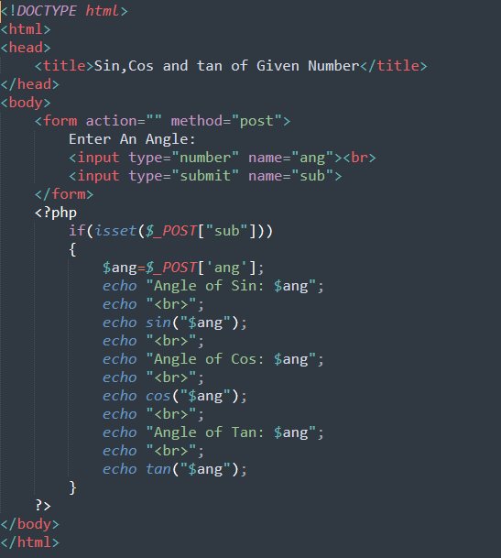

**Output:**

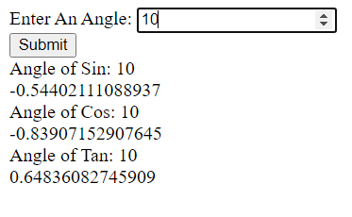

**Practical-6(iv)**

**Aim: Write a script to display the current date and time in different formats.**

**Code:**

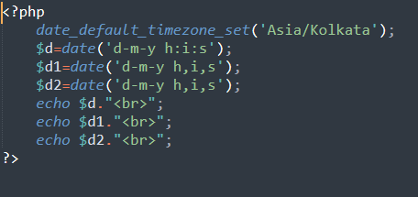

**Output:**

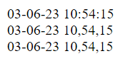

**Practical-7(i)**

**Aim:** **Write a script to:**

**A. Define a class with constructor and destructor.**

**Code:**

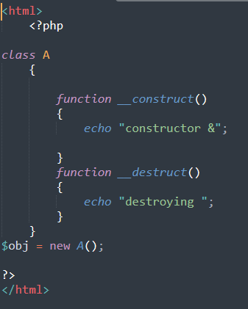

**Output:**



**Practical-7(i)**

**Aim:** **Write a script to:**

**B. Create an object of a class and access its public properties and methods.**

**Code:**

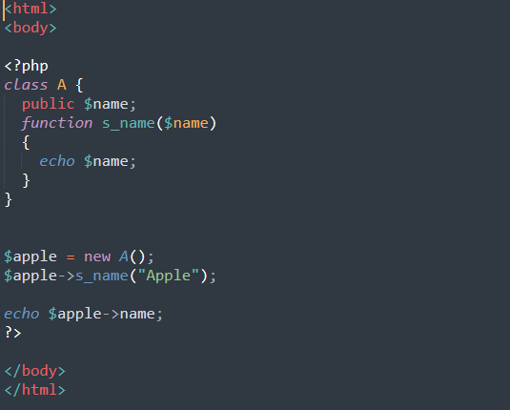

**Output:**



**Practical-7(ii)**

**Aim:** **Write a script that uses the set attribute and get attribute methods to access a class’s private attributes of a class.**

**Code:**

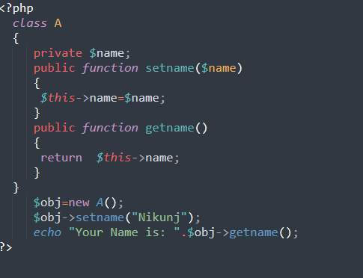

**Output:**



**Practical-7(iii)**

**Aim:** **Write a script to demonstrate single inheritance.**

**Code:**

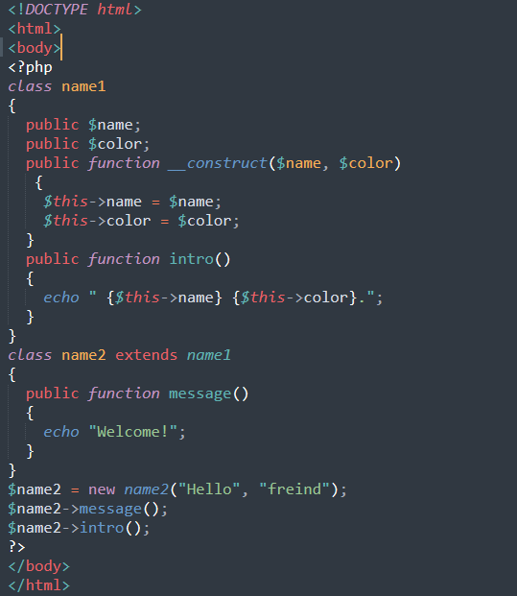

**Output:**



**Practical-7(iv)**

**Aim:** **Write a script to demonstrate multiple inheritance.**

**Code:**

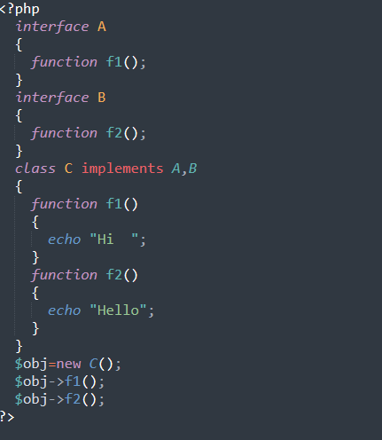

**Output:**



**Practical-7(v)**

**Aim:** **Write a script to demonstrate multilevel inheritance.**

**Code:**

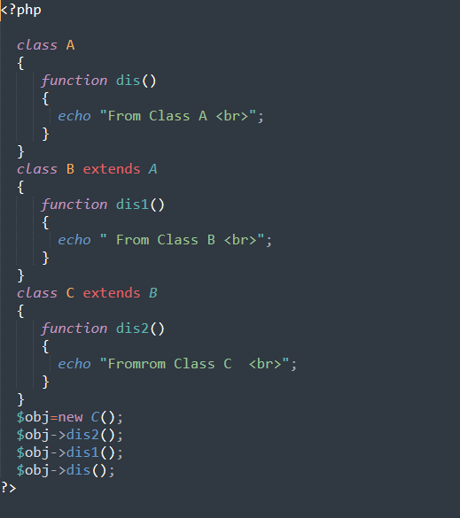

**Output:**

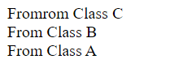

**Practical-7(vi)**

**Aim:** . **Write a script to demonstrate method overriding.**

**Code:**

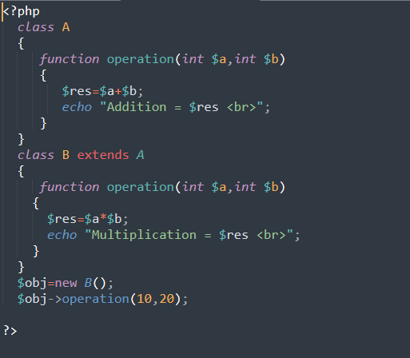

**Output:**



**Practical-7(vii)**

**Aim:** **Write a script to demonstrate method overloading based on the number of arguments.**

**Code:**

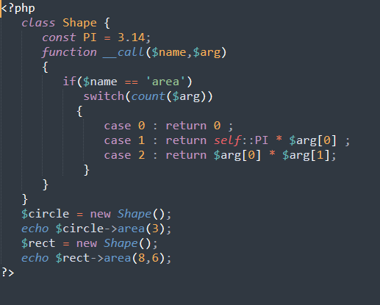

**Output:**

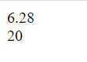

**Practical-7(viii)**

**Aim:** **Write a script to demonstrate a simple interface.**

**Code:**

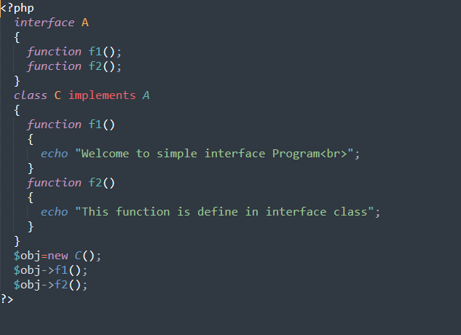

**Output:**

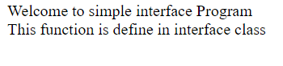

**Practical-7(ix)**

**Aim:** **Write a script to demonstrate a simple abstract class.**

**Code:**

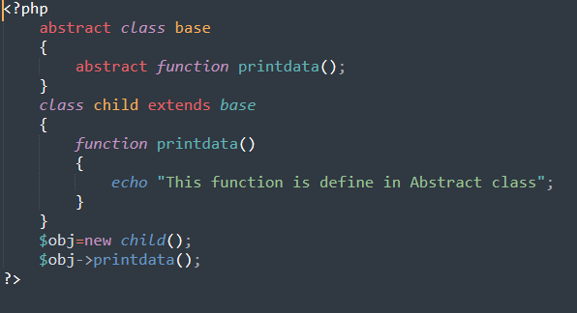

**Output:**



**Practical-7(x)**

**Aim:** **Write a script to demonstrate cloning of objects.**

**Code:**

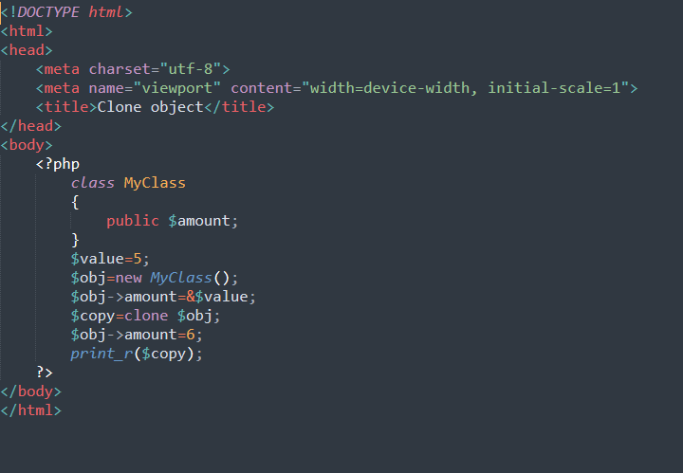

**Output:**

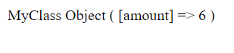

**Practical-8(i)**

**Aim:** **Create a web page using a form to collect employee information.**

**Code:**

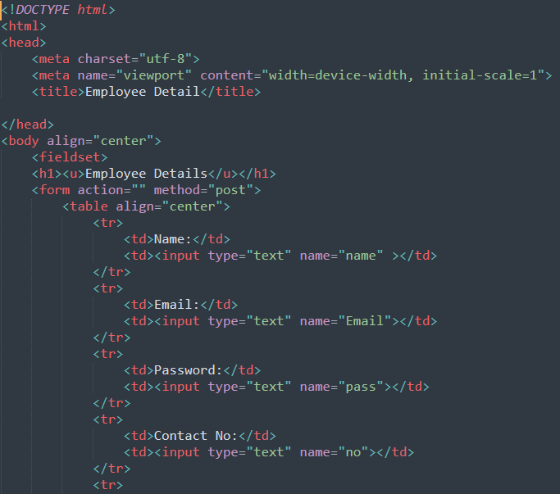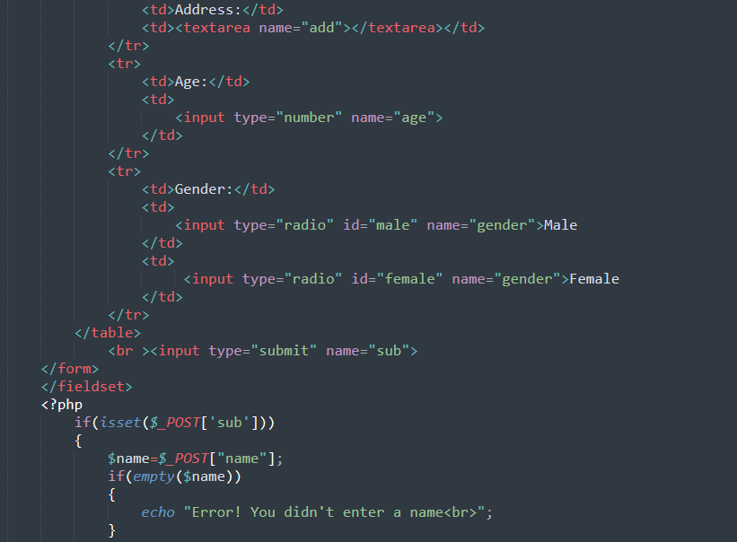 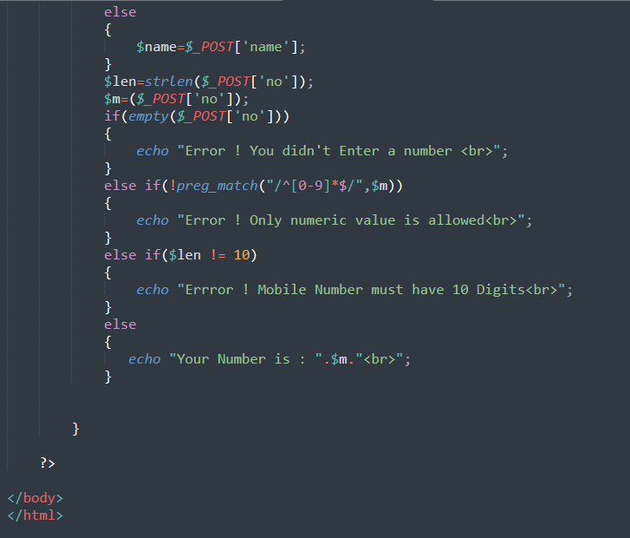

**Output:**



**Practical-8(ii)**

**Aim: Extend practical - 8(i) to validate user information using regular expressions.**

**Code:**