Trust- and Compliance-Aware Decentralised Emergency Vehicle Corridor Coordination Using Local Digital Twins and Swarm Intelligence
Comprehensive System Architecture & UML Design Specification Document
(Derived & Enhanced from Traffic_review2.pptx)
Project Team Members: | Internal Guide:
• V Krishna Teja (23P61A66H6)  • V Manasa (23P61A66H9)  • S Sri Ram (23P61A66F4) | Mrs. T. Adarana  Assistant Professor  Dept. of Computer Science & Engineering

Executive Summary
This document formalizes the software design and architectural modeling for the Trust- and Compliance-Aware Decentralised Emergency Vehicle Corridor Coordination system, derived from and enhancing the research concepts presented in Traffic_review2.pptx (SwarmTwin). The platform resolves urban emergency vehicle bottlenecks through a fully decentralised multi-agent paradigm incorporating independent Local Digital Twins (LDT) on every vehicle, ECDSA NIST P-256 cryptographic message verification, behavioural trust scoring, Isolation Forest anomaly detection, PyTorch LSTM trajectory prediction, XGBoost driver yielding compliance prediction, Distributed Particle Swarm Optimization (DPSO), and A* dynamic route replanning.

1. System Architecture Diagram
The system architecture follows a hierarchical, multi-tier edge-cloud paradigm connecting vehicle onboard units (OBU), cryptographic communication channels, local digital twin state managers, machine learning predictors, swarm optimization engines, and the user dashboard. Below is the system architecture diagram referenced from Slide 8 of Traffic_review2.pptx.

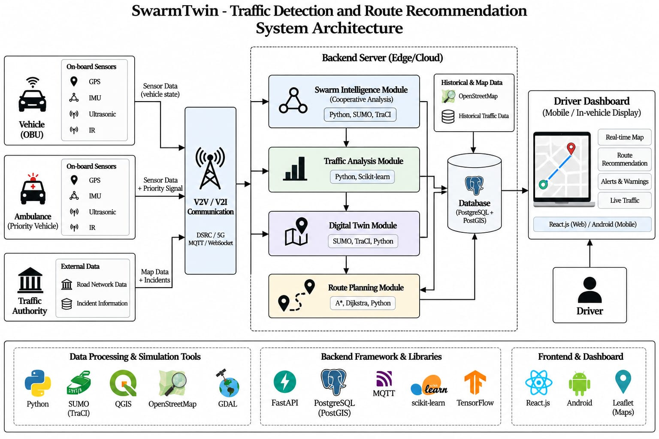
Figure 1: SwarmTwin - Traffic Detection and Route Recommendation System Architecture (Slide 8 Reference)
[ARCHITECTURE ENHANCEMENT] In this implementation, the architecture is upgraded to run as an autonomous software application (FastAPI + React.js) using synthetic JSON datasets. Key enhancements include ECDSA NIST P-256 digital signatures, individual Local Digital Twins per node, and real-time closed-loop dynamic replanning whenever a vehicle fails to yield.

2. Use Case Diagram
The Use Case Diagram defines the interactions between the system boundary and its key actors: Normal Vehicles, Emergency Ambulances, Drivers, and Traffic Authorities. Below is the Use Case Diagram referenced from Slide 11 of Traffic_review2.pptx.

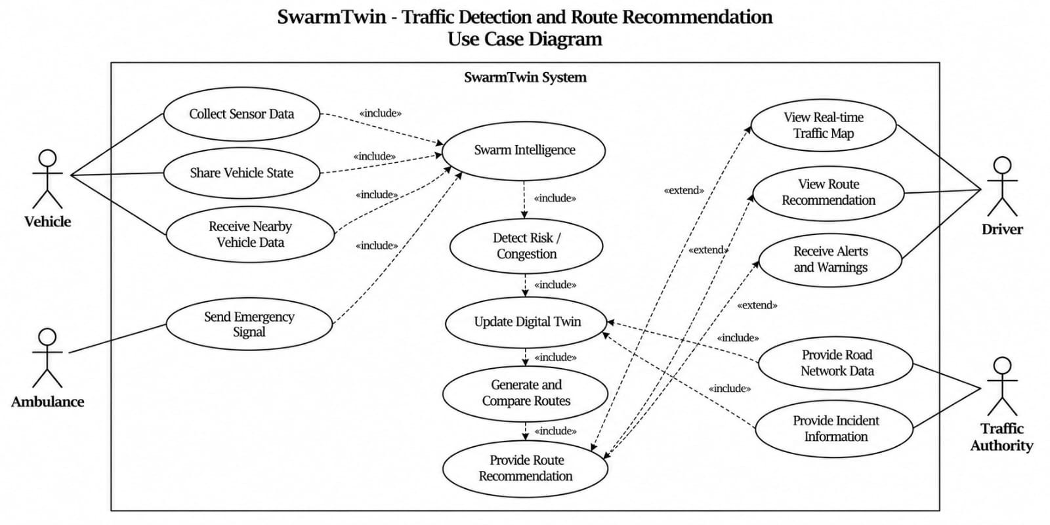
Figure 2: SwarmTwin - Traffic Detection and Route Recommendation Use Case Diagram (Slide 11 Reference)
Key Actors and Primary Use Cases:
1. Vehicle Agent: Collects sensor telemetry (speed, lane, heading), signs V2V beacons, verifies incoming beacons, discovers spatial neighbors.
2. Ambulance (Priority Vehicle): Initiates emergency dispatch broadcast, targets center lane corridor (Lane 2), executes priority navigation.
3. Driver / In-Vehicle UI: Receives recommended lateral lane yielding directives (MOVE_LEFT, MOVE_RIGHT, REDUCE_SPEED), inspects local digital twin, views live traffic map.
4. Traffic Authority: Injects road network topology, road capacity parameters, and static congestion thresholds into the digital twin substrate.

3. Sequence Diagram
The Sequence Diagram captures the chronological message and control flow between the Driver, Vehicle, On-board Sensors, Nearby Vehicles, V2V Cryptography, Swarm Agent, Local Digital Twin, Navigation Engine, and Dashboard. Below is the sequence diagram referenced from Slide 12 of Traffic_review2.pptx.

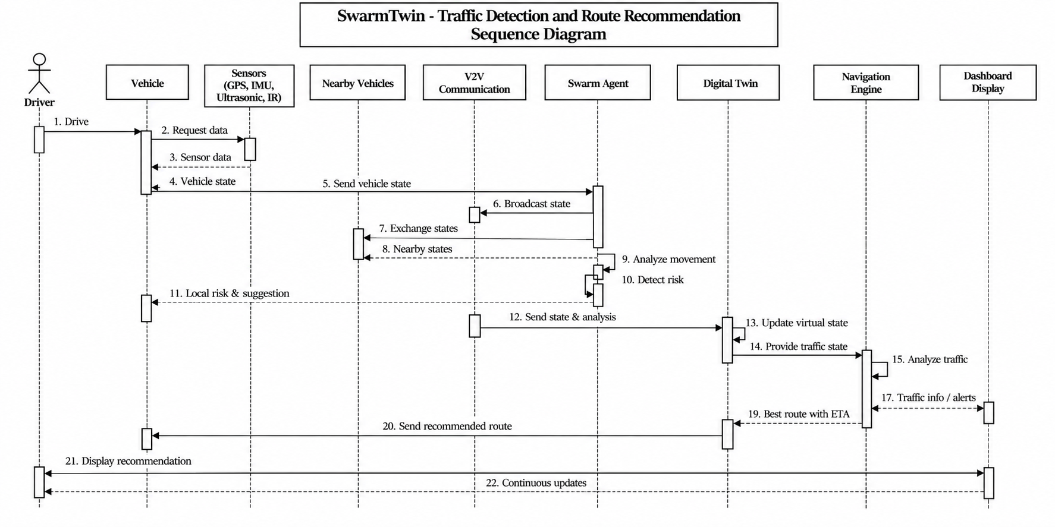
Figure 3: SwarmTwin - Traffic Detection and Route Recommendation Sequence Diagram (Slide 12 Reference)
Step-by-Step Execution Sequence:
• Steps 1-4: Telemetry acquisition from onboard sensors (speed, lane occupancy, heading).
• Steps 5-8: Cryptographic V2V beacon broadcast, neighbor discovery (<450m), and signature verification.
• Steps 9-11: Movement consistency analysis, Isolation Forest anomaly scoring, and local risk assessment.
• Steps 12-14: State integration into independent Local Digital Twins and road graph cost updates.
• Steps 15-18: Distributed Particle Swarm Optimization (DPSO) convergence to identify optimal vehicle yielding actions.
• Steps 19-22: A* route generation, dynamic replan trigger if a driver fails to yield, and real-time dashboard visualization.

4. Activity Diagram
The Activity Diagram illustrates the operational lifecycle, parallel processing pipelines, decision logic gates, and the closed-loop Dynamic Replanning mechanism developed specifically for this project.

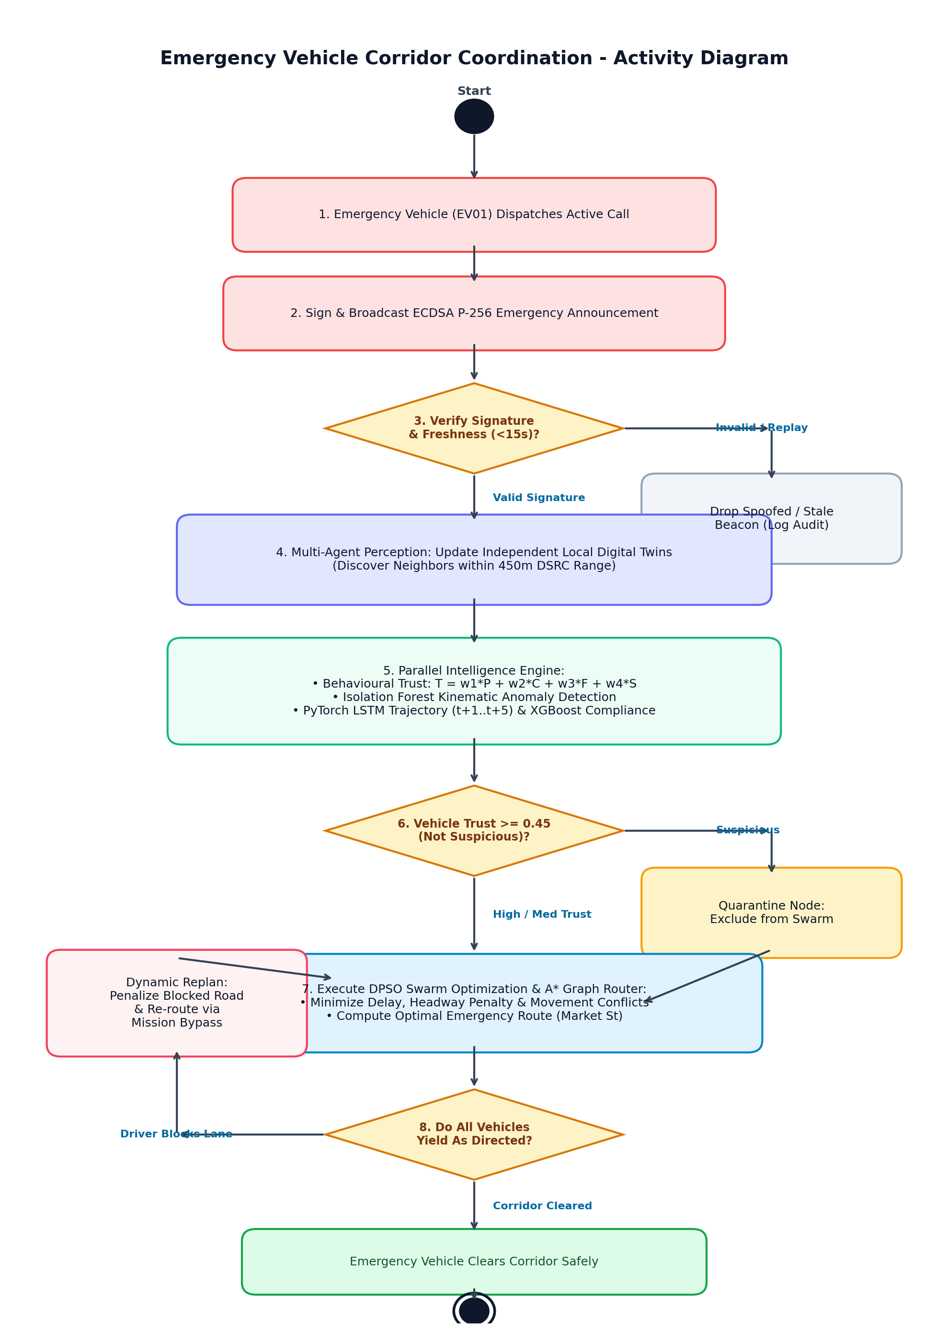
Figure 4: Decentralised Emergency Vehicle Corridor Coordination - Operational Activity Diagram
Detailed Activity Workflow Phases:
1. Initialization & Broadcast: Ambulance EV01 enters active dispatch and issues an ECDSA-signed emergency corridor request.
2. Cryptographic & Freshness Check: Receiving nodes verify the NIST P-256 signature, check monotonic sequence numbers for replay attacks, and discard stale beacons (>15s).
3. Multi-Agent Perception: Each vehicle updates its independent Local Digital Twin (LDT) with discovered neighbors within 450m.
4. Parallel Intelligence Engine: Concurrently computes behavioural trust T(i) = w1*P + w2*C + w3*F + w4*S, executes Isolation Forest anomaly detection, forecasts 5-step trajectories with PyTorch LSTM, and infers driver compliance with XGBoost.
5. Swarm Optimization: DPSO minimizes multi-objective fitness (emergency delay, safety margin, traffic delay, conflict penalty, compliance penalty).
6. Verification & Dynamic Replanning: If a non-compliant driver blocks the primary corridor, the bottleneck is detected, the edge cost is penalized, and A* replans the route via the Mission Bypass in real time.

5. Class Diagram Reference
Below is the Class Diagram from Slide 10 of Traffic_review2.pptx, detailing the object-oriented structure of Vehicles, Sensors, SwarmAgents, Local Digital Twins, Navigation, and Drivers.

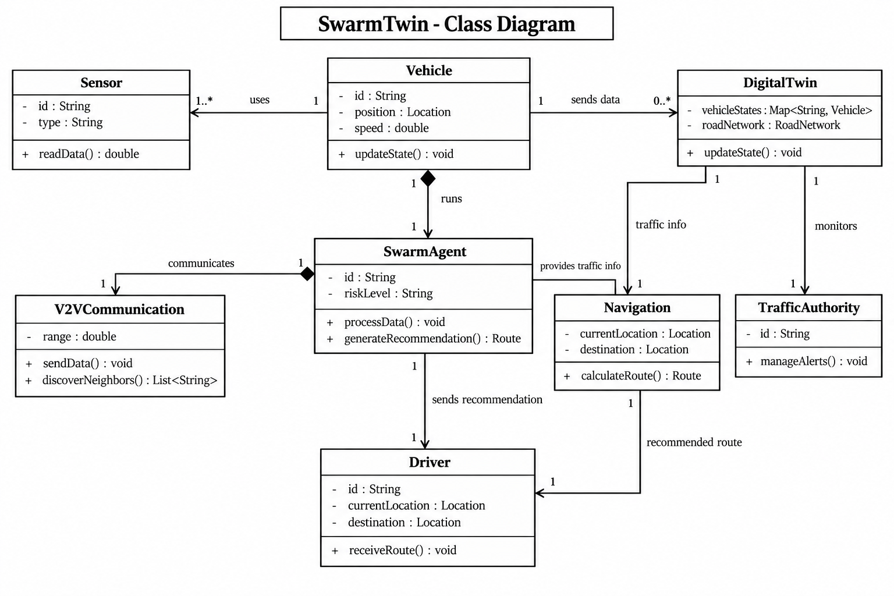
Figure 5: SwarmTwin - Class Diagram (Slide 10 Reference)

