SEC162: Generative AI
PROJECT TITLE:
ClassiNews: Intelligent News Article Categorization System

Submitted by
G. RISHI NEEL VARMA - AP23110010719
K. DIVYAN SASHANK - AP23110010152
G. JAHNAVA - AP23110010164
T.K. ANIRUDH AP23110011627
B. HEVENDRA - AP23110011338



BACHELOR OF TECHNOLOGY in
COMPUTER SCIENCE AND ENGINEERING
SCHOOL OF ENGINEERING AND SCIENCES
SRM University-AP, Neerukonda, Andhra Pradesh 522240
December 2025

Project Description
Media organizations receive thousands of news articles every day across categories like politics, sports, entertainment, business, and technology. Manually categorizing these articles is inefficient and prone to errors. The ClassiNews system aims to build an intelligent text classification model that automatically categorizes news articles, enabling faster content organization and improved delivery of relevant information to readers.

Project Scenarios
Scenario 1: Real-Time News Classification Pipeline
The system receives news articles from different sources through the backend API. Once an article is submitted, the backend performs text cleaning, preprocessing, and sends it to the trained machine-learning model. The model predicts the appropriate category (such as sports, politics, entertainment, etc.). After classification, the article along with its predicted label is stored in the database and made available through the frontend for readers. This scenario helps automate the daily handling of large volumes of news content.

Scenario 2: User Access & Personalized Viewing
Users log in using secure Google Authentication integrated into the backend. Based on their preferred categories or viewing history, the system filters and displays relevant and categorized news articles. The frontend fetches categorized articles through the API and shows them neatly grouped for easy browsing. This scenario improves user experience by presenting personalized and well-organized news content.

Scenario 3: Model Retraining & Continuous Improvement
All incoming articles and editor-reviewed corrections are saved in the dataset. At regular intervals, the classification model is retrained using updated data to improve accuracy. The retrained model is validated, tested, and then deployed into the backend for future predictions. This scenario ensures that the system adapts to new vocabulary, trends, and topics, keeping the classification quality high over time.

Technical Diagram:
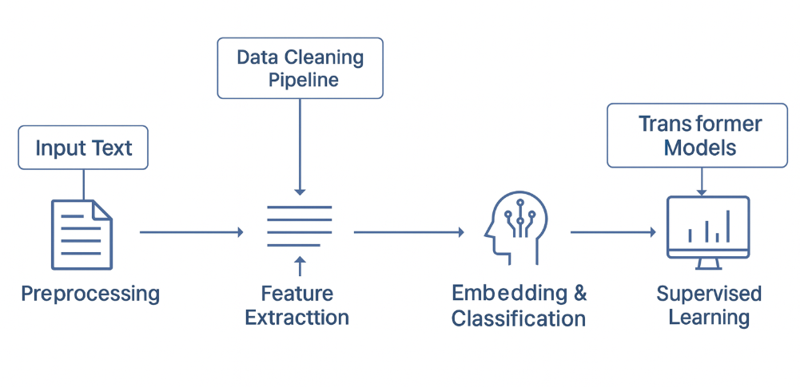

Prerequisites
To complete this project, you must require the following software, concepts, and packages
● Anaconda Navigator or Python 3 Environment
- Install Python 3.8+ or use Anaconda Navigator to manage environments.
- Make sure pip is installed to add required packages.
● Code Editors and Tools
- Visual Studio Code (VS Code) for backend and frontend development
- Postman / Thunder Client for testing API endpoints
- Browser (Chrome/Edge) for running frontend interface
● Python Packages
Open Anaconda Prompt / Command Prompt and install the following packages:
- Type pip install fastapi and click enter.
- Type pip install uvicorn and click enter.
- Type pip install python-multipart and click enter.
- Type pip install scikit-learn and click enter.
- Type pip install pandas and click enter.
- Type pip install numpy and click enter.
- Type pip install nltk and click enter.
- Type pip install joblib and click enter.
- Type pip install tensorflow or pip install torch (depending on your model).
- Type pip install google-auth and click enter.
- Type pip install python-dotenv and click enter.
- Type pip install requests and click enter.
These packages are required for model training, preprocessing, authentication, and backend API.
● Frontend Prerequisites
Open Terminal inside frontend folder and install:
- Type npm install and click enter.
- Type npm install axios and click enter.
- Type npm install react-router-dom and click enter.
● Database / Storage Requirements
- SQLite / PostgreSQL (depending on your project setup)
- Knowledge of basic CRUD operations

Prior Knowledge:
Before working on this project, you should have basic understanding of the following concepts.
1. Python Programming Basics
Resource: https://www.youtube.com/watch?v=rfscVS0vtbw
2. Machine Learning Fundamentals
Resource: https://www.youtube.com/watch?v=ukzFI9rgwfU
3. Natural Language Processing (NLP)
Resource: https://www.youtube.com/watch?v=fNxaJsNG3-s
4. Scikit-learn Library Basics
Resource: https://scikit-learn.org/stable/tutorial/basic/tutorial.html
5. NLTK (Natural Language Toolkit)
Resource: https://www.nltk.org/
6. REST API Concepts / FastAPI Basics
Resource: https://fastapi.tiangolo.com/learn/

Project Flow:
- User Login:
The user logs into the system using Google Authentication for secure access.
- Article Submission:
The user enters or uploads a news article through the frontend.
- Preprocessing:
The backend cleans and processes the article text using NLTK (tokenizing, removing stopwords, formatting text).
- Vectorization:
The cleaned text is converted into numerical features using the saved TF-IDF vectorizer.
- Model Prediction:
The trained machine-learning model predicts the category of the news article.
- Result Display:
The predicted category is sent back to the frontend and displayed to the user.
- Optional Retraining:
New articles can be added to the dataset for improving the model in future.

Project Activities:
1. Load the Dataset
- Import the required libraries like NumPy, Pandas, and NLTK.
- Load the news articles dataset into a DataFrame for processing.
2. Split the Data
- Separate article text as input (X) and category as output (y).
- Prepare the dataset for training and testing.
3. Preprocess the Text
- Clean the text by removing stopwords and unwanted characters.
- Tokenize and normalize the article using NLTK tools.
4. Convert Text to TF-IDF Features
- Use TfidfVectorizer to convert text into numerical format.
- Generate TF-IDF feature vectors for model training.
5. Train and Test the Model
- Train the Multinomial Naive Bayes classifier using training data.
- Test the model to measure accuracy and performance.
6. Predict New Article Category
- Preprocess and convert new text into TF-IDF features.
- Use the trained model to predict the category of the new article.

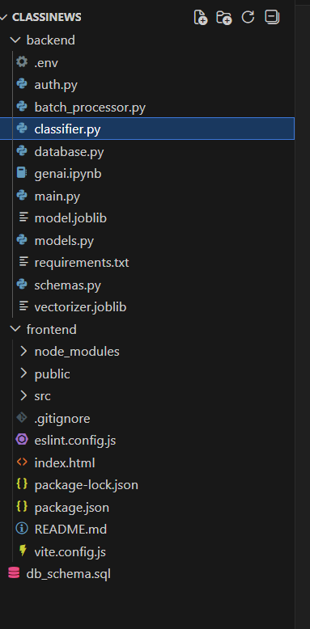

1. main.py
Runs the FastAPI backend and exposes all API routes including the prediction endpoint.
2. classifier.py
Loads the saved model and vectorizer, preprocesses input text, and returns the predicted category.
3. auth.py
Validates Google login tokens and ensures only authenticated users use the application.
4. vectorizer.joblib
Stored TF-IDF vectorizer used to convert news text into numerical features for prediction.
5. model.joblib
Trained machine-learning model that classifies news articles into categories.
6. frontend/
Holds the full frontend interface built using JavaScript (Vite + React or similar).
- public/ – Static files that get served directly (icons, assets).
- src/ – All frontend source code including components, pages, and API calls.
- index.html – Main HTML entry point for the frontend UI.
- package.json – Lists frontend dependencies and project scripts.
- vite.config.js – Configuration file for Vite frontend build and development server.
7. backend/
Contains all backend logic, API endpoints, authentication, machine learning prediction, and database operations.
- auth.py – Handles Google OAuth authentication and user token verification.
- batch_processor.py – Processes multiple news articles in bulk for automated classification.
- classifier.py – Loads the trained model & vectorizer and performs text preprocessing + prediction.
- database.py – Contains database connection and functions to store or retrieve classified articles.
- main.py – Main FastAPI application file that defines routes (e.g., /predict).
- model.joblib – Saved trained machine-learning classification model.
- models.py – Database models and ORM classes used for storing user/article data.
- requirements.txt – List of Python dependencies needed for running the backend.
- schemas.py – Pydantic models defining request and response structures for the API.
- vectorizer.joblib – Saved TF-IDF vectorizer used to convert text into numerical features.
- .env – Stores environment variables such as Google OAuth keys / database credentials.

Milestone 1: Dataset Loading and Environment Setup
Dataset loading focus on preparing the working environment and loading the news dataset so that all further steps—preprocessing, TF-IDF conversion, and model training—can be executed smoothly. This milestone ensures that the required tools, libraries, and dataset are properly set up before moving into machine learning tasks.
1.1 Installing Required Python Libraries
- The first step is to install the core libraries needed for text processing and model building.
- Libraries such as NumPy, Pandas, and NLTK are installed using pip.
- Additional libraries like scikit-learn, joblib, and FastAPI are also essential for training and running the model.
1.2 Setting Up the Python/Anaconda Environment
- Users create a clean project environment using Anaconda or a virtual environment so that all dependencies remain isolated and conflict-free.
- This environment ensures smooth execution of training code and backend APIs without version issues.
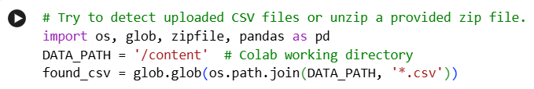

1.3 Importing All Necessary Libraries
- After installation, all libraries are imported in the training script or notebook.
- For example, Pandas is imported for data handling, NLTK for preprocessing, and scikit-learn components like TfidfVectorizer, train_test_split, and Naive Bayes for model development.
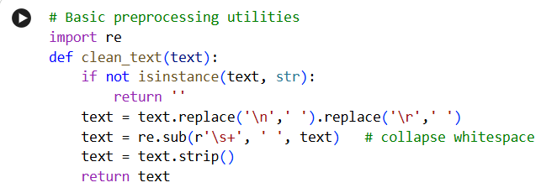
1.4 Downloading NLTK Resources
- NLTK stopwords and tokenizers are downloaded to support text preprocessing.
- This allows your system to remove unnecessary words and convert raw text into a clean format before training.
1.5 Loading the Dataset into Pandas
- The news dataset (news_articles.csv) is loaded using pd.read_csv() exactly as described in your PDF.
- Once loaded, the dataset becomes a Pandas DataFrame containing two main columns:
  - Article Text
  - Category Label (Politics, Sports, Entertainment, Business, Technology)
1.6 Verifying the Dataset Structure
- The .head() function is used to preview the first few rows of the dataset.
- This helps confirm that the CSV was loaded correctly and that the article text and category columns are present.
- It also gives the developer an idea of any cleaning that may be required.

1.7 Checking for Missing or Irregular Data
- Before moving to preprocessing, basic checks are performed to identify missing values, blank categories, or irregular entries.
- This step improves the quality of data fed into the model.
1.8 Preparing Inputs and Labels
- The DataFrame is separated into two parts:
  - X = article text
  - y = category
- This split is essential for training the model, as X represents feature inputs and y represents output labels.

Milestone 2: Data Splitting and Text Preprocessing
Milestone 2 focuses on preparing the dataset for machine learning by separating the data into inputs and outputs, and applying text preprocessing techniques to clean and standardize the article content. This step is extremely important because the quality of preprocessing directly affects the accuracy of the classification model.
2.1 Splitting Independent and Dependent Variables
● Creating Feature and Label Variables
- The dataset contains two important columns:
  - Article Text – the actual content of the news
  - Category – the label such as Politics, Sports, Entertainment, Business, or Technology
- In this step, the article text is stored in a variable like X, and the category labels are stored in y.
- This is necessary because machine learning algorithms require inputs (X) and outputs (y) to learn the patterns.
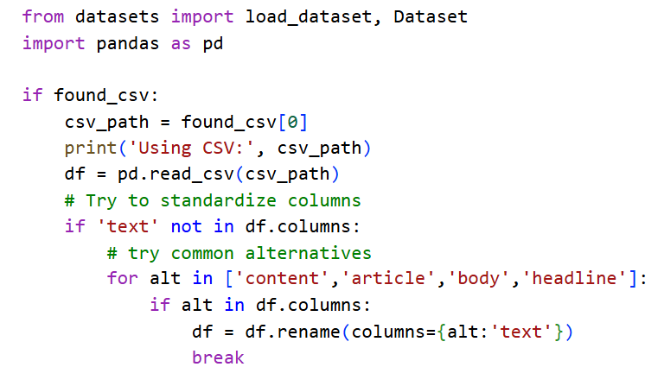
2.2 Handling Missing or Empty Values
In this step, the dataset is checked for any articles that are blank or have missing categories. If an article has no text or the category field is empty, it can cause errors during preprocessing and training. Therefore, these rows are either removed or corrected to ensure the dataset is clean and reliable. This helps the model learn only from complete and meaningful data.

2.3 Converting Text to Lowercase
The entire article text is converted into lowercase letters. This is done to maintain consistency and avoid treating the same word differently just because of capitalization. For example, “Technology”, “technology”, and “TECHNOLOGY” should all be recognized as the same word. Converting text to lowercase helps reduce duplicates and makes the preprocessing cleaner and more effective.
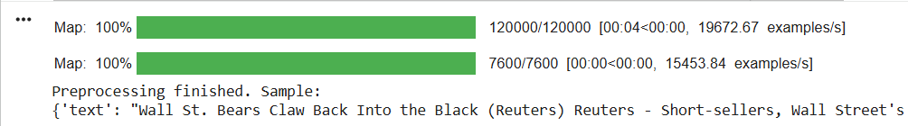

2.4 Removing Special Characters and Numbers
Unwanted elements like punctuation marks, symbols, emojis, and numbers are removed from the article text. These characters do not contribute meaningful information for text classification and can create noise in the data. By removing them, the text becomes cleaner and easier for the model to understand, helping improve the overall accuracy of the classification.

2.5 Tokenization
- Tokenization splits the text into individual words (tokens).
- This step helps the model understand the text in smaller units and apply NLP techniques smoothly.
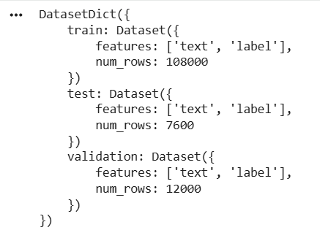

2.6 Stopword Removal
- Many common English words like the, is, at, and do not add meaning to classification.
- Using NLTK’s stopword list, these words are removed from the article text to improve model performance.
- This step reduces noise and focuses only on meaningful words.

2.7 Stemming with PorterStemmer
- Stemming reduces words to their root forms.
Example: “running”, “runs”, “ran” → “run”
- This helps group similar words together and improves feature consistency.
- Your project’s code uses PorterStemmer from NLTK, exactly as mentioned in the PDF.

2.8 Creating a Final Preprocessed Text Column
- After applying lowercase, stopword removal, tokenization, and stemming, the cleaned text is stored in a new column.
- This final processed text is the one used for TF-IDF vectorization and model training.
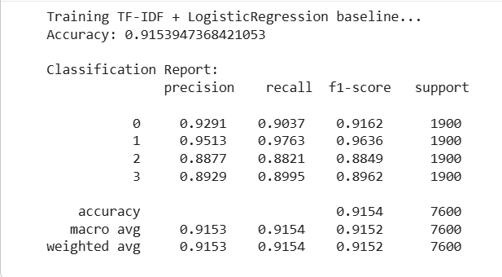

Milestone 3: Feature Extraction using TF-IDF
This focuses on converting the cleaned text data into numerical features that the machine learning model can understand. Since machine learning models cannot work directly with raw text, TF-IDF (Term Frequency–Inverse Document Frequency) is used to convert words into meaningful numeric values based on how important each word is in the article.
3.1 Initializing the TF-IDF Vectorizer
- After preprocessing, the next step is to create a TfidfVectorizer object from Scikit-learn.
- This vectorizer is responsible for converting the cleaned text into a mathematical representation.
- The vectorizer considers how frequently a word appears in an article and how rare it is across all articles.
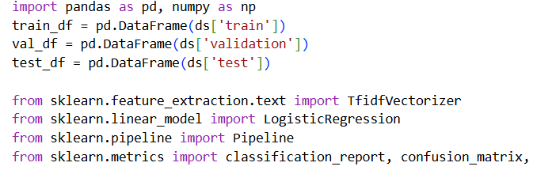

3.2 Fitting TF-IDF on the Training Text
- The TF-IDF vectorizer first learns the vocabulary from all the cleaned articles.
- It calculates word frequencies across the entire dataset.
- This helps the model understand which words are common and which are significant.
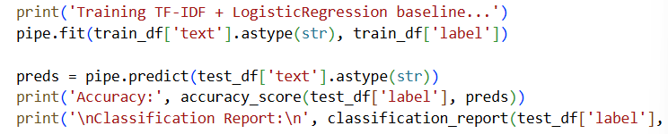

3.3 Transforming Text into Numerical Feature Vectors
- After fitting, the vectorizer converts each cleaned article into a TF-IDF vector, which is a list of numbers.
- These numbers represent the importance of each word in that article.
- The final output is stored as a matrix called X_tfidf, which becomes the input to the classifier.
3.4 Understanding How TF-IDF Works
- Term Frequency (TF): How many times a word appears in an article.
- Inverse Document Frequency (IDF): How rare the word is across all articles.
- TF-IDF = TF × IDF
- This helps the model focus more on meaningful words like “budget”, “tournament”, “government” and ignore common words like “the”, “this”, “and”.
3.5 Creating Feature Matrix for Model Training
- Once all the text is converted, the TF-IDF matrix acts as the feature set for the model.
- Each row represents an article, and each column represents a unique word.
- This matrix allows the Multinomial Naive Bayes classifier to find patterns in the text.
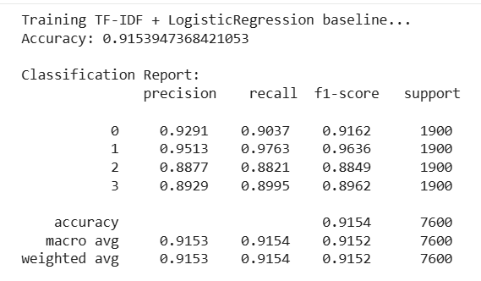

3.6 Saving the TF-IDF Vectorizer for Future Use
- After training, the vectorizer is saved using joblib or pickle so that it can be reused in the backend during prediction.
- This ensures that the text entered by users later is transformed in the same way as the training data.
3.7 Using TF-IDF during Prediction
- When a new article is submitted, the backend loads the saved TF-IDF vectorizer.
- The incoming text is preprocessed and converted into TF-IDF using the same vocabulary used during training.
- This ensures consistent and accurate predictions.

Milestone 4: Model Training and Evaluation
It focuses on training the machine learning model using the TF-IDF feature matrix created in Milestone 3, and then evaluating how well the model performs on unseen data. This step is the core of the project, as it teaches the system how to understand and classify news articles.
4.1 Splitting the TF-IDF Features Into Training and Testing Sets
- Once the TF-IDF matrix (X_tfidf) and category labels (y) are ready, they are divided into 80% training data and 20% testing data.
- The training set helps the model learn patterns from the text, while the testing set checks how well the model performs on new data.
- This split ensures that the model does not simply memorize the data but learns meaningful general patterns.
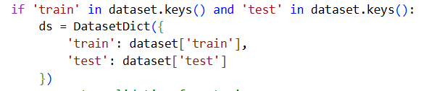

4.2 Initializing the Multinomial Naive Bayes Model
- The project uses the Multinomial Naive Bayes (MultinomialNB) algorithm, which is one of the best and fastest models for text classification.
- It works well with TF-IDF data because it handles word frequency and probability distribution efficiently.
- The model is easy to train, lightweight, and gives excellent results for news classification.

4.3 Training the Model on the Training Dataset
- The model is trained using X_train (TF-IDF features) and y_train (categories).
- During training, the model learns how the presence and importance of certain words indicate each news category.
- For example:
- Words like “election”, “government” → more likely to be Politics
- Words like “match”, “team”, “tournament” → usually Sports
- Words like “startup”, “market”, “finance” → linked to Business
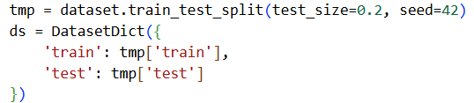

4.4 Testing the Model on Unseen Data
- After training, the model is tested using X_test and y_test.
- This tells us how accurate the model is when predicting categories for new articles it has never seen before.
- Accuracy is calculated by comparing predicted labels with actual labels.

4.5 Evaluating Model Performance
- Besides accuracy, other evaluation methods can be used, such as:
- Confusion matrix
- Precision
- Recall
- F1-score
- These metrics show how well the model performs for each category separately.
- For example, the model may perform very well on Sports but slightly lower on Entertainment depending on word patterns.

4.6 Predicting New Article Categories
- After evaluation, the model is ready for real-world use.
- When a new article is typed in, it is:
- Preprocessed
- Converted to TF-IDF
- Passed to the trained model
- Classified into a category (e.g., "Politics", "Sports")
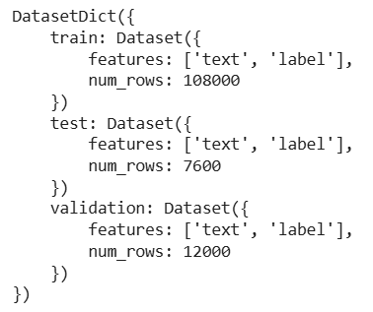

Milestone 5: Model Deployment
It focuses on taking the trained machine learning model and integrating it into a functional backend so real users can submit news articles and receive predictions. This milestone turns the project from a training notebook into a working application.
5.1 Saving the Trained Model and TF-IDF Vectorizer
- After training is completed, both the Multinomial Naive Bayes model and the TF-IDF vectorizer are saved using pickle or joblib.
- This allows the same model to be reused without retraining again each time the application starts.
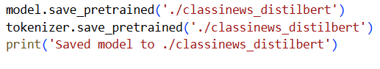

5.2 Loading the Model in the Backend (FastAPI)
- In your backend code, FastAPI loads the saved model and TF-IDF vectorizer at startup.
- This makes the backend ready to classify incoming articles instantly.
- The model is loaded only once, which makes the API fast and efficient.

5.3 Creating an API Endpoint for Prediction
- A POST /predict endpoint is created in your FastAPI backend.
- Users send their article text to this endpoint.
- The backend preprocesses the text, applies TF-IDF, and uses the model to predict the category.
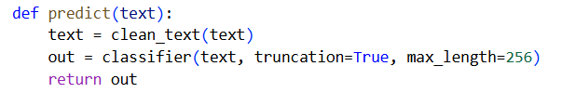

5.4 Running the Application Using Uvicorn
- The entire project is deployed locally using Uvicorn, the ASGI server used by FastAPI.
- Running the command uvicorn app:app --reload starts the backend and makes the model available for real-time classification.

Backend Implementation
The backend of ClassiNews is implemented as a lightweight REST API using FastAPI. Its main responsibilities are: authenticate users, accept article text, run preprocessing, convert text to TF-IDF features, load the trained model, make category predictions, and return structured responses to the frontend. The backend code is located in the classinews/backend/ folder of the project.
- FastAPI Framework Used
The backend is built using FastAPI, which handles HTTP requests, routing, and JSON responses efficiently.
- Google OAuth Authentication
The auth.py file manages Google OAuth2 token verification, ensuring only authenticated users can access key features.
- Text Preprocessing Pipeline
Before prediction, the backend cleans and prepares the article using NLTK (removes stopwords, tokenizes, applies stemming).
- TF-IDF Vectorizer Loading
A pre-trained TF-IDF vectorizer is loaded at startup to convert incoming text into numerical feature vectors.
- Machine Learning Model Loading
The backend loads the trained Multinomial Naive Bayes model (saved using pickle/joblib) to perform real-time predictions.
- Prediction API Endpoint
A POST /predict endpoint receives article text, preprocesses it, transforms it, and returns the predicted category as JSON.
- Error Handling & Validation
The backend validates input data and provides clear error messages to ensure robust and reliable API behavior.
- FastAPI + Uvicorn Execution
The backend runs through Uvicorn, enabling fast development reloads and smooth handling of prediction requests.
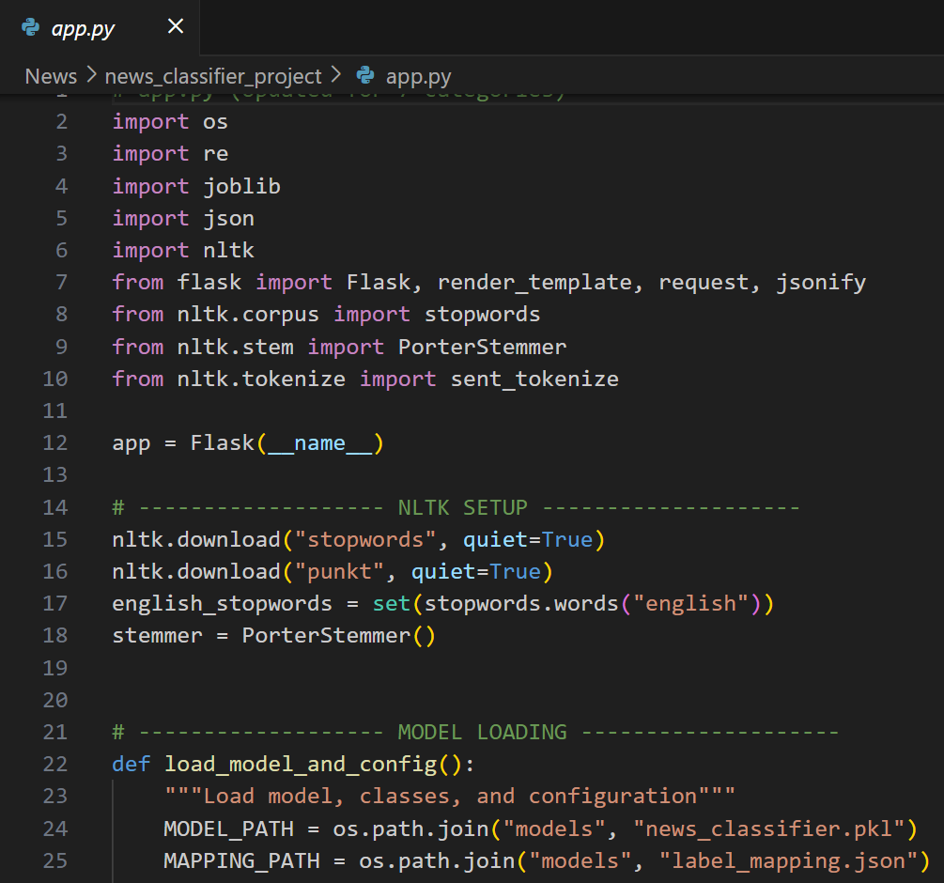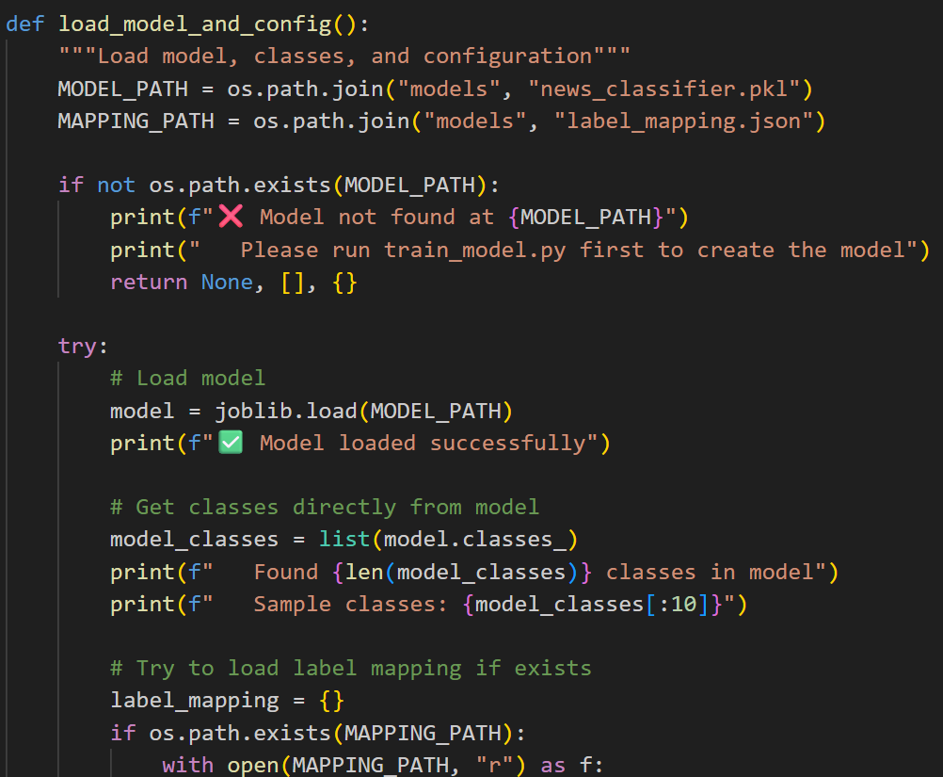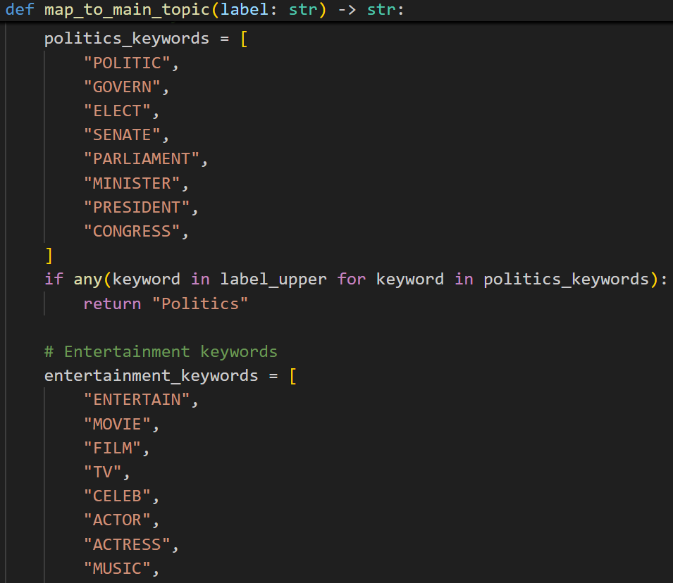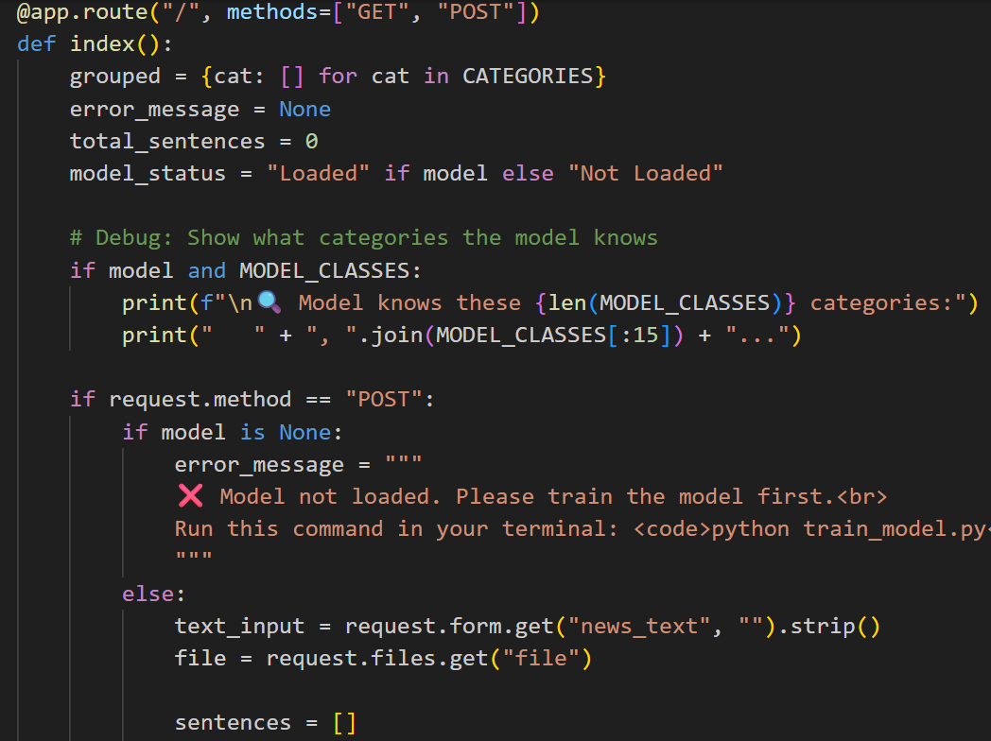
Frontend Implementation (HTML Templates)
- Template Engine & Folder
The frontend uses HTML templates (Jinja2-style) served by FastAPI’s template system. Templates are stored in a templates/ directory and rendered by backend routes to produce the web pages users interact with.
- Main Pages / Templates
Typical templates include: index.html (home / article input), login.html (Google login or sign-in prompt), and result.html (display predicted category). Each template follows a simple layout so users can quickly submit text and view results.
- Article Submission Form
The index.html template contains a form or textarea named (for example) article where users paste or type news content. The form is submitted to the backend either via standard POST or via JavaScript (AJAX/fetch) to the /predict endpoint.
- AJAX / Fetch Integration
JavaScript in the template sends the article text to the backend asynchronously and receives the JSON prediction. This allows the page to show the result without a full page reload and gives a smoother user experience.
- Result Display & UX
The result template or a result panel on the same page shows the predicted category, confidence score, and a short preview of the input article. Clear labels and badges (e.g., “Category: Politics — Confidence: 87%”) improve readability.
- Login & Access Flow
Login buttons and status are integrated into templates. If Google OAuth is used, the login.html or a navbar area contains the sign-in/out flow. Templates conditionally render user info (like email) when authenticated.
- Static Assets (CSS / JS)
A static/ folder holds CSS for styling and small JS files for client-side behavior. Templates reference these static files for responsive layout, fonts, and minimal interactivity (form validation, loader spinner while waiting for prediction).
- Validation & Error Handling in UI
Templates include simple checks and user-friendly error messages (e.g., “Please enter article text” or “Prediction failed — try again”). When backend returns errors, the frontend shows these messages in a toast or inline alert box.

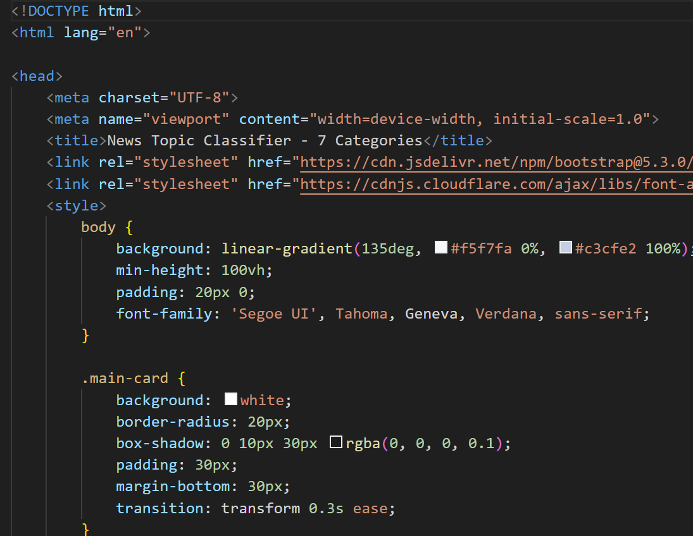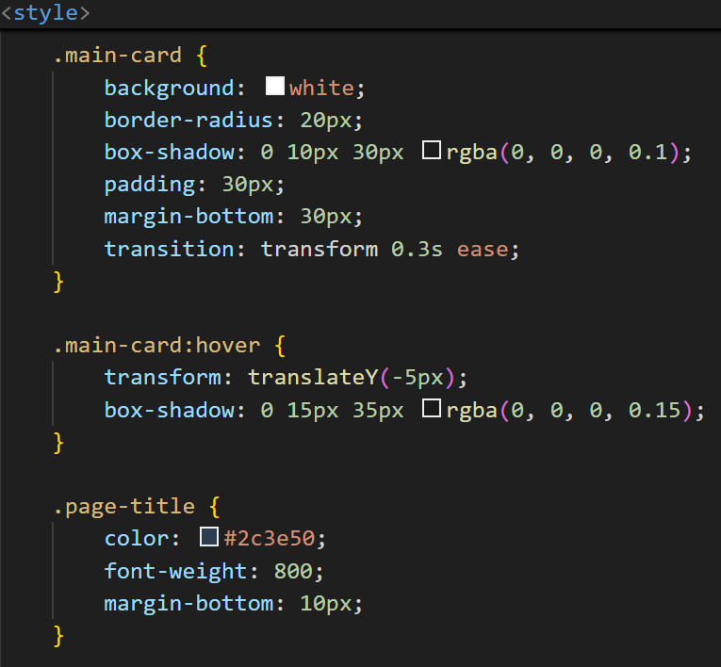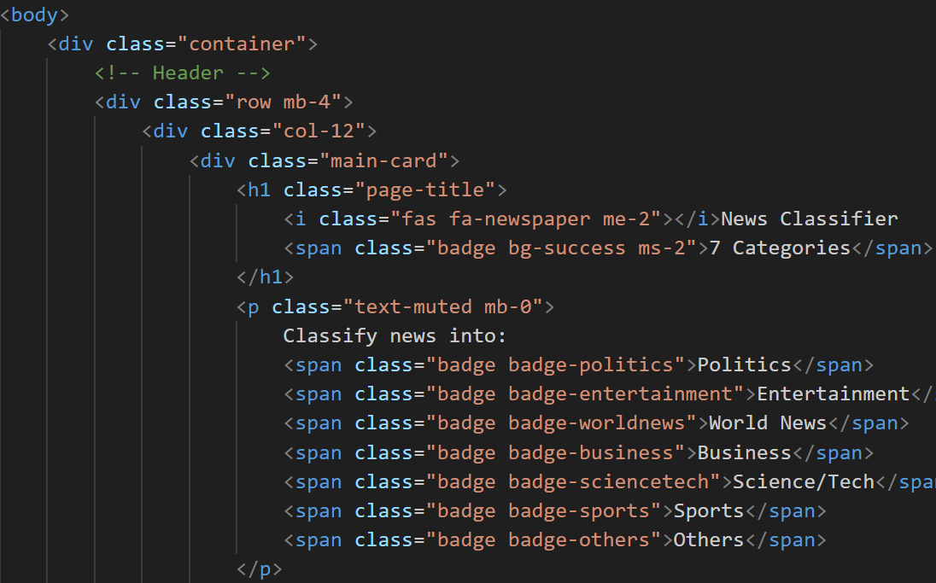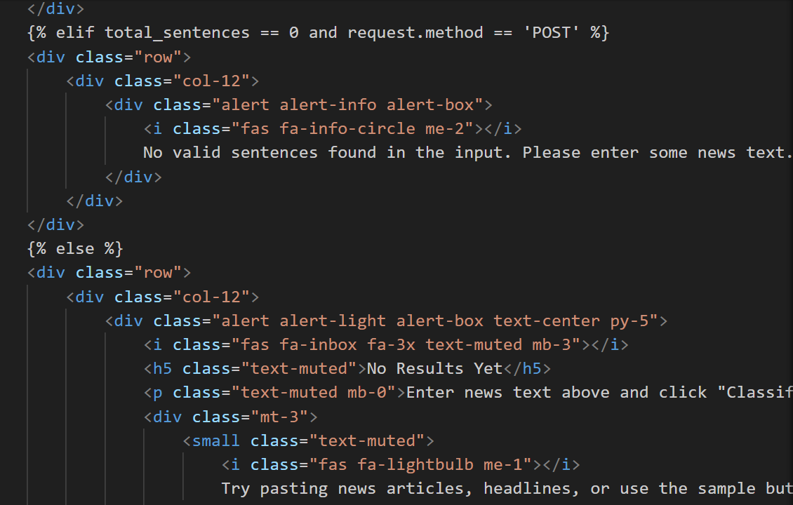

Application Screenshots and Workflow

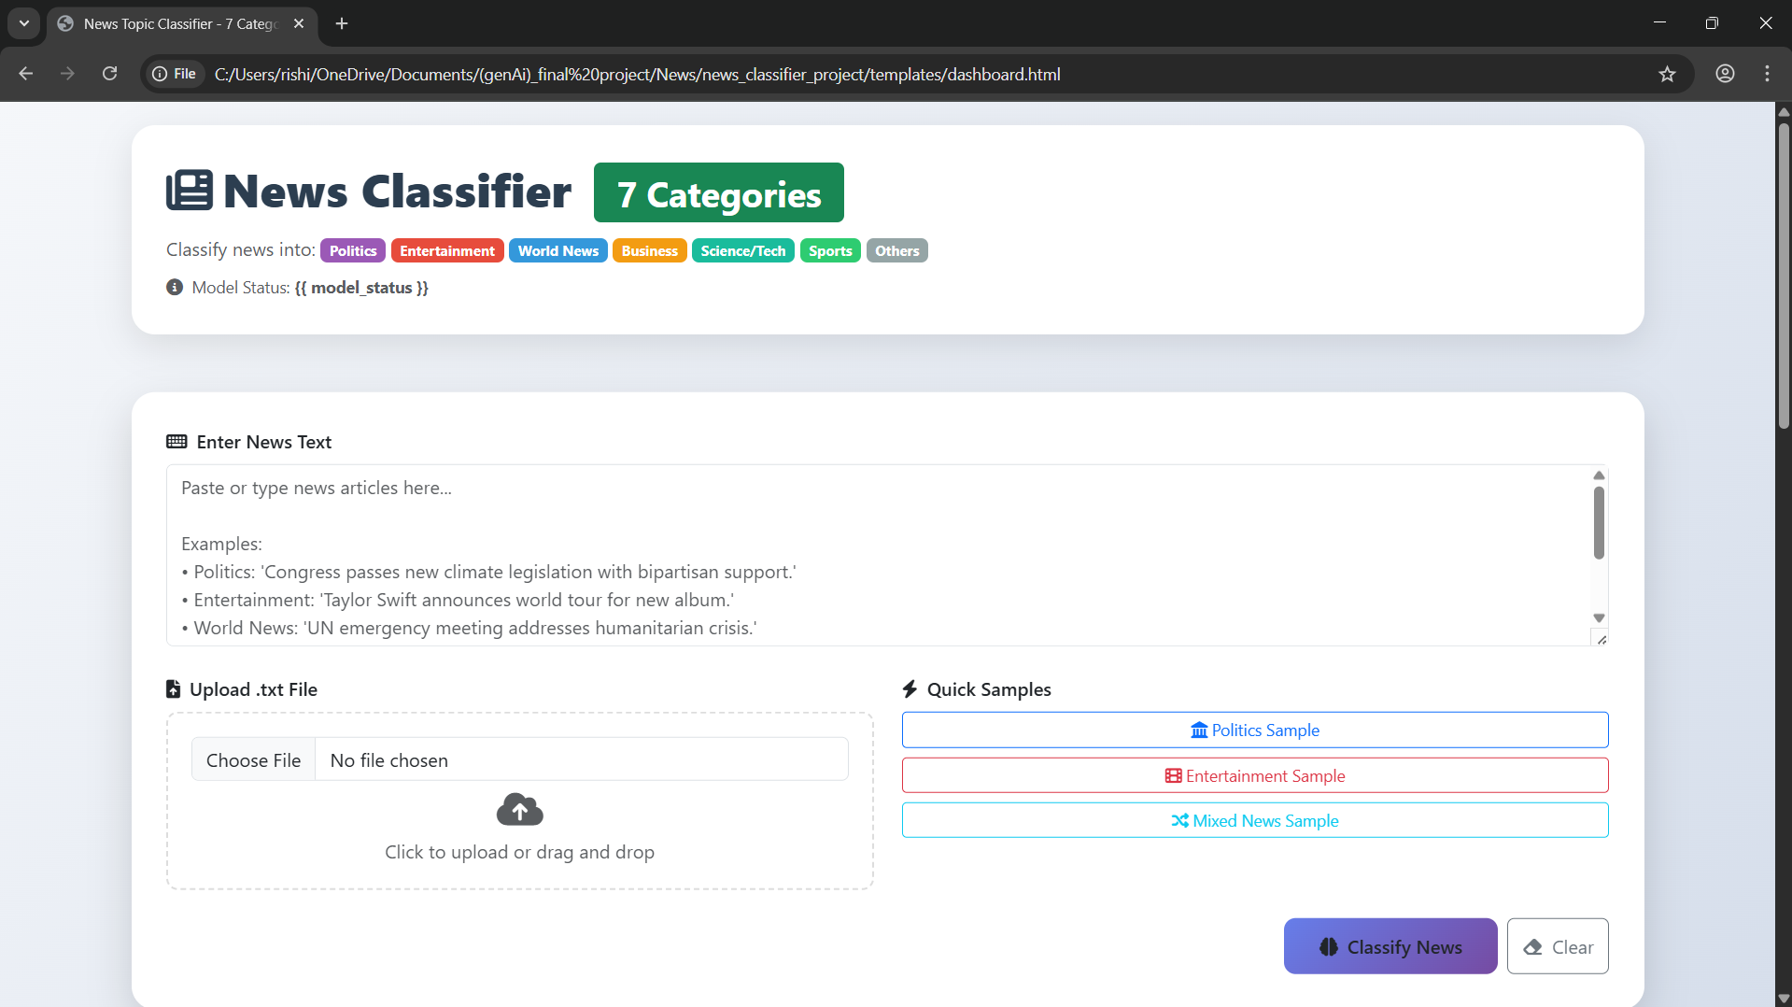

Future Implementations
- Integration of Advanced Deep Learning Models
The system can be upgraded from TF-IDF and Naive Bayes to modern NLP models like BERT or other transformer-based architectures for higher accuracy and better understanding of complex news content.
- Multilingual News Classification
In future versions, the model can be extended to support classification of articles written in multiple languages such as Hindi, Telugu, Tamil, etc., making the system useful for regional and national news platforms.
- Personalized News Recommendations
The system can be enhanced to study user reading patterns and recommend news articles based on their interests, creating a personalized news feed experience.
- Real-Time News Feed Integration
Future implementations may include connecting the system to live news sources (RSS feeds, APIs, web scrapers) so articles are automatically fetched and categorized in real time.
- User Feedback and Continuous Model Improvement
A feedback option can be added where users can mark predictions as correct or incorrect. This feedback can be used to retrain the model periodically, improving accuracy over time.

Conclusion
The ClassiNews project successfully demonstrates how machine learning can be used to automatically categorize news articles into meaningful categories such as politics, sports, entertainment, technology, and business. By using text preprocessing, TF-IDF feature extraction, and a classification model, the system is able to analyze the content of an article and predict its category accurately.
This automated classification helps reduce manual effort, saves time, and ensures that news content is organized more efficiently. It also improves the user experience by delivering relevant articles quickly and consistently. Overall, the project shows how intelligent text classification can support modern media platforms in managing and distributing large volumes of news effectively.

