An Agentic AI Framework for Health Triage in Low-Resource Settings
Dr. Padmanabhan Seshaiyer  Professor and Director, George Mason University  pseshaiy@gmu.edu | Harisri Sanjivan S  Software Engineer, Winter Inc  harisri.sanjivan@peerislands.io |  | Surya Thangaraju  University of Pennsylvania  suryathangaraju04@gmail.com
Varun V  Forward Deployed Engineer, 1hat  vvarun106@gmail.com |  | Rishi Kumar  Forward Deployed Engineer, TH Solutions  rishikummar10@gmail.com

Abstract
More than half the world's population — at least 4.5 billion people — were not fully covered by essential health services in 2021, a gap concentrated in rural and low-resource communities [1]. Where clinicians are out of reach, the first and often decisive step in a health emergency is a judgement made at home: whether a complaint is urgent enough to act on now, or whether it can wait. Delay in that decision — waiting until morning, or until a problem becomes unmistakable — is a long-recognised and frequently fatal failure in such settings, made with little support and no coordination between the patient, a frontline health worker, and the facilities that might help [2]. This paper addresses that gap. We propose an agentic AI framework for message-based health triage — sorting cases by how urgently they need care — developed through a combined design-thinking and software-engineering approach and aligned with UN Sustainable Development Goal 3. The framework coordinates four modules over a shared, typed case record: it reads the message into a structured form, decides an urgency level with a calibrated ability to abstain, prioritises cases, and routes urgent ones to a suitable facility. Its defining mechanism is active follow-up: when the system cannot yet commit, it asks one targeted question and decides again. Here, agentic refers to modules that sense, decide and act in a loop — judging when the information is sufficient, choosing the next question to ask, and watching for emerging patterns — rather than to a model that autonomously calls tools. A small language model is confined to the single task it is good at — understanding free, code-mixed text — while every decision is made by deterministic, auditable logic. On a benchmark of symptom–condition cases the framework is dependable where a prompted model alone is not, and resolves uncertainty through a short exchange of questions rather than by guessing. Because its modules communicate only through the shared case record, the framework is also reusable and extensible: a component can be swapped, or a new capability added, without disturbing the part that makes the urgency decision.
Keywords: agentic AI, software architecture, design thinking, health triage, active follow-up, selective prediction, low-resource settings, SDG-3.

1 Introduction
A community health worker in a village receives a message: “the child has had fever and loose motions for two days”. Someone must decide whether the child should be seen today, taken to a district hospital, or cared for at home. In much of rural India that decision falls to a person with a few weeks of training, a mobile phone, and no clinician within reach. Triage — sorting people by how urgently they need care — is the first and most consequential step in that chain, and it is precisely where help is scarcest. Community health workers are the front line of primary care in these settings [14], and digital tools delivered over a basic phone are increasingly used to support them [13].
This paper asks how a small language model running on ordinary hardware can support that decision, and arrives at a clear design position: the model should read the message, and it should not decide what to do about it. A language model understands a code-mixed, lay description of symptoms remarkably well; asked instead to choose an urgency level, it is confidently unreliable (Section 6). Our response is to surround the model with deterministic structure so that the strengths of each part are used and none is trusted beyond them.
We present this structure as an agentic AI framework, and it is worth being precise about the word. We mean agentic in the classical sense of components that run a sense–decide–act loop — perceiving the current state of a case, deciding what to do next, and acting on that decision — and not in the narrower, more recent sense of a language model that autonomously calls external tools [18, 19, 20]. Several parts of the framework embody this loop. The reading module (Agent 1) does more than extract fields: it judges whether the information gathered so far is enough to decide and, when it is not, hands control to the follow-up module, which decides the single most useful question to ask, asks it, senses the reply, and repeats until the case resolves. The surveillance module (Agent 2) runs the same loop over the stream of incoming cases, deciding when an emerging pattern warrants an alert and acting on it. Crucially, the decisions inside these loops are made by deterministic, auditable logic rather than by the language model's judgement — a deliberate safety property, not a limitation. The modules communicate only through one shared, typed record, so the framework itself is the contribution: its parts are standard, interchangeable choices, and dependable behaviour emerges from simple, inspectable pieces that can be reused and extended. Figure 1 shows the framework at a glance.
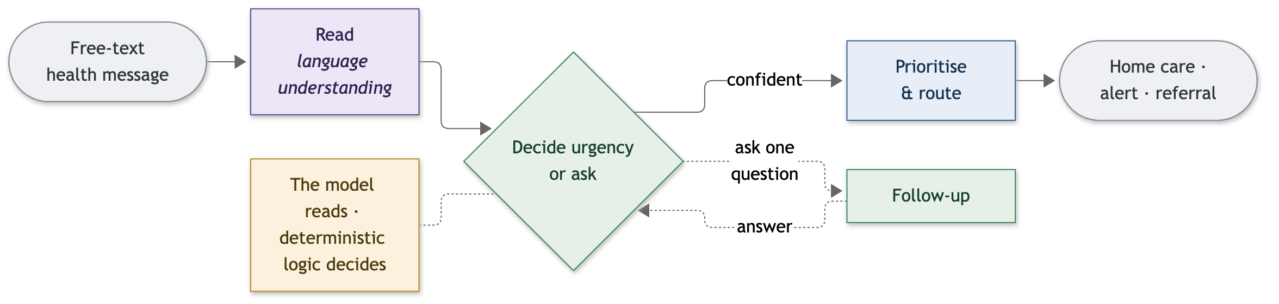
Figure 1. The framework at a glance. A message is read by the language component; a deterministic core decides the urgency or, when unsure, asks one follow-up question and decides again; confident cases are prioritised and routed to an action. The model reads; the logic decides.

Definition (triage framework). An agentic triage framework is a coordinated system of bounded-responsibility modules that transforms a free-text health message into an urgency decision and a recommended action, in which a language component is confined to interpreting the message, every urgency decision is produced by deterministic and auditable logic, and uncertainty is resolved by asking the sender a targeted question rather than by guessing.

Central thesis. Good software design can turn an individually unreliable AI component into a dependable system for a real use case: by confining the model to language understanding, deciding with a method that can decline to decide, and converting uncertainty into a question, the framework behaves dependably where the model alone does not.
Research questions.
- How can a language model be composed with deterministic logic so that its language ability is used without its judgement being trusted?
- How should a triage system represent and act on its own uncertainty, rather than being forced into a confident answer?
- How can such a framework be organised so that new capabilities are added without disturbing the part that makes the urgency decision?
Objectives. First, to propose the framework and the reasoning that leads to each of its modules. Second, to describe each module in two registers — the design intent, then its realisation — so the design is legible to engineers and non-specialists alike. Third, to demonstrate on a benchmark that the framework is dependable, that active follow-up resolves uncertainty efficiently, and that the design extends cleanly.
The paper is organised around the framework. Section 2 frames the problem as four coordinated tasks. Section 3 gives the architecture. Section 4 describes each module, design-first and then in realisation. Section 5 walks a case through the framework. Section 6 evaluates it, Section 7 discusses insights and frontiers, Section 8 relates it to prior work, and Section 9 concludes.

2 The problem, as four coordinated tasks
We treat message-based triage not as one task but as four that must hold together (Figure 2). Reading from the problem rather than from any solution, a usable system has to: (i) understand a short message written in English, a regional language, or a mixture, and turn it into a structured account of the case; (ii) decide an urgency level from that account, or recognise that it cannot yet decide; (iii) prioritise among cases that share an urgency level; and (iv) route urgent cases to a facility that can actually treat them.
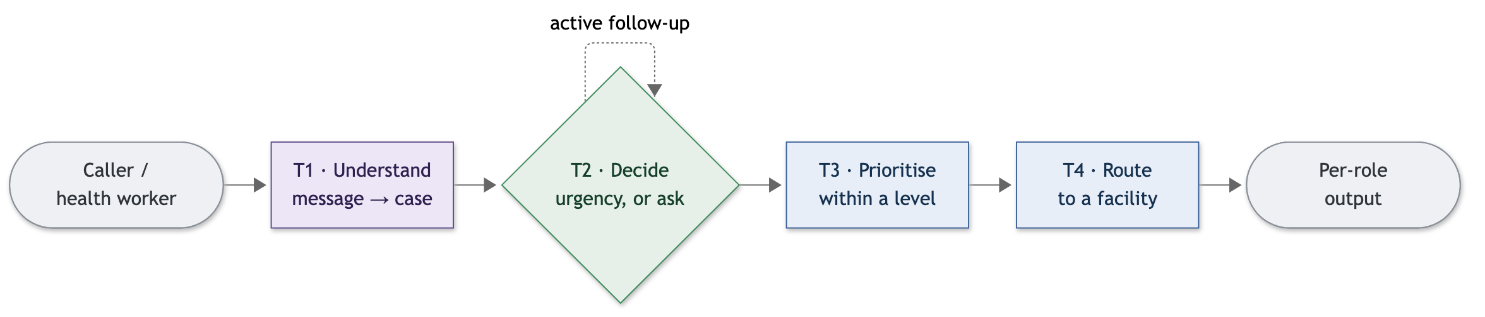
Figure 2. The problem, decomposed into four coordinated tasks. Only the reading task uses the language model; the loop on the decision task is active follow-up.
The decision task is linked to the others by one mechanism. When the system cannot commit to an urgency level, it neither escalates blindly nor guesses: it asks the single most informative question, folds the answer back into the case, and decides again. This active follow-up is the idea the rest of the framework is built to support.
A guiding design principle: the model reads, it does not decide. The language model is used only where language understanding is genuinely required — turning a message into a structured case — and never for the urgency decision itself. Every decision, priority and routing choice is made by deterministic logic that can be inspected and reproduced. This separation is the single most important commitment in the design, and the evaluation (Section 6) is what justifies it.
What “dependable” means here. Throughout, we judge the framework by how it handles its own uncertainty against the urgency levels of a demonstration benchmark, using two plain rates: the fraction of urgent cases it surfaces at too low a level (under-call), and the fraction of routine cases it surfaces at too high a level (over-call). These are engineering properties of the system, not clinical judgements.

3 The framework
Figure 3 shows the framework as four bounded-responsibility modules arranged around a single shared record of the case. A reading module turns the message into that record; a decision module reads the record and writes an urgency level into it; a prioritisation-and-routing module reads the decided record and adds a recommended action. Each module speaks only through the shared record, so none reaches into another's internals. Figure 4 shows the same system as a forward flow, with the two rules that cut across it: the follow-up loop that returns to the decision module, and a safety override that forces the highest urgency whenever a danger sign is present, on any path.
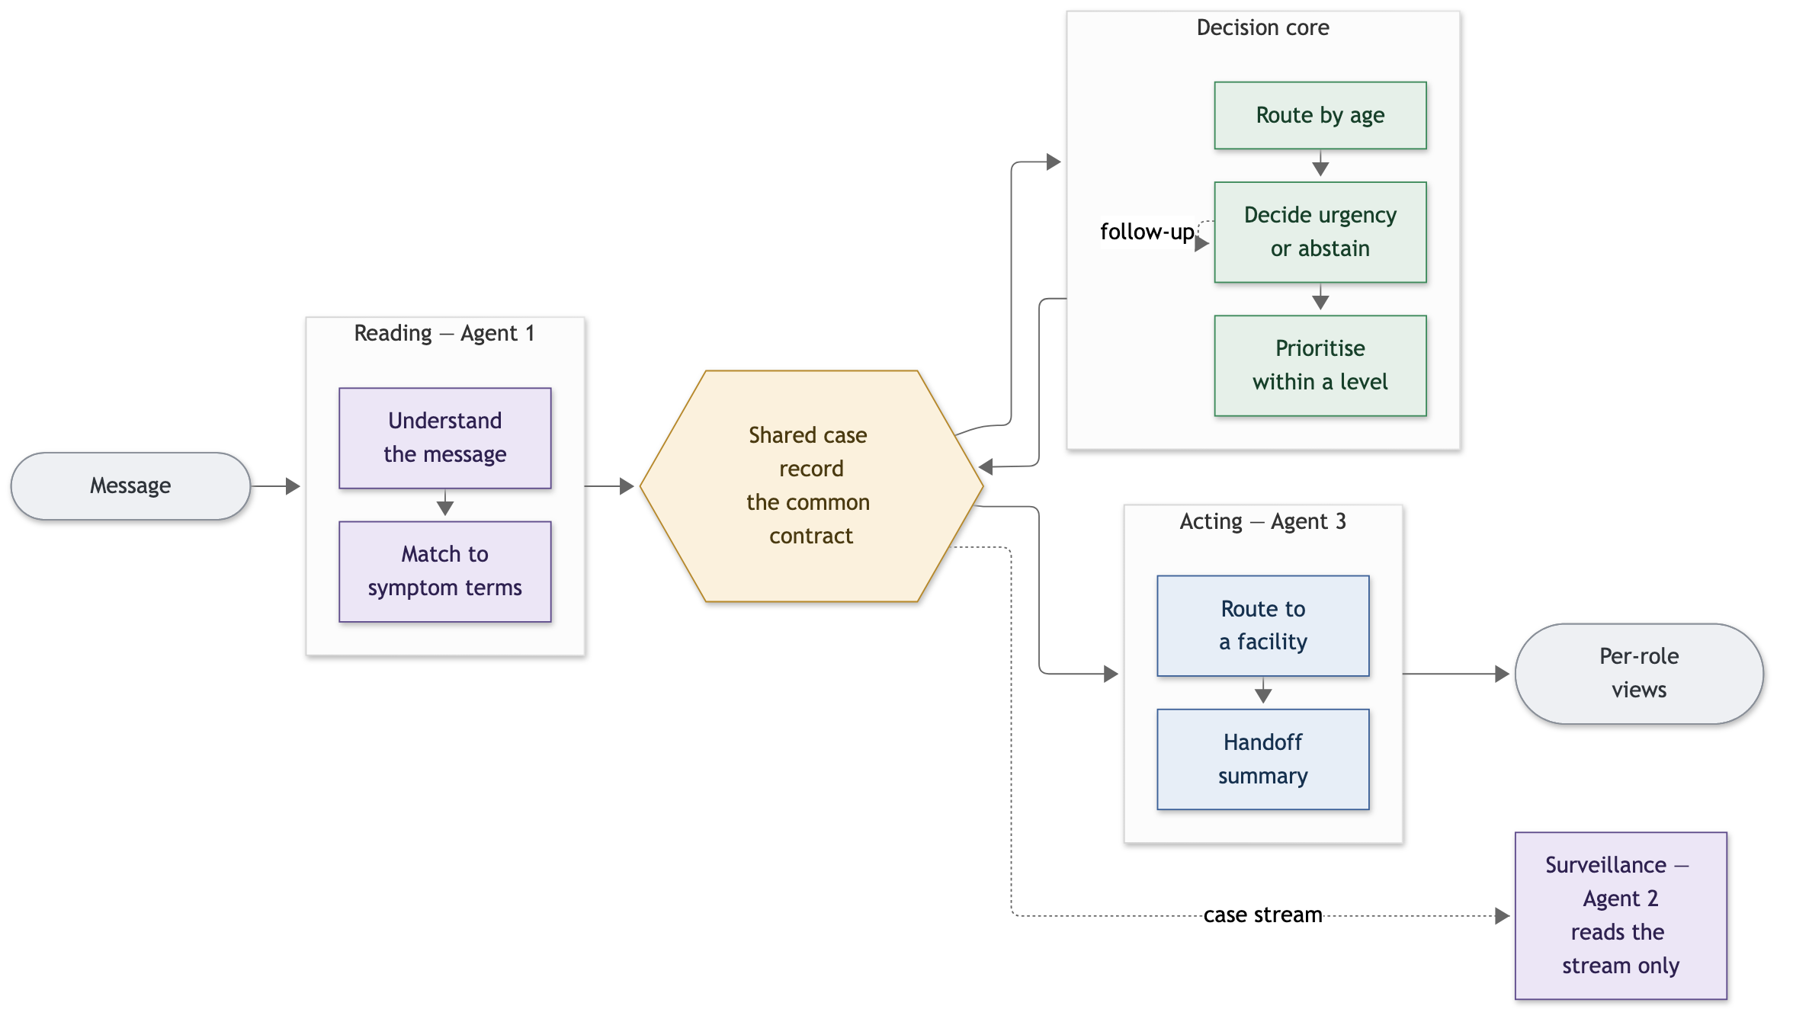
Figure 3. Architecture. Bounded-responsibility modules coordinate through one shared, typed case record — the common language every module speaks. A new capability reads the same record without touching the decision path.
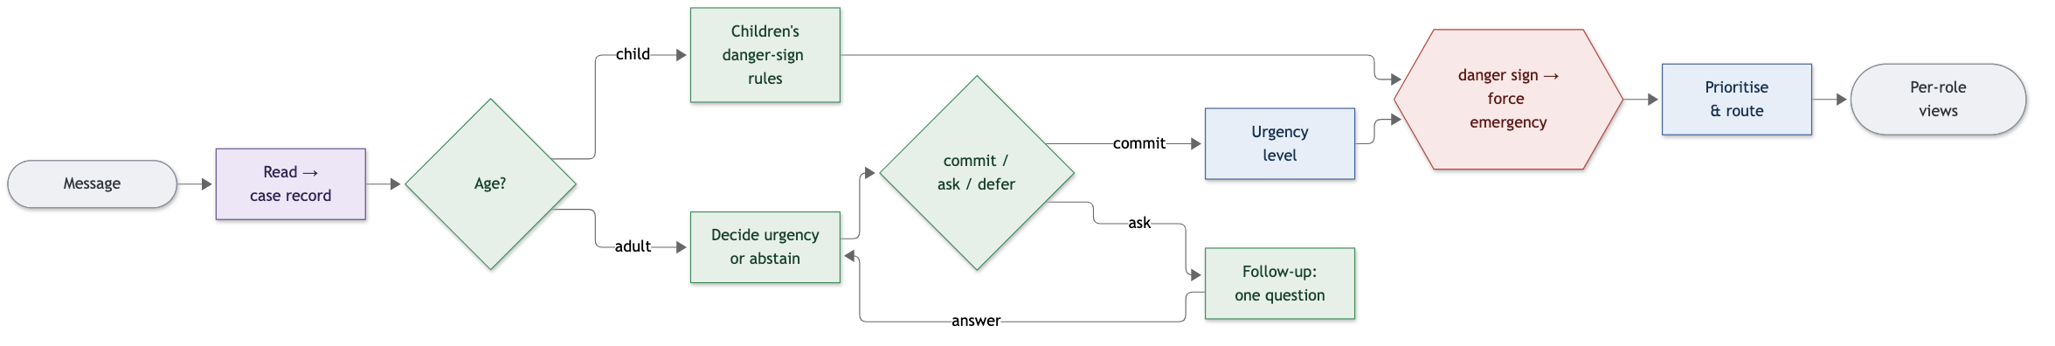
Figure 4. The framework as a forward flow. The dashed arrow is active follow-up: an answer re-enters the decision rather than being added to the output. The safety override applies on every branch.
The shared case record is the contract. The one design decision that makes the framework a framework is that every module reads and writes the same typed record (Figure 5). The record distinguishes three states for every clinical fact — reported present, reported absent, and not mentioned — and nothing downstream is allowed to treat “not mentioned” as “absent”, because that would turn “we do not know” into “we checked and it is fine”. Because the modules share this contract, one can be replaced, or a new one added, without rewriting the others.
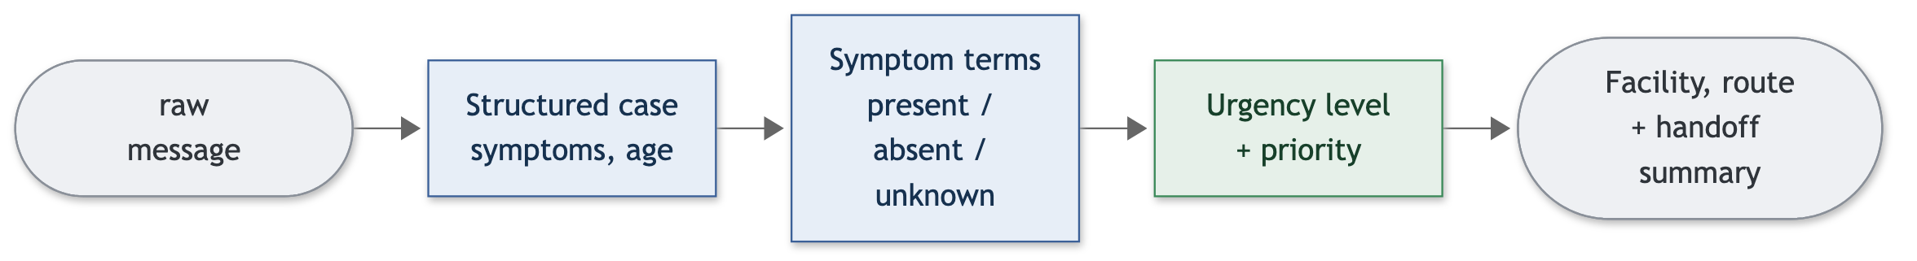
Figure 5. The shared case record as it moves through the framework. Each module reads the record, adds its own fields, and passes it on; the follow-up loop re-enters an earlier stage with one more fact known.

4 The modules
Each module is described in two registers. Design states, from the problem, what the module must achieve and why — the ideation, in plain language. Realisation then states how we build it: the approach chosen, why it is preferred over the alternatives, and the evidence that it works. The two are kept separate so the reasoning is never blurred with the mechanism.

4.1 Reading the message
Design. The first thing the system must do is understand a message that a worried layperson actually writes — short, informal, often mixing languages and scripts, naming a few symptoms rather than a complete history. The module must turn this into a structured account the rest of the framework can act on, and it must be careful about what it does not know: a symptom that was never mentioned is not the same as a symptom that was denied, and the design must preserve that difference. Reading is the one place where genuine language understanding is unavoidable, so it is the one place the language model belongs.
Realisation. We use a small, locally run language model to read the message into the structured case record. A small model is the right choice here: it runs on the modest hardware available at the edge, keeps data on-device, and — as the evaluation shows — reads code-mixed lay language [22] reliably when it is asked only to extract rather than to judge. Because free-text phrases rarely match a fixed vocabulary exactly, each phrase is mapped to a controlled set of symptom terms by nearest-neighbour search over multilingual sentence embeddings [21], with a matching threshold calibrated on a labelled sample (97.5% accuracy at the chosen setting). The module confines the model to interpretation and hands on a clean, typed record.

4.2 Deciding the urgency, or declining to
Design. Given the structured case, the system must decide an urgency level — but a responsible triage design must also be allowed to say “not yet”. Forcing a single answer on thin evidence is exactly how an automated system becomes unsafe. So the decision module is built around an idea stronger than a best guess: it should hold a small set of plausible conditions, commit only when that set points to one answer, and otherwise either ask for more information or defer. When it must act under remaining uncertainty, it should err toward caution — treat the case as the most serious possibility still in play — so that an urgent case is never quietly surfaced as a routine one.
Realisation. Adult cases are decided by a Naive Bayes classifier over the benchmark conditions. We prefer Naive Bayes here deliberately: on the short, few-symptom messages this use case actually produces it is both more accurate and far better calibrated than richer alternatives such as logistic regression, which is overconfident and brittle on such sparse input — and calibration is what the rest of the design depends on. Rather than take the classifier's single best guess, we wrap it in conformal prediction, a standard selective-prediction method that returns a set of plausible conditions with a tunable guarantee on how often the true condition is inside it. The size of that set becomes the decision (Figure 6): one condition means commit; a few means stay uncertain and ask; many means defer. When the set holds more than one, the system labels the case with the most serious urgency level present in it — the one rule that converts the set guarantee into a guarantee about the urgency the health worker sees. A danger-sign override sits above all of this and forces the highest urgency directly. Paediatric cases follow a small, separate set of danger-sign rules rather than the classifier.
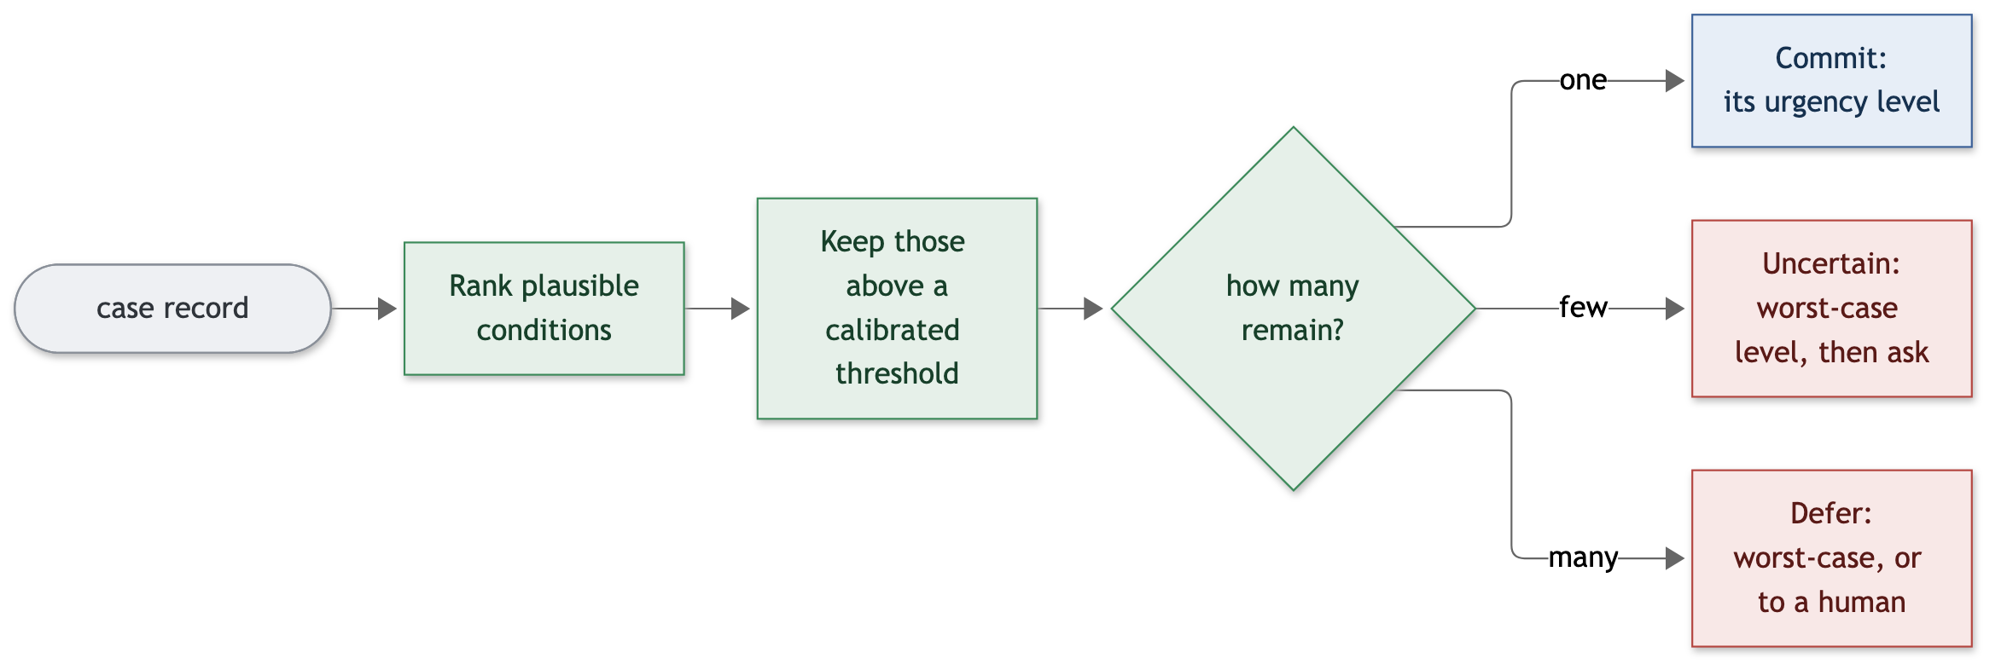
Figure 6. The decision module. The size of the plausible-condition set, not its contents, chooses the next action: commit, ask, or defer. Labelling an uncertain case by its most serious possibility is what keeps an urgent case from being under-called.

4.3 Active follow-up: turning uncertainty into a question
Design. This is the mechanism that defines the framework. When the decision module cannot yet commit, the natural human move is not to escalate everything to be safe, nor to guess, but to ask one more thing. A good design asks the single most useful question — the one whose answer, either way, would most reduce the remaining uncertainty — phrases it in the sender's own language, and must never invent an answer: a hedge or an unclear reply is re-asked, not coerced. A “no” must be as informative as a “yes”, because knowing what the patient does not have is often what separates two conditions. The exchange should be short, and should stop as soon as the case is resolved.
Realisation. The question is selected by deterministic reasoning over the current set of plausible conditions, choosing the symptom whose presence or absence would most shrink that set; the language model only phrases the chosen question, so the policy itself is fully auditable and does not depend on the model's judgement (Figure 7). The reply is read as yes, no, or unclear, and an unclear reply is re-asked. Crucially, a denial is fed back as genuine evidence — treating “no” as informative is what makes the exchange efficient: in evaluation the system resolves 74.8% of initially uncertain cases, in a mean of about two questions, and over-calls fall sharply as a result. The loop stops when the case resolves to a single condition, a small question budget is spent, or no useful question remains.
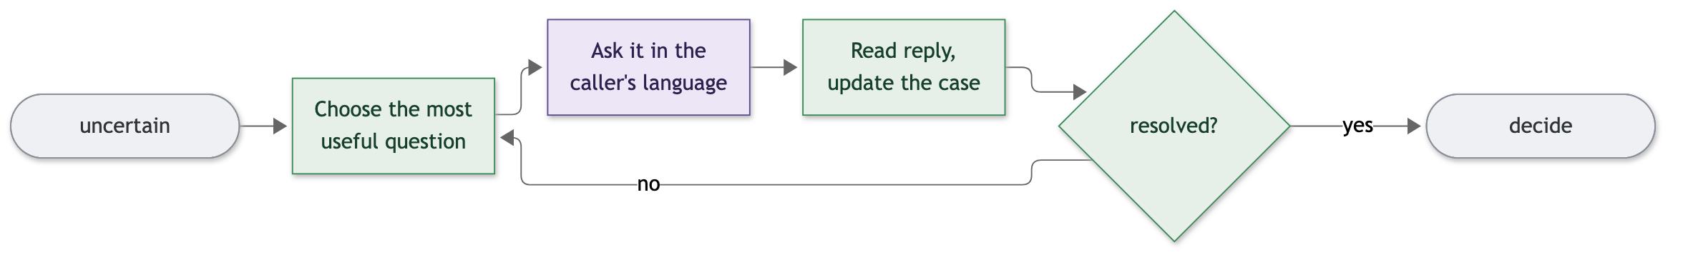
Figure 7. Active follow-up. The question is selected deterministically and only phrased by the model; a “yes” and a “no” are equally informative; a hedge is re-asked; the decision is then re-made.

4.4 Prioritising and routing
Design. Two cases can share an urgency level and still not be equally pressing, so the system must order cases within a level for attention. And for the urgent ones it must point to a facility that can actually help — one that can treat the case, is open, and is reachable — rather than simply the nearest. The output must be shaped for whoever reads it: a caller, a health worker, a receiving clinician.
Realisation. Within a level, cases are ordered by a transparent multi-criteria score (an Analytic Hierarchy Process) over clinically meaningful attributes such as complication risk, time sensitivity and transmissibility, with the attribute weights derived from pairwise comparisons rather than set by hand. This ordering never changes the urgency level; it only sequences cases that share one. Routing filters candidate facilities by what the case needs and then selects by travel distance, behind an interface that can use an offline estimate or a real routing service. A concise handoff summary is produced for the receiving clinician.

4.5 An illustrative extension
Because every module speaks through the shared case record, a new capability can read that same record without touching the decision path. As a demonstration, we added an outbreak-surveillance capability that watches the stream of recorded cases for unusual local clusters and raises an alert with a recommended action (Figure 8, Table 1). It was built against the shared record alone, made no change to the modules that decide urgency, and is kept from depending on the decision logic by an automated check. That a second capability could be added this cleanly is a practical property of the design, shown here rather than merely asserted.
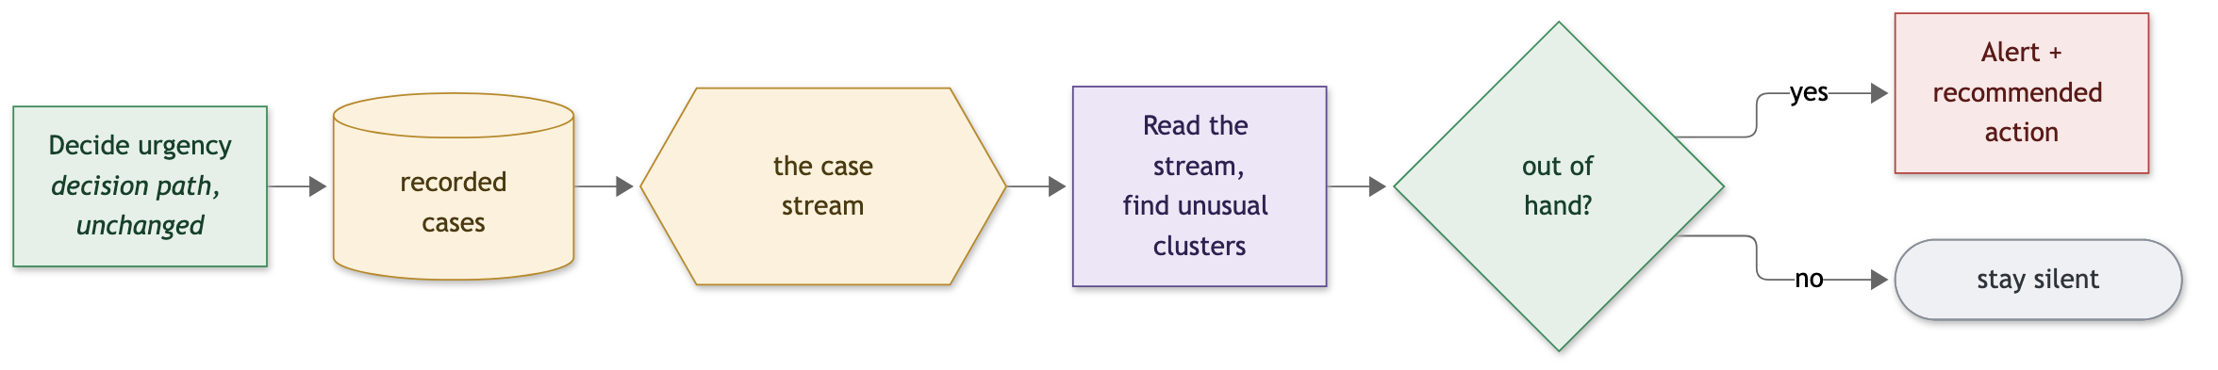
Figure 8. Adding a capability through the shared record. The surveillance module reads the case stream and depends on none of the decision logic, so it extends the framework without disturbing it.
Property | Observed
Changes to the urgency-decision path | none
How it reads data | through the shared case record only
Dependence on the decision logic | none (checked automatically)
Additional changes required | a reader view and one optional field
Alert on a stream containing one injected outbreak | raised, correctly
Alert on a stream with no outbreak | none
Table 1. Adding a capability without touching the decision path.

5 An illustrative application
To show the framework at work, consider a caregiver's message: “child, fever and loose motions for two days”. The reading module turns it into a structured case with two symptoms present and the child's age noted. The decision module finds several childhood conditions consistent with so little information and does not commit. Active follow-up asks the single most useful question — whether the child is able to drink — phrased in the caregiver's language. The answer “no” is strong evidence: it both narrows the plausible conditions and, as a danger sign, triggers the safety override. The case is surfaced as an emergency, prioritised above less time-sensitive cases at the same level, and routed to the nearest facility able to manage a child in that state, with a short summary for the receiving clinician.
The same path handles easier cases with less work. A message describing a mild, self-limiting complaint resolves to a single low-urgency condition on the first pass, with no questions asked and advice to care at home. A message that is genuinely ambiguous is carried by follow-up: two or three questions typically move it from a wide set of possibilities to a single decision, and where they cannot, the system defers to a human rather than guessing. In each case the language model only reads and phrases; the urgency is decided by logic that can be inspected after the fact.

6 Evaluation
We evaluate how the framework handles its own uncertainty on a demonstration benchmark of symptom–condition cases spanning 41 conditions. The benchmark is used as a controlled sandbox in which the framework's behaviour can be observed free of real-world confounders; real-world clinical validation is future work (Section 7). Each case is presented to the system as the few symptoms a person would actually mention, with the full case held back as ground truth, and the framework is evaluated out-of-sample.
Before the numbers, Table 2 summarises what separates the framework from the two obvious alternatives — prompting the model directly, and a plain best-guess classifier — along the properties this section measures. The findings then answer the three research questions of Section 1: that composing the model with deterministic logic uses its language ability without trusting its judgement; that the system represents and acts on its own uncertainty rather than being forced into an answer; and that it extends without disturbing the decision.
Property | Prompted model | Plain classifier | Framework
Reads code-mixed free text | ✓ | ✗ | ✓
Holds uncertainty as a set, not one guess | ✗ | ✗ | ✓
Can decline to decide (abstain or defer) | ✗ | ✗ | ✓
Asks a targeted follow-up question | ✗ | ✗ | ✓
Keeps urgent cases from being under-called | ✗ | ~ | ✓
Decision is deterministic and auditable | ✗ | ✓ | ✓
Extensible with new capabilities | ✗ | ✗ | ✓
Table 2. What each approach provides (✓ yes, ~ partial, ✗ no). Only the framework offers every property; the measured differences are quantified below.

A prompted model alone is not enough. Asked directly to choose an urgency level with a safety instruction in its prompt, the language model collapses onto one answer: it labels most cases “severe”, under-calls one in six genuinely urgent cases, and over-calls the large majority of routine ones (Table 3, Figures 9 and 10). The output is always well-formed; the failure is in the decision, not the format. This is the motivation for the framework, and the reason the model is confined to reading.
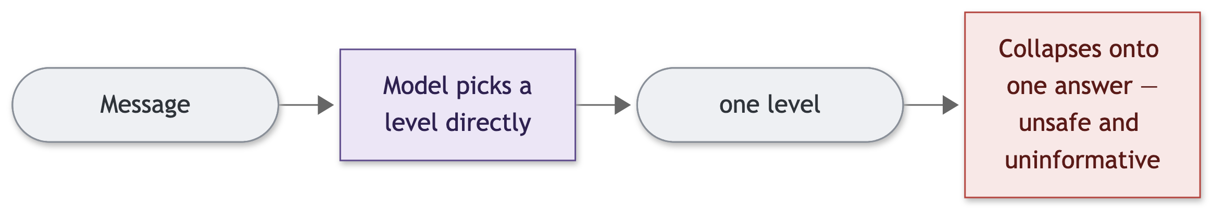
Figure 9. Why a prompted model alone is not enough: asked to decide, it collapses onto one answer and is at once unsafe and uninformative.
System | under-call ↓ | over-call ↓
Prompted model alone (with a safety instruction) | 0.169 | 0.827
The framework (shipped, with follow-up) | 0.021 | 0.056
Table 3. A prompted model alone versus the full framework, on the same cases.

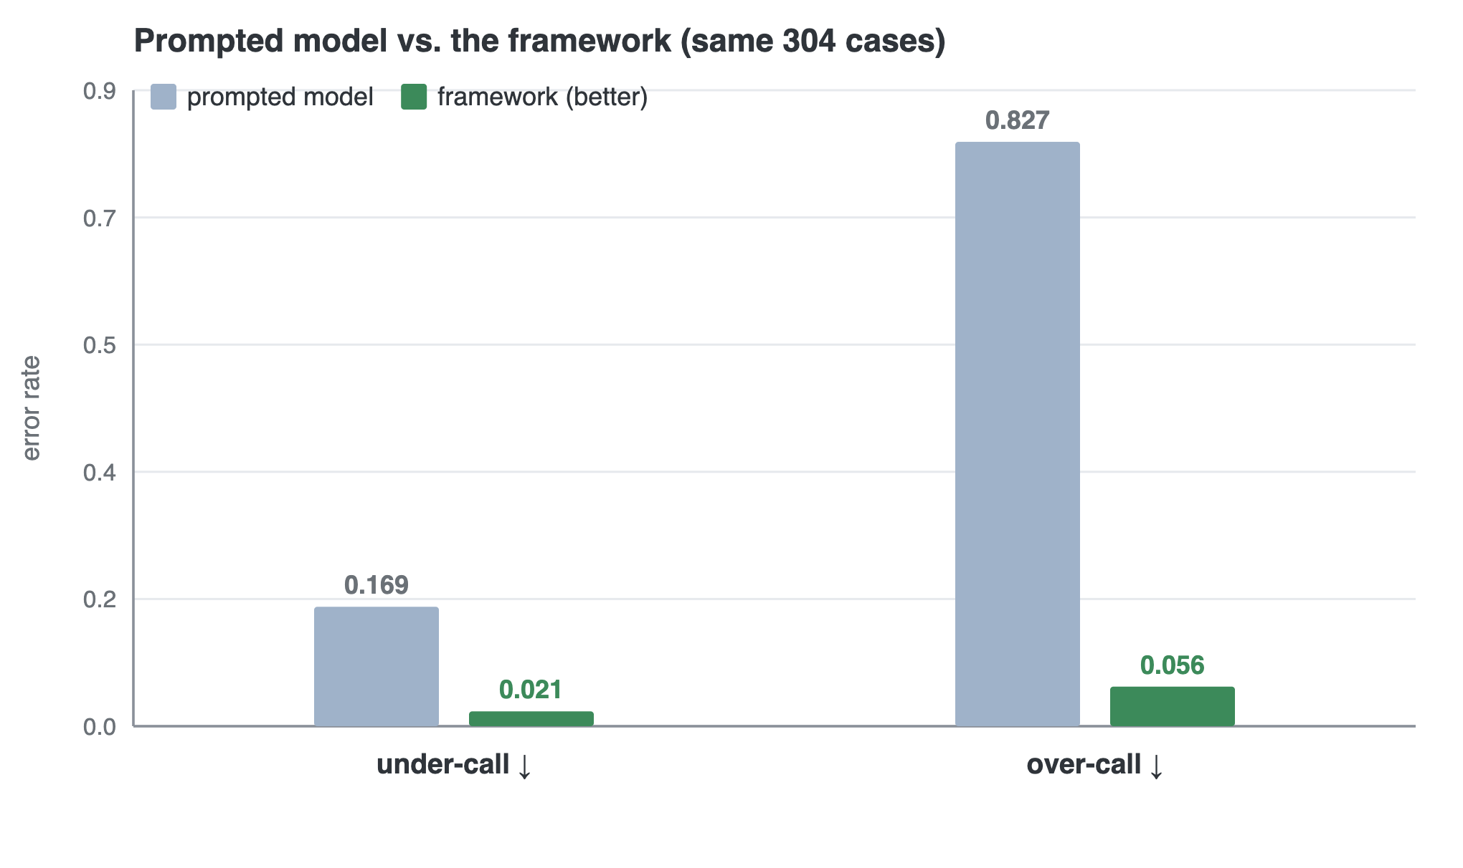
Figure 10. The prompted model versus the shipped framework on the same 304 cases: the framework makes far fewer under-calls (2.1% against 16.9%) and far fewer over-calls (5.6% against 82.7%).
Structure makes the system dependable, step by step. Adding the framework's elements one at a time removes the failure and shows where dependability comes from (Table 4, Figures 11 and 12). A structured decision replaces most of the prompted model's error; the ability to abstain removes more; labelling an uncertain case by its most serious possibility removes the remaining under-calls, at the cost of caution; and active follow-up then buys that caution back. The low under-call rate is a design property rather than a coincidence: an uncertain case is labelled by its most serious possibility, so an urgent case is missed only when the true condition falls outside the prediction set — a rate the decision gate controls. Worst-case labelling alone drives it to zero on this benchmark; the shipped system's 2.1% is the small residual that remains once adaptive follow-up is added.
Configuration | under-call ↓ | over-call ↓
Prompted model alone | 0.169 | 0.827
+ structured decision | 0.092 | 0.068
+ ability to abstain | 0.063 | 0.068
+ cautious labelling of uncertain cases | 0.000 | 0.216
+ active follow-up (full framework) | 0.021 | 0.056
Table 4. Building the framework one element at a time. Each row adds one element to the row above.

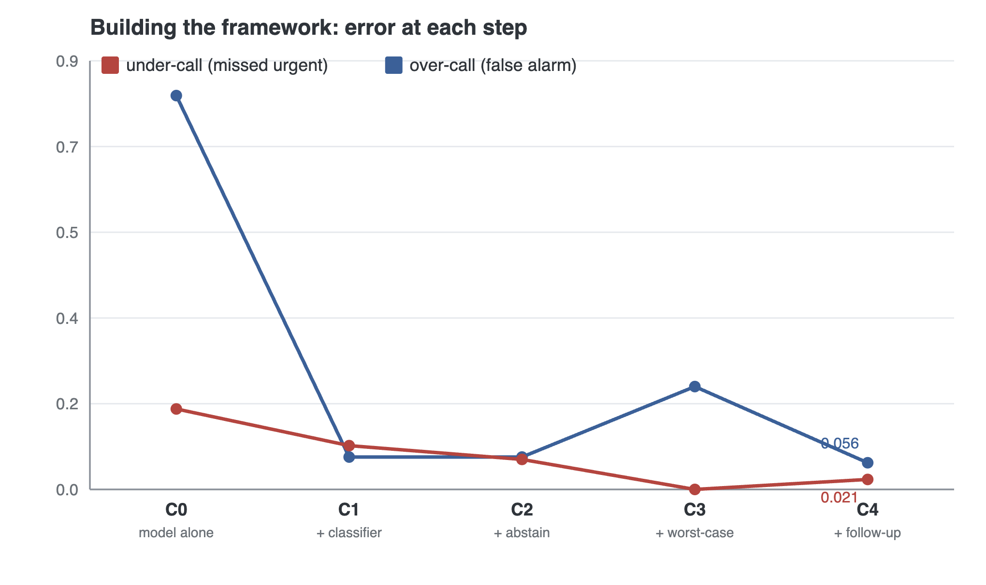
Figure 11. Error at each build-up step. Over-call falls once structure replaces the model, rises when cautious labelling drives under-call to zero, then is bought back by active follow-up; under-call stays low throughout.
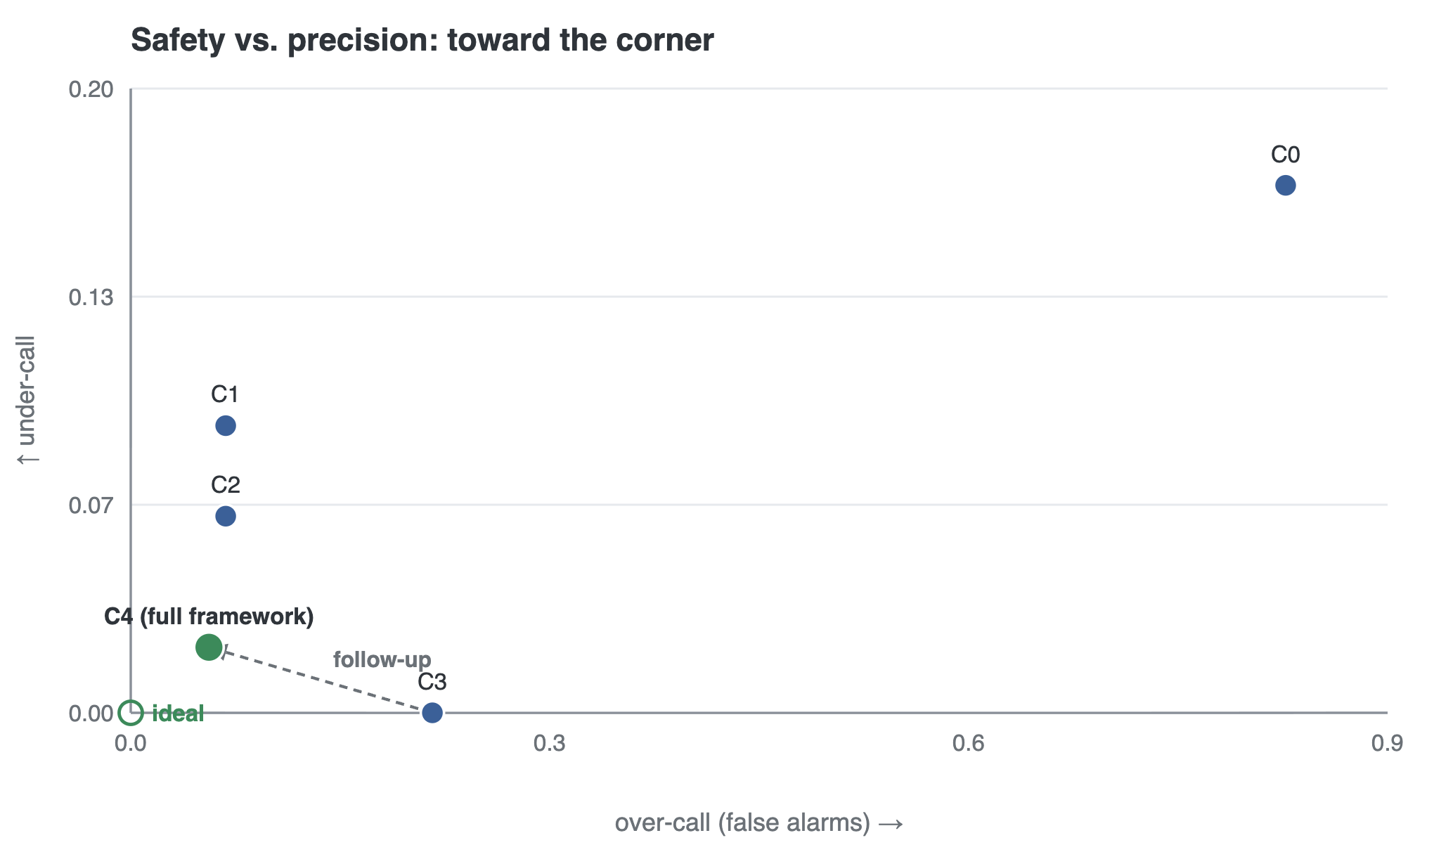
Figure 12. The same configurations in error space. The design moves toward the ideal corner — no missed urgent cases, no false alarms — and active follow-up carries the full system close to it.
Active follow-up resolves uncertainty efficiently. The exchange of questions is where the framework recovers precision without sacrificing safety. Treating a denial as evidence is decisive: with it, a deterministic, most-informative question policy resolves 74.8% of initially uncertain cases to a single condition in a mean of about two questions, and clearly outperforms simpler question strategies (Table 5, Figure 13). The practical effect is a favourable trade: over-calls fall from 21.6% to 5.6% because resolved cases no longer need cautious escalation, while under-calls stay within the designed bound.
Question policy | Resolved | Mean questions | over-call ↓
Most-frequent symptom | 0.427 | 2.62 | 0.105
Random useful symptom | 0.583 | 2.45 | 0.086
Most-informative symptom (ours) | 0.748 | 2.15 | 0.056
Table 5. Active follow-up. “Resolved” is the fraction of initially uncertain cases ending at a single condition.

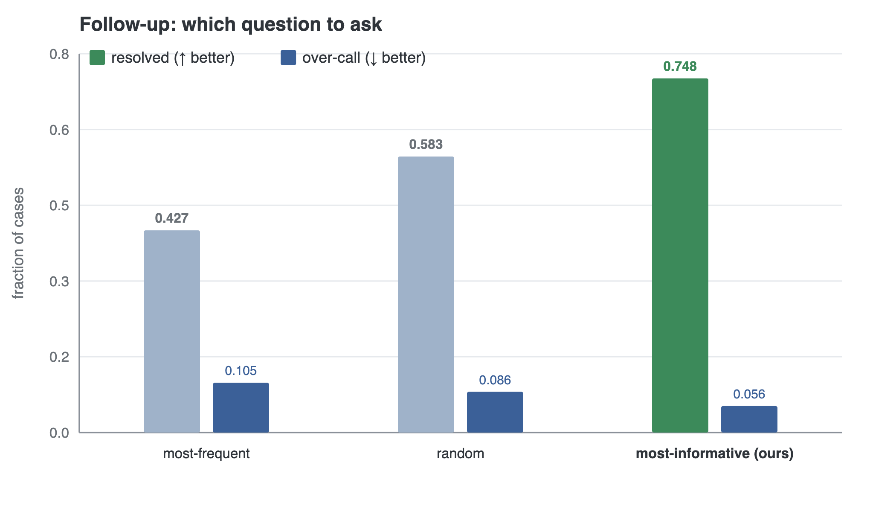
Figure 13. Question-selection policies. The most-informative question resolves far more uncertain cases than the simpler strategies, and at the lowest over-call.
The decision holds through real, lay language. Run end to end from rendered messages rather than from clean symptom lists — including messages rewritten as real caregivers phrase them, mixing English and a regional language — the framework preserves its safety behaviour, at a modest cost in precision (Appendix B). The safety behaviour that holds on clean input survives the messy input the system will actually meet.
The design extends cleanly. The surveillance capability of Section 4.5 was added through the shared record with no change to the decision path and no dependence on the decision logic (Table 1), and it raises an alert exactly when a cluster is present and stays silent otherwise. The framework is a base others can build on, not a single fixed application.

7 Design insights, reflections, and frontiers
Dependability comes from the plainest rule. The element that carries the safety result is not an elaborate one: it is the simple rule of labelling an uncertain case by its most serious remaining possibility. The lesson we draw is that in a composed system the guarantee should be traced back to the exact rule that produces it, and that rule is often the simplest one in sight.
The whole is what must be measured. A question-selection policy and a decision method can each be sound in isolation and still work poorly together if one component's assumptions are not honoured by the other; it is measuring the composed loop, not the parts, that reveals this. We therefore treat the coordinated behaviour of the modules — not any single module — as the object to evaluate and to design.
The model is a reader, not a decider. The evaluation makes the division of labour concrete: the language model reads messy, code-mixed language well, and decides urgency badly. A framework that assigns the model only the first role, and deterministic logic the second, uses each where it is strong. This is the general principle we would carry to other high-stakes, language-fronted tasks.
Frontiers and future work. The framework is demonstrated on a benchmark, not on patients, and its urgency levels are a demonstration scale; anchoring them to a recognised clinical standard with clinician oversight, and validating on real presentations, is the first and most important next step. Beyond it: a live messaging channel behind the existing answer interface; automatic fallback when the local model is unavailable; real road-network routing through the existing routing interface; a fuller paediatric ruleset; and growing the surveillance capability from a working skeleton into an evaluated module. Each is a change at an existing seam of the framework, which is the point of building it this way.

8 Related work
Symptom checkers and language models for triage. Symptom checkers have been audited against clinician judgement for over a decade, and were found to be correct about half the time and consistently risk-averse [11]. A prompted language model reproduces that risk-averse collapse in a newer technology, but without even being safely conservative. Machine-learning triage models can outperform standard acuity scales [17], and large language models perform strongly on medical-knowledge tasks [15, 16]; what stays hard is turning that into a calibrated, auditable decision. Our position is not that language models should be kept out of triage, but that they should read rather than decide.
Selective prediction and set-valued decisions. The idea that a classifier should be allowed to abstain goes back to the reject option [6] and has a modern form for neural models [7]. Conformal prediction [4, 5] provides set-valued predictions with a distribution-free guarantee; the least-ambiguous-set construction we use is from Sadinle et al. [3]. Our contribution is not a new method but a way of acting on the size of the predicted set, used as a design rule for triage.
Multi-criteria prioritisation. The Analytic Hierarchy Process [8] is a standard multi-criteria method; we use it only to order cases within an urgency level, deriving its weights from pairwise comparisons.
Structuring language-model systems. Confining a language model to a well-typed boundary with deterministic logic on either side is established engineering practice; a parallel line of work instead gives the model agency, letting it reason and act or call external tools [18, 19, 20]. Our contribution is a worked account of where, in one such system for a real use case, the dependability actually comes from, and of an architecture that lets the system be reused and extended.

9 Conclusion
A small language model can read a code-mixed health message well and cannot be trusted to decide what to do about it. The framework proposed here keeps the model in the first role and surrounds it with deterministic structure for the second: a shared case record that distinguishes “absent” from “unknown”, a decision that can abstain, cautious labelling that turns uncertainty into a safe urgency level, and a follow-up loop that asks one question when the system is unsure and then decides again. On a demonstration benchmark the framework is dependable where a prompted model alone is not, resolves most uncertain cases with a short exchange of questions, and accepts a new capability without disturbing the decision path. Answering the research questions of Section 1, it composes a language model with deterministic logic so that only its language ability is relied upon, represents and acts on its own uncertainty rather than being forced into an answer, and is organised so that it can grow at its seams. The dataset is a demonstration benchmark and the next step is a clinician: the framework is offered as a practical, extensible basis for AI-assisted triage in low-resource settings, in service of SDG-3 [12].

Reproducibility
The framework, its modules, and every evaluation harness are implemented in a public code repository; each number reported here is regenerated by a scripted harness, and the deterministic harnesses reproduce identically on every run.

References
[1] World Health Organization and World Bank. Tracking Universal Health Coverage: 2023 Global Monitoring Report. World Health Organization and World Bank, Geneva, 2023.
[2] S. Thaddeus and D. Maine. Too far to walk: maternal mortality in context. Social Science & Medicine, 38(8):1091–1110, 1994.
[3] M. Sadinle, J. Lei, and L. Wasserman. Least ambiguous set-valued classifiers with bounded error levels. Journal of the American Statistical Association, 114(525):223–234, 2019.
[4] V. Vovk, A. Gammerman, and G. Shafer. Algorithmic Learning in a Random World. Springer, 2005.
[5] A. N. Angelopoulos and S. Bates. A gentle introduction to conformal prediction and distribution-free uncertainty quantification. arXiv:2107.07511, 2021.
[6] C. K. Chow. On optimum recognition error and reject tradeoff. IEEE Transactions on Information Theory, 16(1):41–46, 1970.
[7] Y. Geifman and R. El-Yaniv. Selective classification for deep neural networks. In Advances in Neural Information Processing Systems 30, 2017.
[8] T. L. Saaty. The Analytic Hierarchy Process. McGraw-Hill, 1980.
[9] World Health Organization. Integrated Management of Childhood Illness: Chart Booklet. WHO, Geneva, 2014.
[10] N. Gilboy, P. Tanabe, D. Travers, and A. M. Rosenau. Emergency Severity Index (ESI): A Triage Tool for Emergency Department Care, Version 4. AHRQ, 2012.
[11] H. L. Semigran, J. A. Linder, C. Gidengil, and A. Mehrotra. Evaluation of symptom checkers for self diagnosis and triage: audit study. BMJ, 351:h3480, 2015.
[12] United Nations General Assembly. Transforming our World: the 2030 Agenda for Sustainable Development. Resolution A/RES/70/1, 2015.
[13] World Health Organization. WHO Guideline: Recommendations on Digital Interventions for Health System Strengthening. WHO, Geneva, 2019.
[14] S. Lewin, S. Munabi-Babigumira, C. Glenton, et al. Lay health workers in primary and community health care for maternal and child health and the management of infectious diseases. Cochrane Database of Systematic Reviews, (3):CD004015, 2010.
[15] K. Singhal, S. Azizi, T. Tu, et al. Large language models encode clinical knowledge. Nature, 620(7972):172–180, 2023.
[16] A. J. Thirunavukarasu, D. S. J. Ting, K. Elangovan, L. Gutierrez, T. F. Tan, and D. S. W. Ting. Large language models in medicine. Nature Medicine, 29(8):1930–1940, 2023.
[17] S. Levin, M. Toerper, E. Hamrock, et al. Machine-learning-based electronic triage more accurately differentiates patients with respect to clinical outcomes compared with the Emergency Severity Index. Annals of Emergency Medicine, 71(5):565–574, 2018.
[18] S. Yao, J. Zhao, D. Yu, N. Du, I. Shafran, K. Narasimhan, and Y. Cao. ReAct: Synergizing reasoning and acting in language models. In International Conference on Learning Representations, 2023.
[19] T. Schick, J. Dwivedi-Yu, R. Dessì, et al. Toolformer: Language models can teach themselves to use tools. arXiv:2302.04761, 2023.
[20] L. Wang, C. Ma, X. Feng, et al. A survey on large language model based autonomous agents. Frontiers of Computer Science, 18(6):186345, 2024.
[21] N. Reimers and I. Gurevych. Making monolingual sentence embeddings multilingual using knowledge distillation. In Proceedings of EMNLP, pages 4512–4525, 2020.
[22] S. Khanuja, S. Dandapat, A. Srinivasan, S. Sitaram, and M. Choudhury. GLUECoS: An evaluation benchmark for code-switched NLP. In Proceedings of ACL, pages 3575–3585, 2020.

Appendix A Sensitivity of the safety behaviour
The decision module has one free setting that trades caution against commitment. Table A1 varies it across its range. The safety behaviour — surfacing no urgent case at too low a level — holds throughout, while the setting controls how often the system commits versus asks. These figures isolate the decision gate before active follow-up, as in the worst-case-labelling step of Table 4; the shipped system, which adds follow-up, is the 2.1% of Table 3. This confirms that the trade-off is a designed dial that behaves predictably, rather than a value that has to be tuned to make the system work.
Setting | under-call | over-call | commits
most cautious | 0.000 | 0.173 | 0.69
intermediate | 0.000 | 0.216 | 0.66
most committing | 0.000 | 0.265 | 0.58
Table A1. Varying the one free setting of the decision module. The safety behaviour holds across the range.

Appendix B End to end, from real messages
Table A2 runs the whole framework from rendered messages rather than clean symptom lists, including messages rewritten as real caregivers phrase them across English and a regional language. The decision gate's safety behaviour survives real extraction; the cost of reading real language is a modest loss of precision.
Input | understood correctly | under-call | over-call cost
clean English (ceiling) | 0.99 | 0.000 | −0.01
lay, code-mixed | 0.96 | 0.000 | +0.05
Table A2. The framework run end to end from messages.

Appendix C Robustness of the message-facing behaviour
Property | Result
Same message submitted repeatedly, same decision | 1.000
Different real phrasings of the same content, same decision | 0.750
A different few-symptom subset of the same case, same urgency level | 0.866
Unclear or hedged replies accepted as an answer (should be zero) | 0.000
Replies read as the opposite answer (should be zero) | 0.000
Table A3. Robustness to phrasing and reliability of the follow-up exchange.

