Week-6 VPC USING BASTION SERVER

- Creation of VPC, private and public subnets.

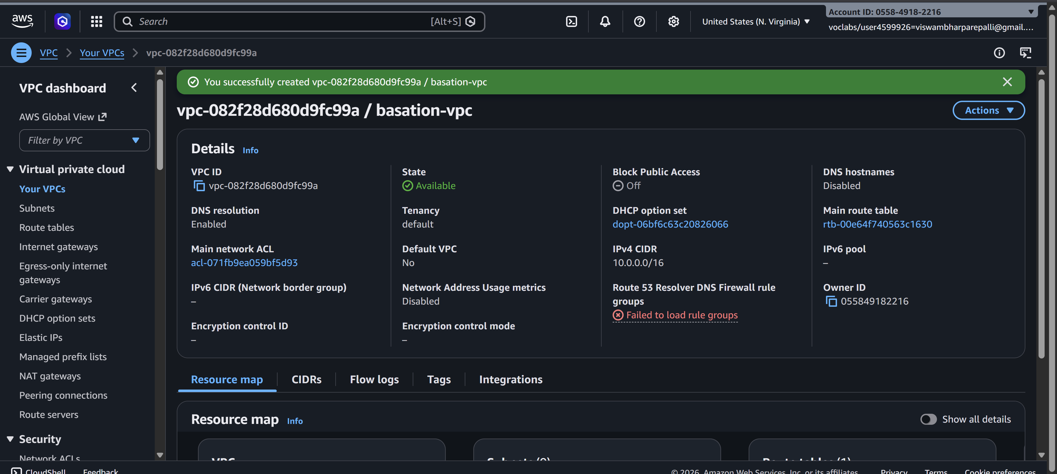

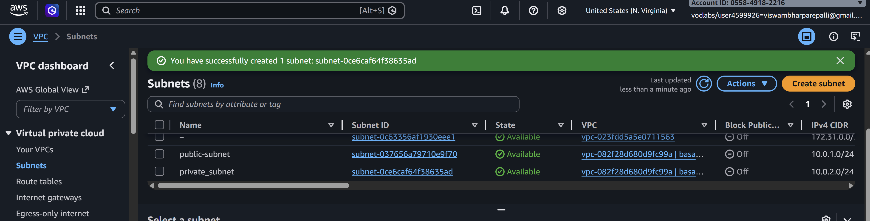
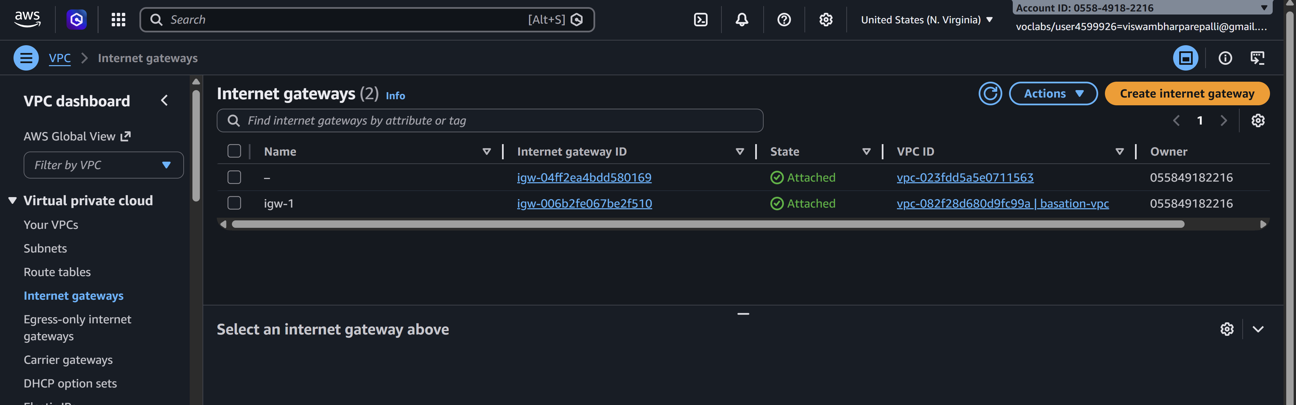
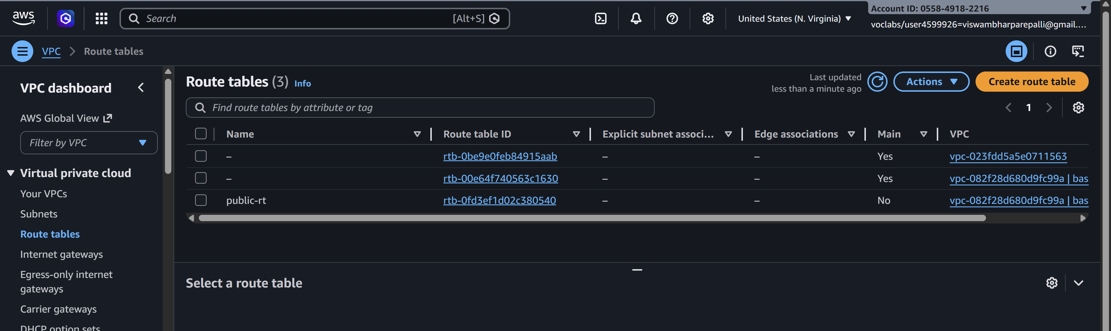
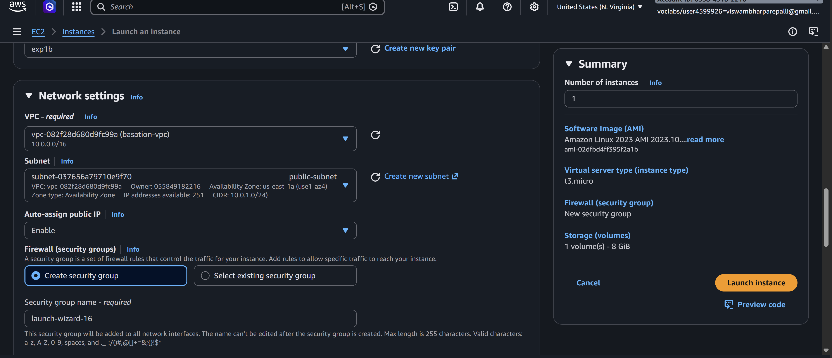
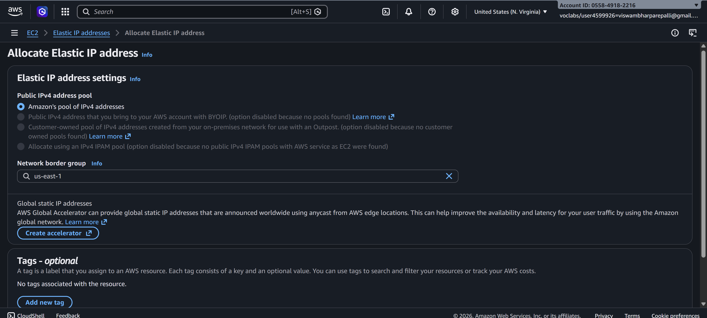

- Inorder to connect to private subnets, we have an option called bastion server. So lets create an ec2 instance with the same name with .ppk keypair.

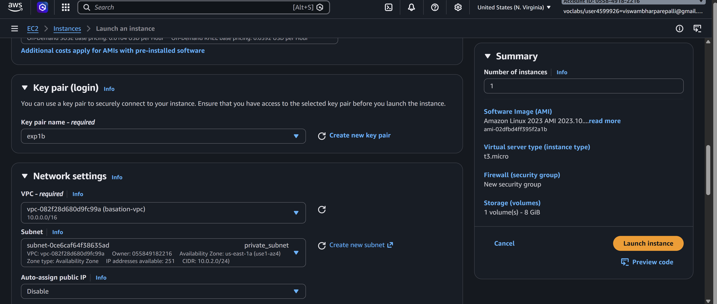

- Create the instance in public subnet, allow ssh and internet traffic along with this, add MYSQl/AURORA also.

- Creation of private server which is to be accessed through bastion

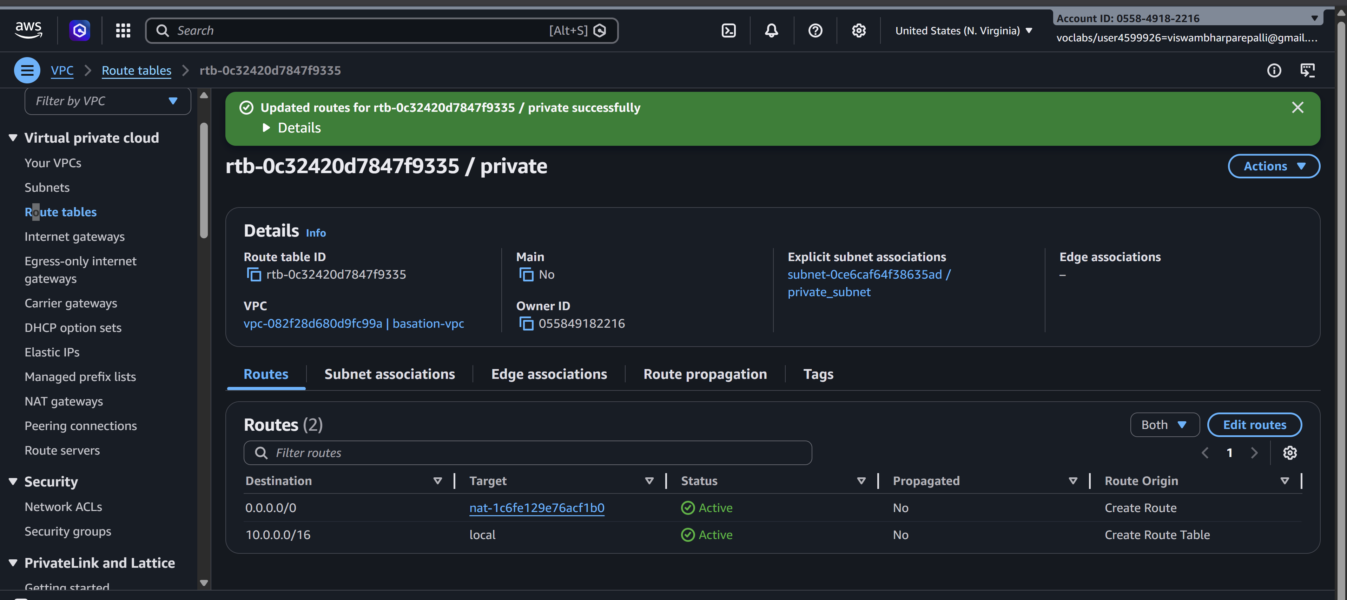

- Download Winscp software for windows from google and install in the computer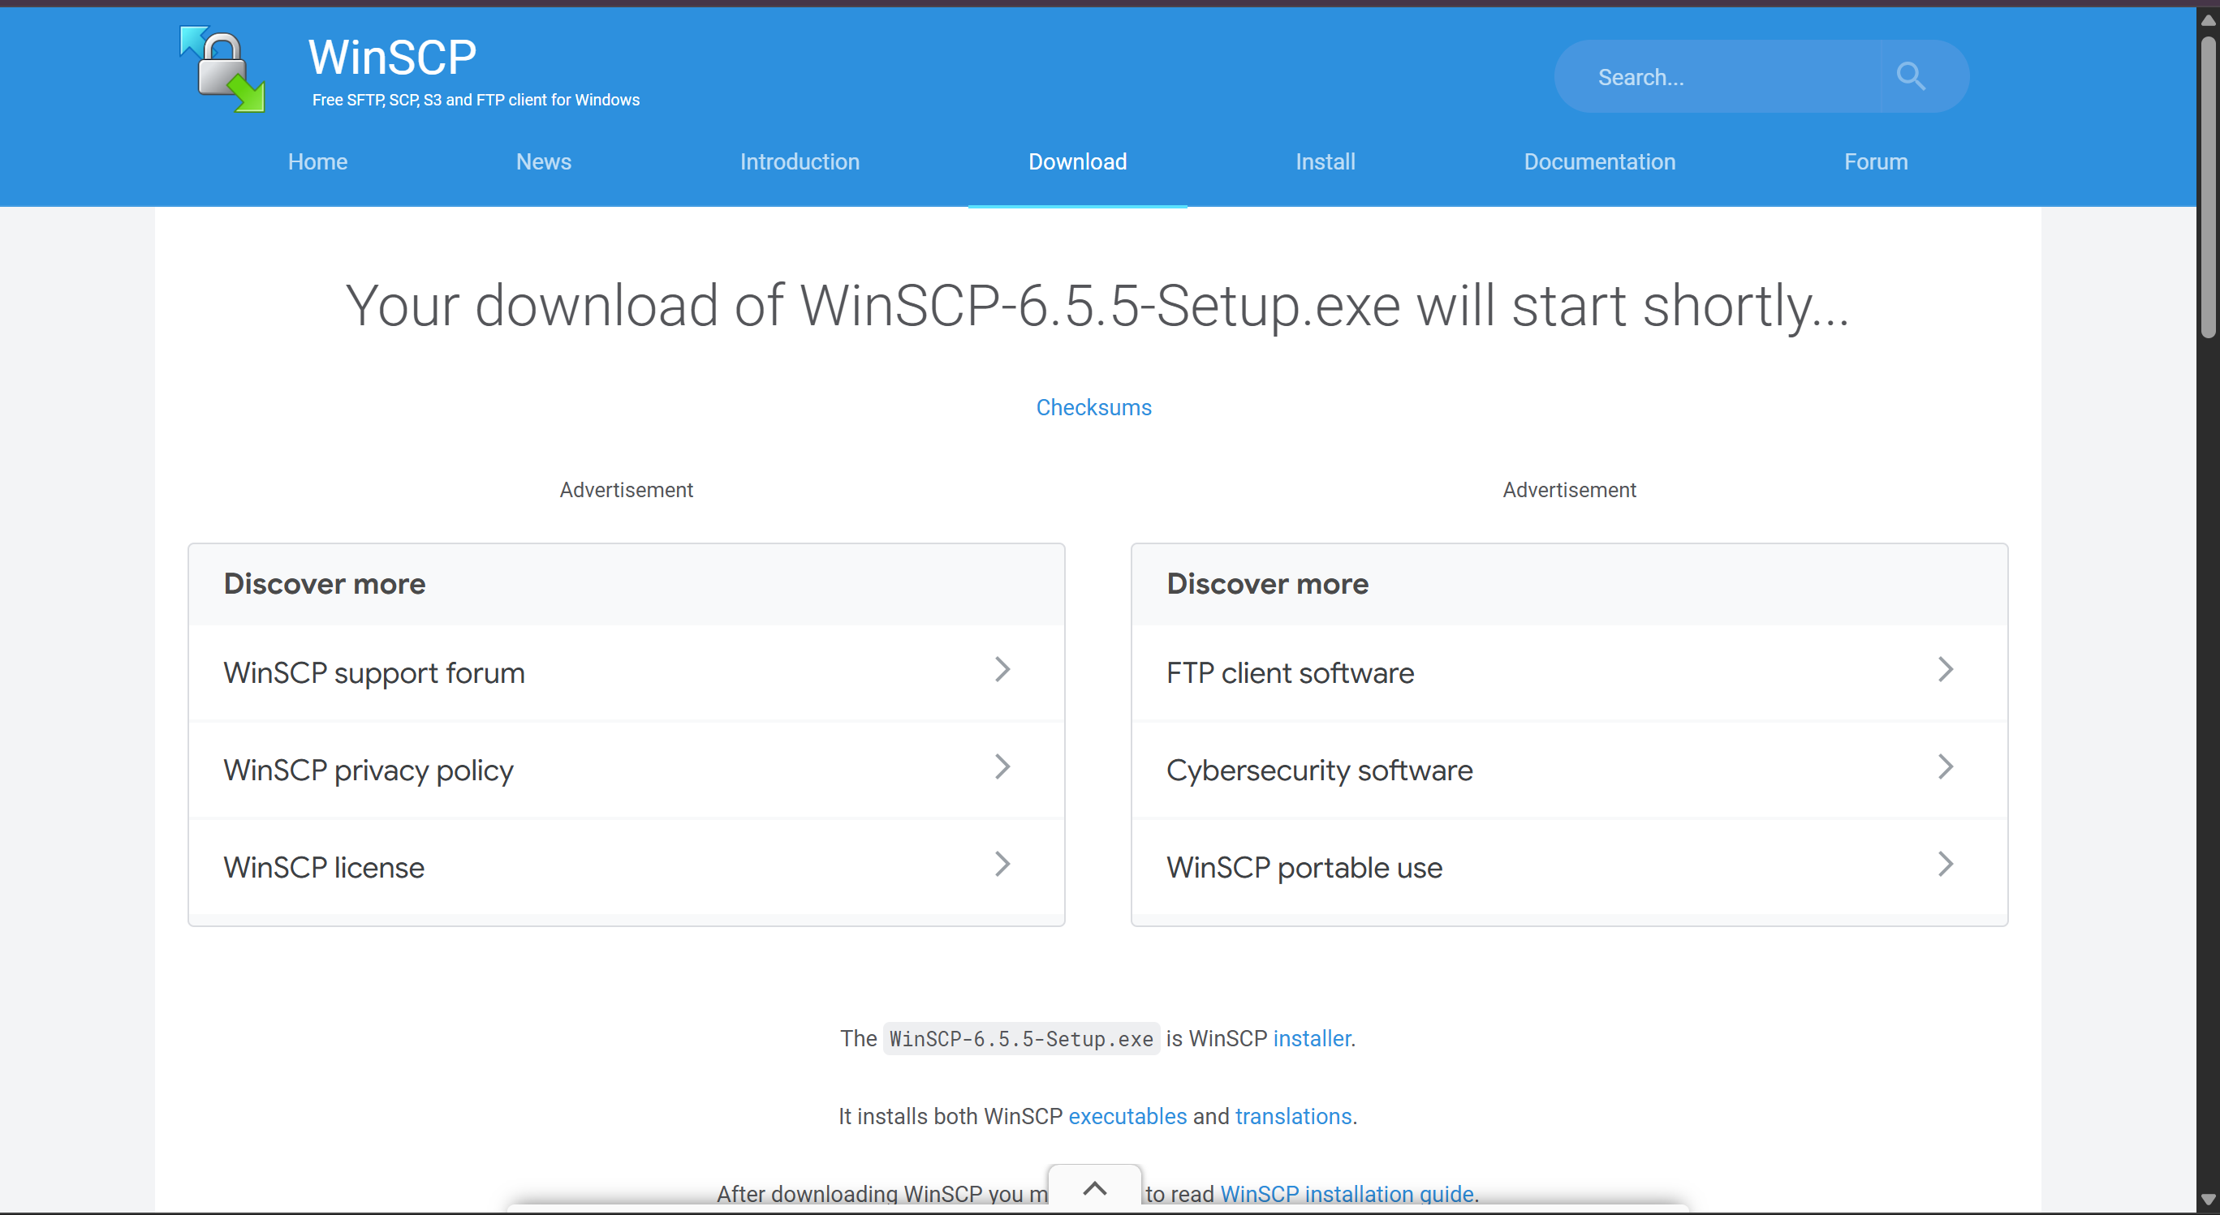
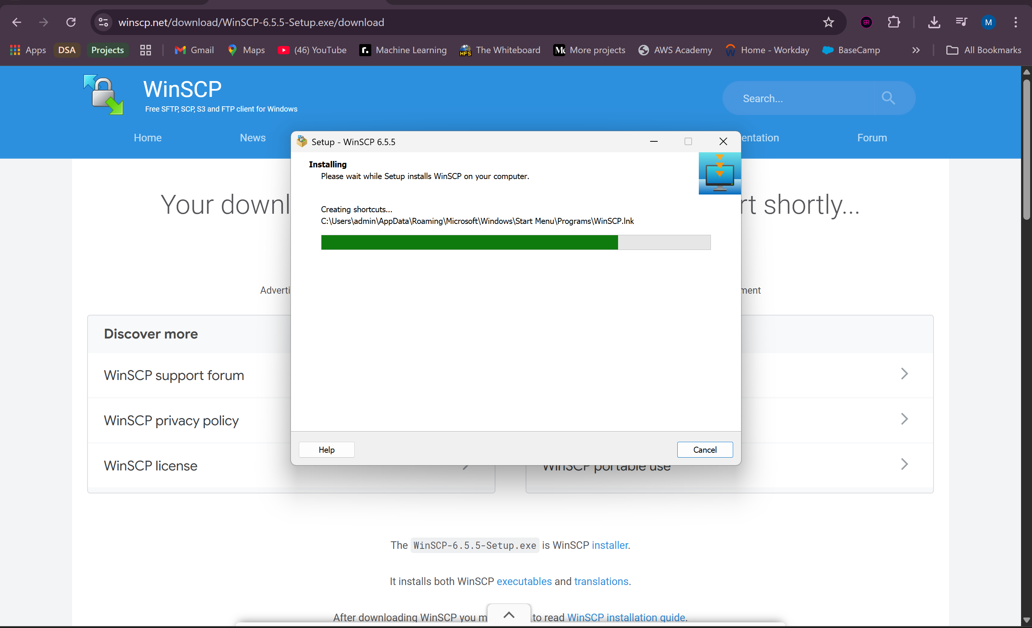
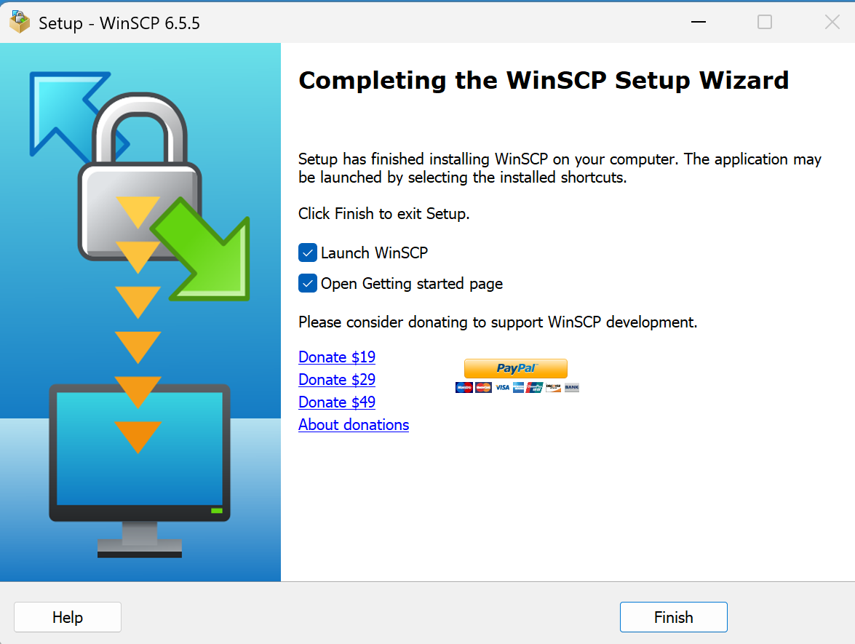

- Copy the public IP address of bastion server and open the winscp in our system.

- Paste the public IP address in Host name and click on advanced.

- In advanced, selct authentication, click on browse and navigate to the folder where your .ppk is present and load that file, click on OK. And click on login. Accept the certificate. Give username as Ubuntu.
- 

- Copy the .pem file from our desktop to the right side terminal. Just drag and drop.

- Now our private subnet is being accessed. Lets connect the bastion server using putty.

- After connecting through putty, give the commands Sudo su, give ls, check .pem file, give the ssh key of private instance as shown below.

- On successful connection, our private subnet 10.0.2.159 will be connected using successfully. And our ipv6 address will be shown in the command prompt.
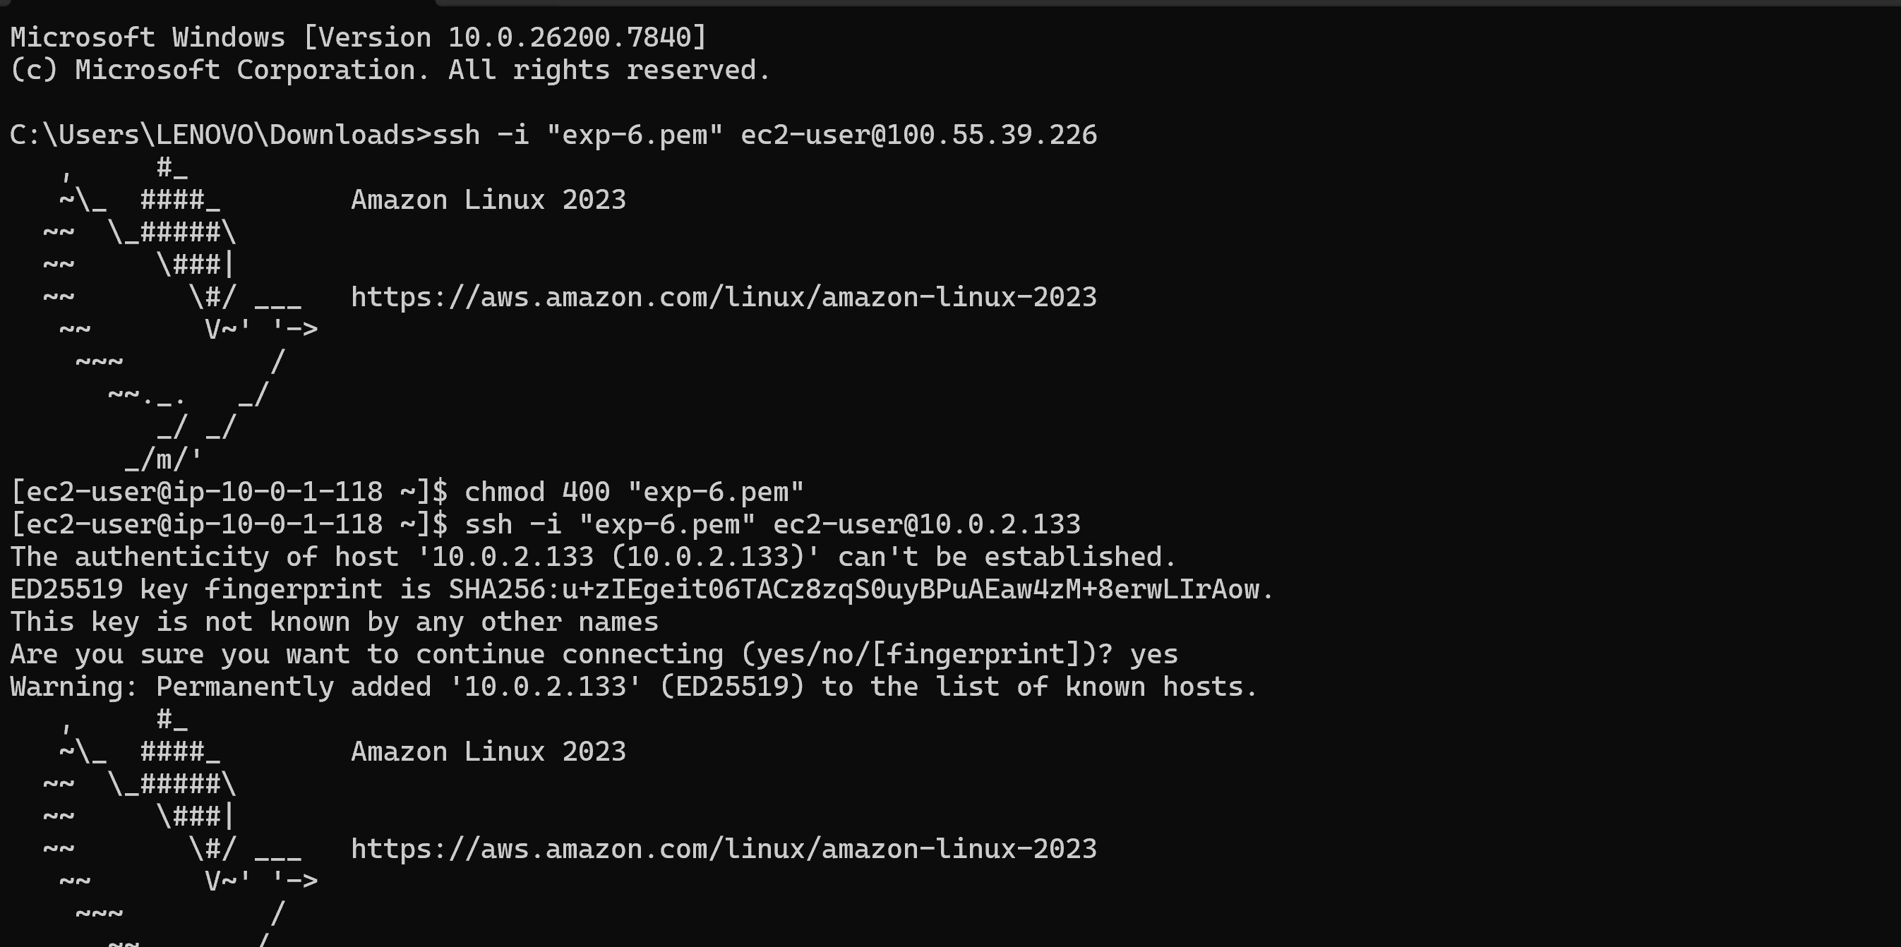

VPC USING NAT GATEWAY

- In the above steps we only connected to private subnet with the help of bastion server. If we want to install or update anything in the instances present in private subnet we cannot do and get the warnings like failed to fetch because internet gateway is not attached to the private subnet as shown below.

- We can overcome this problem with the help of concept called, Network Address Translator (NAT Gateway). Goto NAT Gateway in the left side menu bar and click on create NAT gateway.

- Give the Nat gateway name, select your VPC, scroll down and clock create NAT gateway

- So Now lets create a rout for accessing NATGateway. Goto Route table click on create route table and give the route table name, along with it our customized vpc and click on create route.

- Click on actions, goto edit subnet associations and add private subnet to this bastion route.
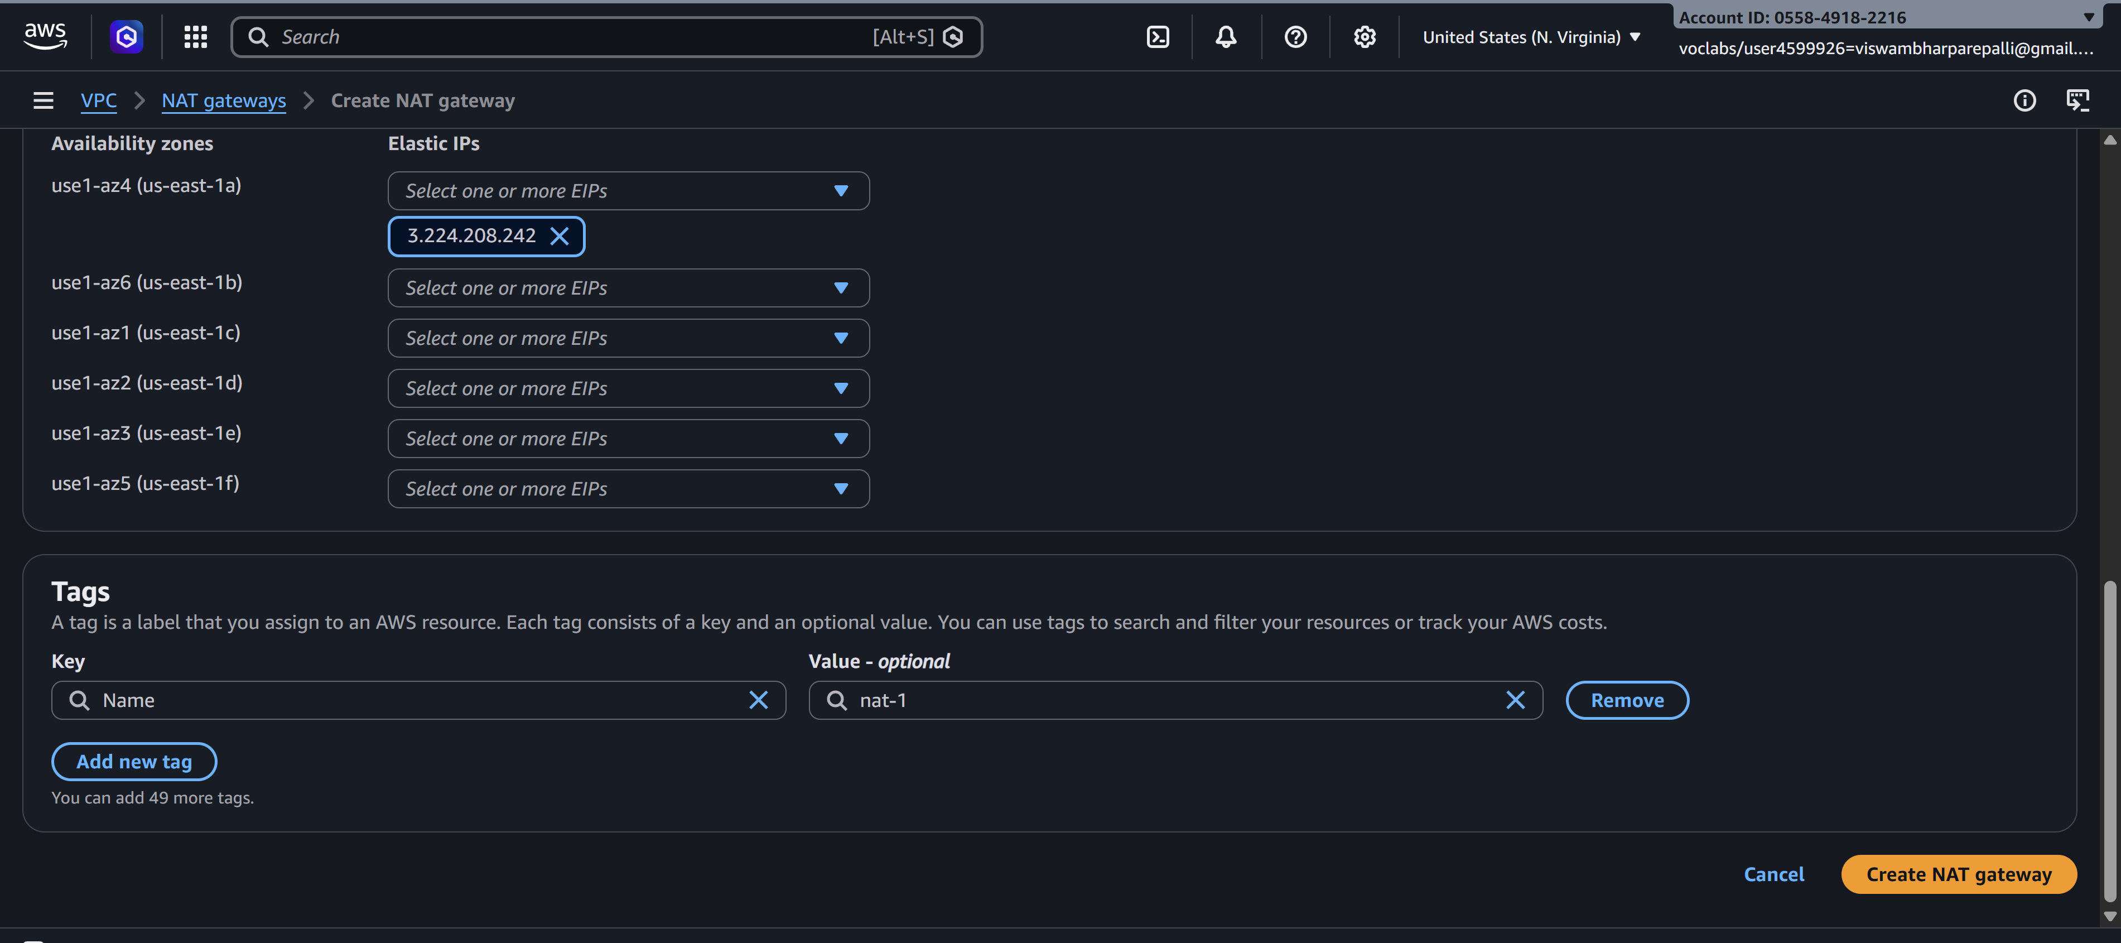
- Again goto actions and click on edit routes, attach NAT Gateway and click on save changes.

- Now that all connections are established, we can install and update any files in the private subnet as given below.
This completes out VPC with NAT Gateway using Bastion Server inorder to connect and do operations in private subnet.

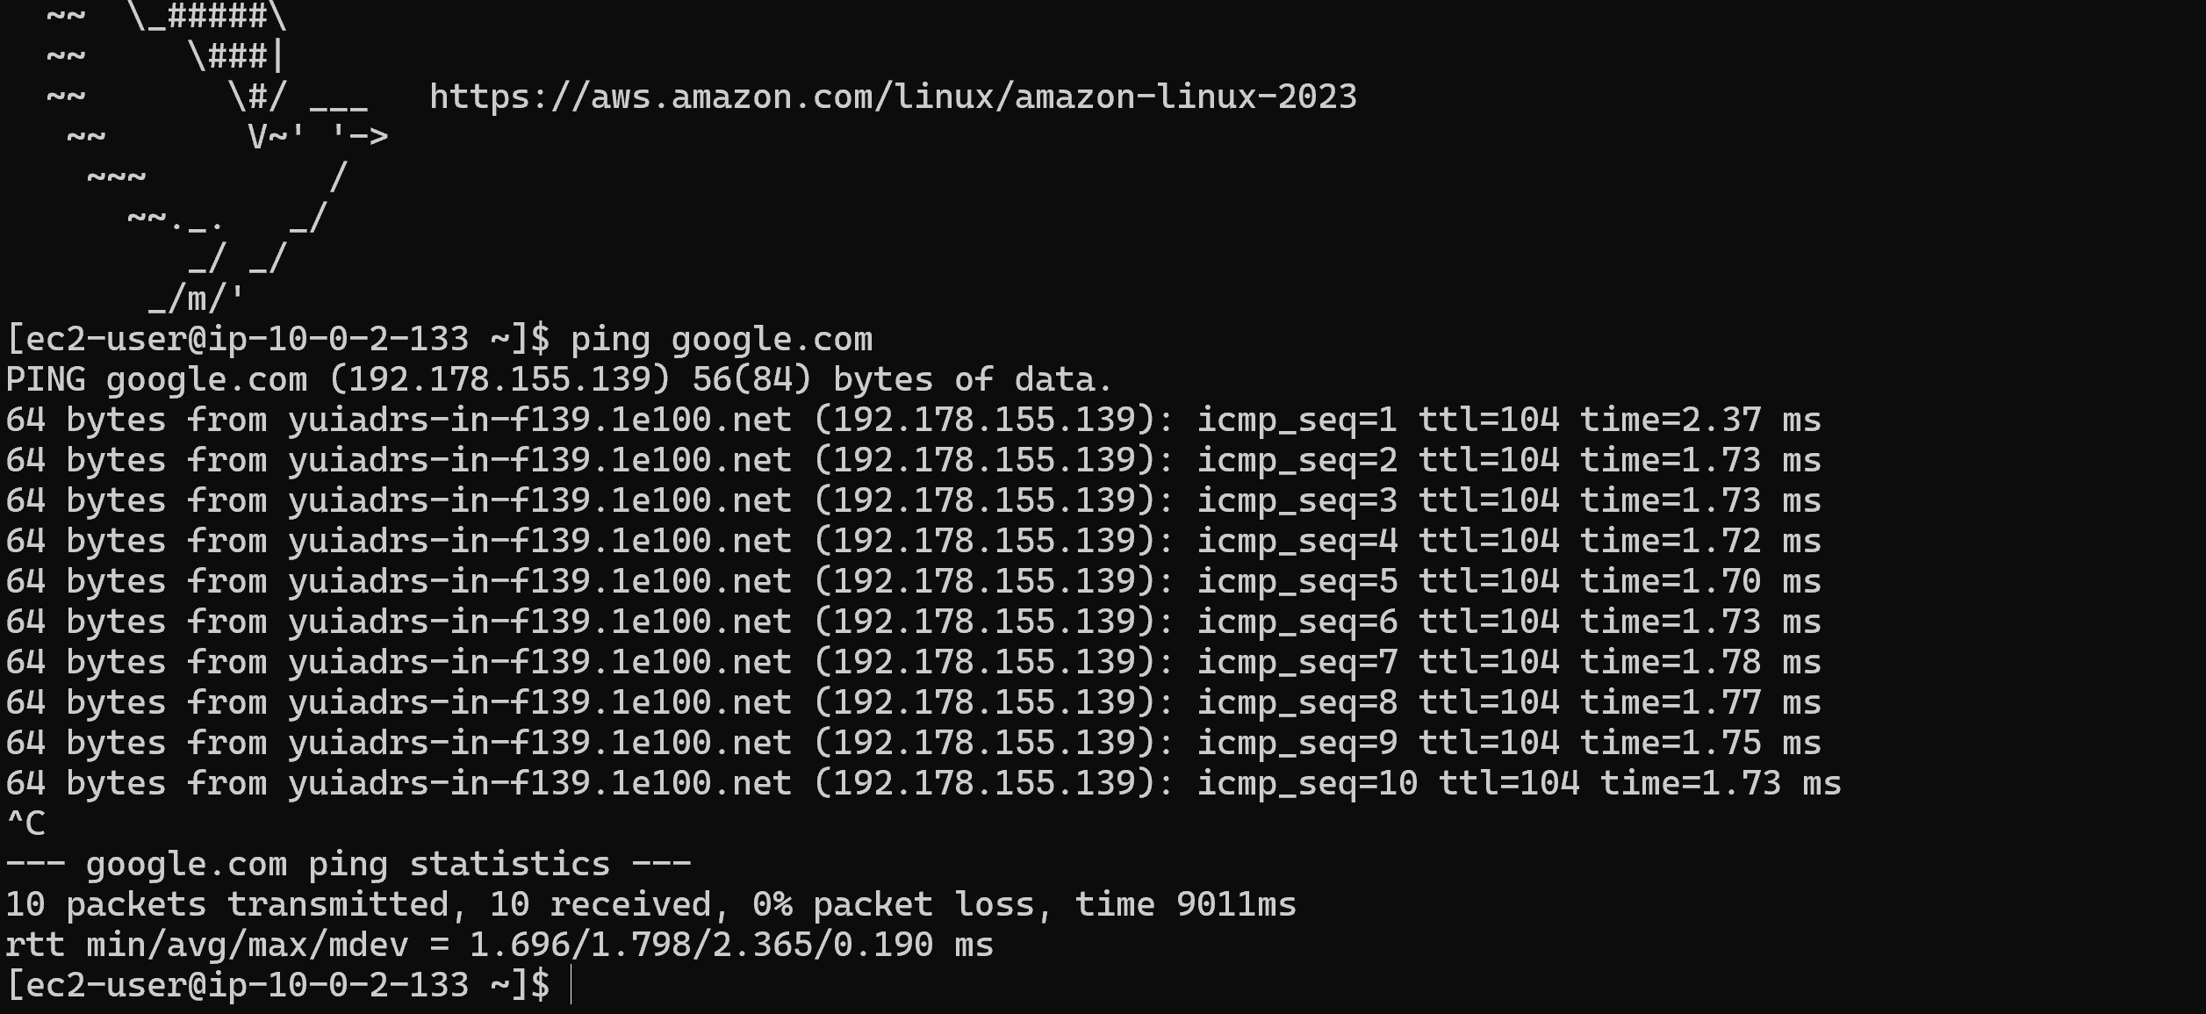

SCENARIO BASED QUESTIONS

1. You have multiple private subnets in different AZs. Should you use one NAT Gateway or multiple NAT Gateways? Explain your design choice.
It is recommended to use multiple NAT Gateways, ideally one NAT Gateway per Availability Zone. Each private subnet should route traffic to the NAT Gateway in the same AZ. This improves high availability and avoids cross-AZ traffic charges. If only one NAT Gateway is used and that AZ fails, all private subnets may lose internet access.

2. Your private subnet instances can reach the internet, but the NAT Gateway shows no traffic. What could be the possible reasons?
Possible reasons include the instances having public IP addresses and accessing the internet directly through the Internet Gateway, the route table pointing to another NAT Gateway, checking metrics of the wrong NAT Gateway, or the instances actually being in a public subnet instead of a private subnet.

3. A NAT Gateway was accidentally created in a private subnet instead of a public subnet. What problem will occur, and how would you fix it?
If a NAT Gateway is created in a private subnet it cannot communicate with the Internet Gateway, so private instances will not get internet access. To fix this, delete the NAT Gateway and recreate it in a public subnet, then update the private subnet route table to route 0.0.0.0/0 traffic through the NAT Gateway.

4. An application running in a private subnet requires outbound access only to a few trusted external services. How would you restrict traffic while still using a NAT Gateway?
Outbound traffic can be restricted using Security Groups or Network ACLs to allow connections only to specific IP addresses, domains, or ports of trusted services. VPC endpoints or firewall rules can also be used to limit which external services the instances can access.

5. Multiple teams share a single VPC and NAT Gateway. One team’s traffic is affecting others. How would you redesign the NAT Gateway setup to isolate traffic?
You can create separate private subnets and dedicated NAT Gateways for each team. Each subnet can have its own route table pointing to its NAT Gateway. This isolates network traffic and prevents one team’s traffic from affecting others.

6. You can successfully SSH into a private EC2 instance using a Bastion server, but yum update / apt update fails inside the private instance. Why?
This usually happens because the private subnet does not have internet access. The route table for the private subnet may not have a route to a NAT Gateway, or the NAT Gateway may not be configured correctly. Without NAT, private instances cannot access the internet to download updates.

7. Private EC2 instances can access the internet through a NAT Gateway, but administrators cannot SSH into them using the Bastion server.
This usually occurs because the private instance security group does not allow SSH access from the Bastion server. It may also happen if the Bastion server and private instance are not in the same VPC or if the route configuration between subnets is incorrect.

8. A Bastion server and NAT Gateway are both created in a private subnet by mistake. What impact does this cause?
The Bastion server will not have a public IP address, so administrators cannot connect to it from the internet. The NAT Gateway will also not work because it cannot reach the Internet Gateway. As a result, both SSH access and internet access for private instances will fail.

9. SSH access to the Bastion server works, but SSH from Bastion to the private EC2 fails. Why?
Possible reasons include the private instance security group not allowing SSH from the Bastion server, incorrect private IP address being used, wrong key permissions, or the Bastion server and private instance not being in properly connected subnets within the same VPC.

10. A student claims that a Bastion server alone is enough to provide internet access to private instances. Why is Bastion not a replacement for NAT Gateway?
A Bastion server is used only for secure administrative access to private instances through SSH. It does not route general outbound traffic for other instances. A NAT Gateway is required to allow private instances to access the internet while still keeping them private from incoming internet traffic.

