WEEK-7 S3 To DynamoDB
step-by-step procedure for setting up an AWS Lambda function to trigger whenever an object is uploaded to an S3 bucket and update a DynamoDB table:

STEP-1: Create the S3 Bucket
-Search for S3 bucket in amazon console
-Click on the create bucket in the S3 bucket console
-Select general purpose
-Name the bucket as you needed
-Enable Versioning
-Click on the create bucket
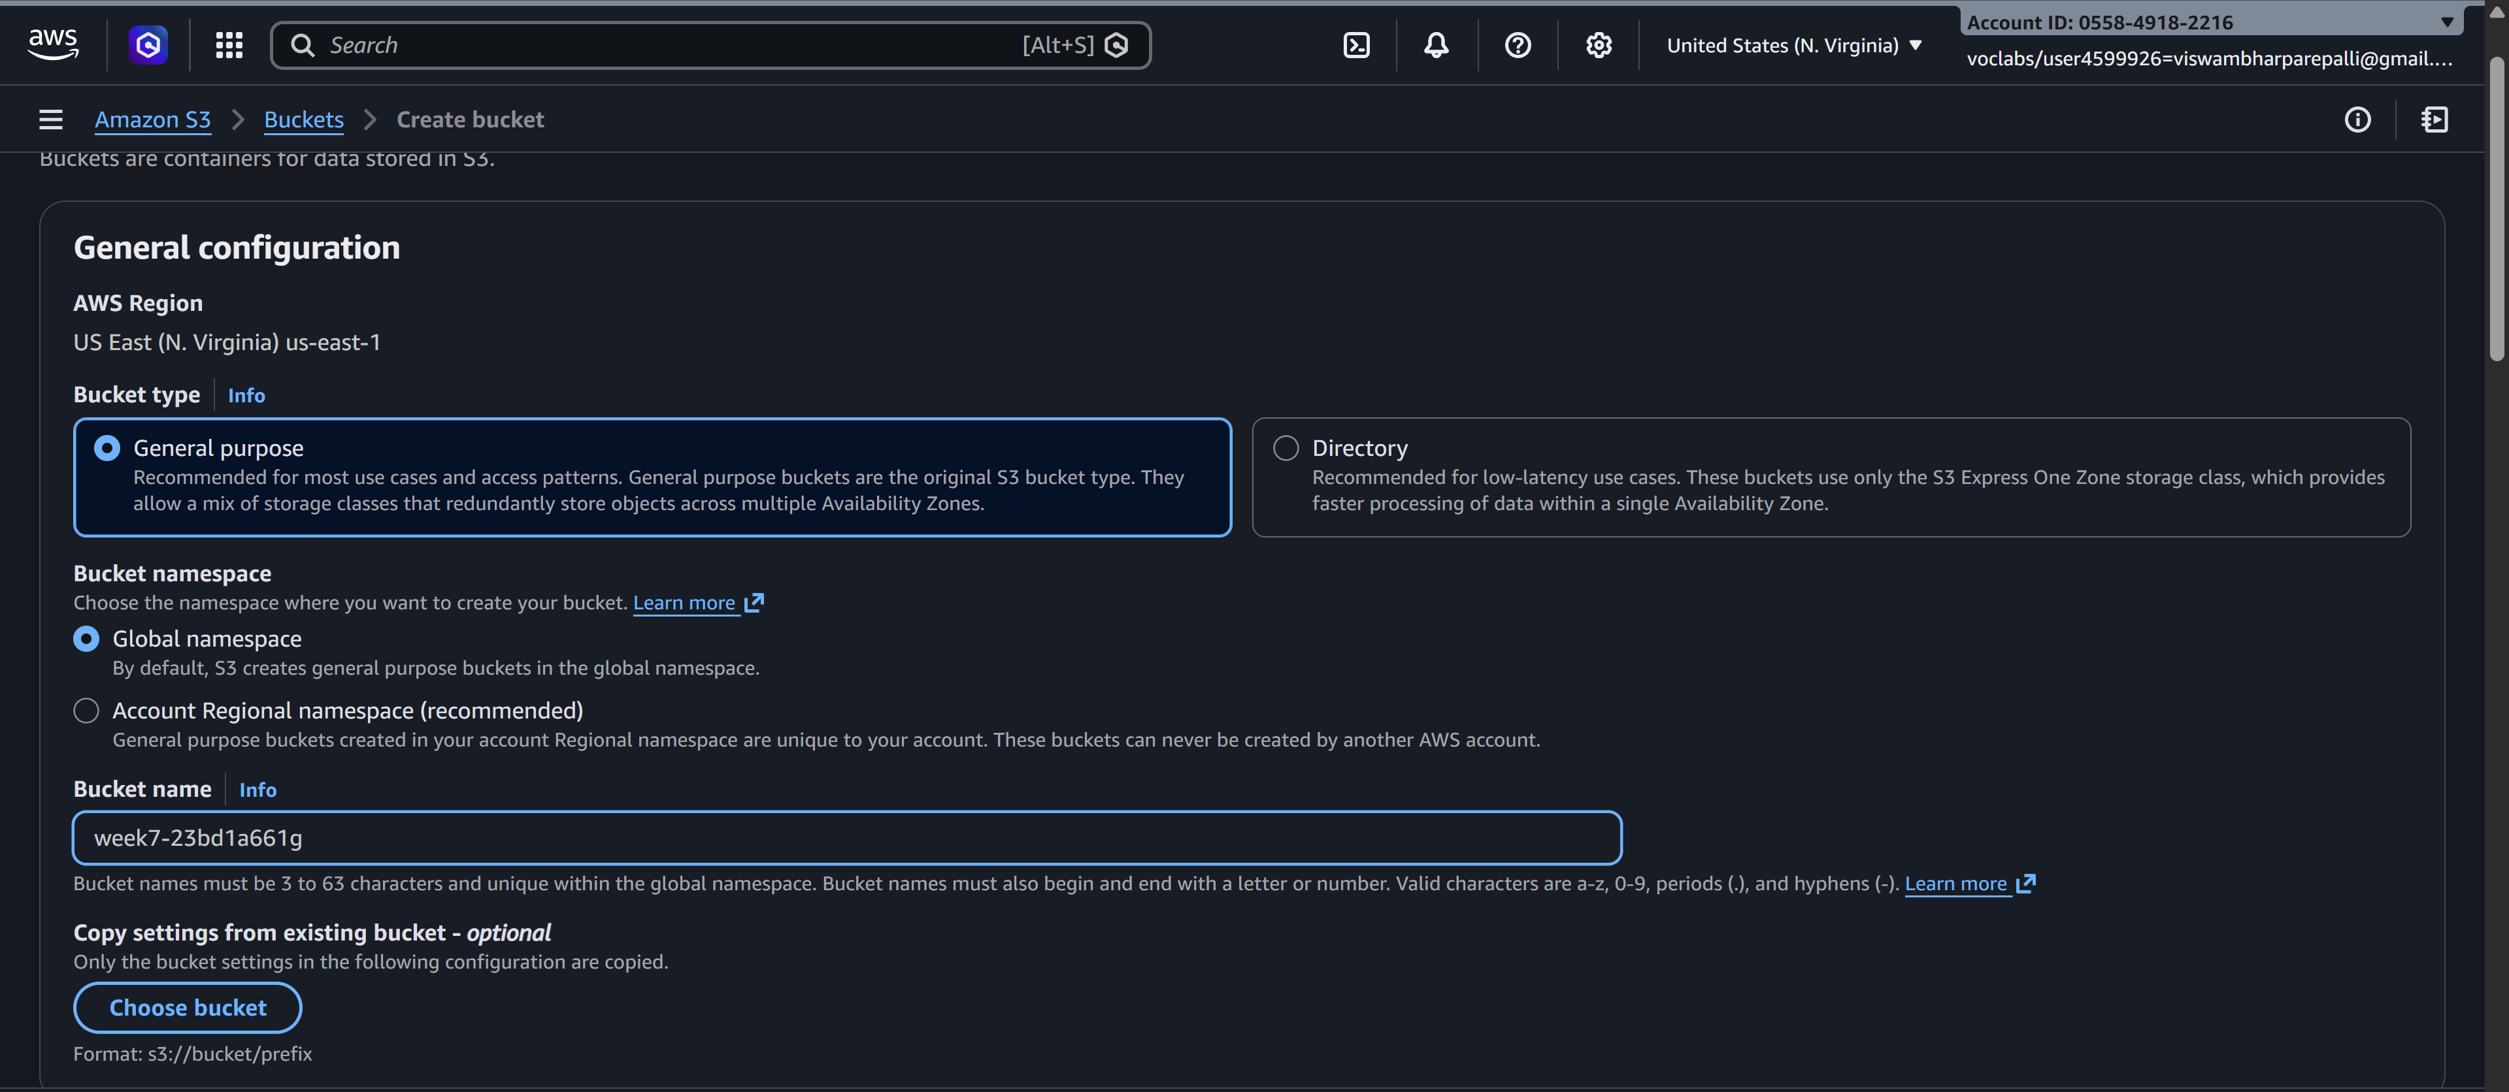
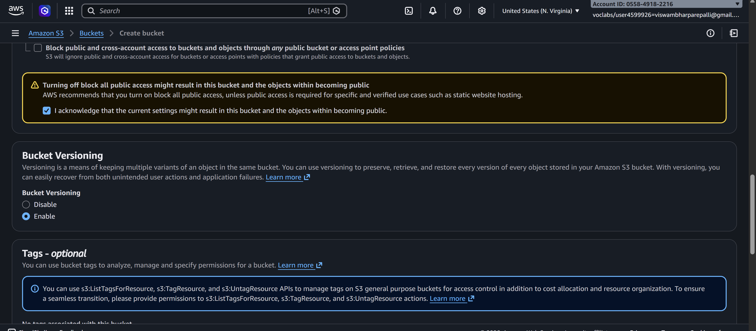

STEP-2: Create a AWS DynamoDB service table

-Search for dynamodb in the search bar of amazon console
-Click on the create table
-GIve any name to the table
Eg. newtable
-Name the row as unique with type string
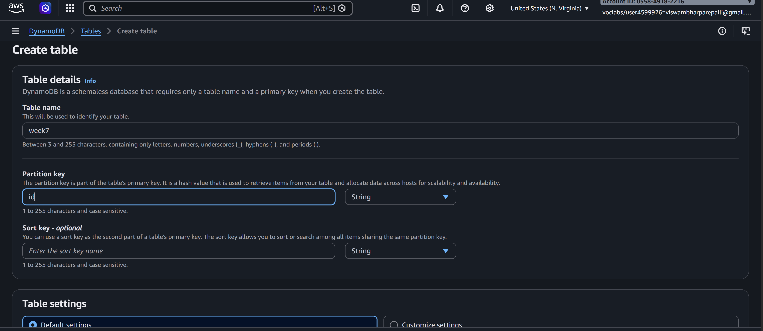

STEP-3: Creating the lambda function

-Search for aws lambda
-Click on the create function
-Choose Author from scratch
-Type any name in the function name input
-Choose a runtime
Eg.Python
-In permissions choose the role type
If available labrole in the existing roles
Or
Create a new role with basic lambda permissions
-click on the create function
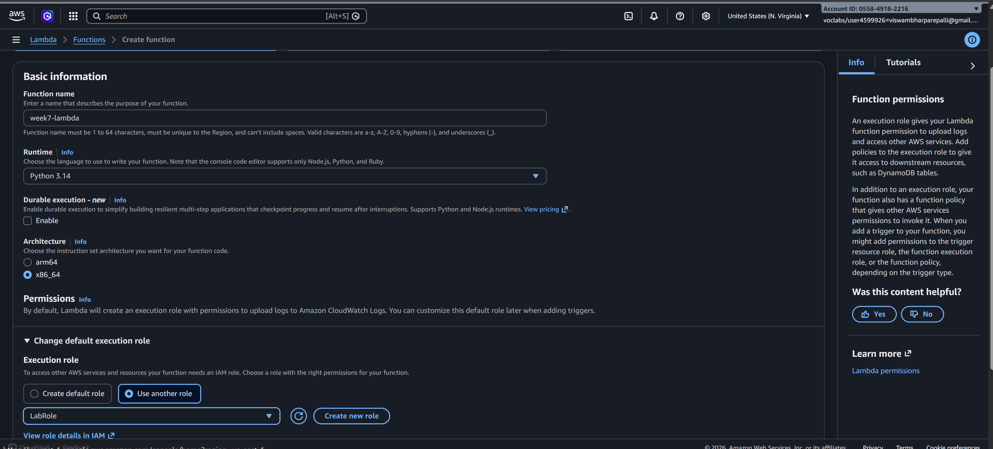

STEP-4: Adding trigger to connect the S3 bucket and DynamoDB

-Click on the Add trigger in the created function
-Search for S3 bucket in the trigger configuration
-Select the S3 bucket
-Choose the bucket which you want to apply the trigger
-Select All object create event in the event type, Acknoledge
-click on the add
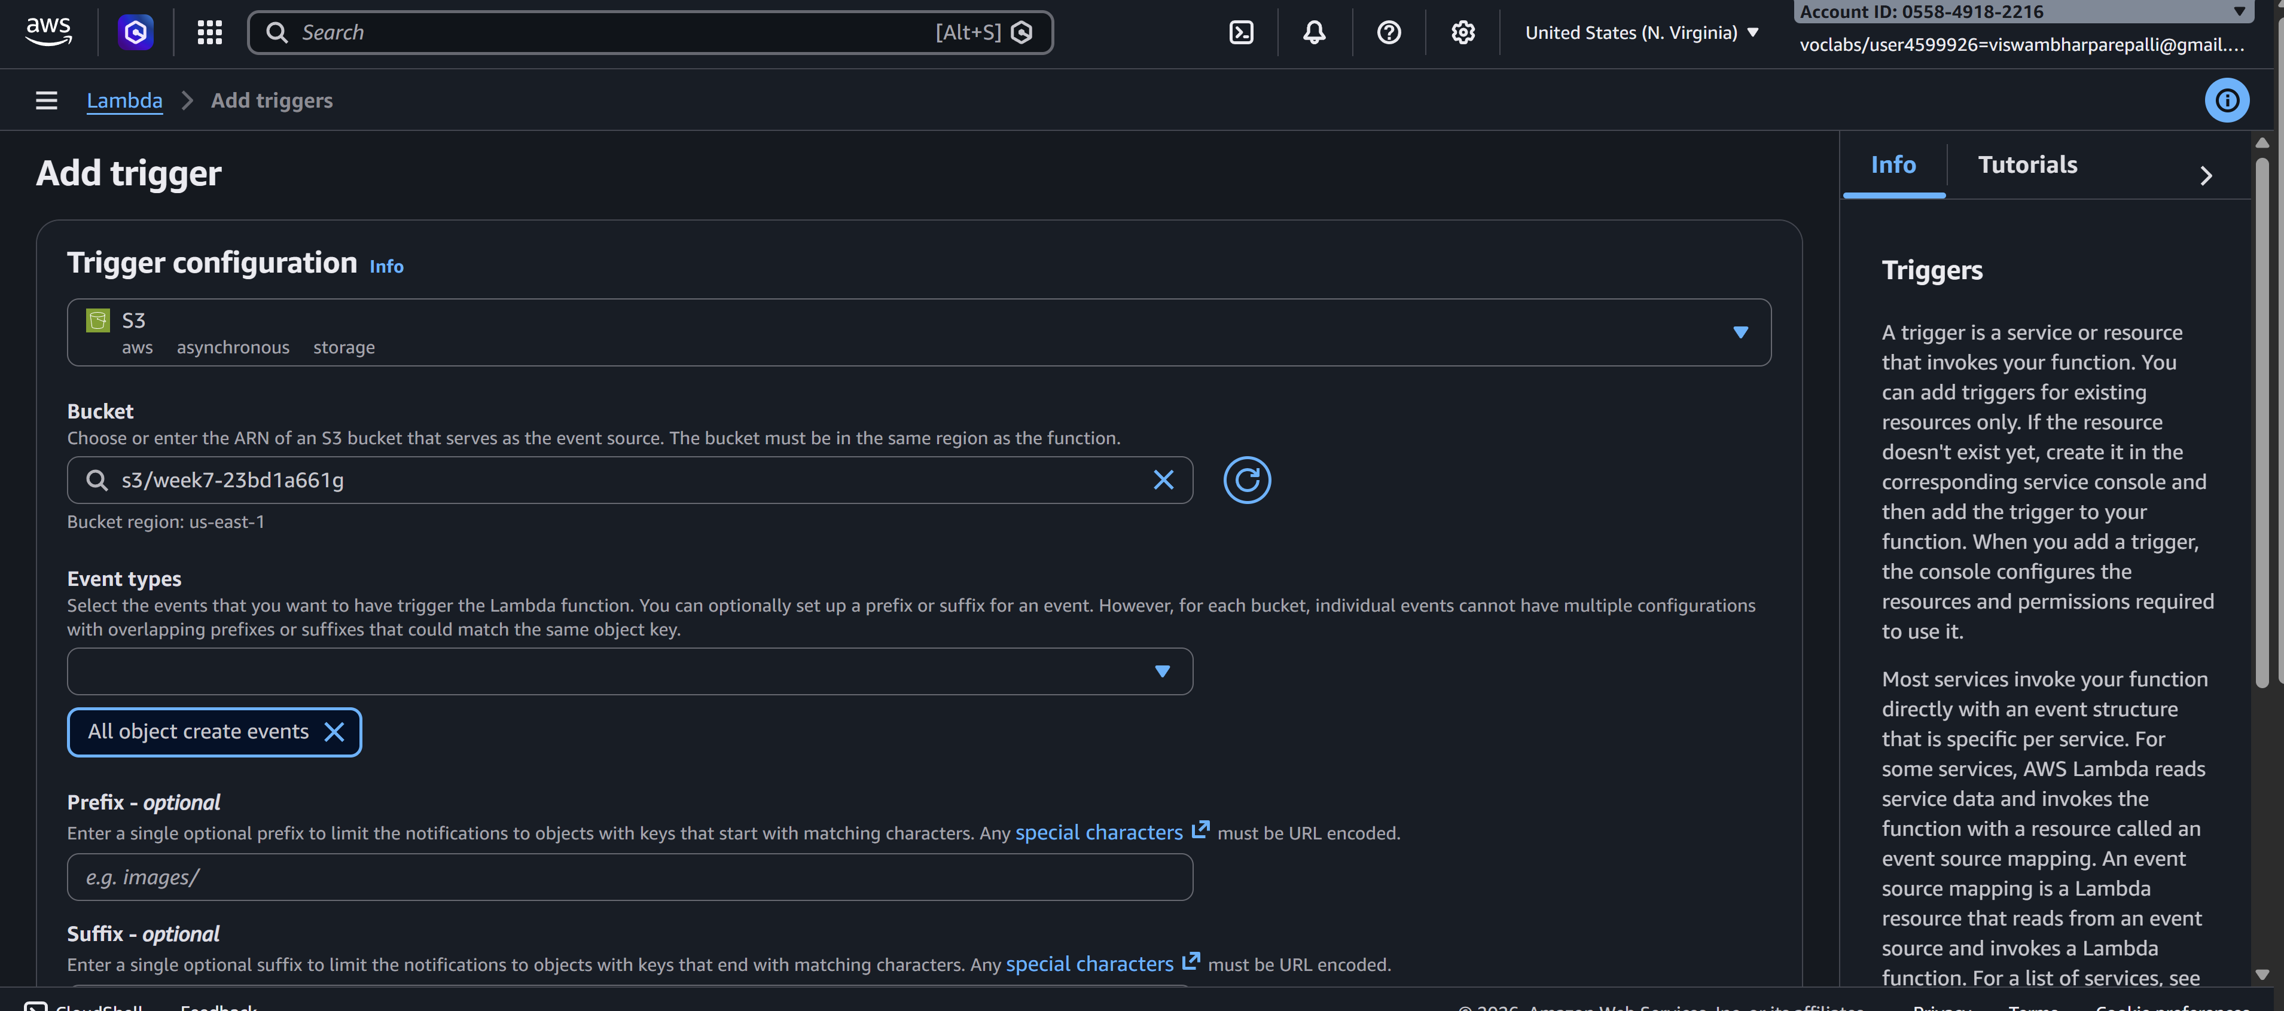

STEP: 5 Creating the deplyoment code and monitoring

-Add the code for triggering when object is uploaded
Eg
import boto3
from uuid import uuid4
def lambda_handler(event, context):
s3 = boto3.client("s3")
dynamodb = boto3.resource('dynamodb')
# Check if the 'Records' key is present in the event
if 'Records' in event:
# Iterate over each record in the event
for record in event['Records']:
bucket_name = record['s3']['bucket']['name']
object_key = record['s3']['object']['key']
size = record['s3']['object'].get('size', -1)
event_name = record.get('eventName', 'Unknown') # Use get() method to handle missing keys
event_time = record.get('eventTime', 'Unknown') # Use get() method to handle missing keys
dynamoTable = dynamodb.Table('newtable')
dynamoTable.put_item(
Item={'unique': str(uuid4()), 'Bucket': bucket_name, 'Object': object_key,'Size': size, 'Event': event_name, 'EventTime': event_time})
else:
# Log a message indicating that the 'Records' key is missing from the event
print("No 'Records' key found in the event.")
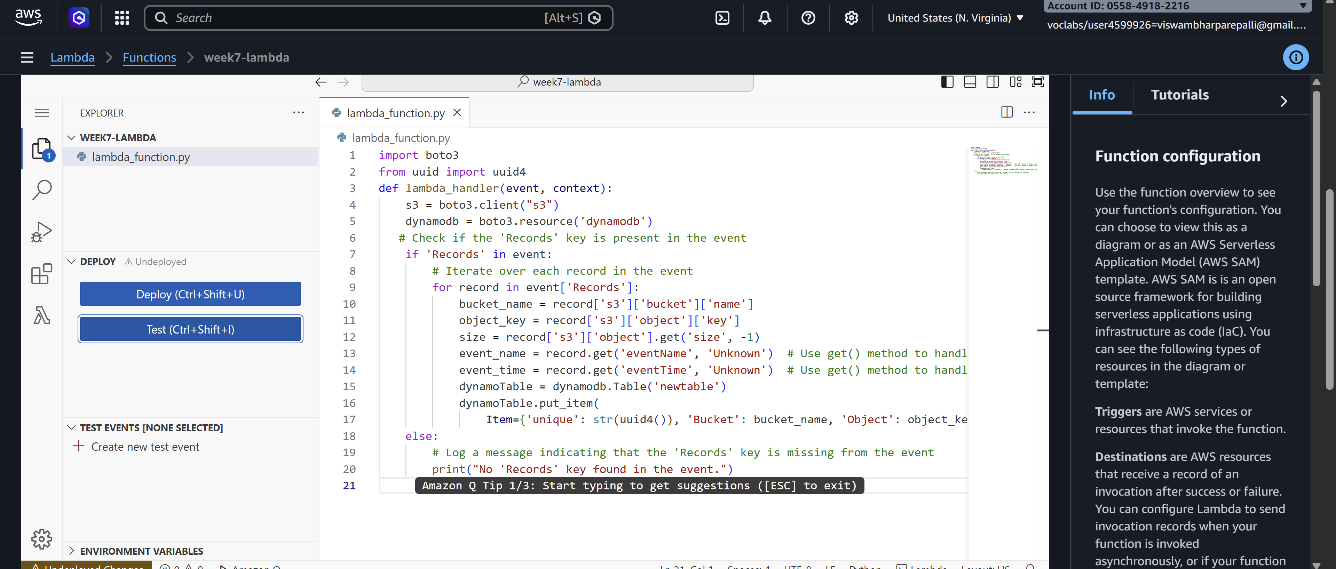

Create a policy if you are getting the Iam role problem Otherwise skip this

-Search for IAM console in AWS console
-Go to roles
-Select the Lamda function name like you gave in the labmda creation

-In permission policies click on add permissions
-Select create inline policy

-Click on the JSON in the policy editor
Write this policy code in that editor

{
"Version": "2012-10-17",
"Statement": [
{
"Effect": "Allow", "Action": "dynamodb:PutItem",
"Resource": "arn:aws:dynamodb:us-west-2:669420739378:table/newtable"
}
]
}

-Click on the next
-Give any policy name
Eg.lambda-dynamo-policy
-Click on the create policy

STEP-6 : Upload any file(s) in the S3 bucket it will triggers and shows in both S3 bucket and the DynamoDB
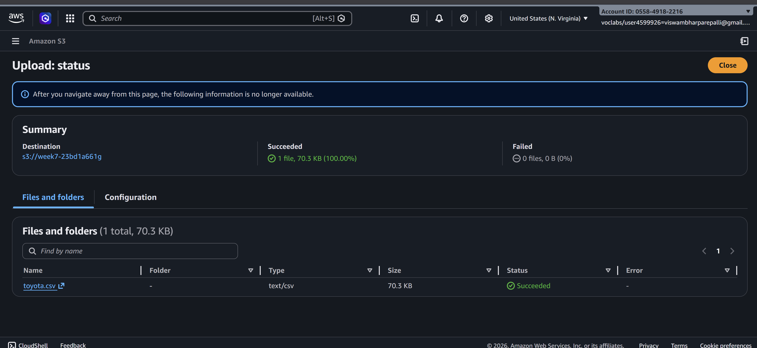

-Click on the explore items in the DynamoDB
-click on the run
You’ll able to see the objects in the dynamodb which is uploaded in the S3 bucket
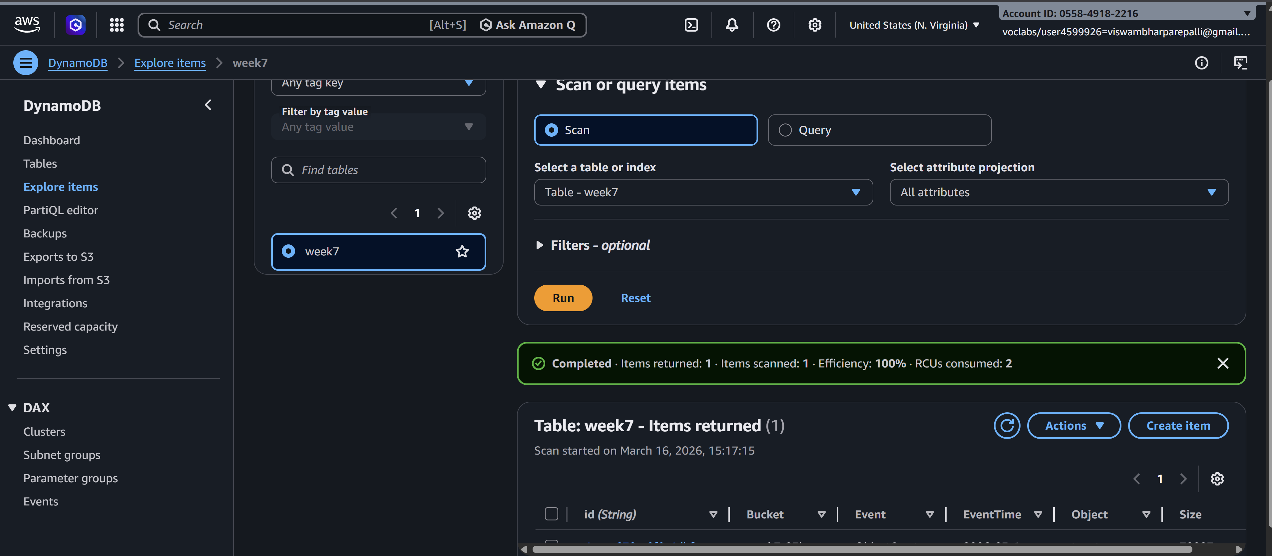
STEP-7: Monitoring using cloud watch

-Click on the Monitor tab in the lambda function
-Click on the view cloudwatch logs
-Click on the time lines and check the logs
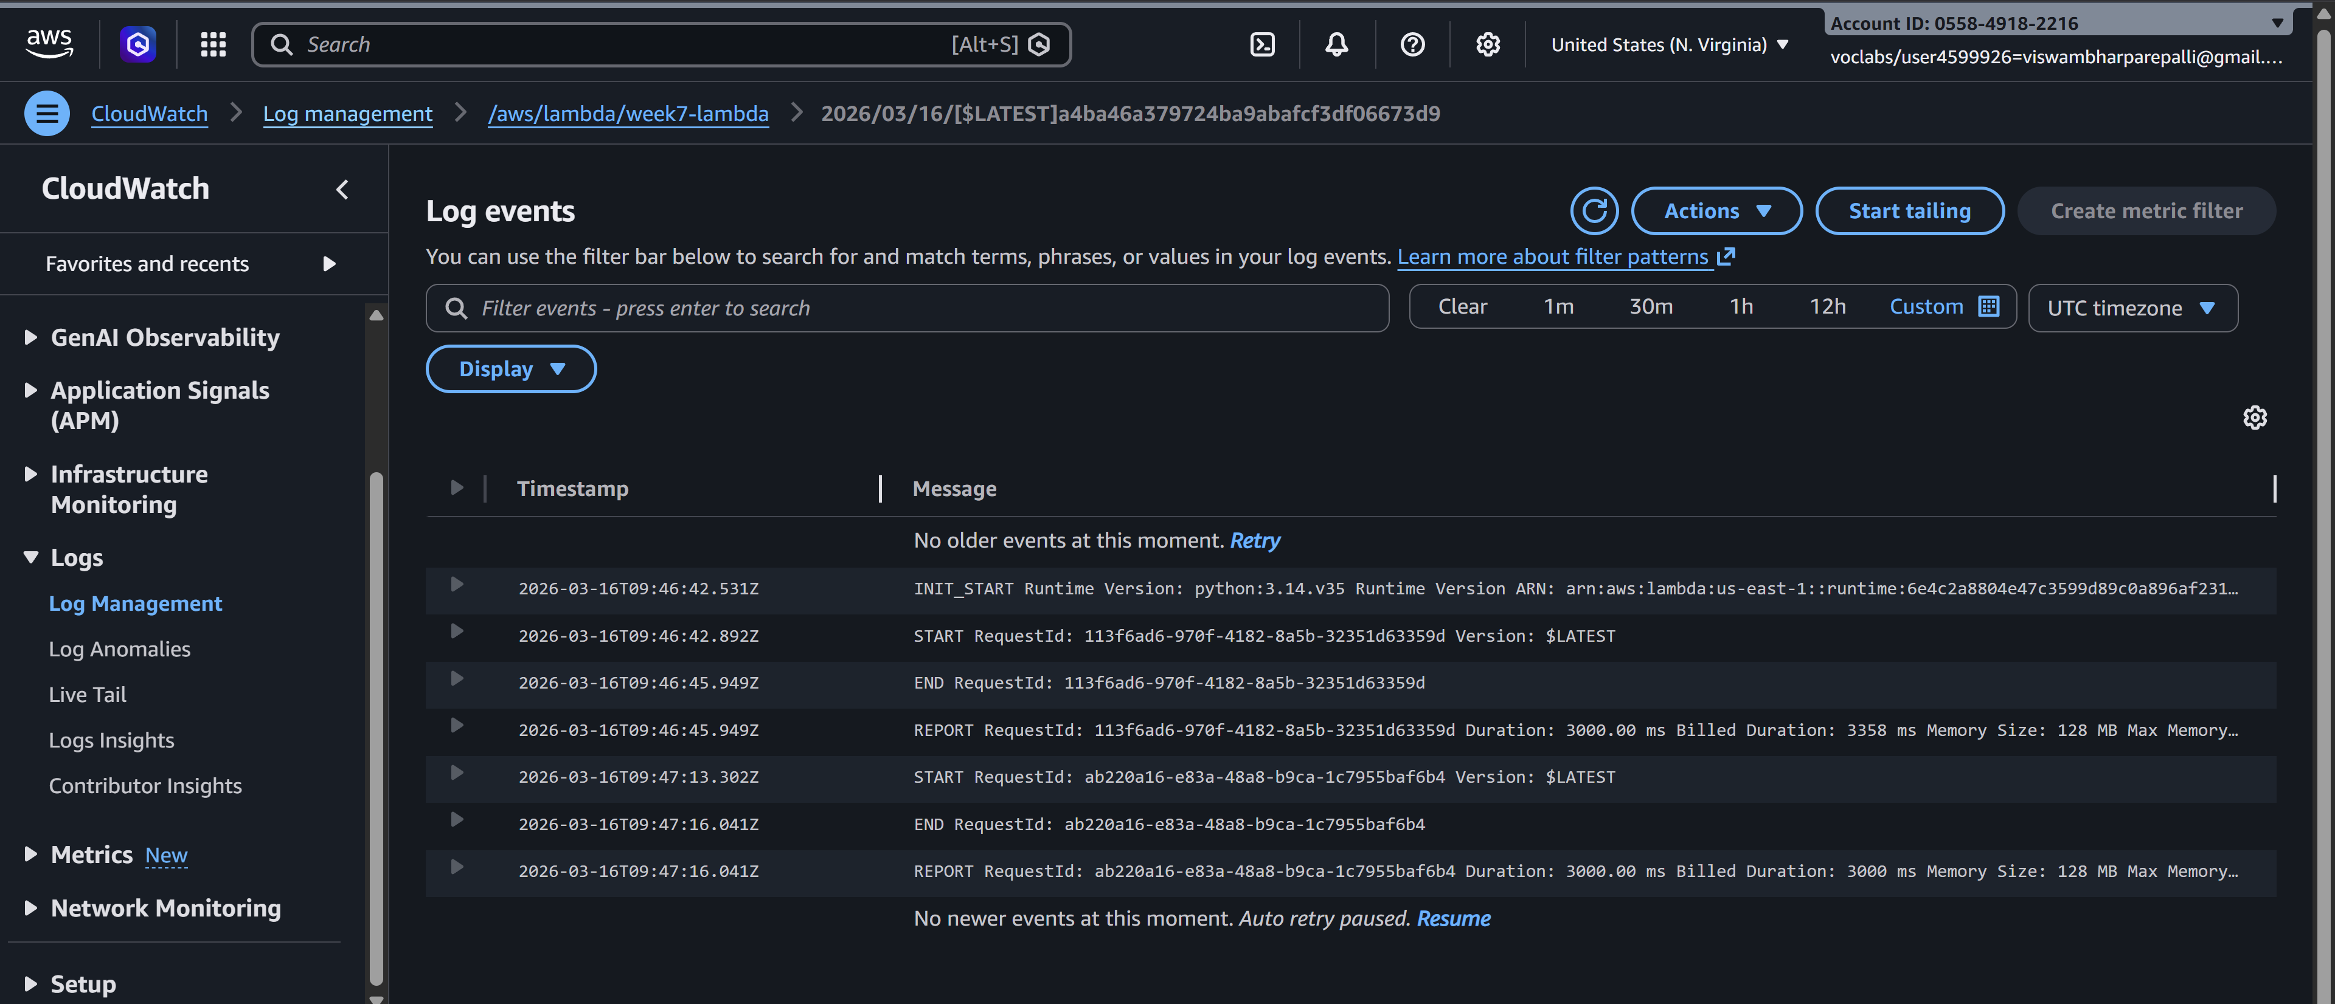
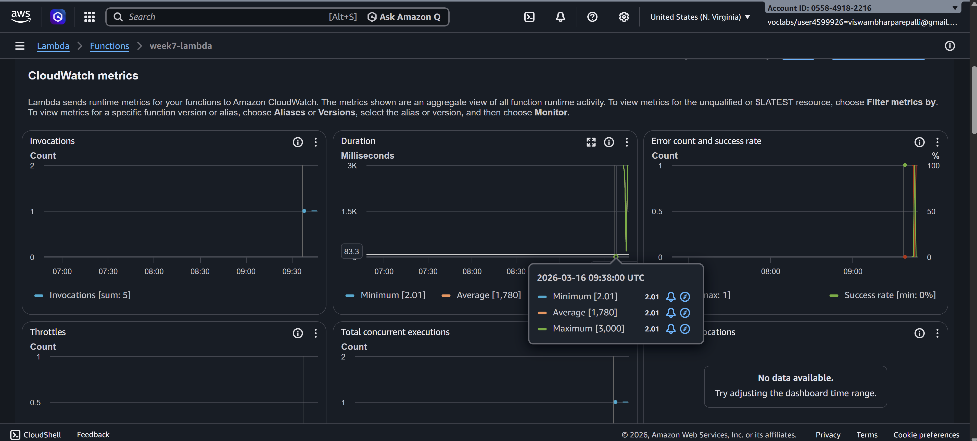

SCENARIO BASED QUESTIONS

1. A company wants to automatically process images whenever they are uploaded to an S3 bucket. The system should resize the images and store them in another bucket. Which AWS service can be used to automatically run the code when the image is uploaded?
Answer:
The company can use AWS Lambda. Lambda can be configured with an Amazon S3 event trigger so that whenever a file is uploaded to the S3 bucket, the Lambda function automatically runs. The function can resize the image and store the processed image in another S3 bucket.

2. A developer created a Lambda function to store uploaded file details into a DynamoDB table, but the function fails with a permission denied error when writing to the database. What could be the reason and how can it be fixed?
Answer:
The most common reason is that the Lambda execution role does not have permission to write to DynamoDB.
Fix:
Attach an IAM policy to the Lambda execution role that allows actions such as:
- dynamodb:PutItem
- dynamodb:UpdateItem
- dynamodb:GetItem
This can be done by attaching a policy like AmazonDynamoDBFullAccess or a custom policy with the required permissions.

3. An application needs to run a piece of code every time a new file is uploaded to an S3 bucket to extract metadata and store it in a database. How would you design this using AWS Lambda?
Answer:
The system can be designed as follows:
- A file is uploaded to an Amazon S3 bucket.
- The S3 bucket is configured with an event notification trigger.
- The trigger invokes an AWS Lambda function.
- The Lambda function extracts metadata from the uploaded file.
- The metadata is stored in a database such as Amazon DynamoDB or Amazon RDS.

4. A Lambda function is configured with an S3 trigger, but it is not executing when files are uploaded. What possible configuration issues might cause this problem?
Answer:
Possible reasons include:
- The S3 trigger is not properly configured.
- The Lambda function does not have permission to be invoked by S3.
- The event type (such as ObjectCreated) is not selected correctly.
- The file is uploaded to a different bucket or folder than the configured trigger.
- Incorrect prefix or suffix filters in the trigger configuration.

5. A company wants to process only .jpg image files uploaded to an S3 bucket using Lambda. How can the trigger be configured so that the function runs only for those files?
Answer:
The S3 event trigger can be configured using a suffix filter.
Set the suffix filter to .jpg in the S3 event notification configuration. This ensures that the Lambda function runs only when .jpg files are uploaded.

6. A Lambda function works correctly for a few uploads but fails when hundreds of files are uploaded simultaneously. What AWS feature helps Lambda handle large numbers of events?
Answer:
AWS Lambda automatic scaling and concurrency handles large numbers of events. Lambda can automatically scale by running multiple instances of the function simultaneously to process many events in parallel.

7. A developer wants to store the table name and bucket name separately from the code so that they can easily change them later. Which Lambda feature can be used to achieve this?
Answer:
The developer can use Lambda Environment Variables.
Environment variables allow configuration values such as table names, bucket names, or API keys to be stored separately from the code.

8. A Lambda function executes but does not show any output in the console, making debugging difficult. Which AWS service can be used to view logs and troubleshoot the issue?
Answer:
Amazon CloudWatch Logs can be used to view logs and debug Lambda functions.
Lambda automatically sends logs (such as print statements or errors) to CloudWatch Logs, where developers can monitor and troubleshoot issues.

9. An organization wants a function to run every day at 10 PM to clean temporary files stored in S3. How can Lambda be triggered automatically at a scheduled time?
Answer:
The Lambda function can be triggered using Amazon EventBridge (formerly CloudWatch Events) with a scheduled rule.
A cron expression can be configured so the Lambda function runs automatically every day at 10 PM.

10. A Lambda function processes uploaded files and stores metadata in DynamoDB, but duplicate records appear in the table when the same file is uploaded again. How can this issue be prevented?
Answer:
Duplicate records can be prevented by:
- Using a unique primary key such as the file name or object key.
- Using conditional writes in DynamoDB (ConditionExpression).
- Checking if the record already exists before inserting it.

11. A Lambda function processes files uploaded to S3, but the processing sometimes takes more than 10 minutes. What limitation of Lambda must be considered here?
Answer:
AWS Lambda has a maximum execution timeout of 15 minutes per invocation.
If processing frequently takes longer than this limit, the system should use another service such as AWS Batch, AWS Fargate, or EC2.

12. A developer wants to allow a Lambda function to read files from S3 and write records into DynamoDB. What type of AWS security configuration must be created?
Answer:
An IAM role (Lambda execution role) must be created with permissions to:
- Read objects from Amazon S3 (s3:GetObject)
- Write items to Amazon DynamoDB (dynamodb:PutItem)
This role is then attached to the Lambda function.

13. A company wants to automatically send a notification email whenever a file is uploaded to S3 using Lambda. Which AWS services can be integrated to achieve this?
Answer:
The following services can be integrated:
- Amazon S3 – detects file upload events.
- AWS Lambda – processes the event.
- Amazon SNS (Simple Notification Service) – sends email notifications to subscribed users.

14. A Lambda function is triggered by S3 uploads, but the function keeps running multiple times for the same file. What could be the possible cause?
Answer:
Possible causes include:
- Multiple S3 event triggers configured for the same bucket.
- The Lambda function writing the processed file back to the same bucket, which triggers the event again.
- Duplicate upload events generated by S3.
A common fix is to use a separate output bucket or prefix for processed files.

15. An organization wants to build a fully serverless application where uploaded files are processed automatically without managing servers. Which AWS services can be combined with Lambda to achieve this architecture?
Answer:
A serverless architecture can be built using:
- Amazon S3 – for file storage and event triggers
- AWS Lambda – for processing uploaded files
- Amazon DynamoDB – for storing metadata
- Amazon API Gateway – for exposing APIs if needed
- Amazon SNS/SQS – for notifications or messaging
These services together create a fully serverless architecture without managing servers.

