WEEK-11 Amazon LEX

Step 1: Open Amazon Lex
- Login to AWS Console
- Search Amazon Lex
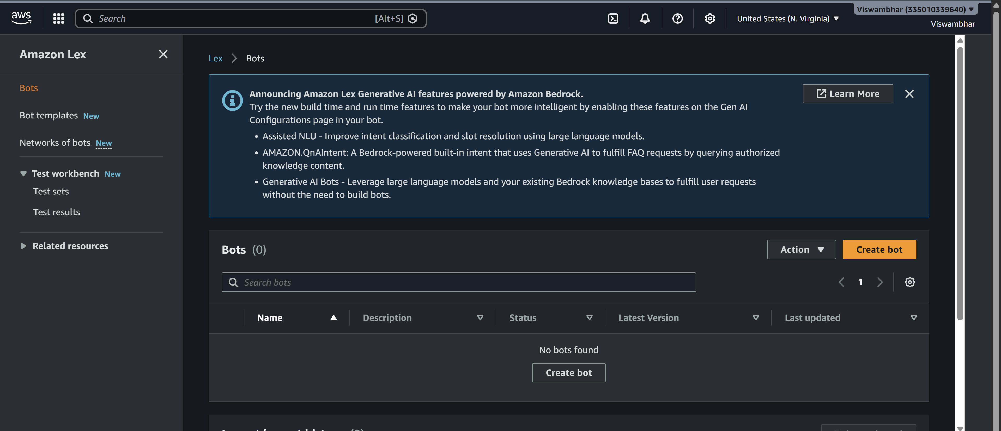
- Click Create bot
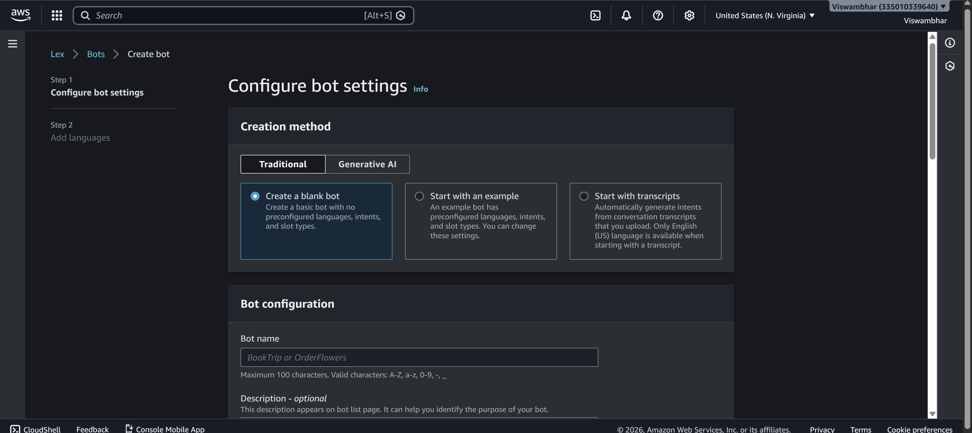

Step 2: Create Bot
- Choose:
  - Create a blank bot
- Enter:
  - Bot name: HotelBookingBot
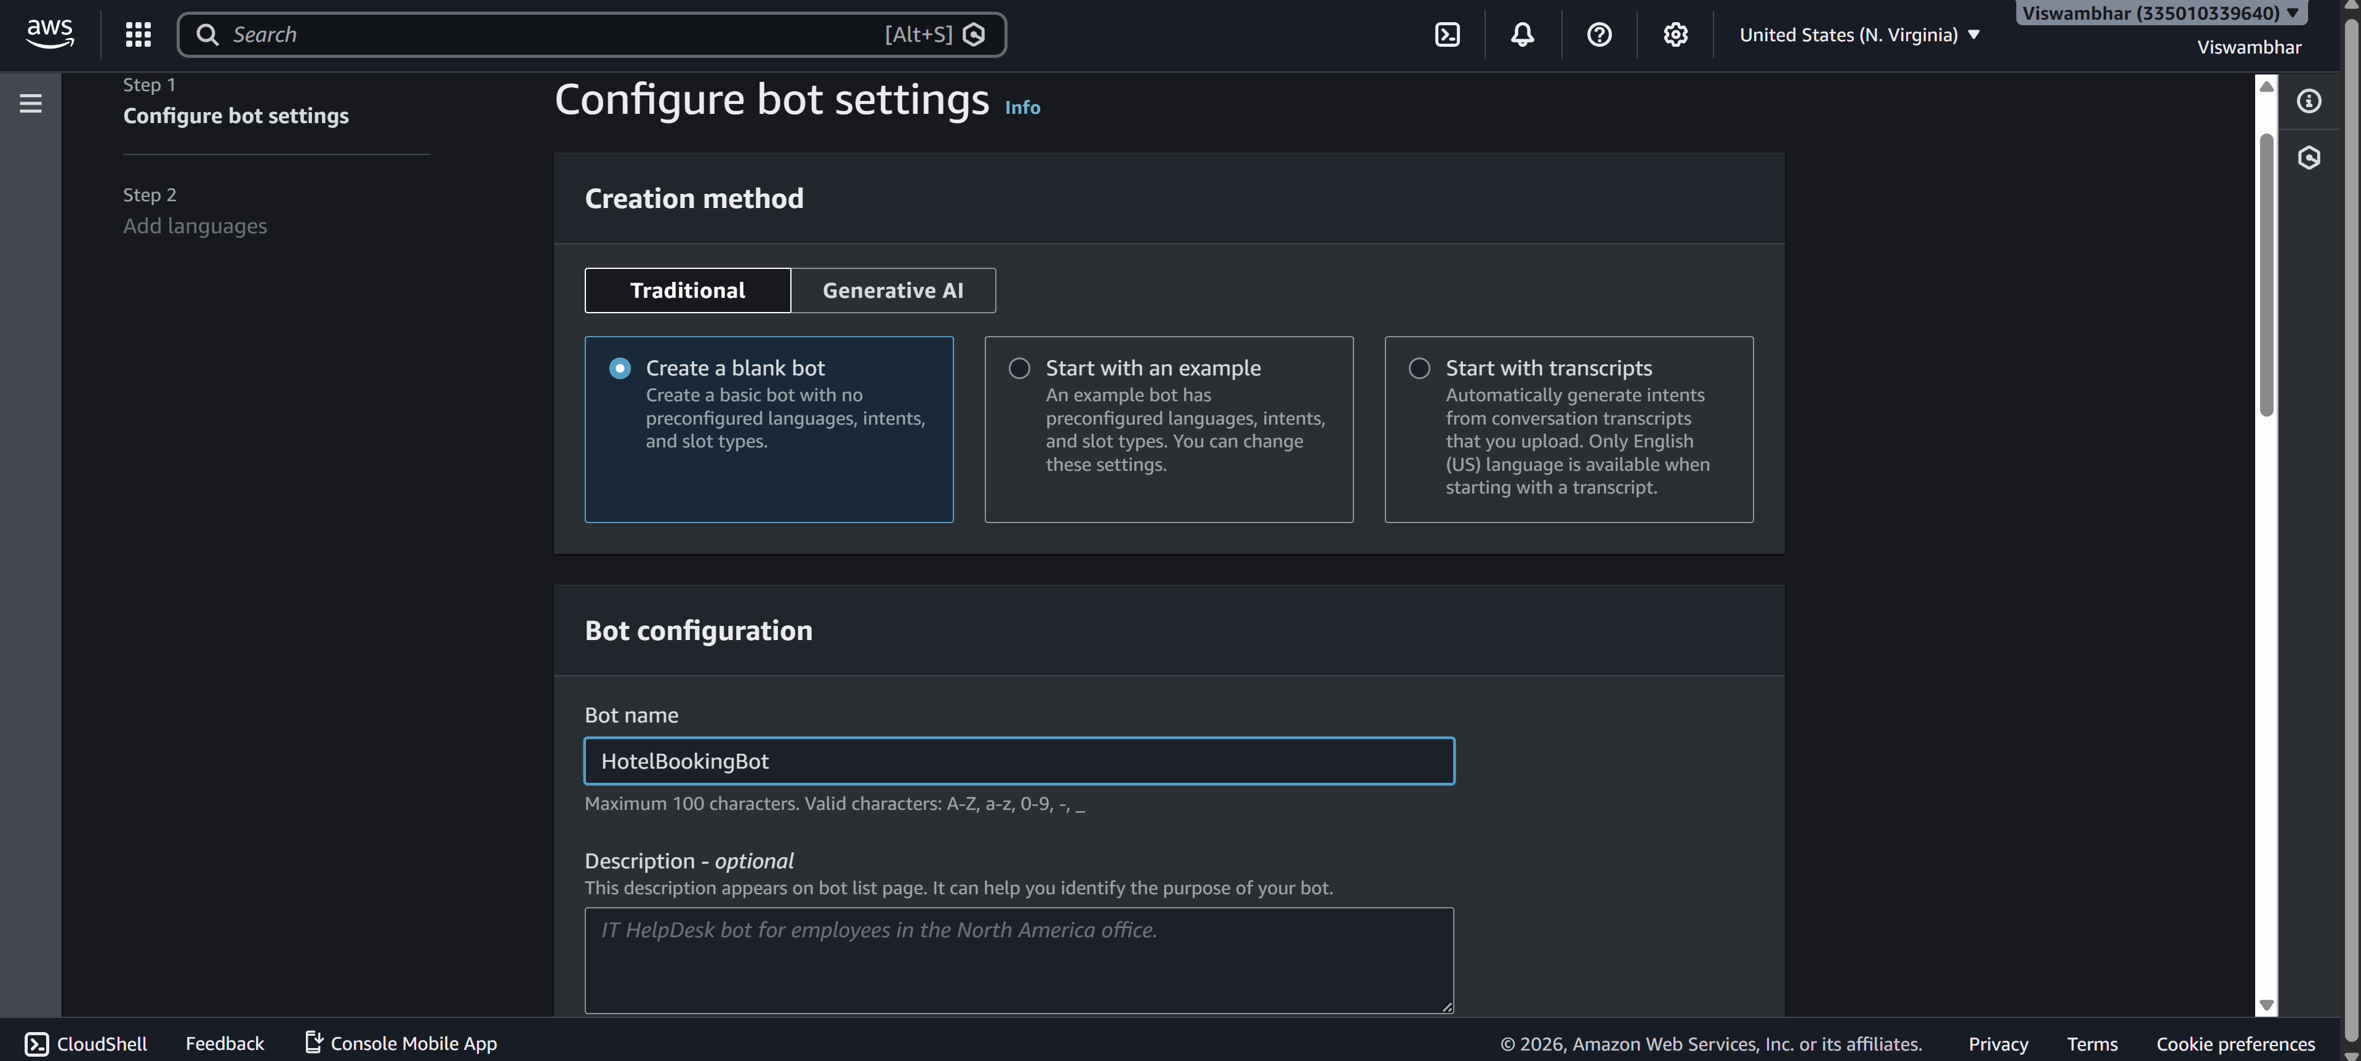
- IAM role → Create new role
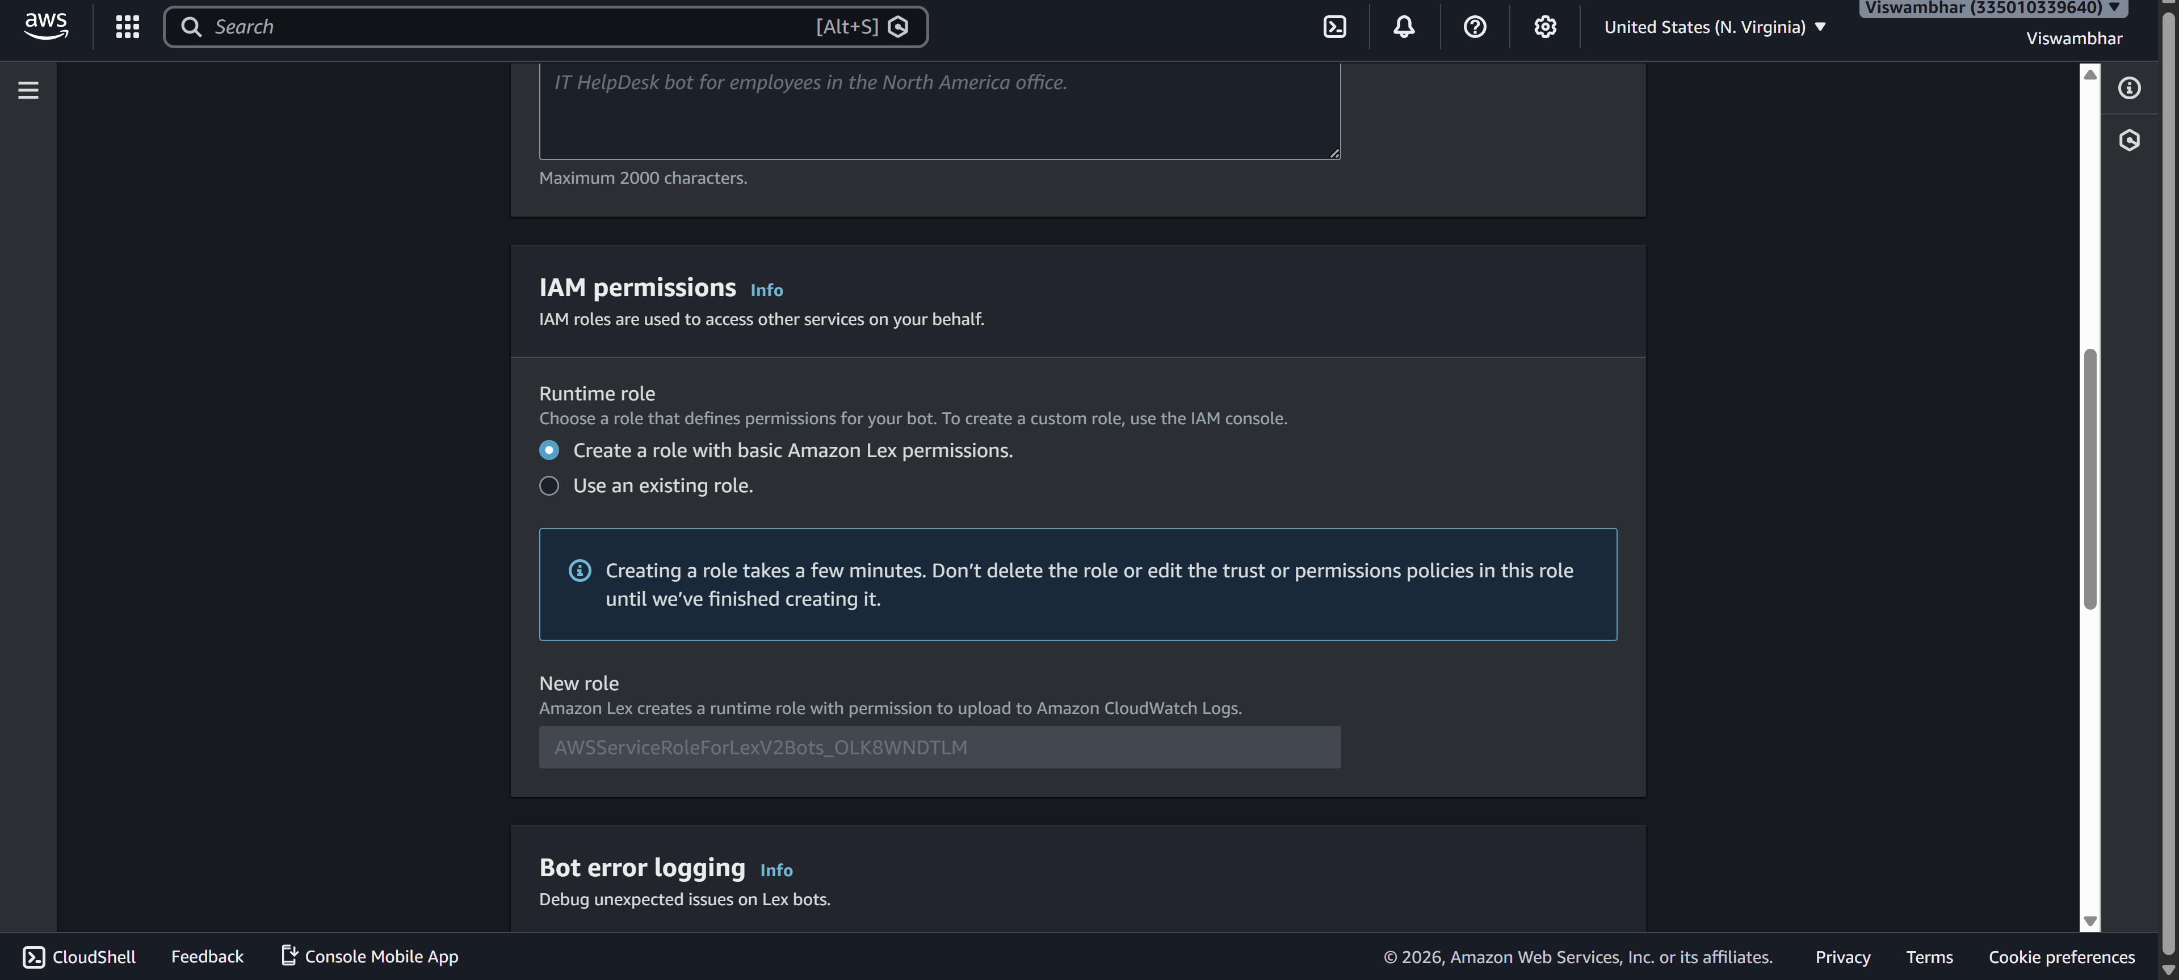
- Remaining defaultnext
- Language: English
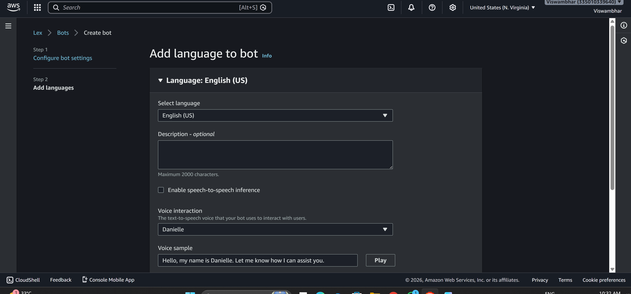
- Voice (optional)
- Click Done
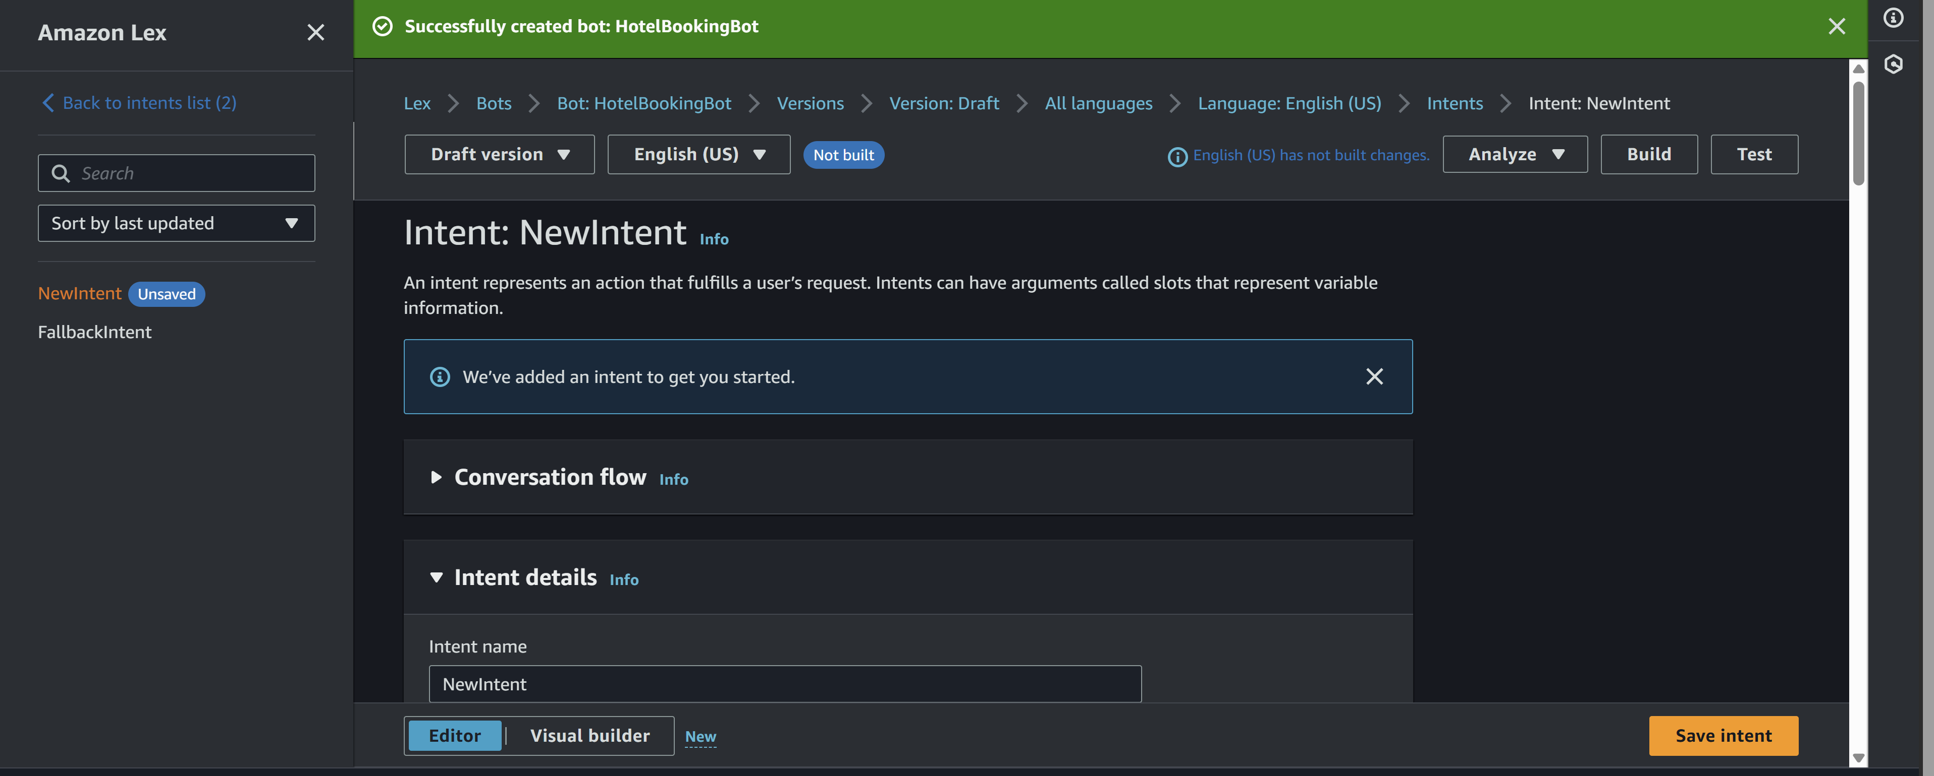

Step 3: Create Intent
- Go to Intents
- Name: BookHotel
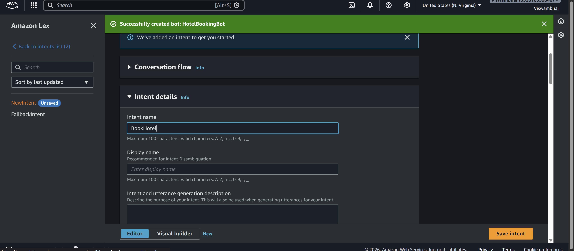
- Click Create

Step 4: Add Sample Utterances
Add user sentences (how user talks):
I want to book a hotel
Book a room
Reserve hotel
I need a room
These are Utterances
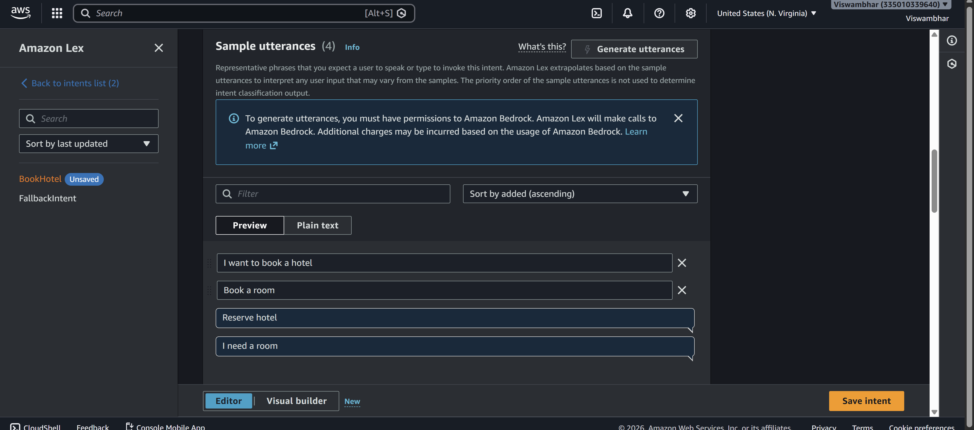

Step 5: Create Slots (User Inputs)
Slots collect user information.
Add Slot
- Click Add slot
- Fill:
  - Slot name: age
  - Slot type: AMAZON.Number
  - Prompt: Which city do you want?
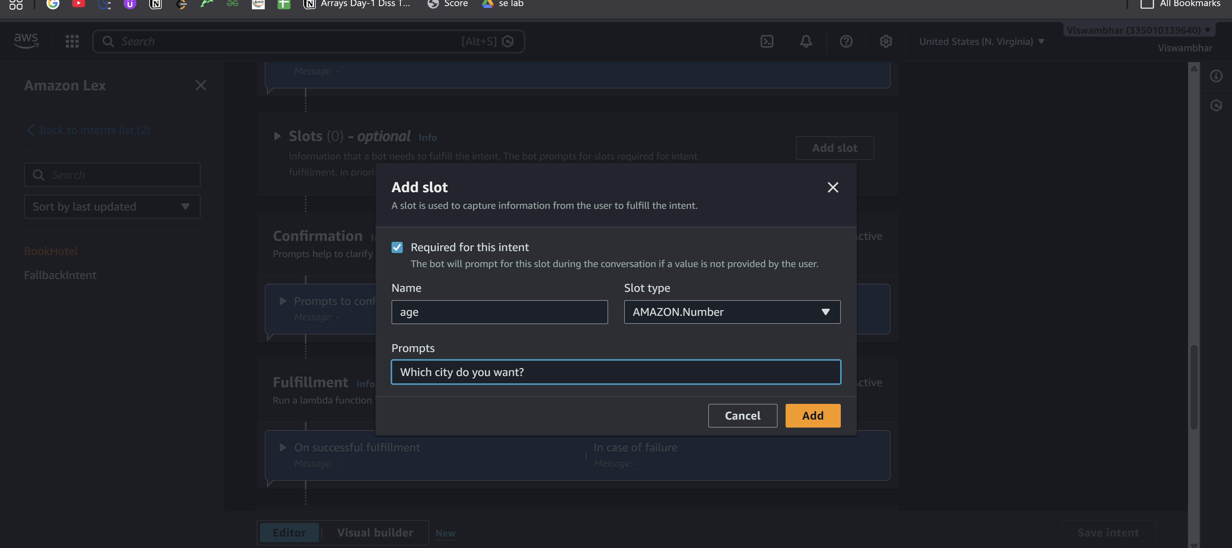
Mark as Required
Add IF Conditions (Conditional Logic)
Used to control flow based on slot values
Example Condition:
If {age} < 18
Steps:
- Go to Intent → Slots -> under Advance options
- Scroll to Slot capture: success response ->Conditional branching
- Click Add condition
Example:
Condition:
If {age} < 18
Response:
Your not eligible for hoot booking?
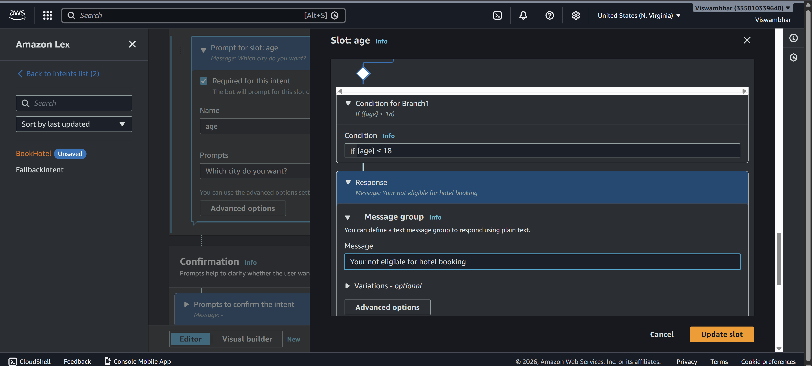

Step 6: Create Slots (User Inputs)
Slots collect user information.
Add Slot
- Click Add slot
- Fill:
  - Slot name: location
  - Slot type: AMAZON.City
  - Prompt: Which city do you want?
- Mark as Required
- 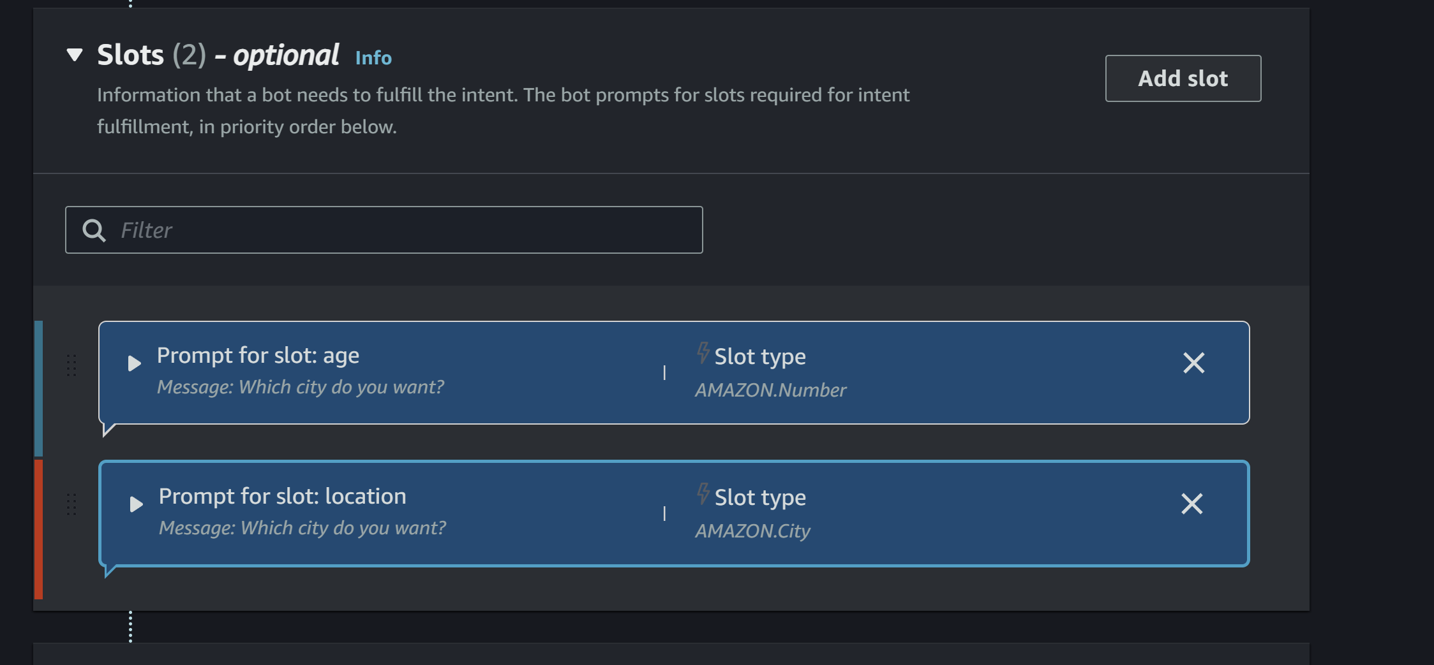

Repeat for other slots.
- Click Add slot
- Fill details:
  - Slot name: checkin
  - Slot type: AMAZON.Date
  - Prompt:
"What is your check-in date?"
- Mark as Required
(Optional but recommended)
  - Add Retry prompt:
"Please provide a valid date (e.g., 2026-03-25)"
- Click Save
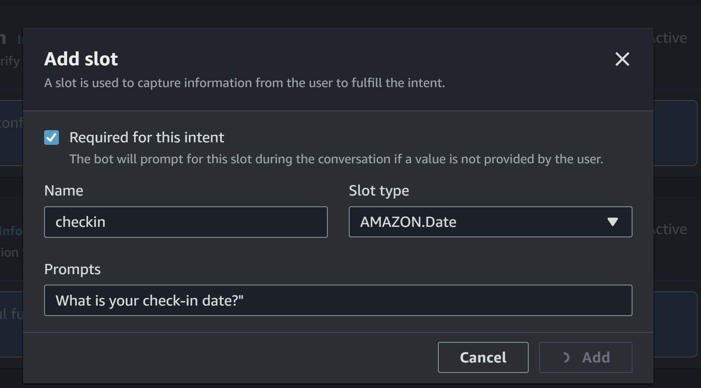

Slot 7: Number of Nights (nights)
Steps:
- Click Add slot again
- Fill details:
  - Slot name: nights
  - Slot type: AMAZON.Number
  - Prompt:
"How many nights will you stay?"
- Mark as Required
- Click Save
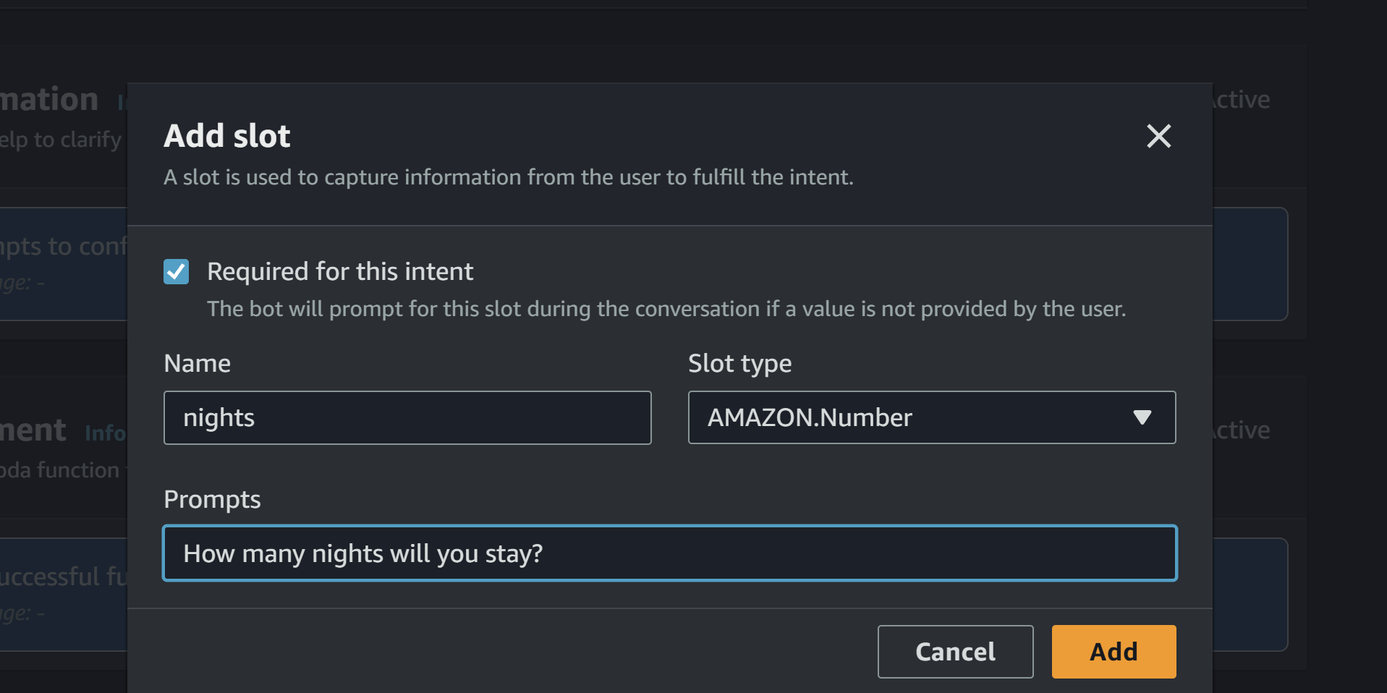

Step 7: Create Custom Slot Type

Save intent

Click on Back to intents
If you want custom values:
- Go to Slot Types
- Click Add slot type ->add blank slot type
- Name: RoomType
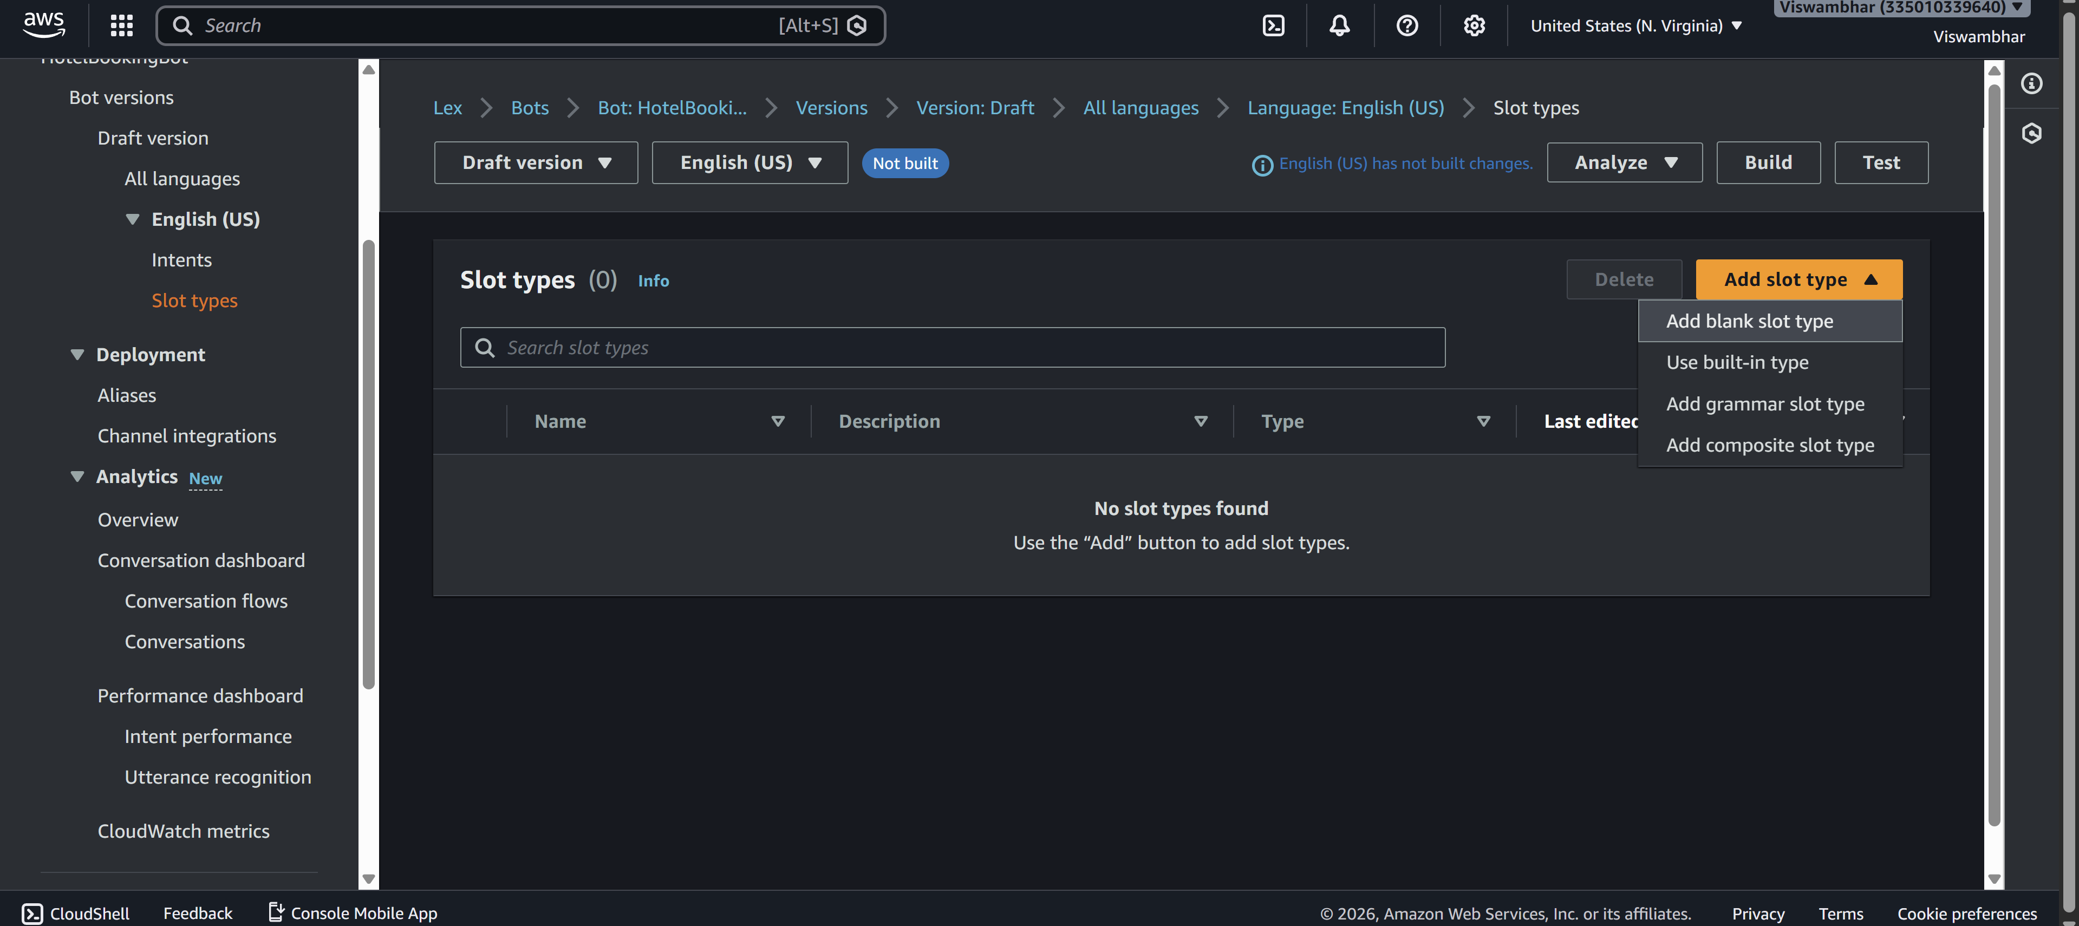
Add values:
Single
Double
Suite
Save slot type
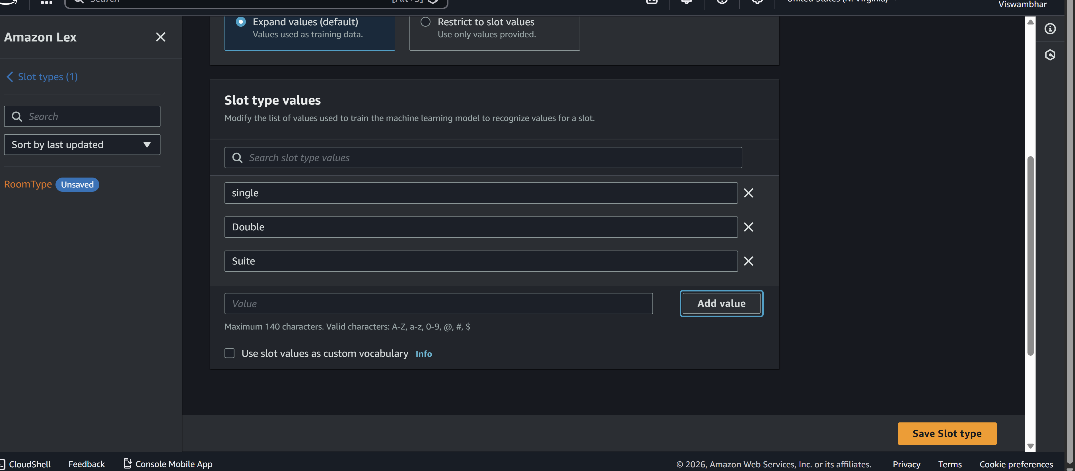
Now use this in slot: go back to intent
- Slot name: RoomType
- Slot type: RoomType
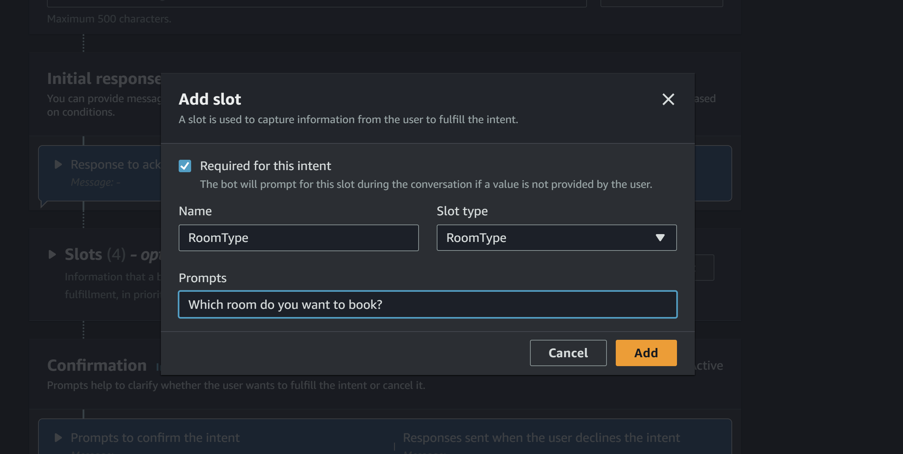

Step 9: Add Response Cards (Card Groups)
Used for buttons (quick replies)
Steps:
- Go to slot prompts -> more prompt options
- Click Add -> add card groups
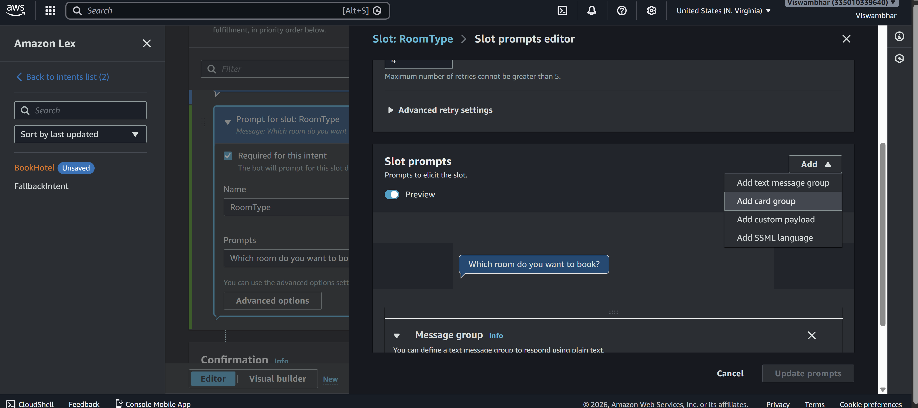
Example:
Card Title: Select Room Type
click on add Buttons:
- Single → "Single"
- Double → "Double"
- Suite → "Suite"
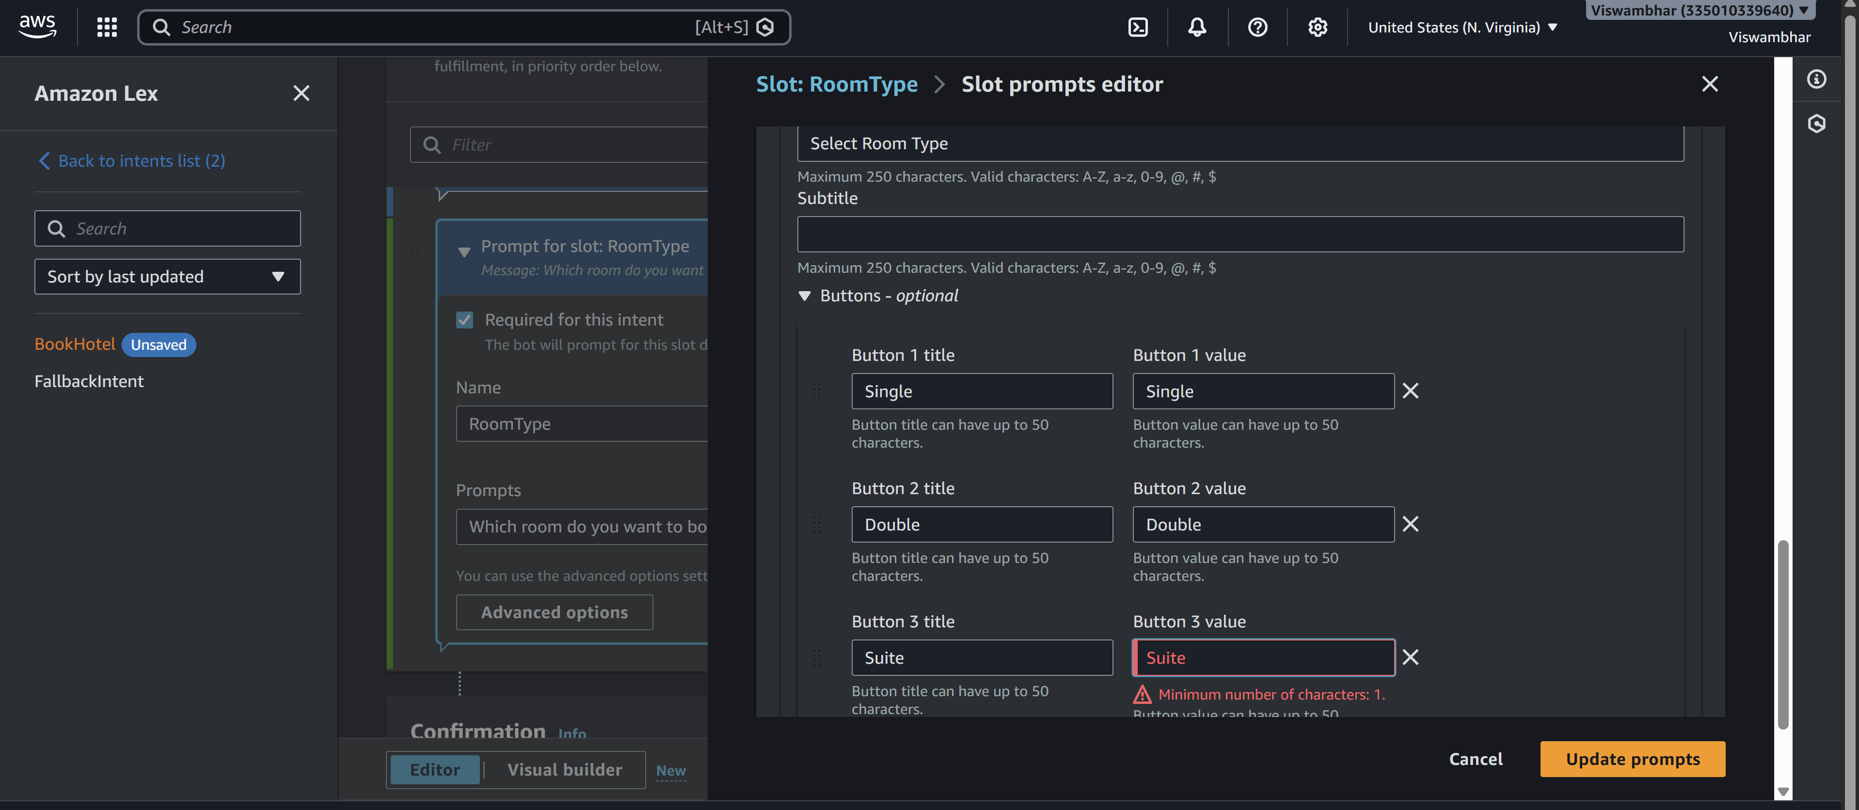

Step 10: Configure Responses
Initial Response:
Welcome to Hotel Booking! What is your name?
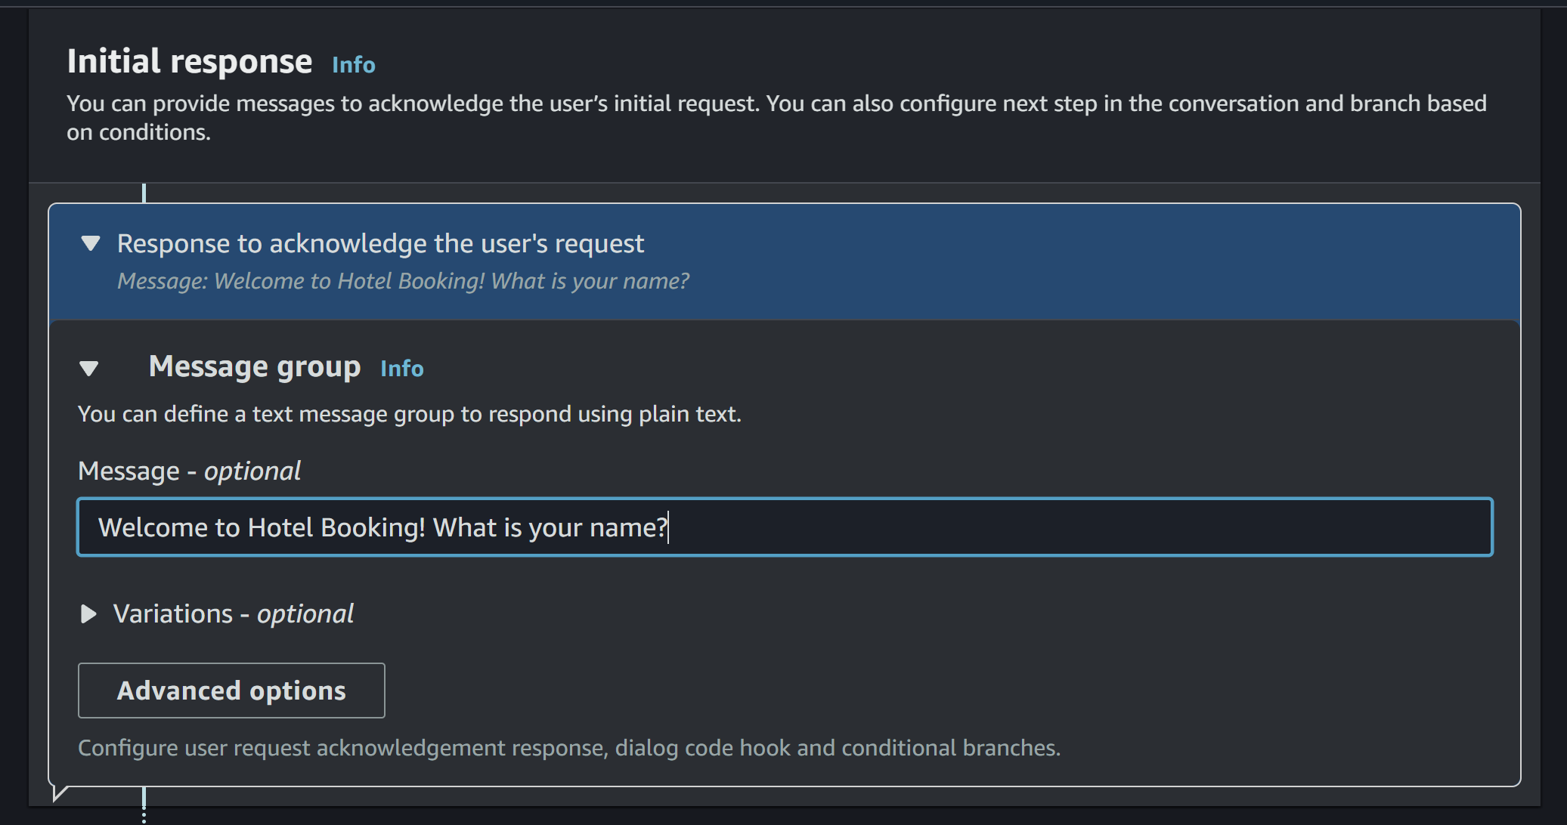
Confirmation:
Do you want to confirm booking in {location} for {nights} nights?
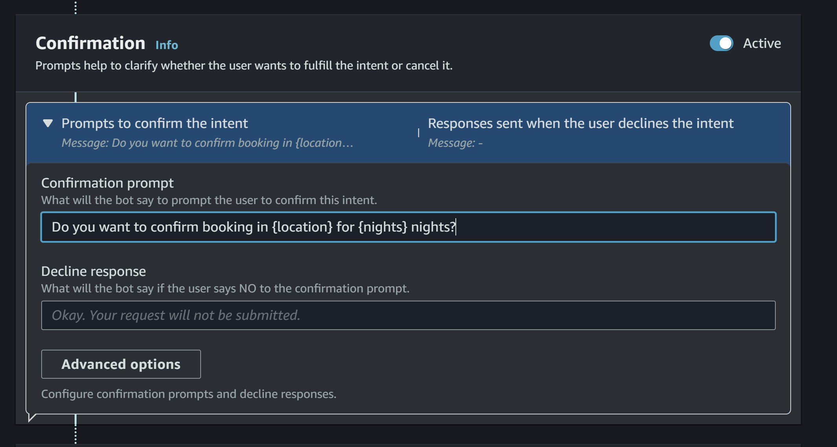

Step 11: Build & Test
- Click Build
- Use Test chatbot panel
- Try:
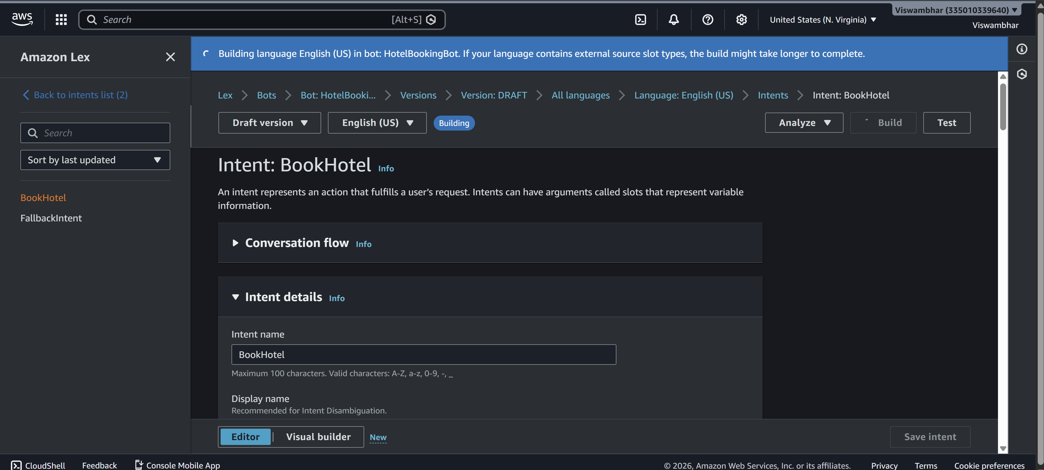
Book a hotel

Sample output
User: Book a hotel
Bot: What is your age?
User: 25
Bot: Which city do you want?
User: Hyderabad
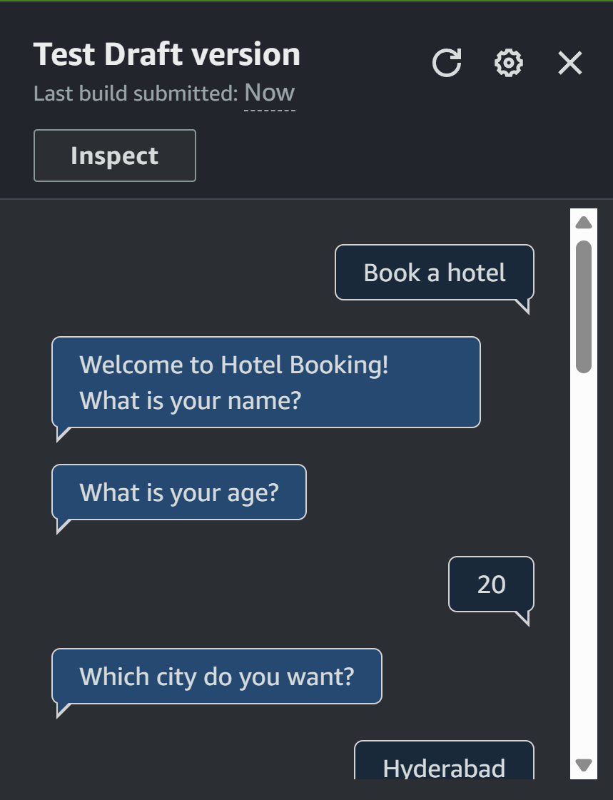
Bot: Check-in date?
User: Tomorrow
Bot: Number of nights?
User: 2
Bot: Select room type
User: Double
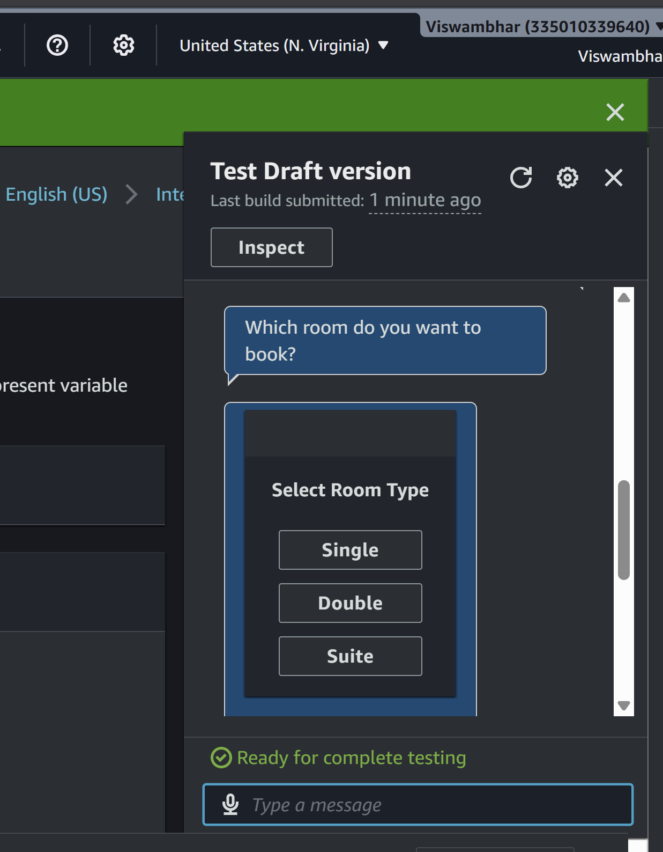
Bot: Do you want to confirm booking in Hyderabad for 2 nights?
User: Yes
Bot: Booking confirmed.
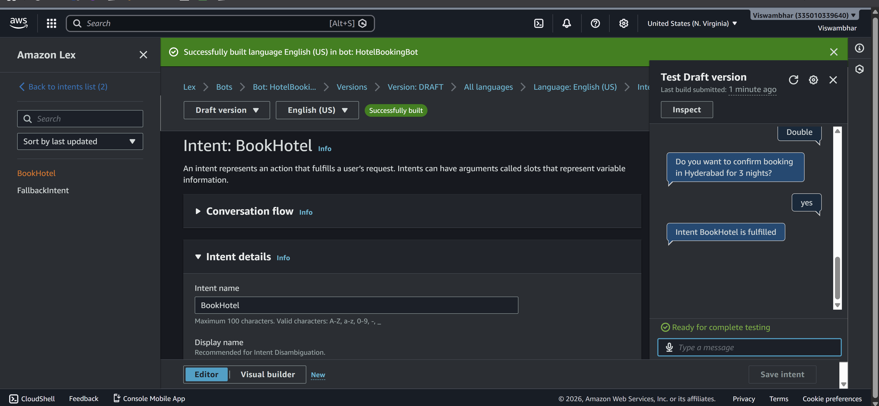

SCENARIO BASED QUESTIONS
Scenario 1: Bot Not Responding
You created a chatbot, but when you test it, the bot does not respond to user input.
• What could be the possible reason for no response?
- Bot not built
- No matching intent
- Wrong version/alias
- Errors in configuration
• Did you build and publish the bot correctly?
- Bot must be built after changes
- Must publish version and assign alias
• How would you troubleshoot this issue?
- Rebuild the bot
- Check intents and utterances
- Test with simple inputs
- Check logs

Scenario 2: Incorrect Intent Matching
A user types a valid query, but the chatbot responds with the wrong intent.
• What could cause incorrect intent recognition?
- Poor or insufficient utterances
- Similar intents causing confusion
• How do utterances affect intent matching?
- They train the model
- More variations improve accuracy
• How can you improve accuracy?
- Add diverse utterances
- Reduce overlap between intents

Scenario 3: Missing Slot Values
The chatbot asks for user input, but fails to capture required slot values.
• What is a slot in Amazon Lex?
- A variable used to capture user input (e.g., city, date)
• Why might slot values not be captured properly?
- Incorrect slot type
- Poor prompt design
- Invalid user input
• How would you fix slot configuration issues?
- Match slot type with prompt
- Add retry prompts
- Validate input

Scenario 4: Fulfillment Not Working
The bot collects all user inputs but does not perform the expected action.
• What is fulfillment in Amazon Lex?
- The process of executing actions after collecting inputs
• Could Lambda integration be misconfigured?
- Yes, wrong permissions or configuration
• How would you verify the backend processing?
- Check Lambda logs
- Test function separately

Scenario 5: Bot Not Accessible
You created the bot successfully, but users are unable to access it.
• Did you deploy or publish the bot?
- Bot must be published
• Could permissions or channel integration be missing?
- Yes, IAM roles or integration may be missing
• How would you make the bot accessible to users?
- Publish bot
- Set alias
- Integrate with application

Scenario 6: Wrong Language Understanding
The chatbot fails to understand user queries written in slightly different formats.
• How does Amazon Lex process natural language?
- Uses NLP and machine learning
• Why is training with multiple utterances important?
- Improves understanding of variations
• How can you improve NLP performance?
- Add more utterances
- Use synonyms and variations

Scenario 7: Versioning Issue
You updated the bot, but users still experience the old behavior.
• Did you create a new version of the bot?
- Changes require a new version
• Why is alias configuration important?
- Alias points to a specific version
• How do you ensure users access the latest version?
- Update alias to latest version

Scenario 8: Lambda Permission Error
The chatbot is connected to a Lambda function, but it fails during execution.
• What type of permission error might occur?
- Access denied error
• How are IAM roles used in this integration?
- Control permissions between services
• How would you fix the permission issue?
- Update IAM policies
- Allow Lex to invoke Lambda

Scenario 9: Bot Gives Default Response
The chatbot always gives a fallback/default response instead of proper answers.
• What is a fallback intent?
- Default intent when no match is found
• Why does the bot fail to match user input?
- Poor utterances
- Weak training
• How can you improve intent recognition?
- Add more utterances
- Improve intent design

Scenario 10: Multi-turn Conversation Issue
The chatbot fails to continue conversation properly after asking follow-up questions.
• What is dialog management in Amazon Lex?
- Managing conversation flow using slots
• How are slots used in multi-turn conversations?
- Collect user inputs step-by-step
• How can conversation flow be improved?
- Proper slot order
- Clear prompts

Scenario 11: Integration with Web Application
A company wants to integrate the chatbot into their website.
• How can Amazon Lex be integrated with web applications?
- Using APIs or AWS SDK
• What services or APIs are required?
- Lex API, API Gateway, Lambda
• What challenges might occur during integration?
- Authentication
- Latency
- UI handling

Scenario 12: Performance Issue
The chatbot responds slowly when many users interact simultaneously.
• What could cause performance delays?
- High traffic
- Slow backend
• How can scalability be handled in Amazon Lex?
- Use serverless scaling
• What AWS services can support high traffic handling?
- Lambda
- API Gateway
- CloudWatch

