**A REACT-NATIVE APPLICATION**

**FOR TIME TRACKING**

**By**

**Baldaniya Shubham Hareshbhai**

**A project submitted**

**In**

**partial fulfillment of the requirements**

**for the degree of**

**BACHELOR OF TECHNOLOGY**

**in**

**Computer Engineering**

**Internal Guide** **External Guide**

Prof. Prashant Jadav Labdhi Shah

Associate Professor Project Manager

Dept. of Comp. Engg. Bacancy Technology



**Faculty of Technology**

**Department of Computer Engineering**

**Dharmsinh Desai University**

**April 2022**

**Certificate**

This is to certify that the project work titled

**“Time Tracking App”**

is the bonafide work of

**Baldaniya Shubham Hareshbhai**

Carried out in the partial fulfillment of the degree of Bachelor of Technology in

Computer Engineering at Dharmsinh Desai University in the academic session

December 2021 to April 2022

Prof. Prashant Jadav Dr. C. K. Bhensdadia

Asst. Professor Head, Dept. Of Computer Engg. Dept. Of Computer Engg.



**Faculty of Technology**

**Department of Computer Engineering**

**Dharmsinh Desai University**

**April 2022**

**ACKNOWLEDGEMENT**

We would like to give our sincere acknowledgement to everybody responsible for the successful completion of our project “**Time Tracking App**”.

The success and final outcome of this project required a lot of guidance and assistance from many people and we are extremely privileged to have got this all along the completion of this project.

We owe our deepest gratitude to our project guide **Prof. Prashant Jadav**, who took interest on our project work and guided us all along till the completion of our project work by providing all the necessary help for developing a good Software Development Project.

We would also like to admiringly acknowledge **Dr. C. K. Bhensdadia** **(Head of Department)** for moral support which helped us to accomplish our goal.We would also like to thank all our lecturers.

Last but not the least we are also thankful to all friends & those who have contributed directly or indirectly by giving their suggestions or even a advice for the completion of this project.

With sincere regards,

**Baldaniya Shubham Hareshbhai.**

**COMPANY CERTIFICATE**

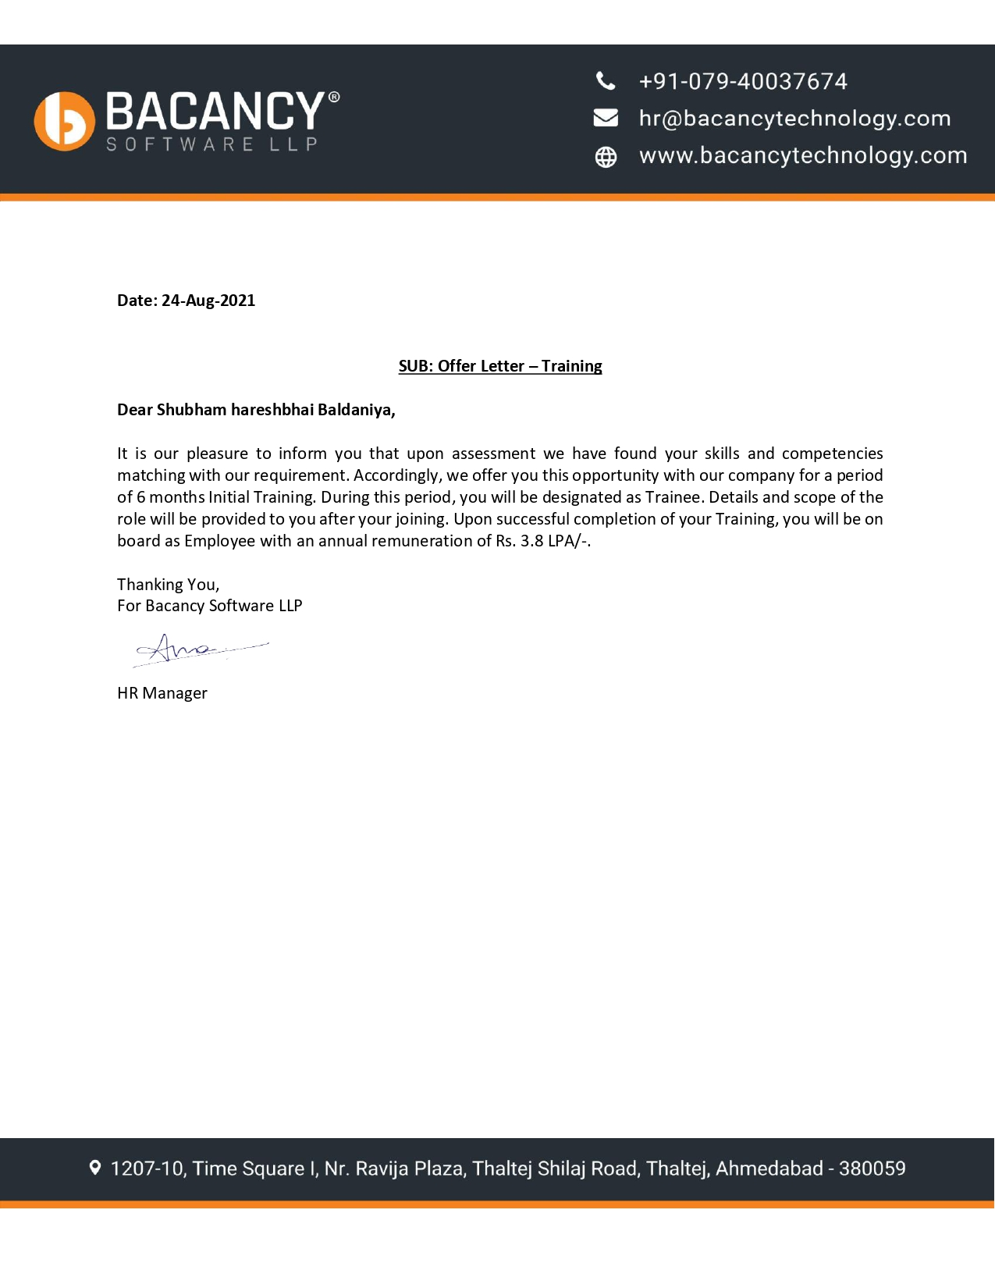

**LIST OF FIGURES** **7**

**1** **Introduction** **9**

1.1 Definition 9

1.2 Technology/Platform/Tools used 9

2 **About the system** **11**

2.1 What is React-Native? 11

2.2 Is it different than React? 11

2.3 What is cross-platform development? 11

2.4 What is Firebase? 12

3 **SYSTEM ANALYSIS** **13**

**3.1** User Requirements 13

3.2 System Requirements 13

3.3 Functional Requirement 13

3.4 Non-Functional Requirement 13

3.5 Software Requirement Specification (SRS) 14

**3.6** **System Design** **18**

**3.6.1** UseCase Diagram 18

3.6.2 Class Diagram 19

3.6..3 DataFlow Diagram 20

3.6..4 Activity Diagram 22

3.6..5 Sequence Diagram 23

3.6..6 E-R Diagram 25

5 **Implementation** **26**

**5.1** Overview 26

5.2 Program/Module Specification 26

6 **Test Case Design and Screenshots** **27**

**6.1** Testing Plan: 27

6.2 Testing Strategy: 27

7 **ScreenShots** **28**

**8** **Conclusion and Future Extensions** **42**

**8.1** Conclusion & Future Extension 42

9 **Bibliography** **43**

# ABSTRACT

Time Tracking App (TTA) for clients is accepted to be tracked down supportive under one of numerous standards Personal and Professional Life Balance. It is pivotal that the framework be created in accordance with clients' individual and expert targets. TTA execution is an interior application produced for proficient working of a hierarchical individual used to screen every one of the errands and feeds of a specific association chipping away at different ventures as well as the individual invested of energy. In this execution timesheet may record the beginning and end season of every client undertakings. The timesheet contains a definite breakdown of errands achieved all through the undertaking. This data might be utilized for CheckIn and CheckOut of client time on a specific undertaking, oversee action, errands relegated to clients, following the update status of each alloted venture and refreshing the note and the executives of each assignments, dividing takes care of among partners. The time following application execution requires advancement of the accompanying assignments: Create errands with clocks beginning and halting with client comfort, chat screen UI permitting the client to connect with different clients, update and alter profile subtleties including the profile picture.

# LIST OF FIGURES

| **Fig No.** | **Discription** | **Page No.** |
| --- | --- | --- |
| Fig 2.1 | React naive | 11 |
| Fig 2.2 | Firebase | 12 |
| Fig 3.4.1 | Use Case Diagram | 18 |
| Fig 3.4.2 | Class Diagram | 19 |
| Fig 3.4.3.1 | Data flow diagram(lvl - 0) | 20 |
| Fig 3.4.3.2 | Data flow diagram(lvl - 0) | 21 |
| Fig 3.4.4. | Activity Diagram | 22 |
| Fig 3.4.5.1 | Sequence Diagram-1 | 23 |
| Fig 3.4.5.2 | Sequence Diagram-1 | 24 |
| Fig 3.4.6 | E-R Diagram | 25 |
| Fig. 6.1 | Login screen | 28 |
| Fig. 6.2 | Signup screen | 29 |
| Fig. 6.3 | HomeScreen | 30 |
| Fig. 6.4 | AddTask Screen | 31 |
| Fig. 6.5 | SelectUser Screen | 32 |
| Fig. 6.6 | Send Message Screen | 33 |
| Fig. 6.7 | Message sent Screen | 34 |
| Fig. 6.8 | UserProfile Screen | 35 |
| Fig. 6.9 | Image added Screen | 36 |
| Fig. 6.10 | AddImage Screen | 37 |
| Fig. 6.11 | update profile details Screen | 38 |
| Fig. 6.12 | Updated profile details Screen | 39 |
| Fig. 6.13 | Reset password message Screen | 40 |
| Fig. 6.14 | Reset password Screen | 41 |
| Fig. 6.15 |  | 42 |

# Introduction

## Definition

A time tracking platform for recording the events of the day, accumulating time in feeds and then sharing those feeds with others. The work week can be meticulously categorized, organized and quantified. Important life events, seasons and phases can be assigned moments in time.

## Technology/Platform/Tools used

* + 1. Front End
* React @17.0.2
* React-Native @0.67.4
* React-natice-vector-icons @^9.1.0
  + 1. Back End
* FireBase
* FireStore [storage]
  + 1. Tools
* IDE: Visual Studio Code
* Version Control: GitHub
* Runtime Environments: Android Studio/ Xcode
* Simulator: iOS Simulator [iPhone 13 Pro with iOS 15.2]
* Emulator: Android Emulator [Google Pixel 3a SDK30 and Android 11]
  + 1. Software and hardware requirements(Development)
* React-Native
* Node
* iOS and Android Simulators/ Real Devices
* Android SDK or Xcode support engine (iOS)
* Expo/ Native CLI
  + 1. Hardware Requirements (minimum)
* CPU: Intel i5/i7/i9 6th Gen or higher
* Memory: 8GB 2400MHz
* GPU: Dedicated (preferable)/ Integrated

# About the system

### What is React-Native?



**Fig. 2.1**

React Native (also known as RN) is a popular JavaScript-based mobile app framework that allows you to build natively-rendered [mobile apps for iOS and Android](https://www.netguru.com/services/react-native). The framework lets you create an application for various platforms by using [the same codebase](https://www.netguru.com/blog/react-native-faq).

### Is it different than React?

In the most simple terms, React Native isn’t a ‘newer’ version of React, although React Native *does* use it.

Both React and React Native use a mixture of JavaScript and a special markup language, JSX. However, the syntax used to render elements in JSX components differs between React and React Native. Additionally, React uses some HTML and CSS, whereas React Native allows the use of native mobile user interface elements.

### What is cross-platform development?

Cross-platform development is the practice of building software that is compatible with more than one type of hardware platform. A cross-platform application can run on Microsoft Windows, Linux, and macOS, or just two of them. A good example of a cross-platform application is a web browser or Adobe Flash that performs the same, irrespective of the computer or mobile device you run it on.so as for reAct-native it can build application for android and ios.

### What is Firebase?



**Fig. 2.2**

React Native Firebase is a collection of official React Native modules connecting you to Firebase services; each module is a light-weight JavaScript layer connecting you to the native Firebase SDKs for both iOS and Android.For this app this is used as database for live data manipulation while App is being used.

# SYSTEM ANALYSIS

## User Requirements

User requirements include minor details, but most importantly users must be aware that the system works properly with full availability, reliability, security and safety. The user responsibility is as follows: Users should know how to use the application and should adhere to the guidelines and prescribed standards.

## System Requirements

### Functional Requirement

* Authenticate users using their own credentials
* Allow users to SignIn/SignUp using their preferred mode of Social Authentication
* Password should be store hashed.

### Non-Functional Requirement

* **Usability** the UI of the TTA should be user friendly so that users can navigate easily through the website.
* **Accuracy** As we were developing the application, we must make the system that is fully accurate in its functions. All the data should keep working properly, keep getting perfect input, process accurately and produce the perfect output. Accuracy is the most important nonfunctional characteristic or requirement of the system.
* **Reliability** Error handling mechanism must be robust to avoid failure of operation and in case of failure the website reports it to the user without any due harm.
* **Performance and Automation** Application should work fast but here in this case automation is more important than performance. Once the application starts, the user application should complete all tasks without errors and give final visualization of TTA.

## Software Requirement Specification (SRS)

**R1 - SignUp**

Description: User can register with Email,Google,Facebook and Apple id.

Input:Register credentials such as email id,password,full name,phone number.

Output: redirect to home screen.

**R2 - SignIn**

Description: User can login with Email,Google,Facebook and Apple id.

Condition: User must be registered before.

Input:Login credentials such as email id,password..

Output: Redirect to home screen.

**R3 - Add profile details**

Description: User can add profile details such as phone number.

Input:User details like name and phone number

Output: User details will be added.

**R4 - Update profile details**

Description: User can update profile details such as phone number.

Input:User details that user want to be updated as name and phone number.

Output: User details will be updated.

**R5 - Add profile picture**

Description: User can add profile picture though camera or from local storage of phone.

Input: Profile picture in form of image.

Output: Profile picture will be added.

**R6 - Update profile picture**

Description: User can update profile picture though camera or from local storage.

Input: Profile picture in form of image.

Output: Profile picture will be updated.

**R7 - Create Task**

Description: User can create task by clicking on a plus (+) sign button and by providing task name and description to that.

Input: Profile picture in form of image.

Output: Profile picture will be updated.

**R8 - Start Task**

Description: User can start task by clicking on start button and timer will be start for that task.

Input: click on start button.

Output: Timer for that task will be started.

**R9 - Stop Task**

Description: User can stop task by clicking on start button and timer will be start for that task.

Input: click on stop button.

Output: Timer for that task will be stopped.

**R10 - Filter Task**

Description: Tasks can be filtered based on tags,so user can use this feature to filter-out all the tasks based on the tags that are used.

Input: Tag for filter and click on filter button.

Output: Tasks that are belong to that tags will be displayed.

**R11 - Send message**

Description: User can message the user that is registered in the app.

Input: Message

Output:Message will be sent to user

**R12 - Forget password**

Description: before login if user wants to recover password then user can click on forget password button and get the link on provided email and can set new password

Input: click on forget password and email address.

Output:link to change password

**R13 - Reset password**

Description: After login if user wants to change/reset password then by reset option user can get link for reset/change password

Input: click on reset password buton.

Output:link to reset/change password

**R14 - Logout**

Description: By using logout option user can log out from app.

Input: click on logout buton.

Output:User will be logged out from app.

# 3.4 System Design

## UseCase Diagram

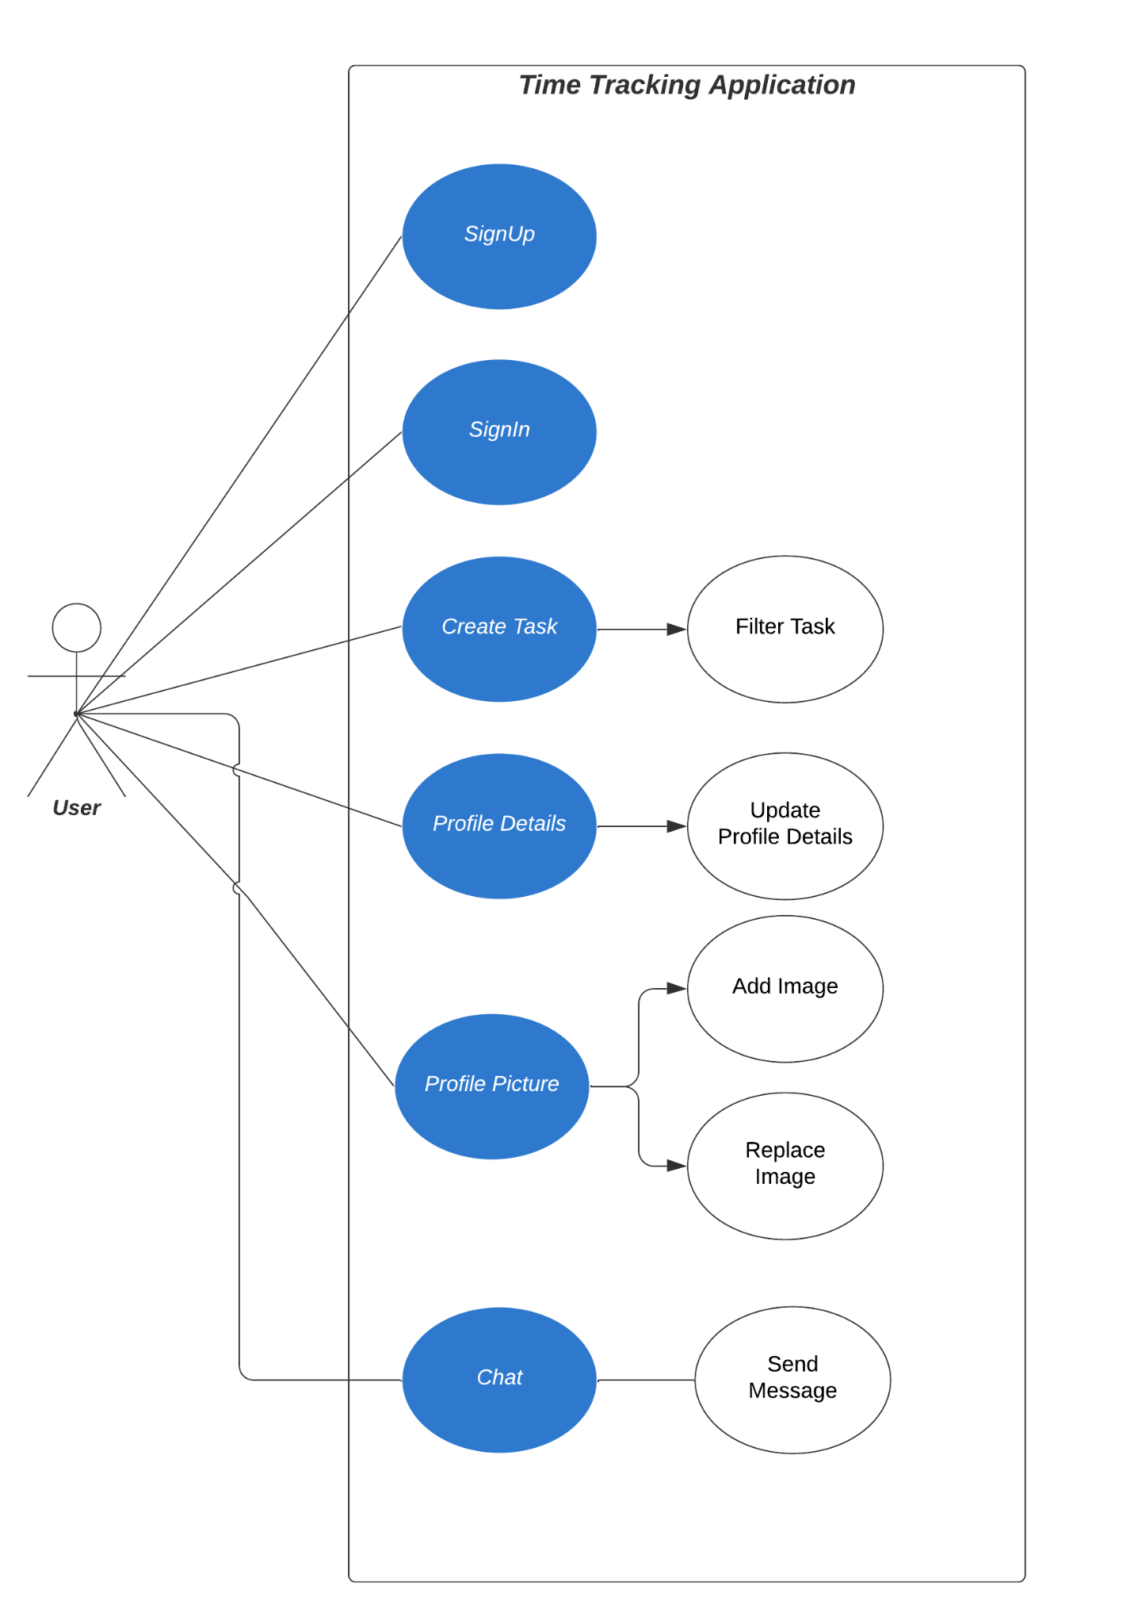

**FIg. 3.4.1**

## Class Diagram

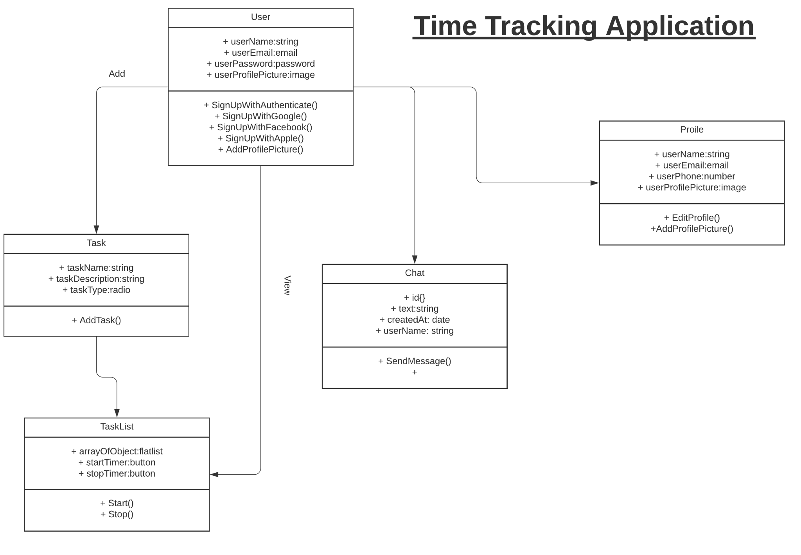

**FIg. 3.4.2**

## DataFlow Diagram

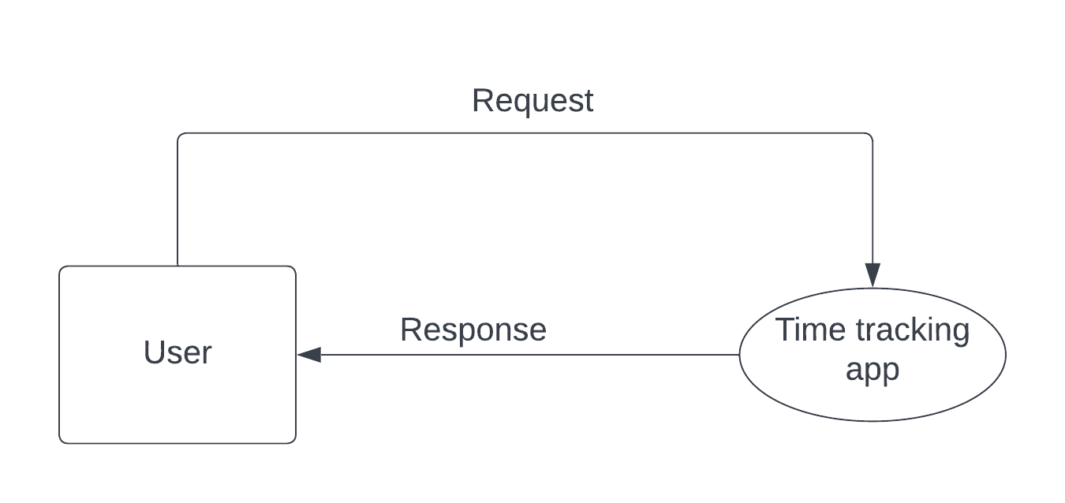

**FIg. 3.4.3.1**

Level - 0

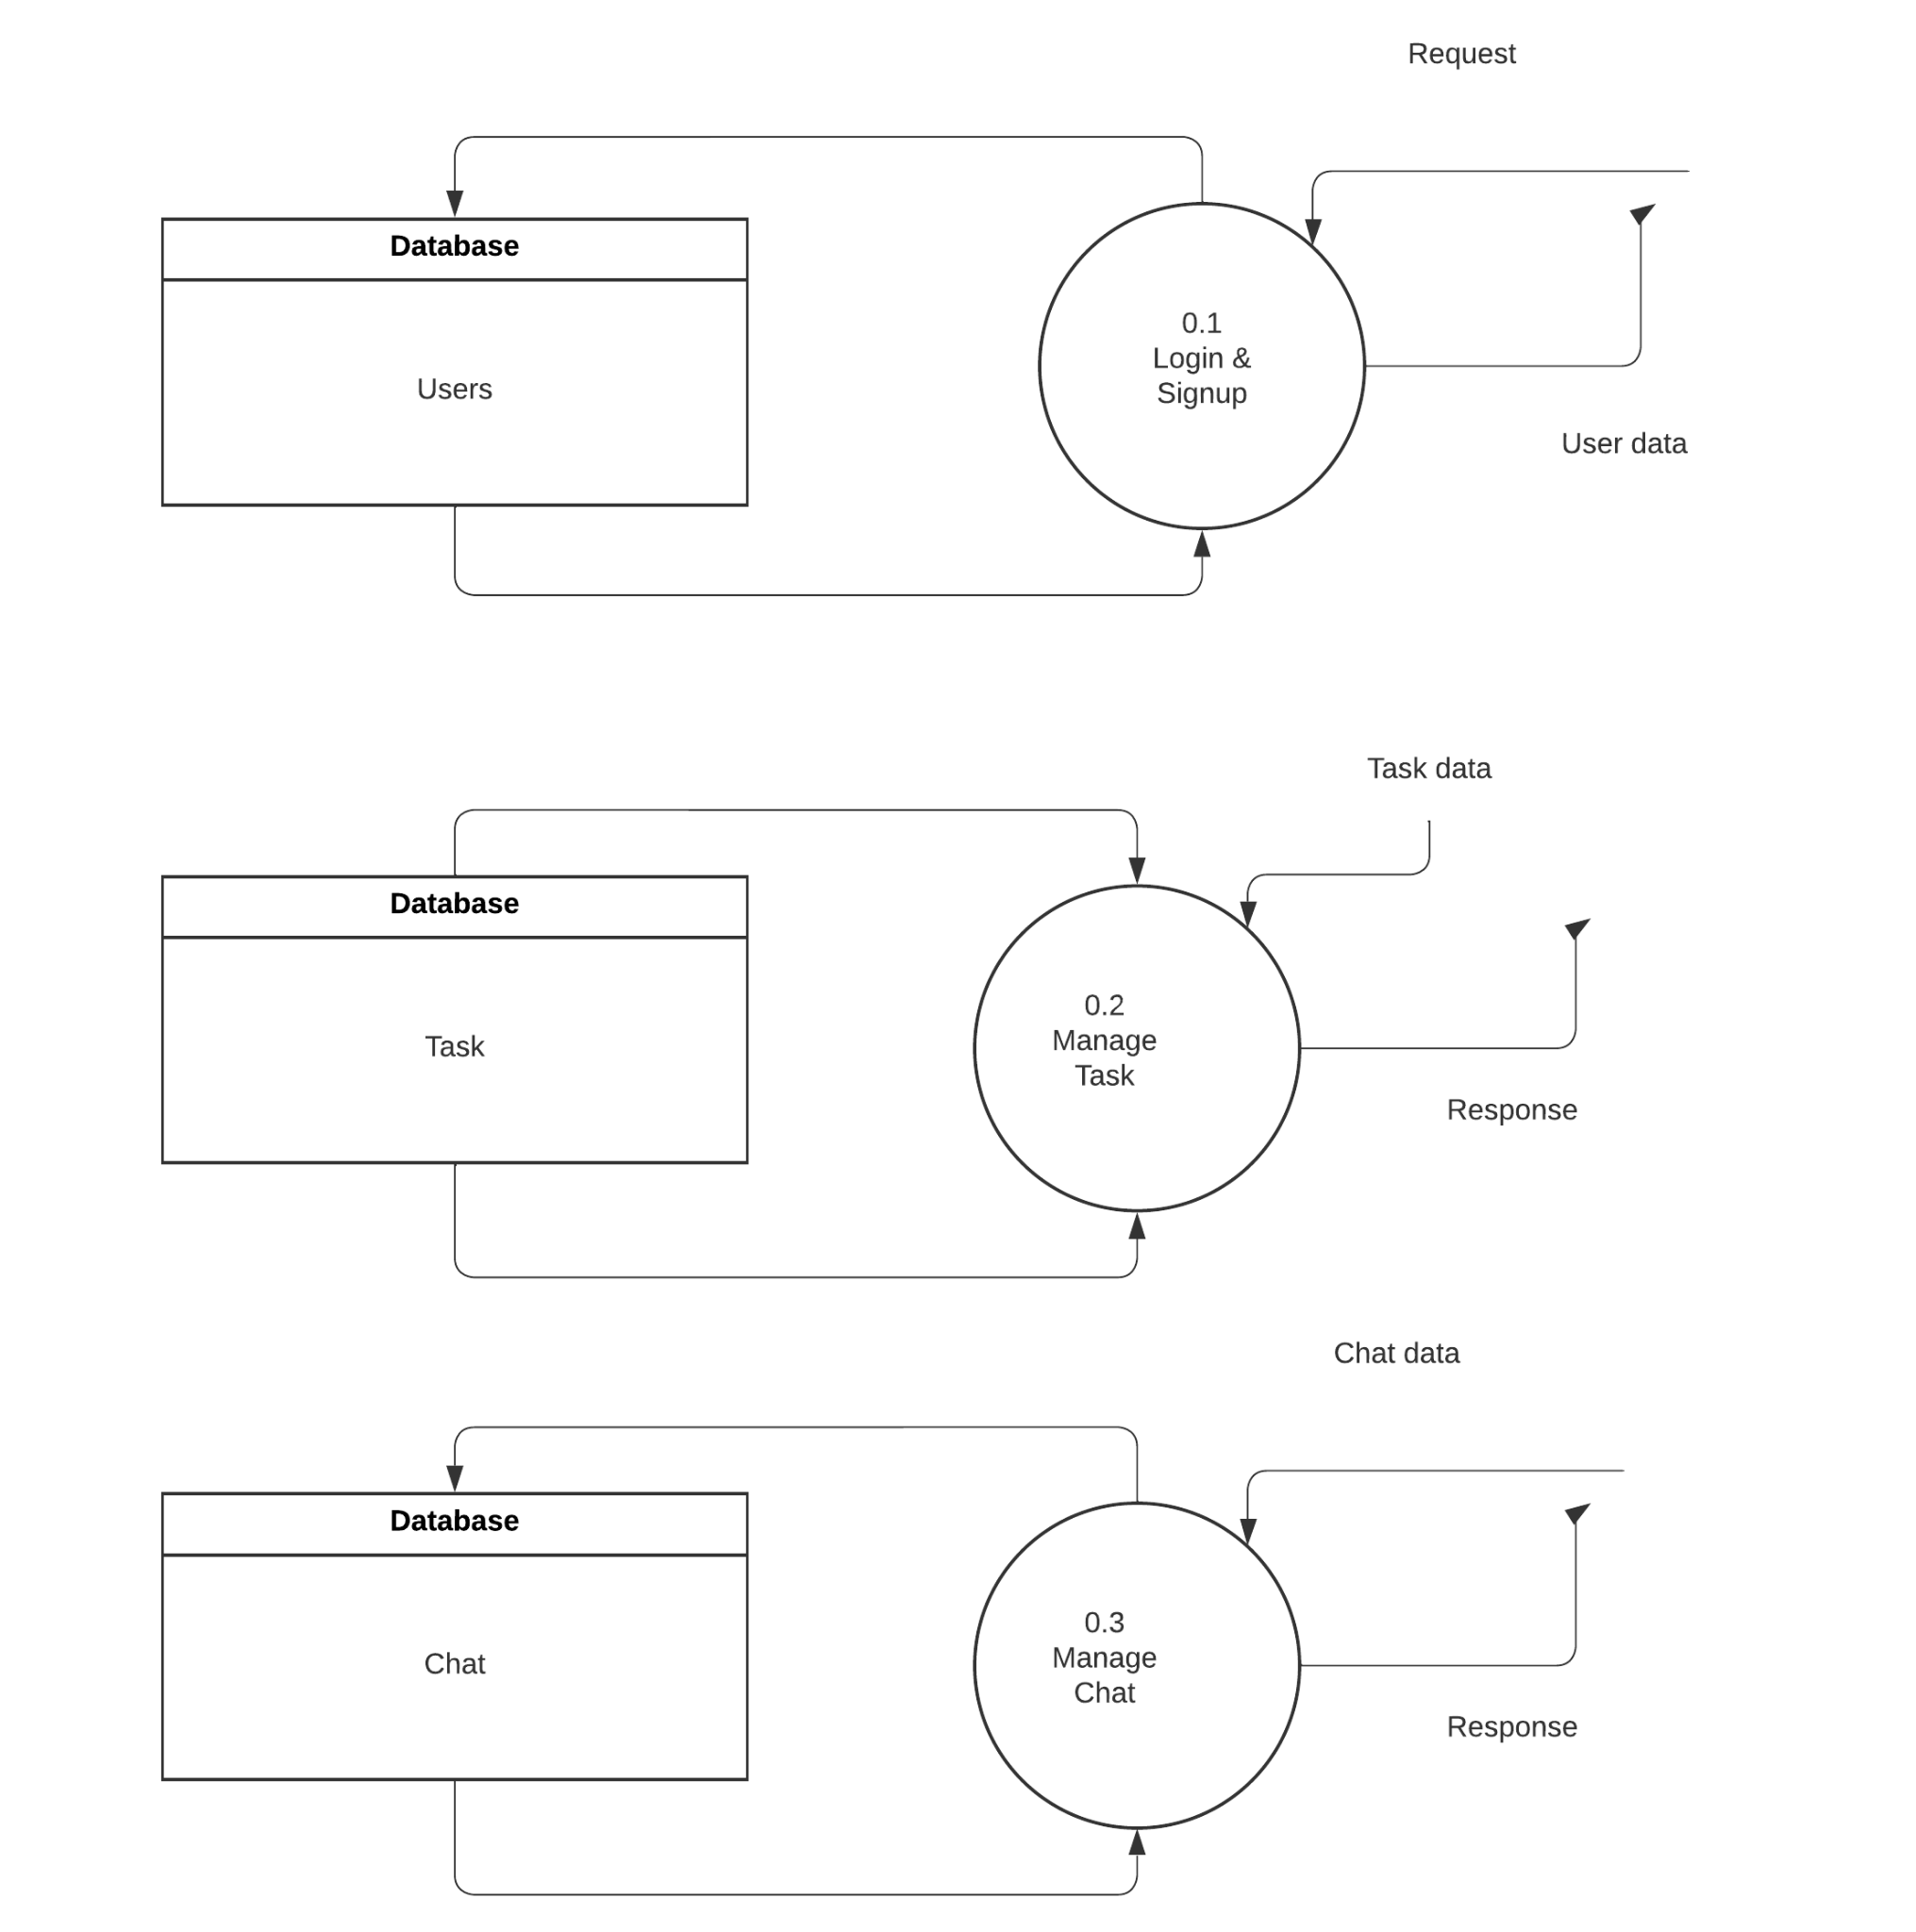

**Fig. 3.4.3.2**

Level - 1

## Activity Diagram

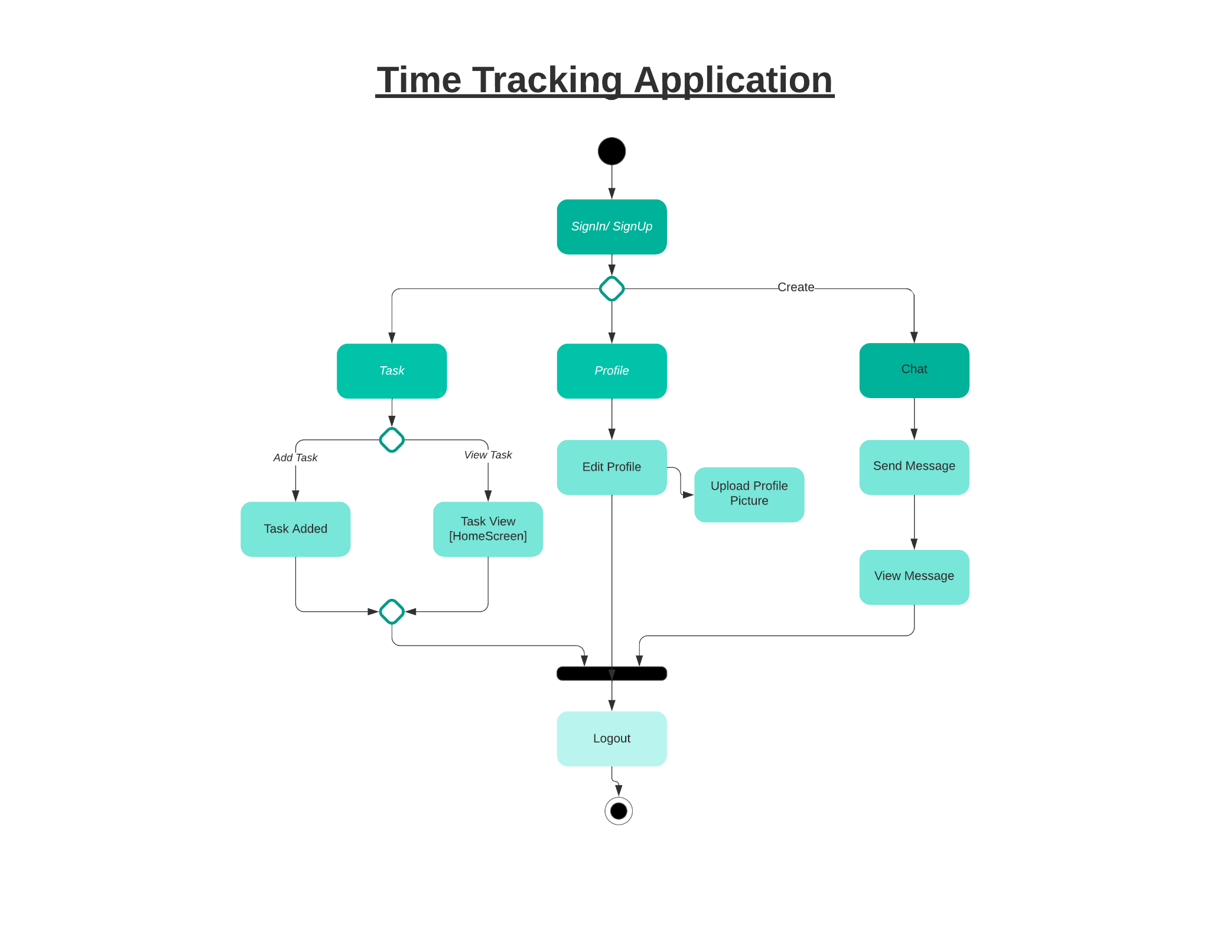

**Fig. 3.4.4**

## Sequence Diagram

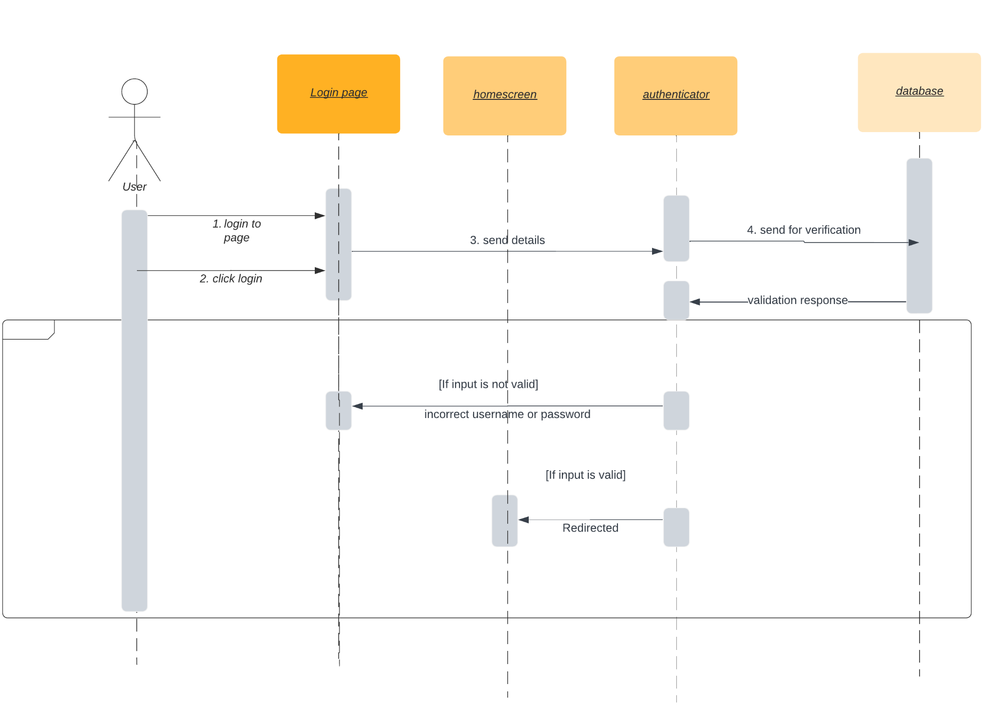

**FIg. 3.4.5.1**

**For User**

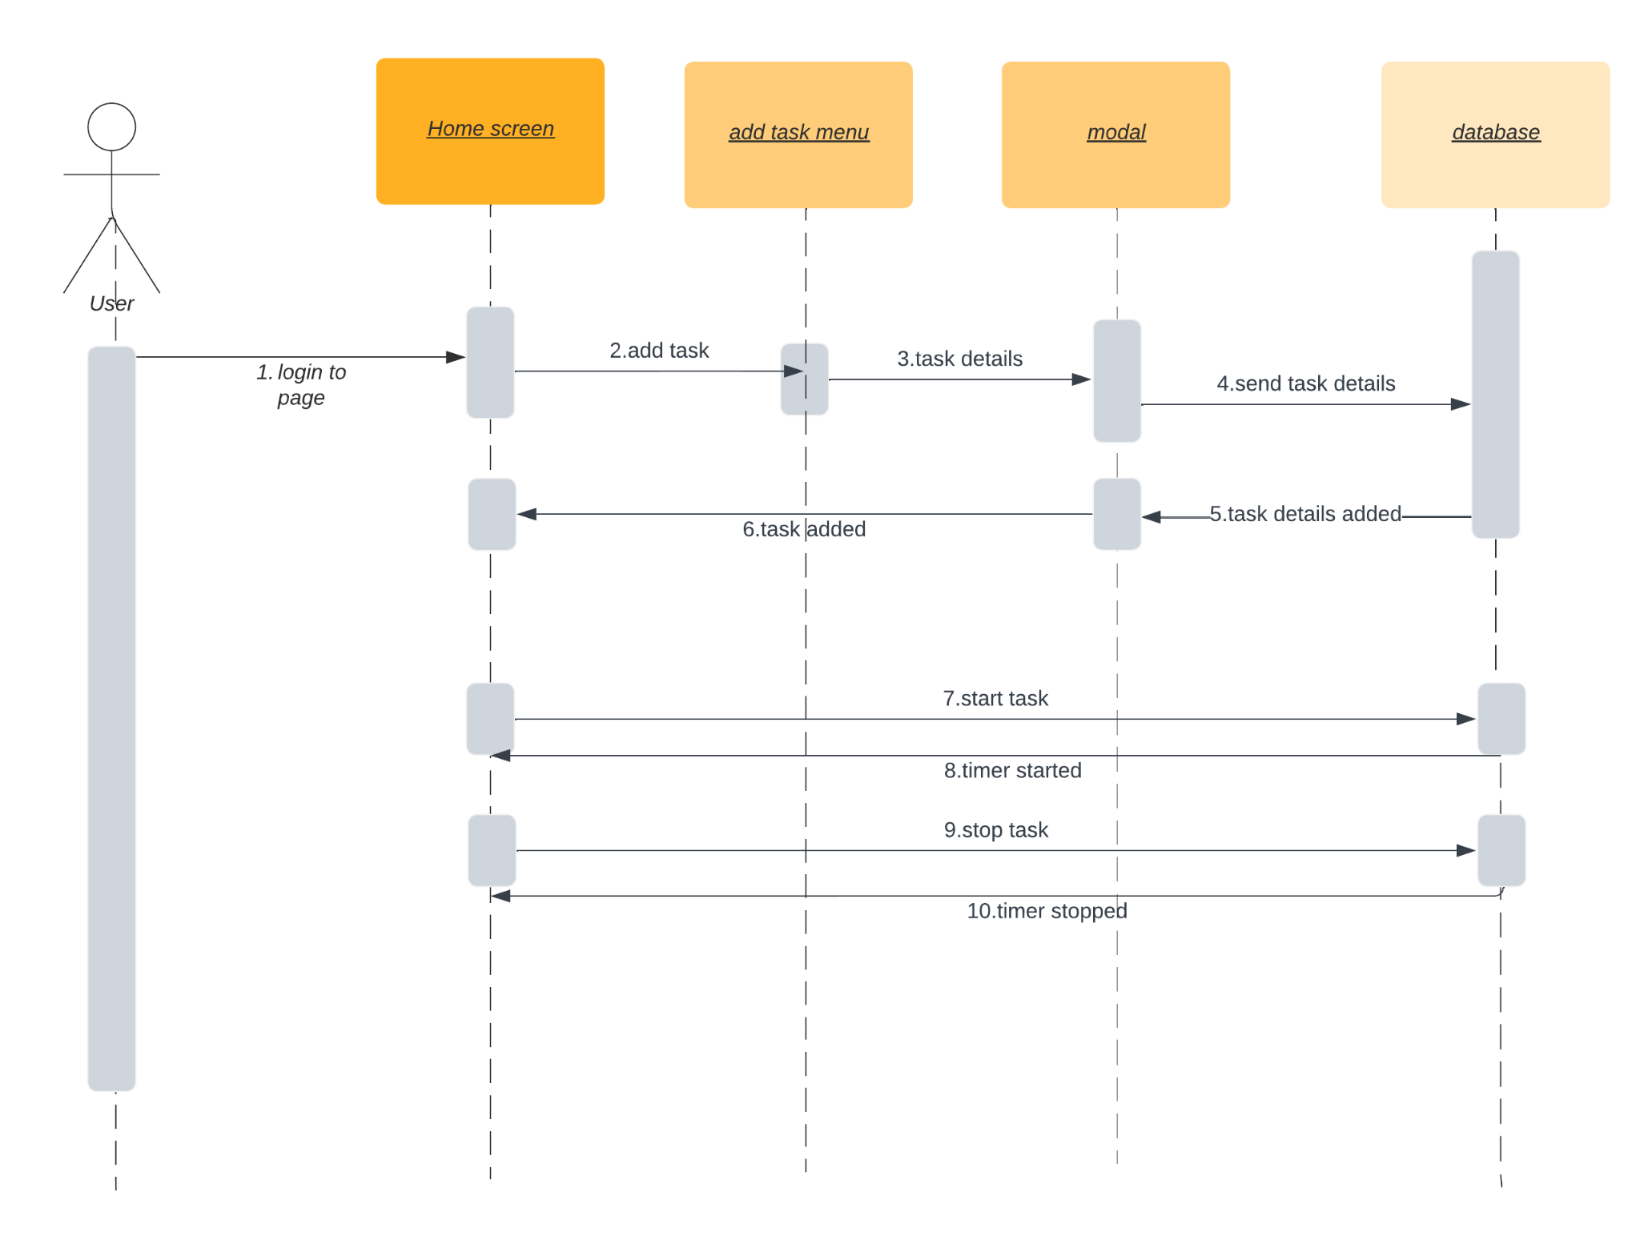

**Fig. 3.4.5.2**

**For Task**

## E-R Diagram

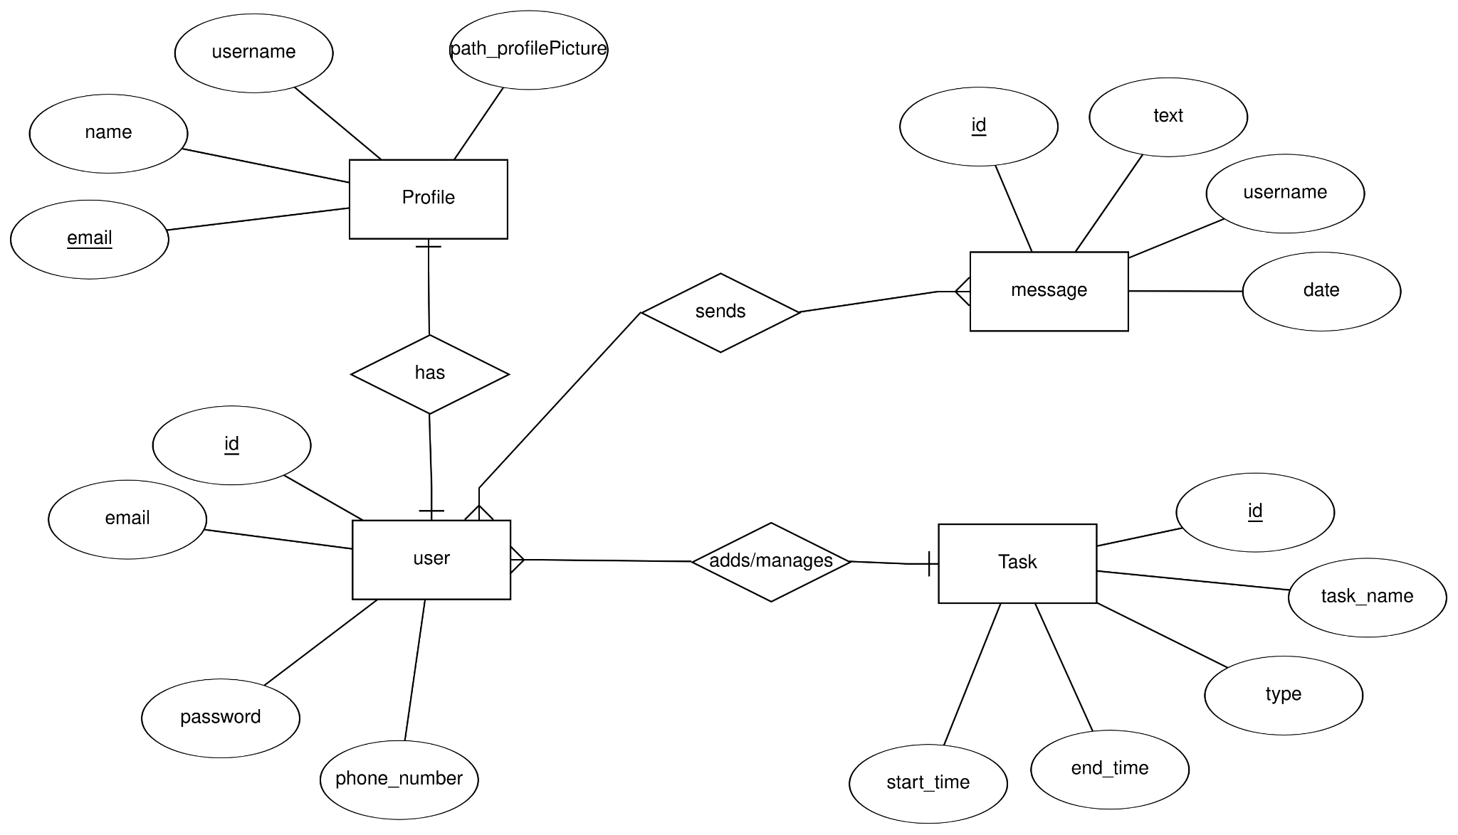

**Fig. 3.4.6**

# Implementation

## Overview

Implementation Planning is an essential aspect of any successful project. However, it can be difficult to turn goals and strategy into tangible action, and, therefore, projects of all sizes and across all industries have a high tendency to fail. Implementation planning can reduce this chance of failure by helping turn strategy into action

## Program/Module Specification

* **Home Module:**

In the home page there will be list of all the tasks which were added by user.so whenever any task will be added then whole list will be re-rendered and in home screens there will be option to add task and navigate to other screens such as messagescreen and user-profile screen.

* **Login/Signup Module:**

In signup module user can register themselves by providing details like name, email, password and mobile no. User will be validated at time of registration that it is previously exists or not and the details provided by him is valid. After thaat user can login to the system by providing email and password.

* **Profile Module:**

In the profile page all details which were provided by user at time of register will be shown such as email id and name and one blank profile image will be there by clicking on plus(+) button useR can add/change profile picture and user also can update the user-details.

* **Message Module**

From home screen user can navigate to message screen using navigation options and in the message screen all the users will be shown to user and based on preference user can choose user and after selecting user it wiLl lead to chat screen where user can send message to selected user

# Test Case Design and Screenshots

## **Testing Plan**:

The testing is a technique that is going to be used in the project is unit testing.

## Testing Strategy:

Unit Testing tests a unit of code after coding of that unit is completed. System testing ensures that the system meets its stated design specifications. Acceptance testing is testing by users to ascertain whether the system developed is a correct implementation of the software requirements specification. Testing is carried out in such a hierarchical manner that each component is correct and the assembly/combination of components is correct. Merely testing a whole system at the end would most likely throw up errors in components that would be very costly to trace and fix. So we will be performing both unit testing to test every component is working as desired or not and then we will perform system testing where we will check that system meets desired requirements or not.

## 

# ScreenShots

**Fig. 6.1 sign in screen**

# 

# 

**FIg. 6.2 signup screen**

# 

**Fig. 6.3 homescreen**

# 

# 

**FIg. 6.4 add task screen**

# 

**FIg. 6.5 Select user screen**

# 

# 

# 

**Fig. 6.6 add message screen**

# 

# 

# 

**Fig. 6.7 message added screen**

# 

**FIg. 6.8 profile screen**

# 

**Fig. 6.9 image added screen**

# 

**Fig. 6.10 Add image screen**

# 

**Fig. 6.11 update profile details screen**

# 

**Fig. 6.12 updated profile details screen**

# 

**Fig. 6.13 reset password screen**

# 

**Fig. 6.14 link for reset password**

# Conclusion and Future Extensions

## Conclusion

Time tracking applications can perceive you a great deal concerning how your representatives work and what they invest their energy in, yet fully trusting these experiences disregarding what might have caused them or what your choices could mean for your workers can lead you to a few misleading ends.

## Future Extension

* Integrating the social network to allow users to communicate with each other via the inbuilt chat feature by adding them as friends.
* Persistent time evaluation [timer doesn’t stop even though the application process is killed]
* Adding the Feed Section for allowing users to share the feeds with the selective group of people in the friends list.
* Deployment of the project over the cloud and migration of database from firebase to client offered specifications.

# Bibliography

1. Reactnative - <https://reactnative.dev/docs/getting-started>
2. Firebase react-native - <https://rnfirebase.io/>
3. Javascript - <https://javascript.info/>
4. Npm Packages:<https://www.npmjs.com/>
5. Stackoverflow: [https://stackoverflow.com](https://stackoverflow.com/)
6. Geeksforgeeks:<https://www.geeksforgeeks.org/>
7. Youtube:<https://www.youtube.com/>
8. W3 Schools:<https://www.w3schools.com/>