A CASE-STUDY BASED REPORT
ON
Used Car Price Estimator: Predicting the Fair Market Value of Pre-Owned Indian Vehicles Using Regression-Based Machine Learning
submitted in partial fulfilment of the requirements for the Course
MACHINE LEARNING
BACHELOR OF TECHNOLOGY
in
A.Y.: 2026-27
by
B Rishik roll 2520030314
Rohan V roll 2520030558
M Nityay roll 2520030618
Under the Esteemed guidance of
Dr.Y.Lakshmi Prasanna
Asst.Professor, Dept. of CS&IT




INDEX
Abstract 3
Introduction 3
Background 3
Motivation for the Project 3
Overview of the Work Carried Out 4
Scope and Responsible-Use Statement 4
Problem Statement 5
Case-Study Scenario 5
Central Case-Study Question 5
Formal Problem Definition 5
Objectives that Guide the Study 5
Assumptions and Limitations 6
Dataset and Exploratory Data Analysis 7
About the Dataset 7
Purpose of EDA 7
Preparation Steps Actually Performed 8
EDA Exploration - Implementation 8
Summary of EDA Findings 11
Algorithm Selection and Implementation 11
Conclusion 14
References 15

Abstract
Pricing a used car is difficult because its value depends on many interacting factors, and in practice it is often set by subjective dealer markups. This case study builds and evaluates a machine-learning system that estimates the fair resale price of a pre-owned car in India from its brand, model, year, kilometres driven, fuel type, transmission, ownership history and engine specification.
A multi-brand dataset of 3,825 listings (10 brands, 47 models) was cleaned to 3,686 records. Three features were engineered (car age, kilometres per year and power per litre), and Linear Regression, Random Forest and Gradient Boosting regressors were trained inside a scikit-learn pipeline on an 80/20 split. On the 738 held-out records Gradient Boosting performed best (R² = 98.02%, MAE = ₹0.37 lakh, RMSE = ₹0.64 lakh), against 96.13% for Random Forest and 75.35% for Linear Regression. Car age, engine size and engine power were the strongest price drivers.
The trained pipeline is served through a Flask web application and a REST API that return a price estimate with a ±5% negotiation band in under 15 ms. The dataset is simulated on Indian-market patterns, so the reported accuracy shows that the pipeline works end to end; it does not yet show that the same accuracy will hold on real marketplace listings. Validation on real data is the main next step.
Keywords: used-car price prediction, regression, Random Forest, Gradient Boosting, feature engineering, Flask REST API.

Introduction

Background
Used-car valuation is a supervised regression task: given a vehicle's age, mileage, brand, engine specification, fuel type, transmission and ownership history, predict the price at which it should resell. India's used-car market was valued at about USD 24.24 billion in 2019, with growth forecast at roughly 15% a year [1]. A car also loses about 20% of its value every year [1], so a small error in age or condition quickly turns into a large error in price.
Machine-learning studies on used-car pricing consistently find that ensemble tree models (Random Forest and gradient-boosted trees) outperform linear models [1]–[4]. This project applies that idea to a multi-brand Indian dataset and goes one step further than most of the surveyed work by packaging the best model as a working web application and REST API.

Motivation for the Project
Buyers, sellers, dealers and online marketplaces in India lack a trusted, data-driven reference price. Three observations motivate the work:
- Pricing is subjective. Dealer markups and rule-of-thumb appraisal lead to overpriced listings, low-ball offers and unfair deals.
- Platforms disagree. Online platforms price cars with different algorithms and can give inconsistent results for the same car [1].
- Existing studies are narrow. The surveyed papers use small or single-city data (one city, one brand or about 200 cars) and mostly stop at reporting model metrics [1]–[4].

Overview of the Work Carried Out
The work followed the full machine-learning lifecycle, summarised in Table 1.
Table 1: Summary of the work carried out
Stage | What was done | Outcome
Data | Generated 3,825 simulated Indian-market listings (12 attributes) with generate_dataset.py | 10 brands, 47 models
Preparation | Removed duplicates, imputed missing values, trimmed outliers | 3,686 clean records
Features | Added car_age, km_per_year, power_per_liter; scaled numerics, one-hot encoded categories | 13 model inputs
Modelling | Trained Linear Regression, Random Forest and Gradient Boosting (80/20 split) | 2,948 train / 738 test
Evaluation | Compared R², MAE and RMSE; extracted feature importance | Gradient Boosting best: R² 98.02%
Deployment | Saved the pipeline with joblib; served it with Flask at /api/predict | Price + ±5% band in under 15 ms

Scope and Responsible-Use Statement
In scope. Estimating the resale price, in ₹ lakhs, of used passenger cars from 10 brands and 47 models sold in India, from 11 user-supplied attributes; comparing three regression algorithms; and serving the best one locally through a web page and a REST endpoint.
Out of scope. Physical condition, accident history, location, colour and service records; real-time market tracking; and any binding valuation.
Responsible use.
- The dataset is simulated, not scraped from real listings. Predictions are therefore illustrations of how the system behaves, not market quotes, and must not be used for real buying, selling, lending or insurance decisions until the model is validated on real data.
- The output is an estimate, not an offer. The ±5% band is a fixed negotiation band, not a statistical confidence interval (see Assumptions and Limitations).
- No personal data is collected or used: the inputs describe the car, never the owner.

Problem Statement

Case-Study Scenario
Consider a seller, Ananya, who wants to sell her 2019 Honda City (petrol, CVT automatic, first owner, 45,000 km) in Hyderabad, and a buyer, Karthik, who is looking for a car of exactly this kind. (The names and details are illustrative.) A dealer quotes Ananya one figure; two online platforms show two different valuations because they use different algorithms [1]; and classified listings for similar cars are spread widely. Ananya cannot tell whether the dealer's figure reflects her car or the dealer's margin, and Karthik cannot tell whether the asking price is inflated.
Both need a neutral reference price before they start to negotiate. Manual appraisal by an expert is slow, costs money and does not scale to online marketplaces. For this exact car our system returns an estimate of ₹5.78 lakh, with a negotiation band of ₹5.49–6.07 lakh, in a few milliseconds.

Central Case-Study Question
Can a regression model trained on the attributes of used cars from many brands estimate the fair resale price accurately enough (R² above 85%) and quickly enough (under one second) to serve buyers and sellers as a data-driven reference for negotiation?

Formal Problem Definition
Let each car be described by a feature vector x of 13 attributes (brand, model, car_age, km_driven, km_per_year, fuel_type, transmission, owner, mileage_kmpl, engine_cc, max_power_bhp, power_per_liter, seats) and let y be its selling price in ₹ lakhs. Given n training pairs (xᵢ, yᵢ), learn a function f that minimises the mean squared error:
f* = argmin_f (1/n) Σ ( yᵢ − f(xᵢ) )²
subject to two requirements measured on records not seen during training: R² above 85%, and an end-to-end response time below 1 second. Model quality is reported with R², Mean Absolute Error (MAE) and Root Mean Squared Error (RMSE).

Objectives that Guide the Study
- To prepare a multi-brand Indian used-car dataset (3,825 simulated listings, 12 attributes), cleaned to 3,686 records with an 80/20 train–test split.
- To design and implement a scikit-learn pipeline (car_age, km_per_year and power_per_liter features) with Linear, Random Forest and Gradient Boosting regressors.
- To evaluate the models using R², MAE and RMSE against a target of R² above 85% and response under 1 second, and to report feature importance.
- To deploy a Flask web app and REST API (/api/predict) that return an instant price estimate with a fair negotiation band.

Assumptions and Limitations
Assumptions
- Price is determined mainly by the 11 attributes captured; unobserved factors (condition, accidents, location) are treated as noise.
- The simulated listings follow realistic Indian-market patterns closely enough to test the pipeline.
- Car age is calculated against a fixed reference year, 2026.
- Future cars arrive from the same distribution as the training data.
Limitations
- Simulated data. All results are on generated data. Part of the very high R² reflects the model relearning the pricing rules used to generate it. Real listings would be noisier and would score lower.
- Single split, hand-set hyperparameters. The models were evaluated on one 80/20 split with hyperparameters chosen by hand. No k-fold cross-validation or hyperparameter search has been run yet.
- The ±5% band is fixed and optimistic. On the test set only 39% of predictions fall within 5% of the true price, and 69% within 10% (mean absolute percentage error 9.3%). A band calibrated from the residuals would be wider.
- Price floor. The generator never produces a price below ₹0.90 lakh, so about 13% of listings (506 of 3,800 before trimming) pile up at that value, mostly cars 12–15 years old.
- Correlated features. Engine size, power and brand carry overlapping information, so individual importance scores should be read with care.
- Narrow coverage. Ten brands, 47 models, India only; no monitoring for data drift after deployment.

Dataset and Exploratory Data Analysis

About the Dataset
The dataset, used_cars.csv, contains 3,825 raw listings of used cars with 12 attributes, covering 10 brands (Maruti Suzuki, Hyundai, Tata, Toyota, Honda, Mahindra, Kia, Volkswagen, BMW and Mercedes-Benz) and 47 models, with manufacturing years from 2011 to 2024. It was produced by the script generate_dataset.py, which simulates the distributions of Indian marketplaces such as CarDekho and Cars24. Table 2 describes the attributes.
Table 2: Dataset attributes
Attribute | Type | Description
brand, model | Categorical | Manufacturer (10) and model (47)
year | Integer | Year of manufacture, 2011–2024
selling_price | Numeric (target) | Resale price in ₹ lakhs
km_driven | Numeric | Odometer reading in km
fuel_type | Categorical | Petrol, Diesel or CNG
transmission | Categorical | Manual or Automatic
owner | Categorical | First, Second, Third, Fourth & Above
mileage_kmpl | Numeric | Fuel efficiency (km per litre)
engine_cc | Numeric | Engine displacement in cc
max_power_bhp | Numeric | Maximum power in bhp
seats | Integer | Seating capacity (4, 5 or 7)

Each price is generated from a base price for the model, reduced by compound yearly depreciation (8.2% for Toyota and Maruti Suzuki, 9.5% for most brands, 13.5% for BMW and Mercedes-Benz), a penalty for kilometres driven, an owner discount (0%, 10%, 20% or 30% for first to fourth owner), a 7% premium for automatics and a 4% premium or discount for diesel or CNG, and finally multiplied by random market noise (standard deviation 5%). About 1.5% of the engine, power and mileage values were deliberately removed and 25 rows were duplicated, so the cleaning step has realistic problems to solve.
Important: this is simulated data. It exercises the full pipeline and gives a controlled test of the algorithms, but it is not evidence about the real used-car market. Replacing it with real listings is the first item of future work.

Purpose of EDA
Exploratory data analysis was carried out before modelling to:
- check data quality: missing values, duplicates and outliers;
- understand the distribution of the target (price) and the main predictors;
- find which attributes relate most strongly to price, and which overlap with each other;
- decide which features to engineer and which models are likely to suit the data.

Preparation Steps Actually Performed
The steps below are implemented in train_model.py and were re-run for this report; the counts are the program's own output.
Table 3: Data preparation steps and their results
Step | What was done | Result
1. Load | Read used_cars.csv | 3,825 rows, 12 columns
2. Duplicates | drop_duplicates() | 25 removed, 3,800 left
3. Missing values | Median imputation of mileage_kmpl, engine_cc, max_power_bhp (19 missing in each) | Medians 17.50 kmpl, 1,452 cc, 104.6 bhp
4. Outliers | Kept km_driven and selling_price between their 1st and 99th percentiles | 114 rows removed, 3,686 left
5. Feature engineering | car_age = 2026 − year; km_per_year = km_driven ÷ max(age, 1); power_per_liter = bhp ÷ (cc/1000) | 3 new features
6. Encoding and scaling | StandardScaler on 8 numeric features; one-hot encoding of 5 categorical features (inside the Pipeline) | Fitted on training data only
7. Split | train_test_split, 80/20, random_state = 42 | 2,948 train / 738 test

EDA Exploration - Implementation
The exploration used pandas for summaries and matplotlib for charts. The core of the analysis is shown below.
df = pd.read_csv("data/used_cars.csv")
df.shape; df.isnull().sum(); df.duplicated().sum() # data quality
df = engineer_features(load_and_clean_data(path)) # as in train_model.py
df["selling_price"].describe() # target distribution
df.groupby("brand")["selling_price"].median().sort_values()
df.groupby("car_age")["selling_price"].median()
df[numeric_cols].corr() # correlation matrix

Table 4: Summary statistics of the cleaned dataset (3,686 records)
Variable | Mean | Median | Min | Max
Selling price (₹ lakhs) | 4.81 | 3.58 | 0.90 | 28.53
Kilometres driven | 92,581 | 86,456 | 16,681 | 210,976
Car age (years) | 8.1 | 8 | 2 | 15

Distribution of the target
Prices are strongly right-skewed (skewness 2.2): most cars sell for a few lakhs, while a small number of luxury cars reach ₹28 lakh. The median (₹3.58 lakh) is well below the mean (₹4.81 lakh). The tall first bar is the ₹0.90 lakh price floor described earlier.
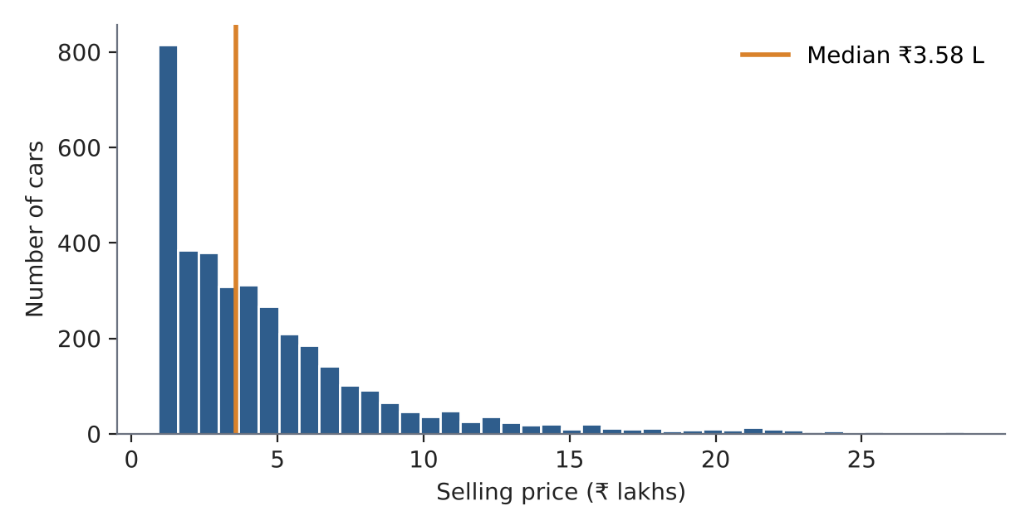
Figure 1: Distribution of selling price (cleaned data)
Price by brand
Brand sets the price level. Luxury brands have the highest median prices (Mercedes-Benz ₹9.87 lakh, BMW ₹9.12 lakh), followed by Toyota (₹6.22 lakh), while Maruti Suzuki is the lowest (₹2.67 lakh).
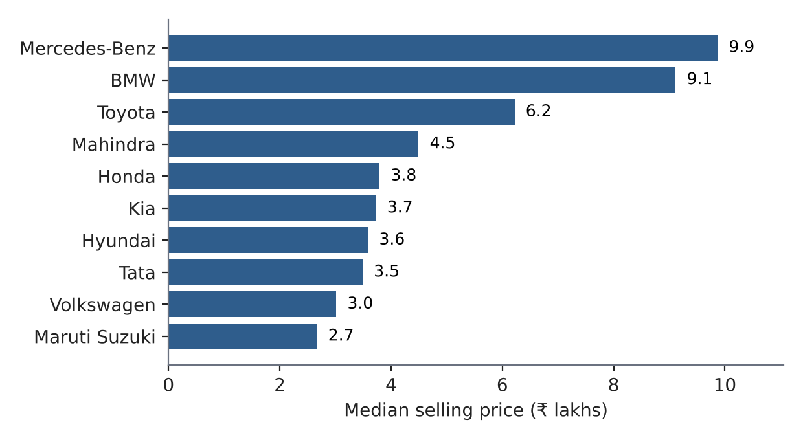
Figure 2: Median selling price by brand
Price against age
Price falls steadily with age and the curve flattens at the floor: the median drops from ₹9.23 lakh at 2 years to ₹3.46 lakh at 8 years and ₹1.10 lakh at 12 years. A curved, non-linear relationship like this is hard for a straight-line model, which anticipates the weaker Linear Regression result later.
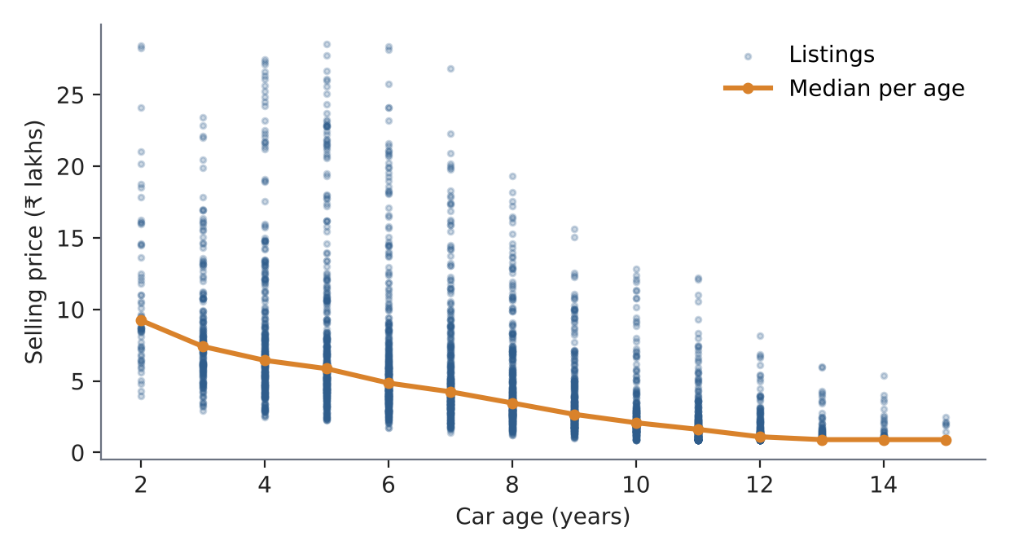
Figure 3: Selling price against car age, with the median at each age
Other attributes
Automatic cars have a higher median price than manual ones (₹4.46 against ₹3.28 lakh). Ownership matters strongly: the median price is ₹4.99 lakh for first owners but ₹1.65 lakh for fourth owners and above. Fuel type has only a small effect (CNG ₹3.26, Petrol ₹3.54, Diesel ₹3.70 lakh).
Correlations
Price is moderately correlated with car age (−0.57), kilometres driven (−0.53), engine size (+0.57) and power (+0.56). Several predictors overlap heavily: age and kilometres driven (0.84), and engine size and power (0.87). The engineered km_per_year feature is almost uncorrelated with price (−0.04) and with age, so it adds separate information about how hard a car was used.
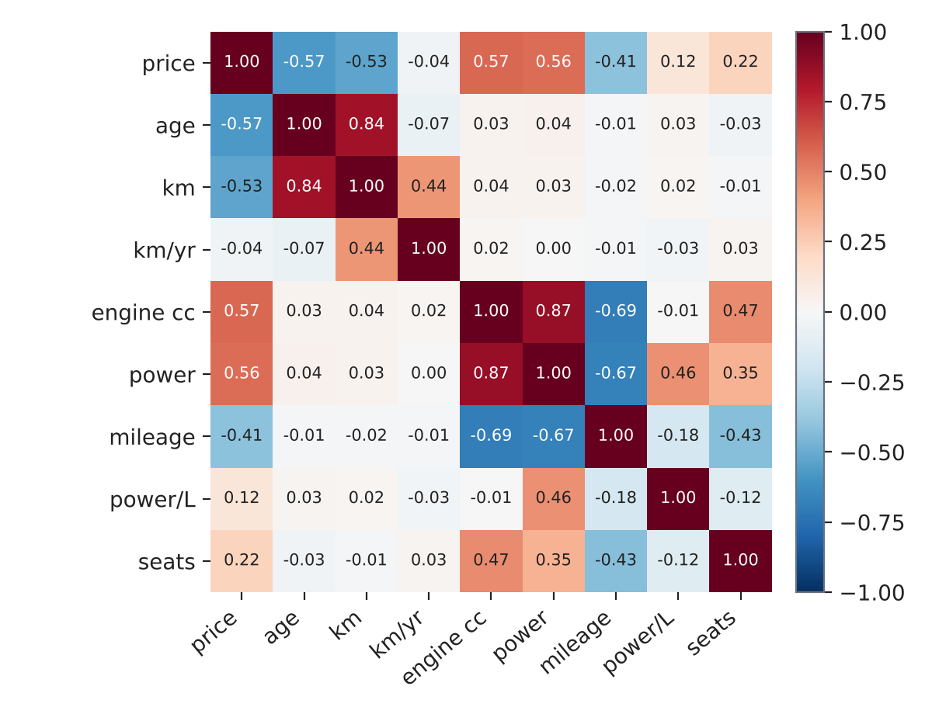
Figure 4: Correlation matrix of price and numeric features

Summary of EDA Findings
- Data quality problems were limited and fixable: 25 duplicates, 19 missing values in each of three columns, and 114 extreme rows.
- Price is right-skewed and has a floor at ₹0.90 lakh, an artefact of the simulator that real data would not show.
- Age, engine size, power and brand are the strongest signals; ownership and transmission add smaller effects, and fuel type very little.
- The age–price relationship is curved, favouring non-linear models over Linear Regression.
- Age and kilometres, and engine size and power, are strongly correlated. Importance scores for these features will overlap.
- Categorical variables (brand, model, fuel, transmission, owner) need one-hot encoding, and numeric features need scaling for the linear baseline.

Algorithm Selection and Implementation
Related work and the gap
Table 5 summarises four recent papers on used-car price prediction. Random Forest and boosting models do best across them, but the studies rely on small or single-source data, show signs of overfitting, and mostly stop at reporting metrics. This project closes three gaps: a multi-brand dataset (data level), three models compared with feature importance (method level) and a live web app and REST API (deployment level).
Table 5: Related work (full citations in References)
Ref. | Technique | Data | Key finding | Limitation
[1] 2021 | Random Forest vs XGBoost | Mumbai, 2,454 records | XGBoost RMSE 0.53 vs 3.44 | Single city; no linear baseline
[2] 2024 | Voting, GB, RF, DT, SVR, Linear; GridSearchCV | 200+ cars | RF 89.75%, GB 88.67% (test) | Tiny data; GB 97.84% train vs 88.67% test
[3] 2024 | Linear, Ridge, RF; RandomizedSearchCV | CarDekho listings | RF best of three | Small sample; no boosting
[4] 2024 | Linear, DT, RF, XGBoost; cross-validation | Ford, 17,966 entries | XGBoost R² 0.9347 | One brand only

Candidate algorithms and why they were chosen
- Linear Regression [6] is the baseline. It is fast and interpretable and shows how much of the price a straight-line model can explain.
- Random Forest [7] averages many decision trees trained on random samples of rows and features. Averaging reduces variance and handles non-linear effects and mixed feature types well.
- Gradient Boosting [8] builds shallow trees one after another, each fitted to the errors left by the previous ones. This mainly reduces bias and is usually the most accurate of the three on tabular data.
These three cover the progression from a simple baseline to a bagged ensemble to a boosted ensemble, and match the models used in the surveyed work. XGBoost [1], [4] was not used; scikit-learn's GradientBoostingRegressor was used instead.
Implementation
All preprocessing and modelling steps live in one scikit-learn Pipeline [5]. A ColumnTransformer imputes (median for numeric, most frequent for categorical), scales the 8 numeric features with StandardScaler and one-hot encodes the 5 categorical features. The regressor is the final step. Packaging both together means the exact transformations used in training are applied at prediction time.
Table 6: Model settings (chosen by hand; not tuned by search)
Model | Main settings
Linear Regression | Default (ordinary least squares)
Random Forest | n_estimators = 150, max_depth = 16, min_samples_split = 4, random_state = 42
Gradient Boosting | n_estimators = 180, learning_rate = 0.08, max_depth = 5, random_state = 42

Results
All three models were trained on 2,948 records and evaluated on the same 738 held-out records. Table 7 gives the results, re-run for this report.
Table 7: Test-set performance of the three models
Model | R² | MAE (₹ lakh) | RMSE (₹ lakh)
Linear Regression | 75.35% | 1.36 | 2.24
Random Forest | 96.13% | 0.49 | 0.89
Gradient Boosting (selected) | 98.02% | 0.37 | 0.64

Gradient Boosting gives the lowest error on every metric, with an average error of about ₹37,000 and R² of 98.02%, well above the 85% target. Random Forest is close behind. Linear Regression is clearly weaker (R² 75.35%) because price falls with age along a curve and depends on interactions, for example between brand and age, that a linear model cannot represent. Gradient Boosting was therefore selected and saved as best_model.joblib. The predictions follow the ideal line closely across the whole price range, with the larger errors at the highest prices where there are fewest cars (Figure 5).
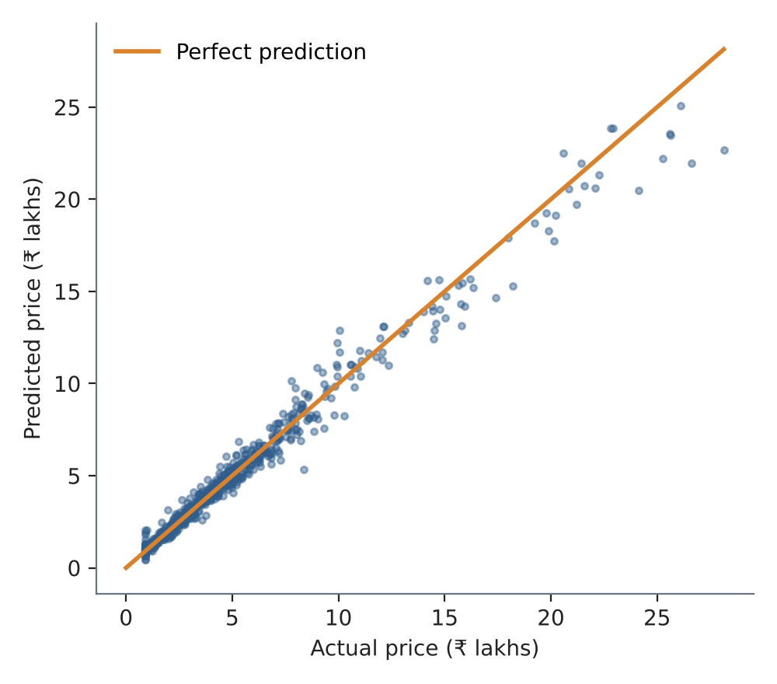
Figure 5: Predicted against actual price on the 738 test records (Gradient Boosting)
In relative terms, 93% of test predictions are within ₹1 lakh of the true price, 69% are within 10% and 39% within 5%.
What the model learned
Feature importance was extracted from the Random Forest, with one-hot columns added back together by original feature (Figure 6). Car age accounts for 45.9% of the importance, engine size for 25.7% and power for 15.8%; brand and model together contribute 6.0% and kilometres driven 2.5%. This agrees with the EDA. Because engine size, power and brand overlap, these figures describe how the forest split the shared information, not each feature's separate effect. Note also that they come from the Random Forest, not from the deployed Gradient Boosting model.
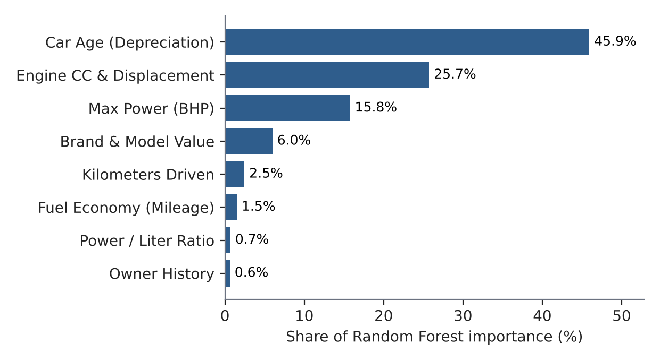
Figure 6: Share of Random Forest feature importance, top eight groups
Deployment and sample predictions
Offline, train_model.py writes the pipeline to best_model.joblib and the metrics to model_metadata.json. Online, the Flask app loads the pipeline once at start-up. A request to /api/predict carries the 11 inputs as JSON (or from the web form); the server fills in missing engine specifications from a lookup table, derives car_age, km_per_year and power_per_liter, builds the 13-column row, runs the pipeline and returns the price in ₹ lakhs with a ±5% band. Calling the API for the app's five preset cars returned the estimates in Table 8. Server-side processing took 6–7 ms per request, and 30 repeated requests per car completed in a median of 7–10 ms (maximum 13 ms) when measured with Flask's test client, comfortably inside the 1-second target.
Table 8: Estimates returned by /api/predict for the five preset cars (simulated-data model)
Preset car | km driven | Predicted price | ±5% band
Hyundai Creta 2021 (Diesel AT) | 38,000 | ₹ 8.31 L | ₹7.89L – ₹8.73L
Maruti Swift 2018 (Petrol MT) | 62,000 | ₹ 3.08 L | ₹2.93L – ₹3.23L
Honda City 2019 (Petrol CVT) | 45,000 | ₹ 5.78 L | ₹5.49L – ₹6.07L
Toyota Fortuner 2020 (Diesel 4x4) | 72,000 | ₹ 20.21 L | ₹19.20L – ₹21.22L
BMW 3 Series 2019 (Luxury Sedan) | 48,000 | ₹ 15.92 L | ₹15.12L – ₹16.72L

Discussion
The comparison shows that tree ensembles are the right choice for this problem, and that the end-to-end system works. The main caution is the one already stated: the data is simulated from a formula, so very high accuracy is expected, and the real test will come from real listings. The planned next steps are real-data validation, k-fold cross-validation with hyperparameter search, calibrated price bands, accident-history and location features, and cloud deployment with drift monitoring.

Conclusion
Used-car prices in India are often set by subjective markups because no standard, data-driven reference exists, and the surveyed studies rely on small or single-city data and stop at model comparison. This case study built a multi-brand, deployable estimator. After cleaning 3,825 simulated listings to 3,686 records and engineering three features, a Gradient Boosting pipeline reached R² 98.02%, MAE ₹0.37 lakh and RMSE ₹0.64 lakh on 738 held-out records, ahead of Random Forest (96.13%) and Linear Regression (75.35%). Car age, engine size and power are the main price drivers. The model is served through a Flask web app and REST API that return a price with a ±5% band in under 15 ms, meeting the targets of R² above 85% and a response under one second.
The results should be read with their limits in mind: the data is simulated, evaluation used a single split, and the ±5% band is nominal rather than calibrated. Future scope: retrain and validate on real marketplace listings; add k-fold cross-validation and hyperparameter search; calibrate the price band from residuals; add accident-history and location features; and deploy on a cloud host with monitoring for drift and performance degradation.

Signature of the Team members
B Rishik (2520030314)
______________________________
Rohan V (2520030558)
______________________________
M Nityay (2520030618)
______________________________

References
[1] C. Longani, S. P. Potharaju and S. Deore, "Price prediction for pre-owned cars using ensemble machine learning techniques," in Recent Trends in Intensive Computing, M. Rajesh et al., Eds. Amsterdam, The Netherlands: IOS Press, 2021, pp. 178–187, doi: 10.3233/APC210194.
[2] P. Bhatnagar, G. H. Lokesh, J. Shreyas, F. Flammini and S. Gautam, "An analysis of car price prediction using machine learning," in Proc. 9th Int. Conf. Machine Learning Technologies (ICMLT), Oslo, Norway, 2024, pp. 11–15, doi: 10.1145/3674029.3674032.
[3] J. Lin, "Predicting used car price based on machine learning," in Proc. 1st Int. Conf. E-commerce and Artificial Intelligence (ECAI), SciTePress, 2024, pp. 553–560, doi: 10.5220/0013270500004568.
[4] Y. Wang, "Price prediction of Ford cars applying multiple machine learning methods," in Proc. 1st Int. Conf. E-commerce and Artificial Intelligence (ECAI), SciTePress, 2024, pp. 280–285, doi: 10.5220/0013214800004568.
[5] F. Pedregosa et al., "Scikit-learn: Machine learning in Python," J. Mach. Learn. Res., vol. 12, pp. 2825–2830, 2011.
[6] T. Hastie, R. Tibshirani and J. Friedman, The Elements of Statistical Learning, 2nd ed. New York, NY, USA: Springer, 2009.
[7] L. Breiman, "Random forests," Machine Learning, vol. 45, no. 1, pp. 5–32, 2001.
[8] J. H. Friedman, "Greedy function approximation: A gradient boosting machine," Ann. Statist., vol. 29, no. 5, pp. 1189–1232, 2001.

