CA-3 · AGENTIC AI PROJECT REPORT
ClaimPilot
Agentic AI for health-insurance cashless pre-authorisation
Six cooperating agents, a local open-source language model and a human medical officer turn a hospital's cashless pre-authorisation request into a validated, explained decision and a letter to the hospital.

Team member | PRN | Role
Rishik Sinha | 24070126154 | Project lead: architecture, orchestrator, LLM pipeline, Critic and safety, dashboard
Rishik Gupta | 24070126153 | Planner, Policy Research and Coverage Executor agents, dataset, core tests

Domain: Healthcare / Health Insurance (TPA operations) · Model: Meta Llama 3.2 3B (default), Qwen 2.5 7B (benchmarked), served locally by Ollama · Code: github.com/RishikSinha06/ClaimPilot-Agentic-PreAuth
Date: October 2026 · All data in this project is synthetic.

Contents
1. Abstract 4
2. Introduction 5
2.1 Problem statement 5
2.2 Why this problem suits Agentic AI 5
2.3 Objectives 5
2.4 Scope 5
3. Dataset and how the agents use it 6
3.1 Pre-authorisation requests (claims.json) 6
3.2 Policy schedules (policies.json) 7
3.3 Policy wording (policy_clauses.json) 7
3.4 Network tariff (tariffs.json) 8
3.5 How each agent uses the data 8
4. System architecture 10
4.1 Design principles 10
4.2 Processes and services at runtime 10
4.3 Full system architecture 11
4.4 The shared state (blackboard) 12
4.5 How the Orchestrator executes a request 12
4.6 The agents in detail 13
4.7 How the agents interact: a real run 13
4.8 Execution sequence diagram 15
5. How the text is prepared for the LLM (stages P1–P13) 16
5.1 Stages P1–P9: cleaning and understanding the text 16
5.2 Stage P10: building the prompt 16
5.3 The PII gate 17
5.4 Stages P11–P13: from the model's text to trusted facts 17
5.5 The complete text pipeline 19
6. How the LLM works and where it is called 20
6.1 The LLM does not orchestrate the agents 20
6.2 What happens inside the model during a call 20
6.3 A real model answer, and how the pipeline checked it 21
6.4 The letter path 21
6.5 Model settings 21
7. Decision logic 22
7.1 Eligibility rules (Coverage Executor) 22
7.2 Payable amount waterfall 22
7.3 The Critic's checks 22
7.4 Decision ladder and human review 23
7.5 Decision logic diagram 24
8. Guardrails, privacy and audit 25
9. Implementation 26
9.1 Technology 26
9.2 Code structure 26
9.3 The dashboard 26
9.4 Running the project 28
10. Testing and validation 29
10.1 Automated tests 29
10.2 Results on the labelled cases 29
10.3 Fault injection: breaking the LLM on purpose 29
11. Results and discussion 31
12. Limitations and future work 32
12.1 Limitations 32
12.2 Future work 32
13. Contribution of team members 33
14. Conclusion 34
References 34
Appendix A. JSON schema for fact extraction 34
Appendix B. System prompt for fact extraction 35

1. Abstract
When an insured patient is admitted to a hospital in India, the hospital asks the insurer, usually through a Third Party Administrator (TPA), to authorise cashless treatment. A TPA executive must read the treating doctor's notes, check the policy (is it in force, are there waiting periods or exclusions), work out deductions such as room-rent limits, sub-limits and co-pay, and reply with a letter. IRDAI expects a decision on a cashless request within one hour. The work is slow, rule-heavy and hard to audit.
ClaimPilot automates this desk with an agentic architecture. A deterministic Orchestrator executes a task plan written by a Planner agent over one shared state (a blackboard). A Document Intake agent cleans and de-identifies the free-text notes in nine NLP stages and asks a local open-source LLM (Meta Llama 3.2 3B or Qwen 2.5 7B, served by Ollama) to extract the clinical facts as schema-constrained JSON. Policy Research retrieves the policy, clauses and network tariff; the Coverage Executor applies eligibility rules and computes the payable amount in plain Python; an independent Critic re-checks everything and can send the amount back for revision or stop the case; the Decision & Letter agent applies a decision ladder and drafts a letter that the LLM polishes under a faithfulness guardrail. Risky cases are escalated to a human medical officer.
On 12 hand-labelled synthetic cases the system makes 12/12 correct decisions with both the simulated model and a real Qwen 2.5 7B model running on a laptop CPU, with 0 wrong decisions sent. A fault-injection study that corrupts the LLM's answers on purpose (115 corrupted runs) showed that the hardened design lets no wrong decision and no corrupted letter through, compared with 14 and 17 before hardening. 87 automated tests cover the pipeline.

2. Introduction

2.1 Problem statement
A cashless pre-authorisation request contains structured fields (patient, policy number, diagnosis, ICD-10 code, proposed treatment, cost estimate, attached documents) and unstructured free text: the treating doctor's notes, full of abbreviations (K/c/o HTN, T2DM x 4 yrs), negations (No h/o DM/HTN) and personal identifiers. Deciding the request requires reading that text correctly, applying many policy rules in the right order and explaining every rupee deducted with a policy clause.

2.2 Why this problem suits Agentic AI
- Multi-step: read → look up → check → calculate → verify → decide → write. Each step needs different tools and knowledge.
- Rule-heavy and exact: waiting periods, exclusions, sub-limits and co-pay must be applied exactly, so they belong in deterministic tools, not in a language model.
- Unstructured input: the doctor's notes need language understanding, which is where an LLM adds value.
- High stakes and explainable: wrong approvals cost money, wrong denials hurt patients; every decision needs reasons, clause numbers and an audit trail, and risky cases need a human.

2.3 Objectives
- Design a multi-agent architecture in which each agent has one responsibility and every hand-off is visible.
- Use a local open-source LLM only for language tasks, behind privacy and hallucination guardrails, with money, dates and rules in deterministic code.
- Produce a decision, amount, clause-cited reasons, a hospital letter, an execution-sequence diagram and an audit record for every request.
- Keep a human in the loop for risky cases, and prove with tests, a real-model benchmark and fault injection that LLM errors do not become wrong decisions.

2.4 Scope
The proof of concept decides on the hospital's estimate at admission (pre-authorisation). Final bill settlement, OCR of scanned documents and integration with real hospital or insurer systems are out of scope. All data is synthetic.

3. Dataset and how the agents use it
ClaimPilot runs on a synthetic dataset created for this project. Real claim records contain personal health information and cannot be used in coursework, and no public Indian pre-authorisation dataset with policy wordings and labelled decisions exists. The data was therefore designed by hand to mirror real TPA documents (policy schedules, a policy wording, a network tariff and hospital requests) and to exercise every rule and every possible decision. It lives in four JSON files in data/, plus two dictionaries built into the NLP code.
Table 1. The dataset at a glance
File | Records | What it holds | Read by
claims.json | 12 requests | Hospital pre-authorisation requests with free-text notes, cost estimates, documents and hand-labelled ground truth | UI → Orchestrator; Intake, Executor, Critic; evaluation
policies.json | 5 policies | Policy schedules: insured members, dates, sum insured, caps, co-pay, waiting periods, declared PED, sub-limits, exclusions | Policy Research (policy_lookup), Executor, Critic
policy_clauses.json | 11 clauses | A simplified policy wording with clause numbers, titles, text and search tags | Policy Research (clause_search), Decision & Letter (citations)
tariffs.json | 10 benchmarks | Network tariff price ranges (min / max) per procedure, as a package or per day | Policy Research (tariff_lookup), Critic, Executor
NLP dictionaries (code) | 41 abbreviations; gazetteer | Medical abbreviations; 7 conditions, 9 procedures, 10 medications, 10 tests, 4 flag groups; 14 negation triggers | Document Intake (stages P3, P6, P7)

3.1 Pre-authorisation requests (claims.json)
Each of the 12 requests carries the fields a hospital sends: claim_id, hospital, policy_no, patient, age, gender, request_date, admission_type (planned / emergency), treatment_type (surgical / medical), diagnosis, icd10, proposed_treatment, free-text doctor_notes, the list of attached documents, and an itemised costs estimate (room rent per day and days, ICU, surgery/OT, medicines and implants, investigations, other).
Each request is also hand-labelled with three kinds of ground truth, used only for evaluation and never shown to the agents:
- expected_decision: the correct outcome (APPROVE, PARTIAL, QUERY, DENY or ESCALATE).
- expected_amount: the hand-calculated payable amount, for the 6 cases where money is authorised.
- gold_extraction: the facts a perfect reader would extract from the notes: procedure, chronic conditions (with duration), cosmetic intent, functional need and accident. These 60 labelled fields (5 per case) measure extraction accuracy.
One request (PA-2026-0106) also carries a query_response describing what the hospital uploads after a query, so the re-submission loop can be tested end to end.
Table 2. The 12 labelled requests and what each one exercises
ID | Treatment (policy) | Expected | What it tests
0101 | Appendectomy, emergency (P1001) | APPROVE ₹1,30,000 | Happy path; negated history No h/o DM/HTN
0102 | Cataract (P1001) | PARTIAL ₹40,000 | Procedure sub-limit
0103 | Knee replacement, senior (P1002) | PARTIAL ₹1,20,000 | Room-rent ratio, sub-limit, 20% co-pay, declared PED
0104 | Hernia, policy 17 days old (P1004) | DENY | Initial and specific waiting periods
0105 | Rhinoplasty, aesthetic (P1001) | DENY | Cosmetic exclusion; no obstruction negated
0106 | Dengue, reports missing (P1003) | QUERY → APPROVE ₹47,000 | Missing documents, hospital re-submission loop
0107 | Angioplasty, K/c/o HTN since 2018 (P1002) | ESCALATE | Abbreviations, PII masking, undisclosed PED → human
0108 | Gallbladder, inflated estimate (P1001) | PARTIAL ₹1,50,000 | Critic → Executor revision loop (tariff cap)
0109 | Pneumonia, policy expired (P1005) | DENY | Policy not in force
0110 | Femur fracture, road accident (P1003) | APPROVE ₹1,75,000 | Accident branch: MLC / FIR check
0111 | Hernia, group policy (P1003) | APPROVE ₹98,000 | Negation-heavy notes; group waiver of waiting periods
0112 | Impacted third molar (P1001) | DENY | Dental exclusion; No h/o trauma or RTA must not trigger accident
The labels cover all five outcomes: 3 Approve, 3 Partial, 4 Deny, 1 Query and 1 Escalate.

3.2 Policy schedules (policies.json)
Five policies cover the common Indian product types: a family floater, a senior-citizen policy with 20% co-pay, a corporate group policy that waives waiting periods, and two individual policies (one only 17 days old, one expired). Each schedule holds the fields the eligibility and payable rules need.
Table 3. Policy fields and the rule that uses each
Field | Meaning | Used by
insured, start_date, end_date | Members covered and the policy period | Executor: member covered, policy in force (clause 2.1)
initial_waiting_days, specific_waiting_months, specific_waiting_conditions | 30-day initial wait; 12–24 month wait for listed procedures | Executor: waiting-period checks (4.1, 4.2)
ped_waiting_months, declared_ped | Pre-existing-disease waiting period; diseases declared at proposal | Executor and Critic: PED checks (4.3)
waiting_waived | Group policy waiver | Executor: bypasses waiting periods
exclusions | Permanently excluded treatments (cosmetic, dental …) | Executor: exclusion check (5.1, 5.2)
room_rent_cap_per_day, icu_cap_per_day | Daily room and ICU limits | Executor: proportionate deduction (3.4)
sub_limits, copay_pct | Per-procedure caps; insured's share | Executor: sub-limit (3.6), co-pay (3.5)
sum_insured, utilised | Cover amount and what is already used | Executor: balance sum insured

3.3 Policy wording (policy_clauses.json)
Eleven clauses form a simplified policy wording. Each has an id (for example 4.3), a title, the clause text and search tags. The Policy Research agent retrieves the relevant ones with a keyword search, and every reason in a decision letter cites a clause number from this file.
Clause | Title
2.1 | Policy period
3.4 | Room rent limit and proportionate deduction
3.5 | Co-payment
3.6 | Sub-limits
4.1 | Initial waiting period
4.2 | Specific waiting period
4.3 | Pre-existing diseases (PED)
5.1 | Cosmetic and aesthetic treatment
5.2 | Dental treatment
6.1 | Documents for cashless authorisation
6.3 | Reasonable and customary charges

3.4 Network tariff (tariffs.json)
Ten benchmarks give the reasonable price range for each procedure in the hospital network, either as a package (surgery) or per day (medical management). The Critic compares the hospital's estimate with the ceiling: an estimate more than 25% above it is sent back to the Executor, which caps the payable at the ceiling (clause 6.3).
Procedure key | Network range | Basis
appendectomy | ₹80,000 – ₹1,50,000 | package
cataract | ₹25,000 – ₹55,000 | package
joint replacement | ₹1,80,000 – ₹3,20,000 | package
hernia | ₹60,000 – ₹1,20,000 | package
rhinoplasty | ₹90,000 – ₹2,00,000 | package
angioplasty | ₹1,50,000 – ₹2,80,000 | package
gallstone | ₹70,000 – ₹1,50,000 | package
fracture fixation | ₹1,00,000 – ₹2,00,000 | package
medical management | ₹6,000 – ₹14,000 | per day
dental surgery | ₹15,000 – ₹40,000 | package

3.5 How each agent uses the data
Table 4. Data flow from the dataset into the agents
Agent | Reads | How it uses it
Planner | Request header (admission type, treatment type, age) | Sets priority, required documents and claim-specific checks; writes the task plan
Document Intake | Doctor's notes, diagnosis, treatment; abbreviation dictionary, gazetteer, negation triggers | Cleans, de-identifies and tags the text; asks the LLM for facts; checks the documents list
Policy Research | policies.json, policy_clauses.json, tariffs.json | Looks up the schedule, retrieves up to 6 relevant clauses, fetches the tariff benchmark
Coverage Executor | Policy schedule, extracted facts, cost estimate | Runs eligibility rules and the payable waterfall
Critic | Everything above, plus an ICD-10 reference table | Re-checks documents, ICD-10, LLM output, PII, PED, tariff and the amount
Decision & Letter | Critic findings, eligibility checks, calculation, clauses | Chooses the decision and writes clause-cited reasons and the letter
Evaluation (not an agent) | expected_decision, expected_amount, gold_extraction | Scores every run: correct / held for review / wrong; facts and amounts
The ground-truth labels are only ever read by the evaluation code (agents/evaluation.py), the tests and the benchmark scripts. The agents never see them, so the measured accuracy is not leaked from the labels.

4. System architecture
ClaimPilot is organised in five layers. Each layer only talks to the layer below it, and agents never talk to each other directly. Figure 1 (next page) shows the complete architecture.
Table 5. Architectural layers
Layer | Components | Responsibility
1 Presentation | Streamlit dashboard (app.py); scripts for benchmark, fault injection, diagrams | Collects the request, shows the live agent trace, results, charts, letter and audit
2 Orchestration | Orchestrator (agents/orchestrator.py) + shared state ctx | Executes the plan, evaluates conditions, runs the loops, records the trace and audit log
3 Agents | Planner, Document Intake, Policy Research, Coverage Executor, Critic, Decision & Letter; human medical officer | One responsibility each; read and write the shared state
4 Capabilities | NLP pipeline P1–P13, guardrails, deterministic tools, LLM client | Text processing, privacy and faithfulness checks, money and date maths, model access
5 Data and services | JSON data files; Ollama server on localhost:11434; hash-chained audit log | Reference data, model inference, tamper-evident record

4.1 Design principles
- Agents never call each other. The Orchestrator passes one shared state (the blackboard pattern) and routes between agents, so every hand-off is visible and recorded.
- The LLM reads and writes text only. Money, dates, policy rules and the final decision are computed by deterministic Python tools, so they are exact and repeatable.
- Nothing the LLM says is trusted blindly. Its output is schema-validated, grounded in the source text, cross-checked against a second, rule-based extractor and reviewed by the Critic.
- Risky cases stop for a human. The system escalates rather than guesses.
- Everything is recorded. Every agent step, tool call, NLP stage, LLM call and guardrail check is traced.

4.2 Processes and services at runtime
At runtime there are at most two processes. The Streamlit process runs the dashboard, the Orchestrator and all six agents; agents interact through ordinary Python function calls inside it. The optional Ollama process runs the language model and exposes an HTTP API on localhost:11434. The only network traffic is between the LLM client and Ollama:
- GET /api/tags lists the installed models, to check Ollama is running and the model is present.
- POST /api/generate sends one prompt and receives one answer. The request carries the model name, system prompt, user prompt, a JSON schema in the format field and fixed options.
POST http://localhost:11434/api/generate
{ "model": "llama3.2",
"system": "You are a clinical information-extraction assistant ...",
"prompt": "### Allowed values ... ### Example ... ### Task ...",
"format": { "type": "object", "properties": { "procedure_key": {...}, ... } },
"options": { "temperature": 0, "seed": 42, "num_ctx": 4096, "num_predict": 512 },
"stream": false }
If Ollama is not running, the factory make_llm() returns MockLLM, a clearly labelled simulated model with the same interface, so the demo never breaks. Agents do not know which backend they use.

4.3 Full system architecture
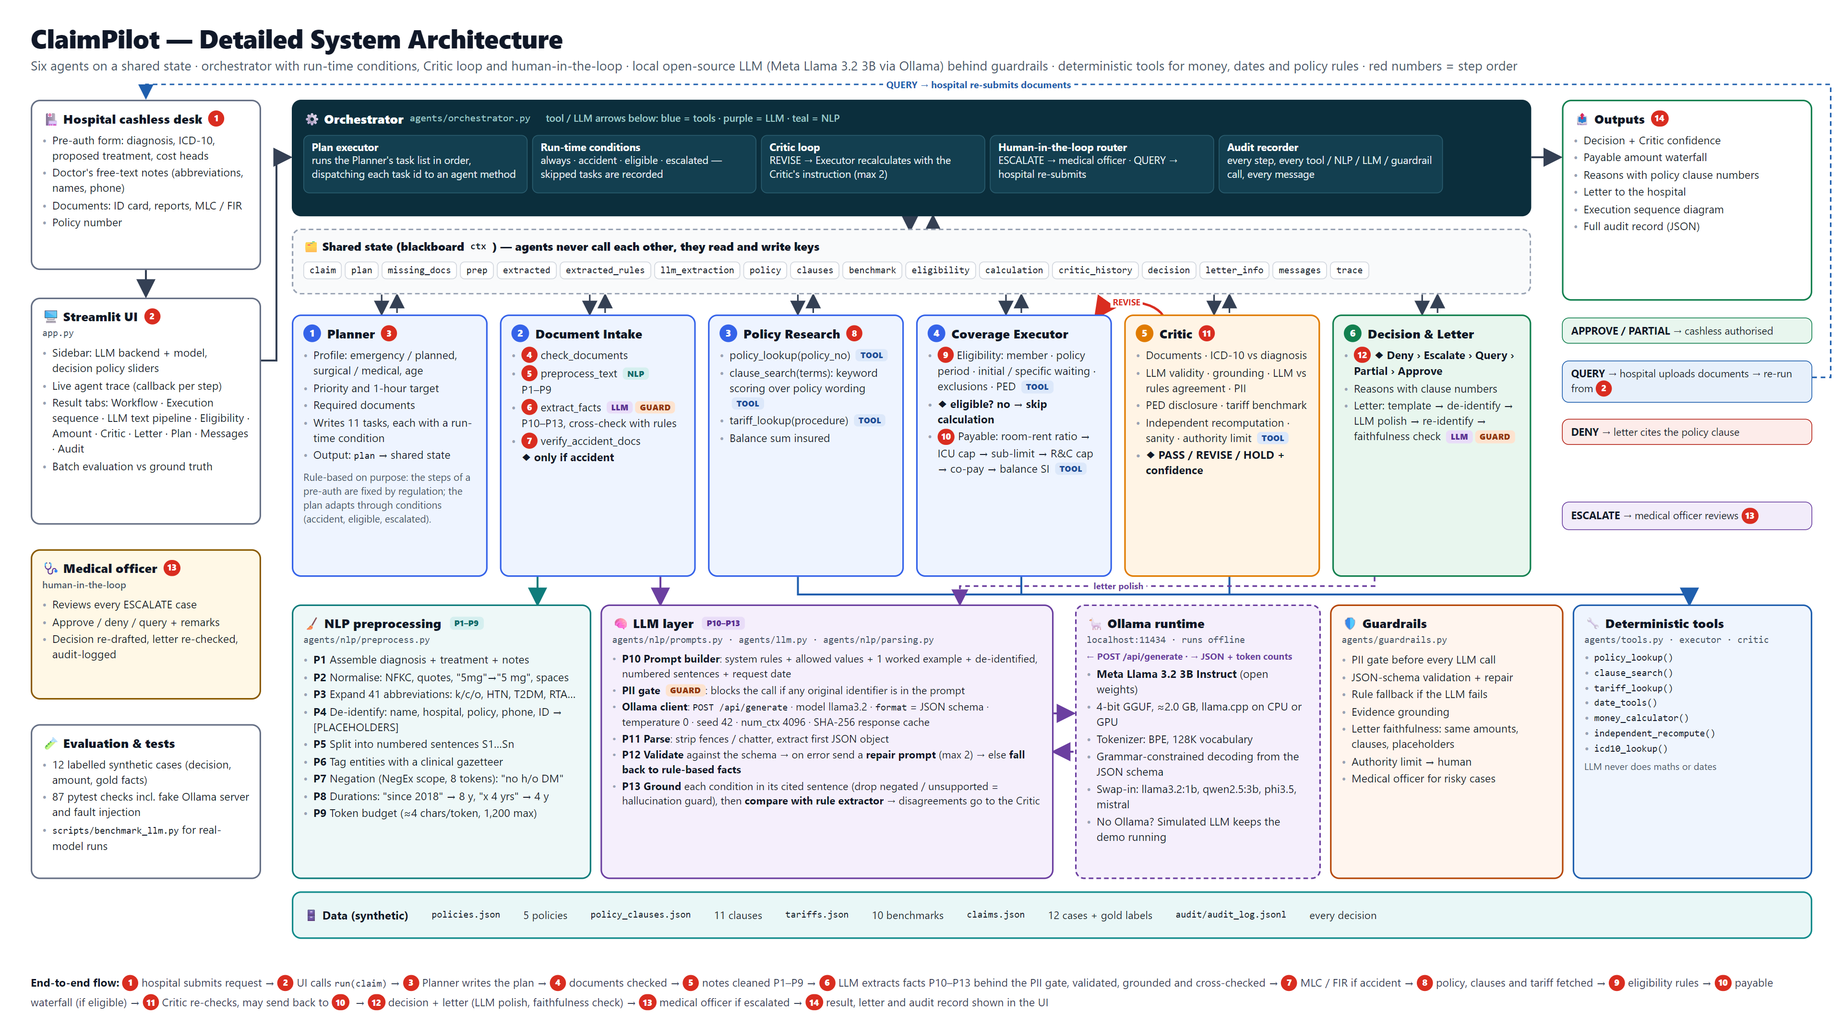
Figure 1. ClaimPilot system architecture: presentation, orchestrator and shared state, the six agents and the human, the capability layer (NLP, LLM, Ollama runtime, guardrails, deterministic tools) and data. Red numbers give the end-to-end order of a request.

4.4 The shared state (blackboard)
All agents read from and write to one Python dictionary, ctx. Table 6 lists the main keys and which agent writes them. Because state is shared and agents are stateless, any step can be re-run (as the revision loop does) and the whole state can be serialised into the audit record.
Table 6. Keys of the shared state and their writers
Key | Written by | Contents
claim | Orchestrator | A copy of the incoming request
plan | Planner | Priority, claim profile, required documents, special checks, 11 tasks with conditions
missing_docs | Document Intake | Mandatory documents not attached (plus MLC/FIR for accidents)
prep | Document Intake | Output of P1–P9: cleaned, de-identified, numbered sentences and tagged entities
extracted, extracted_rules, llm_extraction | Document Intake | Final facts, the rule-based facts, and every LLM attempt, grounding and comparison
policy, clauses, benchmark | Policy Research | Policy schedule, retrieved clauses, tariff range
eligibility, calculation | Coverage Executor | Checks with PASS / WARN / FAIL, and the payable waterfall
critic, critic_history | Critic | Findings, actions, verdict, confidence, the eligibility on rule-based facts
decision, letter_info | Decision & Letter | Decision, amount, reasons, escalation causes, letter and how it was produced
trace, messages, status | Orchestrator | Every step with its tool / NLP / LLM / guardrail calls, every message, each task's status

4.5 How the Orchestrator executes a request
The Planner writes a list of 11 tasks. Each task names its agent and a run-time condition (always, accident, eligible or escalated). The Orchestrator walks the list, skips any task whose condition is false, and runs the rest through one helper, _step(), which opens a trace scope, calls the agent, records the result and logs two messages. In pseudo-code:
ctx = new shared state(claim)
step(Planner.plan) # writes ctx.plan (11 tasks)
for task in ctx.plan.tasks:
if task.id == 'human_review':
status = 'awaiting human' if decision == ESCALATE else 'not needed'
elif not condition(task.when): # always | accident | eligible | escalated
status = 'skipped'
elif task.id == 'validate':
repeat:
step(Critic.run)
if verdict != REVISE or revisions == max_revisions: break
revisions += 1
step(Executor.calculate, cap_at_tariff) # Critic -> Executor revision loop
else:
step(agent_of(task))

def step(agent, fn):
calls = trace.begin() # tools, NLP stages, LLM and guardrails register here (contextvars)
out = fn(ctx) # the agent reads and writes ctx
trace.end(); ctx.trace.append(agent, task, out.summary, out.details, ms, calls)
ctx.messages += [Orchestrator -> agent: task, agent -> Orchestrator: summary]
Table 7. The 11-task plan written by the Planner
# | Task | Agent | Runs when
1 | check_documents | Document Intake | always
2 | preprocess_text | Document Intake | always
3 | extract_facts | Document Intake | always
4 | verify_accident_docs | Document Intake | accident
5 | research_policy | Policy Research | always
6 | check_eligibility | Coverage Executor | always
7 | calculate_payable | Coverage Executor | eligible
8 | validate | Critic | always
9 | decide | Decision & Communication | always
10 | draft_letter | Decision & Communication | always
11 | human_review | Medical officer (human) | escalated
There are three loops. The revision loop lets the Critic send the amount back to the Executor with an instruction to cap it at the network tariff (at most twice). The query loop lets the hospital upload missing documents, after which the whole workflow re-runs. The human-in-the-loop pauses an escalated case until a medical officer approves, denies or queries it; the letter is then redrafted and the decision is logged as the officer's.

4.6 The agents in detail
Table 8. Agents, tasks and tools
Agent | Tasks | Tools | Output written to the shared state
Planner | plan | none (rule-based profiling) | Priority (emergency → 1-hour target), required documents, special checks (senior citizen, surgical benchmark), 11-task plan
Document Intake | check_documents, preprocess_text, extract_facts, verify_accident_docs | NLP pipeline P1–P13, LLM client, PII gate | Missing documents; cleaned text; facts: procedure, chronic conditions with durations, cosmetic intent, functional need, accident
Policy Research | research_policy | policy_lookup, clause_search, tariff_lookup | Policy schedule, up to 6 clauses, tariff benchmark
Coverage Executor | check_eligibility, calculate_payable | date tools, money calculator, assess_eligibility | Eligibility checks; payable waterfall
Critic | validate | independent_recompute, icd10_lookup, assess_eligibility on the rule-based facts | 11+ findings with actions (revise / query / escalate), verdict, confidence
Decision & Letter | decide, draft_letter | decision ladder, LLM client, PII gate, faithfulness check | Decision, amount, reasons, escalation causes, letter
Medical officer (human) | human_review | dashboard form | Final decision with remarks; reasons follow the escalation cause

4.7 How the agents interact: a real run
Table 9 is the actual trace of request PA-2026-0107 (a 64-year-old woman needing an angioplasty, with hypertension and diabetes she did not declare). It shows the 10 agent steps in order and the tools, NLP stages, LLM and guardrail calls each step made. The run produced 23 recorded messages between the participants; the dashboard draws them as a UML sequence diagram (Figure 2).
Table 9. Trace of PA-2026-0107: every agent step and the calls made inside it
# | Agent · task | Calls made inside the step | Result written to the shared state
1 | Planner  plan | — | Priority NORMAL (planned). 11 tasks planned (3 conditional); 2 claim-specific checks.
2 | Document Intake  check_documents | — | All mandatory documents present.
3 | Document Intake  preprocess_text | nlp: P1 Assemble  nlp: P2 Normalise  nlp: P3 Expand abbreviations  nlp: P4 De-identify (PII)  nlp: P5 Segment sentences  nlp: P6 Tag clinical entities  nlp: P7 Detect negation  nlp: P8 Normalise durations  nlp: P9 Token budget | 16 abbreviations expanded, 2 identifier(s) masked, 8 sentences, 9 entities (0 negated), ~162 tokens.
4 | Document Intake  extract_facts | guardrail: PII gate  llm: Mock LLM (simulated, offline) | Facts via Mock LLM (simulated, offline): procedure = angioplasty; chronic = hypertension (8 y), diabetes (4 y); accident = False. 1 LLM attempt(s). LLM and rules agree.
5 | Policy Research  research_policy | tool: policy_lookup  tool: clause_search  tool: tariff_lookup | Senior Care Shield · SI ₹3,00,000 · balance ₹3,00,000. Clauses 4.3, 2.1, 3.4, 3.5, 4.1, 4.2. Tariff: PTCA with single stent: ₹1,50,000–₹2,80,000.
6 | Coverage Executor  check_eligibility | tool: date_tools | 7 checks run. ELIGIBLE. Warnings: PED disclosure: hypertension, PED disclosure: diabetes.
7 | Coverage Executor  calculate_payable | tool: money_calculator | Requested ₹2,50,000 → payable ₹2,00,000 after 1 adjustment(s).
8 | Critic  validate | tool: icd10_lookup  tool: independent_recompute | Verdict HOLD · confidence 70% · 10 checks, 1 failed · actions: escalate.
9 | Decision & Communication  decide | — | Escalated to medical officer: ₹2,00,000. 1 reason(s) recorded.
10 | Decision & Communication  draft_letter | guardrail: PII gate  llm: Mock LLM (simulated, offline)  guardrail: Letter faithfulness | Letter drafted via Mock LLM (simulated: returns the template unchanged).
The pattern is the same for every request: the Orchestrator sends a task, the agent works on the shared state, calling its tools, and returns a one-line summary. Agents learn about each other only through the state: the Executor reads the facts the Intake agent wrote; the Critic reads what the Executor computed; the Decision agent reads the Critic's actions.

4.8 Execution sequence diagram
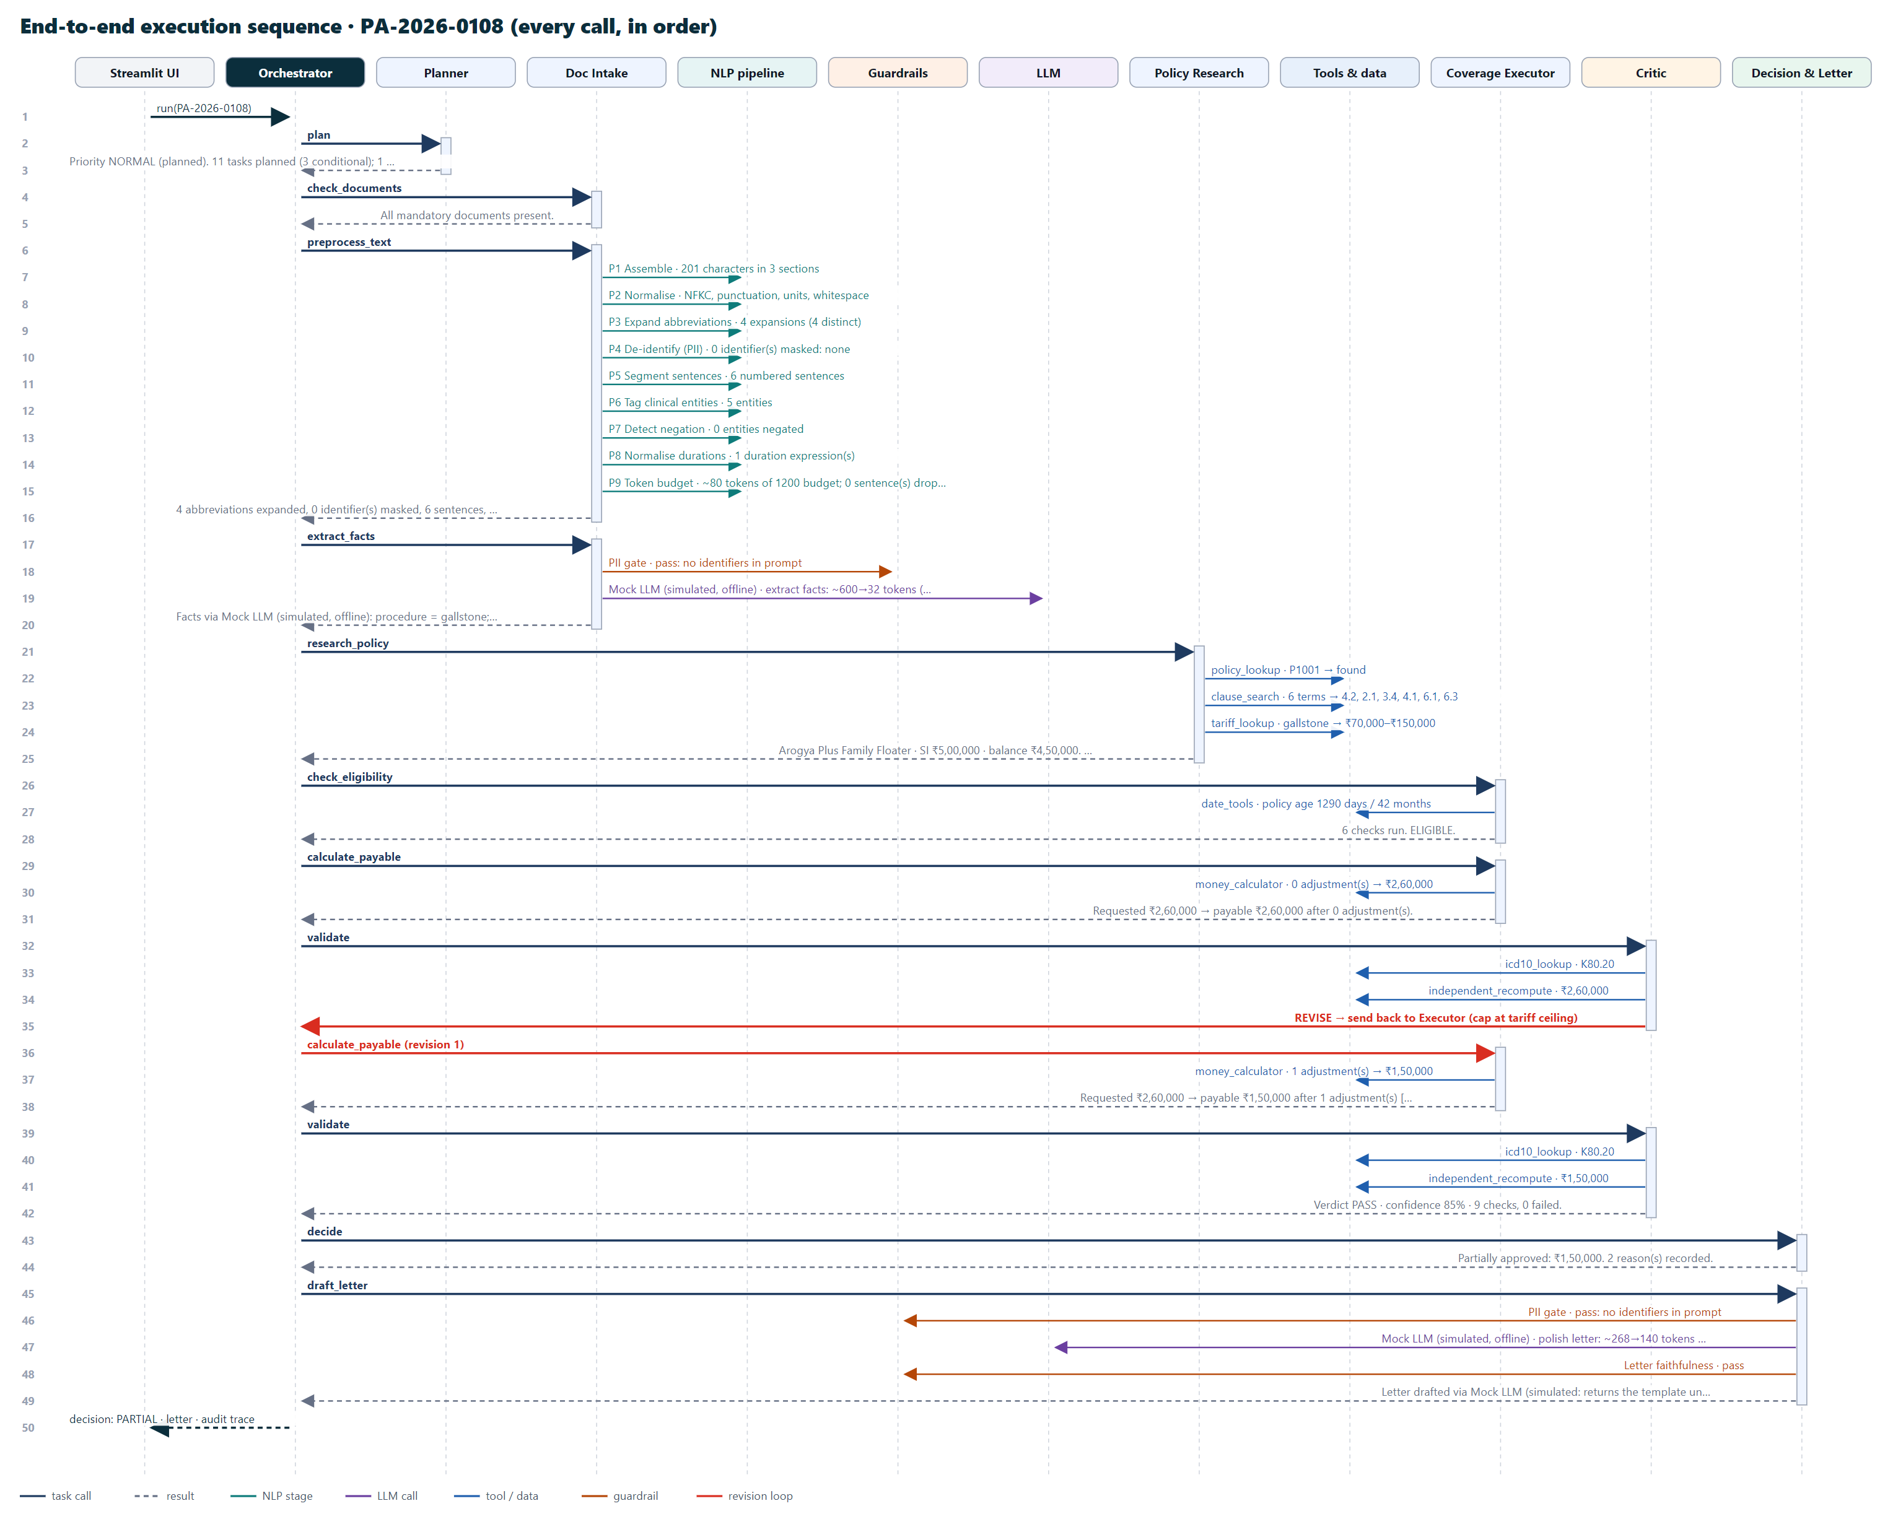
Figure 2. Execution sequence of a real run (PA-2026-0108), drawn automatically from the audit trace: 50 messages between the UI, Orchestrator, agents, NLP pipeline, guardrails, LLM and tools. The red arrow is the Critic sending the amount back to the Executor.

5. How the text is prepared for the LLM (stages P1–P13)
Before any text reaches the language model it passes through nine deterministic NLP stages (P1–P9). After the model answers, four more stages (P10–P13 around the call) build the prompt, parse, validate and ground the answer. The same cleaned text also feeds a rule-based extractor, so the system has two independent readings of every note to compare. Figure 3 (after this section) shows the whole pipeline; this section follows the real example PA-2026-0107 through every stage.
Input (raw doctor's notes):
Mrs Lata Kulkarni, 64F, c/o exertional chest pain x 3 mths. K/c/o HTN since 2018 on Tab. Amlodipine 5mg once daily. T2DM x 4 yrs on Tab. Metformin 500mg twice daily. CAG shows 85% LAD stenosis. Planned PTCA with DES. Attendant contact 9000000001.

5.1 Stages P1–P9: cleaning and understanding the text
Table 10. Pre-processing stages with the real output for PA-2026-0107
Stage | What it does | Result on PA-2026-0107
P1 Assemble | Collects diagnosis, proposed treatment and notes as three sections | 319 characters in 3 sections
P2 Normalise | Unicode NFKC, straight quotes and dashes, removes control characters, spaces number–unit pairs, collapses whitespace | 5mg → 5 mg, 500mg → 500 mg
P3 Expand | Replaces 41 medical abbreviations, longest first; acronyms are case-sensitive, slash forms match whole tokens; x 4 yrs → for 4 years | 16 expansions (12 distinct): K/c/o HTN → Known case of hypertension, T2DM x 4 yrs → type 2 diabetes mellitus for 4 years
P4 De-identify | Masks the patient's name and its parts, hospital, policy and claim numbers, phones, e-mails, Aadhaar / PAN and any titled name (Dr., Mrs …); the mapping stays on the machine | Mrs Lata Kulkarni → Mrs [PATIENT]; 9000000001 → [PHONE_1]
P5 Segment | Splits into numbered sentences S1…Sn, protecting abbreviations such as Dr. and No. | 8 numbered sentences
P6 Tag entities | Gazetteer match, longest first and non-overlapping: conditions, procedures, medications, investigations, flags (cosmetic, accident, functional, declared) | 9 entities: hypertension, diabetes (CONDITION); angioplasty (PROCEDURE); amlodipine, metformin (DRUG); coronary angiography (TEST)
P7 Negation | NegEx-style: a trigger such as no history of negates the next 8 tokens unless a terminator (but, ;) intervenes; post-triggers (ruled out) negate backwards; uncertainty cues are flagged | 0 entities negated (in PA-0111, No h/o DM/HTN/asthma negates all three)
P8 Durations | Converts since 2018, for 4 years, x 3 mths, 2 years ago to years and attaches each to the nearest condition | hypertension → 8 years (2026 − 2018); diabetes → 4 years
P9 Token budget | Estimates ≈4 characters per token; above 1,200 tokens drops low-value sentences (notes without entities first) | ~162 tokens of 1200 budget; 0 sentence(s) dropped
After P1–P9, the numbered, de-identified sentences sent to the model:
S1: Diagnosis: Coronary artery disease, double vessel.
S2: Proposed treatment: percutaneous transluminal coronary angioplasty with drug-eluting stent to left anterior descending artery.
S3: Mrs [PATIENT], 64F, complaints of exertional chest pain for 3 months.
S4: Known case of hypertension since 2018 on Tablet Amlodipine 5 mg once daily.
S5: Type 2 diabetes mellitus for 4 years on Tablet Metformin 500 mg twice daily.
S6: Coronary angiography shows 85% left anterior descending artery stenosis.
S7: Planned percutaneous transluminal coronary angioplasty with drug-eluting stent.
S8: Attendant contact [PHONE_1].

5.2 Stage P10: building the prompt
The prompt has a system part with seven extraction rules (extract only what is written, ignore negated findings, cite the sentence number, use the allowed values, what counts as an accident, cosmetic intent or functional need, never output identifiers) and a user part with four blocks: the allowed values, one worked example (input and the exact JSON expected), and the task (request date, de-identified patient line and the numbered sentences), ending with Output:. The JSON schema of the answer (Appendix A) is sent separately in Ollama's format field.
### Allowed values
procedure_key: appendectomy, cataract, joint replacement, hernia, rhinoplasty, angioplasty, gallstone, fracture fixation, dental surgery, medical management
condition: hypertension, diabetes, osteoarthritis, asthma, thyroid disorder, chronic kidney disease, copd

### Example
Input:
Request date: 2025-03-01
Patient: [PATIENT], age 46, M
S1: Diagnosis: Right inguinal hernia.
S2: Proposed treatment: Laparoscopic hernia repair.
S3: Known case of asthma for 10 years on inhaler.
S4: No history of diabetes mellitus or hypertension.
Output:
{"procedure_key": "hernia", "chronic_conditions": [{"condition": "asthma", "duration_years": 10, "evidence_sentence": 3}], "cosmetic_intent": false, "functional_need": false, "accident": false}

### Task
...
### Task
Input:
Request date: 2026-10-10
Patient: [PATIENT], age 64, F
S1: Diagnosis: Coronary artery disease, double vessel.
S2 ... S8 (the sentences above)
Output:

5.3 The PII gate
Just before the call, a two-way privacy check inspects the final prompt. It blocks the call if (a) any identifier masked in P4 is still present, or (b) an independent scan that does not rely on P4 finds the claim's own identifiers (patient name and each part of it, hospital, policy or claim number), any number of 10 or more digits, an e-mail address or a titled personal name. For PA-0107 the gate result was: pass. If the gate blocks, the LLM is not called and the rule-based facts are used.

5.4 Stages P11–P13: from the model's text to trusted facts
- P11 Parse: strips code fences and chatter, extracts the first balanced JSON object, and canonicalises it (lower-case values, condition synonyms such as high blood pressure → hypertension, "S4" → 4).
- P12 Validate: checks types, allowed values and required keys against the schema. If invalid, a repair prompt quoting the bad output and the validator's errors is sent (at most two retries); if it is still invalid, the rule-based facts are used.
- P13 Ground and compare: every chronic condition must appear, un-negated, in the sentence the model cited (or anywhere in the notes, in which case the citation is corrected); a negated or absent condition is rejected as a hallucination. A duration written in the text replaces the model's, because numbers come from deterministic code. The grounded facts are then compared field by field with the rule-based extractor's facts for the Critic.
Table 11. Grounding and comparison for PA-2026-0107
Claim by the model | Cited sentence | Grounding status
hypertension | S4 | grounded
diabetes | S5 | grounded
procedure: angioplasty | — | grounded

Table 12. LLM facts compared with the rule-based extractor for PA-2026-0107
Field | LLM | Rule-based extractor | Agree
procedure_key | angioplasty | angioplasty | yes
cosmetic_intent | false | false | yes
functional_need | false | false | yes
accident | false | false | yes
chronic_conditions | diabetes (4 y), hypertension (8 y) | diabetes (4 y), hypertension (8 y) | yes

5.5 The complete text pipeline
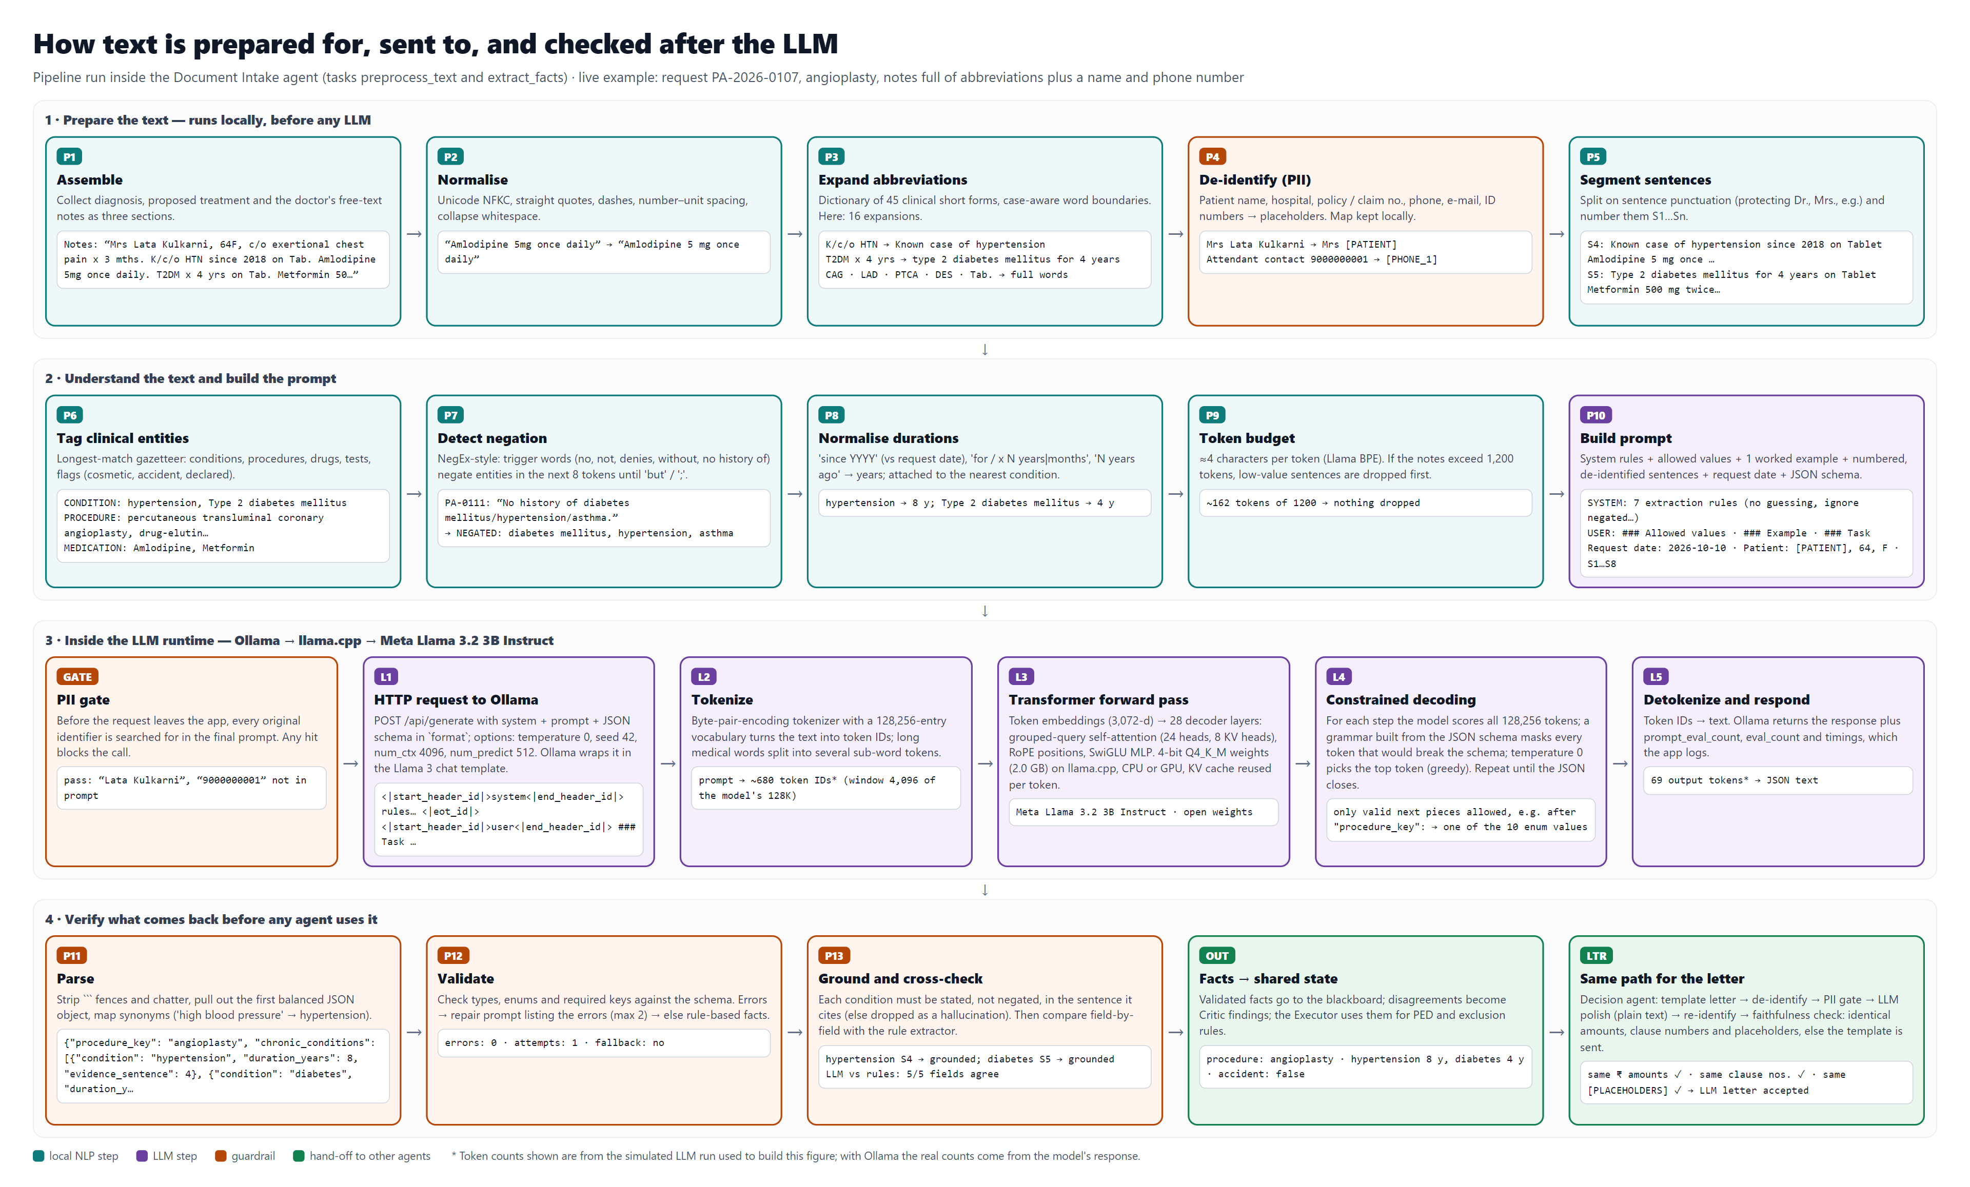
Figure 3. Stages P1–P13 with live example data, including what happens inside the Ollama runtime between the PII gate and parsing.

6. How the LLM works and where it is called

6.1 The LLM does not orchestrate the agents
A common agentic design lets a language model choose which agent or tool to call next (for example in a ReAct loop). ClaimPilot deliberately does not do this. The control flow is decided by the Planner's plan and the Orchestrator, which are deterministic Python: the same request always takes the same path, every branch has an explicit condition, and the path can be audited and tested. The LLM is a tool used in exactly two places:
- Fact extraction, called by the Document Intake agent in task extract_facts: read the de-identified, numbered sentences and return the clinical facts as JSON.
- Letter polishing, called by the Decision & Letter agent in task draft_letter: rewrite the opening paragraph of a template letter in a clear, polite tone, keeping every reason, amount and clause number.
This split is the central design decision. Insurance decisions must be exact, repeatable and explainable, which language models are not. So the model handles what it is good at (reading messy clinical language) and everything else is code. Table 13 summarises who decides what.
Table 13. Who decides what
Decision | Made by
Which agent runs next; whether a task is skipped; loops | Orchestrator, following the Planner's plan and conditions
What the notes say (procedure, conditions, flags) | LLM, then validated, grounded and cross-checked against the rule-based extractor
Durations and all numbers | Deterministic code (P8); the text's value overrides the model's
Eligibility, payable amount, tariff cap | Coverage Executor tools (plain Python)
Whether the results are trustworthy | Critic (independent checks and recomputation)
Final decision | Decision ladder in code; a human for escalated cases
Letter wording | Template in code; LLM may polish the opening paragraph under the faithfulness check

6.2 What happens inside the model during a call
The default model is Meta Llama 3.2 3B Instruct, a decoder-only transformer (28 layers, 3,072 hidden size, grouped-query attention with 24 query and 8 key-value heads, a 128,256-token vocabulary). It runs locally in Ollama, which uses llama.cpp and a 4-bit (Q4KM) quantised model file of about 2 GB, on the CPU or GPU. One call proceeds as follows:
- Chat template: Ollama wraps the system and user prompts in the model's chat format.
- Tokenisation: the text is split into sub-word tokens with byte-pair encoding (the PA-0107 prompt is about 690 tokens).
- Prompt processing: all prompt tokens pass through the 28 transformer layers in parallel; self-attention lets every token use the whole context, so the model can connect hypertension in S4 with since 2018.
- Generation, one token at a time: the network produces a probability for every next token. Grammar-constrained decoding masks every token that would break the JSON schema, so the output can only be valid JSON with allowed values. With temperature 0 and a fixed seed (42) the most likely allowed token is always chosen, so the same prompt gives the same answer.
- Stop: generation ends when the JSON object is complete (at most 512 new tokens); Ollama returns the text with token counts and timings.
The model does not plan, call tools or keep memory between calls; each call is a single, stateless reading task. Its reasoning is guided by the system rules and the one worked example in the prompt (few-shot prompting), which shows how a negated history (No history of diabetes mellitus or hypertension) must be ignored and how a cited sentence number is given. Responses are cached by a SHA-256 hash of the model, options and prompt, so an identical request is not sent twice.

6.3 A real model answer, and how the pipeline checked it
During the benchmark, Qwen 2.5 7B answered PA-0107 with this JSON (taken from results/benchmark_qwen2.5_7b.json):
{ "procedure_key": "angioplasty",
"chronic_conditions": [
{"condition": "hypertension", "duration_years": 4, "evidence_sentence": 4},
{"condition": "diabetes", "duration_years": 4, "evidence_sentence": 5} ],
"cosmetic_intent": false, "functional_need": false, "accident": false }
The answer was valid JSON on the first try, both conditions were grounded in the cited sentences, and the procedure was right. But the model gave 4 years for hypertension, while S4 says since 2018, which is 8 years at the 2026 request date. Grounding replaced the model's value with the duration computed from the text (status duration corrected to 8 y), so the Executor still found that the disease was present before the policy started and not declared, and the case was escalated correctly. Without this check, a two-year-old policy with a four-year condition would still have been flagged, but in other cases a shortened duration can hide a pre-existing disease; Section 10.3 shows this happening under fault injection.

6.4 The letter path
The Decision agent first builds a template letter in code (header, decision paragraph, bullet list of reasons with clause numbers, officer remarks, sign-off). The letter is de-identified (patient, hospital, numbers, names in remarks), passes the PII gate and is sent to the model with an instruction to rewrite only the opening paragraph and copy every other line exactly. The answer is cleaned (code fences and echoed <<<LETTER markers removed), re-identified, and accepted only if the faithfulness check passes: the same ₹ amounts, clause numbers and placeholders, every reason word for word, no new amounts, and no wording of the opposite decision (for example pleased to authorise in a denial). Otherwise the template letter is sent.

6.5 Model settings
Setting | Value | Why
Model | Llama 3.2 3B Instruct (default); Qwen 2.5 7B Instruct (benchmarked); others selectable | Open weights; runs offline on a laptop
Runtime | Ollama (llama.cpp), 4-bit GGUF | No paid API; patient data never leaves the machine
temperature / seed | 0 / 42 | Repeatable answers
numctx / numpredict | 4,096 / 512 tokens | Room for prompt and answer
format | JSON schema (falls back to plain JSON mode on old Ollama) | Grammar-constrained, always parseable output
Fallback | Simulated LLM (rule-based, clearly labelled) | Demo works without Ollama

7. Decision logic

7.1 Eligibility rules (Coverage Executor)
The eligibility rules are a pure function assess_eligibility(claim, policy, facts), so the Critic can re-run them on the rule-based facts. For PA-0107 they produced:
Check | Result | Detail
Member covered | PASS | Lata Kulkarni is on policy
Policy in force | PASS | Period 2025-01-15 to 2027-01-14; request on 2026-10-10 (clause 2.1)
Initial waiting period | PASS | Policy age 633 days vs 30 required (clause 4.1)
Specific waiting period | PASS | 'angioplasty' not on specific waiting list (clause 4.2)
Permanent exclusions | PASS | No exclusion triggered
PED disclosure: hypertension | WARN | Present ~8 yrs (before inception) but not declared at proposal; clinically related to this treatment (clause 4.3)
PED disclosure: diabetes | WARN | Present ~4 yrs (before inception) but not declared at proposal; clinically related to this treatment (clause 4.3)
The rules are: member covered; policy in force (2.1); initial 30-day waiting period unless waived or an accident (4.1); specific waiting period for listed procedures (4.2); permanent exclusions, where cosmetic treatment is excluded unless there is a functional need or an accident and dental treatment is excluded unless caused by an accident (5.1, 5.2); and pre-existing diseases (4.3). A declared, related disease must have served its waiting period; a disease present before the policy started but not declared raises a warning that the Critic turns into an escalation.

7.2 Payable amount waterfall
If the claim is eligible, the Executor computes the payable amount step by step. For PA-2026-0103 (knee replacement, senior-citizen policy): requested ₹3,00,000 → room-rent proportionate deduction −₹78,000 (room ₹5,000/day against a ₹3,000 cap, so 60% of room, surgery and other charges) → sub-limit for joint replacement −₹72,000 → 20% co-pay −₹30,000 → payable ₹1,20,000. The order is: requested estimate, room-rent ratio and ICU cap, procedure sub-limit, reasonable-and-customary cap (only when the Critic asks), co-pay, balance sum insured.

7.3 The Critic's checks
Table 14. Critic findings for PA-2026-0107
Check | Status | Action | Detail
Document completeness | PASS | — | All mandatory documents present
ICD-10 consistency | PASS | — | I25.10 matches 'Coronary artery disease, double vessel'
LLM output validity | PASS | — | Schema-valid JSON on first attempt
Evidence grounding | PASS | — | Every extracted condition is supported by a cited sentence
Extractor agreement | PASS | — | Agree on every field. Expected: the simulated LLM reuses the rule extractor, so this is not independent evidence
PII protection | PASS | — | No patient identifiers were sent to the LLM
PED disclosure | FAIL | escalate | Undisclosed pre-existing condition(s): hypertension, diabetes. Needs medical officer review before any approval
Tariff benchmark | PASS | — | Estimate within 25% of network ceiling ₹2,80,000
Amount re-verification | PASS | — | Independent recomputation agrees: ₹2,00,000
Amount sanity | PASS | — | 0 ≤ payable ≤ requested
Each failed check carries an action: revise (send the amount back to the Executor), query (ask the hospital) or escalate (a human must decide). The verdict is REVISE if any finding asks for a revision, HOLD if any other action is present, and PASS otherwise. Confidence is 1 minus penalties (low 5%, medium 15%, high 30%); for PA-0107 it was 70% with verdict HOLD.
The extractor-agreement check is the key safeguard against model errors. When the LLM and the rule-based extractor disagree, the Critic re-runs the eligibility rules on the rule-based facts. A disagreement on the procedure or the accident flag always needs a human; a disagreement on other fields escalates only if it changes the eligibility outcome, and is otherwise just a warning.

7.4 Decision ladder and human review
- DENY only on failed checks that hold identically under both the LLM facts and the rule-based facts, so a misread note can never deny a claim. Reasons cite the clause.
- ESCALATE when the Critic asks for it, or when the denial rests on disputed facts. The case waits for a medical officer.
- QUERY when documents are missing or the ICD-10 code does not match the diagnosis.
- PARTIAL when the payable amount is below the request; each deduction is a reason with its clause.
- APPROVE otherwise.
For an escalated case the medical officer chooses approve, deny or query and may add remarks. The letter's reason follows the escalation cause (for PA-0107, an undisclosed pre-existing disease under clause 4.3); approving a case escalated for an amount mismatch pays the lower of the two independently computed amounts.

7.5 Decision logic diagram
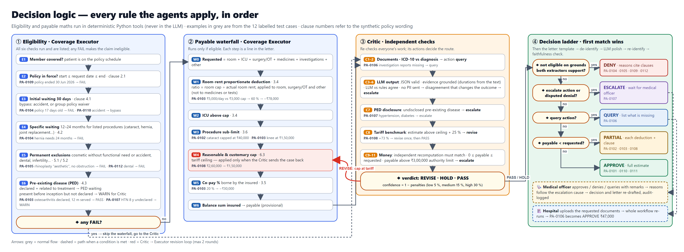
Figure 4. Every rule the agents apply, in order: eligibility checks, the payable waterfall, the Critic's checks and the decision ladder, with examples from the labelled cases.

8. Guardrails, privacy and audit
Table 15. Cross-cutting safeguards
Concern | Mechanism | Where
Patient privacy | De-identification (P4) and a two-way PII gate before every LLM call; the model runs locally | nlp/preprocess.py, guardrails.py
Invalid model output | JSON schema in the request, local validation, repair prompt, rule fallback | nlp/parsing.py, intake.py
Hallucinated facts | Grounding in the cited sentence; negated or absent conditions rejected; text durations win | nlp/parsing.py
Model errors that change outcomes | Second, rule-based extractor; Critic re-runs the rules on its facts; robust-denial rule | critic.py, decision.py
Wrong amounts | Two independently written calculations must agree | executor.py, critic.py
Unfaithful letters | Faithfulness check: amounts, clauses, reasons verbatim, no opposite-decision wording | guardrails.py
Accountability | Per-run trace and downloadable audit record; append-only log where each entry stores the SHA-256 of the previous one | trace.py, orchestrator.py
Robustness | Fault injection: 12 kinds of corrupted LLM answers on every case | faults.py, scripts/fault_injection.py

9. Implementation

9.1 Technology
- Python 3.11; agents, NLP and tools in plain Python with no agent framework, so every step is visible.
- Ollama with Llama 3.2 3B / Qwen 2.5 7B; requests for the HTTP client.
- Streamlit dashboard with Altair charts, a custom light / dark theme and Graphviz workflow diagrams.
- pytest (87 tests) including a fake Ollama HTTP server; Playwright to render the architecture diagrams.

9.2 Code structure
app.py Streamlit dashboard
agents/orchestrator.py plan executor, conditions, loops, human review, audit log
agents/planner.py intake.py research.py executor.py critic.py decision.py
agents/nlp/preprocess.py P1-P9 agents/nlp/prompts.py P10 prompt + schema
agents/nlp/parsing.py P11-P13 parse, validate, ground, compare
agents/llm.py Ollama client + simulated LLM
agents/guardrails.py PII gate, de/re-identification, letter faithfulness
agents/tools.py trace.py deterministic tools, call recorder
agents/faults.py evaluation.py fault injection, scoring
viz/ sequence diagram, dashboard theme, charts
data/ synthetic dataset
tests/ 87 automated tests
scripts/ benchmark, fault injection, diagrams

9.3 The dashboard
The dashboard shows the request, a live timeline of agent steps while the agents work, the agent pipeline coloured by what happened, and the decision with ten detail tabs: workflow, execution sequence, the LLM text pipeline, eligibility, amount, Critic, letter, plan, messages and audit. A sidebar selects the model, injects LLM errors for demonstrations and sets the decision policy.
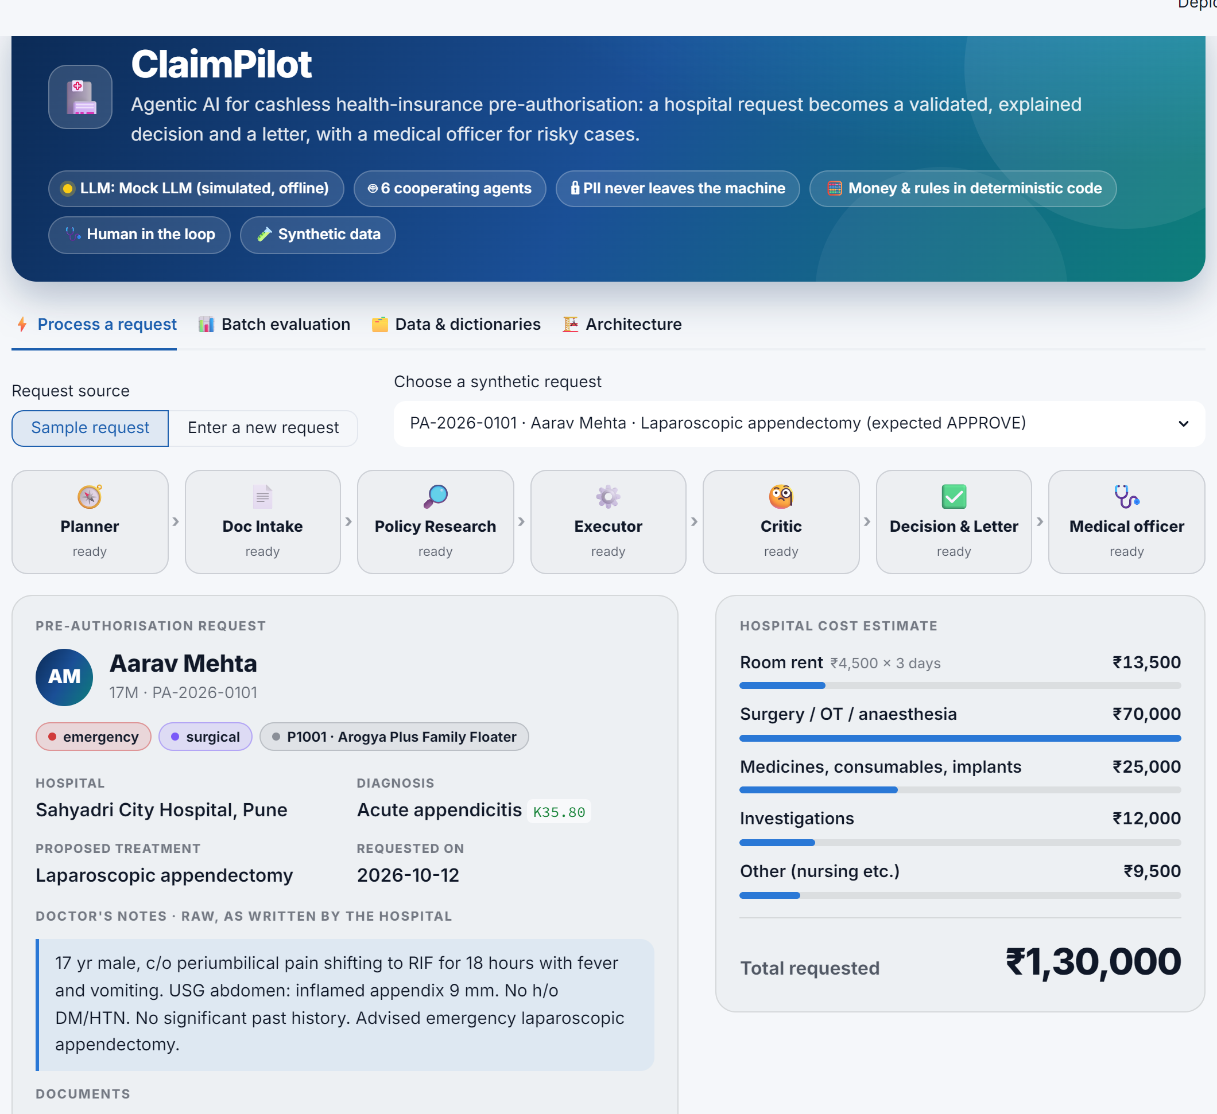
Figure 5. Dashboard: request card, cost breakdown and the six agents plus the medical officer.
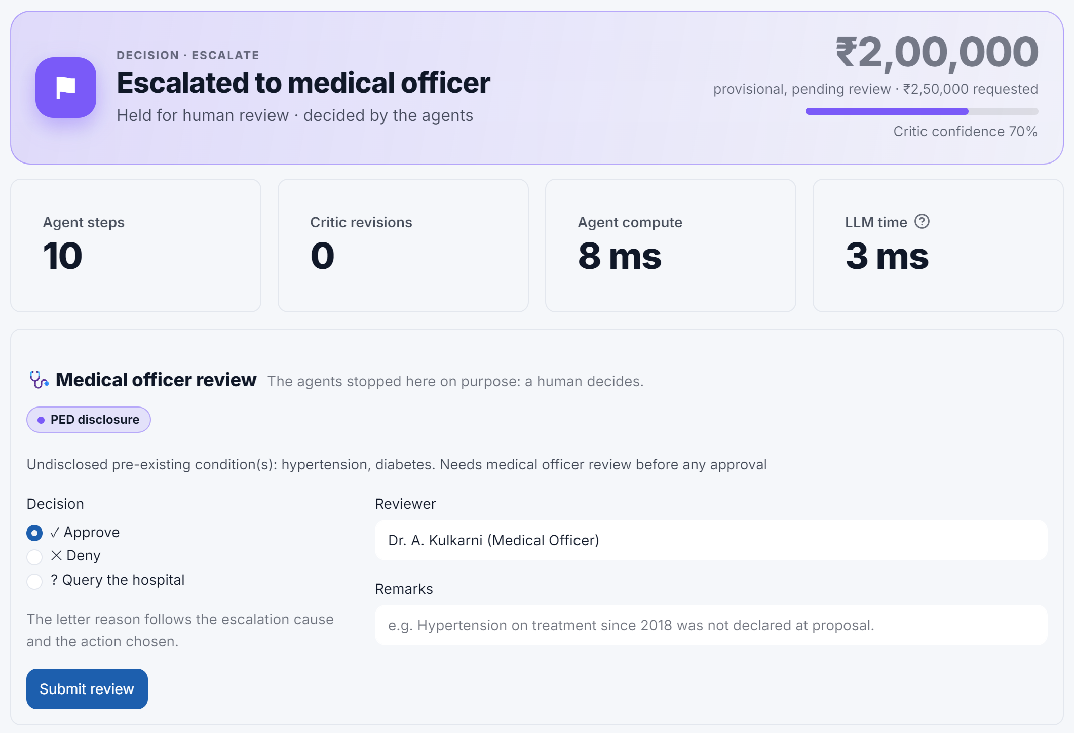
Figure 6. PA-2026-0107 escalated: the decision card and the medical officer's review form.
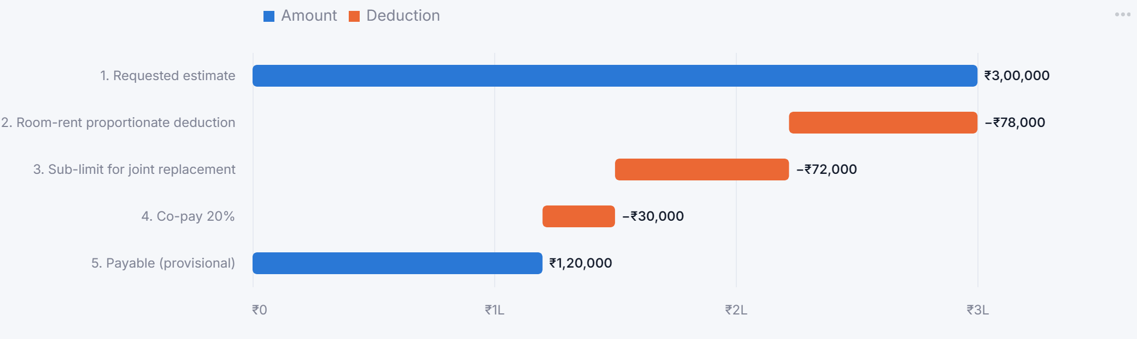
Figure 7. Payable waterfall for PA-2026-0103, from the ₹3,00,000 estimate to ₹1,20,000.

9.4 Running the project
pip install -r requirements.txt
ollama pull llama3.2 # optional: real open-source LLM
streamlit run app.py # dashboard at http://localhost:8501
python -m pytest -q # 87 tests
python scripts/benchmark_llm.py --model qwen2.5:7b --timeout 900
python scripts/fault_injection.py --strict

10. Testing and validation

10.1 Automated tests
Test file | Tests | What is covered
test_pipeline.py | 41 | Decisions, amounts and facts for all 12 cases; revision loop; conditional tasks; query re-submission; human review reasons and amounts; audit record
test_safety.py | 31 | Every injected fault on every case; duration correction; disputed denials; PII scan and its false-positive rate; masking of officer remarks; letter checks; audit hash chain
test_ollama_integration.py | 8 | The real Ollama client against a fake Ollama server: schema and temperature sent, no PII in prompts, repair retry, fallbacks, hallucination rejection, unfaithful and echoed letters, old servers
test_text_pipeline.py | 7 | Normalisation, abbreviations, PII masking, negation, durations, JSON parsing, schema validation
All 87 tests pass.

10.2 Results on the labelled cases
Table 16. Accuracy on the 12 labelled cases
Measure | Simulated LLM | Qwen 2.5 7B (real, CPU)
Decisions correct | 12/12 | 12/12
Wrong decisions sent | 0 | 0
Amounts exact (6 cases) | 6/6 | 6/6
Procedure / conditions / cosmetic / accident | 100% each | 100% each
functional_need | 100% | 67% (25% before a prompt fix)
Valid JSON on first attempt | 12/12 | 12/12
Durations corrected by grounding | 0 | 1 (PA-0107, 4 → 8 years)
Cases with extractor disagreement | 0 | 4, all judged not to change the outcome
LLM letters accepted by the faithfulness check | 12/12 | 12/12
Mean LLM time per case | < 10 ms | ≈ 16 s (≈ 29 s when the machine was busy)
The simulated LLM answers with the same rule extractor the Critic cross-checks against, so its extraction score measures the rule extractor, not a language model. That is why the real-model benchmark matters. The default Llama 3.2 3B has not been benchmarked yet.
The real model also exposed three problems the simulated model hides, all fixed: an ambiguous prompt rule for functional_need; the model echoing the <<<LETTER markers into the letter; and the model rewording letter reasons, which the original faithfulness check did not verify.

10.3 Fault injection: breaking the LLM on purpose
FaultyLLM wraps any model and corrupts its answers in twelve ways: broken JSON, an invented condition, a negated condition reported as present, wrong durations, dropped conditions, a swapped procedure, flipped accident / cosmetic / functional flags, and letters with a changed amount, a dropped reason or the opposite decision. Each fault runs on every case; 115 runs change the model's answer. An outcome is correct, held for review (escalated or queried: safe, but extra work) or wrong (a wrong decision went out).
Table 17. Fault injection before and after hardening (115 corrupted runs)
 | Wrong decisions sent | Corrupted letters sent
Before hardening | 14 | 17
After hardening | 0 | 0
The 14 failures came from four gaps, now closed: a wrong duration hid an undisclosed disease (the text's duration now wins); a flipped functional_need flag paid for cosmetic surgery (the Critic now re-runs the rules on the rule-based facts and escalates if the outcome changes); disputed facts denied payable claims (a denial now needs grounds both extractors support); and letters could drop a reason or flip the decision wording (both are now checked).

11. Results and discussion
- Correct and safe: 12/12 decisions with a real open-source model on a laptop CPU, 0 wrong decisions, and 0 wrong decisions or corrupted letters under 115 corrupted model answers.
- Explainable: every decision carries reasons with clause numbers, the full trace and a sequence diagram; ₹3.15 lakh of non-payable amount was identified across the three partial approvals, each deduction with its clause.
- Fast: about 5 ms of agent compute per request, plus about 16 s for the two LLM calls on a CPU-only laptop, against an assumed 45 minutes of manual handling.
- Private: the model runs locally and identifiers are masked and gate-checked before every call.
The main lesson is that the value of an agentic design comes as much from the checks around the model as from the model itself. The real model was accurate on most fields, but its mistakes (a wrong duration, an over-eager flag, reworded letters) would have mattered without grounding, the second extractor, the Critic's materiality test and the letter checks.

12. Limitations and future work

12.1 Limitations
- Synthetic data with 12 labelled cases and a simplified 11-clause policy wording: enough to show behaviour, not to estimate real-world accuracy.
- Keyword clause retrieval rather than semantic search; a small, English-only abbreviation dictionary and gazetteer.
- The rule cross-check cannot catch a mistake that both extractors make; fault injection tests one wrong extractor at a time.
- The PII scan uses patterns; a name written without a title and not on the claim can slip through.
- No OCR of scanned reports; no real hospital or insurer integration; decisions on the estimate only.

12.2 Future work
- Vector retrieval (RAG) over full policy wordings, and OCR plus LLM extraction for scanned PDFs.
- Connect to hospital systems and India's National Health Claims Exchange (NHCX) through standard tool interfaces.
- A fraud-pattern agent that looks across many claims, and learning from medical-officer overrides.
- Benchmark the default Llama 3.2 3B and other models on a larger, expert-labelled set.

13. Contribution of team members
Table 18. Work distribution
Member | Contribution
Rishik Sinha  24070126154  (project lead) | System architecture and the Orchestrator (shared state, plan execution, conditions, revision / query / human loops, trace and hash-chained audit log)  The complete LLM layer: NLP pipeline P1–P13, prompts and JSON schema, parsing, validation, grounding, the Ollama client  The Critic agent and safety hardening: materiality check, robust-denial rule, PII gate, letter faithfulness, fault-injection framework  Decision & Letter agent and the human-in-the-loop review  Real-LLM benchmarking, the Streamlit dashboard, architecture diagrams, report and presentation
Rishik Gupta  24070126153 | Planner, Policy Research and Coverage Executor agents (eligibility rules and payable waterfall)  The synthetic dataset: policies, policy wording, network tariffs and the 12 labelled requests with gold facts  Core pipeline tests

14. Conclusion
ClaimPilot shows that a cashless pre-authorisation desk can be automated with an agentic architecture that is accurate, explainable and safe: a deterministic Orchestrator coordinating six single-purpose agents over a shared state, a local open-source LLM confined to reading clinical text and polishing letters, deterministic tools for every rule and rupee, an independent Critic, and a human for risky cases. Tested on labelled cases with a real model and under deliberate model failures, the system made no wrong decision, and every decision it made can be traced step by step to the policy clauses behind it.

References
- Insurance Regulatory and Development Authority of India (IRDAI). Master Circular on Health Insurance Business, May 2024.
- Chapman, W. W. et al. A Simple Algorithm for Identifying Negated Findings and Diseases in Discharge Summaries (NegEx). Journal of Biomedical Informatics, 34(5), 2001.
- Meta AI. Llama 3.2 model card (1B and 3B instruct models), 2024.
- Qwen Team. Qwen2.5 Technical Report, 2024.
- Ollama documentation: REST API and structured outputs. ollama.com.
- Streamlit and Vega-Altair documentation.

Appendix A. JSON schema for fact extraction
{
"type": "object",
"properties": {
"procedure_key": {
"type": "string",
"enum": [
"appendectomy",
"cataract",
"joint replacement",
"hernia",
"rhinoplasty",
"angioplasty",
"gallstone",
"fracture fixation",
"dental surgery",
"medical management"
]
},
"chronic_conditions": {
"type": "array",
"items": {
"type": "object",
"properties": {
"condition": {
"type": "string",
"enum": [
"hypertension",
"diabetes",
"osteoarthritis",
"asthma",
"thyroid disorder",
"chronic kidney disease",
"copd"
]
},
"duration_years": {
"type": [
"number",
"null"
]
},
"evidence_sentence": {
"type": "integer"
}
},
"required": [
"condition",
"duration_years",
"evidence_sentence"
]
}
},
"cosmetic_intent": {
"type": "boolean"
},
"functional_need": {
"type": "boolean"
},
"accident": {
"type": "boolean"
}
},
"required": [
"procedure_key",
"chronic_conditions",
"cosmetic_intent",
"functional_need",
"accident"
]
}

Appendix B. System prompt for fact extraction
You are a clinical information-extraction assistant at a health-insurance pre-authorisation desk in India.
You read DE-IDENTIFIED hospital notes split into numbered sentences (S1, S2, ...) and return ONLY one JSON object that matches the schema.
Rules:
1. Extract only facts that are explicitly written. Never guess.
2. Ignore negated findings: "no history of diabetes" means diabetes is NOT present.
3. chronic_conditions = long-standing diseases the patient already has (not the current acute illness). Give duration_years if stated; convert "since <year>" using the request date. evidence_sentence = the number of the sentence that states it.
4. procedure_key must be one of the allowed values. Use "medical management" when no surgery or procedure is planned.
5. accident = true only if the current illness was caused by an accident or injury.
6. cosmetic_intent = true only if the treatment is wanted to change appearance. functional_need = true only when such a cosmetic-type treatment is needed to restore a bodily function (e.g. a blocked nose) or for reconstruction after an accident, burn or cancer. Treating an ordinary illness or injury is NOT functional_need: use false.
7. Never output names, phone numbers or identifiers. Output JSON only, no explanations.

