NAME-Rishika
SAP ID-590016337
BATCH-11
LAB-4 (OOPS)
POLYMORPHISM:

Code 1:
class subject {
int sum(int a, int b) {
return a+b;
}

int sum(int c, int d, int e) {
return c+d+e;
}
}

class Student extends subject {
@Override
int sum(int a, int b) {
return a-b;
}

int display() {
int v = super.sum(4, 5);
return v;
}
}

public class Polymorphism {
public static void main(String[] args) {
subject d = new subject();
Student e = new Student();
System.out.println(e.sum(2, 3));
System.out.println(e.display());
}
}

Output:
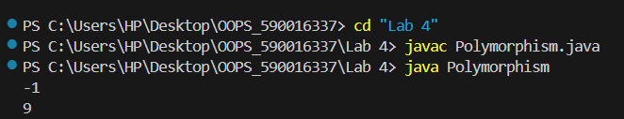

Code 2:
class Animal {

// Method Overloading
void sound() {
System.out.println("Animal makes a sound");
}

void sound(String type) {
System.out.println("Animal sound type: " + type);
}
}

// Method Overriding
class Dog extends Animal {

@Override
void sound() {
System.out.println("Dog barks");
}
}

public class Polymorphism1 {

public static void main(String[] args) {

// Runtime Polymorphism
Animal a = new Dog();
a.sound();

// Compile-time Polymorphism
a.sound("Loud");
}
}

Output:
