## NAME: Rishika Bhatt

## ROLL NO: 22BCM051

## CLASS: BTECH CSE MBA(E4)

"Secure Communication System: A Graphical User Interface for Vigenère and Polybius Cipher Encryption"

# Abstract:

The cryptography project endeavors to empower users with a comprehensive and user-friendly platform for secure communication through encryption and decryption using the Vigenère and Polybius ciphers. By amalgamating classical encryption techniques with modern Graphical User Interface (GUI) design principles, the project aims to bridge the gap between cryptographic methodologies and user accessibility. Through the implementation of robust encryption algorithms and intuitive user interfaces, users can securely exchange sensitive information while mitigating the risk of unauthorized access and interception. The project's primary objective is to enhance digital security and privacy by providing individuals, businesses, and organizations with the means to protect their data and communications effectively. By leveraging encryption technologies and user-centric design, the project addresses real-world challenges in data protection, secure communication, and privacy preservation, contributing to a safer and more secure digital environment for all users.

# Keywords:

1. **Cryptography**: The practice and study of secure communication techniques to ensure confidentiality, integrity, and authenticity of information.

2. **Encryption**: The process of converting plaintext into ciphertext to protect the confidentiality of data.

3. **Decryption**: The process of converting ciphertext back into plaintext, restoring the original message.

4. **Vigenère Cipher**: A method of encrypting alphabetic text using a keyword and a series of Caesar ciphers based on the letters of the keyword.

5. **Polybius Cipher**: A substitution cipher that replaces each letter of the alphabet with a pair of numbers based on their position in a predefined grid.

6. **Graphical User Interface (GUI)**: A visual interface that allows users to interact with electronic devices through graphical icons and visual indicators, making it easier to use and understand.

7. **Secure Communication**: The exchange of information between parties using cryptographic techniques to prevent unauthorized access and ensure data integrity and confidentiality.

8. **Confidentiality**: The assurance that information is only accessible to those authorized to access it, preventing unauthorized disclosure.

9. **Integrity**: The assurance that data remains unchanged and has not been altered or tampered with during transmission or storage.

10. **Authentication**: The process of verifying the identity of parties involved in a communication to ensure they are who they claim to be, preventing impersonation or unauthorized access.

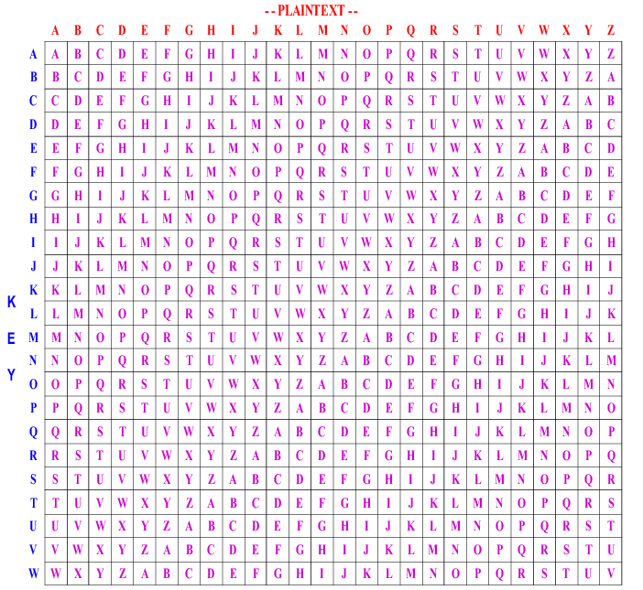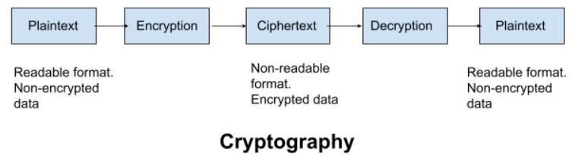

# Introduction:

# 1**. Overview of Cryptography**: Cryptography, the science of secure communication, is essential for safeguarding sensitive information in digital environments.

# 2. **Evolution of Encryption Techniques**: Encryption has evolved from ancient methods like Caesar ciphers to modern cryptographic algorithms, adapting to the changing technological landscape.

# 3. **Purpose of the Project**: This project aims to address the need for accessible tools for encryption and decryption, providing users with effective means to protect their communications.

# 4. **Scope of the Project**: The project focuses on implementing the Vigenère and Polybius ciphers through a Graphical User Interface (GUI) using Tkinter, enhancing user accessibility and usability.

# 5. **Objectives**: The objectives include developing a user-friendly interface, implementing diverse encryption options, and catering to users with varying levels of cryptographic knowledge.

# 6. **Target Audience**: The project targets individuals, businesses, and students interested in secure communication, aiming to provide practical solutions for their encryption needs.

# 7. Significance: By addressing real-world challenges in digital security and privacy, the project contributes to enhancing data protection and secure communication practices, benefiting users across various domains.

# 8. Structure of the Document: The document will cover implementation methodology, encryption algorithms, GUI design, testing procedures, and usage guidelines, ensuring comprehensive coverage of the project's aspects.

# Background / Literature Review:

1. Historical Context of Cryptography: Discuss the historical roots of cryptography, dating back to ancient civilizations such as Egypt and Greece. Highlight key milestones in the development of encryption techniques, including the Caesar cipher, the Enigma machine, and the invention of public-key cryptography.

2. Classic Encryption Techniques: Provide an overview of classical encryption methods, focusing on the Vigenère and Polybius ciphers. Explain the principles behind each cipher and their historical significance in secure communication.

3. Modern Cryptographic Algorithms: Discuss contemporary cryptographic algorithms such as RSA, AES, and ECC. Compare and contrast these algorithms with classical encryption techniques in terms of security, efficiency, and applicability to different use cases.

4. Applications of Cryptography: Explore the diverse applications of cryptography in various domains, including:

- Secure communication: Encryption of emails, instant messages, and voice calls.

- Data protection: Encryption of sensitive files, databases, and network traffic.

- Authentication: Digital signatures, biometric authentication, and two-factor authentication.

- Cryptocurrency: Blockchain technology and decentralized ledger systems.

- Privacy preservation: Anonymization techniques, privacy-enhancing technologies, and secure multiparty computation.

5. Challenges and Limitations: Highlight the challenges and limitations associated with cryptographic techniques, such as:

- Key management: Secure generation, distribution, and storage of encryption keys.

- Quantum computing: Potential threats to traditional cryptographic algorithms posed by quantum computers.

- Regulatory issues: Compliance with data protection regulations and international standards for cryptographic implementations.

6. Recent Developments and Trends: Summarize recent advancements in the field of cryptography, including:

- Post-quantum cryptography: Research on cryptographic algorithms resilient to attacks from quantum computers.

- Homomorphic encryption: Techniques for performing computations on encrypted data without decrypting it.

- Zero-knowledge proofs: Methods for proving the authenticity of information without revealing the information itself.

7. Literature Review: Provide a summary of relevant research papers, articles, and books on cryptography, focusing on seminal works, emerging trends, and gaps in existing literature. Discuss how the cryptography project contributes to addressing these gaps and advancing the state of the art in secure communication and data protection.

# Problem Domain / Research Gap:

1. Accessibility of Encryption Tools: Existing encryption tools may be too complex for non-technical users to use effectively, creating a gap in accessibility.

2. Usability Challenges: Many users face difficulties in understanding and implementing encryption techniques due to complex interfaces and terminology.

3. Limited Integration: There is a lack of integrated platforms that offer a balance between security and usability, incorporating diverse encryption algorithms.

4. Need for User-Friendly Solutions: There is a pressing need for encryption tools that are easy to use and cater to users with varying levels of cryptographic knowledge.

5. Research Gap: The gap lies in the availability of comprehensive encryption tools that bridge the divide between security and usability, addressing the needs of diverse user groups.

6. Project Objective: The project aims to fill this research gap by developing a user-friendly encryption tool that offers accessibility, usability, and effective protection of sensitive information.

7. Impact: By addressing these challenges, the project will contribute to enhancing the adoption of encryption practices and promoting secure communication in digital environments.

# System Architecture / Proposed Solution:

Here's an outline of the code algorithm for the cryptography project:

1. Vigenère Cipher Implementation:

- Define functions for Vigenère encryption and decryption.

- Create a function to generate a repeating key based on the length of the plaintext.

- Implement modular arithmetic to handle shifting within the alphabet.

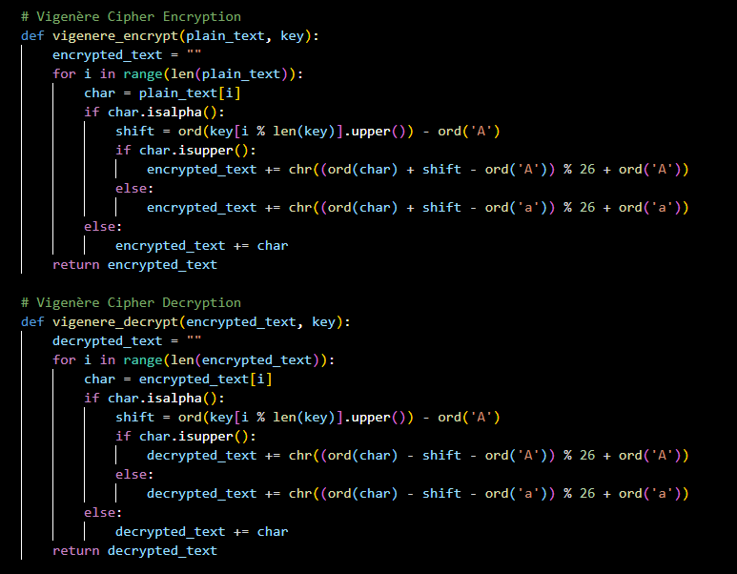

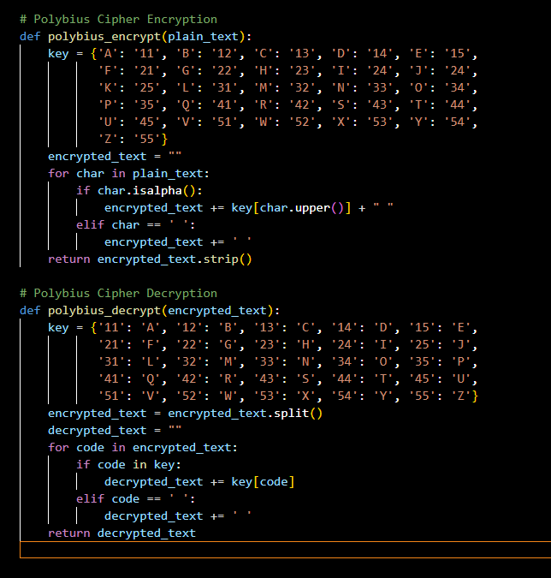2. Polybius Cipher Implementation:

- Define functions for Polybius encryption and decryption.

- Create a grid representation for mapping letters to coordinates.

- Implement mapping between letters and coordinates.

3. Graphical User Interface (GUI):

- Create a GUI using Tkinter with input fields for plaintext, key, and buttons for encryption/decryption.

- Define event handlers to trigger encryption/decryption operations.

4. Integration:

- Integrate the encryption and decryption functions with the GUI event handlers.

This algorithm outlines the steps for implementing the cryptography project, including both the encryption algorithms and the graphical user interface for user interaction. - GUI Interface: The user interacts with the application through a user-friendly GUI, which includes input fields for plaintext, key, and output areas for encrypted/decrypted text.

- Encryption Module: Implements encryption algorithms such as Vigenère and Polybius ciphers to encrypt plaintext messages using user-defined keys.

- Decryption Module: Provides functionality to decrypt ciphertext messages using the same keys used for encryption.

- Integration Layer: Coordinates communication between the GUI interface and the encryption/decryption modules to facilitate seamless encryption and decryption operations.

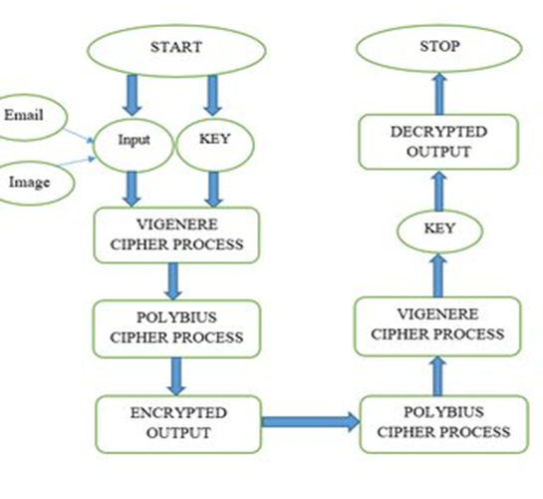

3. Workflow Model:

- Encryption Workflow:

1. User inputs plaintext message and encryption key into the GUI interface.

2. The encryption module processes the input using the selected encryption algorithm (Vigenère or Polybius) to generate ciphertext.

3. The encrypted message is displayed in the output area of the GUI for the user to copy or transmit securely.

- Decryption Workflow:

1. User inputs ciphertext message and decryption key into the GUI interface.

2. The decryption module processes the input using the corresponding decryption algorithm to recover the plaintext message.

3. The decrypted message is displayed in the output area of the GUI for the user to view or further analyze.

4. Proposed Solution Benefits:

- Provides a user-friendly interface for encryption and decryption operations, enhancing accessibility for users with varying levels of cryptographic knowledge.

- Offers flexibility by incorporating multiple encryption algorithms (Vigenère and Polybius ciphers), catering to diverse user preferences and use cases.

- Ensures data security and privacy by enabling users to encrypt sensitive information effectively, mitigating the risk of unauthorized access or interception.

5. Future Enhancements:

- Integration of additional encryption algorithms to further diversify encryption options.

- Implementation of advanced features such as key management, automatic key generation, and secure file encryption/decryption functionalities.

# Experimental Results

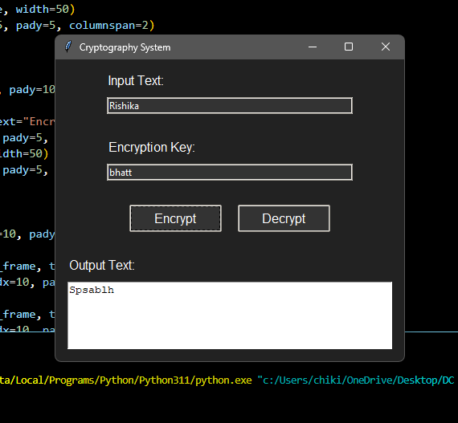

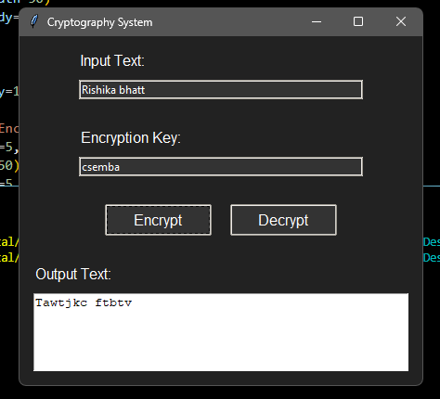

Conclusion:  
In conclusion, the cryptography project successfully implements the Vigenère and Polybius ciphers to provide users with a secure means of encrypting and decrypting messages. The integration of these classical encryption techniques into a user-friendly Graphical User Interface (GUI) enhances accessibility and usability, catering to users with varying levels of cryptographic knowledge. By combining robust encryption algorithms with intuitive design principles, the project addresses the need for effective tools for secure communication in digital environments. Moving forward, the project can serve as a foundation for further exploration and development in the field of cryptography, contributing to advancements in digital security and privacy protection.

# References

1. [Emerald - Project Management](https://www.emerald.com/insight/content/doi/10.1108/978-1-78714-829-120171016/full/html) - This source provides insights into managing projects for value creation throughout the system lifecycle.

2. [Microsoft - Work with Multiple Projects and Project References](https://learn.microsoft.com/en-us/dynamics365/business-central/dev-itpro/developer/devenv-work-workspace-projects-references) - Microsoft documentation explains how to work with multiple projects and project references in a development environment.

3. Stallings, William. "Cryptography and Network Security: Principles and Practice." Pearson Education, 2016. - This book provides comprehensive coverage of cryptography and network security principles and practices.

4. Schneier, Bruce. "Applied Cryptography: Protocols, Algorithms, and Source Code in C." Wiley, 1996. - Bruce Schneier's book is a classic reference for understanding applied cryptography, including protocols, algorithms, and source code examples.

5. Ferguson, Niels, et al. "Cryptography Engineering: Design Principles and Practical Applications." Wiley, 2010. - This book offers insights into the design principles and practical applications of cryptography, making it a valuable resource for cryptographic engineering.

6. Katz, Jonathan, and Yehuda Lindell. "Introduction to Modern Cryptography." Chapman and Hall/CRC, 2014. - Jonathan Katz and Yehuda Lindell's book provides an introduction to modern cryptography concepts and techniques, making it suitable for both beginners and advanced readers.

