**USECASE 1:**

**Context:**

Image classification or Image recognition using Deep Learning.

**Target Industry:**

Health Care Industry.

**Business Goal:**

Leveraging Medical Imaging Solutions.

**Deep Learning Task:**

[Diagnose diseases leveraging medical imaging solutions](https://research.aimultiple.com/looking-for-better-medical-imaging-for-early-diagnostic-and-monitoring-contact-the-leading-vendors-here/), for example recognition of potential cancerous lesions on radiology images.

**Benefits:**

Personalize medical treatments.

Determine patients most at risk in the healthcare system.

**Data Needed:**

Image format data (.jpg , .jpeg , .png)

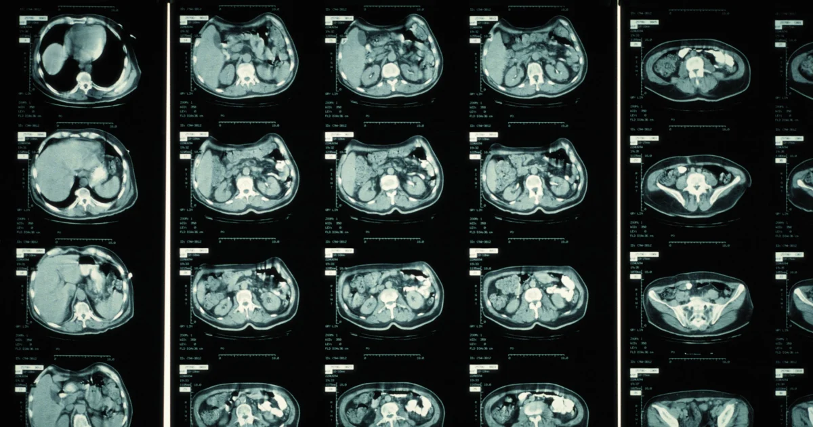

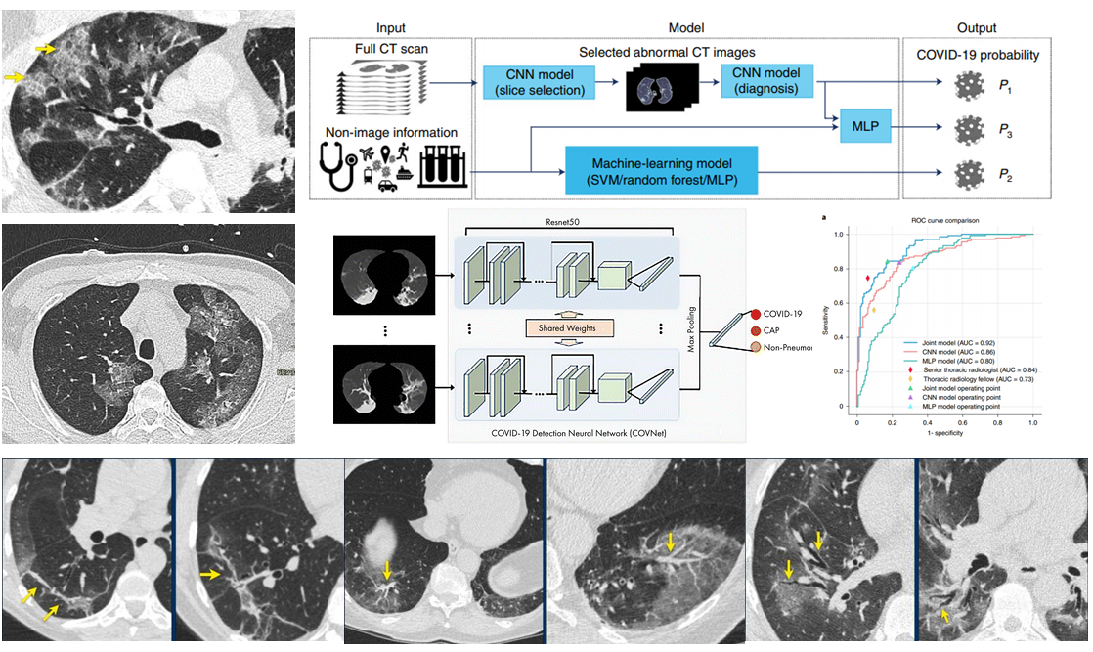

**USECASE 2:**

**Context:**

Provide advanced analytics tools for processing big data about manufacturing.

**Target Industry:**

Manufacturing or Production units.

**Business Goal:**

Generate automated alerts about the issues of production lines in the manufacturing unit.

**Deep Learning Task:**

[Predictive maintenance](https://research.aimultiple.com/predictive-maintenance/)systems by analysing images and also used in predicting the production rate for the future using the existing data.

**Benefits:**

Monitor working environment around heavy machineries automatically to ensure people and items are at a safe distance (Video processing).

Also analyses the production for future thus reducing the loss and energy utilized for the production (simple neural network).

**Data Needed:**

Data consists of both images and numerical data for the forecasting of production rate.

