DR. RVR NRI INSTITUTE OF TECHNOLOGY

PYTHON PROGRAMMING

ACTIVITY-BASED LEARNING (ABL) ASSIGNMENT

CONSOLIDATED REPORT: CASE STUDIES 61–70

Name: V.Rishika Roll No: 26001431
Branch: CSD Section: 1

Nested List Examination Seating Validation

Problem Statement
Validate a complete seating matrix for duplicate roll numbers, reserved positions, empty seats, and invalid student allocations.

Objectives
Use Python lists, tuples, loops and conditions to process the case-study data, apply the required checks and display understandable results.

Assumptions
Seats use 0 for empty and R for reserved; valid rolls are supplied in a list.

Algorithm
- Read seating matrix and valid rolls.

- Visit each row and seat.

- Check reserved, empty, invalid or duplicate.

- Record allocation or issue.

- Display validation summary.

Flowchart (Connected Boxes)

END

Display validation summary

Record allocation or issue

Check reserved, empty, invalid or duplicate

Visit each row and seat

Read seating matrix and valid rolls

START

Pseudocode
B E G I N
R E A D S E A T I N G M A T R I X A N D V A L I D R O L L S V I S I T E A C H R O W A N D S E A T
C H E C K R E S E R V E D , E M P T Y , I N V A L I D O R D U P L I C A T E R E C O R D A L L O C A T I O N O R I S S U E
D I S P L A Y V A L I D A T I O N S U M M A R Y
E N D

Python Source Code
" " " N e s t e d L i s t E x a m i n a t i o n S e a t i n g V a l i d a t i o n " " " v a l i d = [ 1 0 1 , 1 0 2 , 1 0 3 , 1 0 4 , 1 0 5 ]
s e a t s = [ [ 1 0 1 , 1 0 2 , ' R ' ] , [ 1 0 3 , 1 0 1 , 0 ] , [ 9 9 9 , ' R ' , 1 0 4 ] ]
s e e n = [ ]
f o r i i n r a n g e ( l e n ( s e a t s ) ) :
f o r j i n r a n g e ( l e n ( s e a t s [ i ] ) ) : x = s e a t s [ i ] [ j ]
p o s i t i o n = ( i + 1 , j + 1 )
i f x = = ' R ' : p r i n t ( p o s i t i o n , ' R e s e r v e d ' ) e l i f x = = 0 : p r i n t ( p o s i t i o n , ' E m p t y ' )
e l i f x n o t i n v a l i d : p r i n t ( p o s i t i o n , ' I n v a l i d r o l l : ' , x ) e l i f x i n s e e n : p r i n t ( p o s i t i o n , ' D u p l i c a t e r o l l : ' , x ) e l s e : s e e n . a p p e n d ( x )
p r i n t ( ' V a l i d u n i q u e a l l o c a t i o n s : ' , s e e n )

Test Case 1
Execute the Python program using the sample dataset included in the source code.

Actual Output

( 1 , | 3 ) | R e s e r v e d
( 2 , | 2 ) | D u p l i c a t e r o l l : 1 0 1
( 2 , | 3 ) | E m p t y
( 3 , | 1 ) | I n v a l i d r o l l : 9 9 9
( 3 , | 2 ) | R e s e r v e d
V a l i d u n i q u e a l l o c a t i o n s : [ 1 0 1 , 1 0 2 , 1 0 3 , 1 0 4 ]

Additional Test Cases
Test 2: Change a sample input to a boundary value and verify the calculation or validation result.
Test 3: Introduce an invalid or duplicate record (where relevant) and check the displayed result.

Expected Result
The program follows the specified assumptions and displays calculated values or validation findings.

Conclusion
This case study demonstrates the use of beginner-level Python programming to process structured data and report results clearly.

Question 61 - Python IDLE Program Screenshot

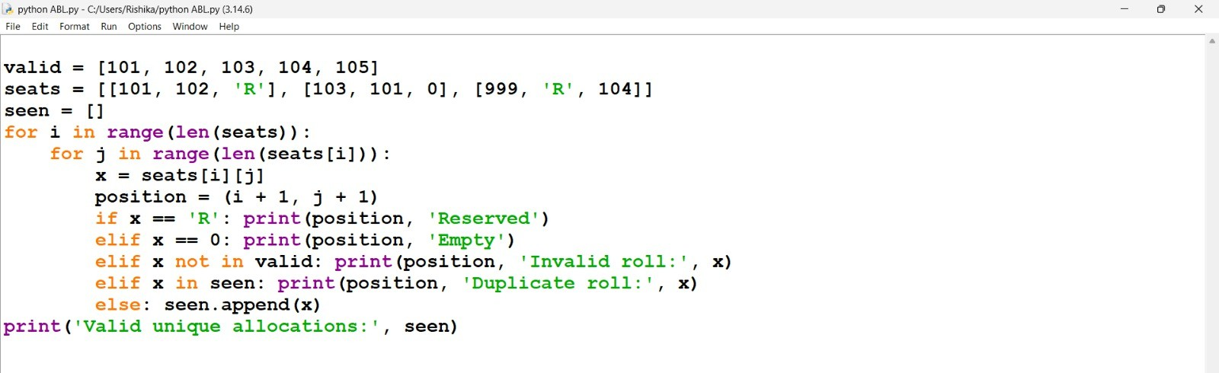

Question 61 - Python IDLE Output Screenshot

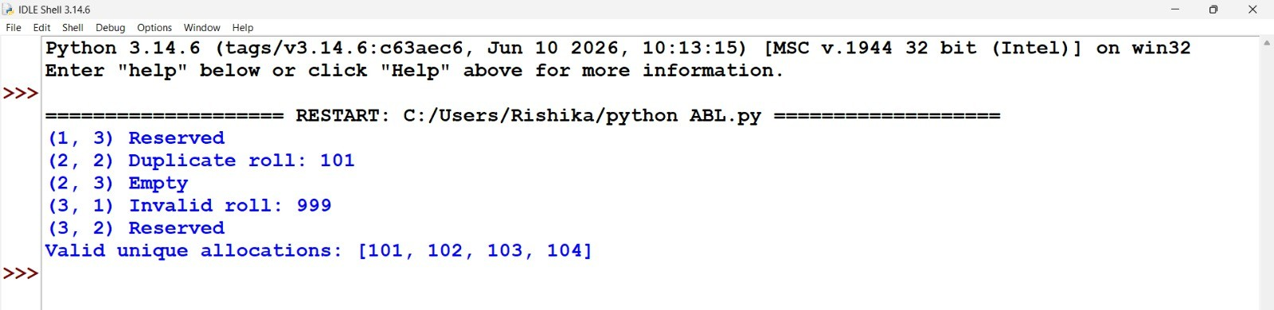

Water Distribution Fairness Analysis

Problem Statement
Analyse area-wise water supply across several days, calculate shortages against demand, compare distribution levels, and identify the most underserved areas.

Objectives
Use Python lists, tuples, loops and conditions to process the case-study data, apply the required checks and display understandable results.

Assumptions
Demand and supply are in kilolitres; demand is daily and nonzero.

Algorithm
- Read demand and daily supply.

- Calculate total supply per area.

- Calculate shortage and coverage.

- Compare coverage percentages.

- Display most underserved area.

Flowchart (Connected Boxes)

END

Display most underserved area

Compare coverage percentages

Calculate shortage and coverage

Calculate total supply per area

Read demand and daily supply

START

Pseudocode
B E G I N
R E A D D E M A N D A N D D A I L Y S U P P L Y C A L C U L A T E T O T A L S U P P L Y P E R A R E A C A L C U L A T E S H O R T A G E A N D C O V E R A G E C O M P A R E C O V E R A G E P E R C E N T A G E S D I S P L A Y M O S T U N D E R S E R V E D A R E A
E N D

Python Source Code
" " " W a t e r D i s t r i b u t i o n F a i r n e s s A n a l y s i s " " " a r e a s = [ ' N o r t h ' , ' S o u t h ' , ' E a s t ' ]
d e m a n d = [ 1 0 0 , 8 0 , 1 2 0 ]
s u p p l y = [ [ 9 0 , 8 0 , 1 0 0 ] , [ 8 0 , 8 5 , 7 5 ] , [ 1 0 0 , 9 0 , 1 1 0 ] ]
r e s u l t s = [ ]
f o r i i n r a n g e ( l e n ( a r e a s ) ) :
t o t a l = s u m ( s u p p l y [ i ] ) ; r e q u i r e d = d e m a n d [ i ] * l e n ( s u p p l y [ i ] ) s h o r t a g e = m a x ( 0 , r e q u i r e d - t o t a l )
r a t i o = t o t a l / r e q u i r e d * 1 0 0 r e s u l t s . a p p e n d ( ( a r e a s [ i ] , s h o r t a g e , r a t i o ) )
p r i n t ( a r e a s [ i ] , ' S u p p l y : ' , t o t a l , ' S h o r t a g e : ' , s h o r t a g e , ' C o v e r a g e : % . 2 f % % ' % r a t i p r i n t ( ' M o s t u n d e r s e r v e d : ' , m i n ( r e s u l t s , k e y = l a m b d a x : x [ 2 ] ) [ 0 ] )

Test Case 1
Execute the Python program using the sample dataset included in the source code.

Actual Output
N o r t h S u p p l y : 2 7 0 S h o r t a g e : 3 0 C o v e r a g e : 9 0 . 0 0 %
S o u t h S u p p l y : 2 4 0 S h o r t a g e : 0 C o v e r a g e : 1 0 0 . 0 0 %
E a s t S u p p l y : 3 0 0 S h o r t a g e : 6 0 C o v e r a g e : 8 3 . 3 3 % M o s t u n d e r s e r v e d : E a s t

Additional Test Cases
Test 2: Change a sample input to a boundary value and verify the calculation or validation result.
Test 3: Introduce an invalid or duplicate record (where relevant) and check the displayed result.

Expected Result
The program follows the specified assumptions and displays calculated values or validation findings.

Conclusion
This case study demonstrates the use of beginner-level Python programming to process structured data and report results clearly.

Question 62 - Python IDLE Program Screenshot

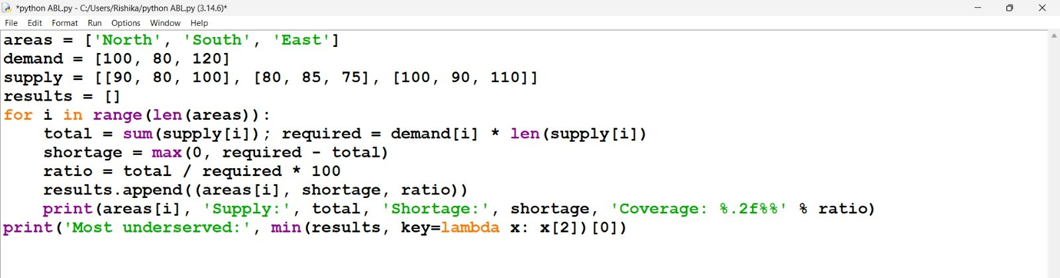

Question 62 - Python IDLE Output Screenshot

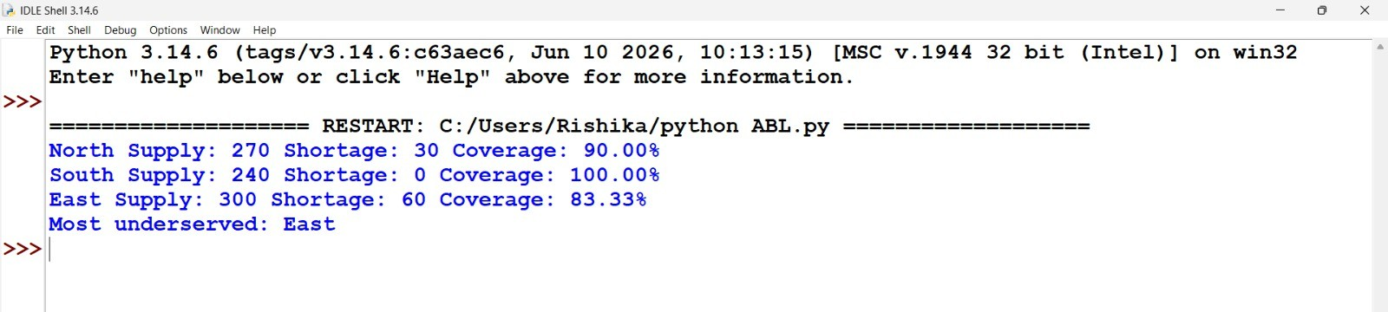

Multi-Product Price Fluctuation Analysis

Problem Statement
Process historical product prices stored in lists, calculate percentage changes, identify maximum fluctuations, and flag products exceeding a supplied threshold.

Objectives
Use Python lists, tuples, loops and conditions to process the case-study data, apply the required checks and display understandable results.

Assumptions
Historical prices are positive; threshold is a percentage.

Algorithm
- Read products and historical prices.

- Calculate consecutive price changes.

- Find maximum percentage change.

- Compare against threshold.

- Display flagged products.

Flowchart (Connected Boxes)

END

Display flagged products

Compare against threshold

Find maximum percentage change

Calculate consecutive price changes

Read products and historical prices

START

Pseudocode
B E G I N
R E A D P R O D U C T S A N D H I S T O R I C A L P R I C E S C A L C U L A T E C O N S E C U T I V E P R I C E C H A N G E S F I N D M A X I M U M P E R C E N T A G E C H A N G E C O M P A R E A G A I N S T T H R E S H O L D
D I S P L A Y F L A G G E D P R O D U C T S
E N D

Python Source Code
" " " M u l t i - P r o d u c t P r i c e F l u c t u a t i o n A n a l y s i s " " "
p r i c e s = { ' R i c e ' : [ 5 0 , 5 5 , 5 2 ] , ' O i l ' : [ 1 0 0 , 1 2 0 , 1 1 0 ] , ' S u g a r ' : [ 4 0 , 4 1 , 4 2 ] }
t h r e s h o l d = 1 0
f o r n a m e , h i s t o r y i n p r i c e s . i t e m s ( ) : c h a n g e s = [ ]
f o r i i n r a n g e ( 1 , l e n ( h i s t o r y ) ) :
c h a n g e s . a p p e n d ( ( h i s t o r y [ i ] - h i s t o r y [ i - 1 ] ) / h i s t o r y [ i - 1 ] * 1 0 0 ) l a r g e s t = m a x ( a b s ( x ) f o r x i n c h a n g e s )
p r i n t ( n a m e , ' C h a n g e s : ' , [ r o u n d ( x , 2 ) f o r x i n c h a n g e s ] , ' M a x : ' , r o u n d ( l a r g e s t , 2 ) ,

Test Case 1
Execute the Python program using the sample dataset included in the source code.

Actual Output
R i c e C h a n g e s : [ 1 0 . 0 , - 5 . 4 5 ] M a x : 1 0 . 0 F l a g : F a l s e
O i l C h a n g e s : [ 2 0 . 0 , - 8 . 3 3 ] M a x : 2 0 . 0 F l a g : T r u e
S u g a r C h a n g e s : [ 2 . 5 , 2 . 4 4 ] M a x : 2 . 5 F l a g : F a l s e

Additional Test Cases
Test 2: Change a sample input to a boundary value and verify the calculation or validation result.
Test 3: Introduce an invalid or duplicate record (where relevant) and check the displayed result.

Expected Result
The program follows the specified assumptions and displays calculated values or validation findings.

Conclusion
This case study demonstrates the use of beginner-level Python programming to process structured data and report results clearly.

Question 63 - Python IDLE Program Screenshot

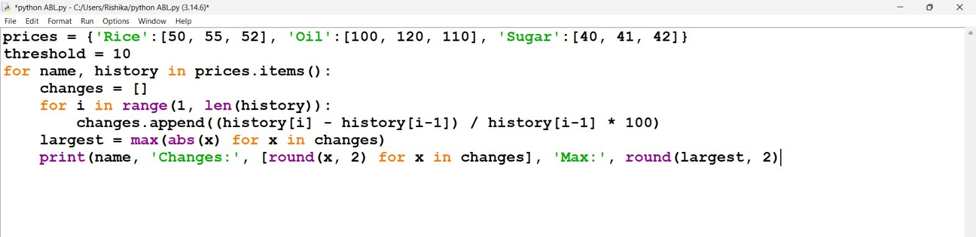

Question 63 - Python IDLE Output Screenshot

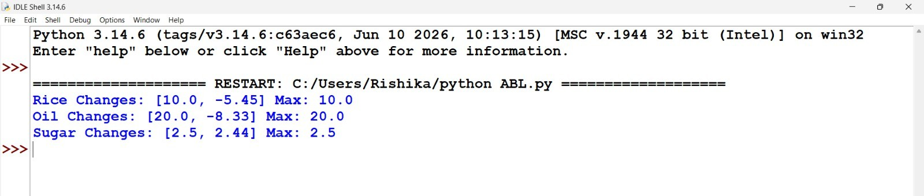

Tuple-Based Course Registration Validation

Problem Statement
Represent course registrations as tuples, identify duplicate registrations and invalid course combinations, and determine students whose selections violate supplied rules.

Objectives
Use Python lists, tuples, loops and conditions to process the case-study data, apply the required checks and display understandable results.

Assumptions
Each registration is a (student, course) tuple; AI101 and AI102 cannot be combined.

Algorithm
- Read registration tuples and rules.

- Check duplicates.

- Check invalid course combinations.

- Record rule violations.

- Display affected students.

Flowchart (Connected Boxes)

END

Display affected students

Record rule violations

Check invalid course combinations

Check duplicates

Read registration tuples and rules

START

Pseudocode
B E G I N
R E A D R E G I S T R A T I O N T U P L E S A N D R U L E S C H E C K D U P L I C A T E S
C H E C K I N V A L I D C O U R S E C O M B I N A T I O N S R E C O R D R U L E V I O L A T I O N S
D I S P L A Y A F F E C T E D S T U D E N T S
E N D

Python Source Code
" " " T u p l e - B a s e d C o u r s e R e g i s t r a t i o n V a l i d a t i o n " " "
r e g i s t r a t i o n s = [ ( ' A ' , ' P Y 1 0 1 ' ) , ( ' A ' , ' A I 1 0 1 ' ) , ( ' A ' , ' A I 1 0 2 ' ) , ( ' A ' , ' P Y 1 0 1 ' ) , ( ' B ' , ' P Y 1 v a l i d = ( ' P Y 1 0 1 ' , ' A I 1 0 1 ' , ' A I 1 0 2 ' )
s e e n = [ ] s t u d e n t s = { }
f o r s t u d e n t , c o u r s e i n r e g i s t r a t i o n s :
i f ( s t u d e n t , c o u r s e ) i n s e e n : p r i n t ( ' D u p l i c a t e : ' , s t u d e n t , c o u r s e ) e l s e : s e e n . a p p e n d ( ( s t u d e n t , c o u r s e ) )
i f c o u r s e n o t i n v a l i d : p r i n t ( ' I n v a l i d c o u r s e : ' , s t u d e n t , c o u r s e ) i f s t u d e n t n o t i n s t u d e n t s : s t u d e n t s [ s t u d e n t ] = [ ] s t u d e n t s [ s t u d e n t ] . a p p e n d ( c o u r s e )
f o r s t u d e n t , c o u r s e s i n s t u d e n t s . i t e m s ( ) :
i f ' A I 1 0 1 ' i n c o u r s e s a n d ' A I 1 0 2 ' i n c o u r s e s : p r i n t ( ' P r o h i b i t e d c o m b i n a t i o n : ' , s t u d e n t )

Test Case 1
Execute the Python program using the sample dataset included in the source code.

Actual Output
D u p l i c a t e : A P Y 1 0 1 I n v a l i d c o u r s e : B B A D P r o h i b i t e d c o m b i n a t i o n : A

Additional Test Cases
Test 2: Change a sample input to a boundary value and verify the calculation or validation result.
Test 3: Introduce an invalid or duplicate record (where relevant) and check the displayed result.

Expected Result
The program follows the specified assumptions and displays calculated values or validation findings.

Conclusion
This case study demonstrates the use of beginner-level Python programming to process structured data and report results clearly.

Question 64 - Python IDLE Program Screenshot

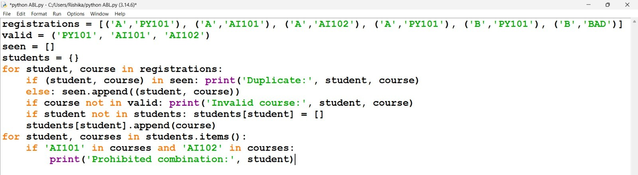

Question 64 - Python IDLE Output Screenshot

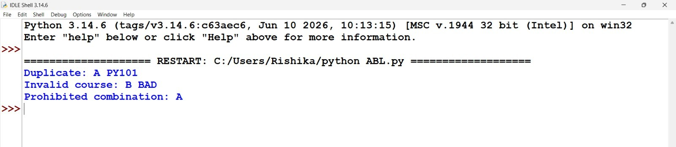

Campus Resource Allocation Under Constraints

Problem Statement
Compare equipment requirements with available resources across multiple activities, calculate shortages, and produce a feasible allocation using a specified priority order.

Objectives
Use Python lists, tuples, loops and conditions to process the case-study data, apply the required checks and display understandable results.

Assumptions
Activities are listed in descending priority; partial allocation is permitted.

Algorithm
- Read equipment, requests and priority.

- Visit activities in priority order.

- Compare requirement and stock.

- Allocate available resources.

- Display allocations and shortages.

Flowchart (Connected Boxes)

END

Display allocations and shortages

Allocate available resources

Compare requirement and stock

Visit activities in priority order

Read equipment, requests and priority

START

Pseudocode
B E G I N
R E A D E Q U I P M E N T , R E Q U E S T S A N D P R I O R I T Y V I S I T A C T I V I T I E S I N P R I O R I T Y O R D E R C O M P A R E R E Q U I R E M E N T A N D S T O C K A L L O C A T E A V A I L A B L E R E S O U R C E S
D I S P L A Y A L L O C A T I O N S A N D S H O R T A G E S
E N D

Python Source Code
" " " C a m p u s R e s o u r c e A l l o c a t i o n U n d e r C o n s t r a i n t s " " " s t o c k = { ' L a p t o p ' : 8 , ' P r o j e c t o r ' : 2 }
a c t i v i t i e s = [ ( ' W o r k s h o p ' , { ' L a p t o p ' : 5 , ' P r o j e c t o r ' : 1 } ) , ( ' S e m i n a r ' , { ' L a p t o p ' : 4 , ' P r o f o r n a m e , n e e d s i n a c t i v i t i e s :
a l l o c a t e d = { } ; s h o r t a g e = { }
f o r i t e m , r e q u i r e d i n n e e d s . i t e m s ( ) :
g i v e n = m i n ( r e q u i r e d , s t o c k . g e t ( i t e m , 0 ) ) a l l o c a t e d [ i t e m ] = g i v e n
s h o r t a g e [ i t e m ] = r e q u i r e d - g i v e n s t o c k [ i t e m ] - = g i v e n
p r i n t ( n a m e , ' A l l o c a t e d : ' , a l l o c a t e d , ' S h o r t a g e : ' , s h o r t a g e ) p r i n t ( ' R e m a i n i n g : ' , s t o c k )

Test Case 1
Execute the Python program using the sample dataset included in the source code.

Actual Output
W o r k s h o p A l l o c a t e d : { ' L a p t o p ' : 5 , ' P r o j e c t o r ' : 1 } S h o r t a g e : { ' L a p t o p ' : 0 , ' P r o j e c t o r ' : S e m i n a r A l l o c a t e d : { ' L a p t o p ' : 3 , ' P r o j e c t o r ' : 1 } S h o r t a g e : { ' L a p t o p ' : 1 , ' P r o j e c t o r ' : C l u b A l l o c a t e d : { ' L a p t o p ' : 0 , ' P r o j e c t o r ' : 0 } S h o r t a g e : { ' L a p t o p ' : 2 , ' P r o j e c t o r ' : 1 }
R e m a i n i n g : { ' L a p t o p ' : 0 , ' P r o j e c t o r ' : 0 }

Additional Test Cases
Test 2: Change a sample input to a boundary value and verify the calculation or validation result.
Test 3: Introduce an invalid or duplicate record (where relevant) and check the displayed result.

Expected Result
The program follows the specified assumptions and displays calculated values or validation findings.

Conclusion
This case study demonstrates the use of beginner-level Python programming to process structured data and report results clearly.

Question 65 - Python IDLE Program Screenshot

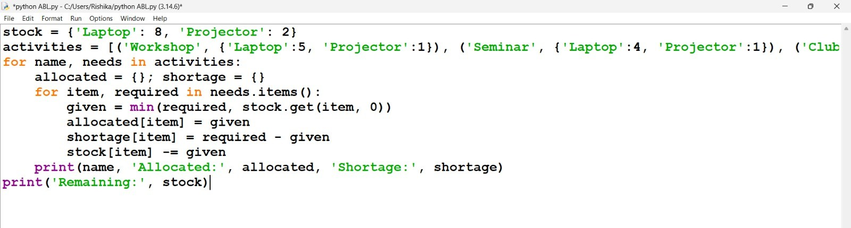

Question 65 - Python IDLE Output Screenshot

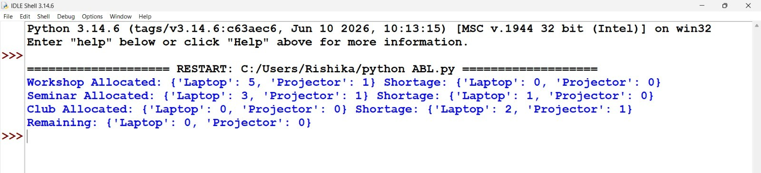

Student Academic Risk Classification

Problem Statement
Combine lists of marks, attendance, and laboratory scores to classify students into risk categories, identify multiple simultaneous risk factors, and generate a summary.

Objectives
Use Python lists, tuples, loops and conditions to process the case-study data, apply the required checks and display understandable results.

Assumptions
Risk factors are marks below 40, attendance below 75%, and lab score below 50.

Algorithm
- Read marks, attendance and lab scores.

- Check each risk threshold.

- Count simultaneous risk factors.

- Assign risk category.

- Display student risk summary.

Flowchart (Connected Boxes)

END

Display student risk summary

Assign risk category

Count simultaneous risk factors

Check each risk threshold

Read marks, attendance and lab scores

START

Pseudocode
B E G I N
R E A D M A R K S , A T T E N D A N C E A N D L A B S C O R E S C H E C K E A C H R I S K T H R E S H O L D
C O U N T S I M U L T A N E O U S R I S K F A C T O R S A S S I G N R I S K C A T E G O R Y
D I S P L A Y S T U D E N T R I S K S U M M A R Y
E N D

Python Source Code
" " " S t u d e n t A c a d e m i c R i s k C l a s s i f i c a t i o n " " " n a m e s = [ ' A n u ' , ' B a l a ' , ' C h a r a n ' , ' D i v y a ' ] m a r k s = [ 8 5 , 3 5 , 4 5 , 3 0 ]
a t t e n d a n c e = [ 9 0 , 7 0 , 6 0 , 6 5 ]
l a b s = [ 8 0 , 4 5 , 7 0 , 4 0 ]
s u m m a r y = { ' L o w ' : 0 , ' M o d e r a t e ' : 0 , ' H i g h ' : 0 } f o r i i n r a n g e ( l e n ( n a m e s ) ) :
f a c t o r s = [ ]
i f m a r k s [ i ] < 4 0 : f a c t o r s . a p p e n d ( ' M a r k s ' )
i f a t t e n d a n c e [ i ] < 7 5 : f a c t o r s . a p p e n d ( ' A t t e n d a n c e ' ) i f l a b s [ i ] < 5 0 : f a c t o r s . a p p e n d ( ' L a b ' )
c a t e g o r y = ' H i g h ' i f l e n ( f a c t o r s ) > = 2 e l s e ( ' M o d e r a t e ' i f f a c t o r s e l s e ' L o w ' ) s u m m a r y [ c a t e g o r y ] + = 1
p r i n t ( n a m e s [ i ] , c a t e g o r y , f a c t o r s ) p r i n t ( ' S u m m a r y : ' , s u m m a r y )

Test Case 1
Execute the Python program using the sample dataset included in the source code.

Actual Output
A n u L o w [ ]
B a l a H i g h [ ' M a r k s ' , ' A t t e n d a n c e ' , ' L a b ' ] C h a r a n M o d e r a t e [ ' A t t e n d a n c e ' ]
D i v y a H i g h [ ' M a r k s ' , ' A t t e n d a n c e ' , ' L a b ' ] S u m m a r y : { ' L o w ' : 1 , ' M o d e r a t e ' : 1 , ' H i g h ' : 2 }

Additional Test Cases
Test 2: Change a sample input to a boundary value and verify the calculation or validation result.
Test 3: Introduce an invalid or duplicate record (where relevant) and check the displayed result.

Expected Result
The program follows the specified assumptions and displays calculated values or validation findings.

Conclusion
This case study demonstrates the use of beginner-level Python programming to process structured data and report results clearly.

Question 66 - Python IDLE Program Screenshot
Original screenshot supplied by student

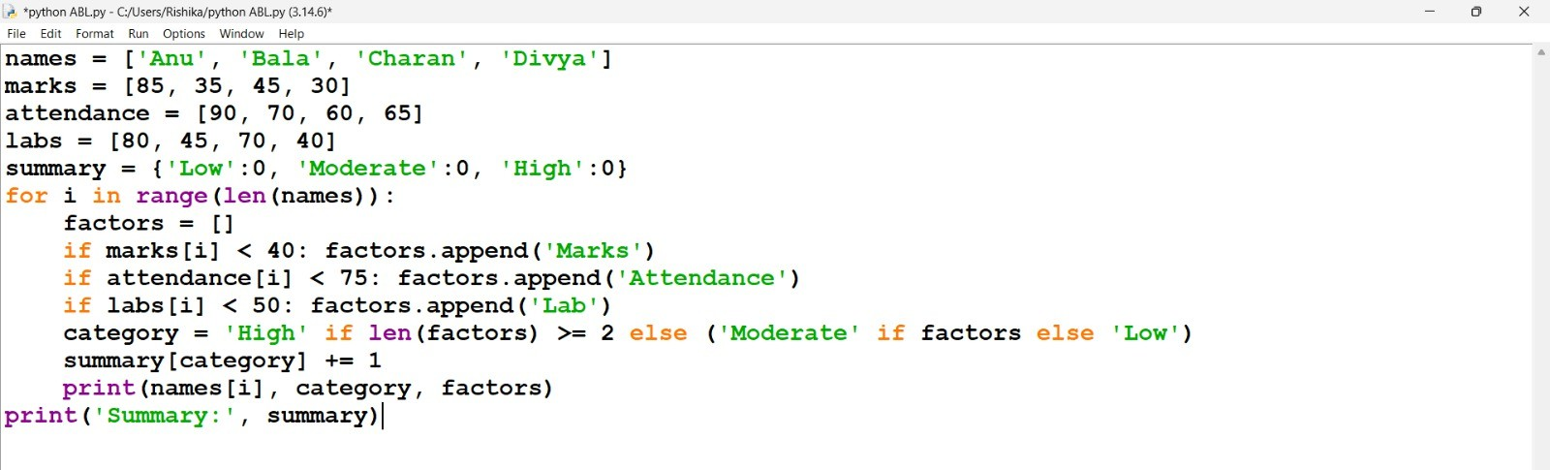

Question 66 - Python IDLE Output Screenshot
Original screenshot supplied by student

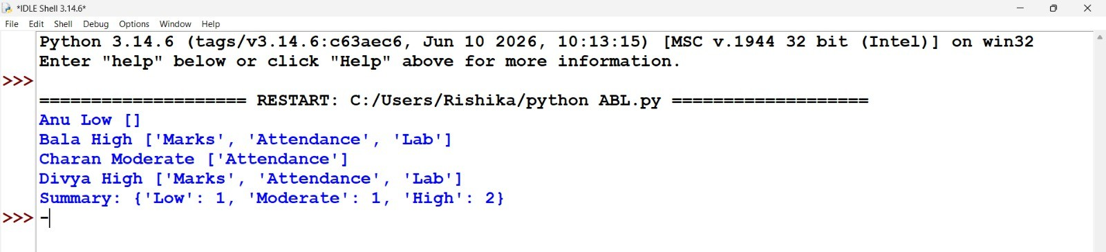

Retail Order Dispatch and Return Analysis

Problem Statement
Process order quantities, dispatch records, and returned quantities; calculate outstanding orders, update inventory, and detect inconsistent records.

Objectives
Use Python lists, tuples, loops and conditions to process the case-study data, apply the required checks and display understandable results.

Assumptions
Returned goods are resalable; starting inventory is given.

Algorithm
- Read orders, dispatch, returns and stock.

- Validate quantity records.

- Calculate outstanding quantities.

- Update inventory.

- Display discrepancies and totals.

Flowchart (Connected Boxes)

END

Display discrepancies and totals

Update inventory

Calculate outstanding quantities

Validate quantity records

Read orders, dispatch, returns and stock

START

Pseudocode
B E G I N
R E A D O R D E R S , D I S P A T C H , R E T U R N S A N D S T O C K V A L I D A T E Q U A N T I T Y R E C O R D S
C A L C U L A T E O U T S T A N D I N G Q U A N T I T I E S U P D A T E I N V E N T O R Y
D I S P L A Y D I S C R E P A N C I E S A N D T O T A L S
E N D

Python Source Code
" " " R e t a i l O r d e r D i s p a t c h a n d R e t u r n A n a l y s i s " " " p r o d u c t s = [ ' P e n ' , ' B o o k ' , ' B a g ' ]
o r d e r e d = [ 2 0 , 1 0 , 5 ]
d i s p a t c h e d = [ 1 5 , 1 2 , 4 ]
r e t u r n e d = [ 2 , 1 , 5 ]
s t o c k = [ 3 0 , 2 0 , 1 0 ]
f o r i i n r a n g e ( l e n ( p r o d u c t s ) ) :
i f d i s p a t c h e d [ i ] > o r d e r e d [ i ] o r r e t u r n e d [ i ] > d i s p a t c h e d [ i ] o r m i n ( o r d e r e d [ i ] , d i p r i n t ( p r o d u c t s [ i ] , ' I n c o n s i s t e n t r e c o r d ' )
c o n t i n u e
i f d i s p a t c h e d [ i ] > s t o c k [ i ] : p r i n t ( p r o d u c t s [ i ] , ' I n s u f f i c i e n t s t o c k ' ) c o n t i n u e
p e n d i n g = o r d e r e d [ i ] - d i s p a t c h e d [ i ]
s t o c k [ i ] = s t o c k [ i ] - d i s p a t c h e d [ i ] + r e t u r n e d [ i ] p r i n t ( p r o d u c t s [ i ] , ' P e n d i n g : ' , p e n d i n g , ' U p d a t e d s t o c k : ' , s t o c k [ i ] )

Test Case 1
Execute the Python program using the sample dataset included in the source code.

Actual Output
P e n P e n d i n g : 5 U p d a t e d s t o c k : 1 7 B o o k I n c o n s i s t e n t r e c o r d
B a g I n c o n s i s t e n t r e c o r d

Additional Test Cases
Test 2: Change a sample input to a boundary value and verify the calculation or validation result.
Test 3: Introduce an invalid or duplicate record (where relevant) and check the displayed result.

Expected Result
The program follows the specified assumptions and displays calculated values or validation findings.

Conclusion
This case study demonstrates the use of beginner-level Python programming to process structured data and report results clearly.

Energy Conservation Before-and-After Analysis

Problem Statement
Compare appliance-wise electricity usage before and after an intervention, calculate savings percentages, and rank appliances by achieved savings.

Objectives
Use Python lists, tuples, loops and conditions to process the case-study data, apply the required checks and display understandable results.

Assumptions
Usage is measured over equal periods; before values are positive.

Algorithm
- Read usage before and after.

- Calculate savings for each appliance.

- Calculate savings percentages.

- Sort appliances by savings.

- Display ranking.

Flowchart (Connected Boxes)

END

Display ranking

Sort appliances by savings

Calculate savings percentages

Calculate savings for each appliance

Read usage before and after

START

Pseudocode
B E G I N
R E A D U S A G E B E F O R E A N D A F T E R C A L C U L A T E S A V I N G S F O R E A C H A P P L I A N C E C A L C U L A T E S A V I N G S P E R C E N T A G E S
S O R T A P P L I A N C E S B Y S A V I N G S D I S P L A Y R A N K I N G
E N D

Python Source Code
" " " E n e r g y C o n s e r v a t i o n B e f o r e - a n d - A f t e r A n a l y s i s " " " n a m e s = [ ' A C ' , ' F a n ' , ' L i g h t ' ]
b e f o r e = [ 2 0 0 , 1 0 0 , 5 0 ]
a f t e r = [ 1 5 0 , 9 0 , 3 0 ]
r e s u l t s = [ ]
f o r i i n r a n g e ( l e n ( n a m e s ) ) : s a v e d = b e f o r e [ i ] - a f t e r [ i ]
p e r c e n t = s a v e d / b e f o r e [ i ] * 1 0 0 r e s u l t s . a p p e n d ( ( n a m e s [ i ] , p e r c e n t ) )
p r i n t ( n a m e s [ i ] , ' S a v e d : ' , s a v e d , ' P e r c e n t a g e : % . 2 f % % ' % p e r c e n t ) p r i n t ( ' R a n k i n g : ' , s o r t e d ( r e s u l t s , k e y = l a m b d a x : ( - x [ 1 ] , x [ 0 ] ) ) )

Test Case 1
Execute the Python program using the sample dataset included in the source code.

Actual Output
A C S a v e d : 5 0 P e r c e n t a g e : 2 5 . 0 0 %
F a n S a v e d : 1 0 P e r c e n t a g e : 1 0 . 0 0 %
L i g h t S a v e d : 2 0 P e r c e n t a g e : 4 0 . 0 0 %
R a n k i n g : [ ( ' L i g h t ' , 4 0 . 0 ) , ( ' A C ' , 2 5 . 0 ) , ( ' F a n ' , 1 0 . 0 ) ]

Additional Test Cases
Test 2: Change a sample input to a boundary value and verify the calculation or validation result.
Test 3: Introduce an invalid or duplicate record (where relevant) and check the displayed result.

Expected Result
The program follows the specified assumptions and displays calculated values or validation findings.

Conclusion
This case study demonstrates the use of beginner-level Python programming to process structured data and report results clearly.

Nested List Sports Performance Analysis

Problem Statement
Analyse players’ scores across multiple matches, calculate consistency measures, identify performance trends, and rank players under supplied tiebreaking rules.

Objectives
Use Python lists, tuples, loops and conditions to process the case-study data, apply the required checks and display understandable results.

Assumptions
Higher total ranks first, then smaller range, then alphabetical name.

Algorithm
- Read player match scores.

- Calculate totals and consistency.

- Identify trends.

- Apply ranking and tie-breaking.

- Display ranked players.

Flowchart (Connected Boxes)

END

Display ranked players

Apply ranking and tie-breaking

Identify trends

Calculate totals and consistency

Read player match scores

START

Pseudocode
B E G I N
R E A D P L A Y E R M A T C H S C O R E S C A L C U L A T E T O T A L S A N D C O N S I S T E N C Y I D E N T I F Y T R E N D S
A P P L Y R A N K I N G A N D T I E - B R E A K I N G D I S P L A Y R A N K E D P L A Y E R S
E N D

Python Source Code
" " " N e s t e d L i s t S p o r t s P e r f o r m a n c e A n a l y s i s " " " p l a y e r s = [ ' A s h a ' , ' B i n a ' , ' C h e t a n ' ]
s c o r e s = [ [ 1 0 , 2 0 , 3 0 ] , [ 2 5 , 2 5 , 2 5 ] , [ 3 0 , 2 0 , 1 0 ] ]
r a n k i n g = [ ]
f o r i i n r a n g e ( l e n ( p l a y e r s ) ) : s = s c o r e s [ i ]
t o t a l = s u m ( s ) ; a v g = t o t a l / l e n ( s ) ; s p r e a d = m a x ( s ) - m i n ( s )
t r e n d = ' I m p r o v i n g ' i f s [ - 1 ] > s [ 0 ] e l s e ( ' D e c l i n i n g ' i f s [ - 1 ] < s [ 0 ] e l s e ' S t a b l e p r i n t ( p l a y e r s [ i ] , ' T o t a l : ' , t o t a l , ' A v e r a g e : ' , r o u n d ( a v g , 2 ) , ' R a n g e : ' , s p r e a d , ' T r r a n k i n g . a p p e n d ( ( p l a y e r s [ i ] , t o t a l , s p r e a d ) )
p r i n t ( ' R a n k i n g : ' , [ x [ 0 ] f o r x i n s o r t e d ( r a n k i n g , k e y = l a m b d a x : ( - x [ 1 ] , x [ 2 ] , x [ 0 ] ) ) ] )

Test Case 1
Execute the Python program using the sample dataset included in the source code.

Actual Output
A s h a T o t a l : 6 0 A v e r a g e : 2 0 . 0 R a n g e : 2 0 T r e n d : I m p r o v i n g
B i n a T o t a l : 7 5 A v e r a g e : 2 5 . 0 R a n g e : 0 T r e n d : S t a b l e
C h e t a n T o t a l : 6 0 A v e r a g e : 2 0 . 0 R a n g e : 2 0 T r e n d : D e c l i n i n g R a n k i n g : [ ' B i n a ' , ' A s h a ' , ' C h e t a n ' ]

Additional Test Cases
Test 2: Change a sample input to a boundary value and verify the calculation or validation result.
Test 3: Introduce an invalid or duplicate record (where relevant) and check the displayed result.

Expected Result
The program follows the specified assumptions and displays calculated values or validation findings.

Conclusion
This case study demonstrates the use of beginner-level Python programming to process structured data and report results clearly.

Multi-Stage Scholarship Shortlisting

Problem Statement
Apply minimum academic eligibility, attendance requirements, income conditions, and ranking rules to select candidates within a fixed scholarship quota.

Objectives
Use Python lists, tuples, loops and conditions to process the case-study data, apply the required checks and display understandable results.

Assumptions
Minimum marks 75, attendance 80%, maximum income 200000; ties: higher attendance then lower income then name.

Algorithm
- Read applicants and eligibility rules.

- Check academic, attendance and income.

- Rank eligible candidates.

- Apply scholarship quota.

- Display selected candidates.

Flowchart (Connected Boxes)

END

Display selected candidates

Apply scholarship quota

Rank eligible candidates

Check academic, attendance and income

Read applicants and eligibility rules

START

Pseudocode
B E G I N
R E A D A P P L I C A N T S A N D E L I G I B I L I T Y R U L E S C H E C K A C A D E M I C , A T T E N D A N C E A N D I N C O M E R A N K E L I G I B L E C A N D I D A T E S
A P P L Y S C H O L A R S H I P Q U O T A D I S P L A Y S E L E C T E D C A N D I D A T E S
E N D

Python Source Code
" " " M u l t i - S t a g e S c h o l a r s h i p S h o r t l i s t i n g " " "
c a n d i d a t e s = [ ( ' A n u ' , 9 0 , 9 5 , 1 5 0 0 0 0 ) , ( ' B a l a ' , 8 5 , 9 0 , 1 8 0 0 0 0 ) , ( ' C h a r a n ' , 9 5 , 7 0 , 1 0 0 0 0 0 ) , ( '
q u o t a = 2 e l i g i b l e = [ ]
f o r n a m e , m a r k s , a t t e n d a n c e , i n c o m e i n c a n d i d a t e s :
i f m a r k s > = 7 5 a n d a t t e n d a n c e > = 8 0 a n d i n c o m e < = 2 0 0 0 0 0 : e l i g i b l e . a p p e n d ( ( n a m e , m a r k s , a t t e n d a n c e , i n c o m e ) )
e l s e : p r i n t ( ' I n e l i g i b l e : ' , n a m e ) e l i g i b l e . s o r t ( k e y = l a m b d a x : ( - x [ 1 ] , - x [ 2 ] , x [ 3 ] , x [ 0 ] ) ) p r i n t ( ' S e l e c t e d : ' , [ x [ 0 ] f o r x i n e l i g i b l e [ : q u o t a ] ] ) p r i n t ( ' W a i t l i s t e d : ' , [ x [ 0 ] f o r x i n e l i g i b l e [ q u o t a : ] ] )

Test Case 1
Execute the Python program using the sample dataset included in the source code.

Actual Output
I n e l i g i b l e : C h a r a n I n e l i g i b l e : E s h a S e l e c t e d : [ ' A n u ' , ' D i v y a ' ] W a i t l i s t e d : [ ' B a l a ' ]

Additional Test Cases
Test 2: Change a sample input to a boundary value and verify the calculation or validation result.
Test 3: Introduce an invalid or duplicate record (where relevant) and check the displayed result.

Expected Result
The program follows the specified assumptions and displays calculated values or validation findings.

Conclusion
This case study demonstrates the use of beginner-level Python programming to process structured data and report results clearly.

