RISHIKA RAVICHANDRAN

DATA SCIENCE INTERN

SAPIENCE EDU CONNECT PVT. LTD.

WEEK 4

**REPORT**

1. **Model Architecture**

This neural network is designed for SMS spam classification using a text-based dataset. The model follows a straightforward feedforward architecture incorporating dense layers and dropout regularization to enhance performance and prevent overfitting.

* The neural network comprises the following layers:
* Input Layer:
  + Fully connected (Dense) layer with 64 neurons
  + Activation function: ReLU (Rectified Linear Unit)
  + Input shape: (number of TF-IDF features, )
* Hidden Layer:
  + Fully connected (Dense) layer with 32 neurons
  + Activation function: ReLU
  + Dropout layer with 30% dropout rate to mitigate overfitting
* Output Layer:
  + Fully connected (Dense) layer with 1 neuron
  + Activation function: Sigmoid (suitable for binary classification tasks)
* Activation Functions:
* ReLU (Rectified Linear Unit): Applied in the input and hidden layers to introduce non-linearity and enhance learning efficiency.
* Sigmoid: Used in the output layer to convert predictions into probabilities ranging between 0 and 1, making it ideal for binary classification.
* Optimization and Loss Function
* Optimizer: Adam (Adaptive Moment Estimation) with a learning rate of 0.001, selected for its adaptive learning rate capabilities.
* Loss Function: Binary Crossentropy, a common choice for binary classification models.
* Regularization Techniques
* Dropout Layers: Introduced after the hidden layer, with a 30% dropout rate to randomly deactivate neurons during training and prevent overfitting.
* 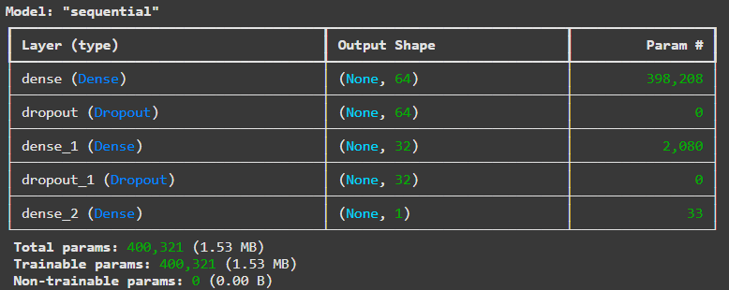Model Summary

1. **Model Evaluation**

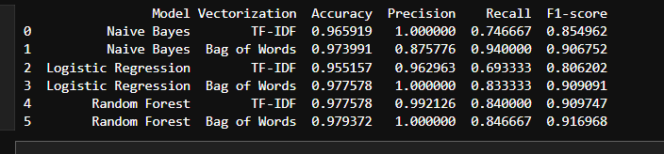

* Naive Bayes performed well, with TF-IDF achieving perfect precision but lower recall. Bag of Words showed a better balance, indicating a trade-off between spam detection and false positives.
* Logistic Regression with Bag of Words outperformed the TF-IDF variant, achieving a high recall and perfect precision. However, TF-IDF underperformed in recall, making it less suitable for scenarios where spam detection is critical.
* The Random Forest model exhibited strong overall performance, with Bag of Words slightly outperforming TF-IDF in recall and F1-score. This model is well-suited for spam classification, given its robustness in both precision and recall.
* **Best Overall Model:** **Random Forest (Bag of Words)** – Achieved the highest accuracy, perfect precision, and a well-balanced recall.
* Neural Network Model Performance:
* Accuracy: 98.2%
* Precision: 97.79%
* Recall: 88.67%
* F1-score: 93.00%
* High accuracy and precision suggest that the model effectively identifies spam messages.
* The recall is slightly lower, indicating some spam messages are still being classified as ham.