Date: June 3, 2026

To,
Mr. Rishikanth S 426/1, Baleguli, KRISHNAGIRI-635204

Subject: Internship Offer – Website Development Intern

Dear Mr. Rishikanth S,

We are pleased to offer you a 1 month, Online internship at Auro Creative Studio as a Website Development Intern.
Your internship will commence on 5 June, 2026 and conclude on July 5, 2026. For those operating in an offline or hybrid capacity, your reporting location will be our Pondicherry / Auroville campus.
During your internship, you will have the opportunity to gain practical exposure, develop industry-relevant skills, and contribute directly to live projects in your domain. You will be working under the supervision of the management team and will receive regular feedback on your performance and progress.
Your key responsibilities related to your domain shall be intimated to you at the time of your joining.
This is an unpaid internship position. The primary focus of this engagement is to provide you with hands-on industry experience and professional skill development. Following the successful completion of your internship, you will be issued an Internship Completion Certificate, and you may be considered for future opportunities based on your performance and the company’s requirements.

Terms and Conditions:
Confidentiality and Intellectual Property: You agree to hold in strict confidence all confidential information relating to Auro Creative Studio's business, including but not limited to client databases, source codes, design assets, marketing strategies, and proprietary processes. This obligation shall survive the termination of your internship.
All work product(s) created by you during your internship shall be the sole and exclusive property of Auro Creative Studio. You hereby assign all rights, title, and interest in such work product(s) to the company. Upon completion of your internship, you will promptly return any company-issued property, data, and documents.
Non-Disclosure and Non-Compete: During your internship and for a period of 1 year following its termination, you agree not to disclose any confidential information to any third party. You also agree not to engage in any business or activity that directly competes with Auro Creative Studio during your internship period.
Other Terms: This internship offer is contingent upon the submission of photocopies of your address proof, ID proof, and a No Objection Certificate (NOC) / Bonafide Certificate from your college (if applicable) on or before your first day. By accepting this offer, you acknowledge that participation in this program does not guarantee permanent employment.

How to Accept This Offer
Please indicate your acceptance of this internship offer by signing, dating, and returning a scanned copy of this letter via email by June 4, 2026.
We look forward to welcoming you to the team and watching you grow with us.

Sincerely,
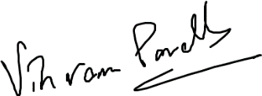
Vikram Parekh
CEO, Auro Creative Studio

Acceptance:
I, Rishikanth S, hereby accept the terms and conditions of the internship offer as outlined in this letter.
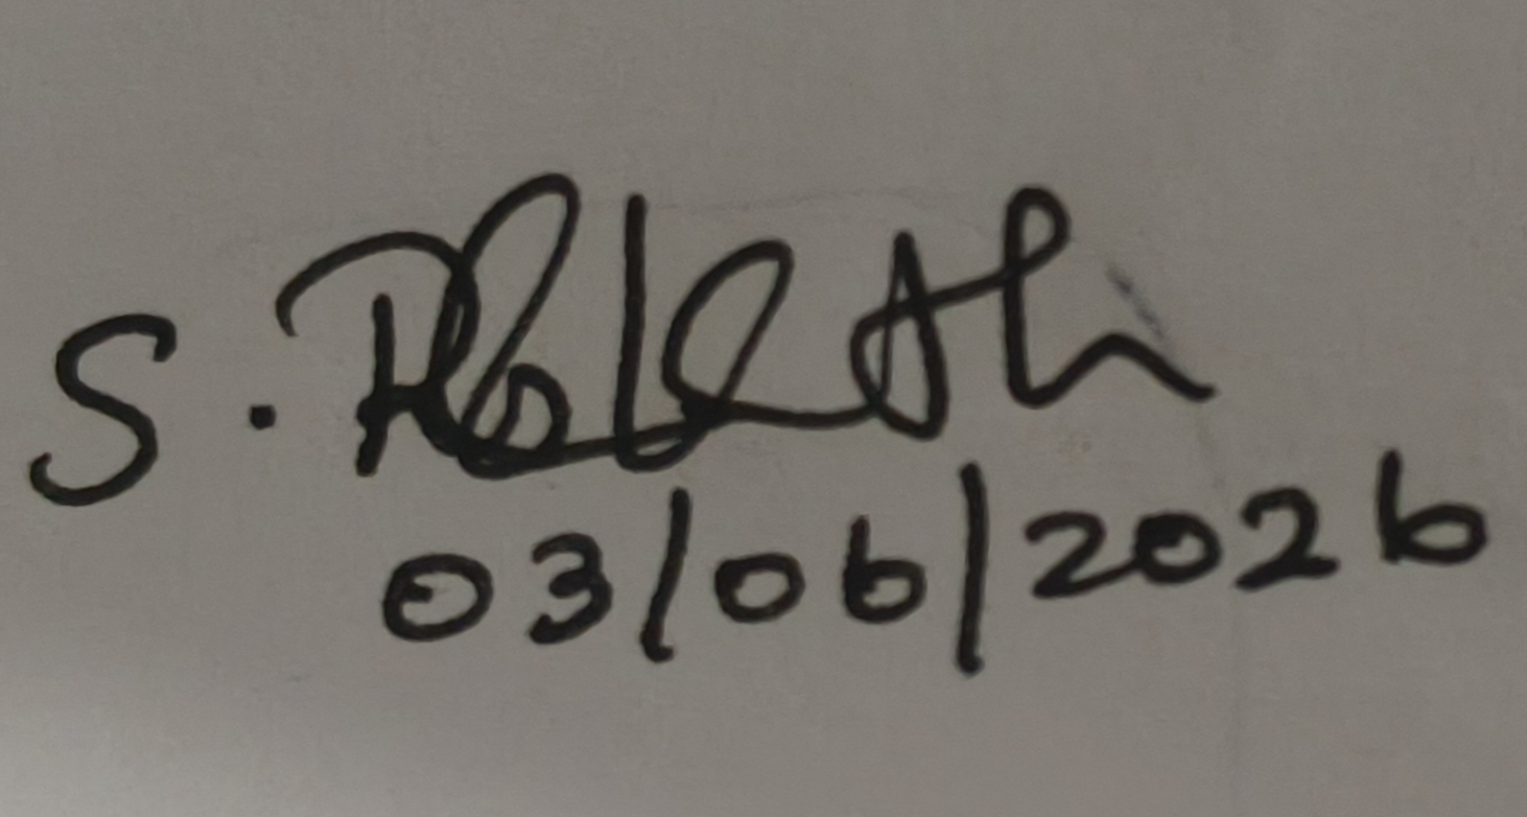

Signature & Date

