A project report

on

Tic TAC TOE

Submitted in partial fulfilment of the requirement of

Project-I

of

Bachelor of Information Technology

**Submitted to:**



Purbanchal University

Biratnagar, Nepal

**Submitted By:**

Rishi Khadka (313343)

Karan Kumar Gupta (313330)

Migeen Lamichhane (313337)

**KANTIPUR CITY COLLEGE**

Putalisadak, Kathmandu

September 20, 2021

A project report

on

TIC TAC TOE

Submitted in partial fulfillment of the requirement of

Project-I

of

Bachelor of Information Technology

**Submitted to:**



Purbanchal University

Biratnagar, Nepal

**Submitted By:**

Rishi Khadka (313343)

Karan Kumar Gupta (313330)

Migeen Lamichhane (313337)

**Project Supervisor**

**Kiran Khanal**

**KANTIPUR CITY COLLEGE**

Putalisadak, Kathmandu

September 20, 2021

**Topic Approval sheet**

**Certificate from Supervisor**

**Acknowledgment**

We would like to use this opportunity to thank all who lend their hand for completing our project successfully. First of all I would like to thank almighty. Who drove us through our project with his blessing and providing us with enough support to make it a success?

We are grateful to our project supervisor 'Mr. Kiran Khanal' who was there to guide us along the project, providing us assistance in doing the things in a proper and appropriate manner. Without him supervision this project would have been a tedious task for us.

We would also like to express our sincere thanks to Mr. Raju Katel (principal of KCC) for giving us this opportunity to undertake this project. We also like to thank our lecturer Mr. Bikesh Neupane sir and all the KCC management, team for whole hearted support.

We would like to extend our gratitude to my Friends and management for providing us with good services and creating an environment for carrying our project. Last but not least, we would like to express our sincere thanks to all our friends and other who helped us directly or indirectly during this project.

**Abstract**

With the advancement of technology means of entertainment have also been advanced in the current time. Now a days there are various means of entertainment where game is also one of the most popular means among the peoples. With this approach we have designed a simple and easy game which is play by entire world and easy to understand entering game for beginners in the gaming world ‘tic Tac toe’.

We have created the Aalu and cross game which is similar to the popular game known as “tic Tac toe” consisting both single and multiplayers mode and in addition best of three which is also one of multiplayers mode. This project is developed in c language and for this we have use C++ compiler.

**LIST OF FIGURES**

**Figure no.1 Figure caption Page no**

1 Gantt chart 3

2 Appendices 15

**LIST OF TABLES**

**Table no. Table caption Page no**

1. Assignment of role and responsibilities 2
2. Requirement gathering 2
3. Function analysis 4
4. Test plan 11

**Table of Contents**

ACKNOWLEDAGEMENT………………………………………...iii

ABSTRACT………………………………………………………...IV

List of figure………………………………………………………..

List of table…………………………………………………………

Chapter 1: Introduction………………………………………………1

* 1. Background…………………………………………………….1
  2. Problem Statement……….………………………………….…1
  3. Significance…………………………………………………….1
  4. Objectives………………………………………………………1
  5. Features………………………………………………………...2
  6. Assignment of role and responsibilities………………………..2

Chapter 2: System Analysis………………………………………….2

2.1 Requirement gathering……………………………………...….2

2.2 Gantt Chart…………………………………………………..…3

Chapter 3: System Design……………………………………………4

3.1 Function Analysis………………………………………….…4

3.2 Algorithm………………………………………………….…5

3.3 Flowchart……………………………………………………..7

Chapter 4: System Development and Implementation…………….11

4.1 Programming Platform……………………………………..11

4.2 Test plan…………………………………………………....11

Chapter 5: Conclusion………………………………………..……13

5.1 Conclusion………………………………………………….13

5.2 Limitation…………………………………………………..13

Reference..........................................................................................14

Appendices………………………………………………………...15

**Chapter 1: Introduction**

* 1. **Background**

This is the game was played from the ancient period back at Egypt, where such game boards have been found on roofing tiles dating from around 1300BCE. In today days this game is famous worldwide name TIC TAC TOE. It is a paper pencil game for two player. This game played by taking whether x or o in a 3x3 grid. The player who succeeds in placing fir three marks in a horizontal, vertical, or diagonal row is a winner. Ultimately several ideas have been incorporated in our project naming it as Aalu and cross.

* 1. **Problem statement**

We have encounter many problem while making this game and some problems are:

* Many error at simple mistake like
* Error while making login method.
* Make many mistake while return value.

**1.3 Significance of the project**

The goal of the game is for players to position their marks so that they make a continuous line of three cells vertically, horizontally or diagonally. An opponent can prevent a win by blocking the completion of the opponent’s line. In our variant of the game, players placed objects on a board.

**1.4 Objective**

Following are the major objective of this game:

* To entertainment people.
* To enhance the decision power of player.

**1.5 Features**

Following are the features that you can get in this game:

* Login method
* Best of three
* Player vs player
* Player vs computer
* Instruction how to play games
* Show scores
  1. **Assignment of role and responsibilities**

|  |  |  |
| --- | --- | --- |
| **Team Members** | **Roll no.** | **Role and responsibilities** |
| Rishi Khadka | 313343 | Documentation and coding, designing |
| Karan Kumar Gupta | 313330 | Documentation and coding, designing |
| Migeen Lamichhane | 313337 | Documentation and coding, designing |

**Chapter 2: System Analysis**

**2.1 Requirement gathering**

|  |  |  |
| --- | --- | --- |
| Requirement no | Requirement name | Requirement description |
| 1 | Operating system | it need windows7, OS or above for processing |
| 2 | Language | It need c language for coding |
| 3 | Developing software | Like Dev++ ,turbo |

**2.2 Gantt Chart**

|  |  |  |  |  |  |  |  |
| --- | --- | --- | --- | --- | --- | --- | --- |
| S.N | TASK | July | August | September | October | November | December |
| 1 | Concept submission |  |  |  |  |  |  |
| 2 | Requirement gathering |  |  |  |  |  |  |
| 3 | Analysis and system design |  |  |  |  |  |  |
| 4 | Coding and  Development |  |  |  |  |  |  |
| 5 | Testing and debugging |  |  |  |  |  |  |
| 6 | Maintenance |  |  |  |  |  |  |
| 7 | Documentation |  |  |  |  |  |  |

**Index:**

|  |  |
| --- | --- |
| Task completed |  |
| Task remaining |  |

**Chapter 3: System Design**

**3.1 Function analysis**

|  |  |  |
| --- | --- | --- |
| Header file | Library function | Description |
| <stdio.h> | -int main()  -fflush(stdin)  -return() | -Begins the execution of the program.  -Clears the input buffer.  -It returns value to the main function. |
| <conio.h> | -clrscr()  -printf()  -getch() | -It clears the screen.  -It display the message in the screen.  -It holds the screen until enter key pressed. |
| <srting.h> | -strcmp() | -It compares strings and gives result according to operation. |
| <Process.h> | -exit() | -It exits the program. |
| <ctype.h> | -isdigit()  -isalpha() | -It checks provided character is digit or not.  -It checks provided character is alphabet or not. |
| <Stdlib.h> | -exit() | -Closes all files and buffers and terminate the programs. |

**3.2 Algorithm**

Step1: Start

Step2: Display cover page

Step3: Display login method

Step4: If user name and password match with the existence credentials goto step5

Otherwise goto step 3

Step5: Display main menu:

5.1 How to play

5.2 Player vs Player

5.3 Computer vs Player

5.4 Best of three (Player vs Player)

5.5 Exit

Step6: Read option from the user

Step7: If 1 how to play goto step8

Step8: Display how the game works.

Step9: Display how to play game and goto step 5

Step10: If 2 player vs player

Step11: Display the player choice x or o

Step12: If player choice whether x or o the goto step 13

Step13: Display game board

Step14: Display x or o win goto step 15 16

Step15: Display x win goto step5

Step16: Display o win goto step5

Step17: If 3 computer vs player then goto step 18

Step18: Display the choice x or o

Step19: If x or o then goto step 20

Step20: Display game board

Step21: If computer win then goto step 22

Step22: Display computer win and goto step 5

Step23: If player win goto step 24

Step24: Display player win and goto step 5

Step25: If 4 best of three goto step26

Step26: Display choose player1 or player2

Step27: If player1 or player2 then goto step 28

Step28: Display game board

Step29: If player1 or player2 win then increase 1 point

Step 30: Display game board

Step31: If player1 or player2 win increase 1 point

Step32: If player1 or player2 have higher point goto step 33

Step33: Display the player1 win and goto step 5

Step34: Display the player2 win goto step5

Step35: If 5 exit

Step36: stop

**3.3 Flowchart:**

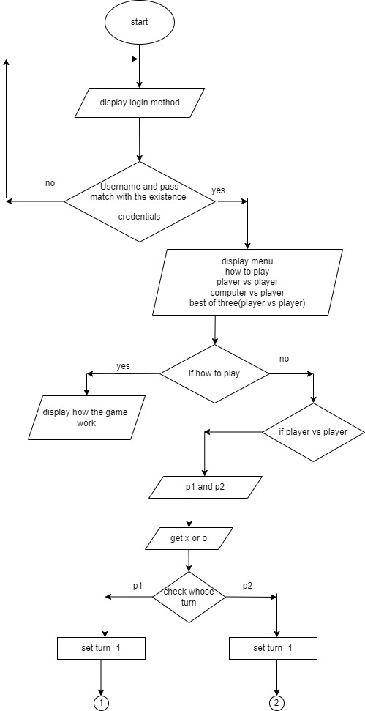

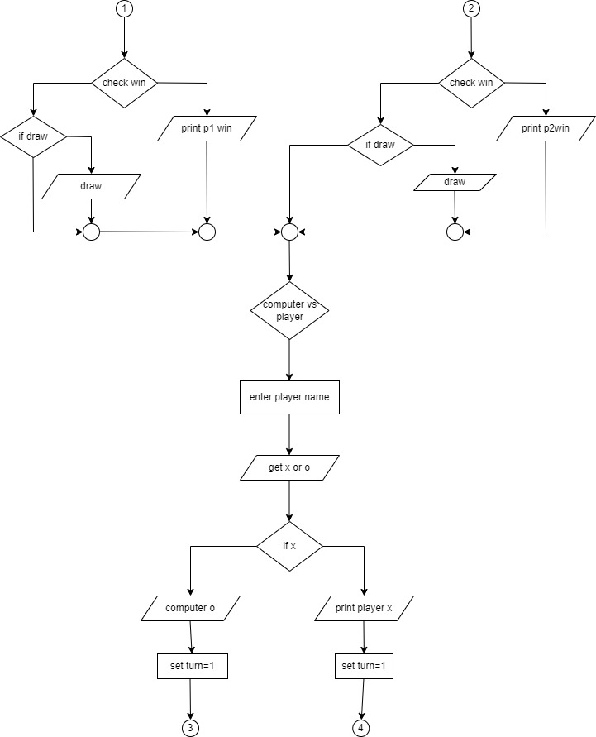

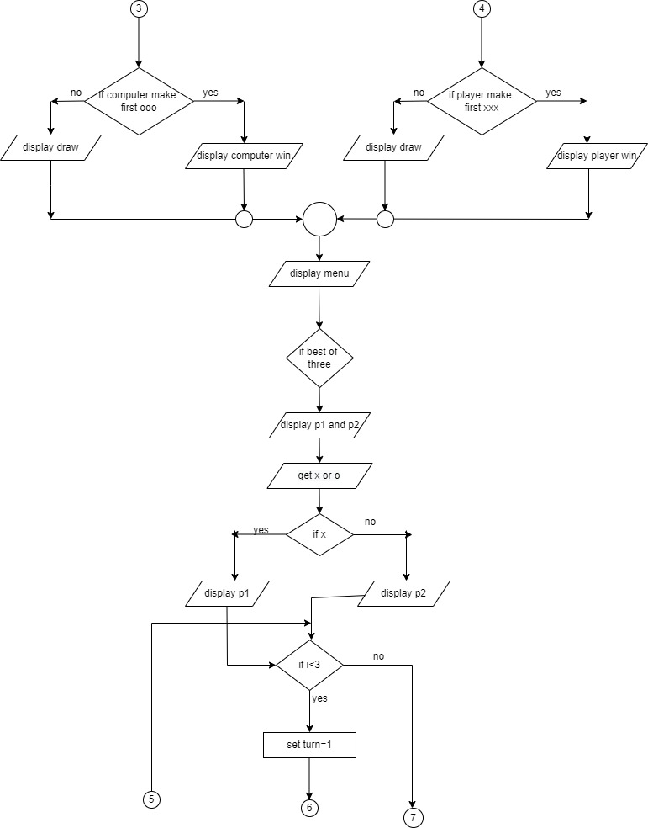

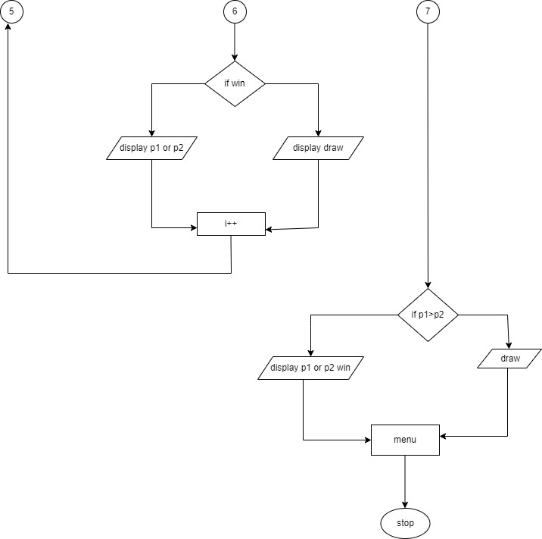

**Chapter 4: System Development and Implementation**

**4.1 Programming Platform.**

It need operating system likes windows7, OS or above. Fronted of the project is designed in Dev C++ compiler. The coding is stored in c file extension.

**4.2 Test plan**

A Test Plan is a detailed document that describes the test strategy, objectives, schedule, estimation, deliverables, and resources required to perform testing for a software product. Test Plan helps us determine the effort needed to validate the quality of the application under test. The test plan serves as a blueprint to conduct software testing activities as a defined process, which is minutely monitored and controlled by the test manager. The test cases, expected outcome, actual result are given below:

|  |  |  |  |  |  |  |  |
| --- | --- | --- | --- | --- | --- | --- | --- |
| **Test scenario** | **Test cases** | **Pre-conditions** | **Test steps** | **Test data** | **Expected result** | **Actual result** | **Status** |
| Check login functionality | Check response on entering valid username and password | Tic-tac-toe must be installed | * Launch app * Enter user name * Enter password * Click the Enter button | User name : aalu  Password 1234 | Login successfully | Login successful | Pass |

|  |  |  |  |  |  |  |  |
| --- | --- | --- | --- | --- | --- | --- | --- |
| **Test**  **scenario** | **Test**  **case** | **Pre-**  **condition** | **Test**  **step** | **Test**  **data** | **Expected**  **Result** | **Actual**  **result** | **status** |
| Check menu | Check  menu  function  working  or not | Must installed game | * Lunch app * Enter login page * Check menu | Menu working  Properly  Or not and show all the option | All the menu are shown and option are given in order | All the option are given in order | pass |

|  |  |  |  |  |  |  |  |
| --- | --- | --- | --- | --- | --- | --- | --- |
| **Test**  **scenario** | **Test**  **case** | **Pre-**  **condition** | **Test**  **step** | **Test**  **data** | **Expected**  **Result** | **Actual**  **result** | **status** |
| Check win | Check  Wining  function  working  properly | Must installed game | * Lunch app * Enter login page * Take your chose * Play game | Game run as we design  Show chose x or o  And also show player1 and 2 | Properly show the result. And the draw between two player also | It show the player who win the game and also show if draw between 2 player | pass |

**Chapter 5: Conclusion and Future Enhancement**

**5.1 Conclusion**

In the end I would like to conclude that our aim to make this project was to develop a game which has extra features which would make the game much more interesting. Tic-tac-toe is most familiar among all the age groups. An algorithm of playing Tic-tac-toe is presented and tested that works in efficient way. Some room for improvements are also there which will be corrected in the future. We would like to thank all those who have helped us and contributed in making this project.

**5.2 Limitation**

Some of the limitation are:

* Mouse can't be used to give the instruction.
* Player cannot return to main menu once he/she enter the specific game mode. So player should finish the game to return to main menu.
* The user can enter user name and passport three time if they make any mistake. The game will be close if there is more than three time.

**Reference**

* Finigami. (2021, August 27). Retrieved from Wikipedia: https://en.m.wikipedia.org/wiki/Ultimate_tic-tac-toe?fbclid=IwAR3F_4YvzepF3fF8BKSXP1fbRQ3xvhEKu7dUG38k8PgXajIrU2rA3uE2eOA#cite_ref-1
* Programming Knowledge (Director). (2020). C Tutorial for Beginners [Motion Picture].

Subedi, D. (2011, June 23). *Code in code*. Retrieved from Code in Code: http://www.codeincodeblock.com/2011/06/mini-project-tic-tac-game-source-code.html?fbclid=IwAR0MXY8qWVt_jfm_V5hqUoKsqruh-c0nu_IbF_SMV-aUbTKu9iUdXsQsUw0

**Appendices**

Login page:-

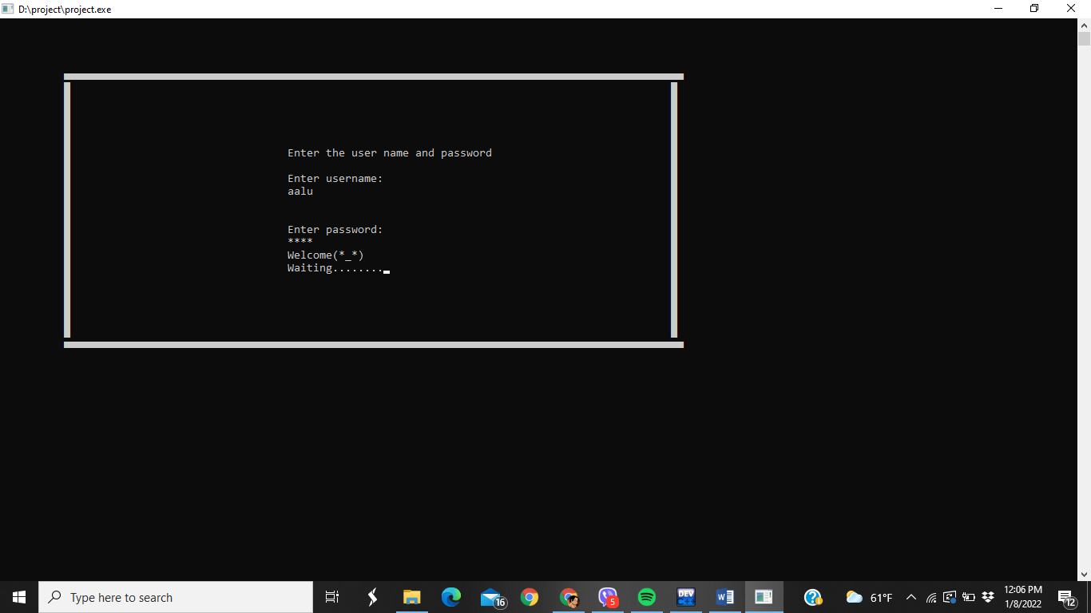

Menu page:-

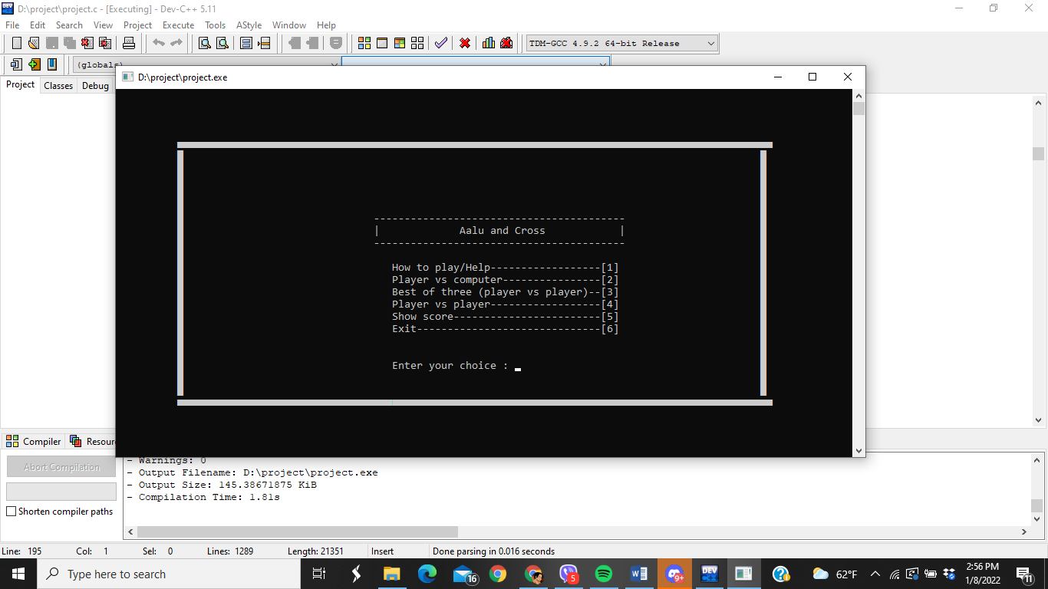

Best of three:-

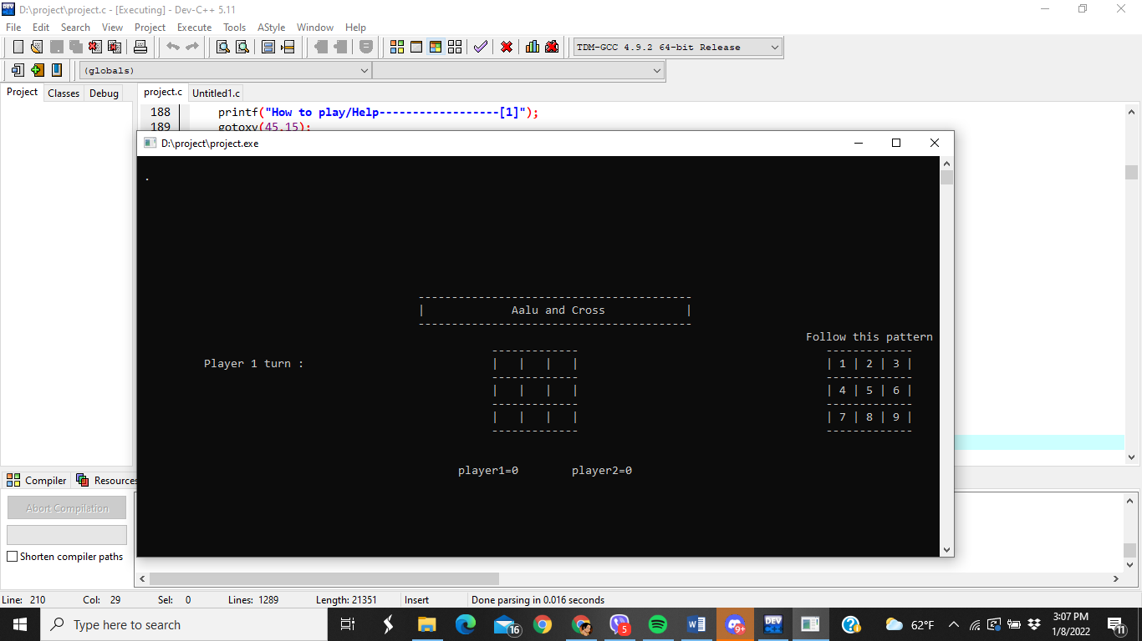

Total score:-

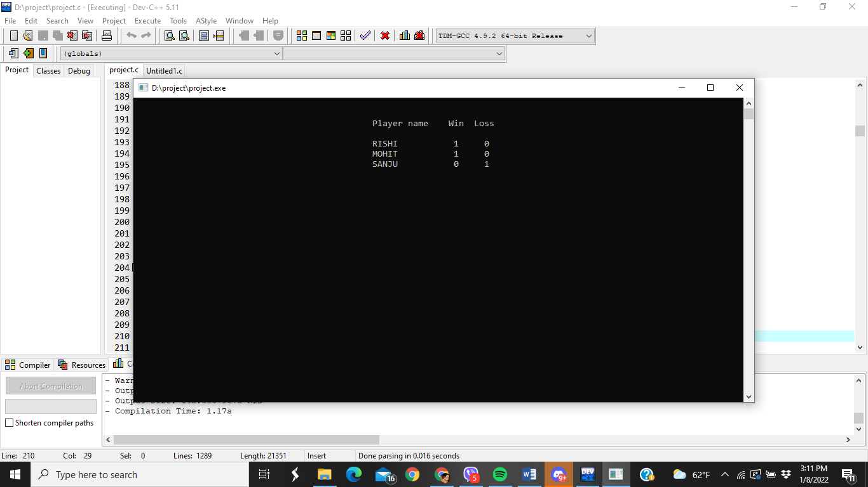

Player vs player

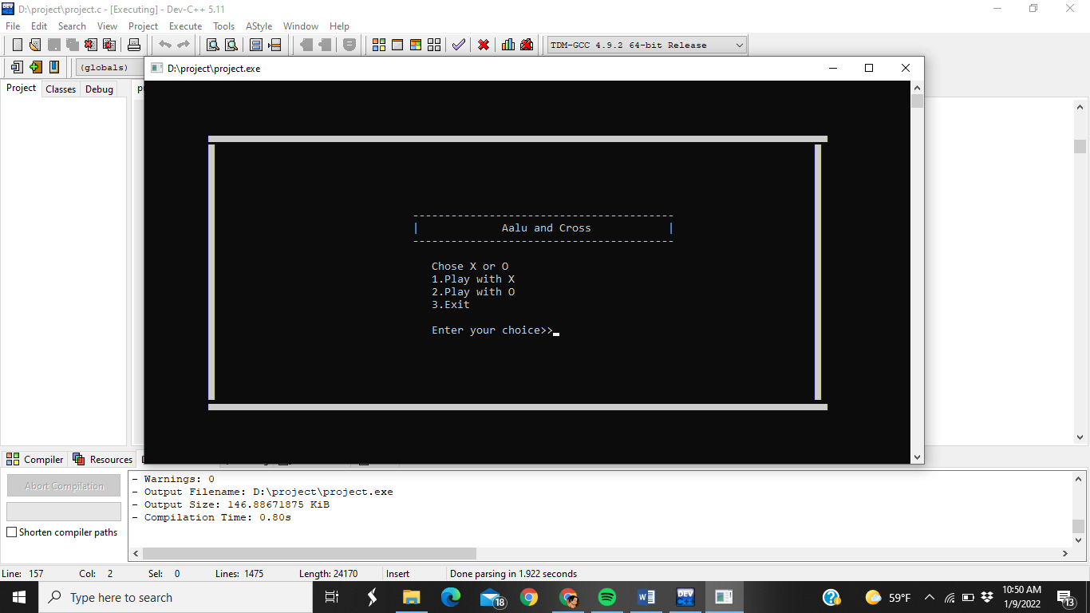

How to play

